Object Oriented Programming Using Java
Hands-On
Duration: 2 hours 30 minutes
Max Marks: 30

Instructions to candidates:
- Follow the class diagram strictly. Read the problem statement, functionality and the other details provided carefully and implement the solution
- Ensure that all the constructors are public and DO NOT change the prototype of the constructor and the methods
- Do not delete the project and files created by the Eclipse plug-in tool used for assessment
- Do not remove/modify the package statement
- Code submitted with compilation errors may not get evaluated
- The coding standards are mandatory wherever applicable

Guidelines:
- The verify option checks only the structural requirements and not the logical requirements of the problem statement given. Hence before submission, please check the code for all the structural and logical requirements of the problem statement given
- In case of system restart save your files on mandrake and after system is up, start the assessment once again and use the code saved on mandrake. It would be good if you can save your code frequently in Mandrake
- Submit your code only through the eclipse plug-in for assessment
- In case of any issue in submission, you can submit the code through hands-on exam client. Ensure to inform your batch owner and invigilator about the same so that your code will get evaluated. Wrong submissions may lead to code not getting evaluated

NOTE: NOT adhering to the above instructions and guidelines may lead to drastic reduction in your score even if the code is executing without any errors

Few errors which might result in mark reduction:
- Removal/modification of package statements
- Use of System.exit() statement
- Infinite loops/infinite recursive calls in the code
- Class diagram violation
- Improper constructor prototype or definition

WISH YOU ALL THE BEST

Problem Description:
NAUGHTEEN LEATHER FASHIONS sells two categories of leather products, namely Bag and Shoe for women. The organization wants to automate the billing process for their customers.
Class Diagram:
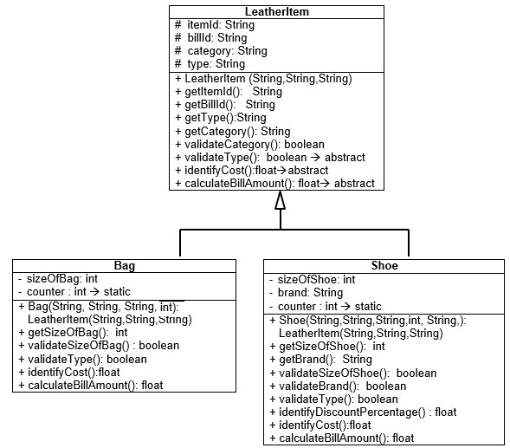
Note
- Do not include any extra instance variables or methods into the given classes
- In the derived classes, the order of passing arguments to the constructor would be the parent class variables followed by the child class variables
- Use case insensitive String comparison wherever applicable
- Do type conversions wherever appropriate
Business rules:
- Category of Leather Item the shop deals with are Imported and Manufactured
- Cost of bag must be identified based on the bag type and size of bag as given in Table-1

Table-1:
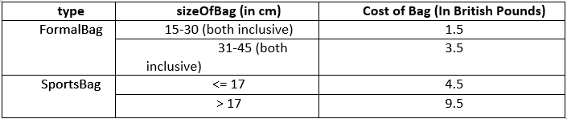
Note: All values other than those mentioned in the table are considered invalid. It is assumed that the combinations of Bag type and size of bag would be correctly passed. There is no need to validate the combinations.

- The cost of shoe must be identified based on the size of shoe and type of shoe as given Table-2

Table-2:
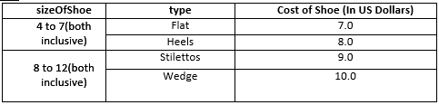
Note: All values other than those mentioned in the table are considered invalid. It is assumed that the combinations of Shoe type and size of shoe would be correctly passed. There is no need to validate the combinations.

- The discount percentage must be identified based on the brand of the Shoe as given in Table-3:
Table-3:
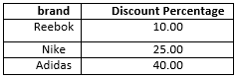
- Tax percentage must be identified based on the category of Leather Item as given in Table-4:
Table-4
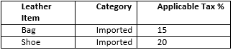
For all other combinations, tax percentage is 0
- The cost of bag is given in pounds and the cost of Shoe is given in dollars. The final calculated value need to be returned in Indian currency, Rupees. Refer Table 5 for conversion rates
Table-5:
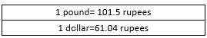
Implementation Details:
LeatherItem Class:
Constructor:
- The constructor of this class initializes the instance variables, itemId, category and type

validateCategory ():
- The valid values for category are provided in business rules
- If the value of category is valid, return true, otherwise return false

Bag Class:
Constructor:
- The constructor of this class initializes the sizeOfBag
validateType ()
- The valid values for bag type are given in Table 1
- If the value of type is valid, return true, otherwise return false

validateSizeOfBag()
- For Formal bags the size must be between 15 and 45 (both inclusive) and for Sports bag, any size is valid
- If the value of sizeOfBag is valid, return true, otherwise return false

Assume that for sports bag the size of bag will always be a non-zero positive value. No check is required for the same.

identifyCost()
- Invoke validateType() and validateSizeOfBag() methods
  - If any one of the above methods return false, display an appropriate error message and return 0
  - Otherwise, identify the cost of the bag as given in Table 1 based on type and sizeOfBag and return the same
calculateBillAmount ():
- Invoke the validateCategory() method. If the method returns false, display an appropriate error message and return 0
- Otherwise,
    - Identify the cost of bag by invoking the appropriate method and convert it into Indian Rupees using the information provided in Table 5
    - If the cost of bag in Indian Rupees is valid (i.e it is a non-zero positive value),
      - Identify and apply the tax percentage on the cost of bag in Indian Rupees
Bill Amount = cost of bag + (cost of bag * Tax percentage)/100
Note: Refer Table-4 to identify the tax percentage and cost of bag must be in Indian Rupees
      - Auto-generate the billId as mentioned below.
Bill Id must begin with the itemId followed by a numeric value starting from 1. Use the counter variable appropriately for auto-generation
      - Return the bill amount
    - Otherwise, display an error message to specify cost of bag cannot be calculated and return 0

Shoe Class:
Constructor:
- The constructor of this class initializes the sizeOfShoe and brand
validateSizeOfShoe():
- The values for sizeOfShoe must be between 4 and 12(both inclusive)
- If the value of sizeOfShoe is valid, return true, otherwise return false

validateType():
- The valid values for type are given in Table 2
- If the value of type is valid, return true, otherwise return false

validateBrand ():
- The valid values for brand is given in Table 3
- If the value of brand is valid return true, otherwise return false

identifyCost()
- Invoke the validateSizeOfShoe() and validateType() methods
  - If any one of the above methods return false, display an appropriate error message and return 0
  - Otherwise, identify the cost of the shoe as given in Table 2 based on type and sizeOfShoe and return the same
identifyDiscountPercentage():
- Invoke validateBrand() method. If it returns false, display an appropriate error message and return 0
- Otherwise, Identify the discount percentage applicable to shoe based on brand using Table-3 and return the same

calculateBillAmount ():
- Invoke the validateCategory() method. If the method returns false, display an appropriate error message and return 0
- Otherwise,
    - Identify the cost of shoe by invoking the appropriate method and convert it into Indian Rupees using the information provided in Table 5
    - If the cost of shoe in Indian Rupees is valid (i.e it is a non-zero positive value),
      - Identify and apply the discount percentage on the cost of shoe in Indian rupees by invoking the appropriate method as mentioned below;
cost of shoe = cost of shoe – (cost of shoe * discount percentage)/100
      - Identify and apply the tax percentage on the cost of shoe in Indian Rupees after applying the discount percentage as mentioned below
Bill Amount = cost of shoe + (cost of shoe * Tax percentage)/100
Note: Refer Table-4 to identify the tax percentage
      - Auto-generate the billId as mentioned below.
Bill Id must begin with the brand and itemId followed by a numeric value starting from 1. Use the counter variable appropriately for auto-generation
      - Return the bill amount
    - Otherwise, display an error message to specify cost of shoe cannot be calculated and return 0

Demo Class
- Demo class is the starter class
- Code for the Demo class is provided to you
- Read and understand the functionality of the code
- You can modify the code of Demo class for testing purpose but ensure that you submit it compilation error free
- Demo class will not be evaluated

Marks Distribution [30 Marks]:
- Implementation of LeatherItem class : 3 marks
- Implementation of Bag class : 10 marks
- Implementation of Shoe class : 12 marks

