Node.js Server – Concept 1

In the first 2 sushi cards, you will bring up a Node.js Server running on IBM Bluemix on the internet, and make some changes.

- Web browsers can make requests to your server at the Bluemix URL your server is brought up on.
- The server accepts the requests, and increments an internal counter. The code within your Node.js application return “Hello”, the value of the internal counter, and “Good Bye”
- In the web browser, the Hello, count, and Good Bye messages are displayed.
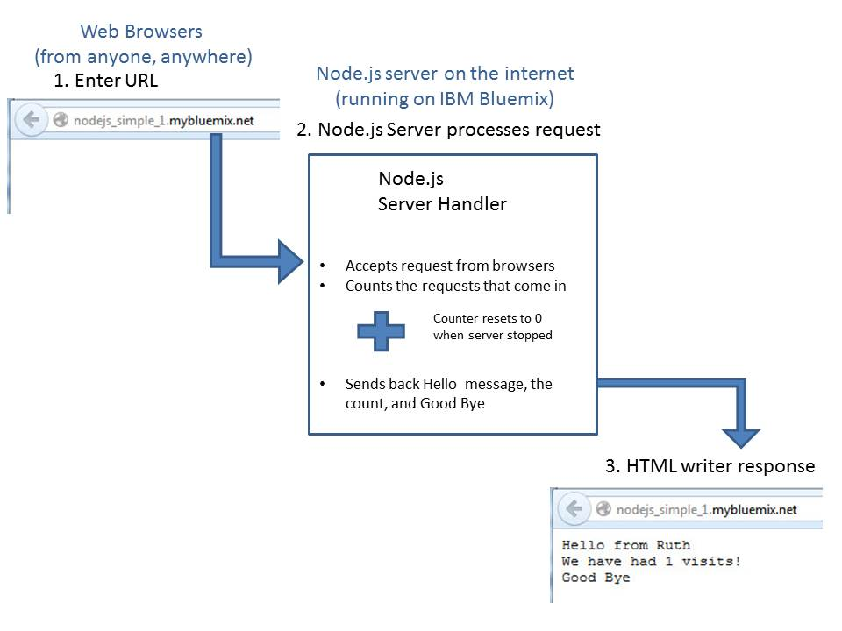
4. You will stop and restart the server. The counter is in memory in your Node.js server. When you stop the server, the memory goes away (the count is forgotten). Therefore, when you restart the server, the counter starts over.

5. You will also make some changes to the code. You make changes in the DevOps Services Integrated Development Environment, and deploy the new version of the application back to Bluemix. The code you write is javascript, and the example walks you through adding another counter.

