Setting up IDs for Bluemix and DevOps Services

In order to use the Bluemix Node.js series, you need to sign up for the IBM Bluemix trial, and also link your IBM Bluemix ID for use in IBM DevOps Services, the IBM Web Development Environment. This card provides the directions.
1 IBM Bluemix is a Platform-as-a-Service (PaaS) based on Cloud Foundry. The PaaS environment will host applications you write, and they will be accessible over the internet for use by others. You only need your web browser and an ID to use Bluemix. To get an ID, in your web browser, go to IBM Bluemix™ at https://bluemix.net and SIGN UP.
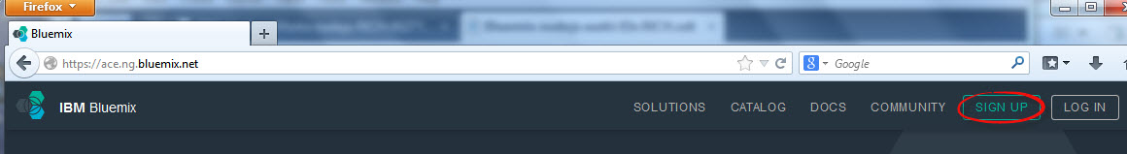
2 Fill in the fields to Begin your free trial, and press Submit.
3 Check your e-mail and open the e-mail from Bluemix with the Confirmation of your trial.
4 Click the Click here to complete your registation link in the e-mail and follow the instructions to Sign In and complete your registration.
5 You now have an IBM ID and access to Bluemix. If you LOG IN to Bluemix, you see the Catalog of services available for use. This series uses the Node.js Runtime and the Redis Service. Bluemix is a pay as you go platform, and both these service include a free tier. After your trial expires, you can continue to use Bluemix for free as long as you stay under the monthly usage limits.
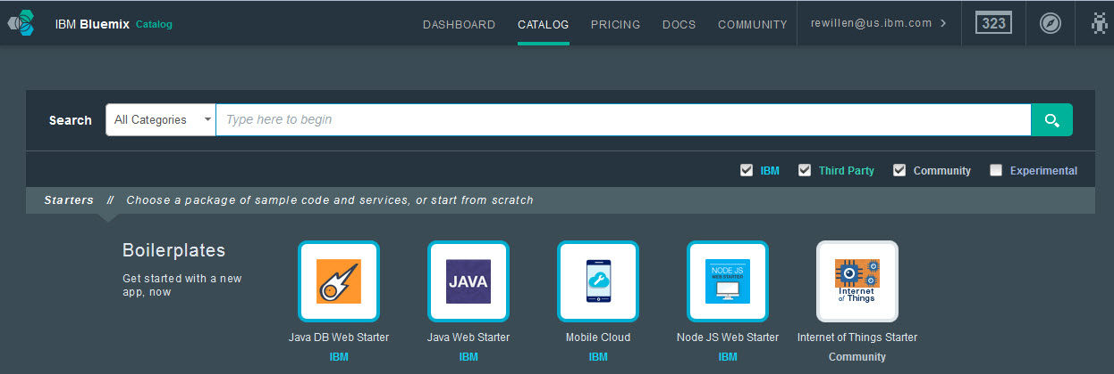
6 IBM Bluemix is where you application will run, but you also want a place to develop your application. This series uses IBM DevOps Services, an Integrated Development Environment (IDE) that is provided as a service. The IDE includes a code editor with capabiilties to deploy to Bluemix, as well as GIT based version management and change tracking. All you need to use DevOps Services with Bluemix is to create a Jazz ID and associate it to your IBM ID.
On a separate tab in your browser, go to DevOps Services at https://hub.jazz.net/ and SIGN IN.
7 Create your Jazz ID by entering a name for your Jazz ID. The name needs to be all lower case letters or numbers. You may want to try your first name or initials. Hit the Create button. This is a one time step.
Your IBM ID is now ready for use in both DevOps Services and Bluemix.
8 SIGN IN to DevOps Services. Here you can EXPLORE different projects and begin using a shared, team based Integrated Development Environment. You will EDIT CODE in DevOps Services and DEPLOY the applications to IBM Bluemix.
