Note: Follow Bluemix-sushi-prereqs for directions to get IDs. This may take up to 24 hours.

Create a Node.js Application

1 In your browser, go to DevOps Services at https://hub.jazz.net/ and SIGN IN.
2 Open the sample project rewillen | NodeJS_Simple_1 in your browser.
Note: if you are working from a hardcopy type: https://ibm.biz/nodejs1 or EXPLORE for “rewillen”
3 Click on FORK PROJECT, provide a unique name for your project, and click CREATE.
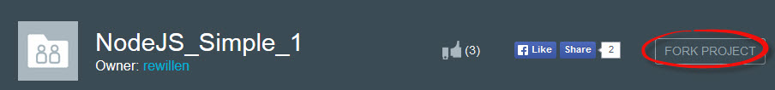
4 Click on EDIT CODE
5 (Optional Step) If you want an easy to remember URL for your website, click the upside down triangle to bring up a configuration screen, and complete steps 6 and 7.
6 (Optional Step) Click the pencil icon.
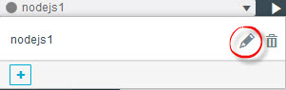
7 (Optional Step) Provide a unique, easy to remember Host name and click SAVE. This will be the URL for your application.
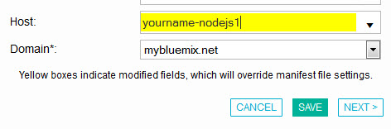
8 Deploy your application.
9 Wait for the deployment to complete and the status to show running. Click on the URL link icon to view your application.
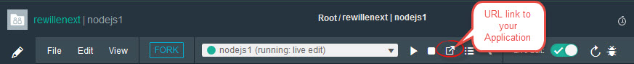
10 A separate browser tab will open with your application.
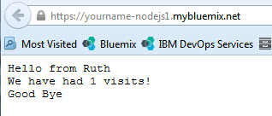
11 Refresh the application in the browser. * What happens? The count should be incremented. Note: depending on your browser, you may see the count increment by more than 1 on the first refresh.
12 To manage your application, follow the link to your application dashboard in Bluemix.
13 Click the STOP button.
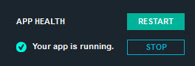
14 Click the START button.
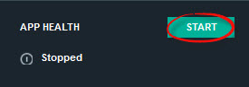
15 Follow the URL link again. The count should be reset to 1 visit. Try the URL from the browser on your phone. Share the URL link to your application with your friends.

