Edit a Node.js Application

1 Go to DevOps Services at https://hub.jazz.net/ and SIGN IN.
2 Continue with the project you used for Card 1.
3 In the left tree view, click on app.js to open the nodejs code for the application.
4 Edit the line that says ‘Hello from Ruth’ to say your name.
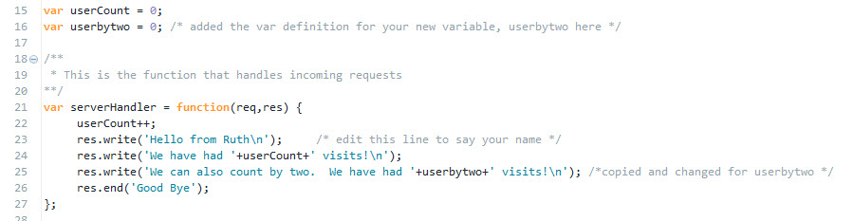
5 Click to turn on Live Edit and then click OK on the message box to Re-deploy your application to enable live edit mode.
6 Follow the URL link to open the application in the browser like you did on card 1. You should see your changes in the browser.
7 Back in app.js under var userCount = 0, add a new variable userbytwo and initialize it to 0.
8 Under the line that increments userCount, add a line to increment userbytwo by 2.
9 Copy and paste the write statement for userCount, and modify it to print out userbytwo.

10 Check that your code looks like this.
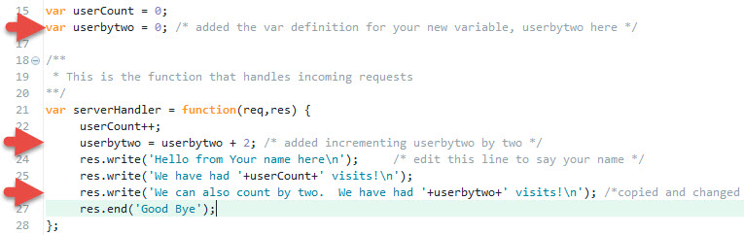
11 Use the Live Edit Quick Restart to update your website.
12 Follow the URL link to your application. Click Refresh button. *What happens? Does the counter increment by two?
13 Share the link with your friends.
14 See what else you can do with javascript. For example, add javascript to the server to get a random number, test if the number is odd or even, and then print out a message that includes the number and whether it is odd or even.

