K.R. MANGALAM UNIVERSITY
SCHOOL OF ENGINEERING AND
TECHNOLOGY


LAB FILE

COURSE NAME: COMPUTER NETWORK
COURSE CODE: ENCS302
NAME : Abhishek Mishra
ROLL NUMBER: 2301730280
COURSE: BTECH CSE (AI and ML)
SUBMITTED TO: MS. JYOTI KAURAV
TABLE OF CONTENTS

S.No. | Experiments
1 | Introduction to Computer Networks and Cisco Packet Tracer (CPT).
 | A. Studying the Cisco Packet Tracker (CPT) Interface.
 | B. Implementing a Peer-to-Peer Network.
2 | Visualizing the various Network Topologies:  - Mesh Topology  - Bus Topology  - Ring Topology  - Tree Topology  - Star Topology
3 | Constructing and understanding the purpose of a LAN.
 | A. LAN using a Hub.
 | B. LAN using a Switch.
4 | Implementation of a Campus Area Network (CAN): Design and the IP assignment.
5 | Implementing over the IP Layer:
 | A. Understanding the concept of Subnetting.
 | B. Implementing Traceroute and the Ping Command in CPT.
6 | Wireless Home Network: Setting up a Router.
7 | Capstone Project.

EXPERIMENT 1

INTRODUCTION TO COMPUTER NETWORKS AND THE CISCO PACKET TRACER (CPT)

EXPERIMENT 1(a): CPT Platform Overview

- Aim
To understand the interface, tools, icons, and functionalities of Cisco Packet Tracer and learn how to create and manage network topologies.

- Software Used
• Cisco Packet Tracer

- Introduction
Cisco Packet Tracer is a network simulation tool used to design, configure, and troubleshoot computer networks in a virtual environment. It provides both logical and physical views of a network along with simulation capabilities.

● 4. Interface Overview (Main Screen Components)

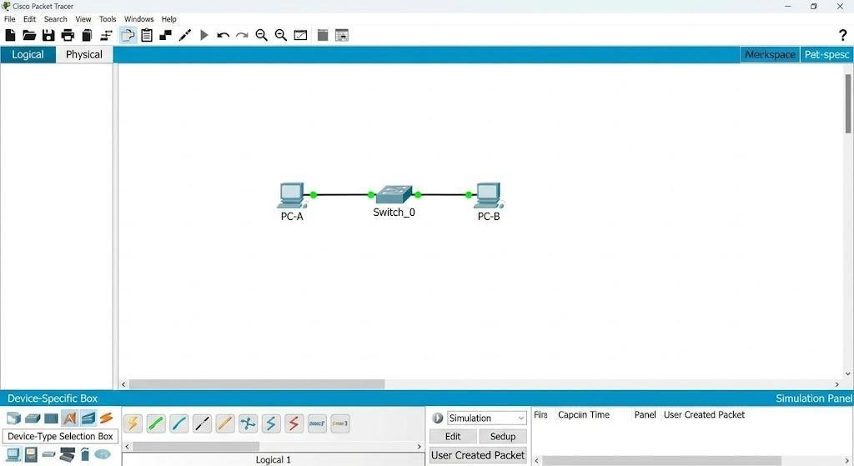
4.1 Menu Bar
Located at the top of the window.
Functions:
  - File: New, Open, Save projects
  - Edit: Undo, redo
  - Options: Preferences/settings
  - View: Zoom, grid
  - Tools: Activity wizard, extensions

4.2 Tool Bar (Main Toolbar Icons)

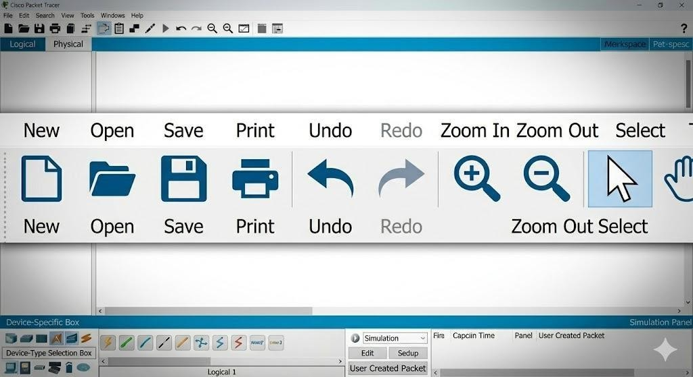

  - [ ‘)] New → Create new project

  - [J)] Open → Open saved file

  - [-.'⬛] Save → Save current work
  - [− ¡.□˙] Print → Print topology
  - [⬛3 ⬛C] Undo/Redo → Reverse actions

  - [Q˙•+/—] Zoom → Adjust view

  - [⬛'] Select → Move/select devices

  - [‘ 7(] Move Layout → Move screen

4.3 Workspace Area Two types:
- Logical Workspace
    - Used to design network topology
    - Add routers, switches, PCs

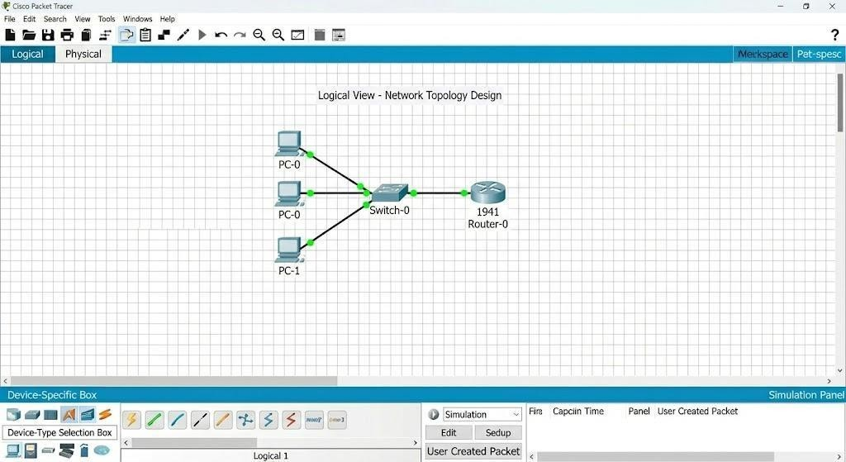

- Physical Workspace
• Real-world representation (buildings, rooms)
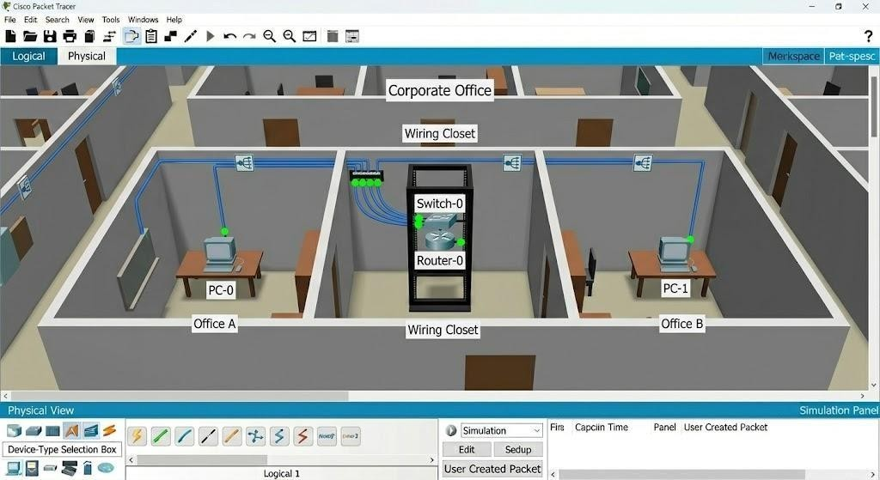
•

Shows

physical

placement

of

devices

4.4 Device-Type Selection Box

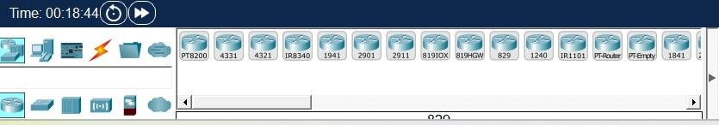
Categories:
    - Network Devices
    - End Devices
    - Components
    - Connections

4.5 Device-Specific Selection Box
• Displays devices like: o Routers o Switches o PCs o Servers

  - Connections Icon () Important)

Cable Type Use
Copper Straight Through PC to Switch
Copper Cross Over | Switch to Switch
Fiber Cable | High-speed connections
Serial Cable | WAN links
Console Cable | Configuration

  - Simulation Panel

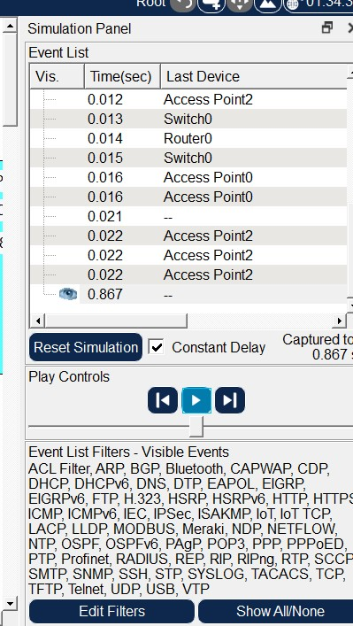

Functions:
    - Event List (packet flow)
    - Play/Pause simulation
    - Capture packets
    - Filters (ICMP, TCP, etc.)
- 5. Options s Customization
    - Change interface colors
    - Enable/disable grid
    - Configure fonts
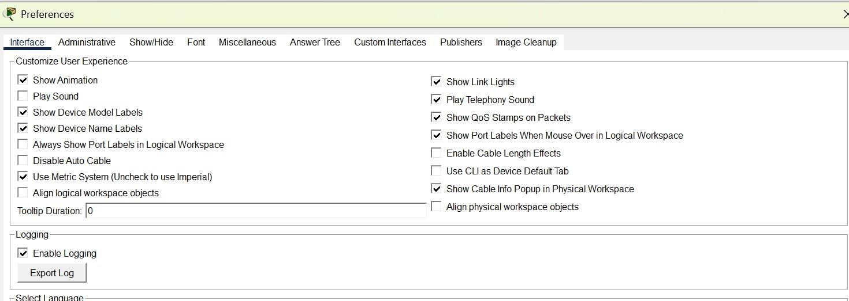
•

Adjust

simulation

speed

●

6.

Logical

Workspace

Operations

6.1 Creating Network Topology Steps:
    - Select device category
    - Drag device to workspace
    - Connect using cables

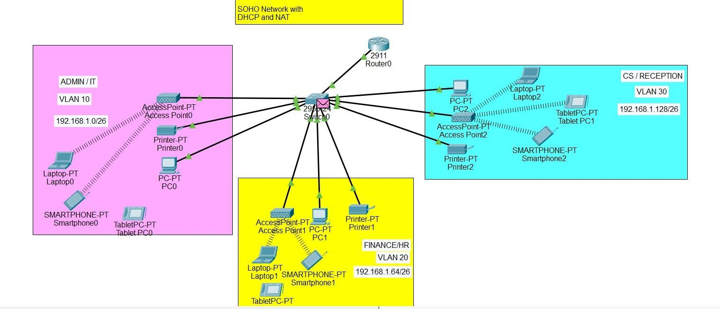
6.2 Custom Device Templates
    - Save frequently used devices
    - Reuse configurations

6.3 Clustering Network
• Group multiple devices
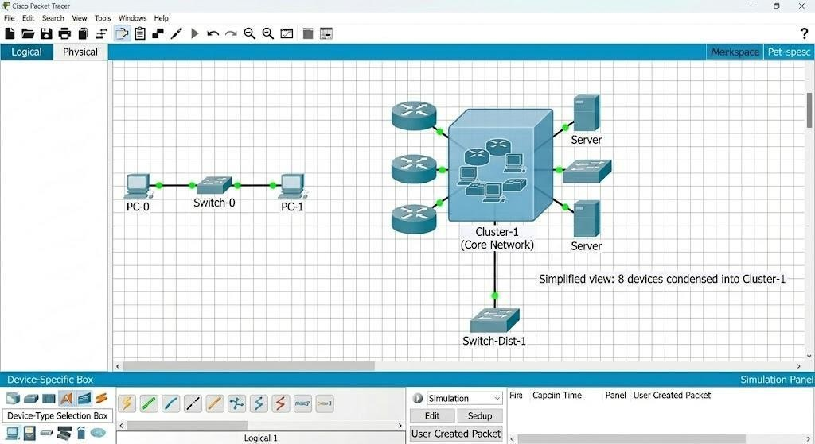
•

Simplifies

large

networks

6.4 Annotation Tools

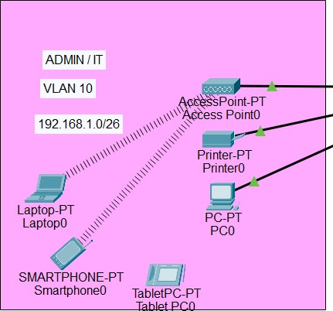

    - Add text labels
    - Draw shapes
    - Highlight connections

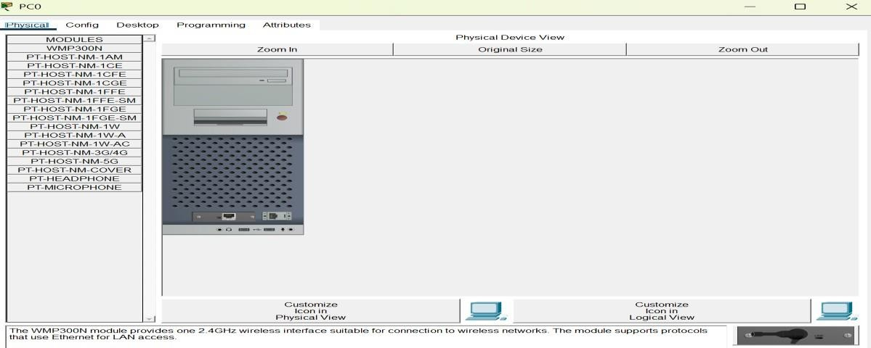
●

7.

Device

Configuration

Tabs

7.1

Config

Tab

    - GUI-based configuration
    - Set IP, routing, interfaces

7.2 Desktop Tab
    - Used in PCs
    - Tools available:
o IP Configuration o Command Prompt o Web Browser

7.3 Services Tab
• Configure services like:
o DHCP o DNS o HTTP

7.4 CLI Tab
• Command-line interface • Used for real Cisco commands ‘z’ Example:
ip address 192.168.1.1 255.255.255.0

- 8. Realtime vs Simulation Mode
Mode Description
Realtime Instant network operation
Simulation Step-by-step packet flow
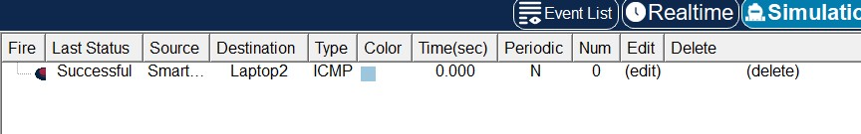

●

G.

Physical

Workspace

    - Shows buildings, wiring, racks
    - Helps in real-world network design

- 10. Important Icons Summary
Icon | Meaning
Router | Network routing
Switch | Connect devices
PC | End device
Server | Provides services
Cloud | Internet/WAN
Wireless Router Wi-Fi network

- 11. Result
Successfully understood the Packet Tracer interface, tools, icons, and basic network creation.
EXPERIMENT 1(b): Peer-to-Peer Network

- Aim
To design and implement a Peer-to-Peer (P2P) Network using Cisco Packet Tracer and understand direct communication between devices without a central server.

- Objective
  - To understand the concept of Peer-to-Peer networking
  - To create a small P2P network
  - To configure IP addresses manually
  - To test connectivity between devices
- Theory
A Peer-to-Peer (P2P) Network is a type of network where all devices (nodes) are equal and can act as both client and server.
–− There is no central server
–− Each computer shares its own resources –− Suitable for small networks (home, labs)
◆ Key Features:
- Decentralized network
- Easy to set up
- Low cost
- Direct communication between devices

- Requirements
  - 2 PCs (minimum)
  - 1 Switch (optional but recommended)
  - Copper Straight Through Cable
  - Packet Tracer software

- Network Topology
–− You will design:
  - PC1 ↔ PC2 (direct or via switch)

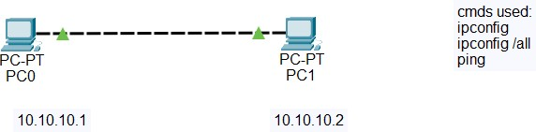

- IP Addressing Table
Device IP Address Subnet Mask
PC1 192.168.1.1 255.255.255.0
PC2 192.168.1.2 255.255.255.0

- Procedure
Step 1: Add Devices
  - Open Packet Tracer
  - Drag and drop 2 PCs into workspace

Step 2: Connect Devices
  - Use Copper Cross-Over cable (direct)
OR
  - Use Switch + Straight Cable

Step 3: Configure IP Address −– On PC1:
  - Desktop → IP Configuration
  - IP: 192.168.1.1
  - Subnet Mask: 255.255.255.0
–− On PC2:
  - Desktop → IP Configuration
  - IP: 192.168.1.2
  - Subnet Mask: 255.255.255.0

Step 4: Test Connectivity
  - Go to PC1 → Command Prompt
  - Type:
ping 192.168.1.2
–− If reply received → Network is working ⬛

- Result
The Peer-to-Peer network was successfully created and communication between devices was verified using ping command.

G. Advantages
- Easy to set up
- No server required
- Cost-effective
- Direct resource sharing

10. Disadvantages • Less secure
- Not scalable
- No centralized control
EXPERIMENT

VIZUALIZATING THE VARIOUS NETWORK TOPOLOGIES

EXPERIMENT 2(a): Star Topology

1. Aim
To design and implement a Star Topology using Cisco Packet Tracer.

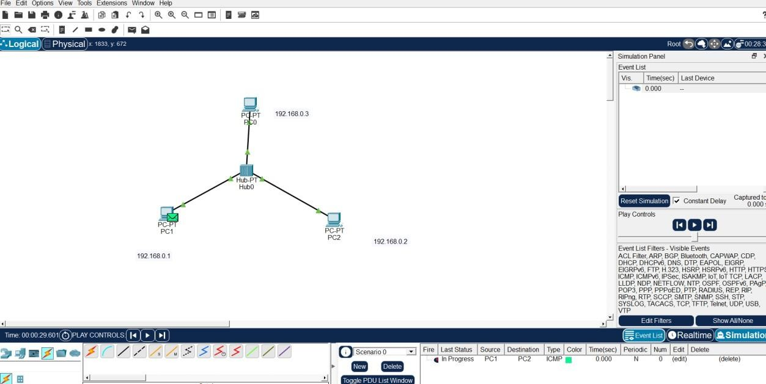
3.

Network

Diagram

- Procedure
  - Add one switch
  - Connect multiple PCs to switch
  - Assign IP addresses
  - Test connectivity using ping

- Result
Star topology was successfully created and verified.

(Networking s Devices)
Parameter | Details
Network Type | Campus Area Network (CAN)
Connecting  Devices  Explanation | Switch, PCs, Ethernet cables  Star topology is widely used in campus networks where all devices connect through a central switch, making management easy and
efficient.

2(b): Ring Topology

- Aim
To design and implement a Ring Topology using Cisco Packet Tracer.

- Theory
In Ring Topology, devices are connected in a circular form, and data flows in one direction through each node.

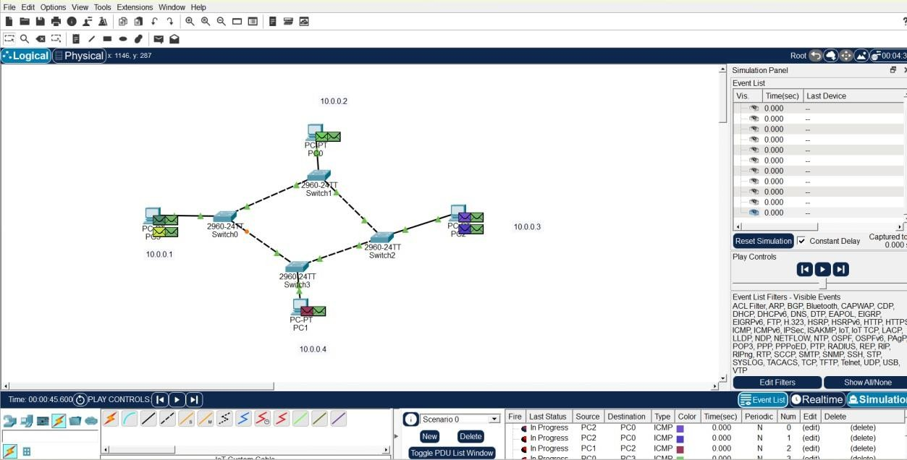
3.

Network

Diagram

4.

Procedure

  - Arrange PCs in circular layout
  - Connect each PC to the next
  - Assign IP addresses
  - Test connectivity

  - Result
Ring topology was successfully implemented and tested.

(Networking s Devices)
Parameter | Details
Network Type | Local Area Network (LAN)
Connecting  Devices | PCs, Ethernet cables
Explanation | Ring topology is suitable for small LANs where controlled data flow reduces collision and ensures equal access.

2(c): Mesh Topology

- Aim
To design and implement a Mesh Topology using Cisco Packet Tracer.

- Theory
In Mesh Topology, every device is connected to every other device, providing multiple paths for communication.

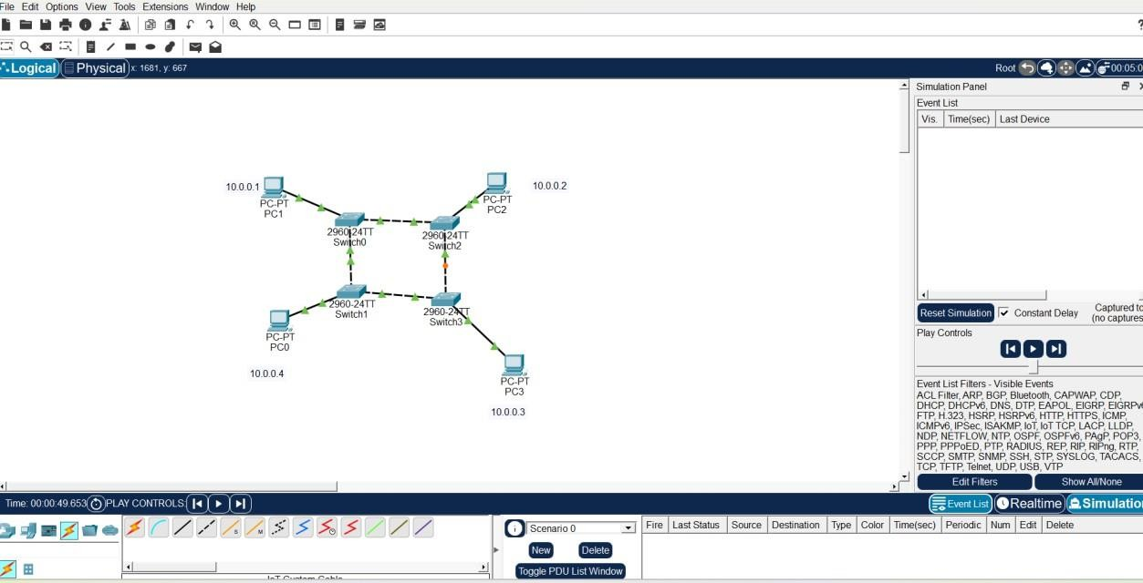
3.

Network

Diagram

4.

Procedure

  - Add multiple PCs
  - Connect each device to all others
  - Assign IP addresses
  - Test connectivity

  - Result
Mesh topology was successfully created and verified.

(Networking s Devices)
Parameter | Details
Network Type | Metropolitan Area Network (MAN)
Connecting  Devices | Routers, switches, multiple links
Explanation | Mesh topology is used in MAN for high reliability and redundancy, ensuring communication even if one link fails.

2(d): Tree Topology

- Aim
To design and implement a Tree Topology using Cisco Packet Tracer.

- Theory
Tree topology is a hierarchical structure that combines multiple star networks in parentchild form.

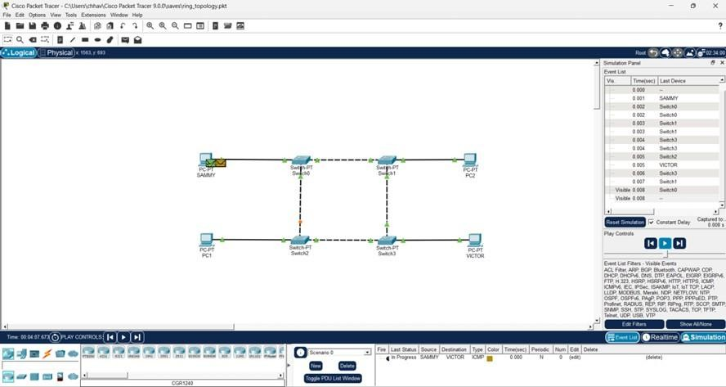
3.

Network

Diagram

4.

Procedure

  - Add a root switch
  - Connect child switches
  - Connect PCs to switches
  - Assign IP addresses
  - Test connectivity

5. Result
Tree topology was successfully implemented and tested.

(Networking s Devices)
Parameter | Details
Network Type | Campus Area Network (CAN)
Connecting  Devices | Core switch, access switches, PCs
Explanation | Tree topology is used in large campus networks where hierarchical
design allows better scalability and management.

EXPERIMENT 3

CONSTRUCTING AND UNDERSTANDING THE PURPOSE OF A LAN

EXPERIMENT 3(a): LAN using Switch

- Aim
To design and implement a Local Area Network (LAN) using a switch in Cisco Packet Tracer.

- Theory
A switch is an intelligent networking device that connects devices in a LAN and works on the Data Link Layer (Layer 2). It sends data only to the intended device using MAC addresses.

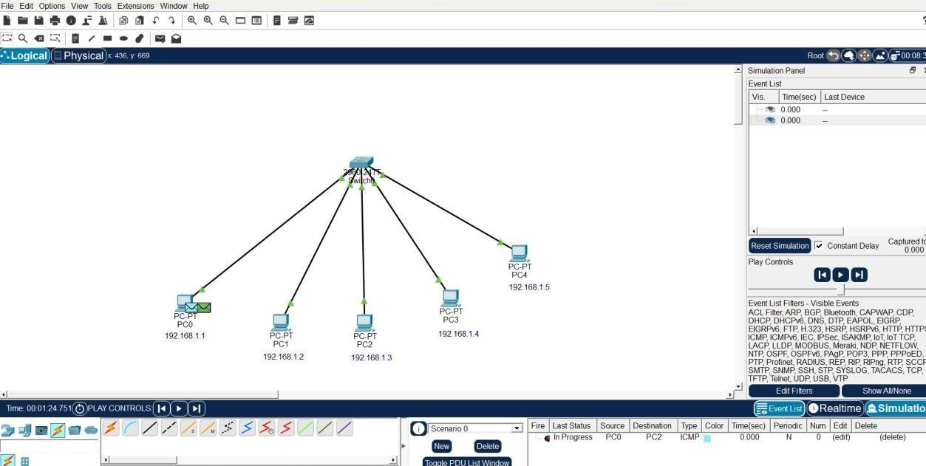
3.

Network

Diagram

- Procedure
  - Place one switch in the workspace
  - Add multiple PCs
  - Connect PCs to switch using Copper Straight Through Cable
  - Assign IP addresses
  - Test connectivity using ping

- Result
LAN using switch was successfully implemented with efficient communication between devices.

- Advantages
  - Faster communication
  - No unnecessary data transmission
  - Better security

- Disadvantages
  - Costlier than hub
  - Requires configuration

(Networking s Devices)
Parameter | Details
Network Type | Local Area Network (LAN)
Connecting  Devices | Switch, PCs, Ethernet cables
Explanation | Switch-based LAN improves performance by sending data only to the
destination device, reducing traffic and collisions.

EXPERIMENT 3(b): LAN using Hub

- Aim
To design and implement a Local Area Network (LAN) using a hub in Cisco Packet Tracer.

- Theory
A hub is a basic networking device that connects multiple computers in a LAN. It works on the Physical Layer (Layer 1) and broadcasts data to all connected devices.

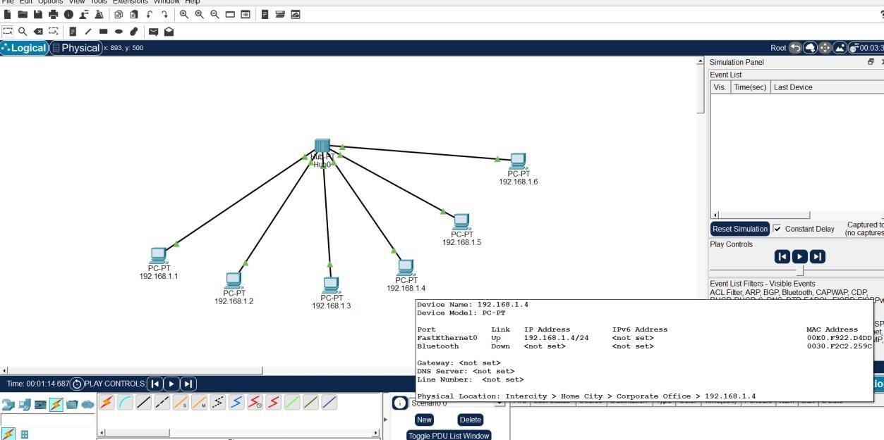
3.

Network

Diagram

4.

Procedure

- Place one hub in the workspace
- Add multiple PCs (3–5)
- Connect all PCs to hub using Copper Straight Through Cable
- Assign IP addresses manually
- Test connectivity using ping

- Result
LAN using hub was successfully created. Communication was established, but data was broadcast to all devices.

- Advantages
  - Simple and low cost
  - Easy to install

- Disadvantages
  - Data broadcast to all devices (low security)
  - Network congestion
  - No traffic control

(Networking s Devices)
Parameter | Details
Network Type | Local Area Network (LAN)
Connecting  Devices | Hub, PCs, Ethernet cables
Explanation | Hub-based LAN is used for basic networking where all devices share the same bandwidth and receive all transmitted data.
EXPERIMENT
IMPLEMENTATION OF A CAMPUS AREA NETWORK

(CAN): DESIGN AND IP SETTINGS

- Aim
To design and implement a Campus Area Network (CAN) and perform proper IP address assignment using Cisco Packet Tracer.

- Objectives
  - To understand the concept of Campus Area Network
  - To design a network connecting multiple departments
  - To assign IP addresses systematically
  - To test connectivity across the network

- Theory
A Campus Area Network (CAN) is a network that connects multiple Local Area Networks (LANs) within a limited geographical area such as a college, university, or organization.
–− It is larger than LAN but smaller than MAN
–− Used for interconnecting departments (Admin, Labs, Library, etc.)
◆ Key Features:
- High-speed connectivity
- Centralized management
- Scalable design

- One central/core switch or router
- End devices (PCs) in each department

- Network Diagram

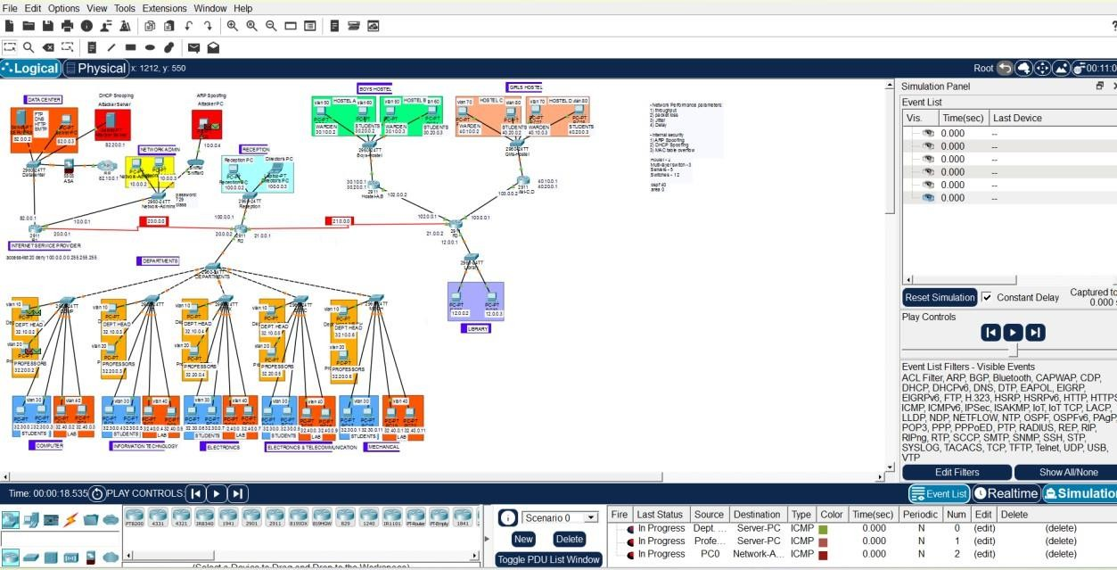
- IP Addressing Scheme
Example:
Department Device IP Address Subnet Mask

Lab | PC1 | 192.168.1.2 255.255.255.0
Lab | PC2 | 192.168.1.3 255.255.255.0
Office | PC1 | 192.168.2.2 255.255.255.0
Library | PC1 | 192.168.3.2 255.255.255.0
–− Each department uses a different network (subnet)

- Procedure
Step 1: Design Network
  - Add switches for each department
  - Add PCs in each department
  - Connect switches to central switch/router

Step 2: Connect Devices
  - Use Copper Straight Through Cable
  - Ensure proper connections

Step 3: Assign IP Addresses
  - Assign IPs based on department • Example:
o Lab → 192.168.1.0/24 o Office → 192.168.2.0/24 o Library → 192.168.3.0/24

Step 4: Test Connectivity
  - Use Command Prompt
  - Run:
ping 192.168.x.x
–− Verify communication within and across departments

- Result
The Campus Area Network was successfully designed and implemented. IP addresses were assigned properly, and communication between devices was verified.

G. Advantages
- Efficient resource sharing
- Centralized control
- Scalable network

10. Disadvantages
- Complex setup
- Requires proper planning
- Higher cost than LAN

^ Footnote (Networking s Devices)
Parameter | Details
Network Type | Campus Area Network (CAN)
Connecting  Devices  Explanation | Core switch/router, access switches, PCs, Ethernet cables  CAN connects multiple LANs within a campus using hierarchical design, allowing efficient communication and centralized
management.

EXPERIMENT 5

Implementing over the IP Layer

A. Understanding the Concept of Subnetting

- Aim
To understand and implement subnetting by dividing a network into smaller subnetworks.

- Objective
  - To understand IP addressing and subnetting
  - To divide a network into multiple subnets
  - To calculate subnet mask, network ID, and broadcast ID

- Theory
Subnetting is the process of dividing a large network into smaller networks (subnets) to improve performance and security.
–− It helps in:
  - Efficient IP utilization
  - Reducing network congestion
  - Better management

- Example of Subnetting
Given Network: 1G2.168.1.0/24
Divided into 4 subnets
Subnet Network Address Usable IP Range Broadcast Address

- 192.168.1.0 192.168.1.1 – 192.168.1.30 192.168.1.31
- 192.168.1.32 192.168.1.33 – 192.168.1.62 192.168.1.63
- 192.168.1.64 192.168.1.65 – 192.168.1.94 192.168.1.95
- 192.168.1.96 192.168.1.97 – 192.168.1.126 192.168.1.127
Subnet Mask: 255.255.255.224 (/27)

- Procedure
  - Take network 192.168.1.0/24
  - Divide into 4 subnets
  - Assign IP addresses to devices
  - Configure network in Packet Tracer
  - Verify connectivity

- Result
Subnetting was successfully implemented, and the network was divided into smaller subnets.

B. Implementing Traceroute and Ping Command in CPT

- Aim
To implement and analyze Ping and Traceroute commands in Cisco Packet Tracer.

- Objective
  - To test connectivity between devices
  - To trace path of packets in network

- Theory
◆ Ping Command
  - Used to check connectivity between devices
  - Uses ICMP protocol
−– Example: ping 192.168.1.2

◆ Traceroute Command
  - Shows the path taken by data packets
  - Helps in troubleshooting
–− Example:
tracert 192.168.1.2

- Network Diagram
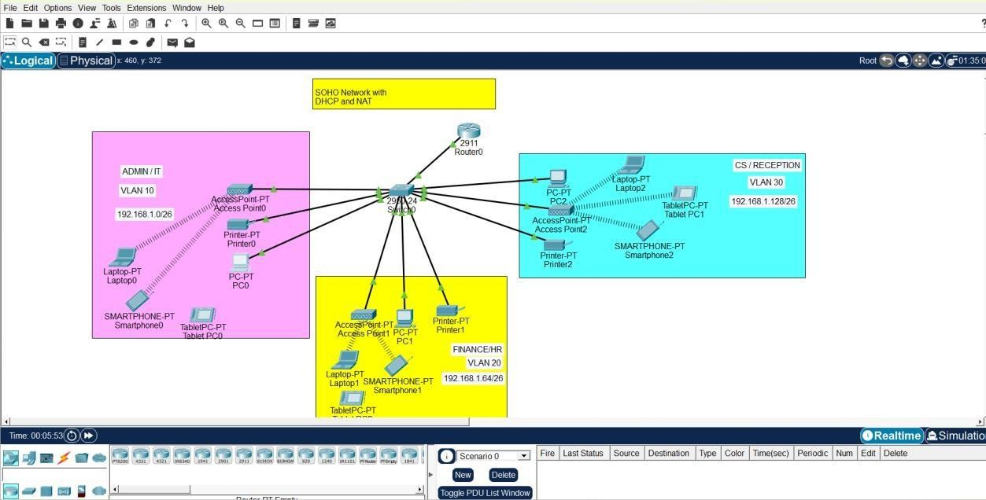

5.

Procedure

Step 1: Create Network
  - Add PCs and routers
  - Connect devices properly

Step 2: Assign IP Addresses
  - Configure IPs on all devices

Step 3: Test Ping
  - Open Command Prompt • Run:
ping 192.168.1.133
–− Check replies

Step 4: Run Traceroute
  - In Command Prompt:
tracert 192.168.1.133
−– Observe path

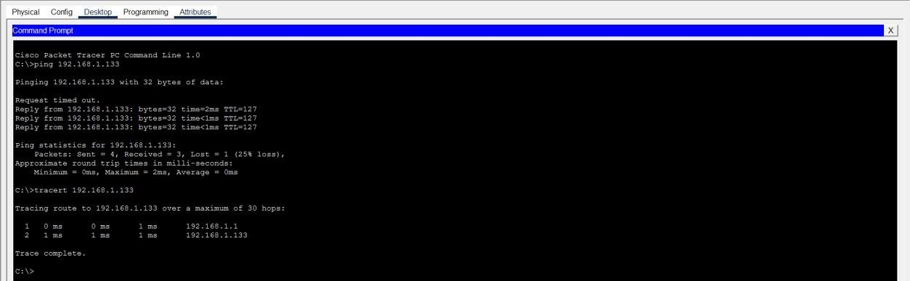
6.

Output

Screenshots

7. Result
Ping command successfully verified connectivity, and Traceroute displayed the path followed by packets.

(Networking s Devices)
Parameter | Details
Network Type | Local Area Network (LAN) / Campus Area Network (CAN)
Connecting  Devices | Routers, switches, PCs, Ethernet cables
Explanation | Subnetting improves network efficiency, while Ping and Traceroute
help in testing and troubleshooting connectivity across networks.

EXPERIMENT 6

Wireless Home Network – Setting up a Router

- Aim
To design and configure a Wireless Home Network using a router in Cisco Packet Tracer.

- Objectives
  - To understand wireless networking concepts
  - To configure a wireless router
  - To connect wired and wireless devices
  - To test network connectivity

- Theory
A Wireless Home Network allows multiple devices (laptops, smartphones, PCs) to connect using Wi-Fi through a wireless router.
–− The router performs:
- DHCP (automatic IP assignment)
- Routing (internet access) • Wireless communication (Wi-Fi)
◆ Key Components:
- Wireless Router
- End Devices (PC, Laptop, Mobile)
- Ethernet cables

4. Network Diagram
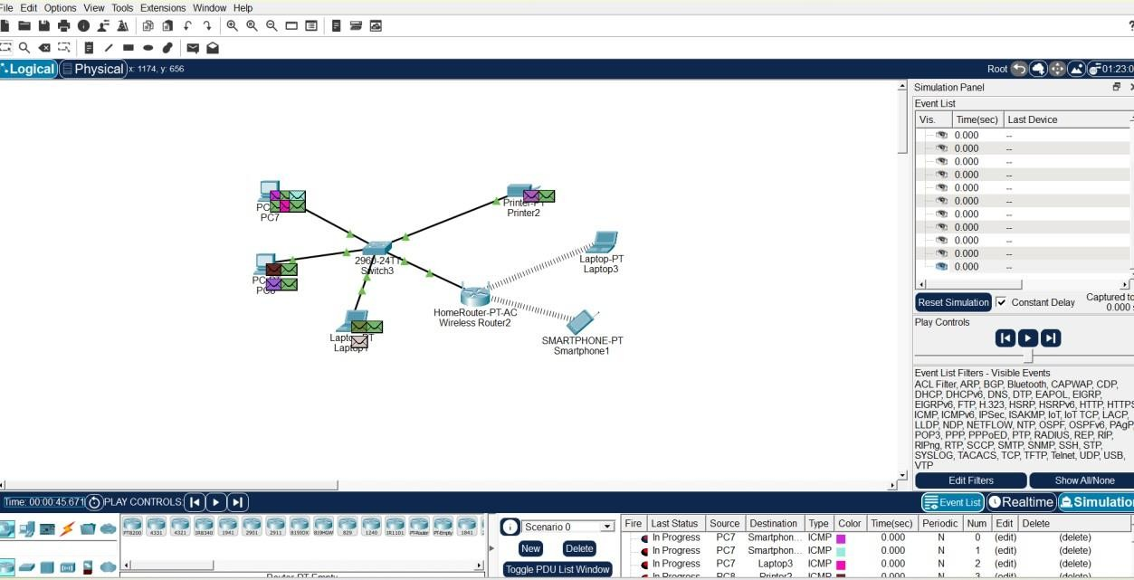

5.

Procedure

Step 1: Add Devices
- Place a Wireless Router (WRT300N)
- Add PCs and Laptops

Step 2: Connect Wired Devices
- Connect PC to router using Copper Straight Through Cable

Step 3: Configure Router
–− Click Router → GUI Tab
- Set SSID (Wi-Fi Name) → e.g., Home_Network
- Set Password → WPA2 security
- Enable DHCP

Step 4: Connect Wireless Device
– −Laptop:
- Desktop → PC Wireless
- Select SSID
- Enter password

Step 5: IP Configuration
- Ensure devices receive IP automatically via DHCP

Step 6: Test Connectivity ping 192.168.0.1
–− Ping router or other device

- Result
Wireless Home Network was successfully configured. Devices were able to connect and communicate through the router.

- Advantages
  - No cables required for wireless devices
  - Easy to install
  - Flexible and mobile

- Disadvantages
  - Security risks
  - Signal interference
  - Limited range

(Networking s Devices)
Parameter | Details
Network Type | Local Area Network (LAN)
Connecting  Devices | Wireless router, PCs, laptops, Wi-Fi
Explanation | Wireless networks allow devices to connect without cables, and routers manage communication using DHCP and wireless signals.

EXPERIMENT 7

CAPSTONE PROJECT: SOHO Network with DHCP and NAT

- Aim
To design and implement a Small Office/Home Office (SOHO) Network using DHCP and NAT in Cisco Packet Tracer.

- Objectives
  - To design a complete SOHO network
  - To configure DHCP for automatic IP assignment
  - To implement NAT for internet access
  - To verify communication within and outside the network

- Theory
◆ SOHO Network
A SOHO network is designed for small organizations or homes where multiple devices share internet and resources.

◆ DHCP (Dynamic Host Configuration Protocol)
- Automatically assigns IP addresses
- Reduces manual configuration

◆ NAT (Network Address Translation)
- Converts private IP → public IP
- Allows multiple devices to access internet using one IP
- Provides basic security

5. Network Diagram


6.

IP

Addressing

Scheme

Device IP Address | Subnet Mask
Router LAN 192.168.1.1 | 255.255.255.0
Router WAN Public IP (e.g., 200.0.0.1) -
PCs DHCP Assigned 255.255.255.0

7. Configuration

◆ Router Configuration (LAN)
interface fa0/0 ip address 192.168.1.1 255.255.255.0 no shutdown

◆ DHCP Configuration
ip dhcp pool LAN network 192.168.1.0 255.255.255.0 default-router 192.168.1.1

◆ NAT Configuration
access-list 1 permit 192.168.1.0 0.0.0.255 ip nat inside source list 1 interface fa0/1 overload

◆ Interface Configuration
interface fa0/0 ip nat inside

interface fa0/1 ip nat outside

8. Procedure
- Place router, switch, and PCs
- Connect all devices
- Configure router interfaces
- Enable DHCP
- Configure NAT
- Test connectivity

G. Testing
◆ Internal Test ping 192.168.1.x

◆ Internet Test ping 8.8.8.8

–− Successful replies = Network working ⬛

- Result
The SOHO network was successfully implemented with DHCP and NAT. Devices received IP automatically and accessed external networks.

- Advantages
  - Automatic IP assignment
  - Efficient internet sharing
  - Secure internal network

- Limitations
  - Depends on router performance
  - Limited scalability

(Networking s Devices)
Parameter | Details
Network Type | SOHO Network
Connecting  Devices  Explanation | Router, switch, PCs, ISP cloud  SOHO networks use DHCP for automatic IP allocation and NAT to allow multiple devices to access the internet securely using a single
public IP.

. Theory In Star Topology, all devices are connected to a central device (switch/hub). All communication passes through this central node.
. Network Design –− Typical design includes: • Multiple switches (for departments)

