DecryptConfig utility

Step 1: Run the executable and provide section name. In case of PrintCenter it is “appSettings”

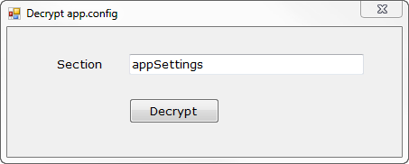

Step 2: Click Decrypt and select the executable whose app.config file needs decryption

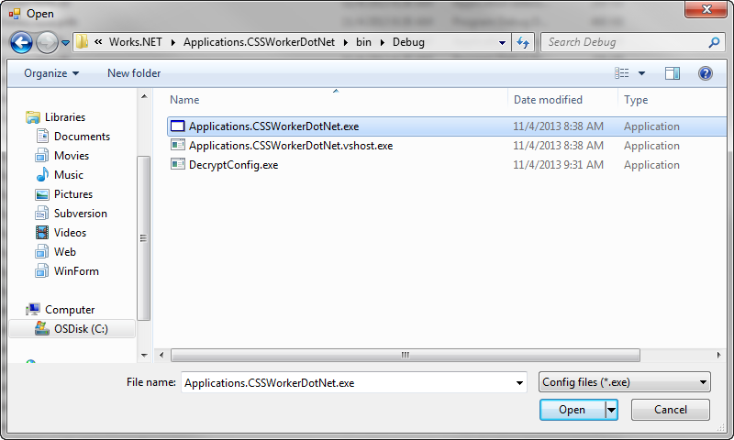

Step 3: The app.config file will be decrypted and values will be shown in notepad



Output

