

e-Learning App Development

Table of Contents

Proposal Details 3

Executive Summary 4

Document Version History 4

Statement of Confidentiality 4

Company Profile 5

Project Objective 6

Scope of Work 7

Technology Stack 16

Resources to be Utilized 17

Testing and QA 17

Project Development Flow 18

Project Development 20

Milestone-based payment schedule 21

Post Development Support 22

General Terms & Conditions 23

Authorized Signatory 24

Contact Details 25

# Proposal Details

**Submitted To**

* **Name:** Mr. Raja
* **Company Name:** Sarasvathi Global solutions
* **Phone Number:** +1 (732) 771-5732
* **E-mail:** NA

**Submitted By**

* **Name**: Rajat Joshi
* **Company Name**: Next Big Technology
* **Phone Number**: +91 9314507703
* **Mail ID**: rajat.joshi@nextbigtechnology.com
* **Skype**: rajat222joshi

# Executive Summary

The purpose of this document is to submit the details regarding the design and development of the new project **‘e-Learning Mobile App Development’**

This document contains information and scope of work provided and discussed with the client till date. We request clients to go through it before progressing to the next stage.

Depending on the type of project, this may require more information, analysis or it may go straight into development.

# Document Version History

|  |  |  |  |  |
| --- | --- | --- | --- | --- |
| Date | Version | Description | Prepared By | Reviewed By |
| 20-10-2021 | 1.0 | Initial Proposal | Rajat Joshi | Amit Shukla |
| 27-10-2021 | 1.1 | Revised SOW | Rajat Joshi | Amit Shukla |
| 05-11-2021 | 1.2 | Final SOW | Rajat Joshi | Amit Shukla |

# Statement of Confidentiality

This proposal document is copyright protected and property of Next Big Technology and is intended for internal use and documentation only. This document contains financially sensitive information and must not be disclosed to any individual or organization outside Next Big Technology and **‘Mr. Raja’** without written permissions. Any unauthorized disclosure may result in penalties and disciplinary action. **‘Mr. Raja’** will be the sole owner of all the intellectual property rights developed at the end of this project, transfer of IPR will be done after completion of the project

# Company Profile

**Next Big Technology (NBT)** is a premium Web & App Development firm established in 2009. NBT always uses the latest technologies for Website & Mobile App development.

As an application development company, we know how to build websites and apps that utilize proper design and programming to build products that will scale. NBT is based in Jaipur with a team of 120+ professionals with wide range of skill sets.

**We provide a full range of services with expertise in:**

Website Design, Website Development, Website Maintenance, Website Redesign, Offshore Outsourcing, Ecommerce Web Development, CMS Web Development, Mobile Application Development, Android Applications, iOS Applications, Cross platform Applications, React Native Development, Hybrid Development, Ionic Development, Search Engine Optimization, Software Consulting, social media marketing solutions, CMS (Content Management System), CSS web design, open source ecommerce websites, personal web pages, custom template design, open source shopping carts, blogs, etc.

**Industries we serve:**

Medical/Health/Fitness, Retail & Ecommerce, Banking & Finance, Travel & Tourism, Hospitality, Sports, Education, Business, Non-Profit Organizations, Entertainment, Kids, Spiritual, Marketing, Agriculture, Government Organizations

Next Big Technology’s dedicated team has gained a reputation for delivering high quality services in a time critical manner.  Our clients are our top priority and every project command our full attention. Quality is what we deliver and we strive to create and add value to your business.

# Project Objective

The objective of the project is to develop an e-learning mobile application that will allow users to purchase and enrol for the courses. Students can browse through the course and take the lessons. It will also have admin panel that will allow system admin to manage and control the entire app.

The app will have 3 modules

* End-user iOS App
* End-user Android App
* Admin panel (web-based)

# Scope of Work

* User-friendly interface
* Fast, scalable, flexible, and robust app
* Highly secured app, users’ personal and sensitive information will be secured
* Less keyboarding and more mobile screen touching
* Legible and beautiful font for the text
* Easy to navigate layout
* Easy to use web-based Admin Panel that lets Admin to operate and control the app
* Optimized code for high performance
* Unique, premium, and customer-centric design

**Splash screen**

* This will be the landing screen of the application and will display the logo & the tagline of the business

**User Sign-up Form**

* First Name
* Last Name
* E-mail
* Phone
* Password
* Confirm Password

**User Log-in Form**

* E-mail ID
* Password
* Login through social media: Facebook, Google

**Forgot Password**

* Enter registered e-mail ID
* Reset link will be sent to the registered mail ID
* Set new password

**After registration user will land on the page that will ask some more queries like**

* City you user is living in currently
* Any specific exams he is preparing for
* Any specific state board exam he is preparing for

**Home Page**

* Banner images with sliders
* Show all the top courses offered on the app related to students’ choices
* Show all the top course categories
* Search bar to search for a particular course on the app

**Category Page**

* When clicked on a particular category, single product category page will open
* Show most popular courses
* Show related categories
* List of all the courses under that category

**Single Course Page**

* After clicking on a product, user will be directed to the single product page
* Show Course title
* Show Course description
* Pre-requisites for taking up the course
* Course duration
* Certifications offered after completing the course
* FAQs (frequently asked questions) for the questions
* Show related courses
* Course material can be downloaded to the device in the PDF format
* Students can take quizzes/ test for the particular chapter
  + A question will be displayed with multiple options
  + Student will have to select one and/ or multiple options and click submit
  + Student will come to know whether the answer was right or wrong
* Students can access and see the pre-recoded video tutorials
  + Play/ Pause video
  + Show video duration
  + Download the video to device
  + Bookmark the video
  + Rate the video lecture
  + Change video quality
  + Watch video in portrait or landscape mode

**Live video doubt solving**

* Here students can solve their doubts by directly connecting with teachers via mobile camera
* They can also type in their doubts and send across to the teachers during the live chat
* Live classes between teachers and students
* Online video classes will execute on defined timing of the class. Each subscribed student and teacher will enter in the video class room session. It will be an interactive session that will allow teachers to render lecture through video call and student can also speak-out while permitted by the teacher.

**Add-on packages**

* Students can take some add-ons by paying extra
* These extra features will be decided by the admin

**Students Statistics**

* This is the study dashboard for the students that will show all the vital stats
  + Time learnt in learning
  + Total subjects studied
  + Total chapters studied
  + No of questions attempted
  + Number of minutes videos watched
  + Number of doubts cleared

**Bookmarks**

* This section will show all the bookmarked videos, lectures, questions, lessons, etc.

**Students Profile**

* This section will contain student’s personal details
* They can manage the following things
  + Name
  + Mail ID
  + Mobile number
  + Change password
  + Guardian’s name
  + Guardian’s phone number
  + Profile picture
* Check pervious orders
* Change password
* Contact help desk
* Rate the apps on app stores
* Log out from the app

**Help centre**

* This section will contain all the help related topics
* This will help the users to solve their queries they have related to apps, subscriptions, feedback, refund, etc,
* This section will also have FAQs

**Search Features**

* Product Search by category and sub-category options
* Search for other content on the app
* Search for products by entering their names in the search bar

**Shopping cart page**

* Show all the courses added in the cart
* Total price
* Discounted cost
* Enter coupon to apply a discount
* Show popular courses
* Remove the course from the cart
* After clicking on the checkout button, user will be directed to the checkout page

**Checkout**

* Enter personal details
  + First name
  + Last name
  + E-mail ID
  + Phone number
* Enter billing address
  + Address
  + ZIP code
  + City
  + Country
* User will enter the payment details: credit card, debit card, or any other
  + Card number
  + Name on the card
  + CVV
  + Expiry date
  + The card details will be saved for future use
* Order confirmation page
* Order details will be sent to user’s registered mail ID
  + Product name
  + Quantity
  + Amount
  + Order number

**Backend/Admin Key Features**

* Log into panel by entering e-mail and Password
* Forgot password
  + Enter registered e-mail ID
  + Reset link will be sent to the registered mail ID
  + Set new password
* Dashboard with following status
  + Category wise monthly sale
  + Category wise monthly profit
* Admin can manage users
  + View user information
  + View number of active users on the app
  + Can add a new user to the app
  + Delete any user
* Admin can manage instructors
  + View instructors information
  + View number of active instructors on the app
  + Can add an instructors to the app
  + Delete any instructor
* Admin can manage the courses
  + See the list of all the courses
  + Change price
  + Add discounted price
  + Set category
  + Set subcategory
  + Add tags
  + Set featured image
  + Add/ change product image gallery
  + Delete a course
  + Add course description
  + Add course title
  + Search for course
* Discount & Promotion Management
  + Create and manage discount codes
  + Add discount codes to categories, or courses
  + Set and manage dates code is active
  + Set minimum and maximum quantity requirements for discount codes
  + Set number of times code can be used before automatically becoming inactive
* Integration with Payment gateway: ‘PayPal, Stripe*’*

**Database Design**

Students / Teachers / Users can be from various sources.

For ex, they can be our (Sarasvathi) direct users, or they could belong to any one of the institutes (school 1, school 2, etc) so called our clients.

In the database design, relationship should be clearly defined. Each user should belong to a institute.

UserId, ClientId, UserName

ClientId, ClientType, ClientName

Sarasvathi

School 1

School 2

Tuition Institute 1

Freelance Instructor

User Type could be Super Admin, Admin, Client Admin, Teacher, Student, etc.

Client Types could be School, Private Institute, Tuition center, Individual, etc.

User

Client

ClientType

UserType

Contact

ContactType

Address

AddressType

* Courses can be standalone, curriculum, Board, Class, Module, Chapter, etc. DB should be designed in a way to organize them and report them properly, all the CRUD operations should be performed seamlessly. Managing the Teacher – Course-Student assignments/relationships.
* Student can ask questions, doubts, etc via online/offline.
* Notification. Single user notification, Parent notification, group notifications, global notification, promotion/Offers, etc to be designed.
* Feedback and Review modules need where applicable. Ex. courses, Teachers, Institute, etc.
* Question module should be capable enough to handle different type of questions like predefined questions, adhoc questions where teacher can assign to student on any given day.
* Role based login privileges
* List/Add/Edit/Delete/Search/Filter – Should be provided to master tables.
* Institute Module
* Institute Name, Type, Contacts, Addresses, Phone Numbers, Logo, ThemeId
* Theme Module (other clients can add their logos and branding),
* Custom themes can be created based on the requirement by the clients where UI Color, font, some UI elements can be controlled by assigning appropriate theme. App theme can change, on, off, etc.
* Course Module – Courses should be broken down, organized flexibly. Like Board Language, Class, Subject, Chapter, Session, Etc.
* Content Creation, Review, Content Breakdown. Standalone/Generic courses like Career development, Management skill courses, Interview, kind of courses can be added to system, anybody can take those courses.

**Package Deals (Bundle)**

* + Bundle courses with name, amount, validity and status
  + Settings, Enable/disable and delete option for each package courses
  + Restore Deleted packages from deleted bundle option
  + Sort bundles by active and inactive

**Configurations**

* + Business Settings
  + Brand Logo setting for the Platform
  + Create brand name, quote, and meta summary for the platform
  + Site Wallpaper Settings
  + Banner search box with acceptable file size for wallpaper settings
  + Enable/disable the banner search box
  + Contact Settings
  + The admin's contact information, such as phone number, email, and address can be customized

**Dashboard**

* + Program View Analytics
  + Exam View Analytics
  + Assignment View Analytics

**Motivational Energy Systems**

* + Similarly to popular learning apps such as” Khan Academy” according to how much of a video that they watched, they will get a certain amount of “Energy points”.
  + These Energy Points will be used to get items such as badges or profile pictures to show on the Student’s profile.
  + Students will get 100 energy points per minute watched, and an additional 50 for completing a video.

**Query/forum system**

* + Interaction module that enables learner to ask question, admin ask question, Parent, teacher, any form of communication can be done.

**Pop-up Mascot**

# Technology Stack

Following technologies are going to be put into use to develop the project

|  |  |
| --- | --- |
| Hybrid Mobile Apps | |
| Language | Dart |
| SDK | Flutter |
| IDE | Android Studio |
| Supported Android Versions | Android 5.0 & Above |
| Supported iOS Versions | iOS 12.4 & Above |

# Resources to be Utilized

Structure of the team that will be deployed on the project development

|  |  |
| --- | --- |
| Project Manager | 1 |
| Sr. Web Developer | 2 |
| Graphic Designer | 2 |
| Tester | 1 |
| Sr. Flutter developer | 2 |
| Business Analyst (Part Time) | 1 |

# Testing and QA

Following testing procedures will be carried out before the final project hand-over

* **Compatibility Testing** - Testing the apps on different mobile devices, screen sizes, and OS versions
* **Functional Testing** - To verify if the application is working as per the required specifications
* **Usability Testing -** In this human and system interaction is tested to improve overall experience of the user
* **Performance Testing –** To check the performance of the application under different loads and different users

# Project Development Flow

1. **Project Initiation**– This is the project planning phase and includes information gathering from the client regarding the project, documenting it, and assigning a team to the project
2. **Front-end Development** - We will send design mock-ups from our side and then take client’s feedback to make changes accordingly till design is finalized; we will capture essence of your business and target segment in the design. We will first design the Home page and then the inner pages. After pages are complete we will convert them into live versions
3. **Back-end Development** - Back-end and functionality of the application with Admin panel will be developed using the agreed technologies. The Admin panel will let you control and manage solution and its content
4. **Beta version release & Testing** - Beta version of the application will be released and testing will be done to ensure its bug and error free. We do rigorous testing to make sure the final system is running as it should be

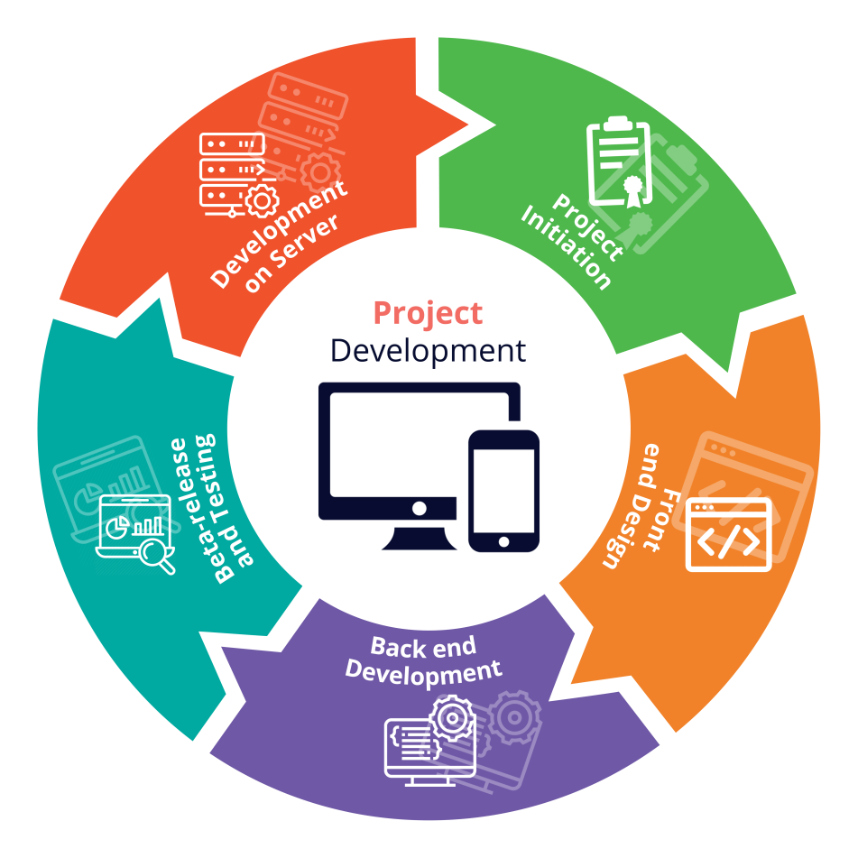

1. **Deployment on Server** - This is the final step of the project development. The application will be developed on NBT servers first. After final testing the code will be ported to the client’s server to make it go live

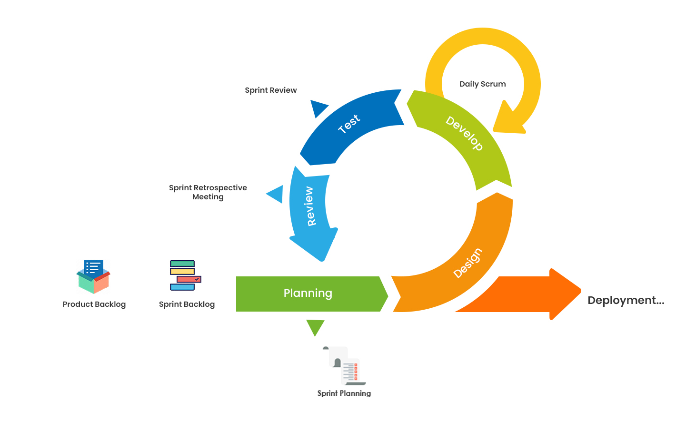

# Project Development

**The project development includes**

* End-user iOS App
* End-user Android App
* Admin panel (web-based)