Details

1. Back arrow button is not working in the DOB page.

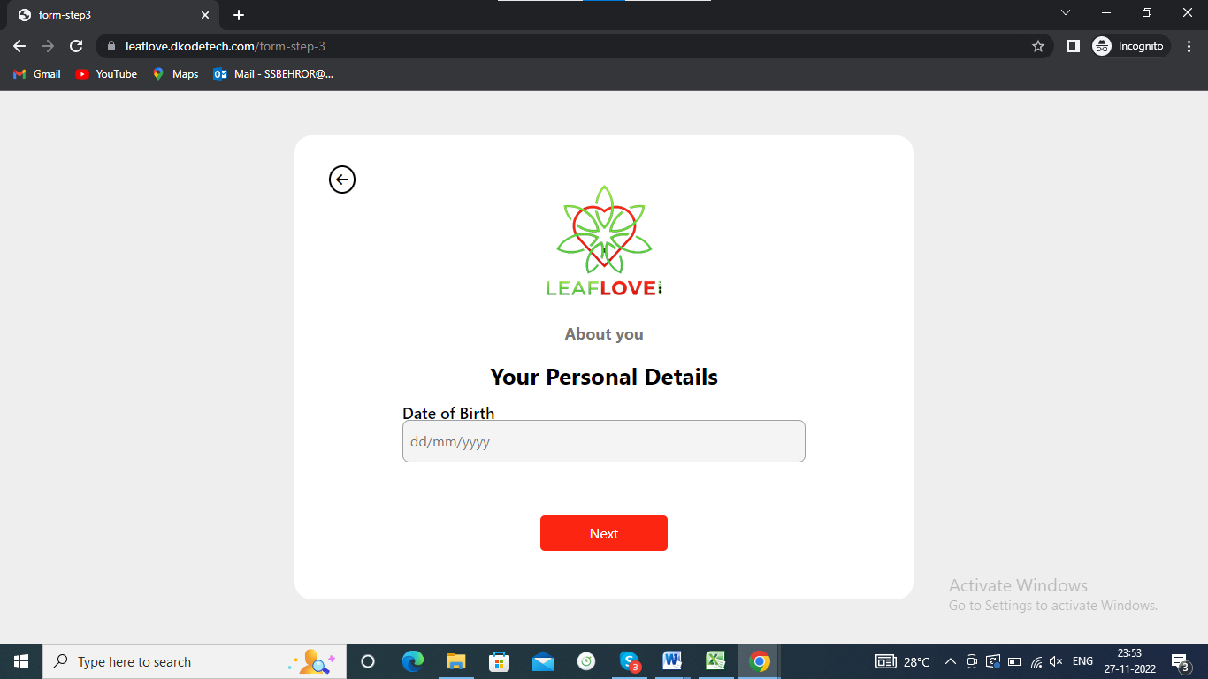

1. Gap should have between text (DOB) and control same as name form.

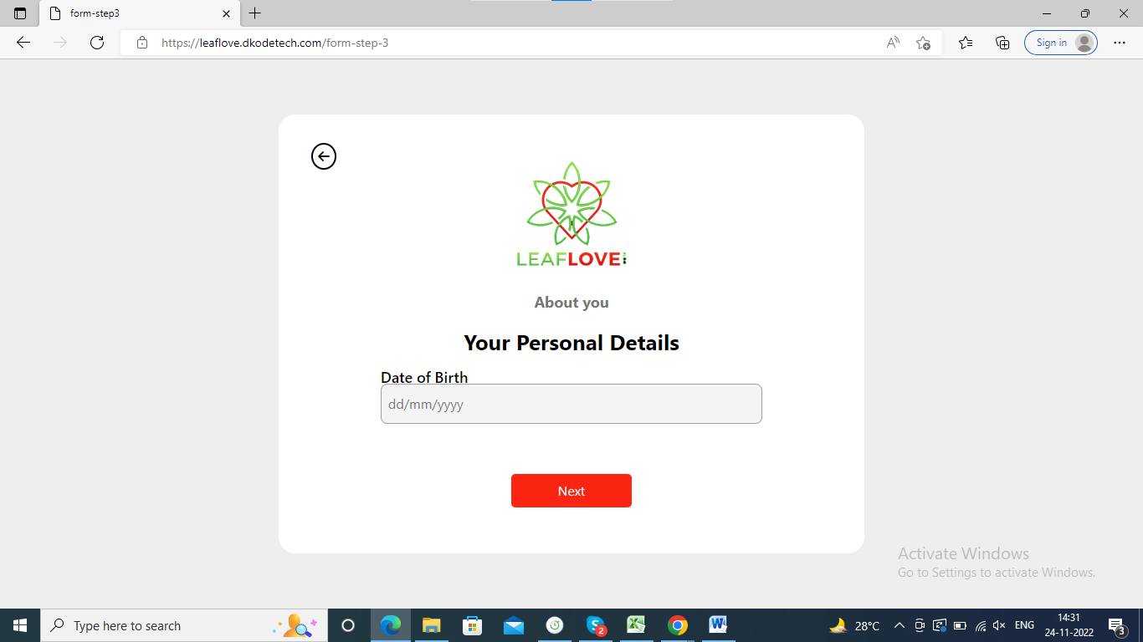

1. Back arrow button is not working.



1. Clicking on back arrow in location page then page is redirecting to dob page but in dob page the given data is not visible it is showing 0000/00/00.

The given data should be visible in dob page.

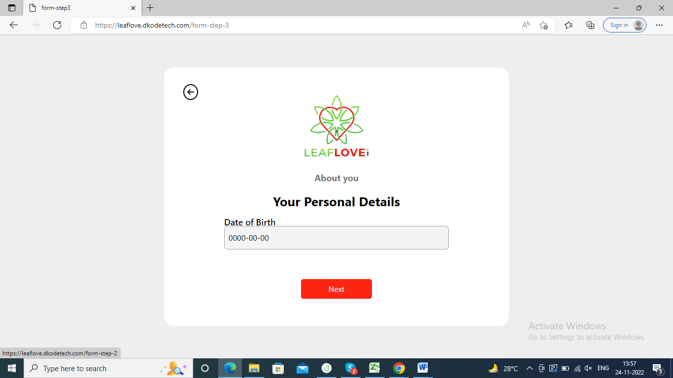

1. Select All option in I want to date page and click on next button then click on back arrow button in relationship page then All option checkbox is showing unchecked.

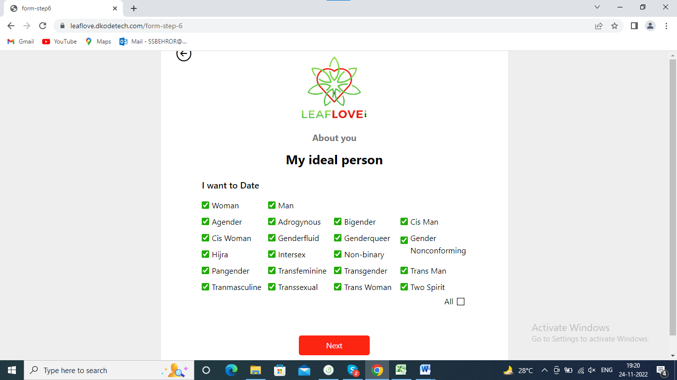

1. Clicking on next button without select image then it is showing wrong error message “The file0 field is required.”

Message should be “Please select at least one photo”.

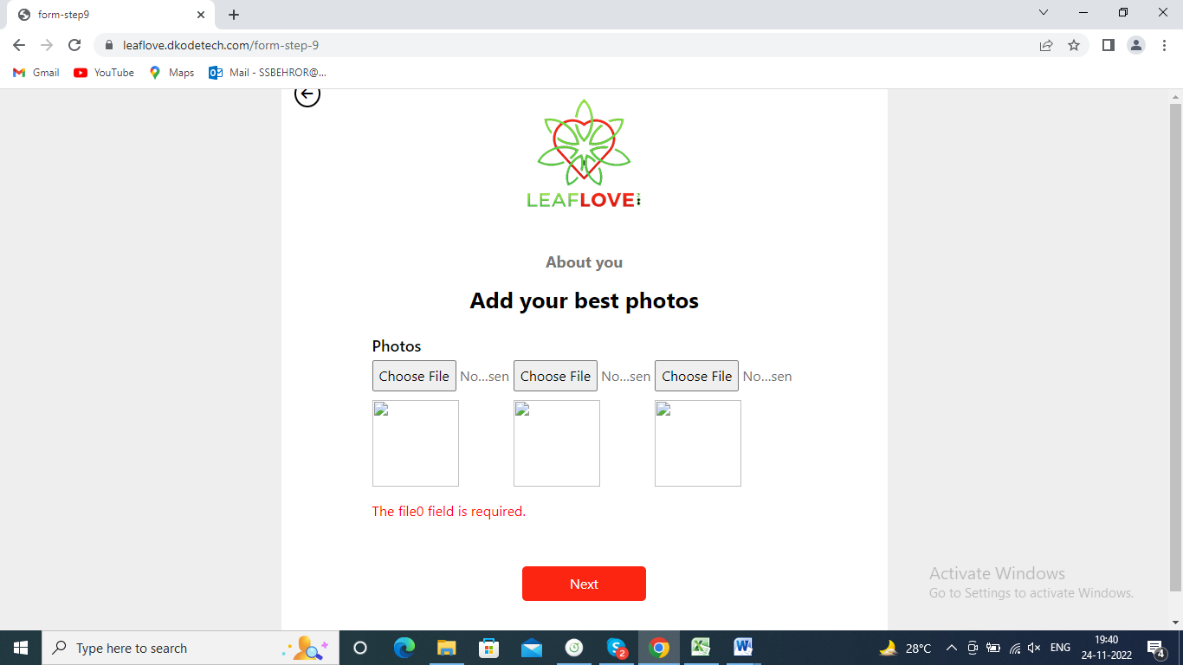

1. If clicking on next button without select checkbox then it is showing wrong error message “The method of use field is required”.

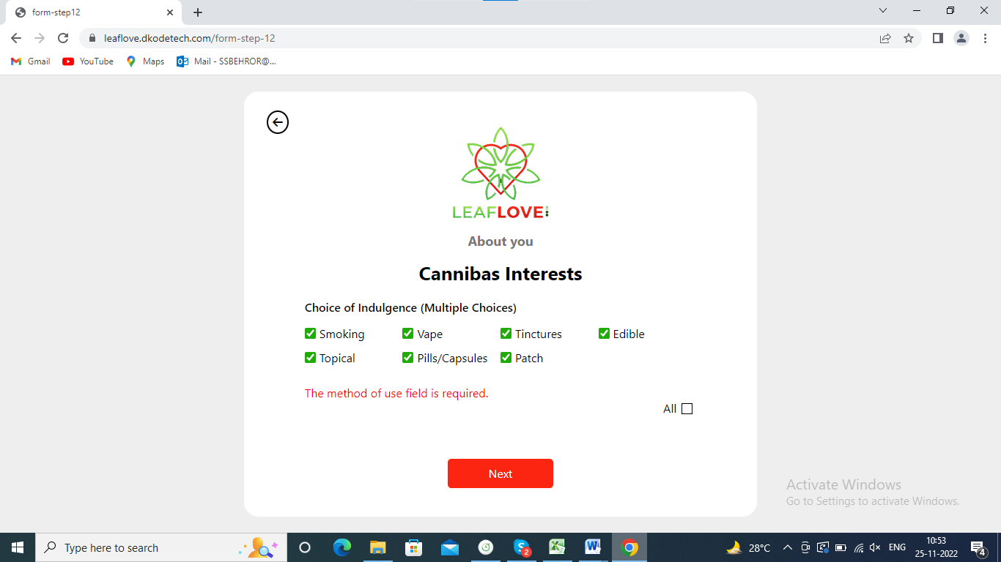

1. Clicking on previous arrow in cannibas interested page then all option should be checked in choice of indulgence page.

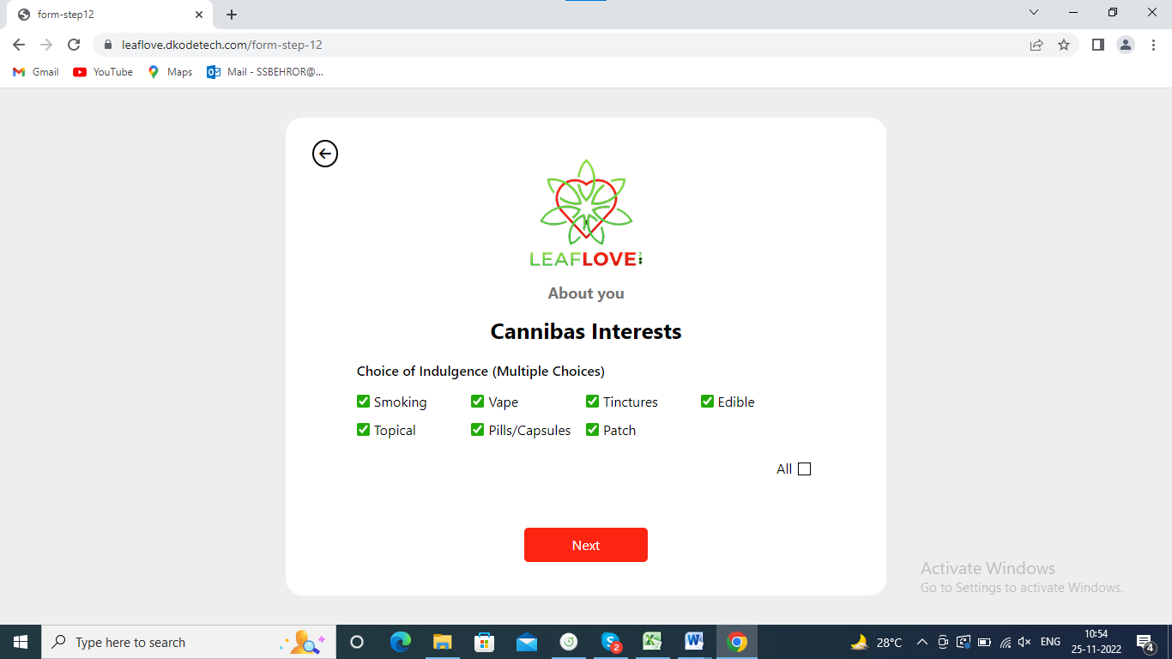

1. Remove All option. Because not required all option on radio button.

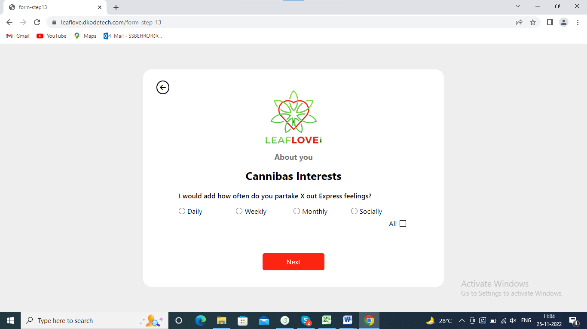

1. <https://leaflove.dkodetech.com/form-step-18>

after step 16,17 is missing

-----------------------------------

Edit Profile

1. All the fields data is retrieved except DOB field.
2. Not able to click on DOB field.

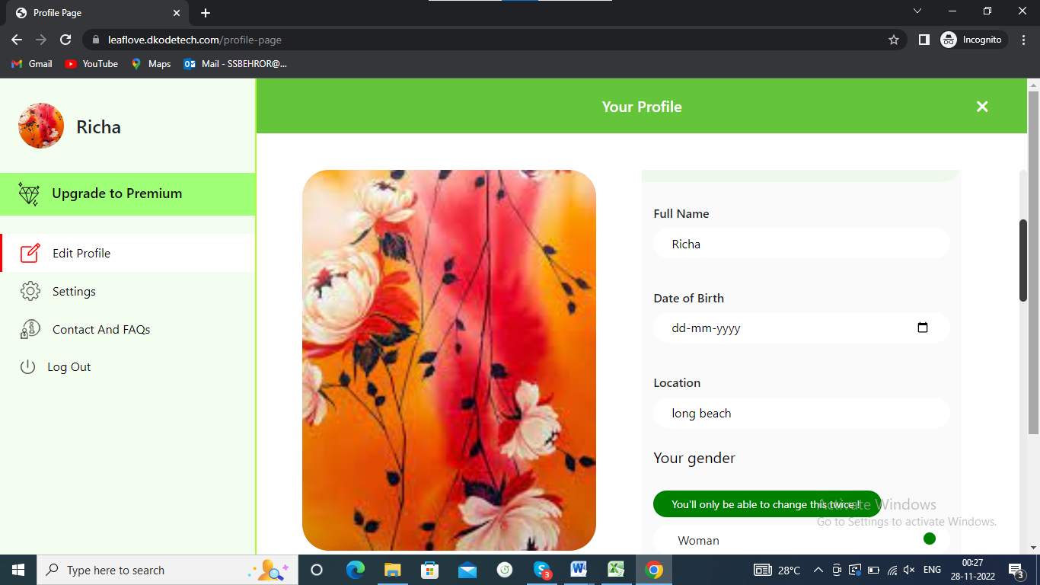

1. 5 words to describe field is missing.

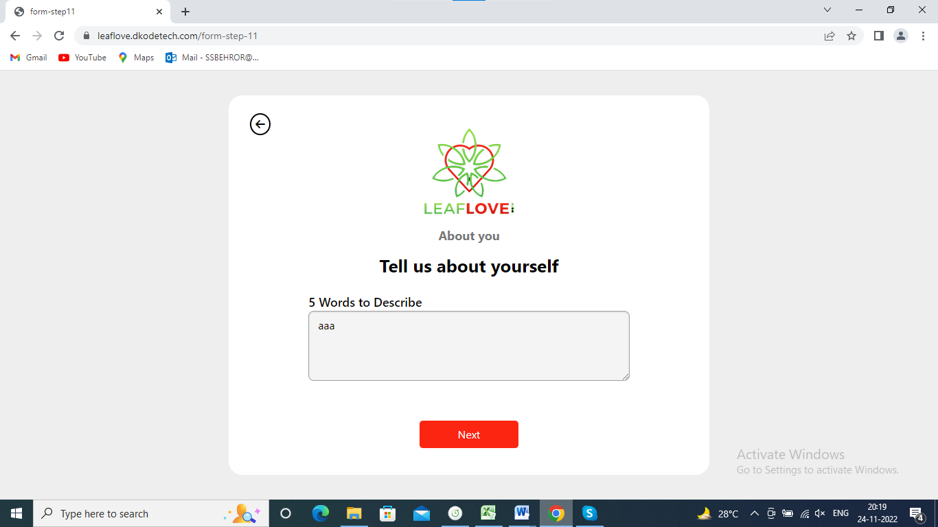

1. Missing the title Choice of indulgence (Multiple Choices).

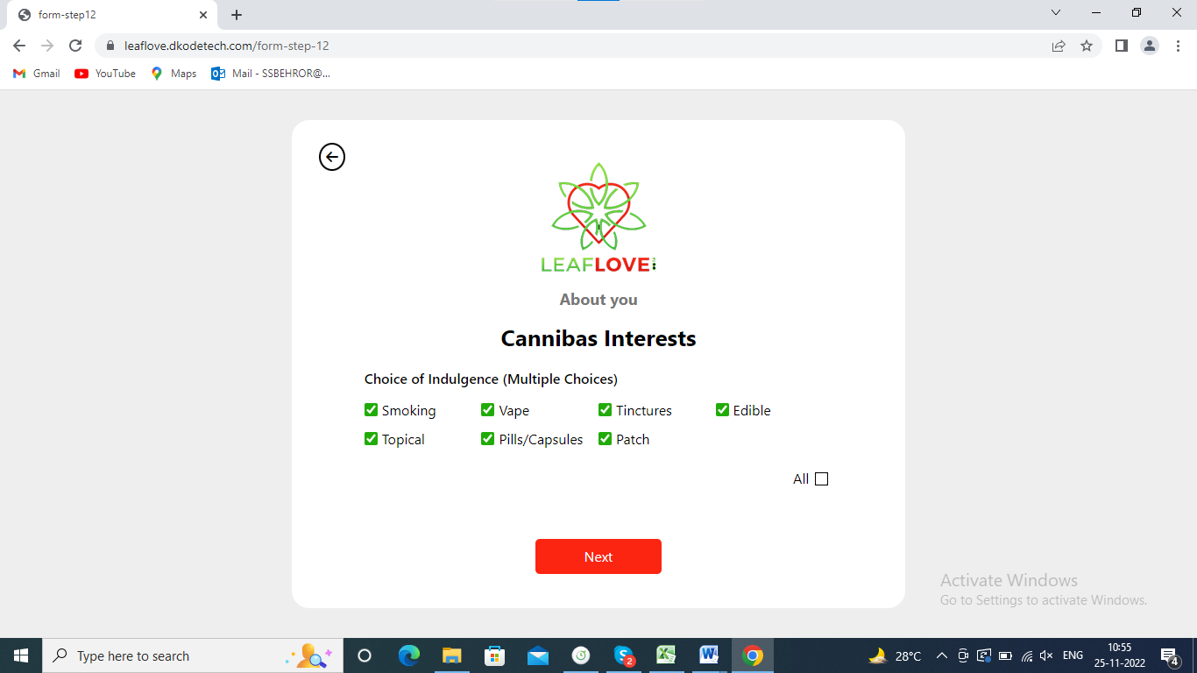

1. Cannibas interested this form is missing.



1. next relationship length field is missing from registration page.

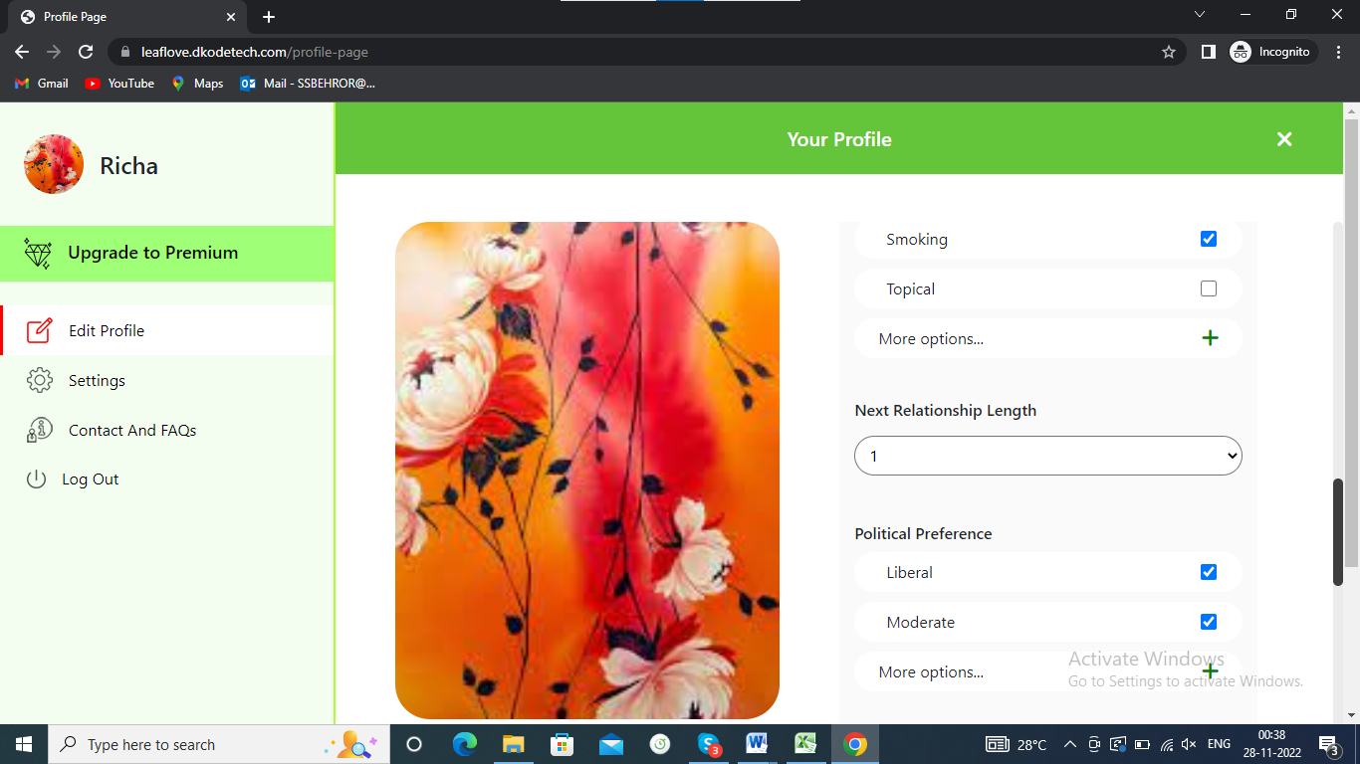

1. astrological sign preference, missing level field is missing from registration page.

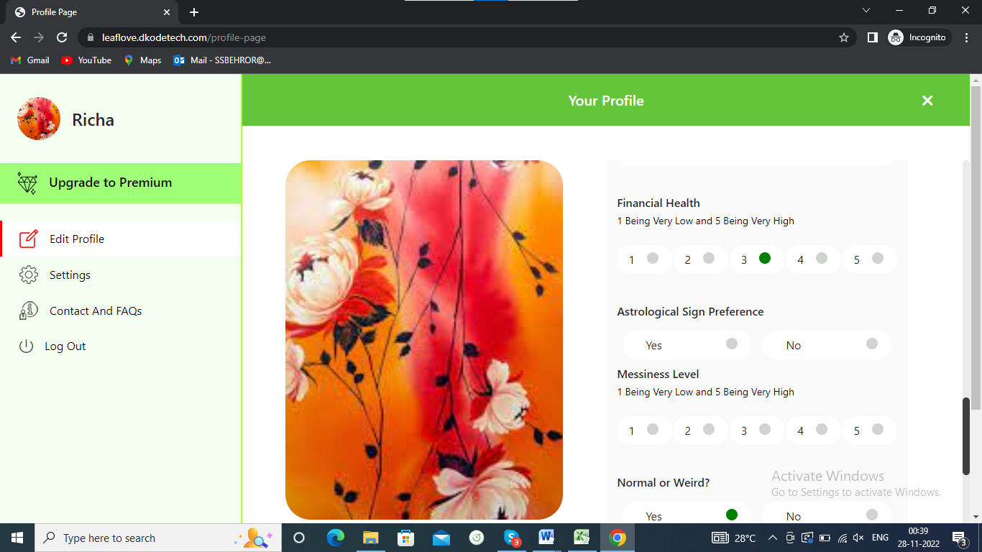

1. In registration page there is showing option Normal or Weird but in edit profile page there is showing option Yes or No.

Option name must be same in both of the page.

Registration page screen shot.

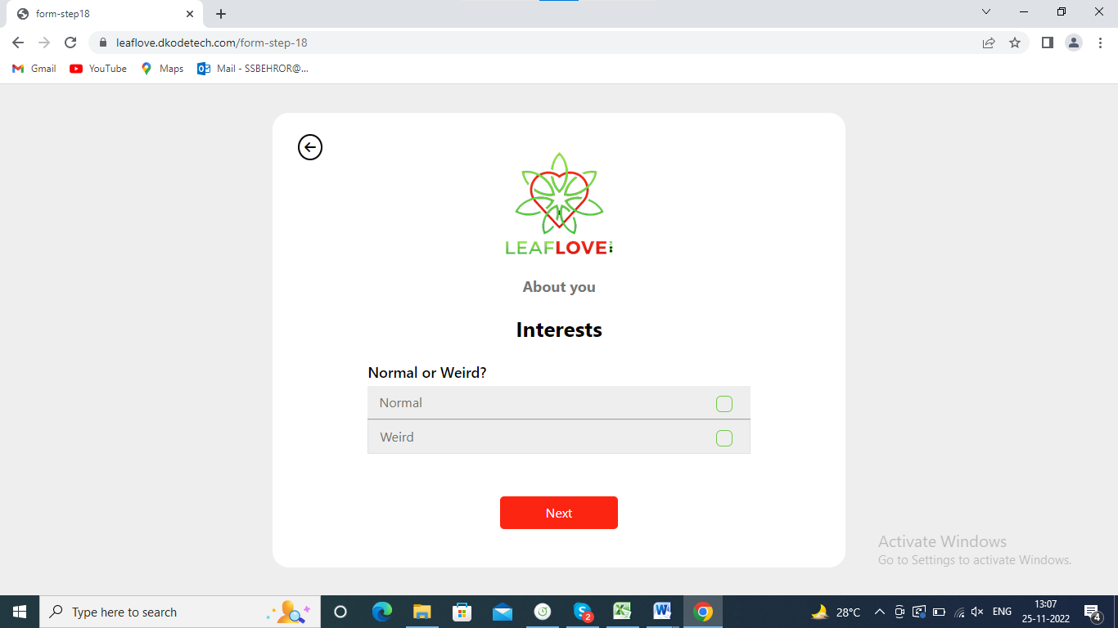

Edit Profile

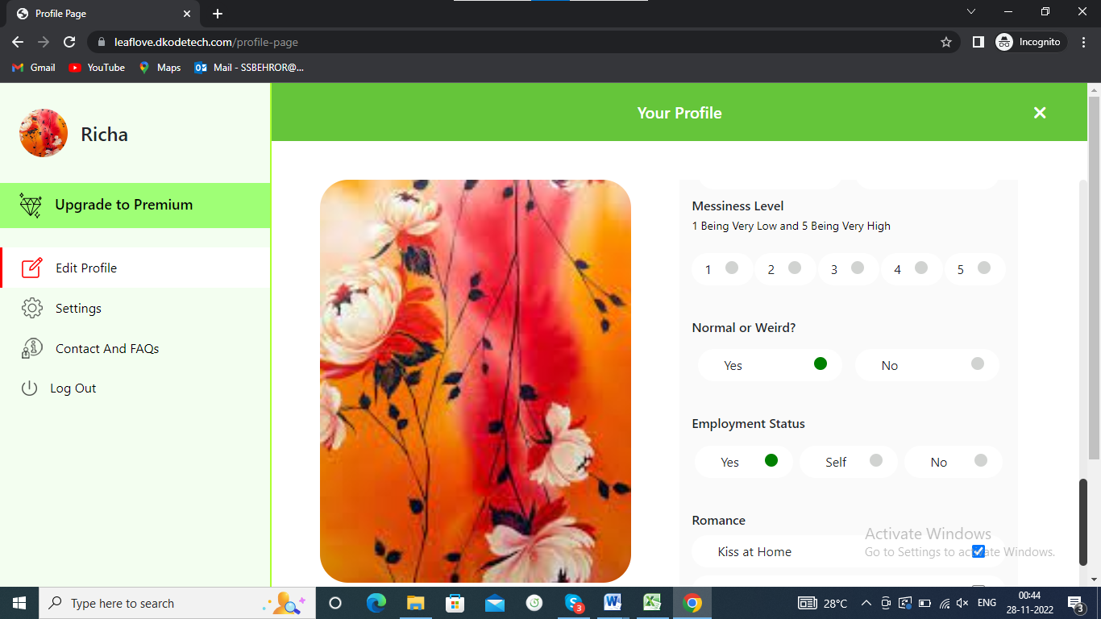

1. In describe yourself there is two option is showing i.e Planner, spontaneous. But in setting page there is yes or no option is showing.

Describe yourself

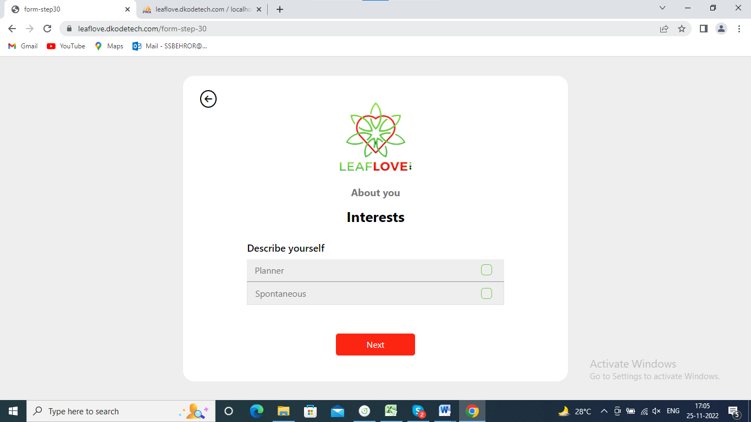

Edit Profile

