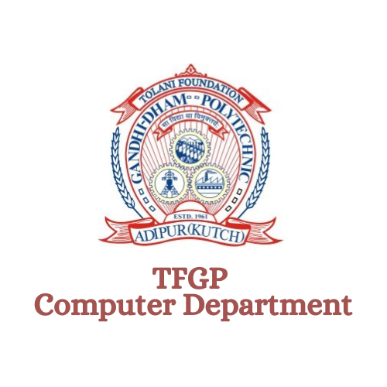

College In Metaverse

**Made by –**

**Abhishek S. Gujarathi (206530307053)**

**Abstract**

The "College in Metaverse" project is a web-based application developed using Three.js and Cannon.js technologies. It aims to provide an immersive virtual experience of a college campus to the visitors of the college website. Through a detailed 3D model of the campus and a player-controlled character, users can navigate the virtual environment and explore various areas of the college.

The project offers a range of features such as 360-degree photos, contact form, about us section, and a blog page. It utilizes Three.js for 3D graphics rendering and Cannon.js for realistic collision detection and physics simulation. The application provides an innovative way for visitors to experience the college environment remotely, fostering engagement and connection.

The documentation includes installation and setup instructions, usage guidelines, and suggestions for future enhancements.

**Introduction**

The "College in Metaverse" project is a web-based application that provides an immersive virtual experience of a college campus. Using advanced technologies like

Three.js and Cannon.js, the project aims to redefine how visitors engage with and explore educational institutions. By leveraging the power of 3D modeling and physics simulation, users can navigate through a realistic virtual environment and interact with various elements of the college.

The primary objective of this project is to create a captivating and interactive platform that allows prospective students, parents, and other visitors to gain a comprehensive understanding of the college's facilities, infrastructure, and atmosphere. Through a combination of 3D models, interactive features, and multimedia content, the "College in Metaverse" aims to bridge the gap between physical and virtual campus experiences.

By exploring the virtual college, users can access information about departments, facilities, faculty, and student life. They can virtually visit classrooms, libraries, laboratories, recreational areas, and other key locations within the campus.

Additionally, the project incorporates 360-degree photospheres at specific points of interest, providing users with a realistic and immersive glimpse of the college from various perspectives.

Furthermore, the "College in Metaverse" project includes additional functionalities such as contact forms, an about us section, and a blog page. These features enable users to connect with the college administration, obtain more information about the institution, and engage with educational content and updates.

Overall, the "College in Metaverse" project strives to enhance the college exploration process, provide an engaging and interactive virtual experience, and facilitate seamless communication between visitors and the college. Through this innovative application, the project aims to showcase the college's strengths, foster student engagement, and attract prospective students to join the institution.

**Aims and Objectives**

The primary aims and objectives of the "College in Metaverse" project are as follows:

Immersive College Experience: The project aims to create a virtual representation of the college campus, allowing visitors to navigate and explore the various areas as if they were physically present. The goal is to provide an immersive and realistic experience that captures the essence of the college environment.

1. Virtual 3D Model: The project focuses on developing a detailed 3D model of the college campus, including buildings, landmarks, and other important features. The objective is to accurately represent the physical layout of the college and create a visually appealing virtual environment.
2. Player-controlled Character: The application provides users with a player-controlled character, enabling them to navigate through the virtual environment. The objective is to give visitors the freedom to move around, interact with objects, and experience the college campus from a personalized perspective.
3. 360-degree Photos: The project aims to incorporate 360-degree photos at various points of interest within the college campus. This feature allows visitors to view panoramic images and gain a comprehensive view of the surroundings, enhancing their overall experience.
4. Contact and About Us Sections: The application includes a contact form and an about us section, providing visitors with easy access to college information and a means to communicate with the college administration. The objective is to facilitate communication and engagement between visitors and the college.
5. Blog Page: The project incorporates a blog page where visitors can read informative and engaging blog posts about college-related topics. Additionally, an admin panel allows authorized personnel to create, update, and delete blog posts. The objective is to provide a platform for sharing valuable information and fostering a sense of community within the virtual college environment.

The "College in Metaverse" project endeavors to create an interactive and immersive virtual experience that showcases the college's facilities, culture, and educational offerings. By leveraging the capabilities of Three.js and Cannon.js, it aims to redefine the way visitors interact with and perceive the college, opening up new possibilities for remote engagement and exploration.

**Features**

1. Interactive 3D Model: The project offers an interactive 3D model of the college campus where visitors can navigate and explore various areas.
2. Player Character: Visitors can control a player character within the 3D environment, providing a first-person-like experience.
3. 360-Degree Photos: Several key spots in the college campus allow visitors to view immersive 360-degree photos, providing a detailed view of specific locations.
4. Contact Us Form: A contact form is provided to allow visitors to send inquiries, feedback, or requests to the college administration.
5. About Us Information: Visitors can access comprehensive information about the college, including its history, mission, vision, and values.
6. Blog Section: A blog page is available for visitors to read articles related to college news, events, or academic topics.
7. Admin Functionality: Admin users have the ability to create, update, and delete blog articles, providing content management capabilities.

**Technology Stack**

**Frontend Technologies:**

* Three.js: A JavaScript library for creating and rendering 3D graphics in the web browser. It provides a wide range of features and functionalities for building interactive and visually appealing 3D scenes.
* Cannon.js: A physics engine library used for realistic collision detection and physics simulation in the 3D environment. It allows for the accurate handling of object collisions, gravity, forces, and other physical interactions.
* HTML, CSS, and JavaScript: The project utilizes standard web technologies for building the user interface, defining the structure and styling of the application, and implementing interactive behavior and logic.

**Backend Technologies:**

* Node.js: A JavaScript runtime environment that enables server-side execution of JavaScript code. It provides a scalable and efficient platform for building server-side applications and handling backend operations.
* MySQL: A popular open-source relational database management system used for storing and managing structured data. It allows for efficient querying, data retrieval, and management of various entities and relationships within the application.

**Additional Technologies:**

* Express.js: A minimalist web application framework for Node.js. It simplifies the development of server-side applications by providing a set of robust features and middleware for handling routing, request/response handling, and other web-related tasks.

**Installation and Setup**

1. Clone the project repository from the provided source code.
2. Install the required dependencies, including Three.js and Cannon.js libraries.
3. Set up a web server or utilize a local development environment to host the project files.
4. Ensure that the required resources, such as 3D models, textures, and 360-degree photos, are appropriately linked and accessible.
5. Configure any backend components, such as the contact form submission handling or blog data storage, if applicable.

**Usage**

1. Upon accessing the college website, visitors can navigate the virtual college campus using the WASD or arrow keys to control the player character.
2. Interact with specific spots in the campus to view 360-degree photos, providing a detailed visual experience of the respective locations.
3. Access the Contact Us page to fill out the contact form and submit inquiries or messages to the college administration.
4. Navigate to the About Us page to read comprehensive information about the college, including its history, mission, vision, and values.
5. Explore the Blog section to read articles related to college news, events, or academic topics.
6. For admin users, a secure login functionality allows access to the blog management interface, enabling the creation, editing, and deletion of blog articles.

**Future Enhancements**

1. Integration of real-time chat or communication features to facilitate interaction between visitors or with college staff.
2. Integration of additional multimedia content, such as videos or interactive elements, to enhance the virtual experience.
3. Integration of social media sharing capabilities to allow visitors to share their experiences or specific blog articles.
4. Expansion of the virtual campus to include more areas, buildings, or interactive elements.
5. Integration with external APIs or services to provide additional functionalities.

**Data Flow Diagrams & User Case Diagram**

1. **Data Flow Diagram :-**

* 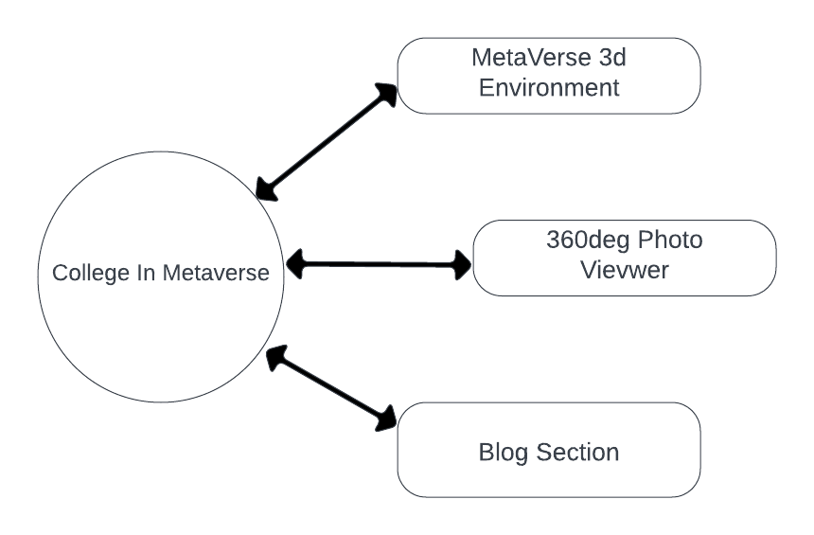**Level 0 :-**
* **Level 1:-**

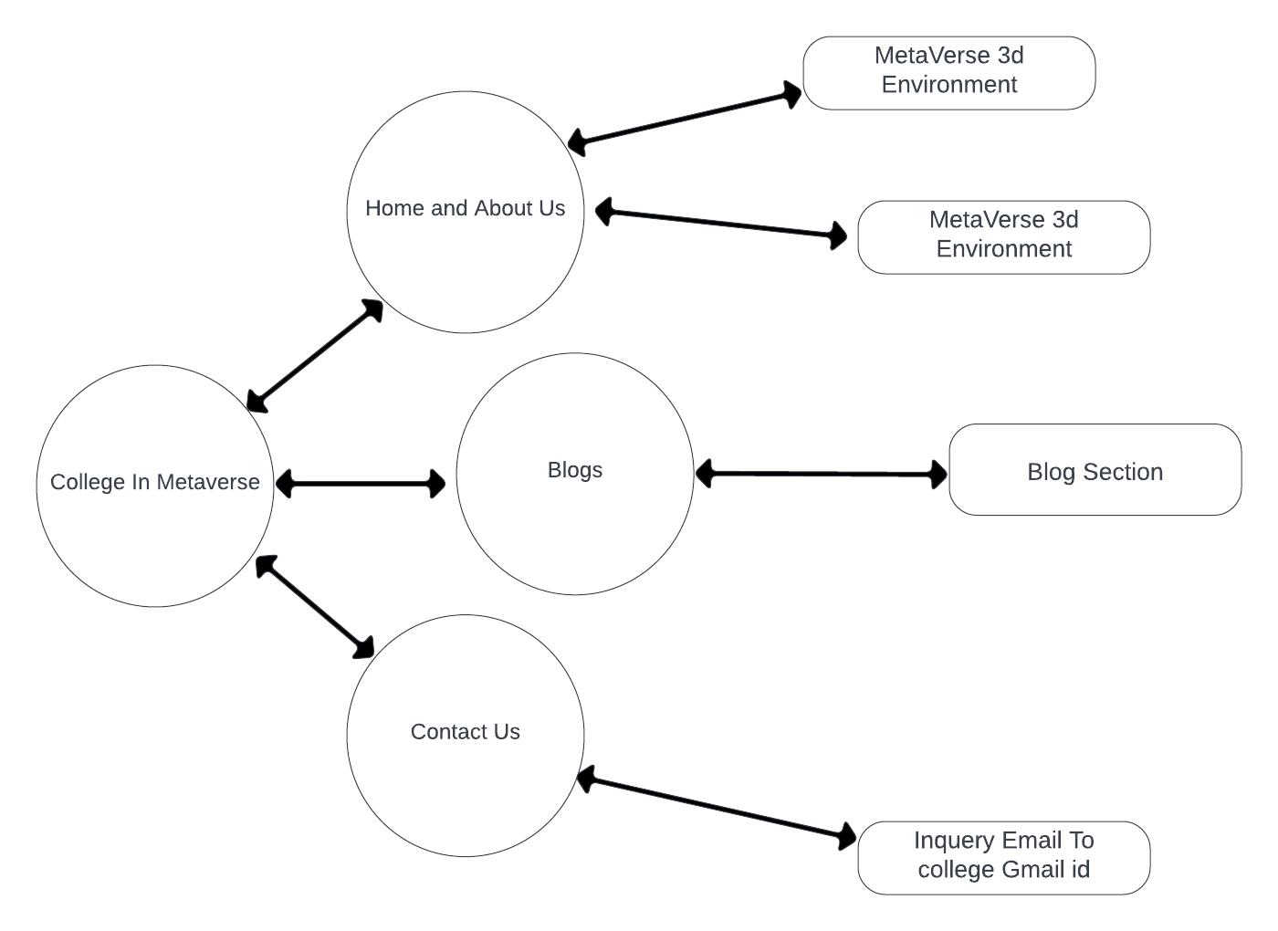

* **Level 2 :-**

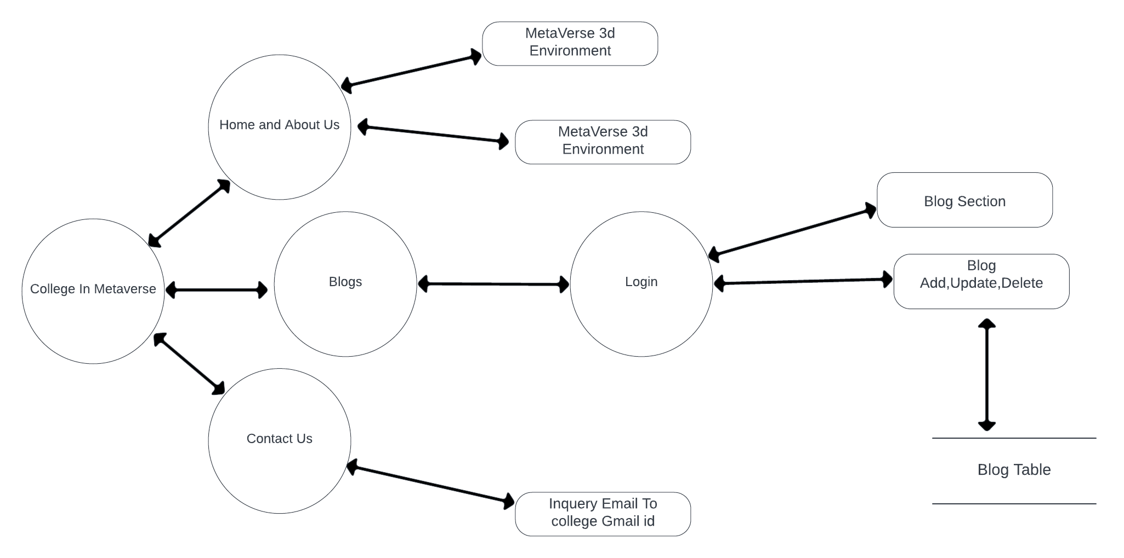

1. **Use Case Diagram :-**

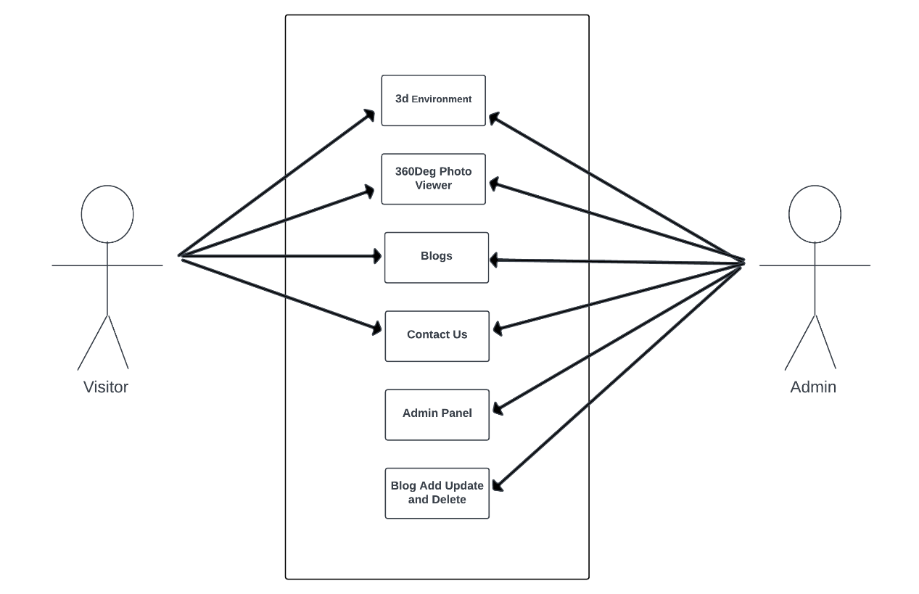

**Data Dictionary**

* 1. AboutUs Table :-

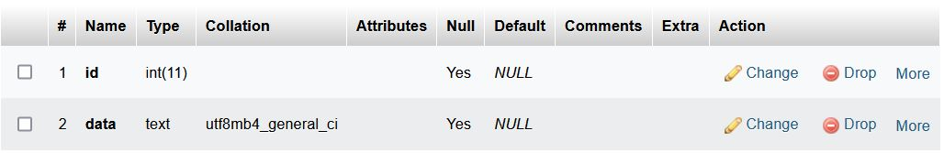

* 1. Blogs table :-

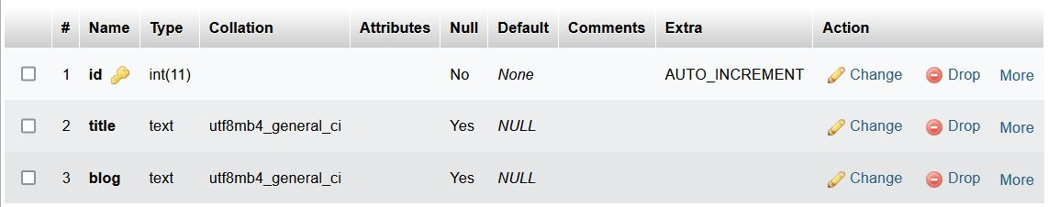

**User Manual**

* 1. 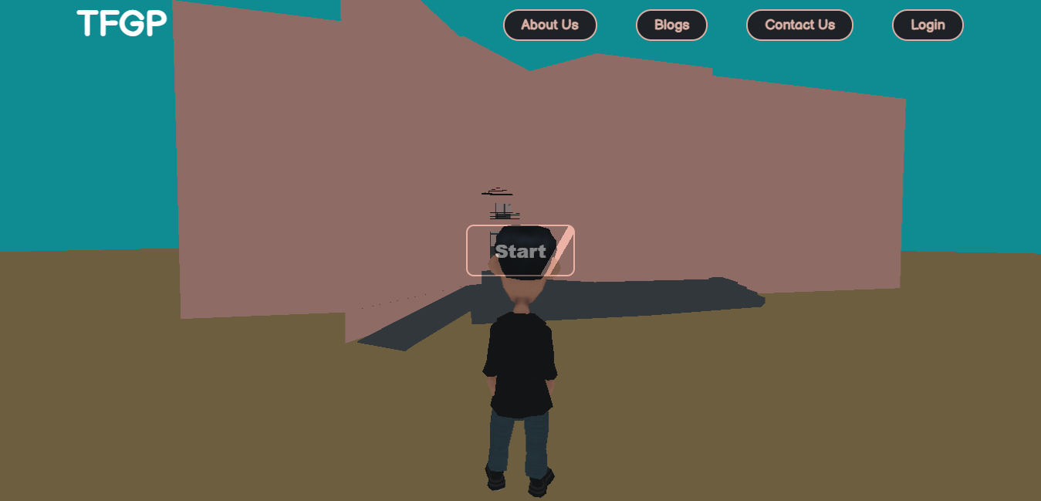Home Page :-
* Press Start to experience The 3d world in which you can move your character using WASD keys.
* There are several points where you can go and experience a 360 view of the college, which makes you feel you are there in college.
  1. 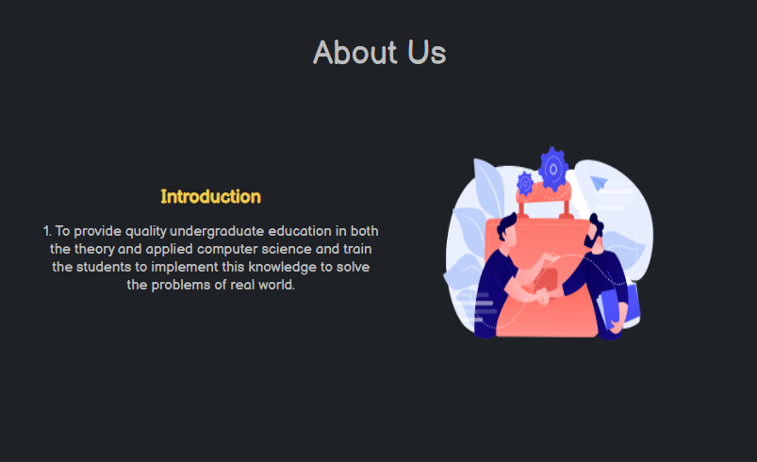About Us :-
* A about us page of our college.
  1. Contact Us:-
* 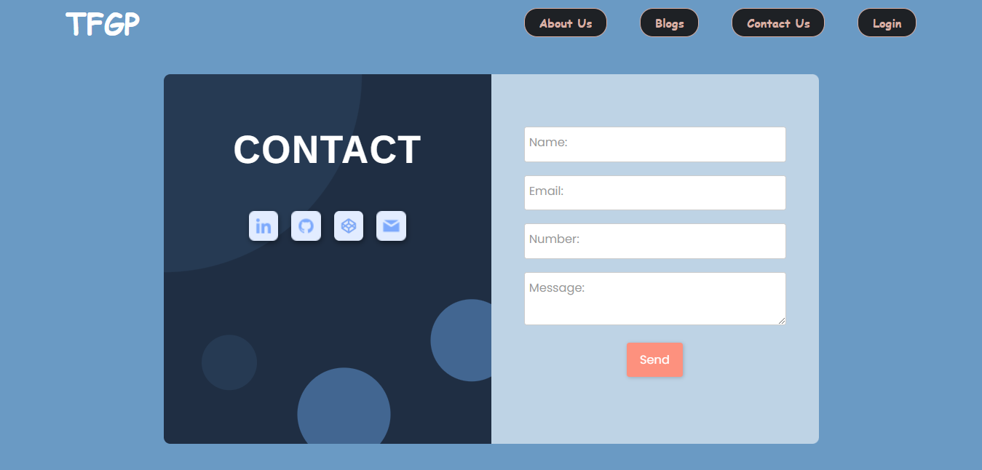A contact us page where user can submit their queries regarding college and admiissions.
  1. Admin Login:-
* 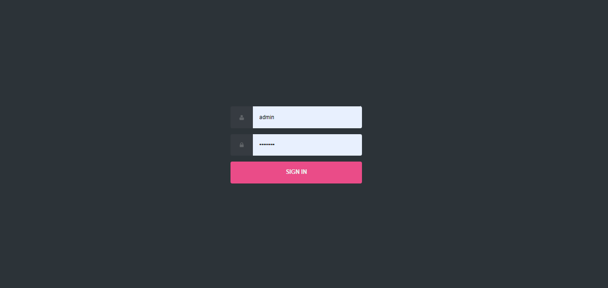Admin Login Page from here admin can login to change and update blogs.
  1. 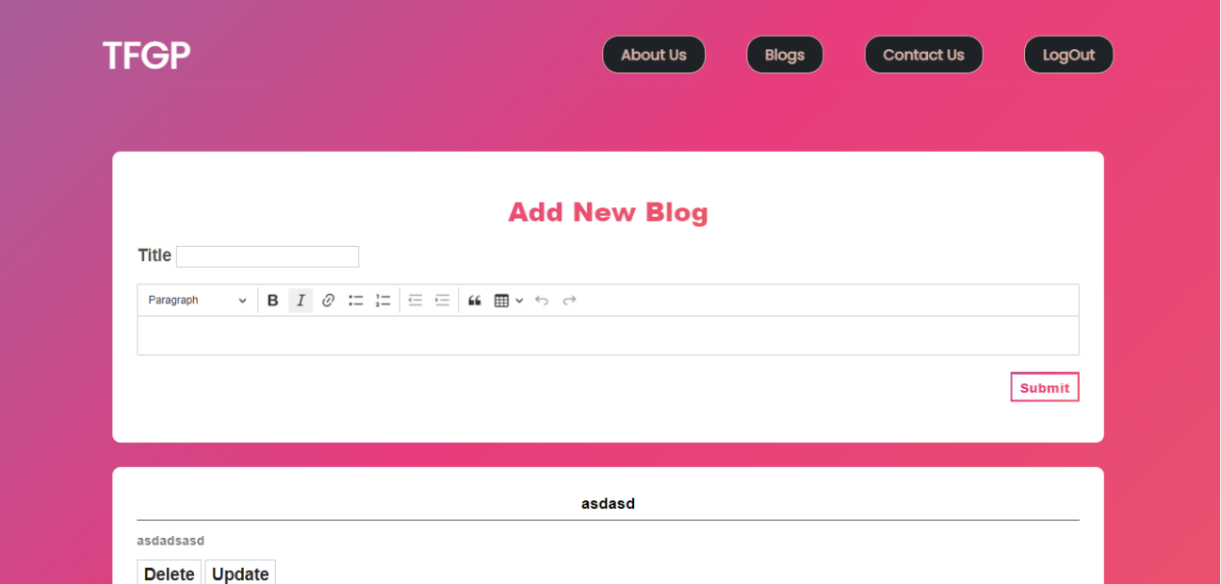Blogs :-
* Blog Page where visitor can come and read the blogs posted by the college.
* If you are logged in as admin you can Add, Update and Delete Blogs.

**Conclusion**

In conclusion, the college project in the metaverse has successfully created a virtual environment that replicates the college campus, offering an immersive and interactive experience. Users can navigate the virtual campus, customize their avatars, access educational resources, and engage in social interactions. This innovative project provides a dynamic platform that enhances traditional classroom learning and fosters collaboration and creativity.