Proceedings of ICTACEM 2007
International Conference on Theoretical, Applied, Computational and Experimental Mechanics
December 27-29, 2007, IIT Kharagpur, India

ICTACEM-2007/0187

Inertial Characterization of Unmanned Aerial Vehicle AX-1
Vikas Agarwalª, Abhishek Halder^{b}, Rohit Garhwal^{c}, Ashay Gupta^{d}, Sayan Ghosh^{e},
Shalabh Saxena^{f} and Dr. Manoranjan Sinha^{g}
^{a , b, c, d, e, f} Student, Department of Aerospace Engineering, Indian Institute of Technology, Kharagpur, INDIA
^{g} Professor, Department of Aerospace Engineering, Indian Institute of Technology, Kharagpur, INDIA
abstract
This paper presents a technique for inertial characterization of an unmanned aerial vehicle (UAV). The method is particularly suitable for small budget UAVs which can not afford costly industrial settings for computing the inertia matrix taking the effect of moving layer of air and entrapped mass of air inside the fuselage into account. The complete theoretical background, experimental set up and results are presented. Particular emphasis is given on how the present method can provide superior accuracy over those already existing.
Keywords: Moments of Inertia, Compound Pendulum, Bifilar Torsional Pendulum, Inertia Ellipse.
1. Introduction
Inertial characteristics of an Unmanned Aerial Vehicle (UAV) are critical system parameters which greatly influence the dynamic behavior of the UAV. Determining them even prior to first flight is necessary for designing control law. Furthermore, the accuracy of the predicted inertial characteristics affects the precision with which the stability and control derivatives can be extracted from flight data. The present study aims to determine the location of center of gravity and moment of inertia tensor of UAV AX-1, a test bed for various flight experiments at Intelligent Systems Lab, Department of Aerospace Engineering, IIT Kharagpur.
Conventional methods for aircraft’s moments of inertia determination include rough estimate from historical database, estimation using CAD software and costly set ups for component build up method. However a low cost UAV of small size can not afford these expensive solutions. But the demand for accuracy is still quite high. The method proposed here is a solution for such cases. Moreover, to the best of authors’ knowledge, this is the first systematic study for inertial characterization of a high wing UAV.
The x_{CG} and y_{CG} locations were determined using weighing pans. For locating z_{CG}, reaction forces were measured normal to an inclined plane. The sensitivity of z_{CG} measurement on the inclination angle was also studied. For moments of inertia determination, the UAV was swung as a pendulum to note the time period of oscillation. The effect of entrapped air inside the airframe structure and the effect of additional mass of air moving with the UAV during oscillation were taken into account. The complete experimental set up for this swinging experiment was designed and manufactured in-house.
The rolling and pitching moments of inertia (I_{xx} and I_{yy}) were determined by swinging the UAV as a compound pendulum and yawing moment of inertia (I_{zz}) was obtained by swinging it as a bifilar torsional pendulum. For roll-yaw cross moment of inertia (I_{zx}) determination, the nose up and nose down swinging were carried out in the z-x symmetry plane in compound pendulum set up.
The novelty of the method described in this paper lies in the fact that it eliminates the need to compute the volume of the vehicle, as opposed to the methods described in Ref. 1 and Ref. 2. Instead, the measurements for compound pendulum set up were taken for three different suspension lengths and an attempt was made to solve three simultaneous bi-variable cubic equations, either graphically or using z_{CG} measurement. Since it is extremely difficult to accurately measure the volume of an UAV, the proposed method promises to offer a superior estimation of moments of inertia, compared to methods cited in literatures. The results were obtained with and without volume calculation and were compared to illustrate this fact. As an added advantage, the proposed method yields the value of volume of the UAV by simultaneously solving the bi-variable cubic equations.
2. theoretical Background
2.1 Relation between mass and weight
Weight, as measured in the laboratory with the help of a spring balance, actually gives the net downward force acting on an object. For a block of mass m kept in atmosphere, there are two forces acting on the block.
They are
1) The gravitational pull of the earth,
2) The buoyant force due to atmosphere.
The measured weight will be
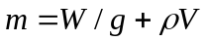. (1)
Here is the mass of the block,  is the density of air,  is the volume of the block, is the weight as given by spring balance.
2.2 Effective mass
When a body moves in air, a layer of air moves with the body, forming an envelope around it. The aerodynamic theory suggests that some momentum is imparted to this air which moves with the body. Hence, it becomes imperative to consider the effect of this air. This effect is accounted by assuming that the effective mass of aircraft is increased by some amount, referred as additional mass. The additional mass depends upon the orientation of the aircraft relative to direction of motion, the velocity of aircraft, the density of air and the dimensions of aircraft. Generally, if the density of body is large enough, the additional mass is very less as compared to mass of the body and hence can be safely neglected. But for lighter bodies such as aircrafts, the contribution from additional mass becomes significant. In case of aircrafts, the value of this mass primarily depends on the aspect ratio of the wing. Detailed calculation of additional mass is given in Ref. 3. Thus for an aircraft,
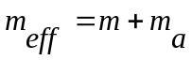 (2)
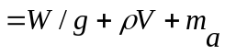 (3)
Here 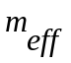 is the effective mass of the aircraft and 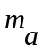 is the additional mass of air.
2.3 Moment of Inertia
The true moment of inertia , ,of an aircraft consists of consists of three parts .First ,a constant part 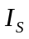 representing the moment of inertia of the entrapped air .Second ,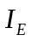 represents the moment of inertia of the entrapped air and varying with the density of air .And third ,the moment of inertia , 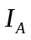,of the air moving with the aircraft ,i.e., of the additional mass. Thus
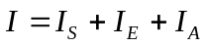 (4)
Experimental determination of involves the motion of the aircraft, hence the experimentally determined value of I is the left hand side of the above equation.

3. EXPERIMENTAl Background
3.1 Methodology
For any pendulum oscillating in vacuum, the governing equation is the following
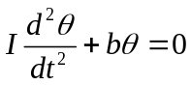 (5)
Where is the moment of inertia of the pendulum about the axis of oscillation, is a constant that depends on the dimensions and weight of the pendulum, is the angular displacement of the pendulum,
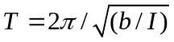 (6)
or, 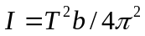 (7)
For a compound pendulum,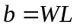, where is the weight of the pendulum, is the distance of c.g. of pendulum from the axis of oscillation .Thus ,
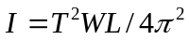 (8)
The above is the moment of inertia about the axis of oscillation. If moment of inertia about the axis passing through c.g. is needed, then parallel axis theorem may be used.
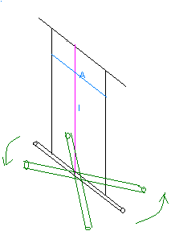
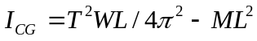 (9)
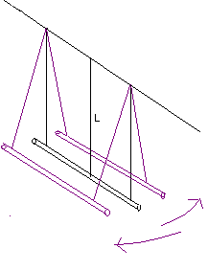

Figure. 1. Compound Pendulum

Figure. 2. Bifilar Torsional Pendulum

Here, the axis of oscillation passes through the c.g. of pendulum and hence the above is the moment of inertia about an axis passing through the c.g.
3.2 Determination of Centre of Gravity
To determine the c.g .of the aircraft, the aircraft is placed on three weighing pans with each of three wheels resting on one of the pans. The reading of the pans directly gives the normal force acting on each of the wheels. If 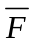,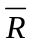 and represent the normal reaction force on the front, right and left wheel respectively, then
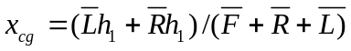 (10)
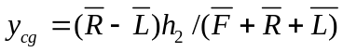 (11)
Determination of 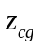 , i.e., the vertical location of the c.g. involves keeping the aircraft on an inclined plane in pitch down position. The forces acting on the aircraft are:
1) , the weight of the aircraft
2) 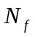,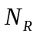 and 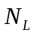,the reaction force normal to the inclined plane acting on the front, right and left wheel respectively.
3) 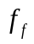,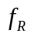and 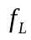, the friction force acting in the plane of inclination on the front, right and left wheel respectively. Summation of moments about the axis passing through the rear wheels gives
(12)
It is seen here that only 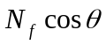 and needs to be measured here. Other quantities are known. The experimental setup used is shown below. To measure , a weighing pan is kept beneath the front wheel in a vertical position. The reading of the weighing pan directly gives . is measured using the relation
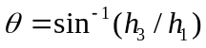 (13)
where 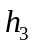 is the vertical distance between the front and the rear wheels It is to be noted here that should be measured after the front wheel is placed on the weighing pan because the vertical movement of the pan will alter the value of .It was observed that was very sensitive to the value of . Thus it was desired that the experiment be conducted at at which 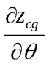is small in magnitude. Thus a high value of was preferred. The c.g. was close to the rear wheel. Hence, the pitch down position was used as this position gave the liberty of using high in the experiment.

3.3 Determination of moment of inertia
The determination of moment of inertia of aircraft is done by swinging it as a pendulum. Since no point on the structure of the plane can be used for suspension, the aircraft is placed on a swinging gear and then this assembly is swung as single pendulum. By noting the time period, it is possible to find the moment of inertia of this assembly about the axis of oscillation. The moment of inertia of the swinging gear alone is determined by swinging it separately and then this is subtracted from the moment if inertia of the aircraft and swinging gear system. The resulting quantity is the moment of inertia of the aircraft alone about the axis of oscillation. To find the moment of inertia about an axis passing through c.g. , parallel axis theorem is used.
3.3.1 Moment of Inertia about the Y body axis
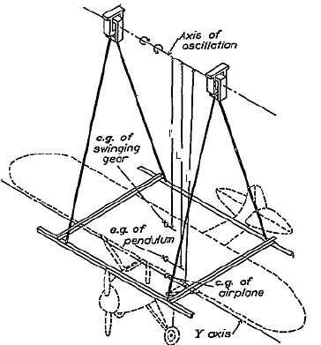
To determine the moment of inertia about Y body axis, the aircraft is swung as shown below.

Figure 3. Determination of moment of inertia about the Y body axis. To determine about the X body axis, aircraft is rotated by 90 degrees on the cradle.

The Moment of inertia  will be given by,
(14)
The first term on the right hand side gives the moment of inertia of the aircraft + swinging gear assembly about the axis of oscillation. 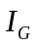 denotes the moment of inertia of swinging gear only, about the axis of oscillation. The term 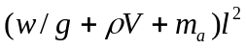 is due to the application of parallel axis theorem. is determined by swinging the gear as an independent pendulum. If the time period of swinging gear is 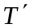 then will be given by,
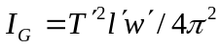 (15)
Using principle of moments,
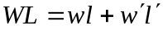 (16)
Substituting (3) in (1), following equation is obtained
(17)
is obtained using the geometry of the cradle and and are known experimentally. Since and are known, can be obtained using (2). Thus in equation (4), , and 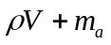 are the unknowns. To solve for the unknowns, three equations would be needed. Hence equation (4) is written for three lengths (denoted by subscripts 1, 2 and 3).
(18)
(19)
(20)
and are related to by
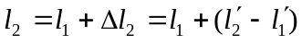 (21)
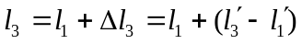 (22)
(8) and (9) are substituted in (6) and (7) respectively to get
(23)
(24)
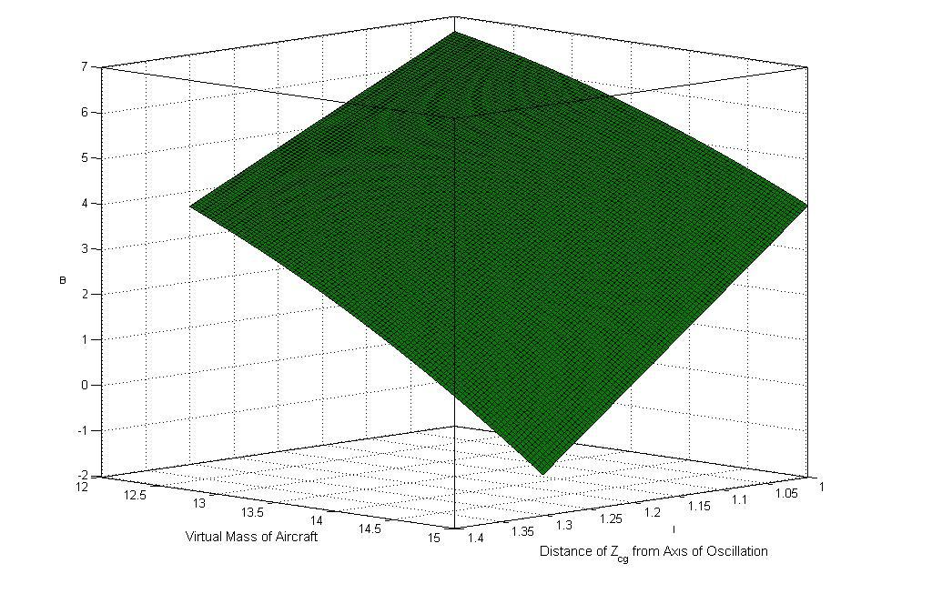
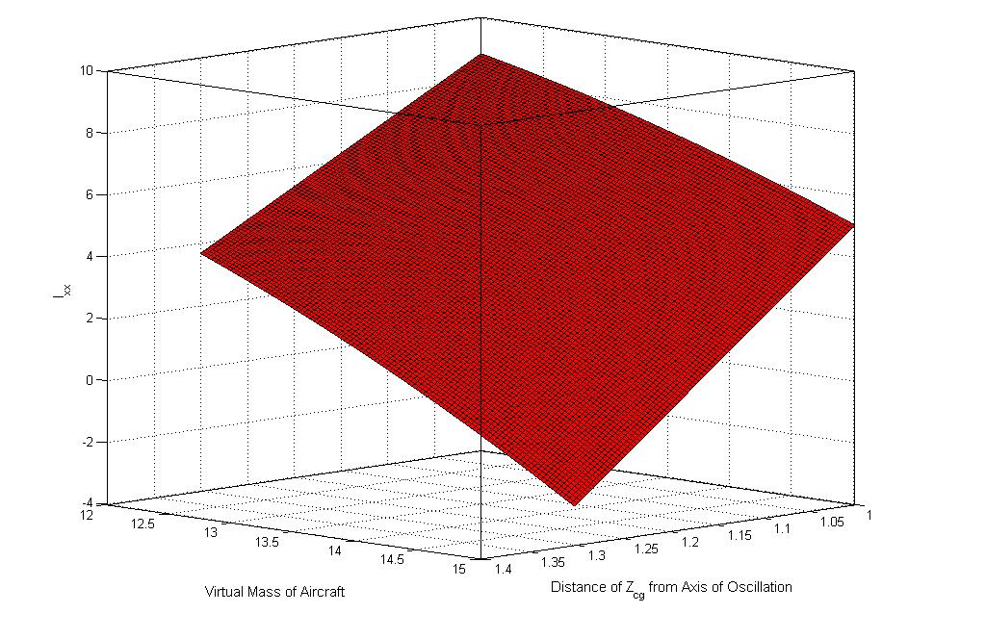
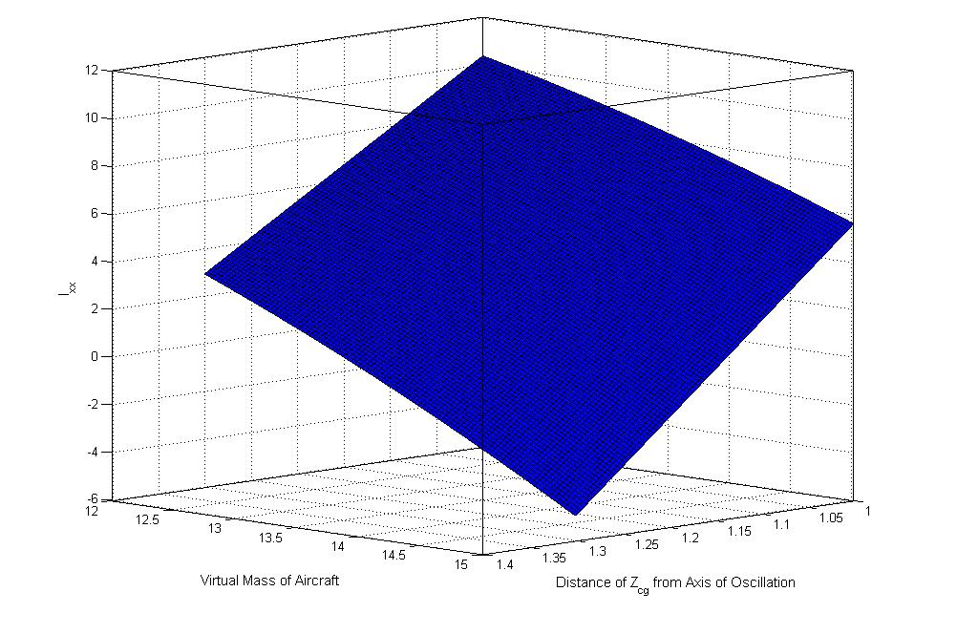
In equations (5), (10) and (11), the unknowns are, and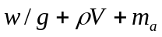. Thus these equations can be solved to determine the unknowns. This method was initially chosen to find. But, it was later found that even the slightest experimental error renders the above system of equations inconsistent. Each of the equations in the above system represents a surface in the rectangular Cartesian co-ordinate system formed by choosing, and as the axes, as shown below.

(a) (b) (c)
Figure 4. Surfaces represented by equation (18), (23) and (24)

Theoretically, these surfaces are expected to meet at a unique point. Due to experimental error, any shift in any one of the three surfaces produces a situation in which every pair of surfaces does meet but no common solution exists, as shown below. This results in inconsistency of the system.
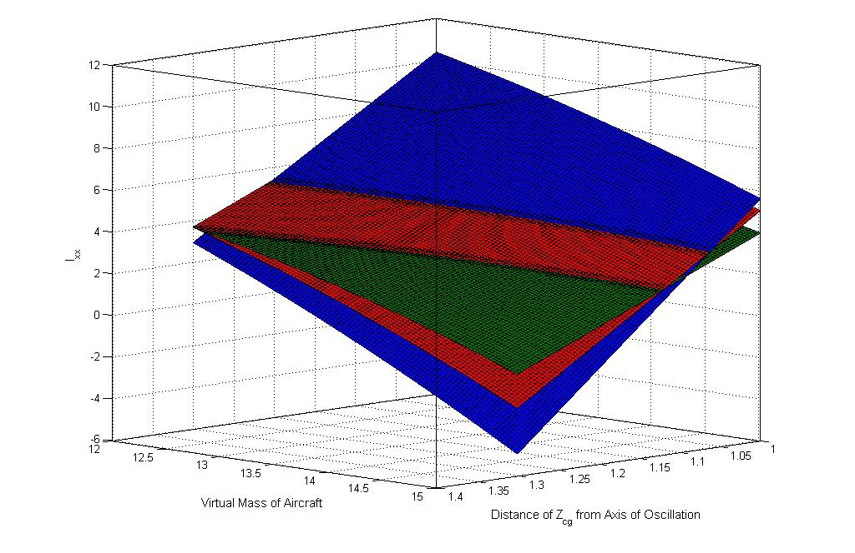

Figure 5. No common point of intersection of the three surfaces exist

Thus as an alternative approach, was determined by other means and substituted in equations (8) and (9) to give and .Equation (5) , (6) and (7) now become three equations in two variables. Thus, choosing two equations at a time, three values,,and 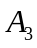 were obtained and then the average of these three values was taken.

Solving equations (5) and (6), is obtained

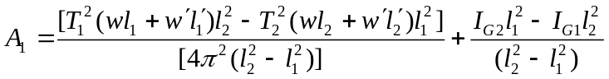 (25)

Solving equations (5) and (7), is obtained
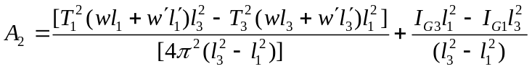 (26)

Solving equations (5) and (7), is obtained

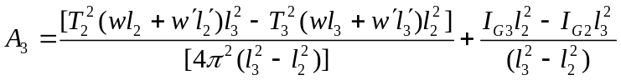 (27)

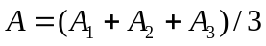 (28)

3.3.2 Moment of inertia about the X body axis
The c.g. of the aircraft is known. Thus, aircraft is swung at two different lengths about an axis parallel to the X body axis and equations analogous to (5) and (6) are written and then solved.

(29)

(30)

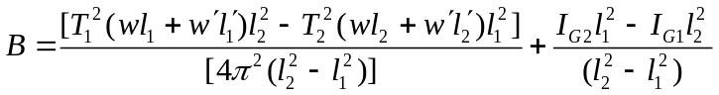 (31)

3.3.3 Moment of Inertia about the Z body axis
To determine C, the aircraft, along with the swinging gear is swung as a bifilar torsional pendulum about a vertical axis passing through the centre of gravity of the aircraft. Here, it is to be made sure that the aircraft centre of gravity and the centre of gravity of the swinging gear lie on the same vertical line. The arrangement is shown below.

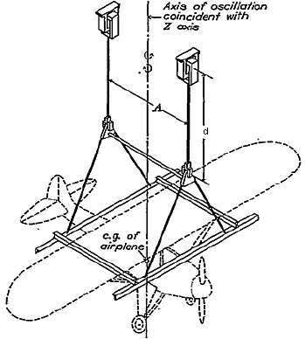
Figure 6. Determination of Moment of Inertia about the Z body axis

Noting the time period and using Equation (8), the moment of inertia of the aircraft +swinging gear system is obtained. The swinging is then swung as an independent pendulum and again using equation (8), its moment of inertia is obtained. Thus
(32)

It is to be noted here that 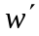 is here is different than the earlier . This is because of the spacer, which increases the weight of the swinging gear.
3.3.4 Determination of principal axes

It has been noted in practice that the principal and the body axes of an aircraft nearly coincide and hence determining the moment of inertia about the body axes should serve as an approximation to the principal moments of inertia. However, in certain cases it may be desired to know the actual values of the principal moments of inertia. Since XZ plane is a plane of symmetry, hence Y axis forms one of the principal axis. The other two lies in the XZ plane and needs to be located. If is the angle between the X body axis and one of the principal axis then would be given by,
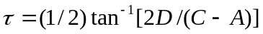 (33)
The product of inertia  in above equation is found using,

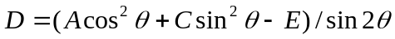 (34)

Here  is the moment of inertia of the aircraft about an axis inclined at to the X body axis and passing through the centre of gravity. is found experimentally by swinging the aircraft about an axis passing through the XZ plane and inclined at an angle to the X body axis. Equation (4) is employed and is substituted from the value obtained during the simultaneous solution of (5) and (6) to get. is evaluated by swinging the gear alone at the same angle and at the same length and using (15).
(35)

The moments of inertia about the principal axes, 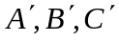, are now obtained using

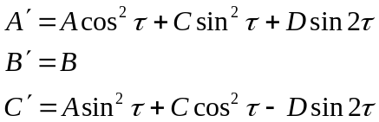 (36)

4. EXPERIMENTAL SET UP: COMPONENT MANUFACTURING

4.1 Swinging gear

The term swinging gear used in the report so far refers to the add ons that were provided to help suspend the aircraft and oscillate it about a definite axis of oscillation. The components used as parts of swinging experiment, in course of experiment, are described below.
4.1.1 Knife edge
The knife edge provides a definite axis about which the pendulum oscillates with very little friction. The knife edge design is picked up from [1]. The dimensions were not available in [1]. Hence the dimensions were chosen by the author. Hardened steel was used to make the knife edge and its seat.
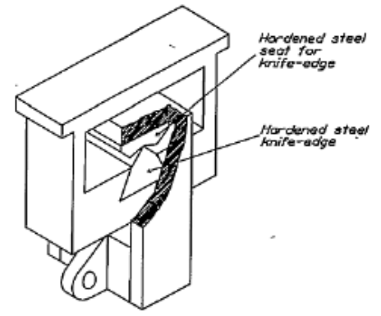
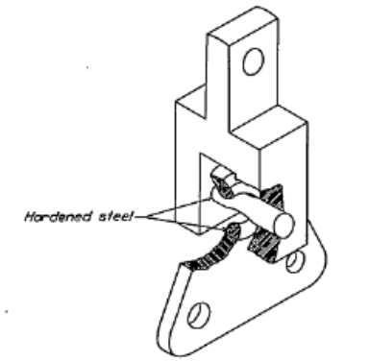

Figure 7. Knife edge Figure 8.Universal joint

4.1.2 Spacer
The spacer was used when the bifilar torsion assembly was implemented. The spacer was meant to ensure that during the oscillations, the pendulum c.g. always remained in the same vertical line as the axis of oscillation. The spacer essentially consists of two parts
a) Universal joint :
The Universal joint ensures that the pendulum c.g. always remains in the same vertical line as the axis of oscillation. The design of universal joint is primarily inspired by the one given in [1]. The dimensions were decided by the author.
b) Spacer rod
The spacer rod ensures that the spacing between universal joints remains fixed (equal to the length of the cradle) during the oscillations. The spacer rod is a mild steel rod. It was joined to the two universal joints by brazing. Welding was avoided because welding consumes material and this could have resulted in a lesser distance between the universal joints than the length of cradle.
3) Cradle
Cradle is the structure on which the aircraft is kept during the course of entire experiment. The cradle is made up two I beams and two L beams. This assembly was chosen because it offers minimum damping when moved in air. The cradle was made up of aluminium. Since I shaped aluminium beams were unavailable, two T shaped beams were welded to compose an I beam. The welding was done in an atmosphere of argon by acetylene flame. This was done because aluminium reacts with oxygen of air. The I beams were joined to the L beams by using screws and nuts. Holes were drilled in the L beam and the I beam for this purpose.
4) Metal wires
Mild steel wires were used for all kind of suspension purposes. They were easy to use and were easily straightened by stretching.
5. Results & OBSERVATIONS
Measuring from the center of the front wheel, the CG position was found to be (x_{CG}, y_{CG}, z_{CG}) = (58.1 cm, 0.3 cm, 41 cm). It can be noted that, since z_{CG} is sensitive to the value of inclination angle of the tilted plane (θ), the experiment was conducted at large θ (to minimize the θ dependency of z_{CG}). Since CG was close to rear wheels, the plane was inclined to make the UAV in pitch down position to avail the liberty of using high value of θ in the experiment.
The three simultaneous equations (each representing a cubic surface) to be solved have three unknowns: rolling moment of inertia (I_{xx}), virtual mass of the UAV and distance of z_{CG} from the axis of oscillation. The volume enclosed by three surfaces represents a measure of experimental error.
Using graphical method and z_{CG} measurement, it was found that I_{xx} = 3.783 kgm², I_{yy} = 3.760 kgm², I_{zz} = 6.928 kgm² and I_{zx} = -1.480 kgm². The principal moments of inertia were also computed: I'_{xx} = 5.223 kgm², I'_{yy} = 3.760 kgm² and I'_{zz} = 5.486 kgm². The inclination (τ) between body axes and principal axes was calculated, τ = -21.63 degrees.
A detailed error analysis was carried out for this experiment. It was found that the aerodynamic damping factor was 1.13 %. The frictional effect of the support equipments was minimized by manufacturing them using high quality mild steel and hardened steel with CNC machining. The nonlinear effect of gravity moment during roll oscillations was treated according to [4]. The experimental accuracy was found to be sensitive on Steiner’s term. It was concluded that experiments with shorter suspension lengths produce less error.
references
- H. A. Soulé, and M. P. Miller, “The experimental determination of the moments of inertia of airplanes,” NACA Report No. 467, pp. 501-513, 1933.
- W. Gracey, “The experimental determination of the moments of inertia of airplanes by simplified compound-pendulum method,” NACA Technical Note No. 1629, pp. 1-26, 1948.
- J. J. A. Gomez, “Experimental methods for determining moments of inertia of small UAVs,” Masters Thesis, LiTH-IKP-EX-1903, Department of Mechanical Engineering (IKP), Linköping University, pp. 1-75, 2001.
- C. H. Wolowicz, and R. B. Yancey, “Experimental determination of airplane mass and inertial characteristics,” NASA Technical Report, NASA TR R-433, pp. 1-64, 1974.

Further author information: (Send correspondence to A. Halder) V. Agarwal: E-mail: viki.iitkgp@gmail.com, Telephone: +91-9332326328 A. Halder: E-mail: halder.abhishek@gmail.com, Telephone: +91-9434230599, Address: Department of Aerospace Engineering, Indian Institute of Technology, Kharagpur – 721 302, INDIA R. Garhwal: E-mail: ur.rohit2003@gmail.com, Telephone: +91- 9932293412 A. Gupta: E-mail: ashay.gupta@gmail.com, Telephone: +91- 9911526322 S. Ghosh: E-mail: sayan.iitkgp@gmail.com, Telephone: +91-9932745647 S. Saxena: E-mail: me.shalabh@gmail.com, Telephone: +91-9932978791 Dr. M. Sinha: E-mail: masinha@aero.iitkgp.ernet.in, Telephone: +91-9434035229

