Fuzzy Quadtree Based Path Planner and Trajectory Smoother for a Low Cost Unmanned Aerial Vehicle
Abhishek Halder1, Sayan Ghosh1, and Dr. Manoranjan Sinha1

1 Intelligent Systems Lab, Department of Aerospace Engineering,
Indian Institute of Technology Kharagpur, West Bengal, 721302, India
halder.abhishek@gmail.com, sayan.iitkgp@gmail.com, masinha@aero.iitkgp.ernet.in
Abstract. This paper presents an effective path planning algorithm for Unmanned Aerial Vehicle (UAV) navigation based on fuzzy quadtrees. This formulation allows the user to specify the desired level of details in the planner depending on the mission complexity. A comparative study is done to investigate the advantage of the proposed fuzzy quadtree path planner over conventional quadtree path planner. It has been shown that fuzzy quadtree path planner offers a significant reduction in storage space and computation time, which are critical for low cost UAV applications. In addition to that, the optimal path predicted by the fuzzy quadtree planner was smoothened by a proposed trajectory smoother, taking vehicle’s kinematic constraint into account. The user inputs the two dimensional map of obstacles to get an optimal path predicted by the fuzzy planner and then a feasible trajectory is obtained, taking UAV turn rate kinematics in consideration.
Keywords: Fuzzy logic, Quadtree, Path planner, Trajectory smoother, Unmanned Aerial Vehicle.
1 Introduction
Development of low cost Unmanned Aerial Vehicles (henceforth UAVs) has seen considerable interest in recent times. Most of the UAV applications need to carry out dull, dirty and dangerous missions. Accomplishing such a mission greatly depends on vehicle’s capability of autonomous navigation. This problem is generally treated in a two step approach. In the first step, a path planner is developed to lay out a tentatively optimal path leading from start to goal position. Next, a trajectory smoother or waypoint generator is prepared to smooth out the dynamically impractical turns predicted by the planner. Sometimes a third step is incorporated where a trajectory tracker is made to track the UAV from the predicted path. Generally this step is performed when smoothing the path is not straightforward.
The basic purpose of a planner is to plan a path avoiding obstacles in the environment. The environment can be structured (map known beforehand) or unstructured (map not known beforehand and liable to sudden change). Further, the planning can be done as one time off-line operation, known as global approach (act-after-thinking) where obstacles remain stationary or can be done as real time on-line operation, known as local approach (act-while-thinking) where obstacles are dynamic.
Both on-line and off-line methods are used in practice for UAV planner as well as waypoint generator. Model predictive control [1], vector calculus [2], receding horizon control [3], GPS feedback [4], evolutionary algorithm [5, 6] are some of the methods used recently for this purpose. In addition there are some classical approaches for solving particular problems. Visibility graph [7], Voronoi diagram [8], freeway net [9], potential field method [10] are some of them.
For problems like urban area navigation, both path planning and trajectory generation are computation intensive. Heuristic-based methods can significantly reduce the computational complexity under such situations keeping in mind the fact that the budgetary constraint can limit the processing ability and storage capacity of on-board hardware of a low cost UAV. Hence fuzzy logic has always been proved to be useful in the field of UAV path planning and trajectory generation [11, 12]. Some research has also demonstrated that formulating one existing method in fuzzy logic framework yields better result than that method itself [13]. The objective of this paper is to show that a fuzzy quadtree approach for path planning can be more efficient compared to quadtree planner itself.
The rest of the paper is organized as follows. Section 2 discusses the path planner in detail with simulation results. Section 3 addresses the trajectory smoother, while section 4 concludes the paper.
2 Path Planning Problem
The path planning approach considered here is based on quadtrees. It is assumed that the map of the obstacles is known beforehand (structured environment). Also the case for static obstacles (global approach) is addressed here.
Quadtree is a hierarchical representation of a 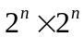 binary array consisting of unit square pixels [14]. It is generally used for regional data description with the representation of a class of hierarchical data structures. This is widely applied in the field of image processing for successively subdividing the image into four equal sized daughter images. A formal definition of quadtree can be found in [15]. In a nutshell, a quadtree can be visualized as a tree having either a leaf node or having four colored nodes. The color of the nodes can be white, gray or black.
2.1 Quadtree Generation
A quadtree structure recursively decomposes a two dimensional space into four sub spaces. Each subspace is termed as node and can be of three types: free nodes or white nodes (no obstacles), obstacle nodes or black nodes and mixed nodes or gray nodes. Unlike free and obstacle nodes, only mixed nodes are recursively subdivided until all daughter nodes are either free or of obstacle type. During this subdivision process, information of neighboring nodes of each node is updated for each iteration through repetitive neighbor finding technique [16]. Fig. 1 shows a typical quadtree generated and Fig. 2 shows all the gray, white and black nodes with the numbering convention in the order of north-west, north-east, south-west and south-east.
Standard quadtree representation is done through pointers. Here a matrix quadtree and linear quadtree [16, 17] representation is adopted instead. This is due to the fact that matrix and linear representation lead to significant execution time economy and memory saving, which are of utmost consideration for a low cost UAV path planner.
To represent quadtrees without pointers, each black node was encoded with a quaternary integer whose digits represent successive quadrant subdivisions. If , 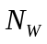 and 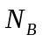stand for total number of nodes, total number of white nodes and total number of black nodes of a quadtree respectively and if denotes quadtree resolution parameter, then it can be shown that, a linear quadtree needs 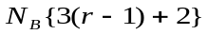bits of memory space [14]. The space complexity, measured in terms of number of nodes, is for a regular quadtree and for a linear quadtree. One can note that, the total number of nodes 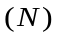can be as high as 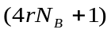. This clearly implies that, linear quadtrees offer at least 66 % saving of storage space compared to regular quadtrees. When is large, the saving is more than 90 %.
If 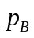 is the total number of black pixels then the worst-case time complexity for encoding a region is 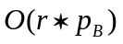. Finding a neighboring node and determining its color can be carried out in time proportional to 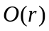. Refining black nodes require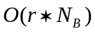time while refinement of all terminal nodes takes 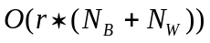time. Given a structured map of obstacles, piecewise path planning is often preferred where the entire map is fragmented into some important sub-maps and then separate planning is done for each of them. This is particularly useful for large urban areas where regions of congestion and significant threats are found to be localized in certain zones of the city. This necessitates quadtree generation for each of these sub-maps and then taking union of these quadtrees. Superposition of two quadtrees having 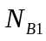 and 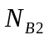black nodes can be performed in 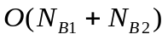time.
Use of linear quadtrees simplifies the union and intersection operations. For union operation, two linear quadtrees are merged into a new sorted array. Union of more than two regions can be achieved in parallel using a multi-way merge. Intersection operations also simplifies to making a new sorted array.
Thus the quadtree generation in matrix and linear quadtree approach is suitable from both space and time complexity consideration. Moreover, linear quadtree representation aids to perform region based spatial union and intersection operations on quadtrees. Since such operations are crucial in practical mission critical applications (e.g. taking decisions at the ground control station by analyzing surveillance images transmitted by the UAV), ensuring their fast execution and space economy is mandatory for hardware implementation of the algorithm.

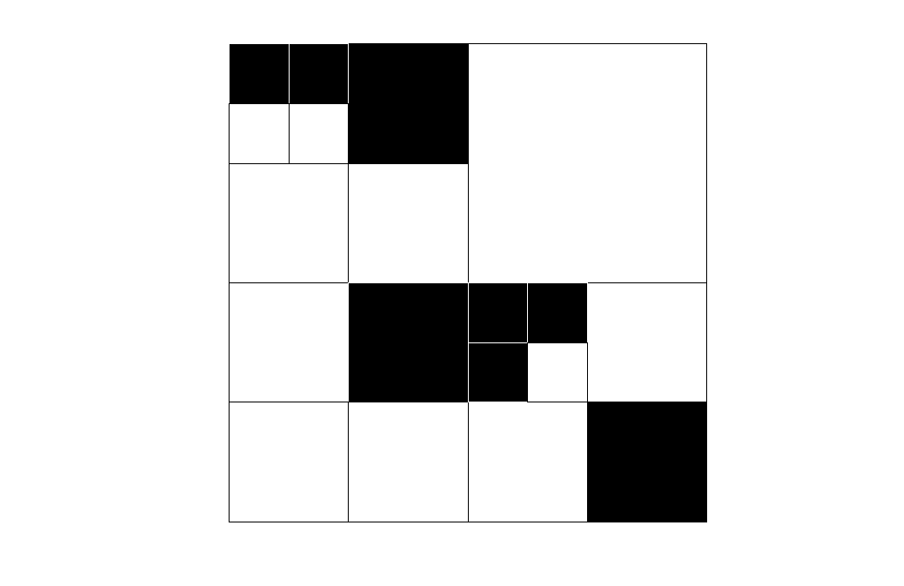Fig. 1. Quadtree of a two dimensional region with obstacle (black) and free (white) nodes.
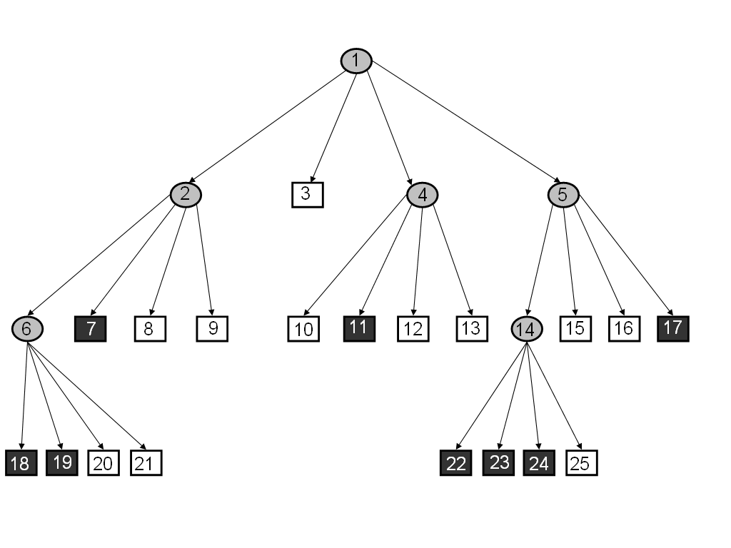Fig. 2. Tree representation of recursive decomposition process for quadtree generation.
2.2 Distance Transformation
Distance transformation or distance map is a function that (for each free quadrant) yields the distance or length of the path to the quadrant containing the user specified goal point.
This transformation has been accomplished here by generating an artificial wave starting from the node containing the goal and by giving a distance value or weight to each node encountered during the propagation of ripples. This weight is directly proportional to the distance propagated by the wave front and the size of the node encountered. Weight assigned to the obstacle nodes are assumed to be infinity (since wave can not propagate through it).
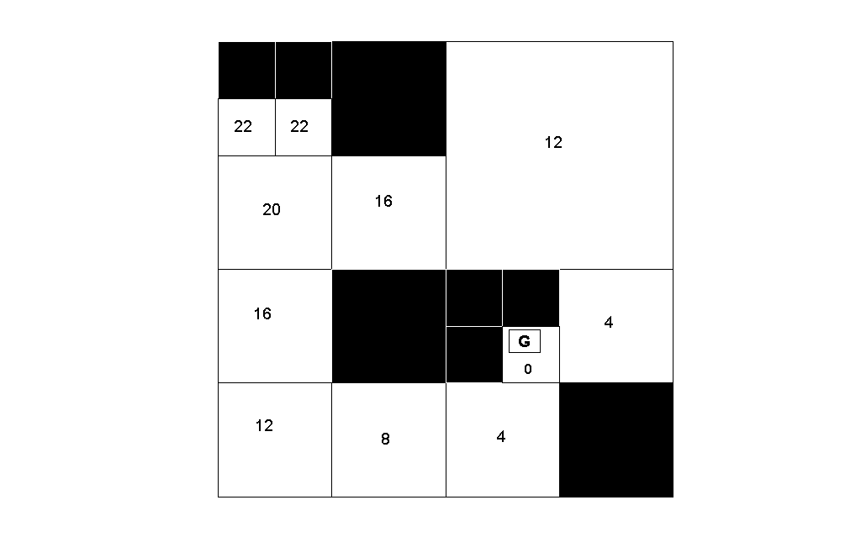

Fig. 3. Quadtree with distance transformation values or weights.

Fig. 3 depicts the quadtree of Fig. 1 and Fig. 2 after distance transformation. The goal point is shown by boxed G. Goal is assigned the minimum weight zero.
2.3 Finding Path
Distance transformation results in a two dimensional weighted terrain where the goal has the lowest value of weight. So the problem remains to traverse downhill from the specified starting point to the goal point.
From the starting point the UAV will follow that obstacle free neighboring node which has lowest value of weight. Essentially this results in a movement in the direction of largest downhill gradient. The outcome of this is a sequence of free squares which contains a number of collision free paths from start to goal. For UAV path planning purpose, it was decided to draw that path which results by joining the mid points of the entry and exit boundary of each square. This ensures a safe path for an airborne unmanned vehicle.
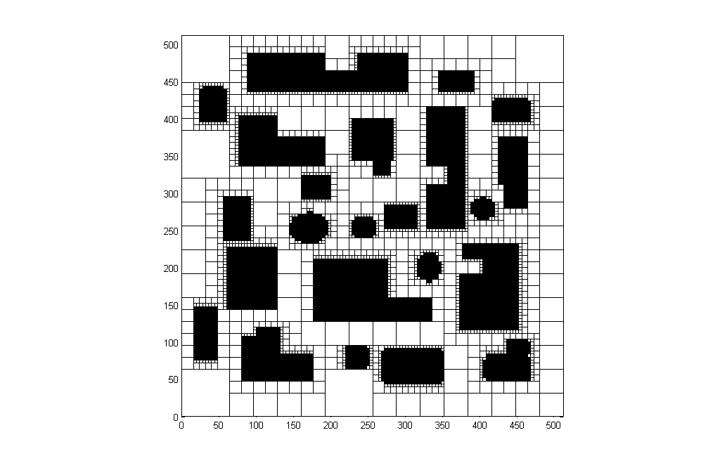
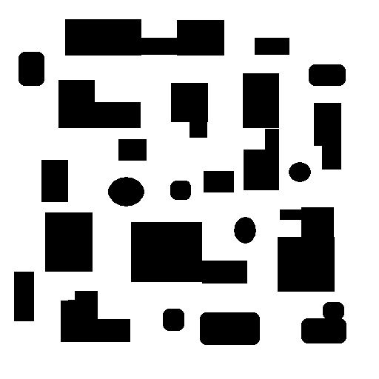

Fig. 5. Generated quadtree.

Fig. 4. Obstacle map of 512 × 512 pixels.

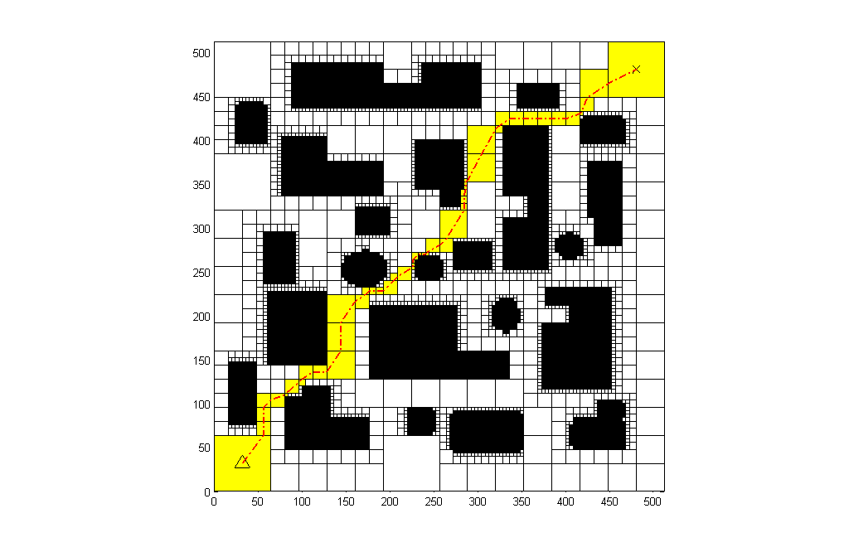
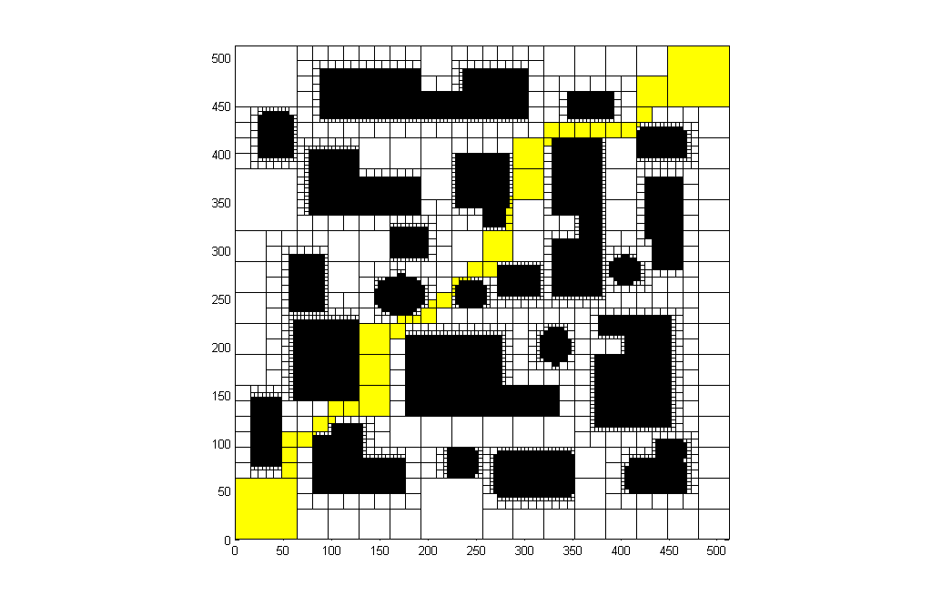

Fig. 6. Generated optimal pavement after distance transformation.

Fig. 7. Generated path from start to goal.

In Fig. 4, a binary image of dimension 2⁹ × 2⁹ is taken and quadtree for the same is generated (Fig. 5). Then distance transformation yields the optimal pavement (Fig. 6), in which a safe path is generated (Fig. 7) leading from start to goal. In Fig. 7, the triangle denotes the starting point and the cross symbolizes the goal. These notations for start and goal are henceforth used in the figures.
2.4 Fuzzy Quadtree Formulation
Though a formal definition of fuzzy quadtree is given in [15], to the best of authors’ knowledge, it has never been applied for path planning problem. It is interesting to note that the nature of UAV path planning problem suits very well to such a heuristic formulation that yields acceptable results with time and space economy. To fuzzify the above quadtree based path planning formulation one simply needs to count the total number of black and white daughter nodes under that level of gray nodes in which the user wants to stop. The user imposed fuzzy leaf node (which actually was a gray node) will then have a fuzzy membership function value equal to total number of black daughter nodes divided by total number of daughter nodes. Following this logic, if any white leaf node actually exists in the user defined level then its membership function value goes to zero (meaning it would have no black daughter nodes if it was not fuzzified). Similarly black leaf node, if exists, will assume the value 1.
If the user demands to fuzzify the quadtree shown in Fig. 1 and Fig. 2 at level 2 then it results a fuzzy quadtree shown in Fig. 8. The corresponding membership function values of each node are also shown.
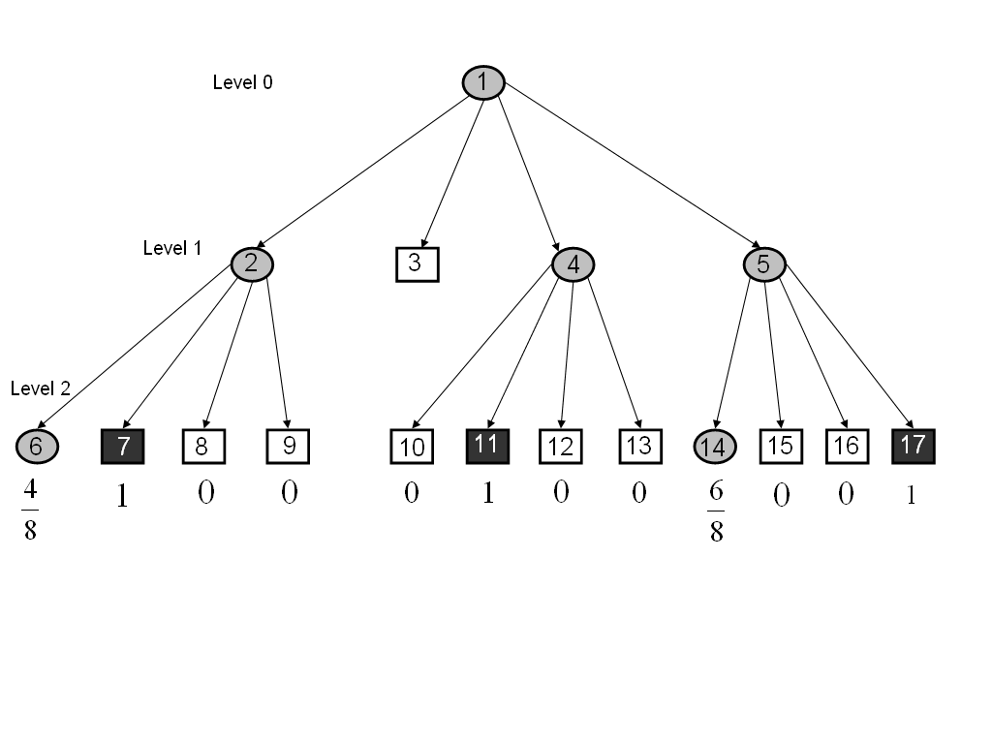

Fig. 8. Fuzzy Quadtree up to level 2.
The fuzzy quadtree of Fig. 8 can also be represented in array notation as shown in Fig. 9.
4/8 | 8/8 | 0 | 0
0 | 0 | 0 | 0
0 | 8/8 | 0 | 0
6/8 | 0 | 0 | 8/8

Fig. 9. Array Representation of Fuzzy Quadtree.

This clearly depicts the significant reduction in storage space for the fuzzy quadtree compared to the original quadtree.

2.5 Salient Features of the Fuzzy Quadtree Planner
A quadtree planner in general and a fuzzy quadtree planner in particular, offers significant reduction in time complexity compared to some well known path planning methods like Voronoi diagram. A quadtree planner requires O(N) time compared to O(N log N) (worst case O(N²)) in Voronoi diagram. Further, fuzzy quadtree planner allows the user to specify the level of quadtree that the planner will retain. In the context of UAV navigation, the map of the static obstacles generally consists of some dedicated theme like building, street etc. for urban environment. So the flexibility that the user can choose the desired level of details saves much memory and execution time. A comparison of Fig. 2 with Fig. 8 and Fig. 9 illustrates this fact.
In fact, if the user demand of detailing is not very high, the path planner can run in real time. This allows one to apply the proposed algorithm for on-line micro aerial vehicle (MAV) navigation in which the ground computer can get the feedback from on-board sensor (like mini laser ranger) and the planner runs at ground and uploads the path in the MAV.
To illustrate the on-line MAV path planning problem, a more realistic scenario is considered where the MAV encounters a static pop-up obstacle which was not present in the structured map of obstacles. It can be due to limited clarity of the satellite image, inefficient image processing or due to time lag between actual snapshot and MAV flight (which can result in typical pop-up obstacles like trees or temporary constructions). This necessitates an update of the pre-planned off-line calculated path in real time. In Fig. 10 a structured obstacle map (no pop-up obstacle) is shown. Corresponding quadtree and optimal path are given in Fig. 11 and Fig. 12 respectively.

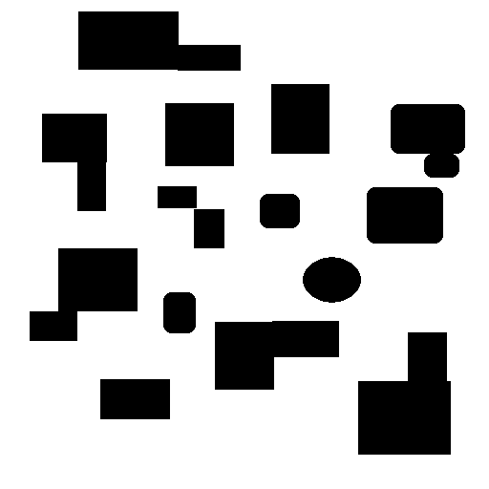

Fig. 10. Structured obstacle map.

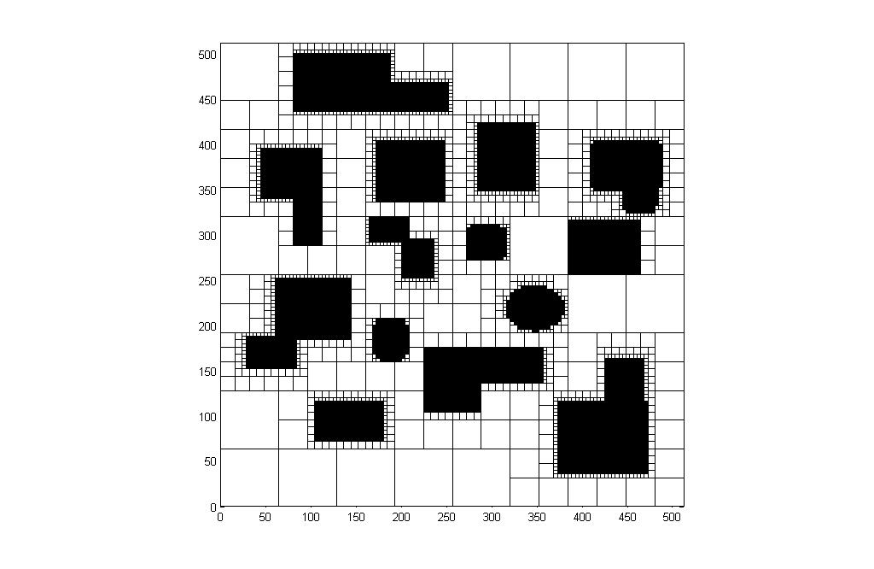
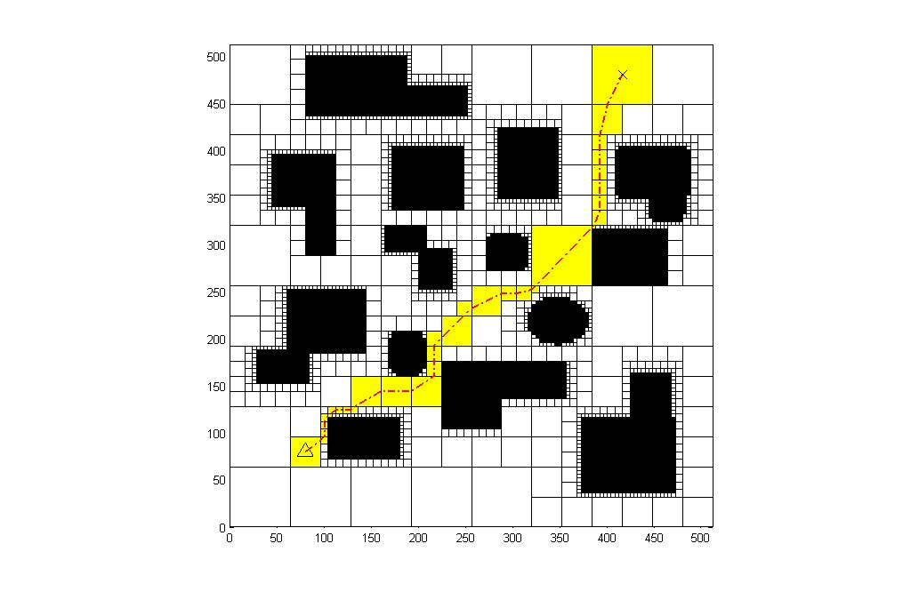

Fig. 11. Quadtree for structured map.

Fig. 12. Optimal path for structured map.

Now when the MAV in actual flight senses (by mini laser ranger) the pop-up obstacle (gray circle in Fig. 13) amid the structured environment of Fig. 10, then it treats it as a two-dimensional object and sends its breadth information (spread angle α) and nearest distance () back to ground computer and a modified quadtree in Fig. 14 (and hence an updated path in Fig. 15) is generated and uploaded to the MAV in real time. The modified quadtree is generated assuming the effective diameter  of the obstacle as

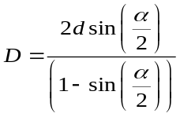
.
(1)

It can be noted that for successful real time operation of the process described above, the sending and receiving data by the MAV should be as quick as possible. Here fuzzy quadtree can offer significant encoding efficiency by reducing the bit length of data transmission. Same holds for the case when surveillance images are sent to ground control station, thus aiding quick initiation of action based on the decision taken at ground.

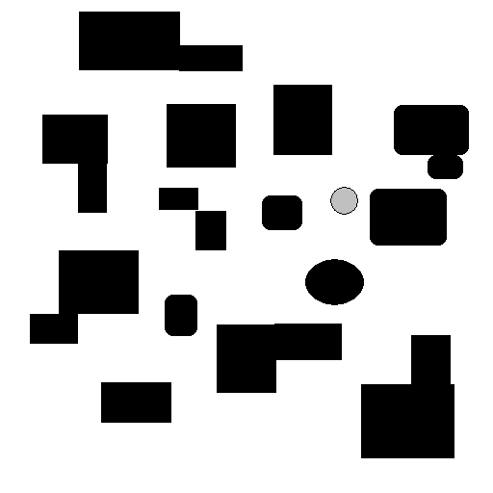

α

Fig. 13. Pop-up obstacle in structured environment of Fig. 10.

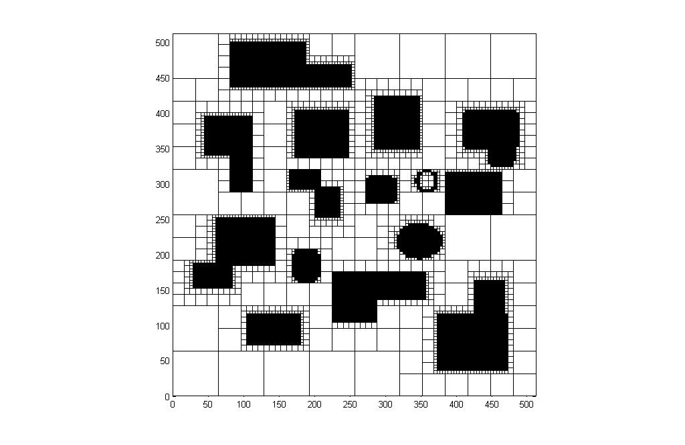
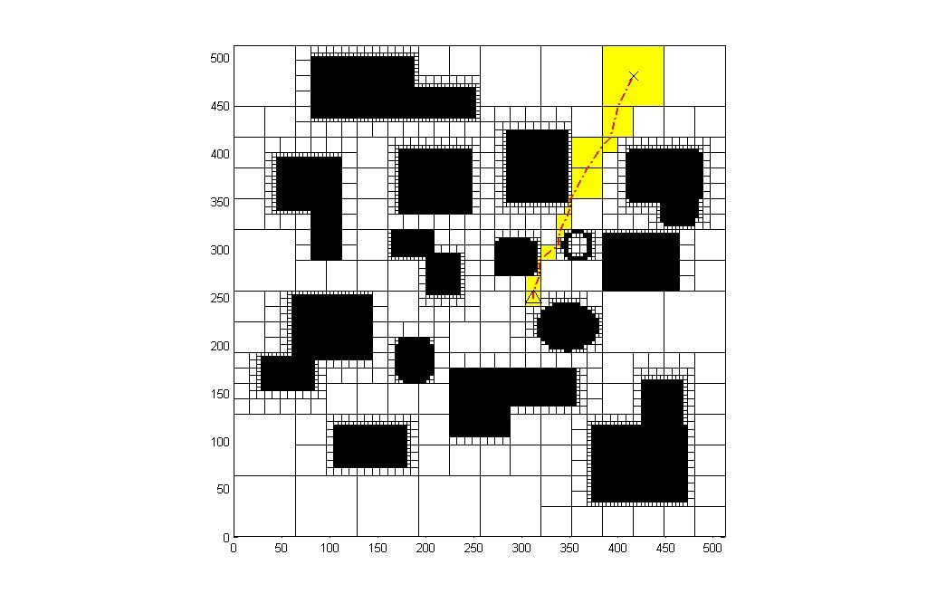

Fig. 14. Modified quadtree.

Fig. 15. Updated path.

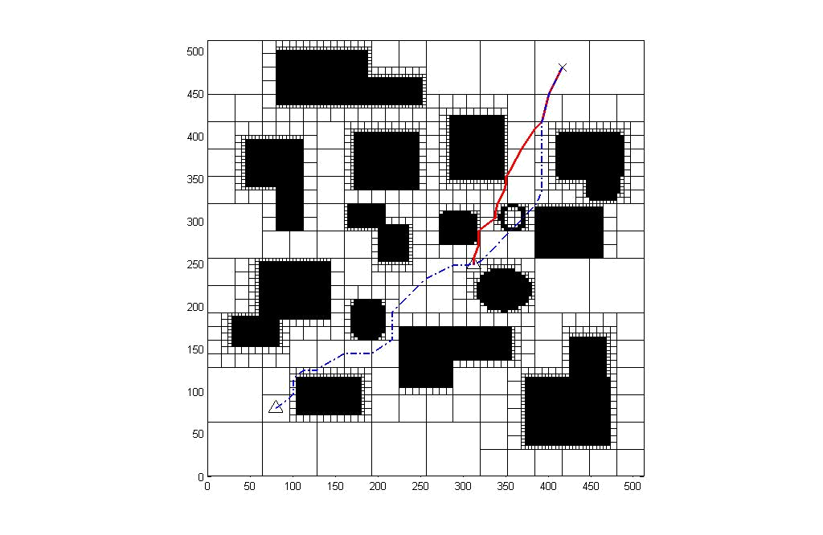

Fig. 16. Comparison of the off-line planned (dotted) path and online updated (solid) path.

In conventional quadtree based planning, the recursive subdivision is done up to pixel level. Since UAV is a safety-critical system, a measure must be taken for minimum length of those squares which make the optimal pavement. So if the minimum length of such squares is less than a specified value λ (its value depends on vehicle’s size) then the quadtree was rebuilt and the path was regenerated such that minimum quad length remains greater than or equal to λ. This is illustrated in Fig. 17, 18 and 19.


Fig. 17. A given obstacle map.

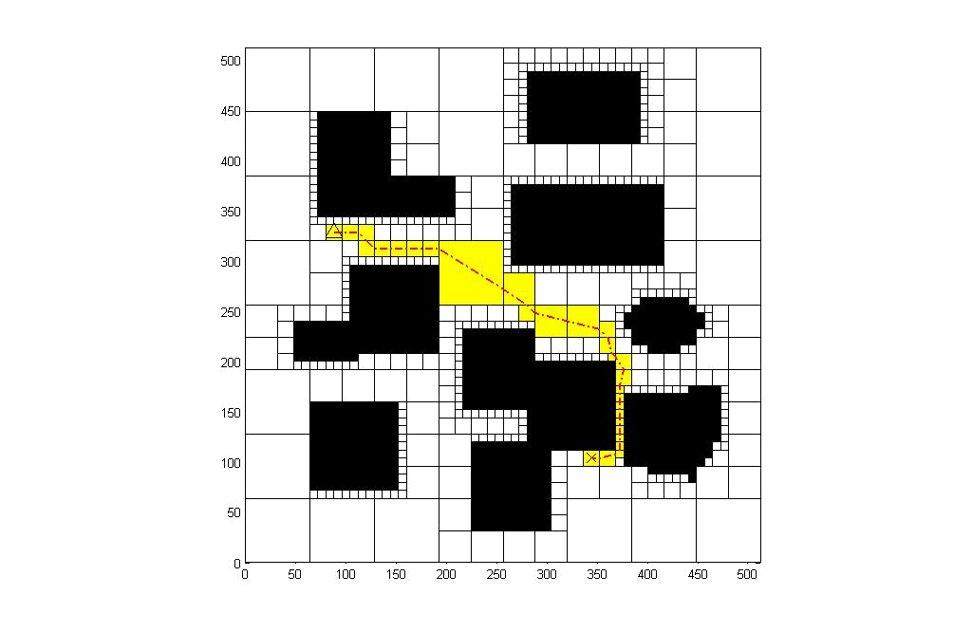
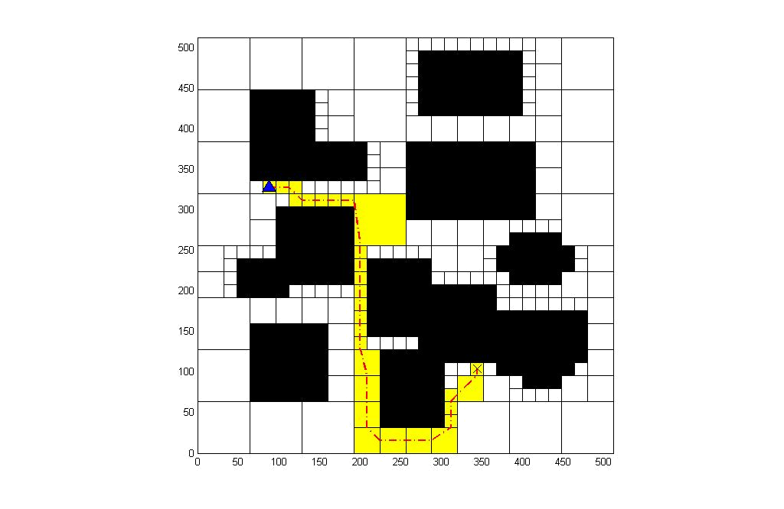

Fig. 18. Path generated without specifying restriction on minimum quad length.

Fig. 19. Path generated with specified minimum quad length λ depending on vehicle dimension.

3 Trajectory Smoothing Problem
The trajectory smoother or trajectory generator or waypoint generator is aimed to develop a trajectory which follows the optimal (in some sense) path (predicted by the path planner) consisting of a set of straight line segments, as closely as possible but simultaneously guaranteeing the feasibility of that trajectory. Erik Anderson [18] proved that this problem has an optimal solution.
The kinematic equations for two dimensional cases can be written as

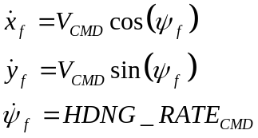
(3)
(4)
.
.
.
(2)

Here 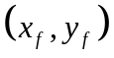denotes inertial position, 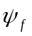denotes heading, 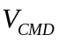 stands for commanded linear velocity along the path and  stands for commanded heading rate.
The constraints are given by
(5)
.
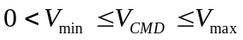
(6)
.

Here minimum velocity is governed by lift requirement (aerodynamic limitation) and maximum velocity is governed by propulsive limitation and stall speed.
Further, if is constant then

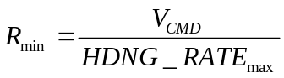
(7)
.

This specifies minimum turn radius. 2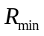 can be taken as the minimum square cell dimension for fuzzy quadtree structure.
Anderson [18] analytically proved that for a trajectory to be time optimal, it will be a sequence of straight line path segments combined with arcs along the edges of local reachability region (circles). The geometric construction for this optimal trajectory can be found in [18].
Again this puts a limit on bank angle (assuming steady co-ordinated level turn) as

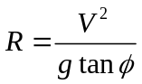
(8)
.

So when decreases then the value of increases. Hence the critical parameter corresponds some. This maximum bank angle is given by:
(9)
.
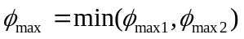

Here 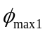is the stall limited bank angle (aerodynamic limitation) and 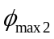is the load limited bank angle (structural limitation).
To calculate the stall limited bank angle, force balance equation is used. For level turn

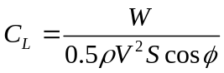
(10)
.

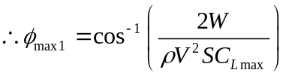
(11)
.

The maximum value of lift coefficient in (11) can be found from the angle of attack versus lift coefficient plot. For UAV flight, density can be taken as constant.
The load limited bank angle is a result of structural load carrying constraint of the UAV while taking a turn. The load factor is a measure of maneuvering load experienced by the vehicle and is given by

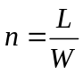 .
(12)

Combining (10) and (12), for level turn one can obtain

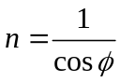 .
(13)

In general wings are not symmetrical with respect to positive and negative loading. Hence one can define

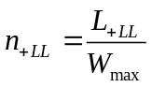 .
(14)

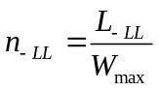 .
(15)

Here the suffix 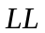stands for load limit (positive or negative). Hence the load factor corresponding to positive (negative) load limit is the ratio of maximum (minimum) allowable positive (negative) lift and maximum gross weight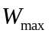. For conventional turning, both and are positive. Therefore considering (13) and (14) together, the load limited bank angle is given by

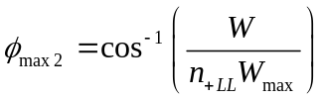 .
(16)

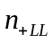 in (16) can be obtained from the 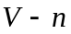 diagram of the UAV. Finally (9) gives the maximum allowable bank angle.
Based on the above discussion, one can now address the quadtree resolution parameter in detail. In UAV planner, since the UAV must be able to turn in the proposed optimal sequence of squares, the minimum quadtree square size can be specified in the code as twice the minimum turning radius. With a factor of safety δ, the minimum quad length or resolution parameter can be taken as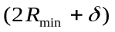. A similar measure for resolution parameter was taken (at the end of section 2.5) through λ. The minimum quad length is the maximum of these two measures.
4 Conclusion
The path planning approach and trajectory smoothing method described above are particularly suitable for small budget UAV applications which can not afford huge on-board memory and fast processing. Moreover, fuzzy quadtree formulation is apt for capturing trend in region rather than pixel level computation. Moreover, the minimum quad size has been governed by minimum turn radius for optimal trajectory which, in turn, restricts maximum bank angle for level turn. Thus the heuristic approach provides a faster, cheaper and better solution for UAV navigation.

References
1. Singh, Leena. and Fuller, James: Trajectory Generation for a UAV in Urban Terrain using Non-linear MPC. Proceedings of the American Control Conference, Arlington, VA, June (2001), 2301–2308.
2. Yang, Guang and Kapila, Vikaram: Optimal Path Planning in Unmanned Aerial Vehicles with Kinematic and Tactical Constraints. Proceedings of the 41st IEEE Conference on Decision and Control, Las Vegas, Nevada, USA, Dec (2002) 1301–1306.
3. Kuwata, Yoshiaki: Real Time Trajectory Design for Unmanned Aerial Vehicles using Receding Horizon Control. M.S. Thesis, MIT, June (2003).
4. Bhat, Sanjay and Kumar, Pradeep: A Feedback Guidance Strategy for an Autonomous Mini-Air-Vehicle. National Conference on Control and Dynamical Systems, January (2005) IIT Bombay.
5. Nikolos et al: Evolutionary Algorithm Based Offline/ Online Path Planner for UAV Navigation. IEEE Transactions on Systems, Man and Cybernetics, vol. 33, no. 6, Dec (2003).
6. Capozzi, J. Brian: Evolution Based Path-Planning and Management for Autonomous Vehicles. PhD Dissertation, University of Washington, (2001).
7. Lozano-Pérez, T. and Wesley, M. A.: An Algorithm for Planning Collision-free Paths Among Polyhedral Obstacles. ACM, vol. 22, no. 10, (1969) 560–570.
8. Leven, D. and Sharir, M.: Planning a Purely Translational Motion for a Convex Object in Two-dimensional Space using Generalized Voronoi Diagrams. Discrete Computational Geometry, vol. 2, (1987) 9–31.
9. Brooks, R. A.: Solving the Find-path Problem by Good Representation of Free Space. IEEE Transactions on Systems, Man and Cybernetics, vol. SMC-13, no. 3, (1983) 190–197.
10. Khatib, O.: Real Time Obstacle Avoidance for Manipulators and Mobile Robots. The International Journal of Robotics Research, vol. 5, no. 1, (1986) 90–98.
11. Tsourveloudis, Nikos C., Doitsidis, Lefteris and Valavanis, Kimon P.: Autonomous Navigation of Unmanned Vehicles: A Fuzzy Logic Perspective. Cutting Edge Robotics, 1st edn. Pro Literatur Verlag, Germany (2005) 291–310.
12. Doitsidis, Lefteris, Valavanis, Kimon P, Tsourveloudis, Nikos C. and Kontitsis, M.: A Framework for Fuzzy Logic Based UAV Navigation and Control. Proceedings of the 2004 IEEE International Conference on Robotics and Automation, New Orleans, LA, April (2004).
13. Tu, Kuo-Young and Baltes, Jacky: Fuzzy Potential Energy for a Map Approach to Robot Navigation. Robotics and Autonomous Systems, vol. 54 (2006) 574–589.
14. Gargantini, Irene: An Effective Way to Represent Quadtrees. Communications of the ACM, vol. 25, no. 12, Dec (1982) 905–910.
15. Chen, Pei-Min: A Fuzzy Quadtree Representation for Spatial Analysis. Proceedings of ICSP, Brighton, England (1996) 1122–1125.
16. Vörös, Jozef: A Strategy for Repetitive Neighbor Finding in Images Represented by Quadtrees. Pattern Recognition Letters, vol. 18 (1997) 955–962.
17. Vörös, Jozef: Low-cost Implementation of Distance Maps for Path Planning Using Matrix Quadtrees and Octrees. Robotics and Computer Integrated Manufacturing, vol. 17 (2001) 447–459.
18. Anderson, E. P.: Constrained Extremal Trajectories and Unmanned Air Vehicle Trajectory Generation. M. S. Thesis, Brigham Young University, Provo, Utah, April (2002).

