**FOURTH MENTOR EVALUATION**

Capstone Project:

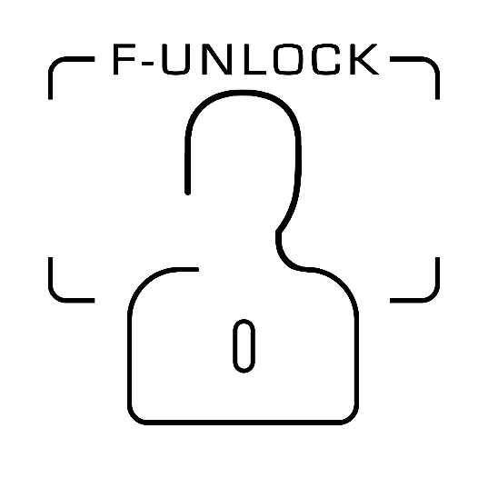**F-Unlock**

Submitted to:

*Dr. Sanmeet Kaur*

Submitted by:

|  |  |
| --- | --- |
| Abhishek Handa | 101503006 |
| Abhishek Salwan | 101503007 |
| Ajay Jindal | 101503016 |

**Table of Contents**

1. Assumptions and Constraints 3
2. Standards 4

# Assumptions and Constraints

1. **Internet Connection**: Internet connection is a constraint because the application fetches data from the server over the internet. So, it is crucial that the application should have an internet connection to function. Whenever a new face is fed to the algorithm to recognise, the algorithm searches the database of the available faces and matches the new face with them. This way the identity of the person is found. Also, during SOS internet connection is crucial for the message to be transmitted.
2. **Accurate Algorithm**: The face recognition algorithm should be accurate because it is to be used in a security system. The algorithm must be able to correctly identify the person within a certain limit of time.
3. **Quick Algorithm**: The face recognition algorithm must be able to find whether the person has access to the room or not with a short duration of time. The execution of the algorithm must not take more than a second.
4. **Relay Operation**: The relay should work properly in response to Raspberry Pi to unlock the door.
5. **SOS**: For the SOS to work properly the audio recorder must work so that user can record audio and then send it to the administrator. The admin will then respond quickly and in case of an emergency alert in the audio message the door will unlock immediately.

# Standards

Standards used for the proposed design solution while developing the project prototype were as follows:

1. [**IEEE 1471**](https://en.wikipedia.org/wiki/IEEE_1471): It is the IEEE standard for software/system architecture according to which the entire architecture of our working prototype was designed.
2. [**IEEE 1233**](https://en.wikipedia.org/wiki/IEEE_1233): IEEE standard for system requirement specifications. It was followed while preparing the SRS document for this system, which is a structured collection of information that embodies the requirements of a system.
3. [**IEEE 830**](https://en.wikipedia.org/wiki/IEEE_830): IEEE standard for software requirement specifications. It was used for the developing the software requirements specification for this system. The software requirements specification is a description of a software system to be developed and lays out functional and non-functional requirements, and includes a set of use cases that describe user interactions that the software must provide.
4. [**IEEE 1016**](https://en.wikipedia.org/wiki/IEEE_1016): It is the IEEE standard for software design description. A software design description is a written description of a software product that describes the overall architecture of the software project. An SDD usually accompanies an architecture diagram with pointers to detailed feature specifications of smaller pieces of the design. Practically, the description needs to outline all parts of the software and how they will work. The standard was followed while describing specific details of the system such as data flow diagrams, architecture diagrams etc.
5. [**IEEE 802.15.4**](https://en.wikipedia.org/wiki/IEEE_1016): It is a technical standard which defines the operation of [low-rate wireless personal area networks](https://en.wikipedia.org/wiki/Personal_area_network) (LR-WPANs). It specifies the [physical layer](https://en.wikipedia.org/wiki/Physical_layer) and [media access control](https://en.wikipedia.org/wiki/Media_access_control)for LR-WPANs, and is maintained by the [IEEE 802.15](https://en.wikipedia.org/wiki/IEEE_802.15) working group, which defined the standard in 2003.