Screenshots:

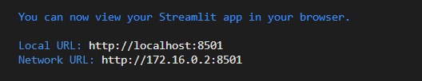

INPUT 1:

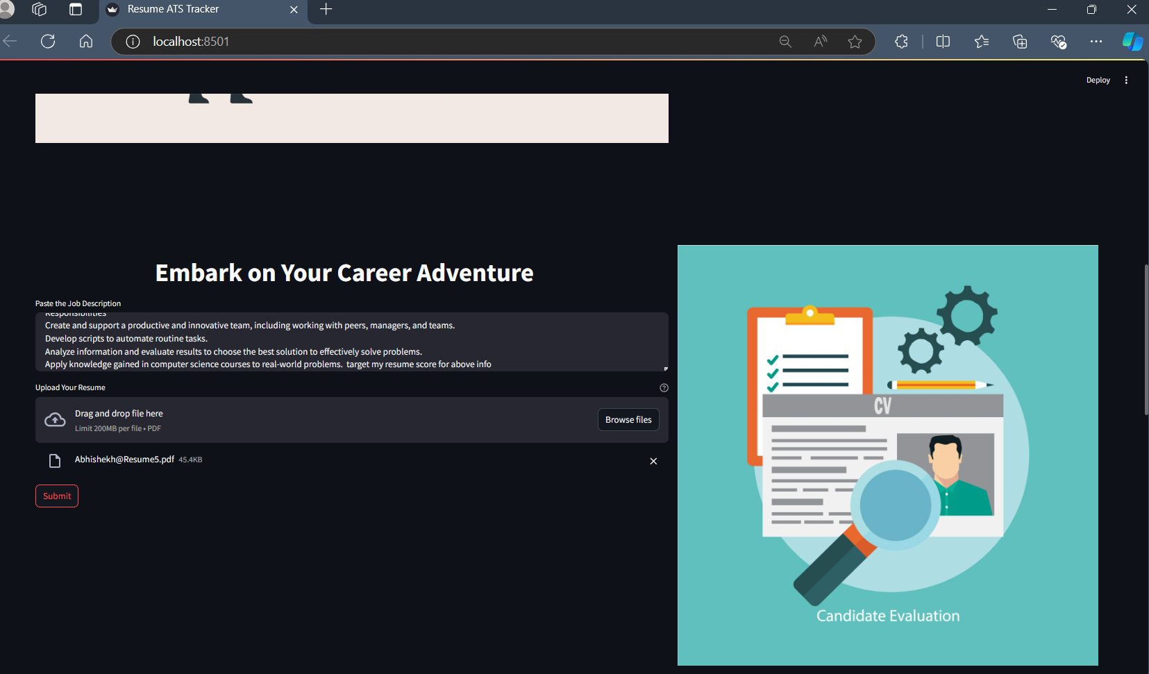

OUTPUT1:

INPUT2:

OUTPUT2:

