**Online Shopping System**

**[Documentation]**



**SOFTWARE PROJECT || SEM-4 || GROUP-86**

**Internal Guide – Prof. Vidhi Sagar**

|  |  |  |
| --- | --- | --- |
| **Tushar Hirpara** | **04(DIV - F)** | **22003401110019** |
| **Abhishek Hirapara** | **03(DIV - F)** | **22003401110018** |
| **Kenil Chandrani** | **19(DIV - F)** | **22004401110133** |

# INDEX

|  |  |  |
| --- | --- | --- |
| **Index** **Content**  **Number** | | |
| **1** | Introduction | **02** |
| **1.1** | Existing System | **02** |
| **1.2** | Need of the new system | **03** |
| **1.3** | Objective of the new system | **03** |
| **1.4** | Problem Definition | **04** |
| **1.5** | Core Components | **04** |
| **1.6** | Project Profile | **05** |
| **1.7** | Assumptions and Constraints | **06** |
| **1.8** | Advantages and Limitations of the Proposed System | **07** |
| **1.9** | Requirement Determination | **08** |
| **1.10** | Requirement Specification | **09** |
| **2.1** | Targeted users | **10** |
| **2.2** | Use Case Diagram | **11** |

# 1. Introduction

Various Shopping items in stock, together with their Name, Brand, Colour, Specifications, and Price, are listed in a central database that serves as an online shopping application project. This project is a application that serves as a one-stop shop for shopping. HTML, CSS, and JavaScript are used to create the front end of this web project, and Python (Django) is used to create the back-end. Details pertaining to various Shopping items are stored in the SQL database. When browsing the website, a user can view numerous Products organised by category. Users can choose preferred Products and view their prices. After choosing a product, the user must fill out a form before the product is ordered on his behalf. The software's three primary parts are as follows:

1. Implementation of new user registration and login.

1. Make it possible for users to select any products.

1. Encourage the consumer to purchase a product.

Python will be used as the programming language to build the Website. The database will be linked using a sqlite3 database.

## Existing System

* Many existing systems lack a centralized platform for business owners to manage multiple products efficiently, resulting in fragmented and time-consuming processes.
* Some platforms struggle to provide adequate tools for sellers to enhance the visibility of their products, hindering their ability to reach a broader customer base.
* Inventory management can be a daunting task for business owners, leading to potential errors, overselling, and stockouts due to the absence of user-friendly and comprehensive tools.
* While the system incorporates basic security measures, there may be vulnerabilities in the payment processing system that need addressing.
* The absence of an AI-based chatbot limits customer support capability, potentially leading to delays in issue resolution and assistance.

## Need of the New System

* This application provides a centralized dashboard for business owners to manage multiple products efficiently, streamlining their operations and saving valuable time.
* Through strategic use of algorithms and personalized recommendations, our platform enhances product visibility, ensuring that sellers can effectively showcase their offerings to a wider audience.
* By offering an internet platform, the electronics business may expand its audience and ease of access. Enhance customer experience by making it easier to search, browse, and buy products.
* Improve efficiency and reduce errors by streamlining inventory management and order processing.

## Objective of the New System

**1. Efficiency Improvement:**

Streamline the order processing workflow to reduce time and resource consumption. Implement optimized database queries for faster data retrieval. Enhance system response time to provide a seamless shopping experience.

**2. Enhancement of Customer Experiences:**

Implement a user-friendly interface with intuitive navigation. Incorporate personalized recommendations based on user preferences. Integrate a feedback system to gather customer input for continuous improvement.

**3. Online Booking and Accessibility:**

Enable users to easily browse, select, and book items online. Ensure the website is accessible across various devices and screen sizes. Implement a responsive design for an optimal user experience on both desktop and mobile platforms.

**4. Real-Time Availability Management:**

Develop a real-time inventory management system to update product availability instantly. Implement notifications for out-of-stock items and restocked products. Provide accurate and up-to-date information on product availability.

**5. Secure Payments Processing:**

Implement industry-standard encryption protocols for secure data transmission. Integrate reputable payment gateways to ensure safe and secure transactions. Conduct regular security audits to identify and address potential vulnerabilities.

**6. Adaptability and Scalability:**

Implement scalable architecture to accommodate increasing user traffic. Ensure the system can handle a growing number of products and users without compromising performance.

## 1.4 Problem Definition

“The current online shopping system has problems like slow order processing, not engaging customers well, and difficulty in using it. We want to improve the system's speed, user-friendliness for users in order to address these problems. We also want to make payments secure, update product availability fast, and make sure the system is easily expandable.”

## 1.5 Core Components

**1. Inventory Management:**

Implement a real-time inventory management system to monitor product availability and updates.

**2. Shopping Cart:**

Implement a secure and efficient shopping cart system for users to add and manage selected items.

**3. Order Processing:**

Develop a streamlined order processing system, including order confirmation and tracking features.

**4. AI-Based Chatbot:**

Integrate an AI-powered chatbot for enhanced customer support and assistance in product selection, order tracking, and issue resolution.

**5. Payment Gateway Integration:**

Integrate reliable and secure payment gateways to facilitate seamless and safe transactions.

**6. Feedback and Rating System:**

Include a feedback system for customers to provide reviews and ratings, enhancing the user experience.

# Project Profile

|  |  |  |
| --- | --- | --- |
| **Project Title** | **Online Shopping Application** | |
| INSTITUTE NAME | L.J. Institute of Computer Application | |
| PURPOSE | Simplify buying and selling, enhance convenience, and connect customers with diverse products seamlessly online. | |
| TEAM SIZE | 3 | |
| INSTITUTE NAME | L.J. Institute of Computer Application | |
| FRONT-END | HTML5, CSS3, JavaScript | |
| BACK-END | Python (Django), sqlite3 | |
| INTERNAL GUIDE | Prof. Vidhi Sagar | |
| DEVELOPED BY | MCA (SEM - 4) | |
| Tushar Hirpara | 22003401110019 |
|  | Abhishek Hirapara | 22003401110018 |
|  | Kenil Chandrani | 22004401110133 |

## 1.7 Assumptions and Constraints

**Assumptions:**

1. **User Authentication:**

* Users are required to create accounts and log in to access the online system.
* User authentication mechanisms are in place to ensure the security of user accounts.

1. **Product Availability:**

* We assume that product information, including availability and pricing, will be regularly updated to reflect real-time inventory status.

1. **Ordering Process:**

* Users can add items to their shopping cart, review orders, and proceed to the checkout for payment.
* The system assumes a smooth and secure payment process is in place.

**Constraints:**

1. **Internet Connectivity:**

* Users need a stable internet connection to access and use the online system.

1. **Security Concerns:**

* Security measures are implemented to protect user data and payment information.

1. **Regulatory Compliance:**

* The system complies with relevant regulations and standards, ensuring legal and ethical business practices.

1. **Data Privacy Regulations:**

* The project must comply with data protection regulations, imposing constraints on the collection, storage, and processing of user data, which may impact certain features and functionalities.

## 1.8 Advantages & Limitation of Proposed System

**Advantages:**

1. **Convenience:**

Customers can browse and purchase items from the comfort of their homes, avoiding the need to visit physical stores.

1. **Wide Product Selection:**

Online platforms can offer a vast catalog of various type of items, providing customers with a wide range of options to choose from.

1. **24/7 Accessibility:**

Online platforms are accessible 24/7, allowing customers to shop at their convenience without being restricted by store operating hours.

1. **Secure Payments Processing:**

Integration with secure payment gateways ensures the safety of customer transactions, fostering trust.

1. **AI-Based Chatbot Support:**

The AI-based chatbot enhances customer support, providing quick responses and assistance 24/7.

**Limitations:**

1. **Lack of Physical Inspection:**

Customers cannot physically inspect or touch the products before purchasing, relying solely on product descriptions and images.

1. **Security Concerns:**

Security risks such as data breaches and online fraud can be a concern, leading to potential compromises of customer information.

1. **Inability to Experience Products:**

Customers miss the tactile experience of physically interacting with products, particularly relevant for items like fabric quality and texture.

1. **Dependency on Internet Connectivity:**

The system's functionality relies on internet connectivity, posing challenges in areas with poor connectivity.

## 1.9 Requirement Determination

1. **User Registration and Authentication:**

* Requirement: Implement a secure user registration and authentication system to ensure that only authorized users can access the platform.
* Rationale: User accounts are necessary for personalized experiences, order tracking, and maintaining user information securely.

1. **Product Catalog Management:**

* Requirement: Develop a comprehensive product catalog with detailed descriptions, images, and pricing for various categories items.
* Rationale: A well-organized and informative catalog is essential for attracting customers and facilitating informed purchasing decisions.

1. **Cart and Checkout:**

* Requirement: Implement a user-friendly shopping cart system that allows users to add items, review their orders, and proceed to a secure checkout process.
* Rationale: Simplifying the purchase process enhances user experience and encourages seamless transactions.

**4. Payment Gateway Integration:**

* Requirement: Integrate a secure payment gateway to facilitate online transactions, supporting various payment methods such as credit cards, debit cards, and online wallets.
* Rationale: A secure and diverse payment system is crucial for user trust and convenience.

1. **Order Tracking:**

* Requirement: Develop an order management system to track and process customer orders efficiently.
* Rationale: Streamlining order processing ensures timely deliveries and enhances overall customer satisfaction.

1. **User Reviews and Ratings:**

* Requirement: Implement a user feedback system, allowing customers to leave reviews and ratings for products.
* Rationale: User-generated content builds credibility and helps potential customers make informed decisions.

## 1.10 Requirement Specification

1. **User Registration and Authentication:**

* Users should be able to register for accounts using legitimate passwords and email addresses.
* In order to access personalized features, users must be able to log in securely.

1. **Searching:**

* To enable visitors to locate certain items based on parameters like size, color, and kind, a search feature has to be included.

1. **Product Details:**

* Every option for products should contain comprehensive details. containing pictures, summaries, and costs. Every item's availability state ought to be visible to users.

1. **Order Management:**

* Orders should be able to be placed and followed by users. Order alerts and updates on the status of orders (processing, shipping, delivered) should be sent to vendors.

1. **Vendor Management:**

* It must be possible for vendors to sign up and make profiles.
* Vendors should have the ability to add, edit and remove decoration items from their inventory.

1. **Security:**

* User data must be encrypted during transmission.
* Passwords should be stored securely using some methods.

## 2.1 Targeted User

**1. Busy Professionals:**

They appreciate the time-saving aspect of online shopping, enabling them to make purchases efficiently amid their busy schedules.

**2. Tech-Savvy Shoppers:**

They seek modern and user-friendly platforms, valuing a seamless online shopping experience with intuitive interfaces and advanced features.

**3. Mobile-First Consumers:**

Users who prefer shopping on-the-go, emphasizing the need for a responsive and mobile-friendly application accessible from smartphones and tablets.

**4. Security-Conscious Customers:**

Individuals who prioritize secure transactions and data protection, valuing a platform with robust security measures for online payments.

**5. Frequent Shoppers:**

Customers making regular purchases, benefiting from features like order tracking and personalized recommendations to enhance their overall shopping experience.

**2.2 Use Case Diagram**

**Data Dictionary**

|  |  |  |  |  |  |
| --- | --- | --- | --- | --- | --- |
|  | | Categories | | | |
| **Field Name** | **Type** | | **Size** | **Constraint** | **Sample Data** |
| Categories_Id | Integer | | **-** | Primary Key | 1 |
| Name | String | | 50 | NotNull | Laptop |

|  |  |  |  |  |  |
| --- | --- | --- | --- | --- | --- |
|  | | Brand | | | |
| **Field Name** | **Type** | | **Size** | **Constraint** | **Sample Data** |
| Brand_Id | Integer | |  | Primary Key | 1 |
| Name | String | | 50 | NotNull | Sony |

|  |  |  |  |  |  |
| --- | --- | --- | --- | --- | --- |
|  | | Colors | | | |
| **Field Name** | **Type** | | **Size** | **Constraint** | **Sample Data** |
| Color_Id | Integer | |  | Primary Key | 1 |
| Name | String | | 50 | NotNull | Red |
| Code | String | | 10 | NotNull | #FF0000 |

|  |  |  |  |  |  |
| --- | --- | --- | --- | --- | --- |
|  | | Products | | | |
| **Field Name** | **Type** | | **Size** | **Constraint** | **Sample Data** |
| Product_id | Integer | | **-** | Primary Key | 1 |
| Image | String | | **-** | NotNull | product_image.jpg |
| Name | String | | 50 | NotNull | Laptop |
| Price | Decimal | | **-** | NotNull | 999.99 |
| Condition | String | | 50 | NotNull | New |
| Information | String | | **-** | NotNull | Lightweight and powerful |
| Description | Text | | **-** | NotNull | High-performance laptop with SSD |
| Stock | Integer | | **-** | NotNull | 100 |
| Status | String | | 20 | NotNull | Active |
| Created_date | DateTime | | **-** | Auto | 2024-02-26 12:00:00 |
| Categories_Id | Foreign Key | | **-** | References Categories(Id) | 1 |
| Brand_Id | Foreign Key | | **-** | References Brand(Id) | 1 |
| Color_Id | Foreign Key | | **-** | References Colors(Id) | 1 |

|  |  |  |  |  |  |
| --- | --- | --- | --- | --- | --- |
|  | | Images | | | |
| **Field Name** | **Type** | | **Size** | **Constraint** | **Sample Data** |
| Image_Id | Integer | | **-** | Primary Key | 1 |
| Image | String | | **-** |  | product_image_1.jpg |
| Product_Id | Foreign Key | | **-** | References Products(Product_id) | 1 |

|  |  |  |  |  |  |
| --- | --- | --- | --- | --- | --- |
|  | | Contact | | | |
| **Field Name** | **Type** | | **Size** | **Constraint** | **Sample Data** |
| Contact_Id | Integer | | **-** | Primary Key | 1 |
| Name | String | | **50** | NotNull | John Doe |
| Email | String | | 50 | NotNull | john@example.com |
| Subject | String | | 255 | NotNull | Inquiry |
| Message | Text | | **-** | NotNull | Product inquiry... |
| Date | DateTime | | **-** |  | 2024-02-26 12:30:00 |

|  |  |  |  |  |  |
| --- | --- | --- | --- | --- | --- |
|  | | User | | | |
| **Field Name** | **Type** | | **Size** | **Constraint** | **Sample Data** |
| User_Id | Integer | |  | Primary Key | 1 |
| Firstname | String | | 50 | NotNull | John |
| Lastname | String | | 50 | NotNull | Doe |
| Email | String | | 50 | NotNull | john@example.com |
| Country | String | | 50 | NotNull | USA |
| Address | Text | |  | NotNull | 123 Main St |
| City | String | | 50 | NotNull | New York |
| State | String | | 50 | NotNull | NY |
| Postcode | String | | 20 | NotNull | 10001 |
| Phone | String | | 20 | NotNull | 555-1234 |
| Additional_info | Text | | - | - | Special instructions... |

|  |  |  |  |  |  |
| --- | --- | --- | --- | --- | --- |
|  | | Orders_Item | | | |
| **Field Name** | **Type** | | **Size** | **Constraint** | **Sample Data** |
| Order_Id | Foreign Key | |  | References Orders(Id) | 1 |
| Product_Id | Foreign Key | |  | References Products(Product_id) | 1 |
| Image | String | |  | NotNull | product_image.jpg |
| Price | Decimal | |  | NotNull | 999.99 |
| Quantity | Integer | |  | NotNull | 2 |
| Total | Decimal | |  | NotNull | 1999.98 |

|  |  |  |  |  |  |
| --- | --- | --- | --- | --- | --- |
|  | | Orders | | | |
| **Field Name** | **Type** | | **Size** | **Constraint** | **Sample Data** |
| Order_Id | Integer | |  | Primary Key | 1 |
| User_Id | Foreign Key | |  | References Users(Id) | 1 |
| Firstname | String | | 255 | NotNull | John |
| Lastname | String | | 255 | NotNull | Doe |
| Amount | Decimal | |  | NotNull | 1999.98 |
| Date | DateTime | |  |  | 2024-02-26 14:00:00 |

**CodingStandard**

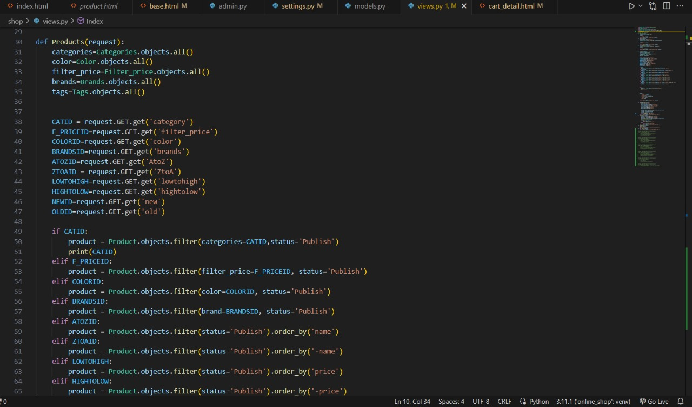

**Screenshots**

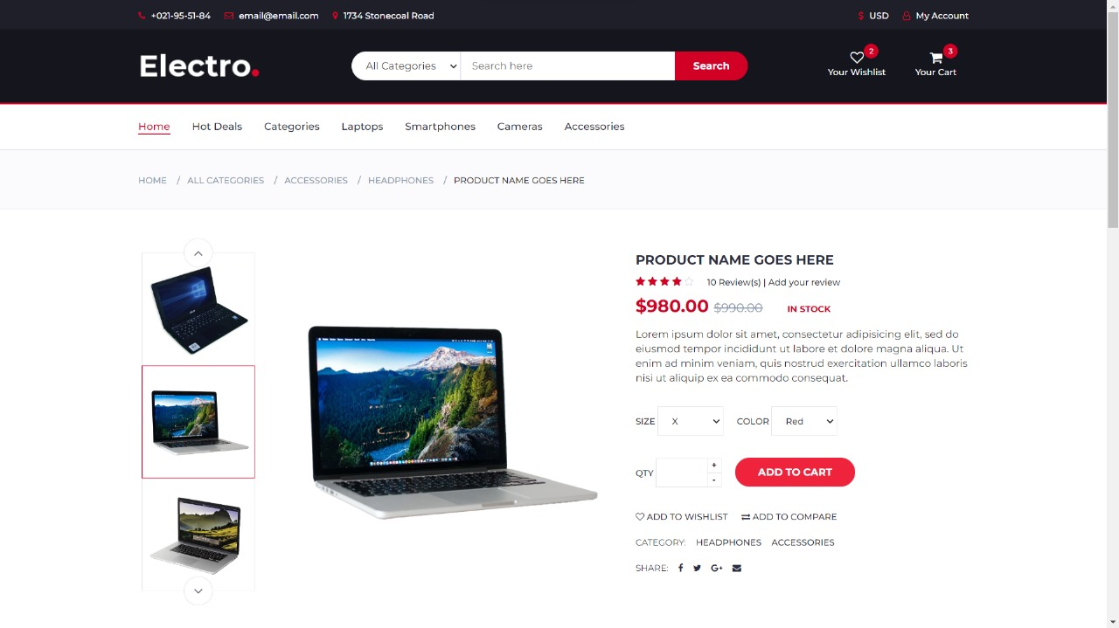

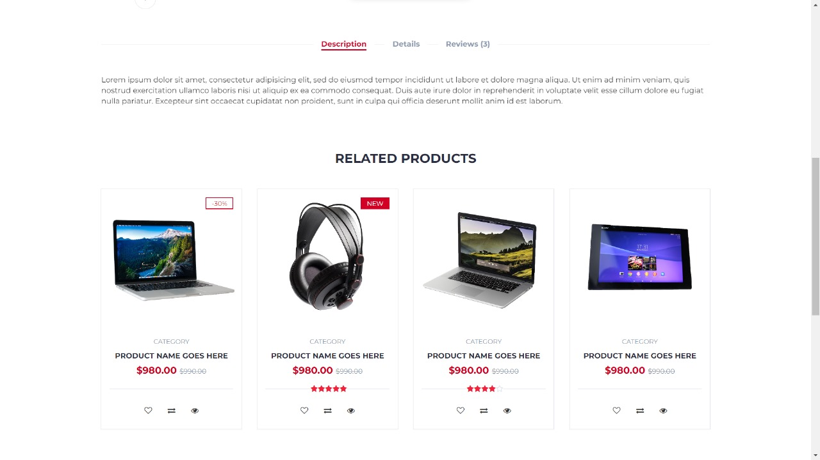

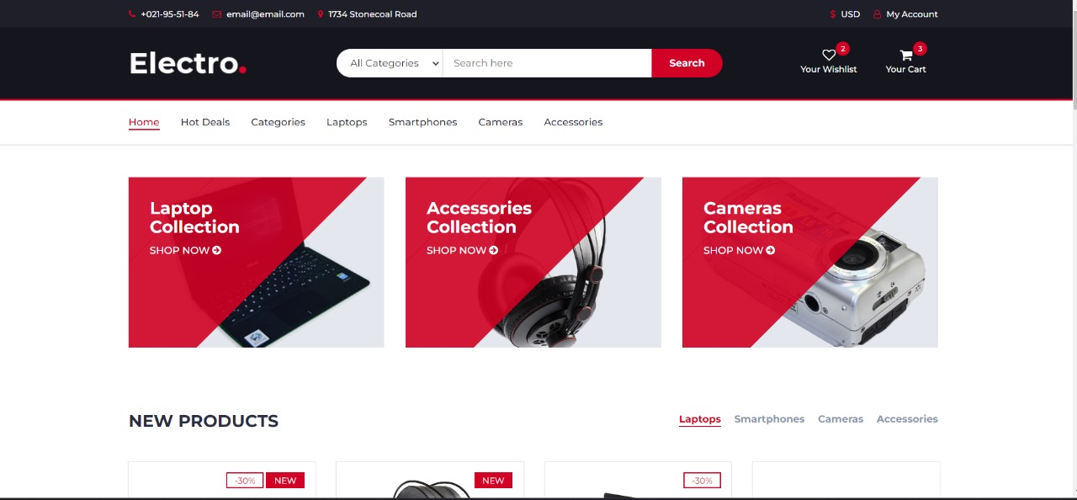

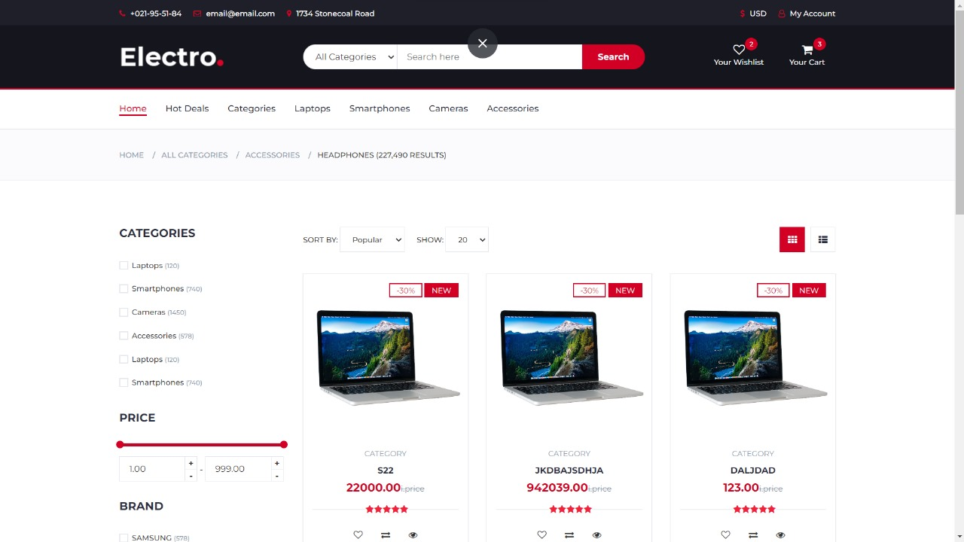

**Agile Project Charter**

|  |  |
| --- | --- |
| Information |  |
| Project Name | Icon Digital |
| Project Champion | Abhishek Hirapara, Tushar Hirpara, Kenil Chandrani |
| Project Sponsor | Jigar Thakkar |
| Project Manager | Abhishek Hirapara |
| Stakeholders | 1. Admin   2.Manager |
| Expected Start Date | 14-1-2024 |
| Expected Completion Date | 25-4-2024 |
|  |  |
| **Project Details** |  |
| Mission | Our mission is selling good products and giving best services to our customers,  To provide a seamless and convenient online shopping experience for  customers looking to purchase digital products such as laptops, mice,  headphones, hard disks and etc.. |
|
|
|
|
|
|
| Vision | To become the go-to destination for customers seeking high-quality  digital products at competitive prices, while offering exceptional  customer service and a wide range of product choices. |
|
|
|
|
|
|
| Risk | **Market Competition**: Competition from established e-commerce  platforms and other digital products retailers.  **Cybersecurity**: Risks related to data breaches, fraud, and security  vulnerabilities in the online platform.  **Supply Chain Disruptions**: Disruptions in the supply chain due to  factors such as manufacturing delays, shipping issues, or global crises.  **Technological Challenges**: Technical issues such as website downtime,  software bugs, or compatibility issues with different devices and  browsers.  **Customer Satisfaction**: Ensuring customer satisfaction with product  quality, delivery times, and after-sales support. |
|
|
|
|
|
|
| Success Metrics | **Sales Revenue**: Monthly and yearly sales revenue generated  through the platform.  **Customer Acquisition and Retention**: Number of new customers  acquired and percentage of repeat customers.  **Conversion Rate**: Percentage of website visitors who make a  purchase.  **Average Order Value**: Average value of orders placed by customers.  **Customer Satisfaction**: Feedback ratings, reviews, and customer  support metrics.  **Website Traffic**: Number of visitors to the website and  engagement metrics such as time spent on site and bounce rate.  **Inventory Turnover**: Rate at which inventory is sold and restocked.  **Return on Investment (ROI)**: Measurement of the profitability of  marketing campaigns, promotions, and investments in technology  and infrastructure.  **Market Share**: Percentage of the market captured compared to  competitors in the digital products retail space.  **Brand Reputation**: Brand awareness, sentiment analysis, and  online presence across social media platforms and review websites. |
|
|
|
|
|
|