

Ohm Surya devaya namaha

(HAM-S1392)
HIGH ATTITUDE MISSILE

Innovate by;
Abhishek neutral ultra

Introduction:

The HAMs1392 missile was innovation model ,it highly explosive and determined model ,impossible to distract any other missile it can travel more than 72 km , it high sensitive and secured code access with c++ language ,it can use war and terrorist blastic attack used.
It universal missile for multiple platform, “fire and forget” principle of operation it high speed use solid fuel speed all through the rocket .
In the is HAM-S1392 most multiple fired launcher’s in the special carry to single model the number of case nine small min launcher inside on the one big launcher ,it most power full and intelligence control by self and it can distract it self , if it in case any one hack the system all system shut down all programming by auto program.

Features of (HAM-S1392)

- LONG fight with varieties of trajectory
- Pin point accuracy & high lethal power
- Max speed mach 3..
- Guidance system ( inertial navigation, system terminal, homing, GPS,)
- Accuracy 2m CEP
- It can control with mobile
- It can use solid and liquid fuel
- The three various explosive in active
- Auto guidance system can proved .

It is most power full and distract able weapon in this generation ,it combined electrical and chemical mixture of weapon .
In the world wild present are low attitude missile now innovated by high attitude missile .
In the use of two type explosive
- Nitroglycerin (C3H5N3O9),RDX (C3H6N6O6) AND TNT
- Deuterium and tritium thermonuclear reaction 100 million kelvin

In there are three part divide by;
#explosive
#control system
#engine and fuel tank

EXPLOSIVE;
In this missile several type
- Nitroglycerine
Preparation ; C3H8O3+3HNO3 C3H5O9N3+3H2O

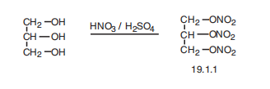
- TNT
Preparation;
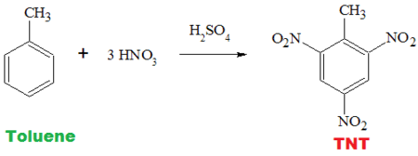
- RDX
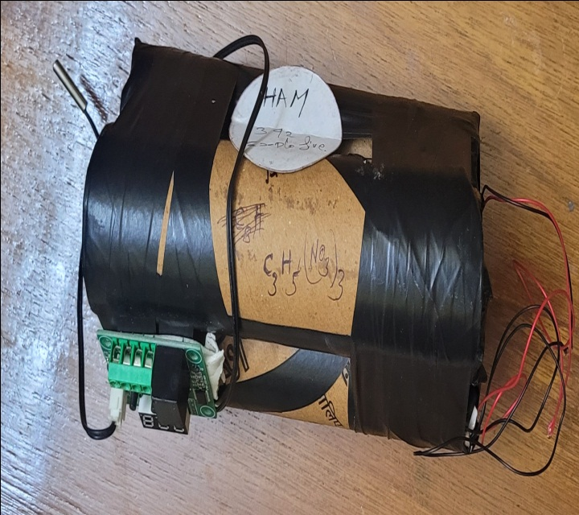

This missile explosive
*THERMONUCLEAR REACTION; Hydrogen bomb

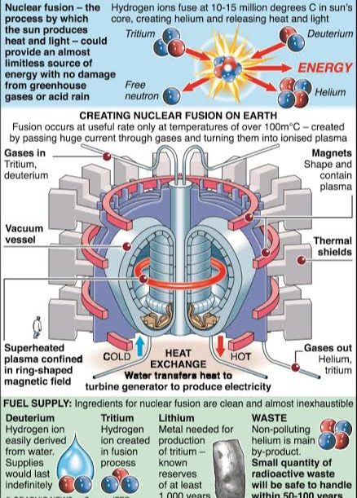

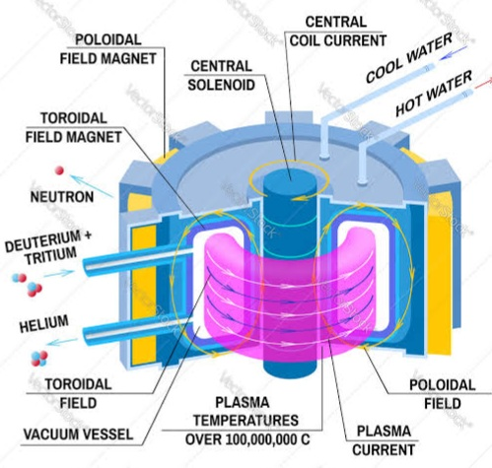
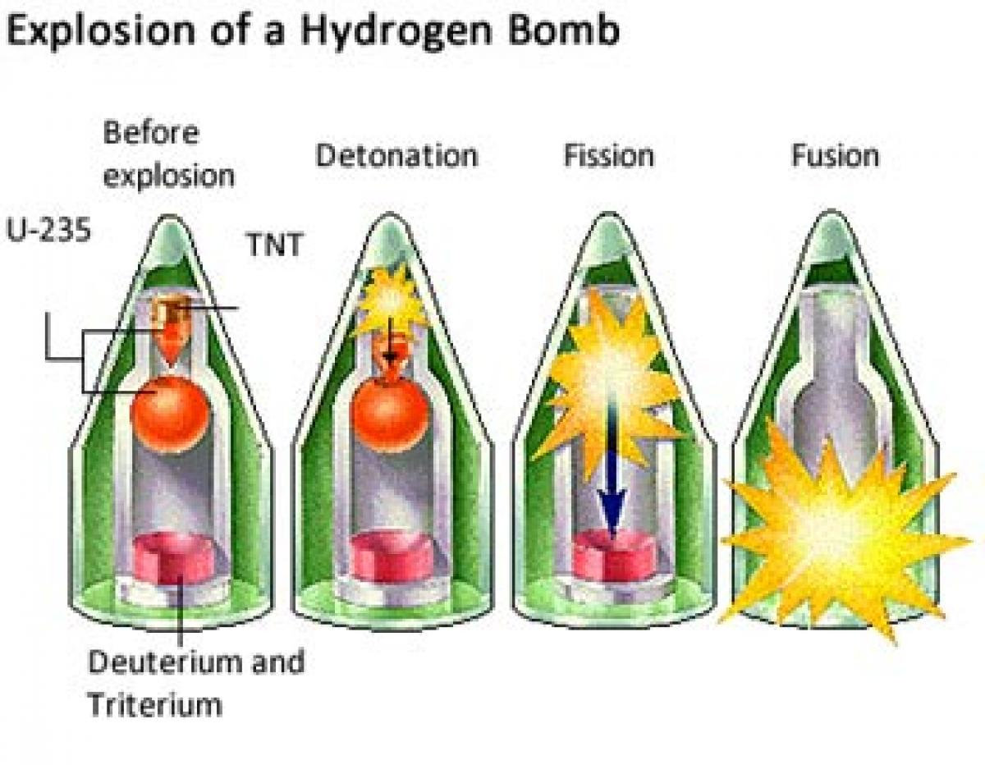
# CONTROLS
- 4 MG995 servo motor (DC)
- Gyroscope mpu6050
- Accelerometer
- Mother board ( nano board , arduino board, raspberry)
- Thermo meter digital
- 12v battery and 5v regulator (7805 IC)
- Igniter denote
- GPS NEO-6M
- Signal increase module MT3608
- LONG distance sensor GY-906 MLX90614
- RESISTOR
- BUZZER
- Wires.
Heat exits cooling system by nitrogen and fan.

By the real image ;;;;;;;

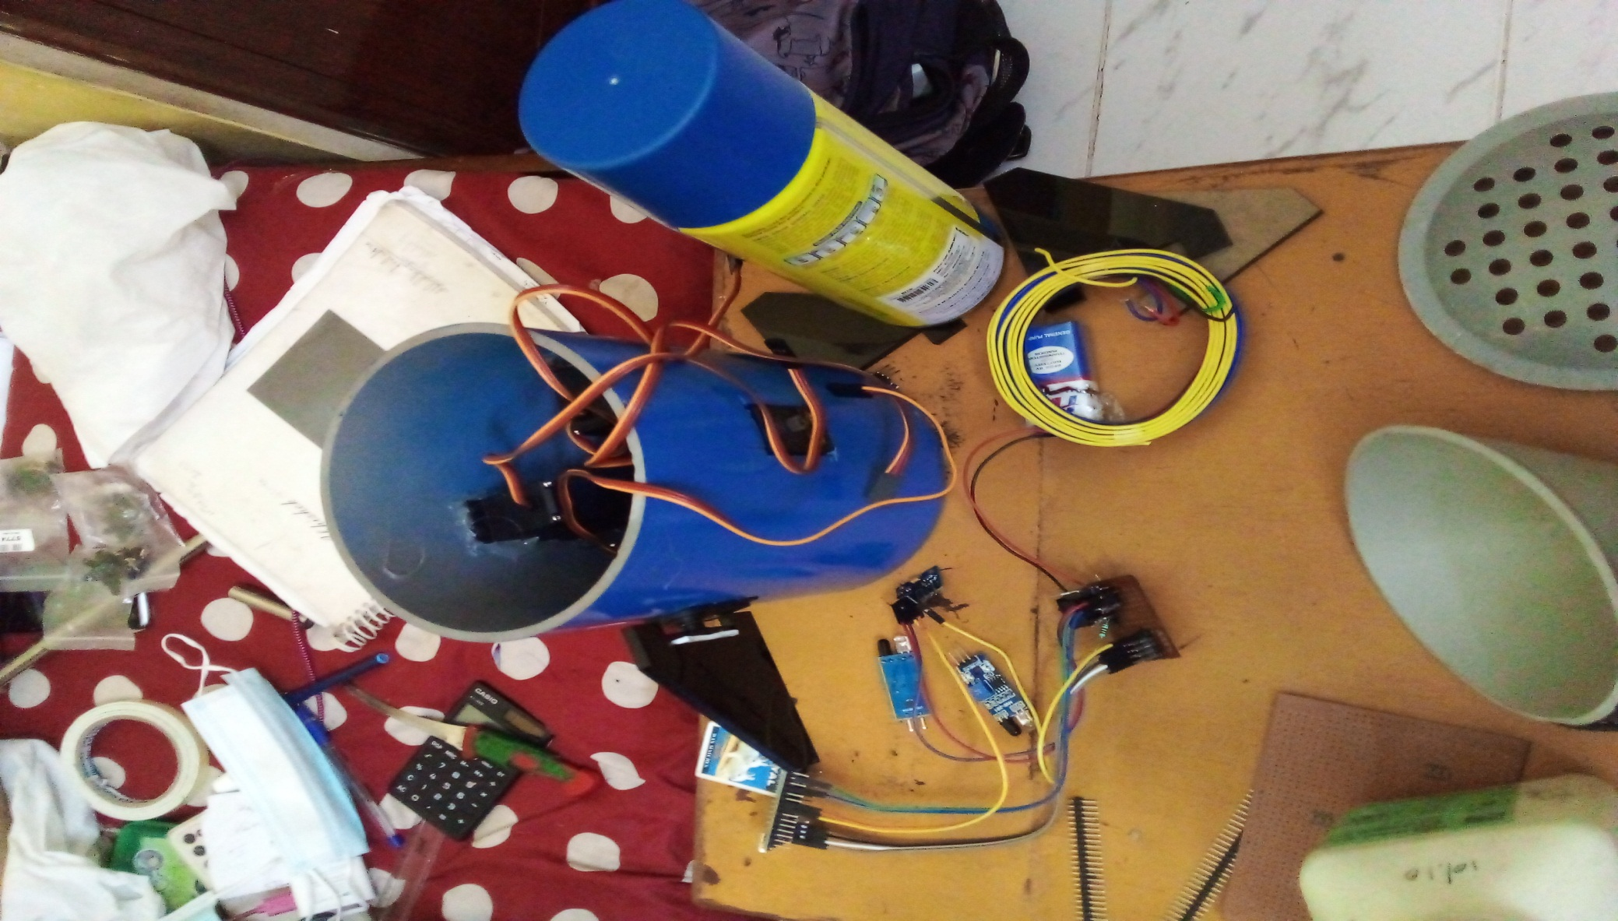

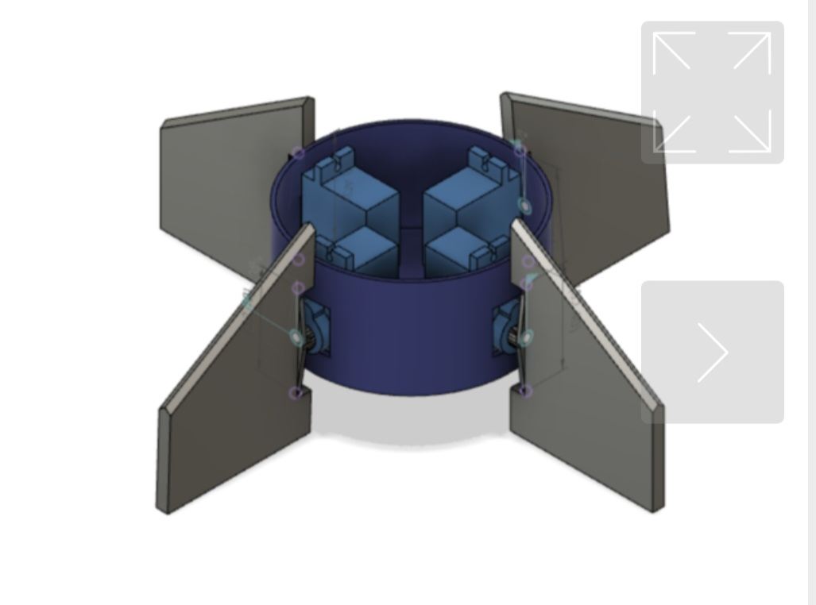
4 servo motor
With 4 wings
They have control by direction without effect air on whole the system, in the inside are gyroscope ,navigation system, sensor with trigger guns and power backup all whole control system are there.

In the LONG distance sensor GY-906 MLX90614 it position Centre it can detect by another missile and take position trigger the small bullet attack in opponent missile, no one can destroyed our missile.

It can control the navigation and sensor auto trigger gun, it cover over 360 degree.
#MISSILE FULE AND STRACTURE;
* solid fuel
- KNO3
- C12H24O11
- POWDERED ALUMINUM
- Al2cl3
- Silicon spray
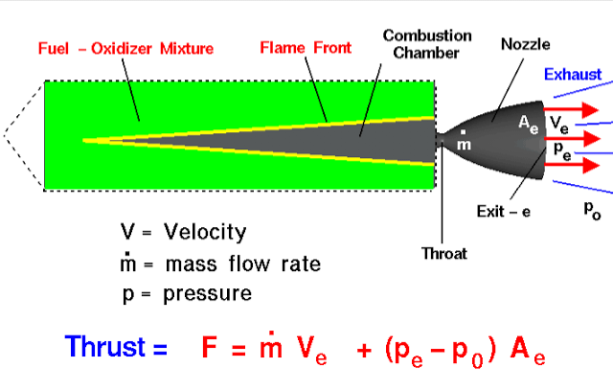
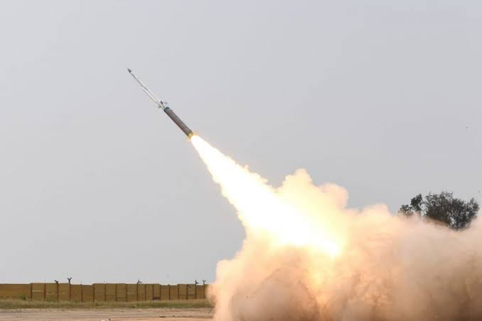
Solid fuel more than thrust by liquid fuel …..

Liquid fuel;
- Liquid oxygen (cryogenic)
- Liquid hydrogen


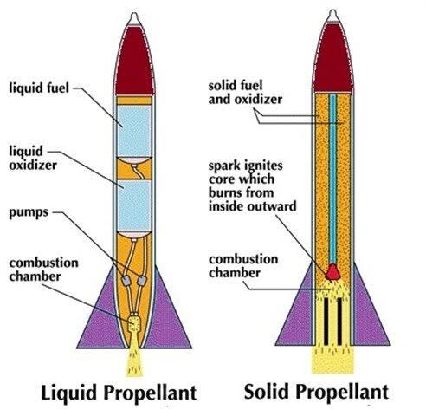

Mupu6050 program
#include "I2Cdev.h"
#include "MPU6050_6Axis_MotionApps20.h"
#include "MPU6050.h"
#if I2CDEV_IMPLEMENTATION == I2CDEV_ARDUINO_WIRE
#include "Wire.h"
#endif

// class default I2C address is 0x68
// specific I2C addresses may be passed as a parameter here
// AD0 low = 0x68 (default for SparkFun breakout and InvenSense evaluation board)
// AD0 high = 0x69
MPU6050 mpu;
//MPU6050 mpu(0x69); // <-- use for AD0 high

/* =========================================================================
NOTE: In addition to connection 3.3v, GND, SDA, and SCL, this sketch
depends on the MPU-6050's INT pin being connected to the Arduino's
external interrupt #0 pin. On the Arduino Uno and Mega 2560, this is
digital I/O pin 2.
* ========================================================================= */

/* =========================================================================
NOTE: Arduino v1.0.1 with the Leonardo board generates a compile error
when using Serial.write(buf, len). The Teapot output uses this method.
The solution requires a modification to the Arduino USBAPI.h file, which
is fortunately simple, but annoying. This will be fixed in the next IDE
release. For more info, see these links:

http://arduino.cc/forum/index.php/topic,109987.0.html
http://code.google.com/p/arduino/issues/detail?id=958

//#define OUTPUT_READABLE_REALACCEL

// uncomment "OUTPUT_READABLE_WORLDACCEL" if you want to see acceleration
// components with gravity removed and adjusted for the world frame of
// reference (yaw is relative to initial orientation, since no magnetometer
// is present in this case). Could be quite handy in some cases.
//#define OUTPUT_READABLE_WORLDACCEL

// uncomment "OUTPUT_TEAPOT" if you want output that matches the
// format used for the InvenSense teapot demo
//#define OUTPUT_TEAPOT

#define LED_PIN 13 // (Arduino is 13, Teensy is 11, Teensy++ is 6)
bool blinkState = false;

// MPU control/status vars
bool dmpReady = false; // set true if DMP init was successful
uint8_t mpuIntStatus; // holds actual interrupt status byte from MPU
uint8_t devStatus; // return status after each device operation (0 = success, !0 = error)
uint16_t packetSize; // expected DMP packet size (default is 42 bytes)
uint16_t fifoCount; // count of all bytes currently in FIFO
uint8_t fifoBuffer[64]; // FIFO storage buffer

// orientation/motion vars
Quaternion q; // [w, x, y, z] quaternion container
VectorInt16 aa; // [x, y, z] accel sensor measurements
VectorInt16 aaReal; // [x, y, z] gravity-free accel sensor measurements
VectorInt16 aaWorld; // [x, y, z] world-frame accel sensor measurements
VectorFloat gravity; // [x, y, z] gravity vector
float euler[3]; // [psi, theta, phi] Euler angle container
float ypr[3]; // [yaw, pitch, roll] yaw/pitch/roll container and gravity vector

// packet structure for InvenSense teapot demo
uint8_t teapotPacket[14] = { '$', 0x02, 0,0, 0,0, 0,0, 0,0, 0x00, 0x00, '\r', '\n' };

volatile bool mpuInterrupt = false; // indicates whether MPU interrupt pin has gone high
void dmpDataReady() {
mpuInterrupt = true;
}

void setup() {
// join I2C bus (I2Cdev library doesn't do this automatically)
#if I2CDEV_IMPLEMENTATION == I2CDEV_ARDUINO_WIRE
Wire.begin();
TWBR = 24; // 400kHz I2C clock (200kHz if CPU is 8MHz)
#elif I2CDEV_IMPLEMENTATION == I2CDEV_BUILTIN_FASTWIRE
Fastwire::setup(400, true);
#endif

// initialize serial communication
// (115200 chosen because it is required for Teapot Demo output, but it's
// really up to you depending on your project)
Serial.begin(115200);
while (!Serial); // wait for Leonardo enumeration, others continue immediately

// NOTE: 8MHz or slower host processors, like the Teensy @ 3.3v or Ardunio

Serial.println(F("Initializing I2C devices..."));
mpu.initialize();

// verify connection
Serial.println(F("Testing device connections..."));
Serial.println(mpu.testConnection() ? F("MPU6050 connection successful") : F("MPU6050 connection failed"));

Serial.println(F("\nSend any character to begin DMP programming and demo: "));
while (Serial.available() && Serial.read()); // empty buffer
while (!Serial.available()); // wait for data
while (Serial.available() && Serial.read()); // empty buffer again

// load and configure the DMP
Serial.println(F("Initializing DMP..."));
devStatus = mpu.dmpInitialize();

// supply your own gyro offsets here, scaled for min sensitivity
mpu.setXGyroOffset(220);
mpu.setYGyroOffset(76);
mpu.setZGyroOffset(-85);
mpu.setZAccelOffset(1788); // 1688 factory default for my test chip

// make sure it worked (returns 0 if so)
if (devStatus == 0) {
// turn on the DMP, now that it's ready
Serial.println(F("Enabling DMP..."));
mpu.setDMPEnabled(true);

// enable Arduino interrupt detection
Serial.println(F("Enabling interrupt detection (Arduino external interrupt 0)..."));
attachInterrupt(0, dmpDataReady, RISING);
mpuIntStatus = mpu.getIntStatus();

// set our DMP Ready flag so the main loop() function knows it's okay to use it
Serial.println(F("DMP ready! Waiting for first interrupt..."));
dmpReady = true;

// get expected DMP packet size for later comparison
packetSize = mpu.dmpGetFIFOPacketSize();
} else {
// ERROR!
// 1 = initial memory load failed
// 2 = DMP configuration updates failed
// (if it's going to break, usually the code will be 1)
Serial.print(F("DMP Initialization failed (code "));
Serial.print(devStatus);
Serial.println(F(")"));
}

// configure LED for output
pinMode(LED_PIN, OUTPUT);
}

void loop() {
// if programming failed, don't try to do anything
if (!dmpReady) return;

// wait for MPU interrupt or extra packet(s) available
while (!mpuInterrupt && fifoCount < packetSize) {

// reset interrupt flag and get INT_STATUS byte
mpuInterrupt = false;
mpuIntStatus = mpu.getIntStatus();

// get current FIFO count
fifoCount = mpu.getFIFOCount();

// check for overflow (this should never happen unless our code is too inefficient)
if ((mpuIntStatus & 0x10) || fifoCount == 1024) {
// reset so we can continue cleanly
mpu.resetFIFO();
Serial.println(F("FIFO overflow!"));

// otherwise, check for DMP data ready interrupt (this should happen frequently)
} else if (mpuIntStatus & 0x02) {
// wait for correct available data length, should be a VERY short wait
while (fifoCount < packetSize) fifoCount = mpu.getFIFOCount();

// read a packet from FIFO
mpu.getFIFOBytes(fifoBuffer, packetSize);

#ifdef OUTPUT_READABLE_QUATERNION
// display quaternion values in easy matrix form: w x y z
mpu.dmpGetQuaternion(&q, fifoBuffer);
Serial.print("quat\t");
Serial.print(q.w);
Serial.print("\t");
Serial.print(q.x);
Serial.print("\t");
Serial.print(q.y);
Serial.print("\t");
Serial.println(q.z);
#endif

#ifdef OUTPUT_READABLE_EULER
// display Euler angles in degrees
mpu.dmpGetQuaternion(&q, fifoBuffer);
mpu.dmpGetEuler(euler, &q);
Serial.print("euler\t");
Serial.print(euler[0] * 180/M_PI);
Serial.print("\t");
Serial.print(euler[1] * 180/M_PI);
Serial.print("\t");
Serial.println(euler[2] * 180/M_PI);
#endif

#ifdef OUTPUT_READABLE_YAWPITCHROLL
// display Euler angles in degrees
mpu.dmpGetQuaternion(&q, fifoBuffer);
mpu.dmpGetGravity(&gravity, &q);
mpu.dmpGetYawPitchRoll(ypr, &q, &gravity);
Serial.print("ypr\t");
Serial.print(ypr[0] * 180/M_PI);
Serial.print("\t");
Serial.print(ypr[1] * 180/M_PI);
Serial.print("\t");
Serial.println(ypr[2] * 180/M_PI);
#endif

#ifdef OUTPUT_READABLE_REALACCEL
// display real acceleration, adjusted to remove gravity
mpu.dmpGetQuaternion(&q, fifoBuffer);
mpu.dmpGetAccel(&aa, fifoBuffer);
mpu.dmpGetGravity(&gravity, &q);
mpu.dmpGetLinearAccel(&aaReal, &aa, &gravity);
Serial.print("areal\t");
Serial.print(aaReal.x);
Serial.print("\t");
Serial.print(aaReal.y);
Serial.print("\t");
Serial.println(aaReal.z);
#endif

#ifdef
mpu.dmpGetQuaternion(&q, fifoBuffer);
mpu.dmpGetAccel(&aa, fifoBuffer);
mpu.dmpGetGravity(&gravity, &q);
mpu.dmpGetLinearAccel(&aaReal, &aa, &gravity);
mpu.dmpGetLinearAccelInWorld(&aaWorld, &aaReal, &q);
Serial.print("aworld\t");
Serial.print(aaWorld.x);
Serial.print("\t");
Serial.print(aaWorld.y);
Serial.print("\t");
Serial.println(aaWorld.z);
#endif

// display quaternion values in InvenSense Teapot demo format:
teapotPacket[2] = fifoBuffer[0];
teapotPacket[3] = fifoBuffer[1];
teapotPacket[4] = fifoBuffer[4];
teapotPacket[5] = fifoBuffer[5];
teapotPacket[6] = fifoBuffer[8];
teapotPacket[7] = fifoBuffer[9];
teapotPacket[8] = fifoBuffer[12];
teapotPacket[9] = fifoBuffer[13];
Serial.write(teapotPacket, 14);
teapotPacket[11]++; // packetCount, loops at 0xFF on purpose
#endif

// blink LED to indicate activity
blinkState = !blinkState;
digitalWrite(LED_PIN, blinkState);
}
Same matter doesn’t mention bcz its secrete operation

The end

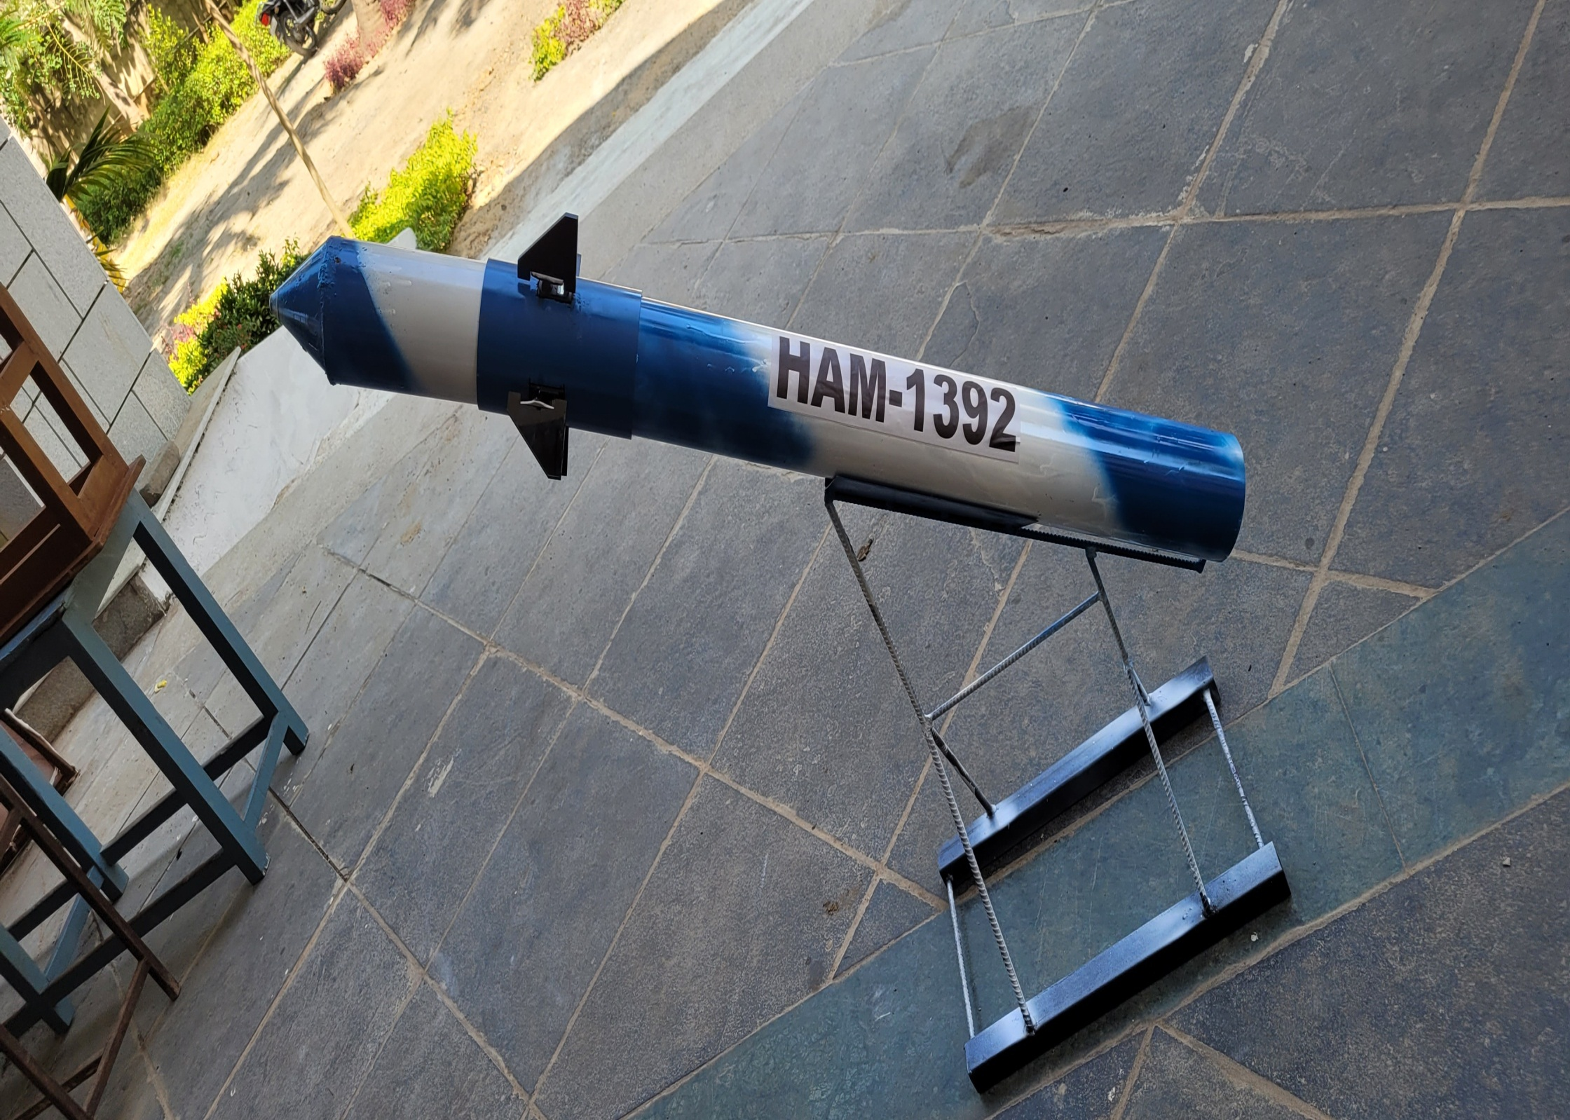

Abhishek neutral ultra
Phone number; 9791391561
e-mail ; abhishekneutralultra@gmail.com

