/////////////////////////////////: README ://////////////////////////////////

PLATFORM: WINDOWS10>>ANACONDA-----SPYDER+JUPYTER NOTEBOOKS(PYTHON3.6)

INTEL I7 6TH GEN, 8GB DDR4, NVIDIA 960M

KAGGLE SCORE:

.375423(gbr)

.343664(rfr)

HIGHEST KAGGLE SCORE FOR THIS PROBLEM: .3924

RUNTIME:185 secs(GRADIENT BOOSTED ALGORITHM)

240 secs(RANDOM FOREST ALGORITHM)

Feature selection: Selection of features as per their importance is also included in the files

Code and its explanation is as below

LINK FOR LEARNING: <http://pbpython.com/categorical-encoding.html>

<http://scikit-learn.org/stable/modules/generated/sklearn.ensemble.RandomForestRegressor.html>

<http://scikit-learn.org/stable/modules/generated/sklearn.ensemble.GradientBoostingClassifier.html>

Courses done during hackathon period for better understanding:  




**USING RANDOM FOREST ALGORITHM**

# Liberty Mutual Group: Property Inspection Prediction

import pandas as pd

import numpy as np

from sklearn import preprocessing

from sklearn.ensemble import RandomForestRegressor

from sklearn.grid_search import GridSearchCV

from sklearn.externals import joblib

#load train and test

df = pd.read_csv('train.csv', index_col=0)

tf = pd.read_csv('test.csv', index_col=0)

df.head()

tf.head()

tf.drop('T2_V10', axis=1, inplace=True)

tf.drop('T2_V7', axis=1, inplace=True)

tf.drop('T1_V13', axis=1, inplace=True)

tf.drop('T1_V10', axis=1, inplace=True)

tf.shape

labels = df.Hazard

df.drop('Hazard', axis=1, inplace=True)

df.drop('T2_V10', axis=1, inplace=True)

df.drop('T2_V7', axis=1, inplace=True)

df.drop('T1_V13', axis=1, inplace=True)

df.drop('T1_V10', axis=1, inplace=True)

df.shape

df.head()

columns = df.columns

test_ind = tf.index

print(columns)

print(test_ind)

df = np.array(df)

tf = np.array(tf)

print(df)

print(tf)

# label encode the categorical variables

for i in range(df.shape[1]):

if type(df[1,i]) is str:

lbl = preprocessing.LabelEncoder()

lbl.fit(list(df[:,i]) + list(tf[:,i]))

df[:,i] = lbl.transform(df[:,i])

tf[:,i] = lbl.transform(tf[:,i])

df = df.astype(float)

tf = tf.astype(float)

print(df)

print(tf)

param_grid = {'n_estimators': [100]}

model = GridSearchCV(RandomForestRegressor(), param_grid)

model = model.fit(df,labels)

print("Best parameters found by grid search:")

print(model.best_params_)

print("Best CV score:")

print(model.best_score_)

preds = model.predict(tf)

joblib.dump(model, 'Random_forest_regressor_model.pkl')

#generate solution

preds = pd.DataFrame({"Id": test_ind, "Hazard": preds})

preds = preds.set_index('Id')

preds.to_csv('abhishek_jagtap_rf_model.csv')

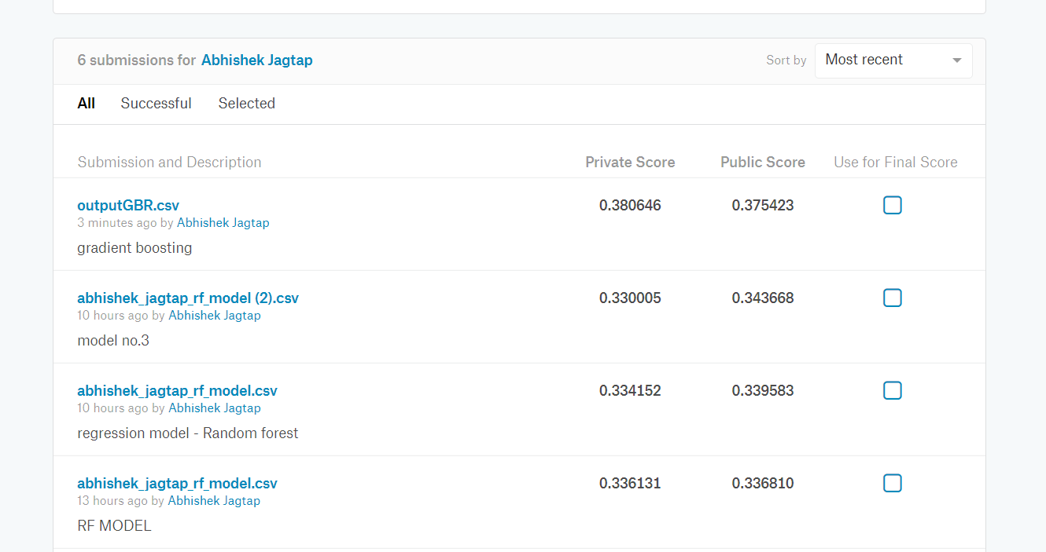

**USING GRADIENT BOOSTING ALGORITHM**

#author - abhishek jagtap

#liberty mutual group property inspection prediction

#model used- gradient boosting regressor

#total runtime observed- 185secs on intel 6th generation 6500HQ edition 2.4GHZ CPU

#GPU - 960M # 8GB DDR4 RAM

#import necessary libraries

import pandas as pd

from sklearn.model_selection import train_test_split

from sklearn import ensemble

from sklearn.metrics import mean_absolute_error

from sklearn.externals import joblib

# Load the data set

df = pd.read_csv("train.csv")

tf= pd.read_csv("test.csv")

# This is to remove the unnecessary feature and creating the problem of overfitting

# This removal is done by checking the importance of each feature using feature selection file

df.drop('T2_V10', axis=1, inplace=True)

df.drop('T2_V7', axis=1, inplace=True)

df.drop('T1_V13', axis=1, inplace=True)

df.drop('T1_V10', axis=1, inplace=True)

# Alternative to remove the fields from the data set that we don't want to include in our model

#del df['T2_V10']

#del df['T2_V7']

#del df['T1_V13']

#del df['T1_V10']

#same thing for test data

tf.drop('T2_V10', axis=1, inplace=True)

tf.drop('T2_V7', axis=1, inplace=True)

tf.drop('T1_V13', axis=1, inplace=True)

tf.drop('T1_V10', axis=1, inplace=True)

labels = df.Hazard

df.drop('Hazard', axis=1, inplace=True)

columns = df.columns

# Replace categorical data with one-hot encoded data

features_df = pd.get_dummies(df, columns=['T1_V4','T1_V5','T1_V6','T1_V7','T1_V8',

'T1_V9','T1_V11','T1_V12','T1_V15','T1_V16',

'T1_V17','T2_V3','T2_V4','T2_V5','T2_V11','T2_V12','T2_V13'])

features_tf = pd.get_dummies(tf, columns=['T1_V4','T1_V5','T1_V6','T1_V7','T1_V8',

'T1_V9','T1_V11','T1_V12','T1_V15','T1_V16',

'T1_V17','T2_V3','T2_V4','T2_V5','T2_V11','T2_V12','T2_V13'])

features_df = features_df.astype(float)

features_tf = features_tf.astype(float)

test_ind=features_tf.index

#print the dimensions of the data after performing one-hot encoding

print("\n \n The dimensions of the train data are:")

print(features_df.shape)

print("\n \n The dimensions of the test data are:")

print(features_tf.shape)

# Split the data set in a training set (70%) and a test set (30%)

X_train, X_test, y_train, y_test = train_test_split(features_df, labels, test_size=0.3, random_state=0)

#n_estimator=1000

# Fit regression model

model = ensemble.GradientBoostingRegressor(

n_estimators=100,

learning_rate=0.1,

max_depth=6,

min_samples_leaf=9,

max_features=0.1,

loss='huber',

random_state=0

)

model.fit(X_train, y_train)

# Save the trained model to a file so we can use it in other programs for updating purpose

joblib.dump(model, 'trained_house_classifier_model.pkl')

# Find the error rate on the training set

m1 = mean_absolute_error(y_train, model.predict(X_train))

print("Training Set Mean Absolute Error: %.4f" % m1)

# Find the error rate on the test set

m2 = mean_absolute_error(y_test, model.predict(X_test))

print("Test Set Mean Absolute Error: %.4f" % m2)

#abhi=joblib.load('trained_house_classifier_model.pkl')

model.fit(features_df,labels)

yp=model.predict(features_tf)

#predict the values and save it to csv file

preds = pd.DataFrame({"Id": test_ind, "Hazard": yp})

preds = preds.set_index('Id')

preds.to_csv('Abhishek_jagtap_SVM.csv')

