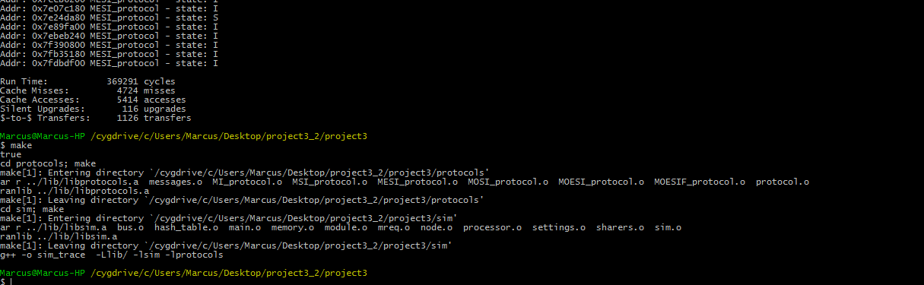

No files apart from the protocols and their respective header files were changed and the project was run on Cygwin for windows 7 64 bit system