**Discuss the concept of class imbalance in the context of Bayesian classification. How does it affect the performance of classifiers based on Bayes' Theorem?**

Class imbalance occurs when one class (e.g., positive cases) is much more prevalent than another class (e.g., negative cases). For instance, in a dataset of 1,000 samples, if 950 belong to class A and only 50 belong to class B, the dataset is imbalanced.

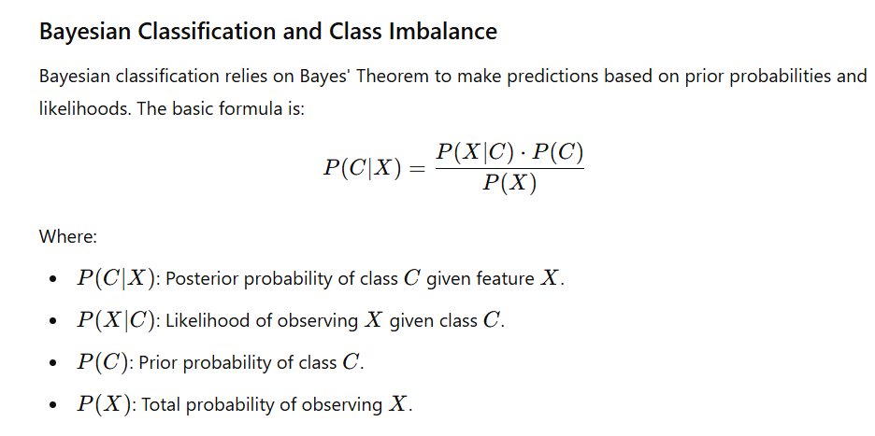

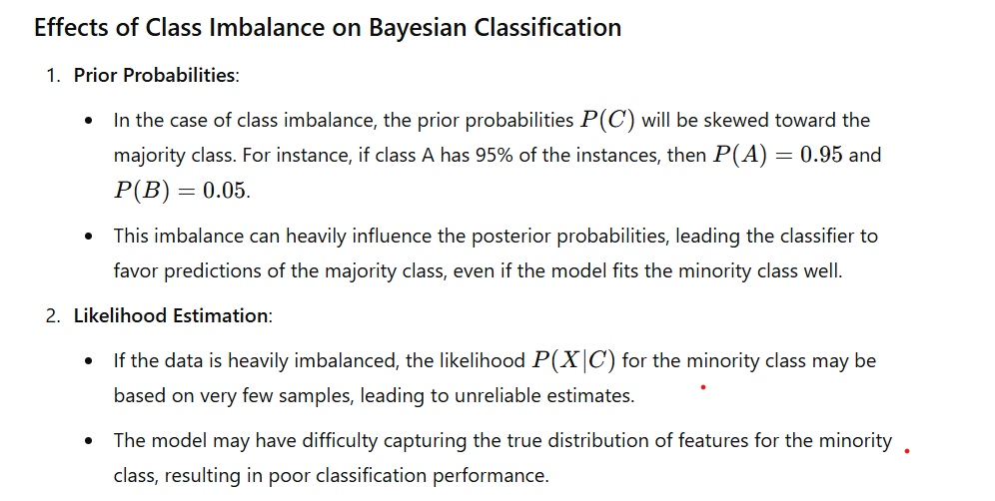

**Can you explain how Bayes' Theorem is used in spam filtering algorithms? Provide a step-by-step explanation.**



