AIRLINE OPERATIONAL
PERFORMANCE ANALYTICS
U.S. Domestic Flights - January 2025
SQL | Python | Statistical Inference | Power BI

Scope | Value
Source | U.S. Bureau of Transportation Statistics (BTS), Reporting Carrier On-Time Performance
Analysis period | January 2025
Raw records | 539,747 scheduled flight records
Completed flights | 522,269
Final analytical fields | 51 selected/derived variables
Primary outputs | SQL analysis, EDA, statistical tests, explanatory regression, Power BI dashboard

Technical Project Report
August 2026

1. Executive Summary
This project analyzes airline operational performance using the Bureau of Transportation Statistics (BTS) Reporting Carrier On-Time Performance data for January 2025. The objective was to build a reproducible analytics workflow that combines large-table querying, exploratory data analysis, statistical inference and interactive business-intelligence reporting. The study focuses on delay frequency, cancellation behavior, carrier and airport differences, time-of-day effects and recorded delay causes.
Metric | Result
Total flights | 539,747
Completed flights | 522,269
Cancelled flights | 16,312 (3.02%)
Diverted flights | 1,166
Arrival delay >= 15 min | 18.79% of completed flights
Mean arrival delay | 3.76 min (95% CI: 3.60 to 3.91 min)
Median arrival delay | -8 min
Mean departure delay | 10.24 min
Mean taxi-out / taxi-in | 19.05 / 8.32 min

BTS classifies a late-arriving flight as one arriving 15 minutes or more after its scheduled arrival time. This threshold was used consistently for the project delay-rate metrics [1,2].

Key findings
- Arrival-delay risk increased through the day: early-morning flights had a 14.41% delay rate, compared with 22.01% in the afternoon and 22.59% in the evening.
- Recorded delay minutes were dominated by carrier-related delay (36.16%) and late-arriving aircraft delay (34.72%), followed by National Air System delay (19.90%).
- Among the 15 busiest origin airports, DFW and DEN had the highest departure-delay rates, at approximately 23.44% and 23.36%, respectively.
- Airline mean arrival delays differed statistically (ANOVA p < 0.001), but the effect size was small (eta-squared = 0.0053), indicating that carrier identity alone explained only a small share of flight-level variability.
- Cancellation status was associated with airline (chi-square p < 0.001; Cramer's V = 0.085), and delay status was associated with departure period (chi-square p < 0.001; Cramer's V = 0.082).
- An explanatory OLS model achieved R-squared = 0.969 because departure delay is strongly propagated into arrival delay; this model is interpreted operationally rather than presented as a forecasting model.

2. Data Source and Analytical Dataset
The analysis uses the BTS TranStats Reporting Carrier On-Time Performance database, which stores flight-level scheduled and actual operating information for reportable U.S. domestic operations. The official specification includes carrier, flight number, origin/destination airports, scheduled and actual departure/arrival times, elapsed time, cancellation status, and cause-specific delay minutes [1-3].

2.1 Raw data
Item | Description
Period | January 1-31, 2025
Rows | 539,747
Original fields | 110
Core identifiers | Flight date, carrier, flight number, origin, destination
Operational variables | Scheduled/actual times, departure/arrival delay, taxi times, air time, elapsed time, distance
Irregular operations | Cancellation, cancellation code, diversion
Delay causes | Carrier, weather, NAS, security, late-arriving aircraft

2.2 Cleaning and feature engineering
- Selected 41 source variables and created 10 derived variables, producing a 51-field analysis table.
- Parsed FlightDate as a date field and retained carrier/airport codes as categorical identifiers.
- Created IsCancelled, IsDiverted and CompletedFlight flags.
- Created IsArrivalDelayed15 and IsDepartureDelayed15 using the BTS 15-minute threshold.
- Converted scheduled departure HHMM values into ScheduledDepHour and grouped departures into Early Morning, Late Morning, Afternoon, Evening and Night.
- Created DayName and directional Route (Origin-Destination) fields.
- Removed only exact duplicate records; no duplicates were present.
- Excluded cancelled and diverted records from flight-completion delay statistics because actual arrival-delay measures are not comparable for those operations.
The final dataset retained all 539,747 scheduled records. Delay analyses used 522,269 completed, non-diverted flights.

2.3 Analysis architecture
Stage | Tool | Purpose
Data preparation | Python / pandas | Column reduction, cleaning, derived fields, reusable CSV
Database analytics | SQLite | Aggregation, CTEs, CASE logic, window functions, views
Statistical analysis | Python / SciPy / statsmodels | Confidence intervals, ANOVA, chi-square, effect sizes, OLS
Visualization | Matplotlib + Power BI | Static analytical figures and interactive dashboard

3. SQL Analytical Workflow
The cleaned flight table was imported into SQLite as a table named flights. Fifteen analytical queries were written to demonstrate both operational analysis and reusable SQL patterns rather than relying only on Python group-by operations.
SQL task | Main SQL concepts
Overall flight KPIs | COUNT, SUM, AVG, CASE
Airline delay ranking | GROUP BY, conditional aggregation, ORDER BY
Airline cancellation ranking | HAVING, rate calculation
Origin-airport performance | Traffic threshold + conditional aggregation
Busiest routes | Multi-column grouping, LIMIT
Departure period / weekday | CASE ordering, grouped rates
Delay-cause composition | CTEs + UNION ALL
Carrier performance rank | RANK() window function
Traffic-adjusted airport rank | DENSE_RANK() + CTE
Daily delay trend | 7-day rolling AVG() window
Cancellation reason | CASE WHEN mapping
High-delay routes | HAVING sample-size control
Distance bands | CASE-based binning
Reusable output | CREATE VIEW airline_kpi_view

3.1 Example: traffic-controlled airport ranking
WITH airport_perf AS (
SELECT Origin AS airport, COUNT(*) AS total_flights,
100.0 * AVG(CASE WHEN CompletedFlight=1
THEN IsDepartureDelayed15 END) AS delay_rate
FROM flights
GROUP BY Origin
HAVING COUNT(*) >= 2000
)
SELECT airport, total_flights, delay_rate,
DENSE_RANK() OVER (ORDER BY delay_rate ASC) AS performance_rank
FROM airport_perf;

3.2 Why traffic thresholds were used
A raw airport-delay ranking can be dominated by small airports with few flights. The dashboard therefore uses the 15 busiest origin airports when comparing delay rates. This separates operational performance from unstable percentages caused by very small denominators.
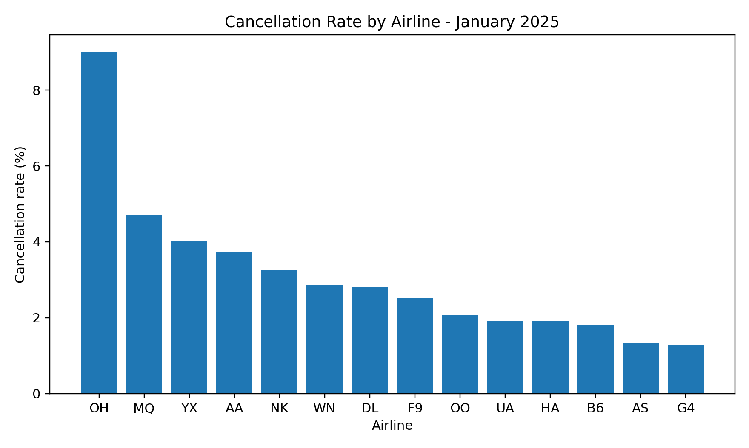
Figure 1. Cancellation rate by airline. OH had the highest January cancellation rate among the analyzed carriers (9.00%).

4. Exploratory Operational Analysis

4.1 Carrier performance
Airline | Flights | Cancellation % | Mean arrival delay (min) | Arrival delay >=15 min %
WN | 105,307 | 2.86 | -1.17 | 15.21
DL | 76,306 | 2.80 | 5.22 | 19.32
AA | 75,088 | 3.73 | 5.57 | 19.23
OO | 65,036 | 2.07 | 7.94 | 20.88
UA | 62,007 | 1.92 | 1.29 | 17.63
OH | 21,094 | 9.00 | 14.14 | 25.48
B6 | 17,918 | 1.80 | 5.81 | 24.46
F9 | 15,526 | 2.52 | 10.82 | 25.98
HA | 6,690 | 1.91 | 6.04 | 13.55

The large difference between the overall mean arrival delay (+3.76 min) and median (-8 min) indicates a right-skewed distribution: most flights are near schedule or early, while a smaller number of severely delayed flights pull the mean upward.
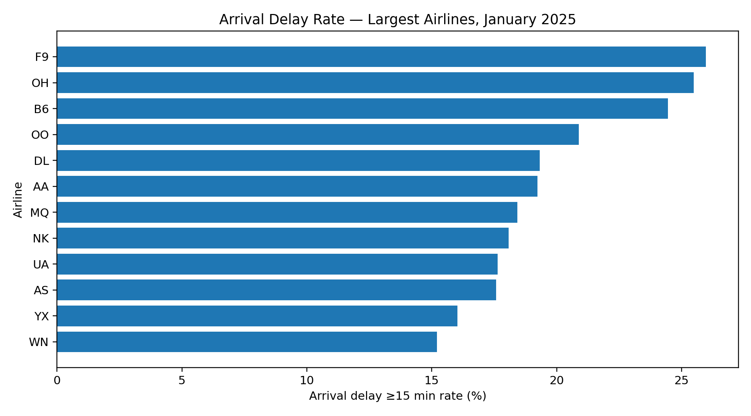
Figure 2. Arrival-delay rate among the largest carriers.

4.2 Departure-time effect
Departure period | Completed flights | Mean arrival delay (min) | Delay >=15 min %
Early Morning | 154,197 | 0.05 | 14.41
Late Morning | 162,610 | 3.50 | 18.66
Afternoon | 127,987 | 6.77 | 22.01
Evening | 76,456 | 6.83 | 22.59
Night | 1,019 | -3.77 | 13.54

The Night category contains only 1,019 completed flights and should not be interpreted on equal footing with the much larger daytime groups.

5. Airports, Delay Causes and Daily Variation

5.1 Busiest-airport performance
Restricting the comparison to the 15 busiest origin airports produced a more stable operational ranking. DFW (23.44%), DEN (23.36%), ATL (22.41%) and MIA (22.15%) had the largest proportions of departures delayed by at least 15 minutes in this group, while LAX and SFO were both approximately 13.85%.
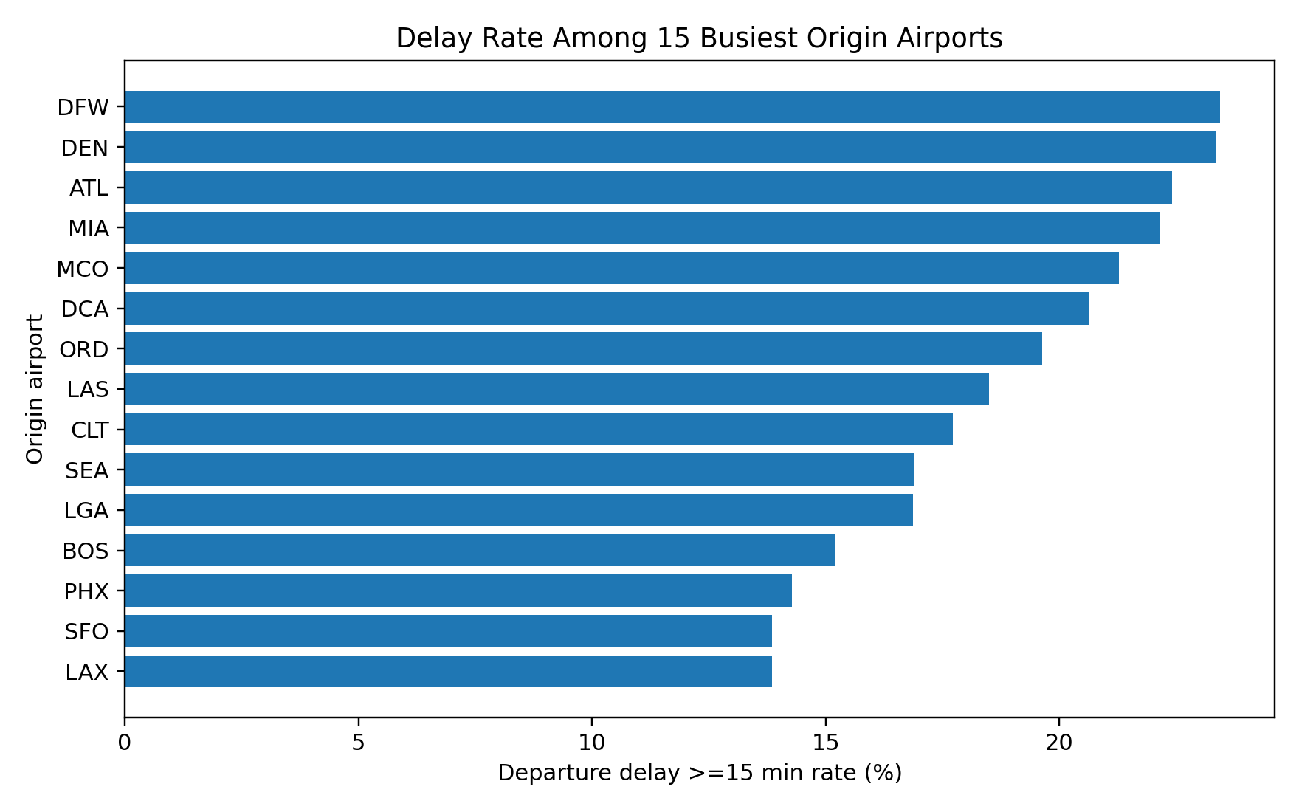
Figure 3. Departure-delay rate among the 15 busiest origin airports in the January dataset.

5.2 Recorded delay causes
Cause | Delay minutes | Share of recorded delay minutes
Carrier | 2,510,886 | 36.16%
Late-arriving aircraft | 2,410,759 | 34.72%
National Air System | 1,381,827 | 19.90%
Weather | 629,972 | 9.07%
Security | 10,550 | 0.15%

Carrier delay and late-arriving aircraft together accounted for approximately 70.9% of recorded delay minutes. These categories are operationally related to carrier processes and network propagation, highlighting how disruption can carry forward through aircraft rotations.

5.3 Daily variation
Daily mean arrival delay varied substantially across the month. January 6 had the highest mean arrival delay (approximately 29.0 minutes), followed by January 5 and January 10 (both about 22.8 minutes). The plot below is descriptive only; the project does not attribute individual daily spikes to a specific cause without additional event-level investigation.
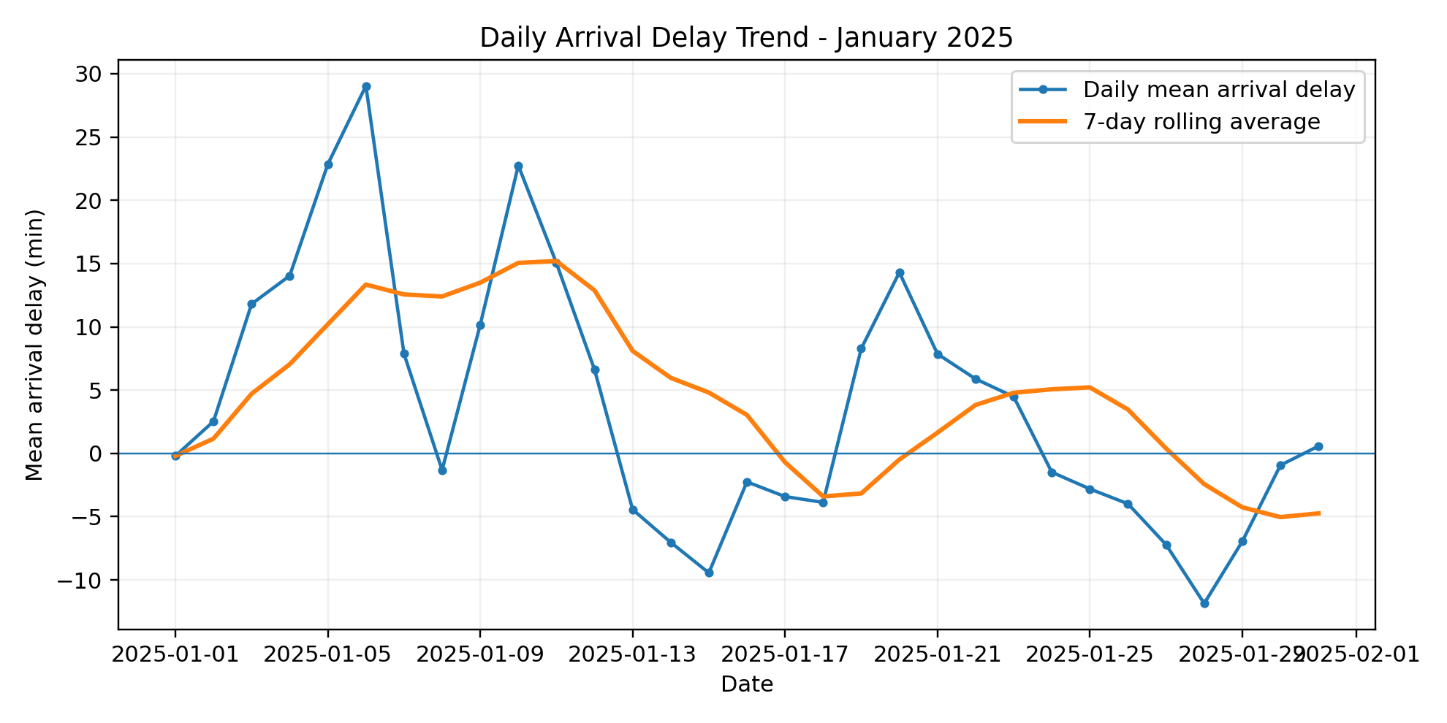
Figure 4. Daily mean arrival delay and seven-day rolling average.

6. Statistical Inference
Statistical tests were used to determine whether observed differences were larger than would be expected from sampling variation. Because the dataset is very large, p-values alone can indicate significance for practically small effects; effect-size measures were therefore reported alongside hypothesis tests.

6.1 Confidence interval for mean arrival delay
For 522,269 completed flights, mean arrival delay was 3.757 minutes. The 95% confidence interval was 3.602 to 3.911 minutes. The narrow interval reflects the large sample size, not necessarily low flight-to-flight variability.

6.2 Airline differences: one-way ANOVA
Statistic | Value
Airlines included | 14 carriers with >=5,000 completed flights
F statistic | 215.88
p-value | < 0.001
Eta-squared | 0.0053

The null hypothesis of equal airline mean arrival delays was rejected. However, eta-squared = 0.0053 is small, showing that airline identity explained only about 0.5% of the total arrival-delay variance in this unadjusted comparison. Thus, statistically detectable carrier differences should not be interpreted as the dominant driver of individual-flight delay.
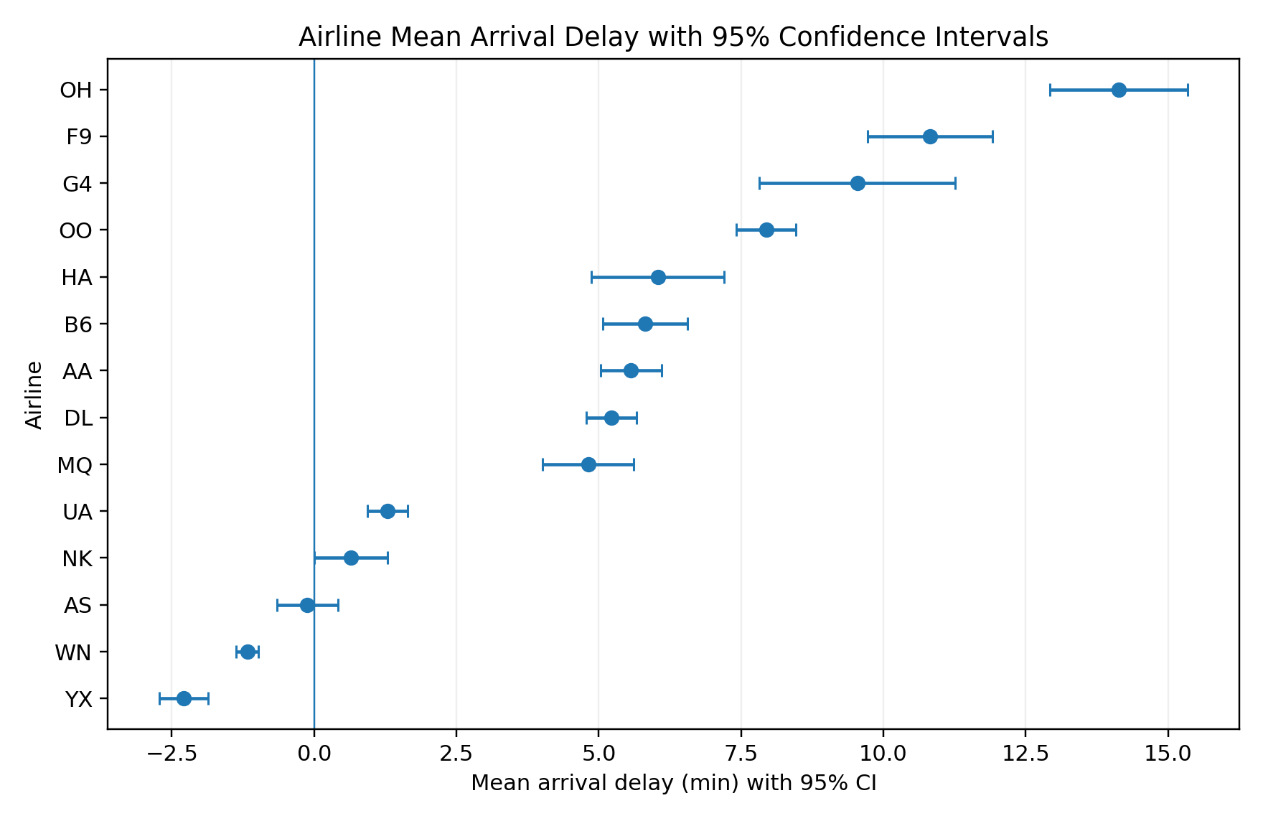
Figure 5. Mean arrival delay by airline with 95% confidence intervals.

6.3 Categorical associations
Test | Chi-square | df | p-value | Cramer's V | Interpretation
Airline x cancellation | 3901.34 | 13 | <0.001 | 0.085 | Significant, modest association
Departure period x 15-min arrival delay | 3552.44 | 4 | <0.001 | 0.082 | Significant, modest association

7. Explanatory Regression and Power BI Dashboard

7.1 Multiple regression
An ordinary least-squares model was fitted on a reproducible random sample of 120,000 completed flights. The response variable was arrival delay (minutes). Predictors were departure delay, distance, taxi-out time, taxi-in time, scheduled departure hour, day of week and airline.
Predictor | Coefficient | Interpretation (holding other modeled variables constant)
Departure delay | +0.998 | One additional departure-delay minute was associated with almost one additional arrival-delay minute.
Taxi-out time | +0.911 | Longer taxi-out time was positively associated with arrival delay.
Taxi-in time | +0.853 | Longer taxi-in time was positively associated with arrival delay.
Scheduled departure hour | +0.128 | Later scheduled hours had a small positive conditional association.
Distance | -0.0041 per mile | Small negative conditional coefficient after controlling for the other variables.

Model metric | Value
Observations | 120,000
R-squared | 0.9693
Adjusted R-squared | 0.9693

The very high R-squared is expected because departure delay is temporally adjacent to arrival delay and carries much of the same operational disruption. The regression is used to explain delay propagation, not presented as a pre-departure forecasting model.

7.2 Interactive Power BI dashboard
The final dashboard consolidates the main operational KPIs and comparisons into one page. It includes total/completed/cancelled flight cards, arrival-delay rate by airline, delay rate by departure period, traffic-filtered origin-airport performance, delay-cause composition, and slicers for airline, origin airport and weekday.
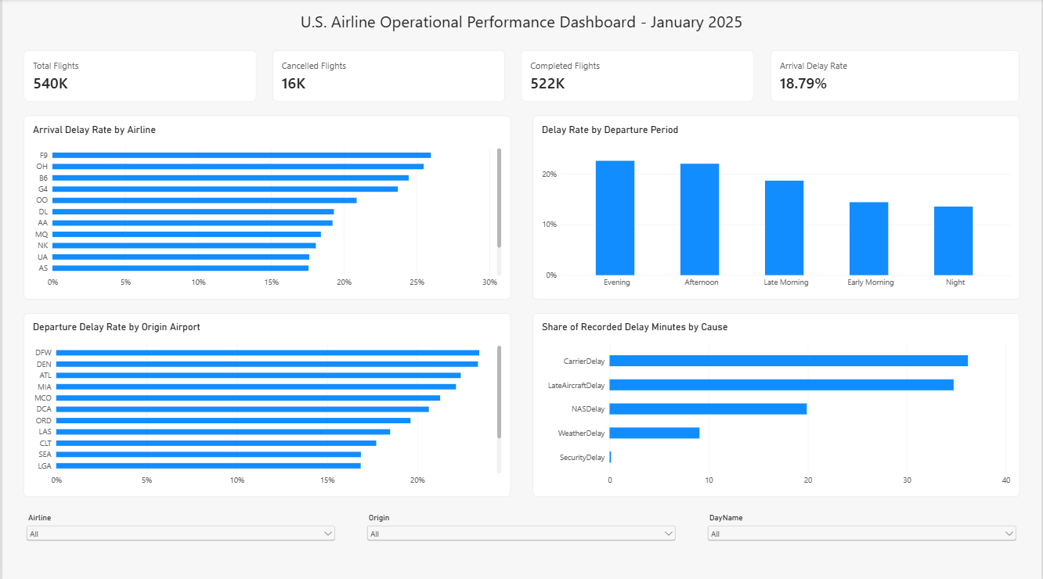
Figure 6. Final Power BI dashboard for U.S. airline operational performance, January 2025.

8. Operational Interpretation, Limitations and Conclusions

8.1 Operational interpretation
- Schedule timing matters: delay rates rise materially from early morning into afternoon/evening operations, consistent with disruption accumulation over the operating day.
- Delay propagation is central: late-arriving aircraft account for more than one-third of recorded delay minutes, and departure delay has an almost one-for-one conditional relationship with arrival delay in the regression.
- Carrier and airport comparisons are useful for performance monitoring, but raw rankings should be paired with traffic thresholds and effect sizes to avoid overstating differences.
- The dashboard can support exploratory operational review by filtering results by airline, origin and weekday without requiring repeated SQL or Python execution.

8.2 Limitations
- The study covers January 2025 only. It captures winter-month operations but cannot represent full-year seasonality or long-term carrier/airport performance.
- The analysis is observational. Statistical association does not establish that carrier, airport or departure period causes a specific delay outcome.
- Delay-cause fields are reported according to BTS carrier reporting rules for qualifying delayed flights and should not be interpreted as a complete causal decomposition of every minute of operational variation.
- Airport comparisons use origin-level aggregates; weather, runway configuration, traffic management and route mix were not separately modeled.
- The OLS model contains departure delay, so it is intentionally explanatory and unsuitable as a true advance prediction model without redesigning the feature set.

8.3 Conclusions
The project demonstrates an end-to-end operational analytics workflow on more than half a million flight records. SQL was used for scalable KPI and ranking logic; Python supported cleaning, exploratory analysis and statistical inference; and Power BI translated the results into an interactive operational dashboard. The January 2025 data show clear within-day delay accumulation, substantial network-propagation effects, measurable but modest carrier/cancellation associations, and meaningful performance variation among high-volume airports. The combination of statistical significance, effect-size reporting and traffic-aware filtering provides a more defensible interpretation than rankings alone.

References
[1] U.S. Bureau of Transportation Statistics, Reporting Carrier On-Time Performance (1987-present), TranStats database and field documentation.
[2] U.S. Bureau of Transportation Statistics, Technical Reporting Directive #39 - On-Time Performance, effective January 1, 2025.
[3] U.S. Bureau of Transportation Statistics, On-Time Reporting requirements under 14 CFR Part 234.
[4] Python data-analysis stack used in this project: pandas, NumPy, SciPy, statsmodels and Matplotlib.
[5] SQLite database engine and Microsoft Power BI Desktop used for query analysis and interactive reporting.

Appendix A. Deliverables
- Cleaned analysis dataset: BTS_Jan2025_clean.csv
- SQLite database: airline_operations.db
- SQL script: Airline_Operations_Analytics_SQL_Queries.sql
- Statistical outputs: confidence intervals, regression coefficients and hypothesis-test summary CSV files
- Power BI file: Airline_Operations_Analytics_Final_Clean.pbix (final dashboard version)
- Technical report: this document

