TECHNICAL PROJECT REPORT
Urban Stormwater Drainage Network Modelling
and Sensitivity Analysis using EPA SWMM
Rainfall intensity • Urbanization • Conduit capacity

Software | EPA SWMM 5.2
Model scale | Conceptual 12-ha urban drainage network
Routing | Dynamic Wave
Infiltration | Horton method

Study objective
To evaluate how rainfall intensity, imperviousness and drainage capacity affect runoff, flooding and hydraulic performance in an urban stormwater network, and to identify a critical conveyance bottleneck and effective capacity-upgrade scenario.
Important scope note: This is a conceptual sensitivity-analysis model driven by a synthetic design storm. It is not a calibrated or site-validated drainage model, and results are interpreted comparatively rather than as predictions for a specific real catchment.

1. Executive Summary
A 12-ha urban stormwater drainage model was developed in EPA SWMM to study how rainfall forcing, surface imperviousness and pipe capacity influence flooding. The network contains six subcatchments, seven junctions, eight circular conduits and one free outfall. Horton infiltration and Dynamic Wave routing were used so that surface runoff generation and surcharge/backwater effects could be represented within a single model.
Three sensitivity groups were evaluated: (i) rainfall intensity from 0.6P to 1.4P, (ii) imperviousness increases of +15 and +30 percentage points, and (iii) enlargement of the critical outlet conduit C5 from 0.75 m to 0.90 m and 1.05 m. The model showed a strong nonlinear increase in flooding as rainfall intensified, a large rise in flooding as imperviousness increased, and a major reduction in flooding after increasing the diameter of C5.
- Rainfall sensitivity: total flooding increased from 202 m³ at 66 mm rainfall to 7,230 m³ at 154 mm, while peak outfall discharge approached a plateau near 1.31 m³/s.
- Urbanization sensitivity: a +30 percentage-point imperviousness increase raised flooding from 202 to 1,255 m³ under the same rainfall input.
- Capacity sensitivity: increasing C5 from 0.75 m to 0.90 m reduced flooding from 202 to 17 m³ (91.6% reduction); increasing it further to 1.05 m reduced flooding to 5 m³.

2. Model Configuration
The model represents a compact urban drainage system with two connected branches that merge at junction J5 before discharging through conduit C5 to the outfall. The configuration was selected to permit simultaneous study of runoff production, hydraulic bottlenecks, surcharge and flooding.
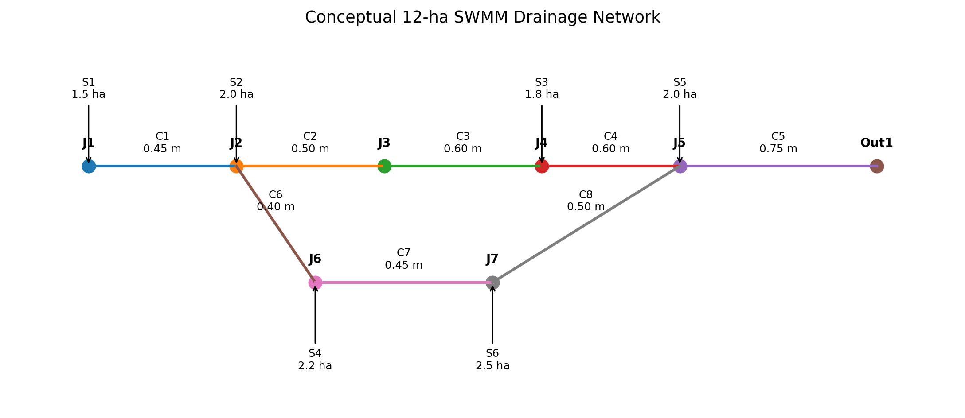
Figure 1. Conceptual drainage-network schematic. Node positions are illustrative rather than geographic.

2.1 Subcatchments
Subcatchment | Area (ha) | Width (m) | Slope (%) | Imperv. (%) | Outlet
S1 | 1.5 | 120 | 1.0 | 55 | J1
S2 | 2.0 | 140 | 1.2 | 60 | J2
S3 | 1.8 | 130 | 0.9 | 50 | J4
S4 | 2.2 | 150 | 1.1 | 65 | J6
S5 | 2.0 | 140 | 0.8 | 55 | J5
S6 | 2.5 | 160 | 1.0 | 70 | J7
All subcatchments used Horton infiltration with maximum infiltration rate 75 mm/h, minimum rate 10 mm/h, decay coefficient 2 h⁻¹ and drying time 7 days. Surface roughness values were n = 0.013 for impervious area and n = 0.24 for pervious area; depression storage depths were 1.5 mm and 5 mm, respectively.

2.2 Drainage network
Conduit | Connection | Length (m) | Diameter (m)
C1 | J1 → J2 | 150 | 0.45
C2 | J2 → J3 | 180 | 0.50
C3 | J3 → J4 | 200 | 0.60
C4 | J4 → J5 | 180 | 0.60
C5 | J5 → Out1 | 250 | 0.75
C6 | J2 → J6 | 120 | 0.40
C7 | J6 → J7 | 140 | 0.45
C8 | J7 → J5 | 160 | 0.50
All conduits were circular with Manning roughness n = 0.013. Junction maximum depth was 3 m. Out1 was assigned a FREE outfall condition. Dynamic Wave routing was used with a 30-s routing step and 1-min reporting interval.

3. Forcing and Scenario Design
The baseline event was defined as 0.6P, where P is a synthetic 10-min-block storm pattern with intensities of 10, 20, 35, 60, 90, 120, 100, 80, 60, 40, 25, 15 and 5 mm/h. The 0.6P baseline produces 66 mm total rainfall. The storm is synthetic and is not assigned a return period.

3.1 Rainfall-intensity scenarios
Scenario | Total rainfall (mm)
0.6P | 66
0.8P | 88
1.0P | 110
1.2P | 132
1.4P | 154

3.2 Urbanization scenarios
The baseline imperviousness values were increased uniformly by +15 and +30 percentage points. This isolates the hydrologic effect of increasing impervious cover while keeping the rainfall event and drainage geometry unchanged.

3.3 Capacity scenarios
Conduit C5, the final conveyance link from J5 to the outfall, was tested at diameters of 0.75 m (baseline), 0.90 m and 1.05 m. All other parameters were unchanged. This isolates the effect of enlarging the critical downstream conveyance element.

4. Results

4.1 Rainfall sensitivity
Case | Rainfall  (mm) | Runoff depth  (mm) | Peak outfall  (m³/s) | Flooding  (m³) | J7 flooding  (m³) | C5 Max/Full
0.6P | 66 | 42.574 | 1.174 | 202 | 137 | 1.67
0.8P | 88 | 63.151 | 1.245 | 1,367 | 617 | 1.77
1.0P | 110 | 84.414 | 1.288 | 3,096 | 1,147 | 1.83
1.2P | 132 | 105.928 | 1.308 | 5,064 | 1,695 | 1.86
1.4P | 154 | 127.516 | 1.308 | 7,230 | 2,238 | 1.86
Flooding increased from 202 m³ to 7,230 m³ as rainfall increased from 66 to 154 mm, an increase of about 35.8 times. In contrast, peak outfall discharge rose only from 1.174 to about 1.308 m³/s and then effectively plateaued. This divergence indicates that the drainage system reaches a conveyance-limited regime: additional runoff can no longer be passed through the outlet at the same rate and is instead stored or lost as flooding at nodes.
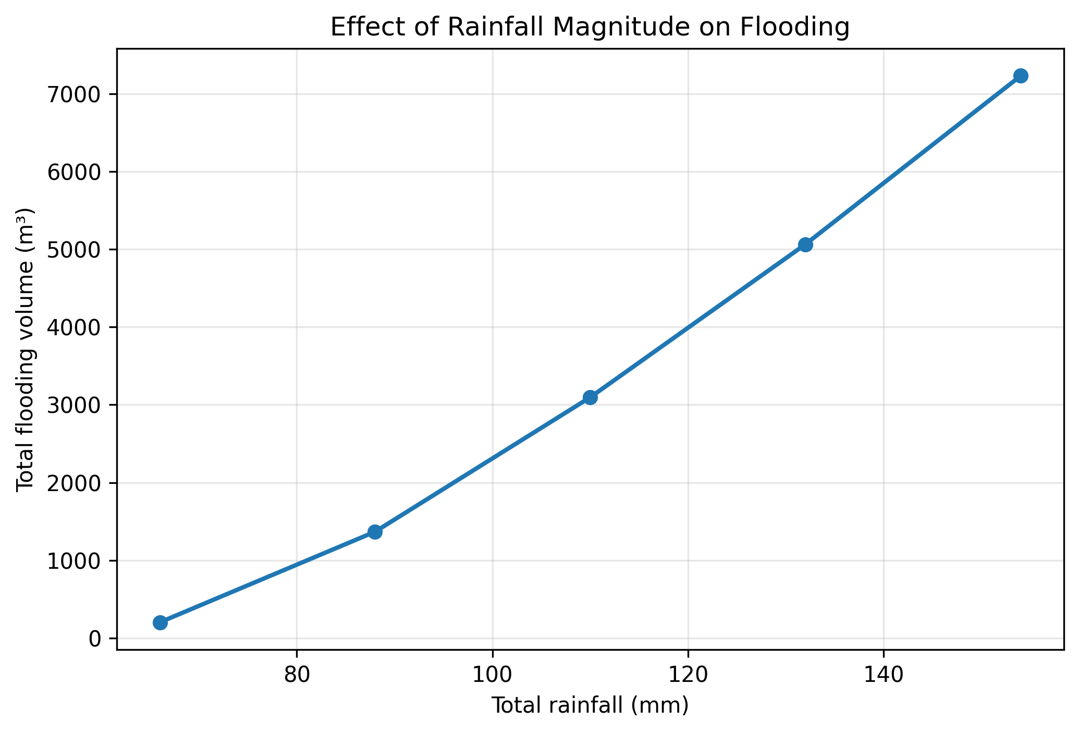
Figure 2. Flooding volume versus rainfall forcing.
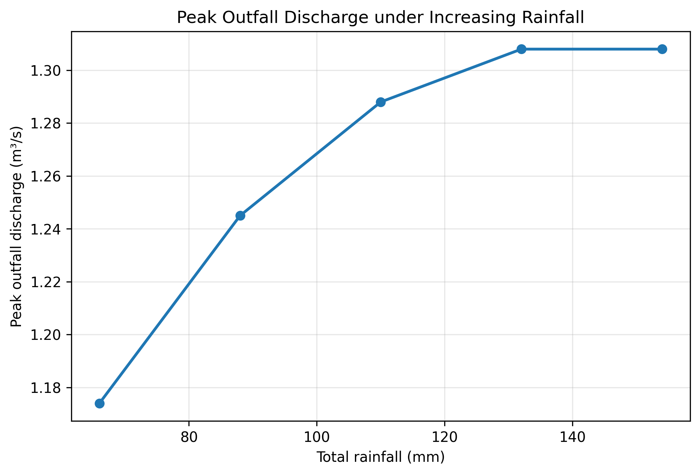
Figure 3. Peak outfall discharge versus rainfall forcing, showing approach to a capacity plateau.

4.2 Urbanization sensitivity
Case | Imperviousness shift  (pp) | Runoff depth  (mm) | Peak outfall  (m³/s) | Flooding  (m³) | J7 flooding  (m³) | C5 Max/Full
Baseline | 0 | 42.574 | 1.174 | 202 | 137 | 1.67
U2 | +15 | 51.274 | 1.229 | 675 | 352 | 1.75
U3 | +30 | 59.565 | 1.251 | 1,255 | 550 | 1.78
A +30 percentage-point increase in imperviousness increased runoff depth from 42.574 to 59.565 mm (about 40%) but increased flooding from 202 to 1,255 m³ (about 6.2 times). The much larger percentage change in flooding than in runoff demonstrates the nonlinear response of a drainage network operating near hydraulic capacity.
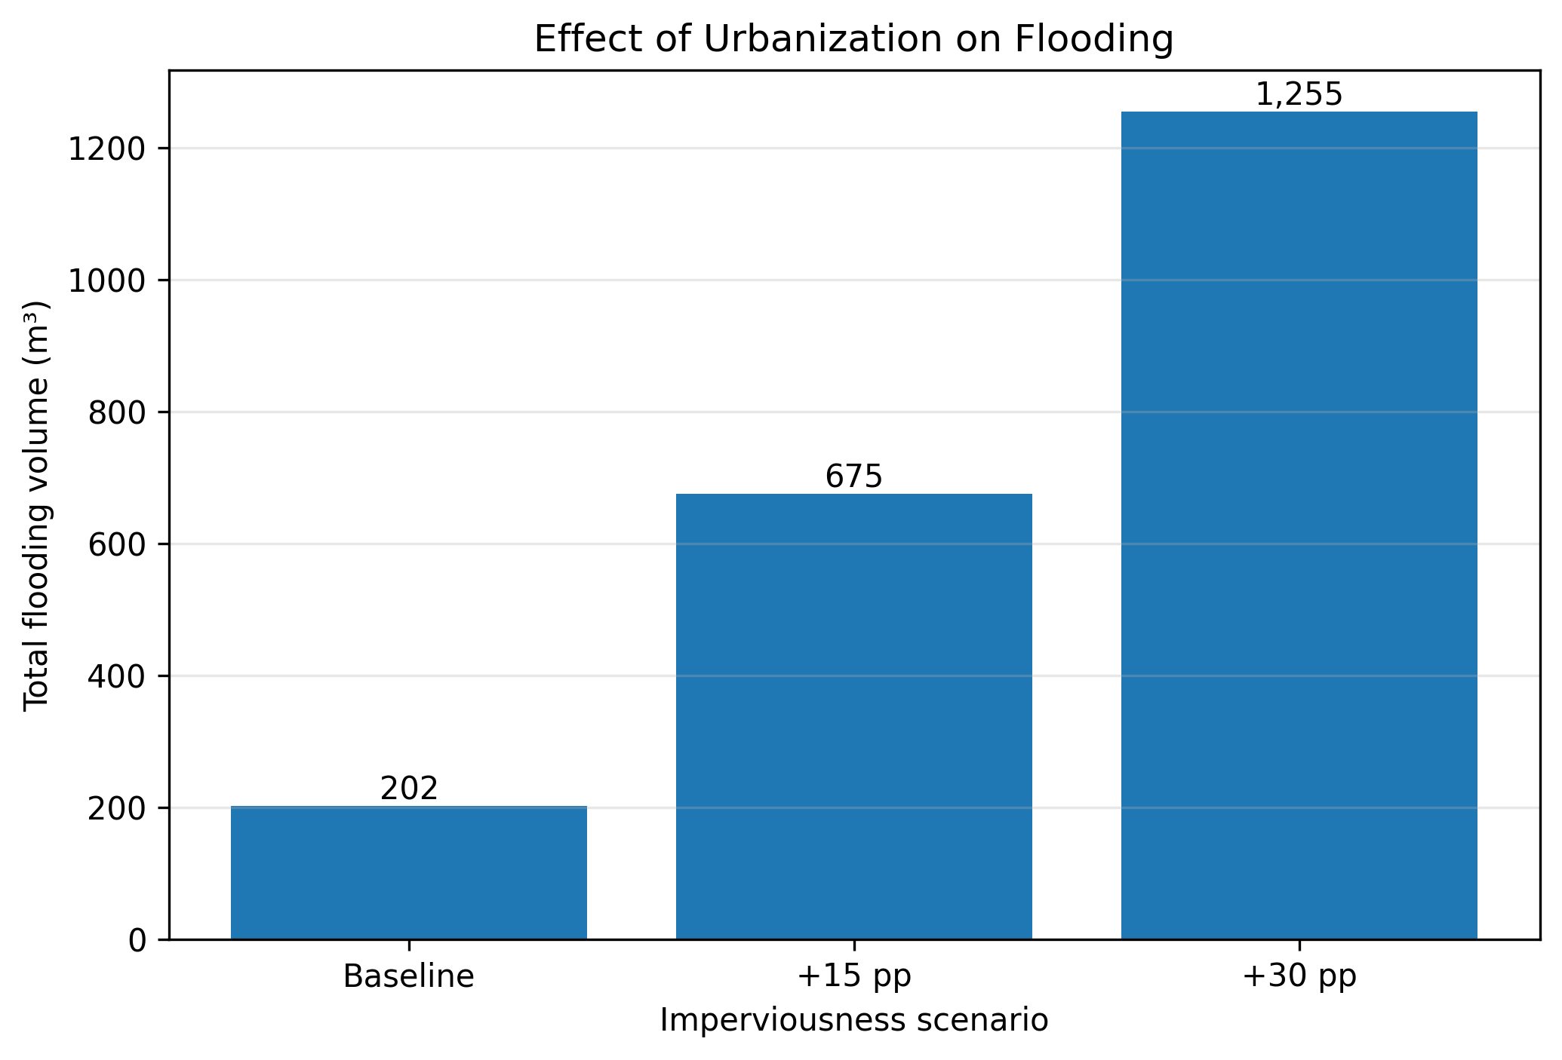
Figure 4. Flooding response to increased imperviousness.

4.3 Critical-conduit capacity sensitivity
Case | C5 diameter (m) | Peak outfall (m³/s) | Flooding (m³) | C5 Max/Full
Baseline | 0.75 | 1.174 | 202 | 1.67
P2 | 0.90 | 1.348 | 17 | 1.18
P3 | 1.05 | 1.394 | 5 | 0.81
Increasing C5 from 0.75 m to 0.90 m reduced total flooding from 202 to 17 m³, corresponding to a 91.6% reduction. Increasing C5 further to 1.05 m reduced flooding to 5 m³ (97.5% reduction relative to baseline), but the incremental benefit beyond 0.90 m was much smaller. Because no economic analysis was performed, 0.90 m should be described as an effective hydraulic upgrade rather than a formally optimized diameter.
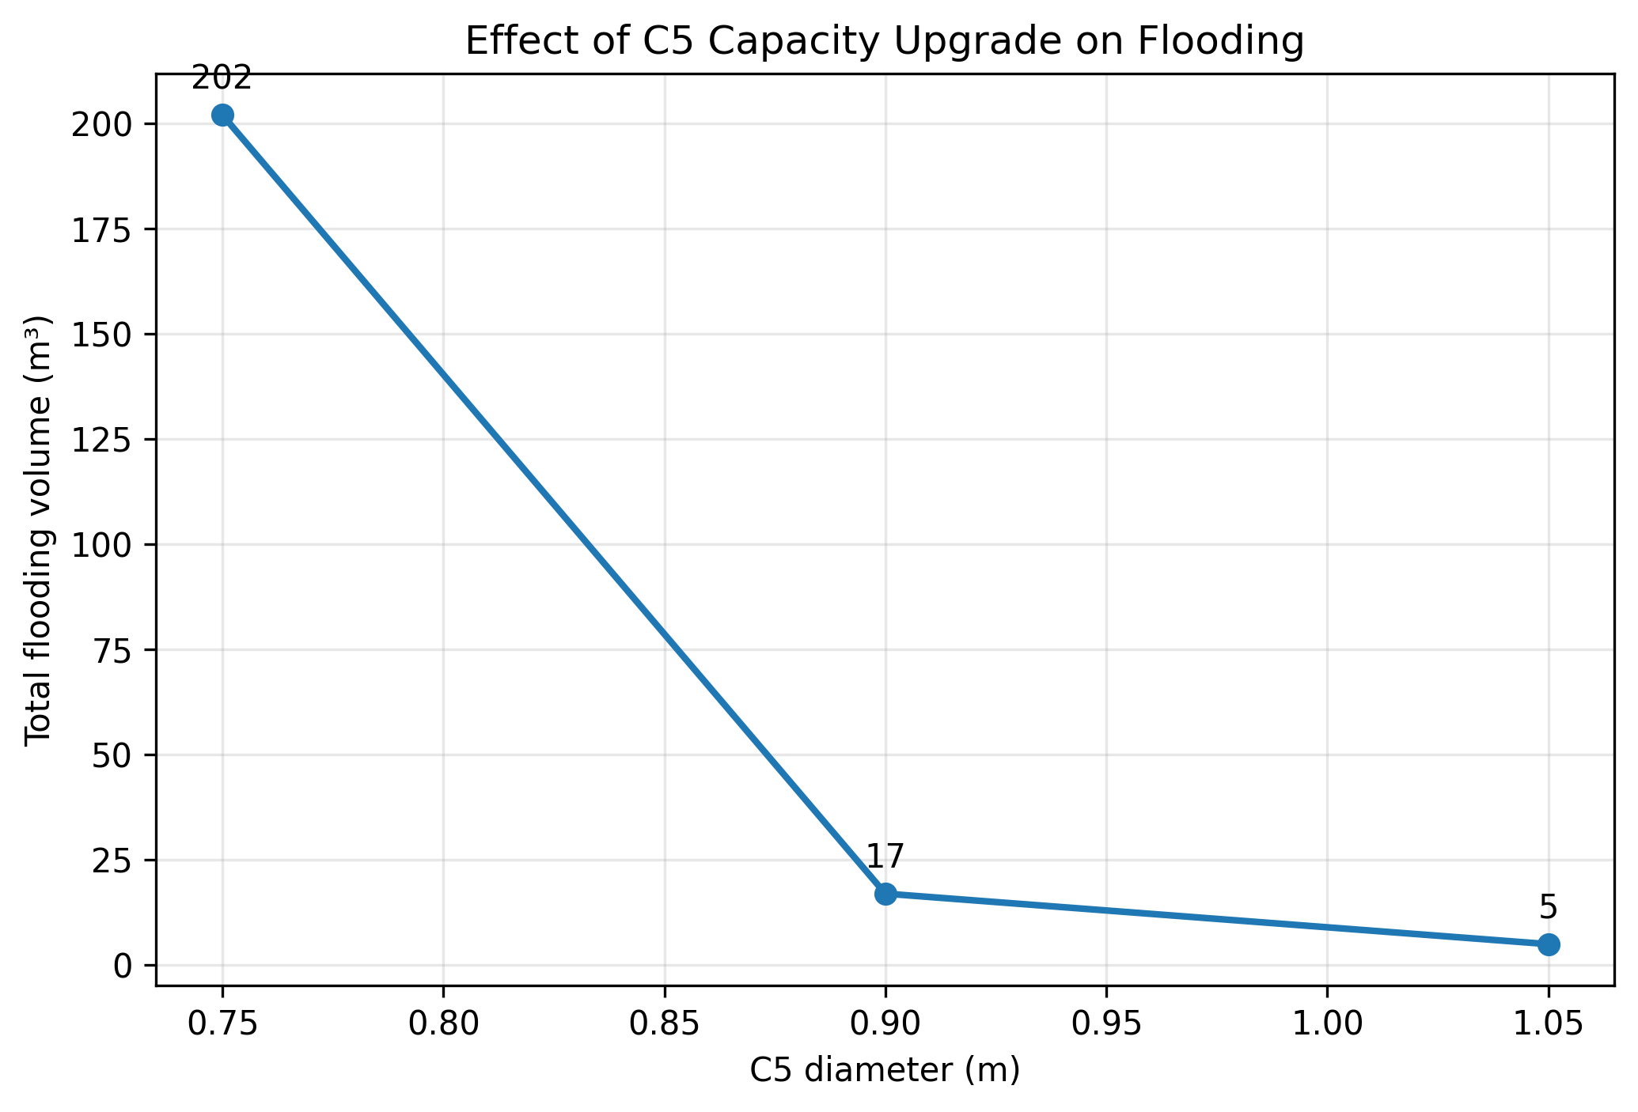
Figure 5. Flooding reduction as C5 diameter increases.
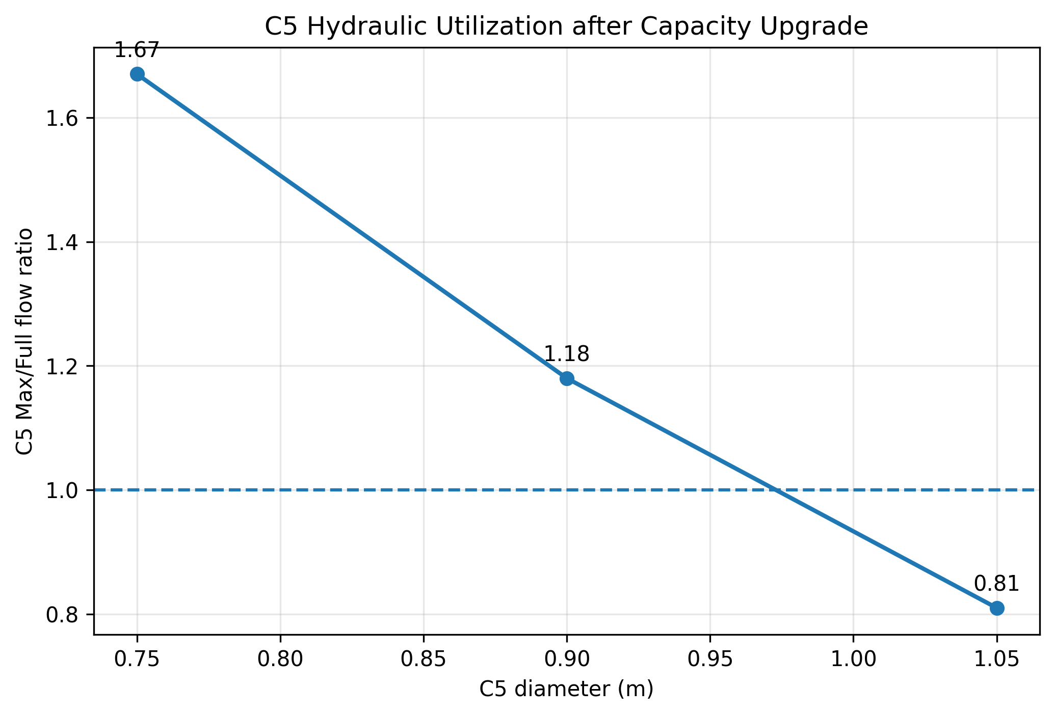
Figure 6. C5 maximum/full-flow indicator for the capacity scenarios.

5. Numerical Checks and Interpretation

5.1 Continuity and scenario consistency
Across the scenario set, reported runoff continuity errors were approximately −0.007% to −0.009%, while routing continuity errors were approximately −0.10% to −0.25%. These small continuity errors support internal mass-balance consistency. The scenario responses were also physically consistent: rainfall and imperviousness increases raised runoff and flooding, whereas greater downstream conveyance capacity reduced flooding and increased outfall discharge.
Some reports contained a non-negligible fraction of routing steps that did not fully converge. Therefore, the results are best treated as comparative sensitivity results rather than high-precision calibration outputs. The low continuity errors and smooth scenario trends nevertheless indicate that the model is suitable for the intended conceptual study.

5.2 Consistency with SWMM theory and published applications
EPA describes SWMM as a dynamic rainfall-runoff model for planning, analysis and design of urban drainage systems, with hydrologic runoff generation coupled to routing through pipes, channels and storage elements. The present use of Horton infiltration and Dynamic Wave routing is consistent with that intended application. Published SWMM studies also commonly report increased runoff and flood volumes with increasing imperviousness and rainfall forcing, and use conduit-capacity modification as a drainage-adaptation measure. The direction of the trends obtained here is therefore consistent with established SWMM applications, although this conceptual model has not been calibrated against field observations.

6. Practical Engineering Applications
Application | How this model supports it
Drainage-capacity screening | Identify conduits that become hydraulically limiting as rainfall intensity increases.
Urbanization assessment | Estimate how increasing impervious cover can shift a network from acceptable operation to surcharge and flooding.
Climate/storm sensitivity | Test how stronger design storms affect flood volume and critical nodes, without changing the physical network.
Upgrade prioritization | Compare targeted pipe enlargements and quantify the hydraulic benefit before considering detailed cost optimization.
Green-gray planning | The same model structure can be extended with SWMM LID controls to compare source-control measures with pipe-capacity upgrades.

7. Limitations and Recommended Extensions
- The network geometry and rainfall pattern are conceptual; no real catchment GIS, survey, rainfall-gauge or flow-monitoring data were used.
- The synthetic storm has no assigned return period, so the scenarios should not be described as 10-year, 50-year or 100-year events.
- The model was not calibrated or independently validated against observed hydrographs, node depths or flood extents.
- Pipe-upgrade scenarios were assessed hydraulically only; capital cost, constructability and downstream impacts were not optimized.
- A future extension could add observed rainfall, calibrated subcatchment parameters, LID controls, spatially distributed land-use change, and cost-based multi-objective optimization.

8. Conclusions
- The modeled network exhibits a clear transition toward conveyance-limited behavior as rainfall increases: flood volume grows sharply while peak outfall discharge approaches ~1.31 m³/s.
- Increasing imperviousness strongly increases flood risk. A +30 percentage-point imperviousness change increased modeled flooding from 202 to 1,255 m³ under the same storm.
- Conduit C5 is the principal downstream hydraulic bottleneck in the baseline configuration. Increasing its diameter from 0.75 to 0.90 m reduced modeled flooding by 91.6%.
- Further increasing C5 to 1.05 m produced additional hydraulic benefit but with diminishing flood-reduction gains relative to the 0.90 m upgrade.
- The study demonstrates how SWMM can be used for structured sensitivity analysis of rainfall, urbanization and infrastructure capacity, while also highlighting the need for calibration before site-specific design decisions.

9. References
1. Rossman, L. A., and Simon, M. (2022). Storm Water Management Model User’s Manual Version 5.2. EPA-600/R-22/030, U.S. Environmental Protection Agency.
2. Rossman, L. A., and Huber, W. C. (2016). Storm Water Management Model Reference Manual Volume I - Hydrology (Revised). EPA/600/R-15/162A, U.S. Environmental Protection Agency.
3. Rossman, L. A. (2017). Storm Water Management Model Reference Manual Volume II - Hydraulics. EPA/600/R-17/111, U.S. Environmental Protection Agency.
4. U.S. Environmental Protection Agency. Storm Water Management Model (SWMM): software, documentation and applications.
5. Zhou, Q., Leng, G., Huang, M. (2019). Impacts of urbanization and climate change on urban flood volumes: importance of urban planning and drainage adaptation. Science of the Total Environment, 658, 24-33.
6. Recent SWMM-based studies in rapidly urbanizing cities have similarly evaluated the effects of imperviousness, drainage capacity and green/gray infrastructure on runoff and flood mitigation; these are used here only for qualitative trend comparison, not direct validation.

Appendix A. Scenario Continuity Summary
Scenario | Runoff continuity error (%) | Routing continuity error (%)
0.6P baseline | −0.007 | −0.208
0.8P | −0.008 | −0.230
1.0P | −0.008 | −0.192
1.2P | −0.009 | −0.116
1.4P | −0.009 | −0.120
Imperv. +15 pp | −0.008 | −0.234
Imperv. +30 pp | −0.008 | −0.251
C5 = 0.90 m | −0.007 | −0.150
C5 = 1.05 m | −0.007 | −0.103

