LIMIT.LESS

Dataset Research and
Development Report
  - SAS Data Analytics Hackathon · Round 2
Pookie Blinders | Team ID 117
Research design · Statistical methodology · Implementation plan · Evaluation
Prepared 7 October 2026

Executive overview
This project analyses four supplied datasets to help a university placement or training team make better informed decisions about data-career learning priorities. The main deliverable is a reproducible analysis and a judge-facing Round 2 report. The web interface exists to make the evidence, calculations and limitations easy to inspect.
The analytical contribution is a robustness-first workflow: skill and role patterns are tested under reasonable changes in text mapping, duplicate/template treatment and supplied weights. Junior skill outcomes and senior personality traits remain separate exploratory studies. Every headline finding carries its source, denominator, method, uncertainty and limitation.
The supplied Manus PDF reports valuable counts and associations, but those figures still need reproduction against the exact source files and an execution record. This report defines the research and build plan; it does not represent unexecuted analyses as completed. The next milestone is one traceable source-to-result run followed by reconciliation of every carried-forward claim.

Report map
- 1 Problem definition and stakeholders
- 2 Rubric and evidence strategy
- 3 Data and prior work
- 4 Research review and existing approaches
- 5 Proposed solution and user experience
- 6 Data preparation methodology
- 7 Skill extraction and evaluation
- 8 Market analysis and robustness
- 9 Trait analysis and small-sample validation
- 10 From evidence to an action
- 11 Architecture and execution
- 12 Implementation sequence
- 13 Existing implementation versus remaining work
- 14 Testing and acceptance
- 15 Feasibility and scale
- 16 Limitations and failure modes
- 17 Expected impact and future scope
- 18 Demo and report delivery
- 19 Resource selection

SAS Data Analytics Hackathon · Round 2 research and build plan Team: Pookie Blinders · Team ID: 117 Project: Limit.less Prepared: 7 October 2026
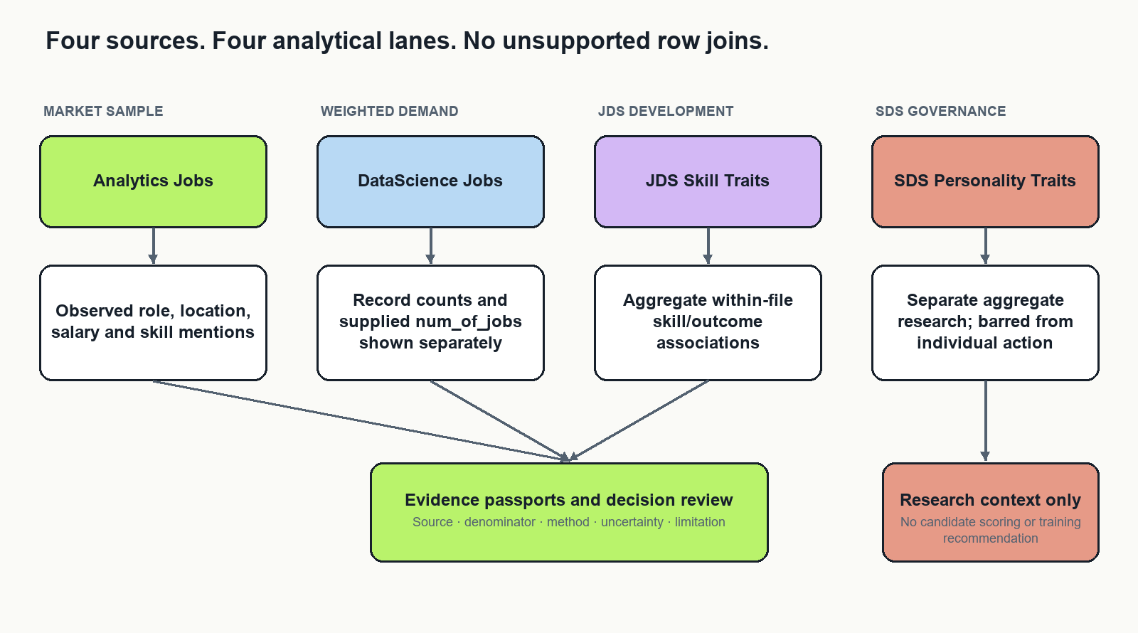
Four independent evidence lanes

Purpose and decision
Limit.less will be developed as a dataset-analysis project for evidence-informed data-career training decisions. Its primary deliverable is a reproducible analysis and a clear Round 2 approach note. An evidence interface will help evaluators inspect the findings, methods and limitations. The existing career-platform features are outside this project's core scope.
The recommended research question is: Which skill and role patterns in the supplied job samples are sufficiently stable to inform a training investigation, and what separate development hypotheses emerge from the supplied skill and personality samples?
The distinctive contribution is a robustness-first decision workflow. We will measure how conclusions change when defensible preparation and measurement choices change, rather than presenting a single attractive ranking as settled truth. This is an engineering and analytical contribution; it is not a claim to have invented a new statistical method.
This report defines the proposed methods, implementation and evaluation. Existing code is identified separately from planned work. Previously reported Manus figures are leads for reproduction, not newly verified experimental results. Research sources were reviewed on 7 October 2026. The research review is targeted, not a systematic review of every available publication.

1 Problem definition and stakeholders

1.1 The decision being supported
A university placement or training team has limited teaching time. It needs to identify worthwhile areas for data-career learning, understand which role families request them, and explain its choices. A raw frequency chart is insufficient: repeated advertisement templates, missing descriptions, ambiguous skill names and supplied job-count weights can change the ranking. Small internal trait datasets introduce further uncertainty and describe different populations.
The project supports a decision about which aggregate training topics to investigate or pilot. It does not decide who should be hired, promoted or rejected. The primary stakeholder is a placement or curriculum team. Learners are secondary beneficiaries of clearer, reviewable learning priorities. Researchers use the separate trait views to examine associations and measurement limitations.

1.2 Research questions
RQ1: What observed skills, role families, locations, experience categories and compensation fields can be described reliably within each supplied job dataset?
RQ2: Which apparent demand rankings are stable under reasonable alias, duplicate/template and weighting choices? Which are driven by a few records or uncertain mappings?
RQ3: Within JDS, how are measured skill dimensions associated with the supplied salary-hike label, and does a small regularized model improve on a prevalence baseline under careful validation?
RQ4: Within SDS, how stable are aggregate trait associations and model diagnostics under repeated-ID and evaluation choices? What prevents their use in individual decisions?
RQ5: Can an evidence interface help a reviewer choose a defensible training investigation and correctly understand its limitations faster than a static frequency table?

1.3 Scope and exclusions
The four supplied datasets are the primary evidence. External resources contribute methods, vocabularies and optional transfer tests, never additional observations silently merged into the challenge samples. Exclude live scraping, social publishing, application submission, resume scoring, facial or voice analysis, individual personality screening and future-demand forecasts from the core submission.
No reliable time series has been established. Therefore, the project uses terms such as observed frequency and supplied weighted demand, not rising demand or future shortage. Job advertisements measure stated requirements in a selected sample, not hiring outcomes or the entire labour market. OECD research highlights the need to assess representativeness of online posting data [R2].

2 Rubric and evidence strategy
The organizer brief specifies a 20–25-page Word approach note excluding appendices. Its preferred formatting is 12-point, single-spaced text. The document says technology agnostic and instructs participants to upload data to VFL if using SAS. It also prohibits outside data transfers during the event. The execution environment and any artifact sharing must comply with the event's actual rules; SAS access and transfer permissions are separate questions.
Round 2 area | Marks | Deliverable that earns consideration
Problem definition | 10 | One stakeholder decision, research questions, observation units and boundaries
Approach | 15 | Justified analytical sequence, comparison methods and reproducible protocol
Data exploration and preparation | 25 | Audit tables, parsing rules, duplicate diagnostics, weighting and provenance
Data analysis | 30 | Quantitative analyses, baselines, uncertainty, sensitivity and validation
Results and conclusions | 10 | Reproduced findings, negative results and conclusions answering the questions
Implications | 10 | Specific stakeholder actions, feasibility and a measurable pilot plan

Do not allocate development effort by visual appeal. Preparation and analysis carry 55 marks. The interface earns its place by making those methods inspectable. No score forecast is defensible without completed results and independent judging.
The final submission should distinguish research evidence, implementation evidence and impact evidence. A passing software test does not validate a statistical conclusion. A high AUC does not establish useful training advice. A positive usability pilot does not establish improved employment outcomes.

3 Data and prior work

3.1 Four independent evidence sources
Source | Observation unit | Main fields and use | Critical interpretation
Analytics Jobs | Posting-like source row | Designation, skills, description, location, experience, salary | Sample mentions; text availability changes denominators
DataScience Jobs | Company/title source record | Salary summaries, minimum experience, num_of_jobs | Record counts and supplied weights are different quantities
JDS Skill Traits | Junior skill observation | Five skill dimensions and salary-hike label | Association within this sample; ID semantics require checking
SDS Personality Traits | Senior trait observation | Five personality dimensions and success label | Separate aggregate exploratory research

The organizer describes the job samples as relating to 2024–25. That description alone does not provide reliable dates for each record. The trait samples are described as company observations and may include masked or self-reported information. Field names and measurement meanings must be checked against the actual imported schemas.

3.2 What the Manus packet contributes
The supplied nine-page PDF reports 15,841 Analytics rows, 1,602 DataScience rows, 139 JDS observations and 161 SDS observations. It reports substantial Analytics job-type and description missingness, repeated identifiers, a supplied weight sum, descriptive associations and model sensitivity runs. These figures are author-reported until reproduced from the exact source files and code.
Create a reconciliation ledger with one row per reported claim: original wording, source page, expected calculation, newly reproduced value, numerical tolerance, discrepancy explanation and reviewer. Do not change a parser solely to make a result match the prior report. Differences may come from tokenization, missing-value definitions, grouping or decimal handling and should be explained.
The architecture memo correctly prioritizes provenance, conservative parsing, separate datasets and evaluated skill normalization. Its software stack is a proposal. Its numerical diagnostics and references do not prove the current application implements them.

3.3 Why no record-level join is justified
There is no documented shared person, employer, role or time key connecting all four files. Matching row numbers, similar job titles or repeated IDs would manufacture links. Keep four physical source tables and independent analysis outputs. A manually reviewed mapping between a market skill family and a JDS dimension is conceptual metadata, not an observation-level join. It may motivate a learning hypothesis, but cannot create a combined outcome model.

4 Research review and existing approaches

4.1 What existing approaches already do
Public skills-intelligence dashboards already summarize occupations and skill demand from online postings. Cedefop Skills-OVATE is a relevant example [R3]. An attractive skill-frequency dashboard alone is therefore not a strong originality claim.
Skill-extraction research addresses the distinction between identifying a skill phrase and assigning it to a standardized concept. SkillSpan supplies expert annotation guidance and an extraction benchmark [R1]. Weak-supervision research explores scalable taxonomy-based extraction [R4]. Neither removes the need to evaluate on the challenge's text and terminology.
Embedding methods support semantic retrieval. Sentence-BERT provides a basis for comparing sentence representations [R5]. Similarity is useful for suggesting candidate mappings; it is not a calibrated probability that a mapping is correct.
Small tabular classification is also well established. The difficulty here is evaluation integrity, not access to a powerful model. Model selection can overfit an evaluation criterion, motivating separation of tuning and evaluation [R6]. Calibration concerns the agreement between predicted probabilities and observed frequencies; discrimination alone does not measure it [R7].

4.2 Gaps this project will address
Common implementation pattern | Weakness in this setting | Our proposed response
One top-skills chart | Ranking hides parser and sample choices | Publish scenario rank ranges and mapping coverage
One model and accuracy score | Small-sample uncertainty and tuning leakage | Baseline, bounded model comparison and nested evaluation where feasible
One combined dashboard dataset | Incompatible observation units | Four isolated analyses and a reviewed conceptual comparison
Automated advice from a high score | No evidence of causality or transportability | Reviewable training hypotheses with explicit next evidence
Animated pipeline graph | Visual activity may imply nonexistent execution | Generate statuses from run receipts and checks
More external data | Changes provenance and may violate event boundaries | Keep challenge analysis primary; external references remain separate

These are project-specific design gaps, not claims that all existing products lack these capabilities. We have not established global novelty. The defensible contribution is demonstrating the integrated method on these supplied datasets and measuring its advantage over transparent baselines.

4.3 The strongest differentiator
Add an assumption sensitivity view. A reviewer selects a finding and sees which reasonable decisions change it: strict versus reviewed aliases; raw posting records versus equal template-cluster contribution; ordinary supplied weights versus a clearly labelled influence diagnostic. Each scenario preserves its definition and denominator.
This is inspired by specification-curve research, which exposes dependence on analytical choices [R8]. Our descriptive scenario comparison is not a full inferential specification-curve analysis unless its joint inference procedure is implemented. Scenario stability measures robustness within specified alternatives; it does not correct selection bias or establish truth.
Pair that view with an evidence collection queue. An unstable recommendation should specify what to inspect next: ambiguous phrases, unclear weight meaning, missing salary units or repeated IDs. The queue makes uncertainty operational instead of displaying a generic confidence badge.

5 Proposed solution and user experience
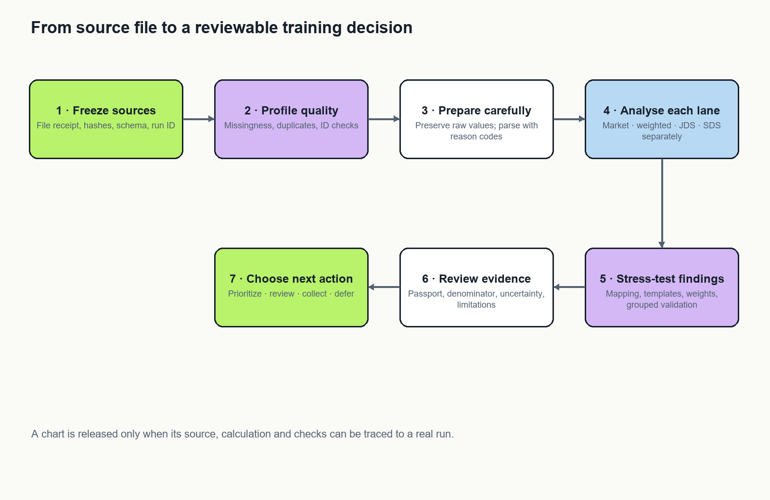
End-to-end analysis and decision workflow
The solution consists of an analysis pipeline, a result store and a six-view evidence interface. The essential interface can be implemented in SAS Visual Analytics for the chosen SAS execution path. A local web view is an optional presentation layer only where permitted.
View | Purpose | Essential interaction
Research overview | State the decision, source versions and available analyses | Open a question and its evidence status
Data quality | Explain missingness, invalid values and identifiers | Inspect field-level denominators and exclusions
Market evidence | Explore role/skill and weighted distributions | Filter a defined sample and see recalculated denominators
Robustness | Compare defensible analytical scenarios | Inspect rank changes and influential assumptions
Development research | Inspect JDS and SDS separately | Compare associations and validation diagnostics
Evidence and runs | Trace every finding to its calculation | Open a passport, check result and execution receipt

The overview should answer: What question is being investigated? Which data was used? What has actually run? What finding is supported? What should a human do next? These answers take priority over a dense graph.
A training reviewer might explore an entry-level analytics role family, inspect a skill's source mentions, discover that its rank changes under alias review, and request review before including it in a pilot. Another skill might remain stable across the tested scenarios and become a candidate for a reversible learning experiment. These are example interactions, not challenge results.

6 Data preparation methodology

6.1 Reproducible source receipt
Preserve originals. Record filename, byte size, cryptographic hash where supported, receipt date, sheet name, encoding, import options, software version, row count and schema. A hash proves file identity, not authenticity or accuracy. Record a run identifier and configuration version for every execution. Keep the data and derived artifacts inside the authorized environment.
Use dataset-specific contracts. Required fields, expected types, permitted outcome labels and missing-value tokens belong in a reviewed configuration file. Fail clearly when a required field changes. Do not silently coerce a missing field to zero or use a similarly named column.

6.2 Missingness and observation units
Count nulls, empty strings and reviewed missing-value tokens separately before combining them. Compare missingness by sufficiently populated role or location groups. Treat complete-case analysis as a sensitivity view because rows with descriptions may differ systematically from those without them. Do not assume missing at random.
Publish both an all-row mention fraction and a text-eligible mention rate. If m rows mention a skill, N is all rows and E is rows with usable relevant text, these measures are m/N and m/E respectively. They answer different questions. Missing text means unobserved content, not absence of a skill.

6.3 Duplicates and templates
Separate exact full-row duplicates, duplicate normalized content and repeated identifiers. A repeated ID alone does not justify deletion. Normalize whitespace and case for diagnostics while preserving raw values. For near-duplicate descriptions, compare token shingles or character n-grams and manually inspect a sample of proposed clusters. Freeze a similarity threshold before evaluating its effect on rankings.
Report the original-record analysis and an equal-cluster-contribution diagnostic. The latter tests template influence; it is not a claim that every cluster represents a single vacancy. Without validated entity semantics, neither representation becomes a unique-jobs estimate.

6.4 Salary and experience
Keep raw salary text, parsed lower/upper bounds, explicit currency, period, parser status and exclusion reason. Do not infer annual pay or currency from plausibility alone. Use separate panels for incompatible units and an unresolved category. Treat missing, negotiable and undisclosed as different values where supported.
Experience parsing should preserve ranges, minimums and ambiguous strings. A midpoint is a derived approximation. Report sensitivity to using lower bounds versus midpoints when both are meaningful. Avoid assigning zero years to failed parses.

6.5 Supplied job weights
For DataScience Jobs, retain both record count and sum of num_of_jobs. Validate numeric conversion, non-negativity and missing values. Show quantiles, maximum weight and the fraction of total weight attributable to the largest records. Report exclusions explicitly.
As diagnostics, compare unweighted ranks, supplied-weight ranks and leave-one-largest-record-out ranks. A cap-at-quantile scenario changes the estimand and must be labelled as such; it cannot replace the original without source justification. The concentration quantity (sum w)^2 / sum(w^2) describes weight concentration here, not a valid independent sample size or survey correction.

7 Skill extraction and evaluation

7.1 A staged method
Begin with an exact phrase baseline using boundaries and reviewed aliases. Preserve source field, phrase span, normalized phrase, canonical concept if accepted, method and review status. Count each skill at most once per source record for posting prevalence; retain phrase counts separately for error inspection.
Next, use a pinned vocabulary such as ESCO as a concept reference [R9]. Local vocabulary gaps remain unmapped rather than being forced into an inaccurate concept. The source taxonomy's geography and language coverage do not validate local employer usage.
An optional local semantic retriever proposes a short candidate list for unresolved phrases. Choose its acceptance threshold on development labels; leave a frozen evaluation sample untouched. Include an abstain outcome. Do not send challenge text to a hosted model or API as a shortcut. If the permitted environment cannot run the retriever, the reviewed dictionary remains a complete baseline.

7.2 A practical annotation protocol
Start with approximately 300 sampled text units as a workload target, not a guarantee of precise metrics. Stratify by role family, field availability, phrase frequency and ambiguous terms. Include negative examples, generic responsibilities, software names with ordinary-language meanings, and soft-skill phrases. Do not sample only the phrases the extractor already found, because that cannot measure recall.
Use two reviewers for an overlap subset, record disagreements and adjudicate them. Split by posting/template group before development and evaluation; otherwise near-identical sentences can leak across sets. If challenge data has already informed a dictionary, disclose that and reserve genuinely unreviewed units for final testing.
The label schema includes unit ID, source field, character start/end, hard/soft skill class, accepted concept, ambiguous flag and reviewer decision. Keep annotation material in the authorized environment. A review workload log makes feasibility measurable.

7.3 What to measure
Report exact-span precision, recall and F1; a separately defined overlap measure if useful; concept accuracy on accepted mappings; coverage and abstention. Publish error examples only in an authorized form. Calculate uncertainty by resampling at the posting or cluster level where feasible. Do not treat phrases from the same posting as independent observations.
Compare exact dictionary, reviewed aliases and optional semantic candidates on the same held-out material. Report both accuracy and review effort. Acceptance of the more complex method requires a useful gain on the project's evaluation criteria; model novelty alone is insufficient.

8 Market analysis and robustness
Create role-by-skill prevalence heatmaps with minimum group support and visible denominators. Report raw designations beside reviewed role families. For multi-location strings, use a declared primary-location rule or fractional allocation and show how results change. Avoid counting one posting several times while labelling the result as a unique-row distribution.
Use co-occurrence only after extraction evaluation. For skills A and B, report shared-record support and Jaccard = count(A and B) / count(A or B). Hide edges below a predeclared support threshold and provide a table alternative. A co-occurrence edge represents shared mention, not a prerequisite, causal relation or guaranteed curriculum sequence.
Define a small scenario registry before rerunning rankings. Each scenario records its purpose, inclusion rule, mapping version, weighting definition and comparable outcome. Do not combine incompatible estimates into one mean. The denominator-only scenarios change rates but may leave within-scenario ranking unchanged; make that clear.
For comparable skill rankings, show minimum/maximum rank, top-k inclusion frequency and the assumptions responsible for changes. A scenario inclusion frequency is not a probability that the skill is important. Use cluster bootstrap ranges only as conditional sample uncertainty; they cannot solve missing population coverage.
The strongest presentation is a concrete finding that changes after a defensible audit, followed by the explanation. If all tested findings are stable, show that honestly. Do not search for an impressive reversal and then conceal the selection process.

9 Trait analysis and small-sample validation

9.1 Descriptive analysis first
For each workbook independently, confirm class labels and measurement scales. Inspect impossible values, repeated IDs, inconsistent labels and class counts. Report group means, standard deviations, medians and distributions, with a clearly defined standardized difference and uncertainty. Account for multiple exploratory comparisons, for example using a declared false-discovery adjustment, without equating adjusted significance with practical value.
For JDS, distinguish associations useful for a development hypothesis from effects of an intervention. For SDS, keep all findings aggregate and isolated from learner recommendations. No personality-to-hiring score is part of the project.

9.2 Bounded modelling
Use an intercept-only prevalence predictor, a regularized logistic model and at most one shallow nonlinear challenger. Five measured predictors and small samples do not justify a large model search. Use a bounded, predeclared tuning grid.
Where ID semantics support grouping, keep all records from an ID in one fold. If semantics remain unresolved, show row-stratified and grouped sensitivity analyses and explain both limitations. First verify that each fold contains both outcomes. Do not assume a particular fold count is feasible.
A proposed maximum is five outer folds with three inner folds and a few repeated seeds, reduced when class/group counts demand it. All imputation, scaling, feature selection, tuning and any calibration belong inside training folds. The untouched outer fold estimates performance. Repeated-fold scores are dependent; their standard deviation is not an independent confidence interval [R6, R10].

9.3 Evaluation and falsification
Primary probability diagnostics are Brier score and log loss relative to the baseline; ROC-AUC and balanced accuracy provide secondary discrimination information. Include a cautiously interpreted calibration plot and class prevalence. Calibration fitting consumes data, so defer it when the sample cannot support independent fitting and evaluation [R7].
Add a shuffled-label check that reruns the full modelling procedure under a valid exchangeability scheme. Respect grouping if groups are meaningful. Use it to detect suspicious pipeline behaviour, not to prove deployment readiness. Compare removal of unresolved repeated-ID groups as a sensitivity analysis, with its sample-selection limitation.
Inspect stability of coefficient direction across permissible specifications. Do not turn coefficients into causal skill values or merge JDS and SDS predictions. If an advanced model fails to beat the baseline credibly, retain the baseline and report the negative result. That is a sound research outcome.

10 From evidence to an action
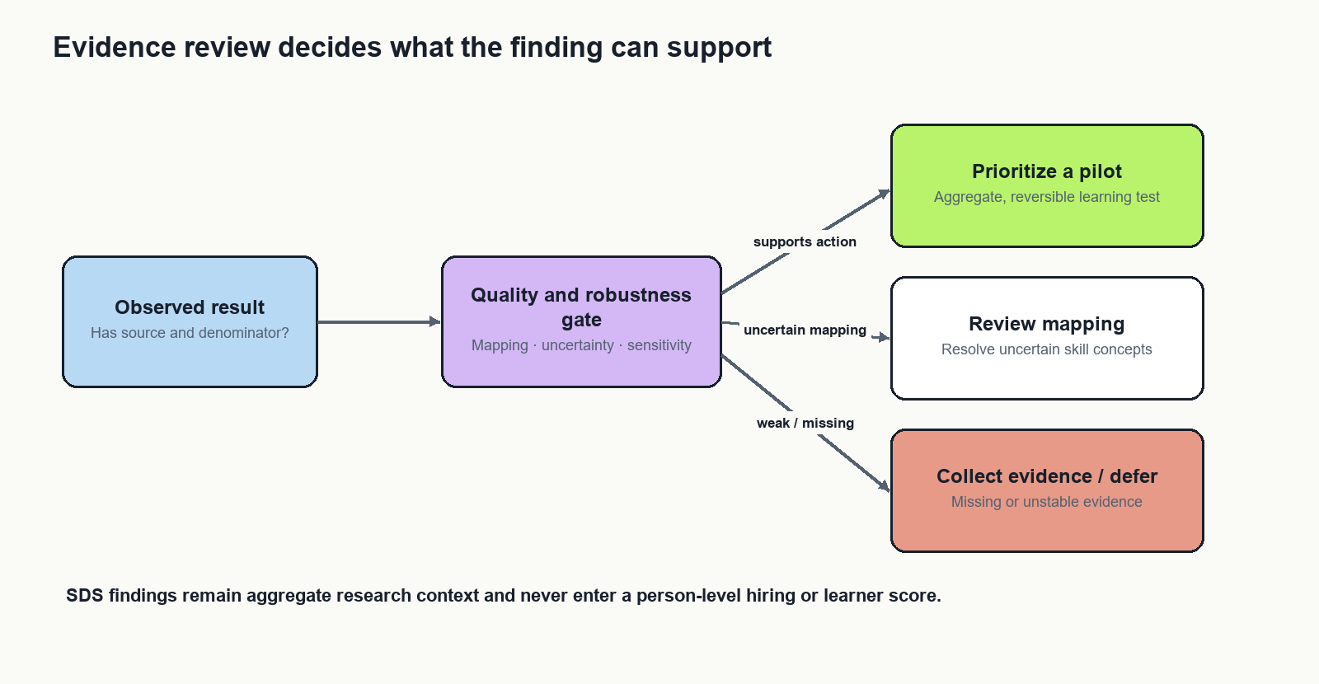
Evidence review and permitted action paths

10.1 Evidence Passport
Every headline result must include a claim ID, research question, source version, observation unit, numerator, denominator, method/configuration, exclusions, mapping evaluation, sensitivity summary, uncertainty, limitation, reviewer and next evidence request. Preserve these dimensions separately. Do not average them into an unexplained confidence score.
A result can be technically calculated and still be unsuitable for action. Therefore, distinguish execution status from evidence-review status. A finished computation is not an approved recommendation.

10.2 Action categories
Action | Meaning | Example next step
Prioritize a pilot | Reviewed evidence supports an aggregate, reversible investigation | Test a small learning module
Review mapping | A phrase/concept decision materially affects interpretation | Adjudicate ambiguous examples
Collect evidence | The decision needs missing information | Clarify salary units or ID semantics
Defer | Current evidence cannot support the proposed action | State what would reopen the question

Rules should be explicit and versioned. Any numerical threshold is a project policy chosen before evaluation, not a universal scientific boundary. Show why an action was assigned and permit a reviewer to record a reasoned override without rewriting the underlying result.

10.3 Optional curriculum scenario
Only after the basic analyses are sound, allow a training team to specify a learning-time budget and candidate modules with reviewed skill coverage and explicit estimated costs. Choose a small module set to cover supported skill families under that budget. Compare with a top-frequency baseline using the same costs and constraints.
Evaluate coverage across several admissible demand scenarios, leaving SDS completely outside the objective. Do not combine JDS effect sizes with job weights into a pseudo-economic value. The output is a curriculum planning scenario, not a prediction of jobs or salary gains. Module costs are stakeholder inputs and need validation. This is a stretch feature; it must not delay the required analysis.

11 Architecture and execution

11.1 Selected implementation path
Use SAS Studio in VFL for imports, preparation, tabular analyses and reproducible programs. Use SAS Visual Analytics for the first evidence views. Use Model Studio or SAS code for the bounded modelling protocol only after confirming available procedures, grouping support and execution permissions. SAS documents these tools as analysis and modelling environments; account capabilities still need inspection [R11].
Retain the existing React/TypeScript and FastAPI stack for an optional evidence presentation surface. The current web package already includes chart and graph libraries. A graph-library replacement is unnecessary for this analysis scope. Publish approved aggregate artifacts through a read-only adapter only when the event environment permits it. Otherwise demonstrate entirely in VFL.
Optional Python components are appropriate only in an approved environment with the required packages available. They can reproduce statistical calculations or run local semantic retrieval. They do not require a second transactional database, distributed compute or an external LLM service.

11.2 Component contracts
Component | Input | Output | Failure behaviour
Import and contract check | Four original files and schema config | Independent source tables and receipt | Stop dependent analysis on missing fields
Preparation | Source table and rules | Derived fields and audit counts | Preserve unresolved values and reasons
Analysis | Prepared file-local table and method config | Aggregate result tables | Mark unavailable outputs explicitly
Validation | Results, labels and scenario config | Metrics, sensitivity and check records | Keep failed checks attached
Evidence review | Results and validation | Passport and action record | Withhold unsupported action
Presentation | Approved versioned artifacts | Charts, tables and run inspector | Show missing or stale state truthfully

11.3 Run and gate state
Run lifecycle: queued, running, completed, failed or cancelled, only when a real executor supports these states. Gate state: PASS, WARN, BLOCKED or NOT_RUN. Keep the two concepts separate. A source-presence PASS means a table exists, not that its content is valid.
Store run ID, program version, configuration hash, source receipt, started/finished times, output identity and safe failure summary. The inspector should distinguish a planned workflow edge from a recorded dependency. A graph animation may emphasize selection; it must not imply live data flow without telemetry.

11.4 Minimal result schema
Result: result_id, dataset_id, run_id, question_id, metric_name, metric_value, unit, numerator, denominator, scenario_id and review_state. Unknown quantities are null with a reason, never zero.
Passport: result_id, claim, permitted_interpretation, limitation, mapping_version, validation_reference, source_reference and reviewer_decision. The SDS dataset identifier is rejected by the training-action builder. This is an enforceable contract, not merely a disclaimer on a chart.

12 Implementation sequence

Stage 1 Define and reproduce
Freeze the question, source contracts and reconciliation ledger. Run the existing VFL preflight and profiling scripts after confirming actual table and column names. Reproduce each prior numerical claim with a recorded calculation. Exit criterion: every source has an audit table and every carried-forward claim has a reproducible origin.

Stage 2 Build the defensible baseline
Complete parsing, separate weights, reviewed skill aliases and descriptive charts. Build the annotation sample and freeze evaluation material. Exit criterion: all chart denominators reconcile and extraction quality is measured or clearly unmeasured.

Stage 3 Add analytical depth
Implement the small scenario registry, template influence diagnostics and bounded trait evaluation. Add shuffled-label and leakage checks where modelling is performed. Exit criterion: headline conclusions have sensitivity evidence and all modelling metrics come from declared evaluation procedures.

Stage 4 Make evidence inspectable
Build the six views and passports. Start with tables and charts; add a compact lineage graph afterward. Use the actual run manifest. Exit criterion: selecting a chart finding opens its exact source/method/denominator, including failed or unrun checks.

Stage 5 Prepare the evaluation package
Write the results and implications from executed outputs. Complete the Word approach note, appendices and a short demo. Conduct a reproducibility rerun and a reviewer comprehension check. Exit criterion: every number shown to judges reconciles to an approved artifact and the presentation contains no unexecuted capability claims.
With two contributors, profile/configuration work and literature/report structure can proceed in parallel. Human annotation and method decisions remain dependencies. A planning estimate is roughly 7–10 focused working days if access and dependencies are ready; this is not a deadline promise. With 48 hours, retain preparation, descriptive analyses, a small sensitivity study and the report; omit semantic models and curriculum optimization.

13 Existing implementation versus remaining work
Item | Repository evidence | Current interpretation
SAS preflight and quality programs | sas/00_vfl_preflight.sas and 10_quality_profile.sas | Starter code exists; successful VFL execution not established
Market programs | sas/20_market_signals.sas | Candidate mention/co-occurrence and weighted summaries exist in code
Trait program | sas/30_trait_research.sas | Separate descriptive summaries; field mapping still needs confirmation
Closeout and synthetic smoke | sas/99_run_closeout.sas and tests/synthetic_smoke.sas | Scaffold for artifact checks; not validation of real results
Local analysis utility | scripts/hackathon_local_analysis.py | Useful prior implementation; dependencies and output equivalence need verification
Research graph | Existing admin component | Presentation scaffold; no demonstrated VFL execution connector
Robustness and annotation workflow | This report's specification | Proposed; not represented as completed
Final empirical approach note | Requires reviewed run outputs | Not yet a completed results submission

Do not borrow the wider app's passing test counts as proof of this new analytical pipeline. The next implementation milestone is one complete, reproducible source-to-finding path, followed by the remaining lanes.

14 Testing and acceptance

Data and analytical tests
Use synthetic fixtures for missing columns, mixed missing tokens, invalid salary ranges, ambiguous experience, duplicate IDs with conflicting labels, zero/negative weights and tiny classes. Verify that raw fields survive transformations and that counts reconcile. Test that repeated within-row skill phrases contribute one posting mention.
For a small hand-calculated dataset, verify prevalence, supplied-weight sums, Jaccard and influence diagnostics. Compare SAS and an approved independent calculation on synthetic fixtures before using either implementation as a reference. Fix random seeds and record non-deterministic steps.
Leakage tests should show no identifier group crosses training and test folds. Preprocessing must be fit only on training folds. Inject an obviously invalid field or forbidden cross-lane dependency and verify that the run blocks instead of producing a plausible chart.

Interface and reproducibility tests
Test that filters update numerators and denominators together, absent results display as unavailable, and screenshots contain the source/version label. Every graph operation must have a keyboard-accessible table alternative. Check narrow screens, colour-independent statuses and reduced motion.
Rerun a locked configuration from original sources. Expect identical deterministic counts and documented tolerance for numerical procedures. Test a stale artifact and a failed import. The last successful output must retain its original version; it must not masquerade as a fresh run.

Measured comparison
Compare the evidence interface with a simple frequency-table baseline on identical tasks. Ask a small group of volunteer reviewers to identify an eligible sample, explain a denominator, detect an unsupported conclusion and select a next evidence request. Record task correctness, time and errors. With a small convenience pilot, report feasibility and observed usability only; do not claim population-level superiority.

15 Feasibility and scale
The reported dataset sizes fit ordinary tabular analytics. The computational bottleneck is unlikely to be database scale; it is annotation, source semantics and careful validation. CPU execution is sufficient for the baseline. A local embedding model is optional and should be justified by measured benefit.
No paid API is necessary for the core method. SAS account availability and permitted compute remain prerequisites. External model downloads or taxonomy packages should be prepared only through allowed channels. Dependency versions and licenses must be recorded when components are selected.
At larger scale, partition source releases, cache normalized phrases, process only changed records and keep immutable aggregate releases. Introduce a scheduler only when recurring real runs exist. Add a query engine only when measured response times justify it. These are future engineering choices, not current implemented capabilities.

16 Limitations and failure modes
The source sample may not represent the country, industry or current labour market. Missingness can be systematic. Masked data may preserve or distort relationships in unknown ways. Skill extraction has measurement error; taxonomy coverage may be uneven. Repeated IDs and salary units need source clarification. Associations can reflect unmeasured factors and cannot establish intervention effects.
Robustness across selected scenarios does not cover every possible bias. Bootstrap intervals do not repair non-random sampling. High within-sample model discrimination does not imply external validity. Cross-file conceptual comparison remains weaker than linked longitudinal evidence.
The project can fail usefully: if skill rankings are unstable, recommend review; if models do not beat the baseline, report that; if salary units are unresolved, omit comparison; if the event environment cannot host the web interface, use VFL charts and the report. A defensible negative result is preferable to a fabricated capability.

17 Expected impact and future scope
Expected value is improved quality and traceability of training decisions. Measure analyst preparation time, error detection, extraction quality, reviewer comprehension and the proportion of findings with complete passports. These are proposed outcomes, not demonstrated benefits.
A later opt-in learning pilot could measure completion, assessed skill improvement and participant feedback using a declared baseline. Employment and compensation outcomes require longer follow-up and an appropriate study design. Do not promise them from this hackathon analysis.
Future work includes additional dated and permissioned samples, independent validation, reviewed local-language skill vocabularies, clearer occupational mappings and replication across institutions. Any live-data extension stays a separate source release with its own provenance and coverage assessment.

18 Demo and report delivery

Demo sequence
Use a seven-minute walkthrough: explain the stakeholder decision; show the four independent sources; inspect one important quality issue; show a demand finding and its denominator; change one analytical assumption; inspect separate JDS research; finish with an evidence passport and a training investigation or evidence request. Keep an approved static fallback available. Do not rely on live paid APIs or an external crawler during evaluation.
For a judge asking why the model is simple, explain the small samples and the role of validation. For a question about originality, demonstrate the measured assumption-sensitivity and evidence-action workflow. For a question about national demand, state the sample boundary. For a question about SAS integration, show an actual VFL run receipt or clearly state that it has not executed.

Final Word report allocation
Required section | Suggested pages | Core exhibits
Problem definition | 2 | Stakeholder decision and research questions
Approach | 3 | Research basis, architecture and isolation diagram
Data exploration | 5 | Audit, missingness, identifiers, parsing and weighting
Data analysis | 7 | Skill evaluation, market views, scenarios and trait validation
Results and conclusions | 3 | Reproduced findings and negative results
Implications | 2 | Actions, impact pilot, feasibility and limitations

This totals 22 content pages before appendices. Actual pagination must follow the completed evidence, not artificial page filling. Appendices hold detailed schemas, rules, source receipts, software versions, test outputs and full references. This research-and-build report supplies the method and implementation basis; it cannot substitute for the missing empirical results section.

19 Resource selection
Use research and official documentation to justify specific decisions. The main document deliberately omits infrastructure repository names; their interface patterns inform the design without becoming claims of originality. No code from those projects was copied in preparing this report. If later code reuse occurs, retain applicable license notices in the software distribution.
For the smallest implementation, use SAS Studio and Visual Analytics; add the existing web stack only when needed and permitted. For an approved Python reproduction path, use dataframe processing, schema validation, standard statistical routines and a bounded model pipeline. Avoid introducing several overlapping orchestration systems.
ESCO is an optional vocabulary reference, not an extra outcome dataset. SkillSpan is a source of annotation guidance and an external extraction benchmark, not proof of performance on these files. External labour-market reports provide methodological context, not numeric substitutes for missing observations. No new external dataset is necessary to answer the core questions.

20 Research references
R1. Zhang et al. (2022). SkillSpan: Hard and Soft Skill Extraction from English Job Postings. NAACL. Use: annotation and extraction evaluation. https://aclanthology.org/2022.naacl-main.366/
R2. OECD (2024). How well do online job postings match national sources in large English speaking countries? Use: representativeness and interpretation of posting samples. https://www.oecd.org/content/dam/oecd/en/publications/reports/2024/03/how-well-do-online-job-postings-match-national-sources-in-large-english-speaking-countries_e67205a2/c17cae09-en.pdf
R3. Cedefop. Skills-OVATE. Use: existing public skills-intelligence context, not a novelty claim. https://www.cedefop.europa.eu/en/tools/skills-online-vacancies
R4. Zhang et al. (2022). Skill Extraction from Job Postings using Weak Supervision. Use: candidate extraction and taxonomy mapping. https://arxiv.org/abs/2209.08071
R5. Reimers and Gurevych (2019). Sentence-BERT: Sentence Embeddings using Siamese BERT-Networks. Use: optional semantic candidate retrieval. https://aclanthology.org/D19-1410/
R6. Cawley and Talbot (2010). On Over-fitting in Model Selection and Subsequent Selection Bias in Performance Evaluation. JMLR. Use: separate tuning from evaluation. https://www.jmlr.org/beta/papers/v11/cawley10a.html
R7. Scikit-learn documentation. Probability calibration. Use: probability diagnostics and calibration design. https://scikit-learn.org/stable/modules/calibration.html
R8. Simonsohn, Simmons and Nelson (2020). Specification curve analysis. Nature Human Behaviour. Use: transparent sensitivity to defensible analytical decisions. https://www.nature.com/articles/s41562-020-0912-z
R9. European Commission. ESCO download and model documentation. Use: versioned concept vocabulary; select and record an exact package before implementation. https://esco.ec.europa.eu/en/use-esco/download
R10. Scikit-learn documentation. Cross-validation: evaluating estimator performance. Use: grouped and nested evaluation design. https://scikit-learn.org/stable/modules/cross_validation.html
R11. SAS. SAS Studio and Model Studio support documentation. Use: implementation capabilities; verify availability in the actual VFL account. https://support.sas.com/en/software/studio-support.html and https://support.sas.com/en/software/model-studio-support.html
Local source A. Organizer Problem Context Brief, SAS VFL Demos, Guidelines Dos and Donts.pdf, especially pages 5–17 and 23–25. Source of problem context, rubric and event instructions.
Local source B. Data Description Doc.pdf, pages 1–3. Source of field meanings and observation descriptions.
Local source C. SAS_hackathon_completed_output.pdf, nine pages, supplied by the user. Prior reported analysis requiring reproducibility checks.
Local source D. Limit.less — Deep Technical Research and Architecture Decision.md, supplied by the user. Prior research/design proposal, not implementation evidence.

