With valid **password** and **username:**

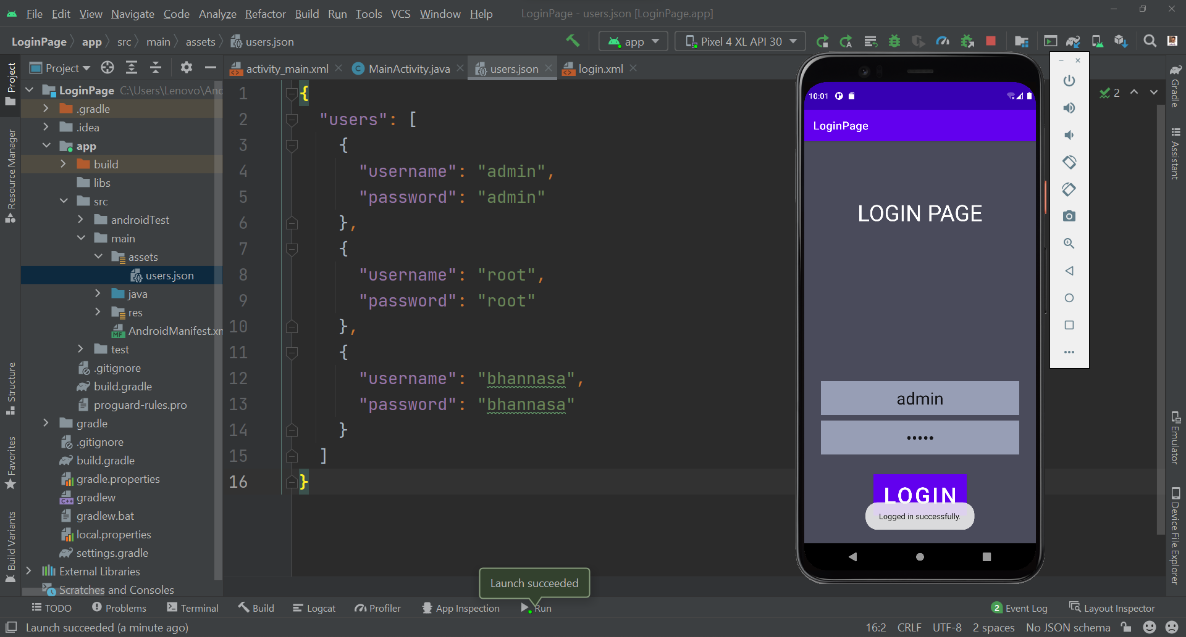

With invalid **password** or **username:**

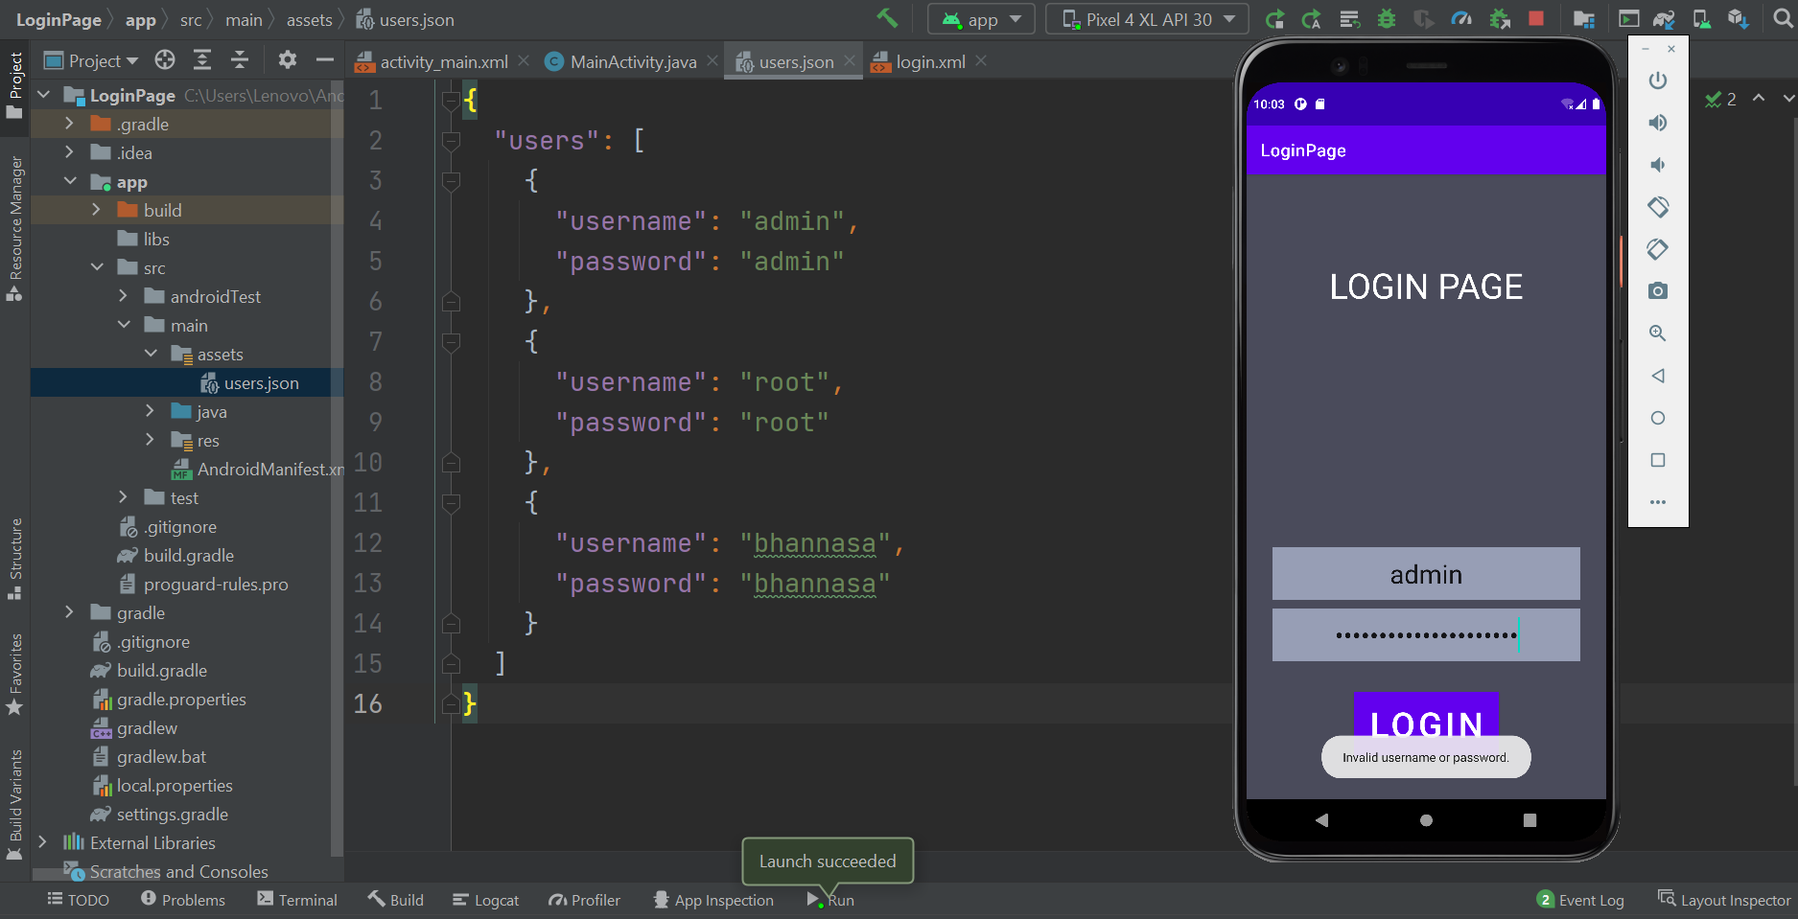

MainActivity.java

package com.example.loginpage;  
  
import androidx.appcompat.app.AppCompatActivity;  
  
import android.content.Context;  
import android.os.Bundle;  
import android.util.Log;  
import android.view.View;  
import android.widget.Button;  
import android.widget.TextView;  
import android.widget.Toast;  
  
import org.json.JSONArray;  
import org.json.JSONObject;  
  
import java.io.IOException;  
import java.io.InputStream;  
  
public class MainActivity extends AppCompatActivity {  
 private static final String *TAG* = "tag123";  
 public static String getAssetJsonData(Context context) {  
 String json = null;  
 try {  
 InputStream is = context.getAssets().open("users.json");  
 int size = is.available();  
 byte[] buffer = new byte[size];  
 is.read(buffer);  
 is.close();  
 json = new String(buffer, "UTF-8");  
 Log.*i*(*TAG*, "success");  
 } catch (IOException ex) {  
 ex.printStackTrace();  
 Log.*i*(*TAG*, ex.toString());  
 return null;  
 }  
 return json;  
 }  
 @Override  
 protected void onCreate(Bundle savedInstanceState) {  
 super.onCreate(savedInstanceState);  
 setContentView(R.layout.*login*);  
  
 TextView username = (TextView) findViewById(R.id.*username*);  
 TextView password = (TextView) findViewById(R.id.*password*);  
  
 Button loginButton = (Button) findViewById(R.id.*loginButton*);  
 loginButton.setOnClickListener(new View.OnClickListener() {  
 @Override  
 public void onClick(View view) {  
 try{  
 String usersJSON = *getAssetJsonData*(getApplicationContext());  
 JSONObject obj = new JSONObject(usersJSON);  
 JSONArray users = obj.getJSONArray("users");  
 String usernameVal = username.getText().toString();  
 String passwordVal = password.getText().toString();  
 boolean found = false;  
 for(int i = 0; i < users.length(); i++){  
 String _username = users.getJSONObject(i).getString("username");  
 String _password = users.getJSONObject(i).getString("password");  
 if(_username.equals(usernameVal) && _password.equals(passwordVal)){  
 found = true;  
 }  
 }  
 if(found){  
 Toast.*makeText*(MainActivity.this, "Logged in successfully.", Toast.*LENGTH_SHORT*).show();  
 }else{  
 Toast.*makeText*(MainActivity.this, "Invalid username or password.", Toast.*LENGTH_SHORT*).show();  
 }  
 }catch (Exception e){  
 Log.*i*(*TAG*, "onClick: error");  
 }  
 }  
 });  
 }  
}

users.json

{  
 "users": [  
 {  
 "username": "admin",  
 "password": "admin"  
 },  
 {  
 "username": "root",  
 "password": "root"  
 },  
 {  
 "username": "bhannasa",  
 "password": "bhannasa"  
 }  
 ]  
}

login.xml

<?xml version="1.0" encoding="utf-8"?>  
<androidx.constraintlayout.widget.ConstraintLayout xmlns:android="http://schemas.android.com/apk/res/android"  
 android:layout_width="match_parent"  
 android:layout_height="match_parent"  
 android:background="#4A4B5B"  
 xmlns:app="http://schemas.android.com/apk/res-auto">  
 <TextView  
 android:layout_width="wrap_content"  
 android:layout_height="wrap_content"  
 app:layout_constraintLeft_toLeftOf="parent"  
 app:layout_constraintRight_toRightOf="parent"  
 app:layout_constraintTop_toTopOf="parent"  
 android:layout_marginTop="100dp"  
 android:gravity="center"  
 android:textSize="40sp"  
 android:textAllCaps="true"  
 android:textColor="@color/white"  
 android:text="Login page"  
 />  
 <LinearLayout  
 android:layout_width="match_parent"  
 android:layout_height="wrap_content"  
 android:orientation="vertical"  
 android:gravity="center"  
 app:layout_constraintBottom_toBottomOf="parent"  
 android:layout_marginBottom="50dp"  
 >  
 <EditText  
 android:id="@+id/username"  
 android:layout_width="wrap_content"  
 android:layout_height="wrap_content"  
 android:gravity="center"  
 android:ems="10"  
 android:inputType="text"  
 android:background="#979EB5"  
 android:hint="username"  
 android:layout_margin="5dp"  
 android:padding="10dp"  
 android:textSize="30sp"  
 />  
 <EditText  
 android:id="@+id/password"  
 android:layout_width="wrap_content"  
 android:layout_height="wrap_content"  
 android:gravity="center"  
 android:layout_weight="0.3"  
 android:ems="10"  
 android:inputType="textPassword"  
 android:background="#979EB5"  
 android:hint="password"  
 android:layout_margin="5dp"  
 android:padding="10dp"  
 android:textSize="30sp"  
 />  
 <Button  
 android:layout_width="wrap_content"  
 android:layout_height="wrap_content"  
 android:textSize="40sp"  
 android:background="@color/purple_200"  
 android:layout_marginTop="30dp"  
 android:id="@+id/loginButton"  
 android:text="Login"  
 />  
 </LinearLayout>  
</androidx.constraintlayout.widget.ConstraintLayout>