PrivaSure – Sales Enablement Inputs
Oct 12, 2026 · @Mridul
Hi Gaurav, here's where PrivaSure stands against each of your questions. I've gone through the codebase, our internal docs and the email trail. Anything marked Not done yet is something we don't have in place yet.

1. What is live today, available through configuration, in pilot or on the roadmap?
To be upfront: PrivaSure isn't in the market yet, and it isn't on our production environment. That said, the product is built and working, so if a client wants to use it, we can run it for them. Its de-identification engine is also already running inside HealthLLM Fabric, which is on production.
What PrivaSure does today
It de-identifies structured healthcare data (CSV and Excel files) using three methods, which together give around 15 techniques:
- HIPAA Safe Harbor: removal, redaction, masking, obfuscation and generalisation of the 18 identifier types.
- Expert Determination: order, date, interval, encoding and redaction hierarchies, plus an automatic mode.
- Custom privacy models: k-anonymity (Datafly and Mondrian), l-diversity and t-closeness.
Around that, we have:
- PHI detection: column names, pattern matching and NLP (spaCy) to pick up identifiers in free-text fields.
- Ready-made EHR mappings: Epic Clarity, Oracle Cerner and Athenahealth column layouts, so hospital exports can be mapped quickly.
- Proof of de-identification: every output file carries a hidden signature and fingerprint, and it can be checked later through a verification page or QR code.
- Re-identification risk assessment: a separate tool that checks uniqueness and k/l/t thresholds, simulates linkage attacks and produces a PDF report.
Status by category
Status | What sits here
Live (through HealthLLM Fabric) | Safe Harbor de-identification of clinical text, images and PDFs, inside the Fabric privacy firewall
Built and ready to use (not on production) | All three methods above, PHI detection, EHR mappings, signature verification, risk report
Available through configuration | Choice of method and technique per column, k / l / t thresholds, EHR source system
In pilot | No active pilots.
Roadmap | PrivaSure v2 (in development), a direct PrivaSure connection inside MarketPlace (today a MarketPlace request is handled manually by our team), sandbox environments for payers and providers (Not implemented), a formal expert sign-off workflow (Not implemented; the "expert signature" in our docs is a file watermark, not a human sign-off)

2. Latest architecture and security materials (data flows, hosting, integrations, access controls, approvals and responsibilities)
Hosting. PrivaSure runs on Microsoft Azure. The web app sits on Azure Static Web Apps, and the three engines (Safe Harbor, Expert Determination, Custom) each run as their own Azure App Service. It's built in Python with a React front end.
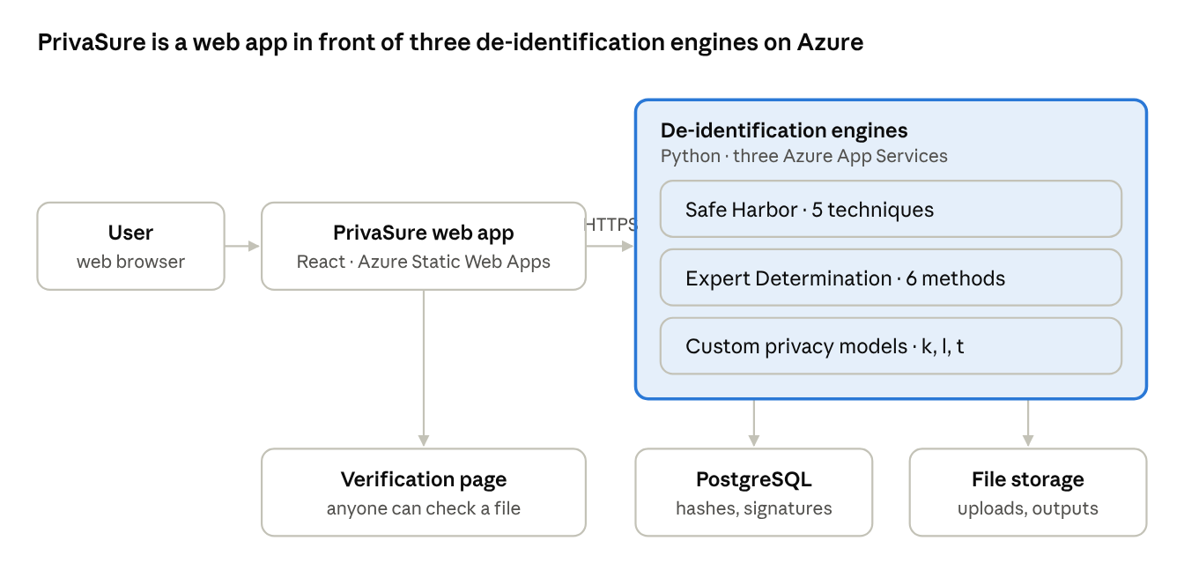
PrivaSure architecture · drawn from the current codebase
We didn't have an up-to-date PrivaSure architecture diagram, so I've drawn this one from the code. PHI detection (patterns plus spaCy NLP) runs inside each engine.
How data flows through it
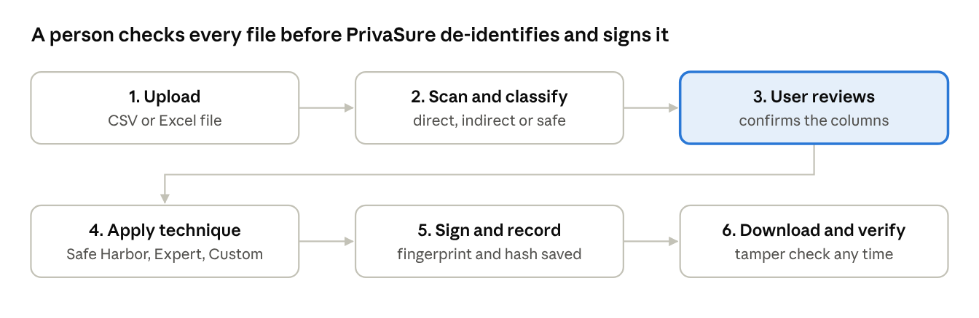
PrivaSure data flow · 6 steps
Step 3 is the safeguard: nothing gets de-identified until a person has confirmed which columns are identifiers.
Security in place today
- All traffic is over HTTPS (TLS 1.2 / 1.3).
- Outputs carry SHA-256 / HMAC fingerprints for integrity checks.
- Processing activity is written to an audit trail.
Being hardened before production (please keep these out of buyer material for now)
- Proper user login and role-based access (Not implemented).
- Encryption of stored files and managed key storage with Azure Key Vault (Not implemented; in the deployment plan only).
- Persistent, secure file storage (Not implemented).
These are on the PrivaSure 2.0 compliance checklist Rameez shared in May.
Integrations. It has the EHR column mappings mentioned above, and its engine is embedded in HealthLLM Fabric. There are no live EHR / FHIR connections and no API link with MarketPlace yet.
Approvals and responsibilities (who signs off a de-identified dataset, and what's on the client vs. on us): Synapsehealthtech signs off the de-identified data against set rules of de-identification in safe harbor and expert determination.

3. Which certifications, customer examples and measured product outcomes are verified and approved for external use?
Certifications:We don't hold SOC 2, ISO 27001 or HITRUST yet. PrivaSure is built around the HIPAA Safe Harbor and Expert Determination methods, and it's fine to say that. But please don't call it "HIPAA certified" or "HIPAA compliant" in the collateral.
Customer examples:
Measured outcomes: Our internal docs mention a PHI detection rate above 95% and processing at 500–1,000 records per second (Not implemented as a tested benchmark).

4. Pricing and implementation cost inputs, along with customer baselines or results for the business value document
Pricing: TBD
Implementation cost inputs. Here's what we do have:
- Hosting: TBD
- Setup effort: TBD
- Client-specific effort (data mapping, onboarding, support): TBD
Business value angles we've been using
- Data as a revenue stream: de-identified data can be licensed or shared
- Sandboxes: payers and providers can give researchers safe access without exposing PHI.
Customer baselines or results:

