Screen 1:

|  |  |  |  |  |
| --- | --- | --- | --- | --- |
| **Samastha Glocal** | **About us**  Core Values | **Services**  Website Dev  Mobile App Dev  DevOps Trans  Cloud & Migration  Data Analytics  Maintenance | **Industries**  Fin Tech  Healthcare  Insurance  Retail/E-commerce  Transportation & Logistics | **Contact** |

Some text to showcase motive/highlights of the company. (This text will be on the picture.)

**We help our clients with:**

|  |  |
| --- | --- |
| (a small icon) Website Development | (a small icon) Mobile App Development |
| (a small icon) DevOps Transformation | (a small icon) Cloud & Migration services |
| (a small icon) Data Analytics | (a small icon) Maintenance & Support |

Eg: 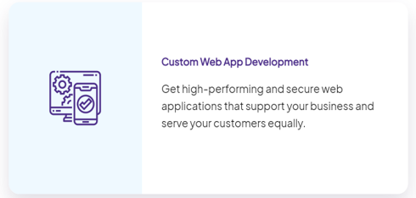

**Our Business values:**

|  |  |  |
| --- | --- | --- |
| Digitalization | Lightbulb  Innovative approach | Bullseye  Result oriented approach |
| Enhanced Customer Experience | Accountability | Head With Gears  Strategy |

Footer:

Quick links Countries Services Contact: email & phone num

About us:

On a picture, below text:

A blend of talent, expertise, and wisdom.

|  |
| --- |
| Who we are |
| Information/description about Samastha and team |

About us => Core Values:

|  |  |
| --- | --- |
| (a small icon) Process Driven | (a small icon) Out of the box thinking |
| (a small icon) Collaborative | (a small icon) Committed |
| (a small icon) We are Agile | (a small icon) Integrity |