# 

Table of Contents

1. Code Completion and Context: 2

2. Chat Interface: 4

3. Ghost Text and Code Generation: 5

4. Inline Chat and Collaboration: 7

5. Best Practices and Dos and Don’ts: 7

6. Security and Privacy Considerations: Unauthorized Code Access 9

7. Game Screenshots 11

# 1. Code Completion and Context:

* **Open relevant files in your project.**
* **Write a code snippet where you need assistance (e.g., a function, class, or method).**
* **Observe how GitHub Copilot provides code suggestions based on the context.**
* **Take a screenshot of the code suggestion and include it in your assignment document.**

**Screenshots showing the GitHub copilot providing suggestions:**

# 2. Chat Interface:

* **Use the chat interface within GitHub Copilot to ask for help with a specific coding problem.**
* **Describe the problem briefly and capture a screenshot of the chat interaction.**
* **Explain how the chat interface assisted you in solving the problem.**

**Screenshots showing the GitHub chat interface:**

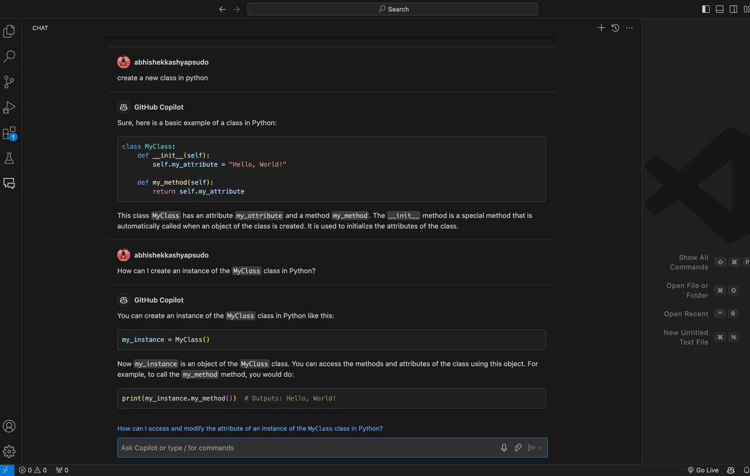

**Problem**

As a Java developer, this was my first time using Python. I was unsure about how to create classes and read/write files in Python.

**How Chat Interface assisted me in the problem:**I asked the chat interface how to create classes in Python and save scores to a file. The GitHub chat interface promptly provided code snippets and thorough explanations on how to achieve these tasks.

# 3. Ghost Text and Code Generation:

* **Write a comment or placeholder in your code (ghost text).**
* **Observe how GitHub Copilot generates code based on the ghost text.**
* **Provide an example of ghost text usage and include the generated code.**
* **Explain how this feature can improve your coding efficiency.**

**Screenshots showing the GitHub Copilot generating ghost text on the basis of comments/placeholder:**

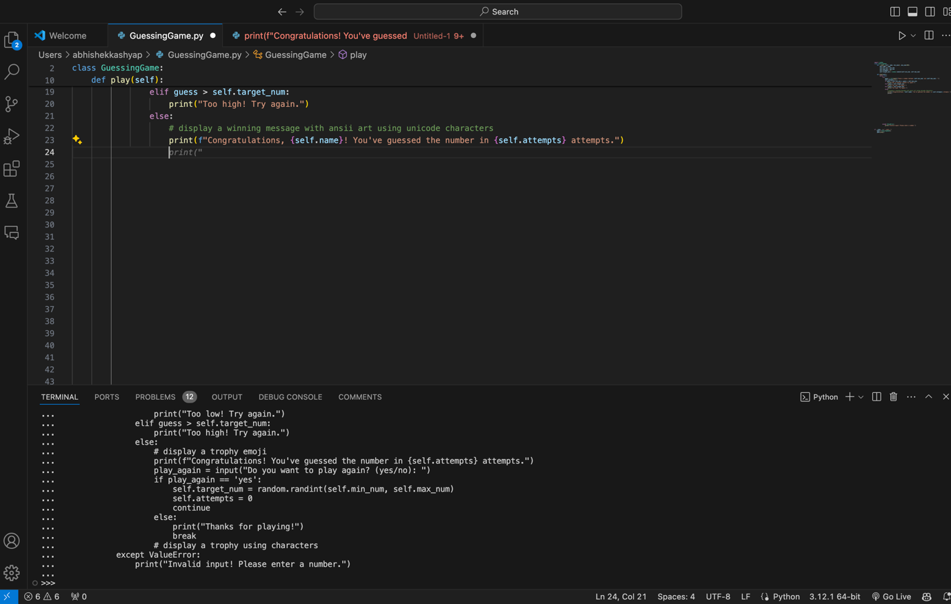

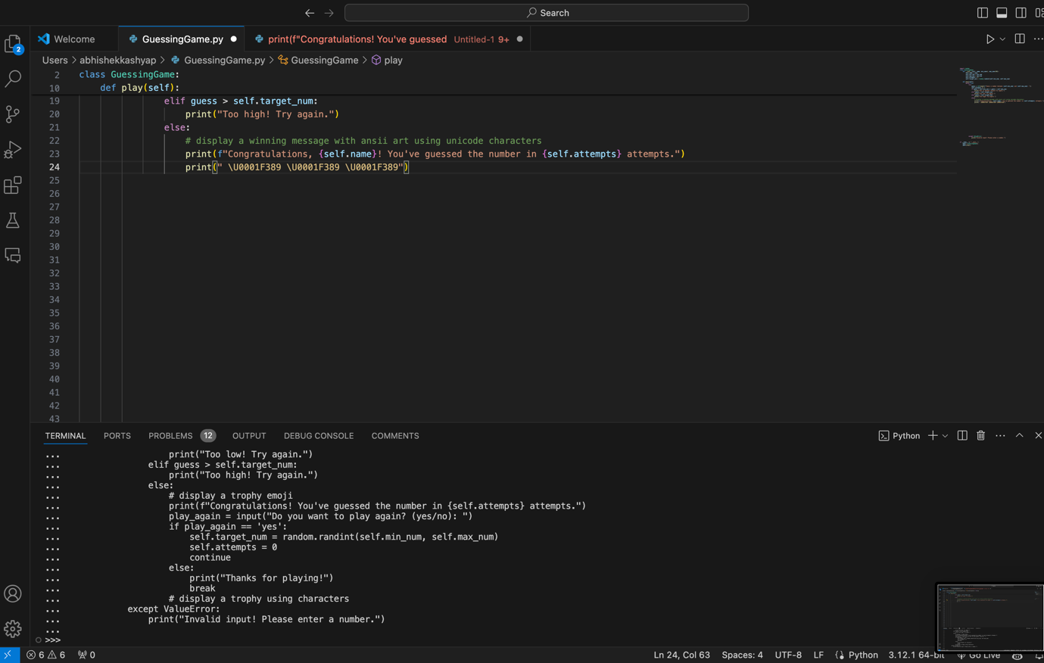

* **Explain how this feature can improve your coding efficiency.**

This feature was incredibly helpful while writing my code. As soon as I started coding and adding comments or placeholders to outline my strategy, GitHub Copilot quickly provided relevant suggestions. This significantly increased my development speed and decreased the likelihood of missing any critical scenarios while planning the solution.

# 4. Inline Chat and Collaboration:

* **Collaborate with a colleague or friend using GitHub Copilot’s inline chat.**
* **Share code snippets, discuss solutions, and make real-time edits.**
* **Describe your experience with inline chat and its benefits.**

# 5. Best Practices and Dos and Don’ts:

* **Research best practices for using GitHub Copilot.**
* **List at least three dos and three don’ts when working with the tool.**
* **Explain why following these practices is essential.**
* **Research best practices for using GitHub Copilot.**

1. Don’t rely blindly on suggestions. Always review and understand the code Copilot generates.
2. Treat Copilot as a tool to enhance your productivity, not replace your coding skills.
3. Keep up with the latest updates and improvements to GitHub Copilot to make the most of new features and capabilities.

* **List at least three dos and three don’ts when working with the tool.**

**Dos**

1. Always review the code suggestions to ensure they meet your project’s requirements and follow best practices.
2. Use comments and placeholder text to guide Copilot in generating code that fits your specific needs.
3. Leverage Copilot for repetitive or boilerplate code to save time and reduce errors.

**Don’ts**

1. Don’t rely solely on Copilot for critical code without understanding and verifying it yourself.
2. Avoid using generated code that could introduce security vulnerabilities without thorough review.
3. Don’t use Copilot to generate code for sensitive or proprietary algorithms without careful consideration and review.

* **Explain why following these practices is essential.**

1. By reviewing and understanding the generated code, you ensure that it meets quality standards and is maintainable.
2. Following best practices helps prevent introducing security vulnerabilities through automatically generated code.
3. Using Copilot for appropriate tasks like boilerplate code can significantly enhance productivity, allowing developers to focus on more complex aspects of their projects.
4. By customizing suggestions and reviewing generated code, developers can learn and improve their coding skills, rather than becoming overly dependent on the tool.

# 6. Security and Privacy Considerations: Unauthorized Code Access

* **GitHub Copilot may inadvertently generate code that exposes sensitive information, such as authentication tokens or API keys.**
* **Discuss the risks associated with exposing such information in code comments.**
* **Explain the potential impact if an unauthorized person gains access to these tokens.**
* **Propose preventive measures to avoid accidental exposure.**
* **Discuss the risks associated with exposing such information in code comments.**

1. GitHub Copilot may inadvertently suggest code that includes sensitive information such as authentication tokens or API keys, especially if it learns from public code repositories that contain such data.
2. If these tokens or keys are exposed in code comments, anyone with access to the code can potentially see and misuse them, leading to security breaches.
3. Sensitive information exposed in comments can be inadvertently copied into other parts of the codebase or shared publicly, further increasing the risk of unauthorized access.

* **Explain the potential impact if an unauthorized person gains access to these tokens.**

1. If an unauthorized person gains access to authentication tokens or API keys, they could gain unauthorized access to your services, APIs, or databases, leading to data breaches.
2. Exposed tokens can be used to steal sensitive data, compromising user privacy and organizational security.
3. Data breaches can result in significant legal repercussions and non-compliance with data protection regulations, potentially leading to fines and legal action.

* **Propose preventive measures to avoid accidental exposure.**

1. **Review and Filter Suggestions**:
   1. Always review the code suggestions provided by GitHub Copilot. Ensure no sensitive information is included before integrating the code into your project.
   2. Use specific comments and placeholders to guide Copilot’s suggestions, avoiding any references to actual sensitive data.
2. **Environment Variables**:
   1. Store sensitive information like API keys and tokens in environment variables rather than hard-coding them in the code.
   2. Use configuration management tools to handle environment variables securely.
3. **Code Scanning and Auditing**:
   1. Implement automated code scanning tools to detect and alert for any hard-coded sensitive information in your codebase.
   2. Conduct regular code audits to ensure that no sensitive information is exposed.
4. **Access Control**:
   1. Restrict access to the code repository to only those who need it. Use role-based access control to minimize the risk of unauthorized access.
   2. Monitor access logs and set up alerts for any unusual access patterns to the repository.
5. **Education and Awareness**:
   1. Educate developers about the risks of exposing sensitive information and best practices for handling it securely.
   2. Provide clear documentation on how to manage and store sensitive data properly within the organization’s coding standards.

# Game Screenshots

