README:

The project WfsNotes is a single page application build in Angular Js.

1. <http://localhost:2532/MyNotes.html>

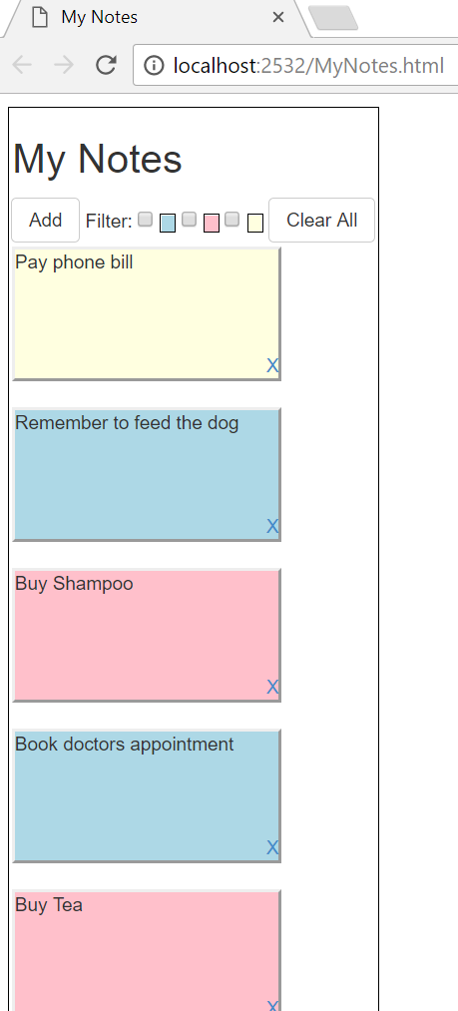

* It displays the list of notes.
* Note is sorted in the way its added.
* On selection of filters the notes of that particular colour gets filtered.
* On click on “Add” button a popup will appear to add a note.

Popup screen as below:

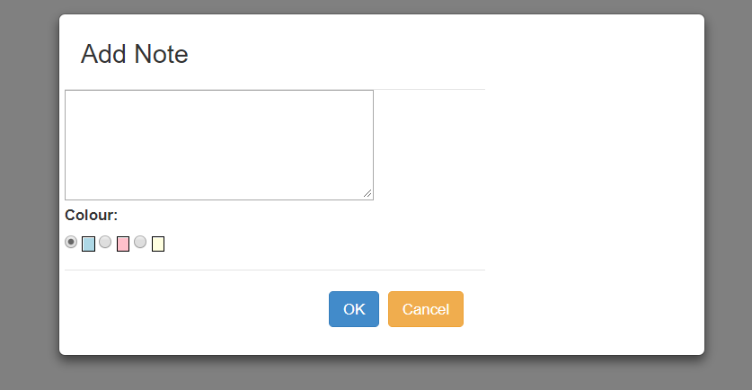

* Enter the note and select the colour, by default blue is selected.
* Press Cancel if you don’t want to save this note.
* Press Ok to save the note, and the note appears on the parent page.

Extra feature:

* Every note has a “X”, on click of which you can delete the note
* There is also a “Clear All” button on top to clear all the notes.