Building At Chembur.

1. Project Information
- Project Name: Gami Jaydeep Estella
- Location: Chembur, Mumbai
- Plot Area: 1685 sq.mt.
- Built-up Area: 200000 sq.ft.
- Project Type: High-rise residential /retail redevelopment
- Client/Developer: Gami Jaydeep
- Architect: Wall Voids Architects
- Status: On Going- Finishing stage.

Project Overview and Concept
The project is conceived as a contemporary residential tower that combines efficient planning, climate-responsive design and integrated greenery. A well-designed commercial base creates an active and welcoming relationship with the surrounding urban environment, accommodating retail outlets, cafés, services, the main entrance, building support functions and parking access. Carefully planned frontage, shaded walkways and a clearly defined arrival zone help establish a vibrant and pedestrian-friendly street edge.
Above the commercial spaces, the residential floors follow a clear structural and façade rhythm. Recessed balconies provide shaded outdoor extensions to the living spaces, while screens, projecting frames and deep openings offer protection from Mumbai’s sun and monsoon rain. Landscaped terraces and shared rooftop amenities provide spaces for recreation, wellness and informal gathering.
The architectural concept, “Vertical Garden Frame,” organizes the tower as a composition of slender vertical frames rising above a well-integrated commercial base. Strong fins emphasize height and give the façade visual order, while a central glazed bay, recessed balconies and planted ledges reduce the apparent mass of the building.
The commercial spaces form the active public layer of the project. Their transparent façades, visible entrances and flexible layouts support retail, cafés, services and other neighbourhood-oriented uses. This creates a lively urban edge while maintaining a clear separation between public commercial activity and the private residential areas above.
The design becomes progressively lighter and greener as it rises. Integrated planting extends from private balconies to elevated terraces and rooftop amenities, creating a continuous relationship between architecture, landscape and everyday residential life.
The building is organized into three primary components: a vibrant and human-scaled commercial base, an efficient residential tower and a distinctive upper profile. A restrained palette of light-toned frames, warm soffits, glazing and greenery reinforces its contemporary character while maintaining a calm and uncluttered appearance.
Together, these elements create a climate-responsive metropolitan landmark that is active at street level, ordered through its vertical form and softened by an elevated landscape.

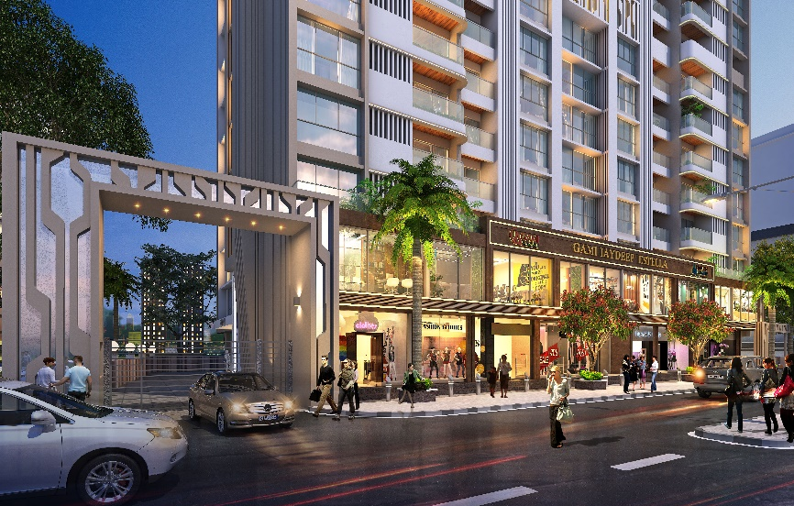
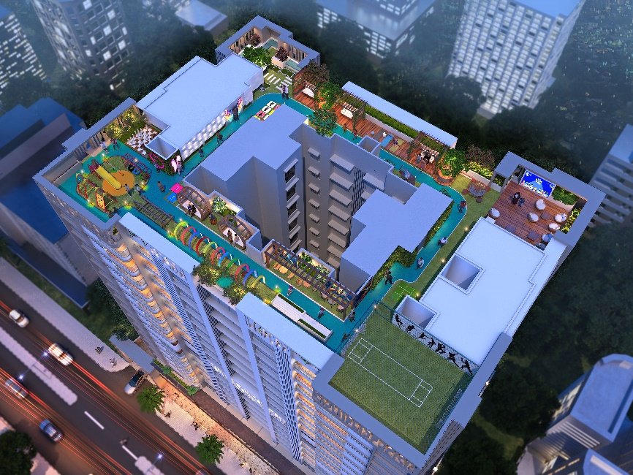
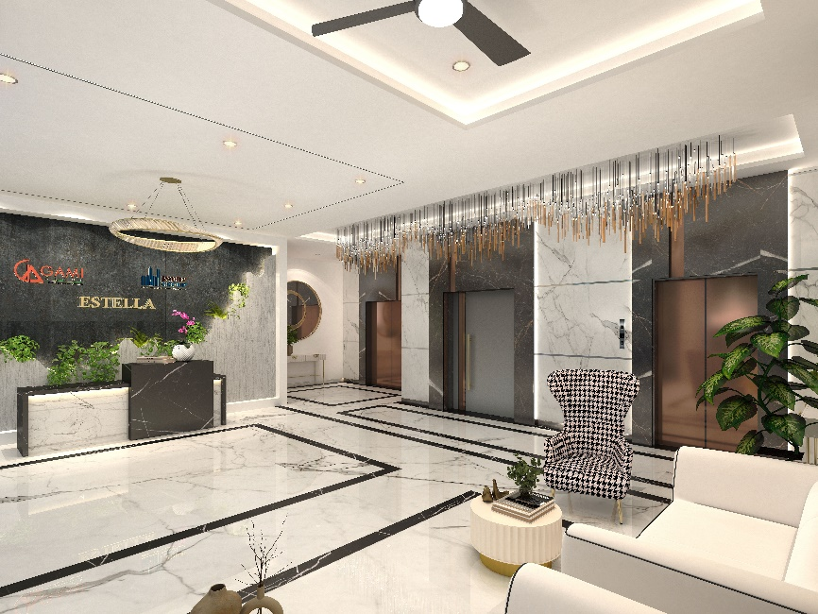
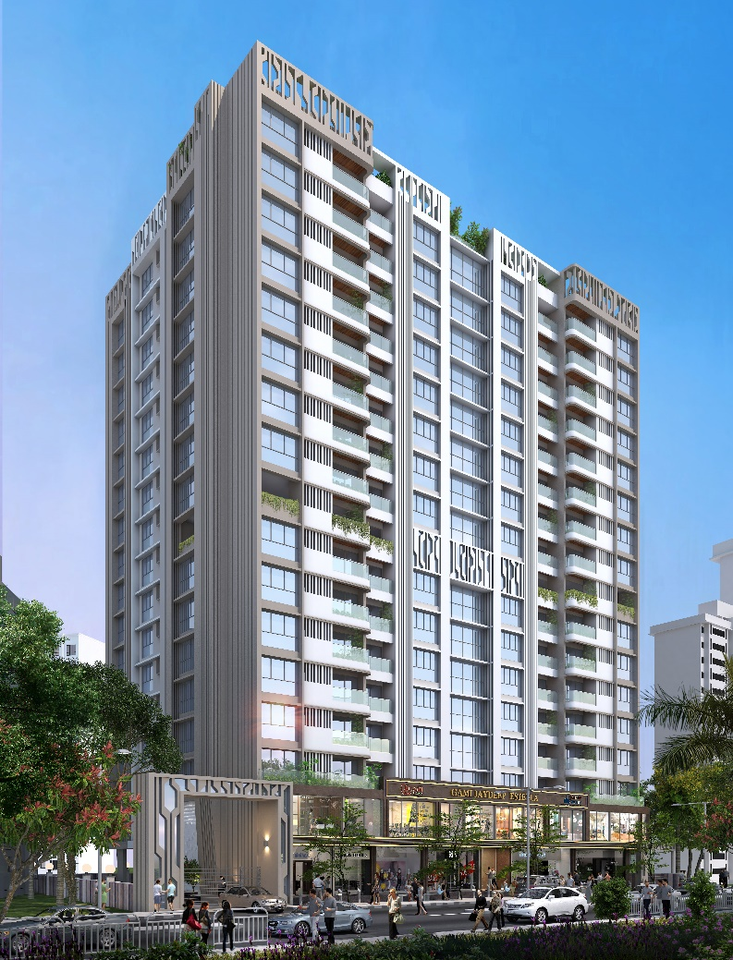
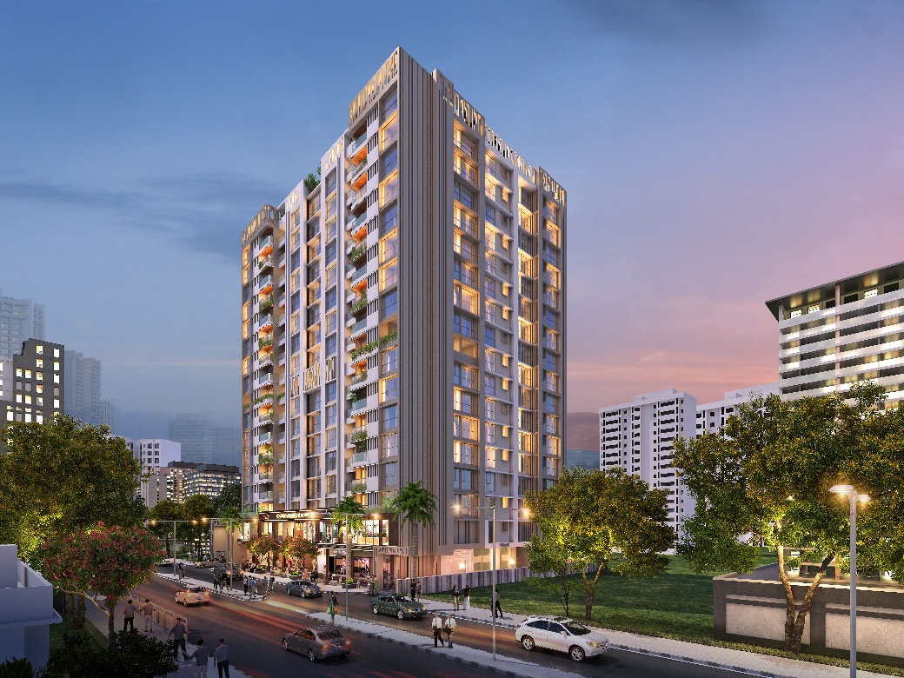
Image 3
Image 2
Image 1
Image 4
Image 5

