Building At Khar.

1. Project Information
- Project Name: Transindia Celeste
- Location: Khar, Mumbai
- Plot Area: 2307 sq.mt.
- Built-up Area: 211040 sq.ft. (approx.)
- Project Type: High-rise residential /retail redevelopment
- Client/Developer: Transindia Group
- Architect: Wall Voids Architects
- Status: Approval stage

Project Overview and Concept

The Celeste is envisioned as a contemporary mixed-use residential tower in Khar, Mumbai, combining premium urban living with an active commercial frontage. A transparent, illuminated ground floor accommodates retail spaces and a clearly defined residential entrance, creating a lively and welcoming street edge.

The residential floors feature broad balconies, generous glazing and integrated planters that extend the living spaces while providing shade, natural ventilation and greenery. Rounded balcony edges soften the building’s mass, while vertical glazed bays and dark louvered screens emphasize height and establish a clear façade rhythm. Recessed openings and projecting elements respond to Mumbai’s intense sunlight and monsoon rain, giving the tower a refined, climate-responsive identity.

Concept — Sunset Living Terraces

The concept, “Sunset Living Terraces,” is inspired by Khar’s relaxed yet vibrant urban lifestyle. Generous sundecks and continuous balconies extend the residences outdoors, creating comfortable spaces to unwind, socialize and enjoy Mumbai’s evening sky.

Curved balcony edges, integrated greenery and protective overhangs provide shade, privacy and shelter from seasonal rain. These elevated terraces transform the façade into a layered vertical community, celebrating open-air living and the experience of spending evenings outdoors within the city.

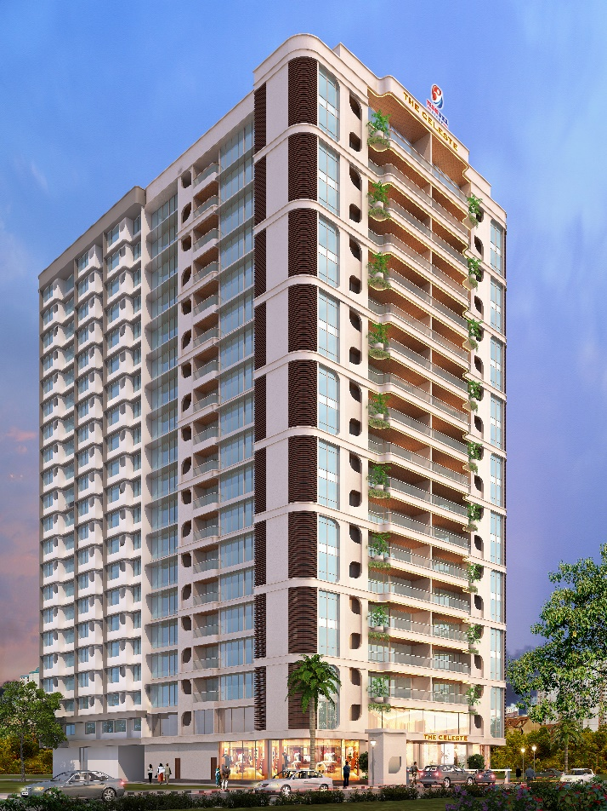  Image 1 | 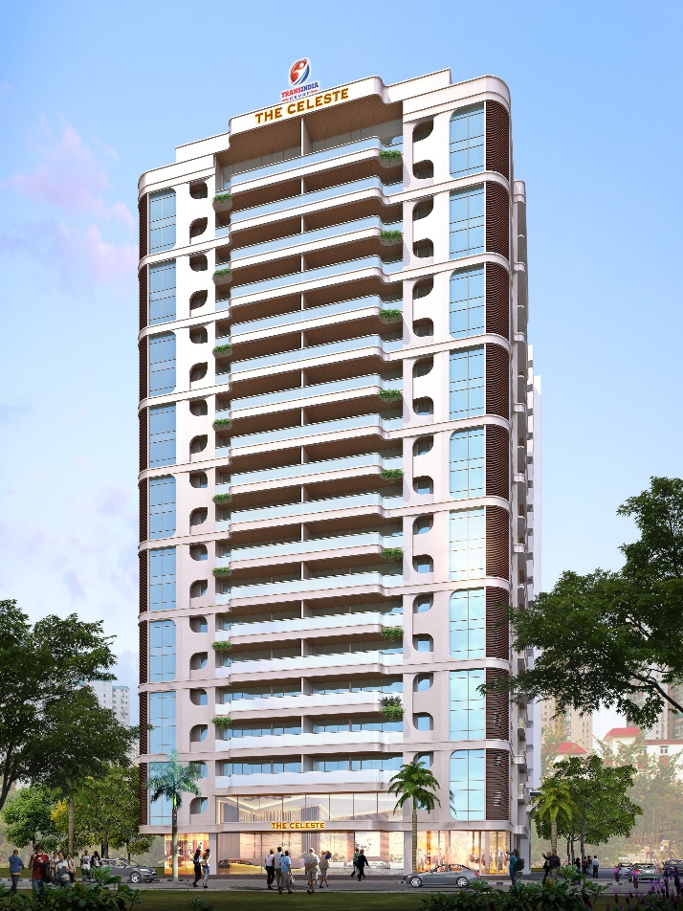  Image 2
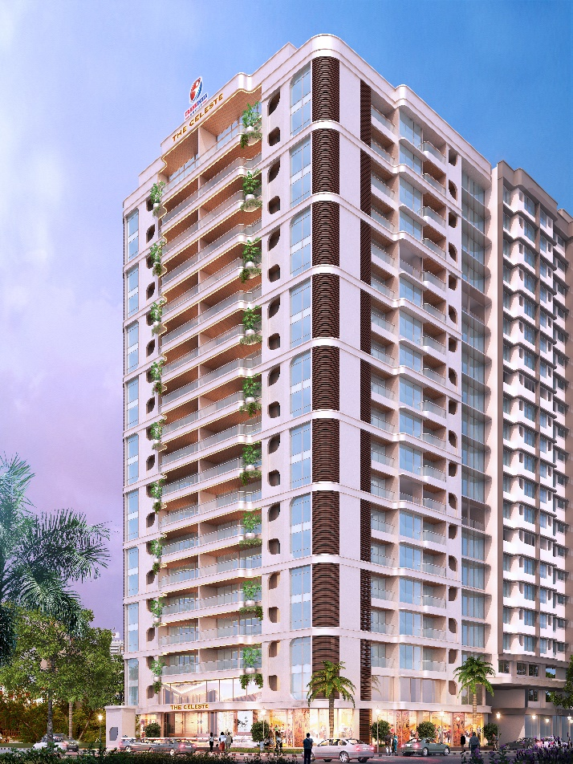  Image 3 | 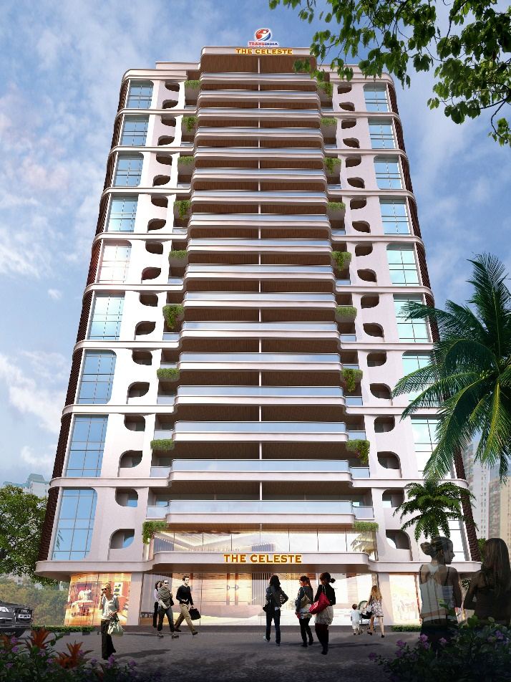  Image 4

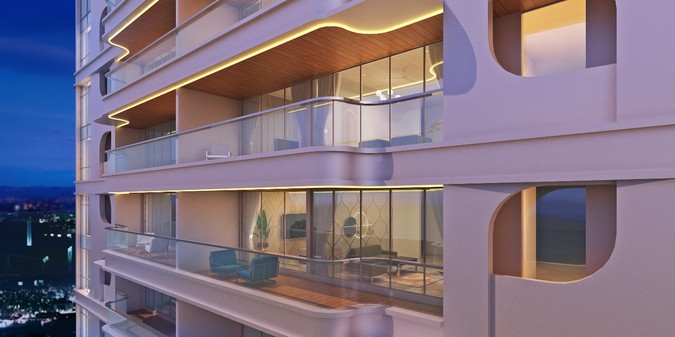
Image 5. Terrace.

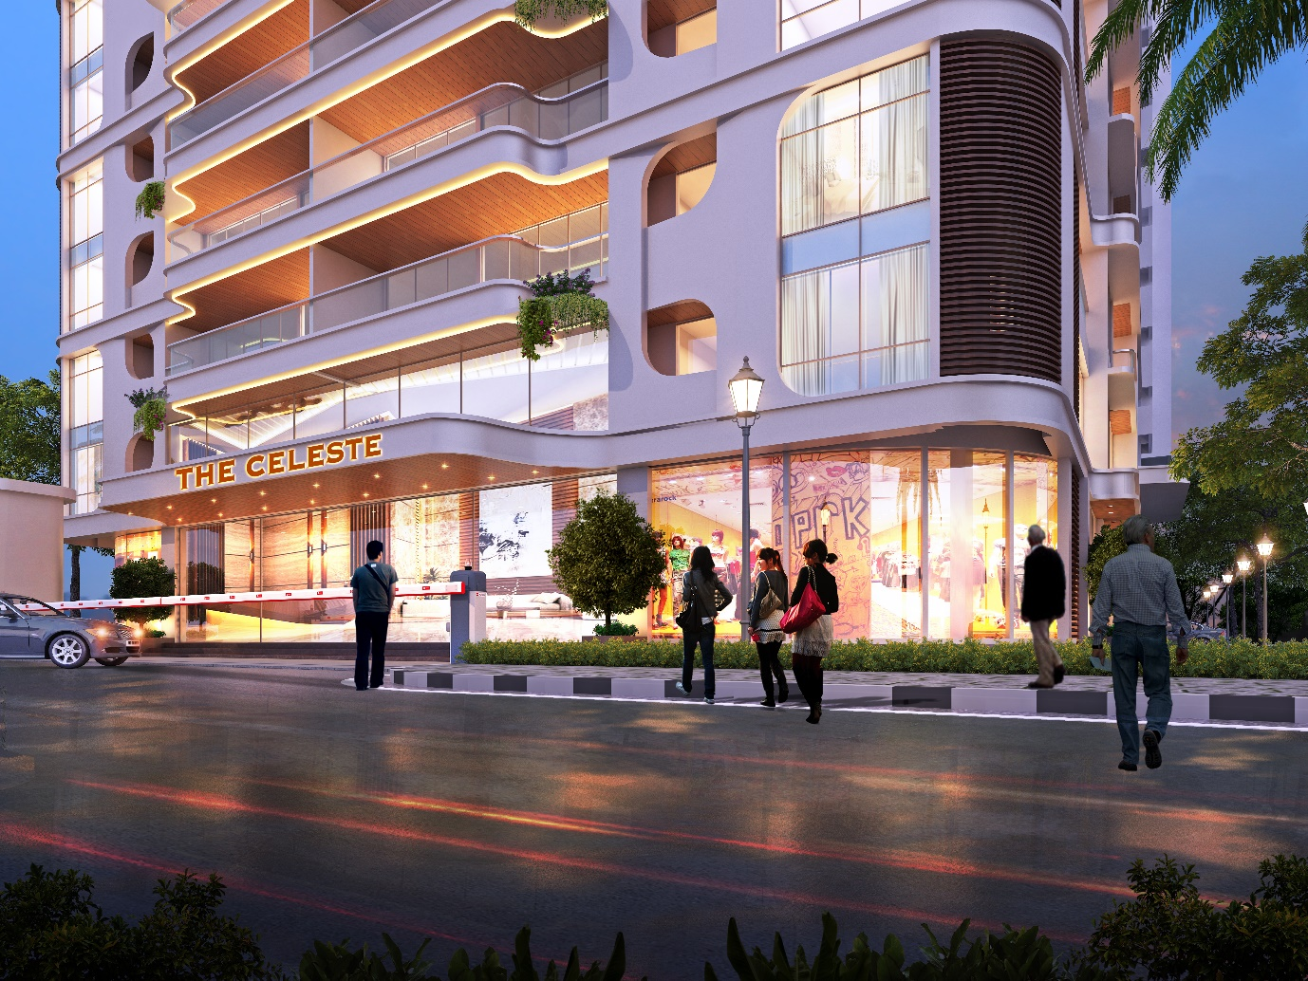
Image 6. Entrance Gate Night

