Prince Tower.

1. Project Information
- Project Name: Prince Tower
- Location: Dharavi, Mumbai
- Plot Area: 2115 sq.ft.
- Built-up Area: 101220 sq.ft. (Sale Building)
- Project Type: High-rise residential redevelopment
- Client/Developer: Punit Construction
- Architect: Wall Voids Architects
- Status: Completed

2. Project Overview & Design Concept
Prince Tower is a high-rise residential redevelopment planned within an existing structural framework, with the original plinth and columns retained and integrated into the new design. Instead of rebuilding, the project focuses on improving the residential planning, circulation, façade and overall architectural identity within the existing structure.
The planning provides five residences on a typical floor, arranged around a central core with four lifts. Separate staircases provide circulation and fire safety, while two open-to-sky courts bring natural light and ventilation into the apartments. A wide lift lobby and connecting passages create a more comfortable circulation experience.
The apartments feature curved external edges inspired by the form of lotus petals. These petal-like curves shape the building's distinctive form while allowing the existing structural grid to be adapted into more fluid and efficient layouts.
The façade continues this idea through continuous curved balcony bands, which soften the vertical scale of the tower and create a flowing architectural expression. White structural frames, large glazed areas and warm finishes give the building a clean and elegant character, while the curves create depth, movement and changing shadows throughout the day.
The design also aims to break the visual monotony of the surrounding buildings. Instead of following the straight and repetitive forms of the existing context, the lotus-inspired curves introduce a softer and more organic architectural language. This gives Prince Tower a distinctive presence and helps reshape the surrounding skyline.
A sculptural rooftop feature completes the composition and strengthens the building's identity

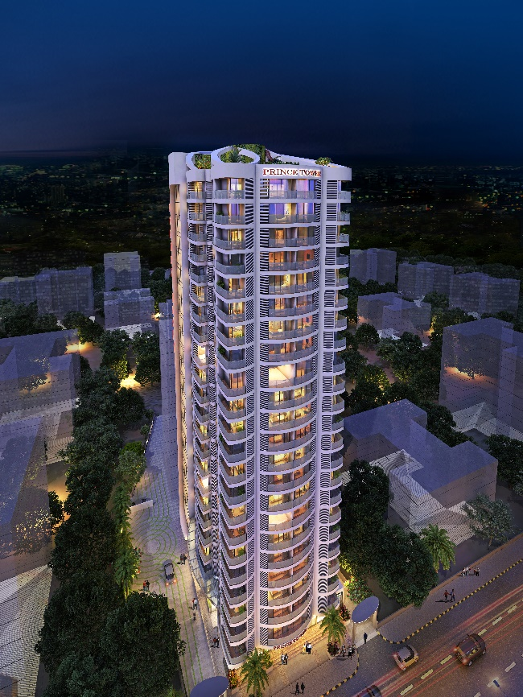
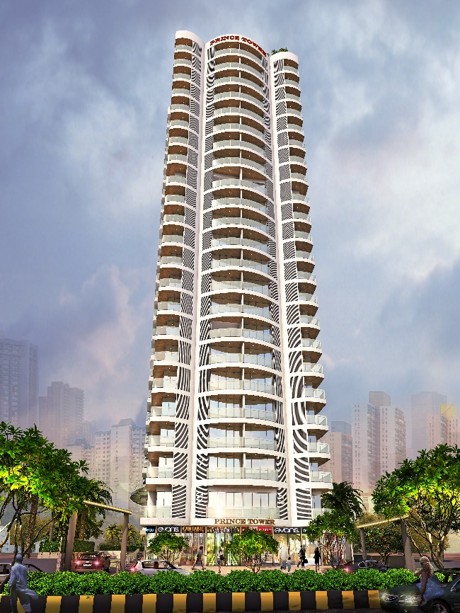
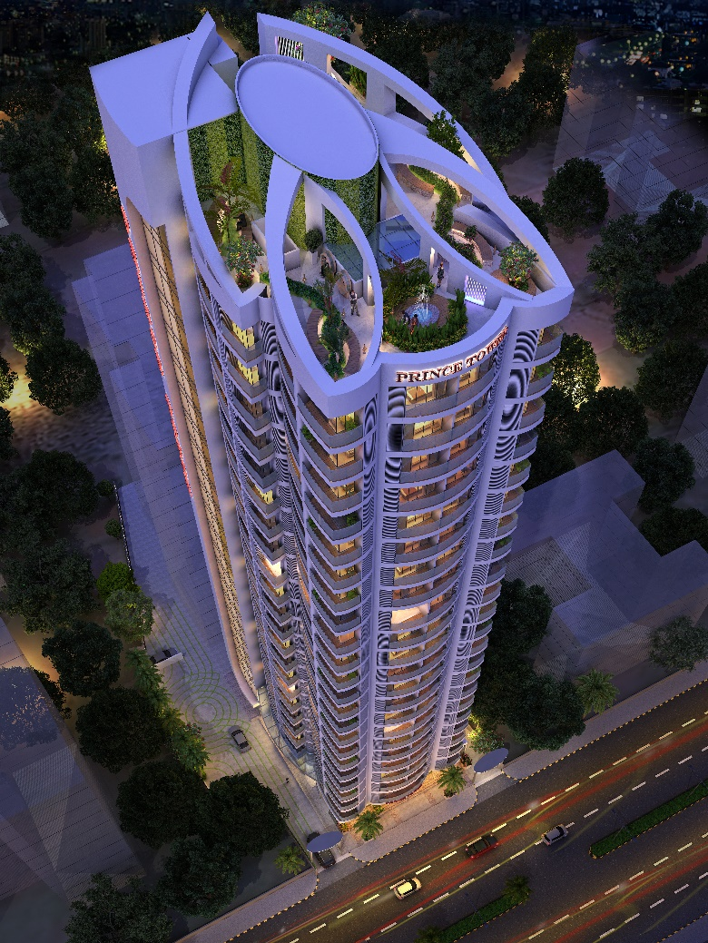
Image 1
Image 2
Image 3

