* Never Store Objects in database.
* Store these in special database called object database.
* Use CloudFront for CDN
* Object Store -> Storage -> S3
* Distribution -> CDN -> Cloudfront
* Distribution is costly. Optimize it.
* BE are dynamic, so we have to distribute it via edge networks.
* By default , s3 buckets are not accessible in public . You will have to create OAC and copy the policy in s3 bucket.
* Change domain of CDN

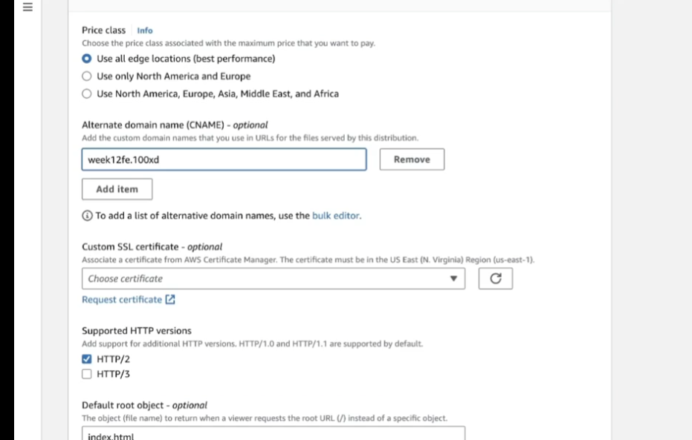

* AWS Certificate Manager will serve you certificate for HTTPS.
* Check for CNAME Record.