PROJECT SYNOPSIS
on
"FREELANCE BIDDING PLATFORM"
(A MERN Stack Based Web Application)
Submitted to [School / Department Name], [University Name]
in partial fulfillment of the requirement for the degree of
Bachelor of Computer Applications
Submitted by
[YOUR NAME]
{ Your Roll No. }
Under the Supervision Of
[Supervisor's Name]
School of Computer Applications
Academic Session 2025 - 26
[Your College / University Name]

Table of Contents
(Right-click below and choose "Update Field" in Word to generate page numbers.)
Table of Contents 1
1. Introduction 1
2. Modules and Page-wise Description 1
2.1 Common Module (Landing Page) 1
2.2 Admin Module 1
2.3 Client Module 1
2.4 User / Freelancer Module 1
3. Database Schema (MongoDB Collections / Mongoose Models) 1
3.1 Model: Admin 1
3.2 Model: User (Freelancer) 1
3.3 Model: Client 1
3.4 Model: Project 1
3.5 Model: Bid 1
3.6 Model: SubscriptionPlan 1
3.7 Model: Payment 1
3.8 Model: FinalDeal 1
3.9 Model: Notification 1
3.10 Model: Review 1
4. Entity Relationship Diagram (ERD) 1
5. Relationships Between Models 1
6. Forms and Form Controls Used 1
6.1 Registration Form (Client / Freelancer) 1
6.2 Login Form 1
6.3 Add Project Form (Client) 1
6.4 Place Bid Form (Freelancer) 1
6.5 Contact Us Form (Common Module) 1
7. Tools & Platform (MERN Stack) 1
7.1 Technology Stack 1
7.2 Suggested Project Structure 1
8. Project Flow 1

1. Introduction
The freelance economy has grown into one of the largest segments of the modern digital workforce, with platforms such as Upwork and Fiverr demonstrating that a well-designed bidding marketplace can connect clients who need work done with skilled freelancers who can do it, anywhere in the world. The Freelance Bidding Platform is built to serve exactly this need on a smaller, project-oriented scale: it is a dynamic, full-stack web application developed using the MERN stack (MongoDB, Express.js, React.js, and Node.js) that lets clients post projects, lets freelancers bid competitively for that work, and gives an administrator full control over users, projects, subscriptions, and disputes.
Traditionally, freelance-matching is done informally through personal networks, social media groups, or generic classifieds, which makes it hard to compare bids, verify freelancer credibility, or manage payments transparently. This project solves that problem by building a single, structured marketplace where every project, bid, and deal is stored as a document in a MongoDB collection rather than tracked manually. A client can publish a project in minutes; a freelancer can browse open projects and place a bid with a proposed price and timeline; and the client can compare all bids side-by-side before selecting the best freelancer for a final deal.
Architecturally, the project follows a standard three-tier MERN architecture. The MongoDB layer stores all persistent data as JSON-like documents, modeled through Mongoose schemas (covered in detail in Section 3 of this synopsis). The Express.js and Node.js layer forms the backend REST API, containing all business logic — for example, deciding which bids are still open, calculating a freelancer's bid ranking, or checking whether a client's subscription plan allows another active project. The React.js layer is the frontend single-page application: it consumes the REST API over HTTP/JSON and renders the Admin, Client, and Freelancer dashboards as interactive, component-based pages. This separation of concerns means the database schema, the API logic, and the user interface can each be developed, tested, and scaled independently, which is one of the biggest advantages of a modern MERN stack over a traditional server-rendered application.
The system is designed around three kinds of users. The Admin oversees the entire platform — approving users and clients, monitoring bidding activity, managing subscription plans, and resolving disputes. Clients register, subscribe to a plan, post projects, review incoming bids, and finalize a deal with the freelancer of their choice. Freelancers register, browse open projects, place competitive bids, and track the status of their bids. In the database layer, all three roles — Admin, Client, and Freelancer — are stored in a single Users collection, distinguished by a role field.
Because the project is built on the MERN stack, it also inherits a number of production-grade capabilities 'for free': Mongoose provides schema validation and safe query building against MongoDB; Express middleware combined with JSON Web Tokens (JWT) and bcrypt password hashing provides secure, stateless authentication for all three user roles; and React's component model, together with a state-management layer such as Redux Toolkit or the Context API, keeps the dashboards for Admin, Client, and Freelancer consistent and maintainable even as new features are added. This means a student developer can focus on designing the database schema, the bidding workflow, and the role-based dashboards — the parts that are genuinely specific to a bidding platform — rather than reinventing basic infrastructure such as login systems, routing, or form validation.
In summary, this project is not simply 'a website' but a role-based marketplace application. It demonstrates practical, industry-relevant skills — NoSQL database design, REST API development, JWT-based authentication, role-based access control, subscription and payment handling, and a competitive bidding workflow — while producing a genuinely useful, extensible deliverable comparable in spirit to real-world freelance marketplaces.

2. Modules and Page-wise Description
The system is divided into four functional modules — a Common module shared by all visitors, and three role-based modules for Admin, Client, and Freelancer — mirroring the three login options presented on the landing page. Within each module, the items below are listed in the same order in which they appear in the sidebar/dashboard navigation, so the structure described here matches the database schema in Section 3 exactly.

2.1 Common Module (Landing Page)
- Home: The public landing page introducing the platform, its value proposition, and calls-to-action to Register or Login.
- About: Overview of the platform, how the bidding process works, and who it is built for.
- Services: A summary of the categories of work supported on the platform (e.g., web development, design, writing).
- Pricing: Public-facing summary of the Basic, Standard, and Premium subscription plans (see Section 2.2).
- Contact: Contact details and a message form for visitor queries.
- Login: A single login entry point that authenticates the user and redirects to the Admin, Client, or Freelancer dashboard based on role.
- Register: Registration form for new Clients and new Freelancers (Admin accounts are seeded/created separately, not self-registered).

2.2 Admin Module
- Dashboard: Summary cards and charts showing total users, clients, active projects, open bids, and revenue at a glance.
- Manage Users (Freelancers): View Users, Approve Users, and Block/Delete Users — full moderation control over freelancer accounts.
- Manage Clients: View Clients, Approve Clients, and Delete Clients — moderation control over client accounts.
- Manage Projects: View Projects, Approve Projects, and Remove Projects — oversight of every project posted on the platform.
- Manage Subscription: Configure the Basic, Standard, and Premium plans and update their pricing, duration, and feature limits.
- Manage Bidding: View All Bids, Monitor Bids, and Resolve Issues — oversight and dispute-resolution tools for the bidding process.
- Payments: A record of all platform transactions: client payments, subscription payments, and freelancer payouts.
- Reports: Aggregate reports on user growth, project volume, bid activity, and revenue for a chosen date range.
- Logout: Ends the admin session.

2.3 Client Module
- Dashboard: Overview of the client's own active projects, open bids received, and upcoming deals.
- Profile: The client's editable profile: name, company, contact details, and profile photo.
- Add Project: A form to publish a new project with title, description, budget, category, and deadline.
- Manage Project: Edit, Update, and Delete — full control over the client's own posted projects.
- View Bids: A list of all bids received on a given project, shown side-by-side for comparison.
- Select Freelancer: The action of choosing the winning bid and freelancer for a project.
- Final Deal: Confirmation screen that finalizes the agreed price and timeline between client and freelancer.
- Payment: Interface to pay the freelancer (or platform escrow) once a final deal is confirmed.
- Subscription: View and upgrade the client's current subscription plan.
- Logout: Ends the client session.

2.4 User / Freelancer Module
- Dashboard: Overview of the freelancer's active bids, ongoing deals, and recent payments.
- Profile: The freelancer's editable profile: name, skills, portfolio links, experience, and profile photo.
- Browse Projects: A searchable/filterable listing of all open projects available for bidding.
- View Project Details: Full description, budget range, deadline, and client details for a selected project.
- Subscription Plans: View and upgrade the freelancer's current subscription plan, which may control the number of bids allowed per month.
- Place Bid: A form to submit a bid: proposed price, delivery timeline, and a cover message to the client.
- My Bids: A list of every bid the freelancer has placed, across all projects.
- Bid Status: Status tracking for each bid — Pending, Accepted, or Rejected.
- Final Deal: Confirmation screen shown once a client accepts the freelancer's bid.
- Payment History: A record of all payments received for completed deals.
- Logout: Ends the freelancer session.

3. Database Schema (MongoDB Collections / Mongoose Models)

3.1 Model: User (users collection)
Field | Type | Description
_id | ObjectId | Primary key, auto-generated by MongoDB.
name | String | Full name of the user.
email | String | Unique login email (unique index).
password | String | Bcrypt-hashed password.
role | String | Enum: Admin / Client / Freelancer — used for role-based access control. All three roles live in this single collection.
phone | String | Contact phone number.
location | String | City/region of the user.
bio | String | Short bio/about text.
profilePic | String | URL/path to the profile photo.
headline | String | Short professional headline (freelancers).
hourlyRate | Number | Freelancer's hourly rate, in INR.
skills | String | Comma-separated / tag list of skills (freelancers).
credit | Number | Bidding credits remaining — freelancers only; decremented by 1 each time a bid is placed.
status | String | Enum: Active / Blocked — set by Admin.
createdAt | Date | Account creation timestamp.
updatedAt | Date | Last profile update timestamp.

3.2 Model: MasterPlan (master_plans collection)
Field | Type | Description
_id | ObjectId | Primary key.
name | String | Display name of the plan.
price | Number | Plan price in INR (0 for Starter).
credits | Number | Number of bid credits granted by the plan.
tagline | String | Short marketing tagline shown on the Pricing page.
features | [String] | List of feature highlights shown on the Pricing page.
featured | Boolean | Whether this plan is highlighted as the recommended option.
isActive | Boolean | Whether the plan is currently available for purchase.
createdAt | Date | Record creation timestamp.

3.3 Model: Subscription (subscriptions collection)
Field | Type | Description
_id | ObjectId | Primary key.
userId | ObjectId (ref: User) | The user who purchased the plan.
planId | ObjectId (ref: MasterPlan) | The plan purchased.
status | String | Enum: active / expired / cancelled.
createdAt | Date | Purchase timestamp.

3.4 Model: Project (projects collection)
Field | Type | Description
_id | ObjectId | Primary key.
clientId | ObjectId (ref: User) | The client (role = Client) who posted the project.
title | String | Project title.
description | String | Full project description/requirements.
budget | Number | Client's budget for the project, in INR.
duration | String | Expected project duration/timeline.
status | String | Enum: Active / Deal Finalized / Closed.
createdAt | Date | Date the project was published.
updatedAt | Date | Last update timestamp.

3.5 Model: Bid (bids collection)
Field | Type | Description
_id | ObjectId | Primary key.
projectId | ObjectId (ref: Project) | The project this bid was placed on.
freelancerId | ObjectId (ref: User) | The freelancer (role = Freelancer) who placed the bid.
bidAmount | Number | The price the freelancer is bidding, in INR.
proposal | String | Proposal / cover message to the client.
status | String | Enum: Pending / Accepted / Rejected.
createdAt | Date | Date the bid was placed.
updatedAt | Date | Last status update timestamp.
The database structure below follows the standard Field / Type / Description table format for each collection, and lines up directly with the Entity Relationship Diagram in Section 4 so a reader moving between the two is never confused about which fields are real references (foreign keys). Every collection additionally carries createdAt and updatedAt timestamps (via Mongoose's { timestamps: true } option), and most carry a status field so the admin can approve, block, or archive records without deleting them outright.
Suggested backend structure: a single Node.js/Express server exposing REST routes grouped by resource (/api/users, /api/projects, /api/bids, /api/subscriptions, /api/plans), backed by the following Mongoose models.

4. Entity Relationship Diagram (ERD)
The diagram below shows each collection as a table (PK/FK marked in the left column) with connecting lines showing the foreign-key relationships between them. MasterPlan is a lightweight, mostly-standalone collection referenced only from Subscriptions, while Users → Projects → Bids forms the central chain that represents the actual bidding workflow — a bid's status flips to Accepted, and the parent project's status flips to 'Deal Finalized', once a client selects a winner.
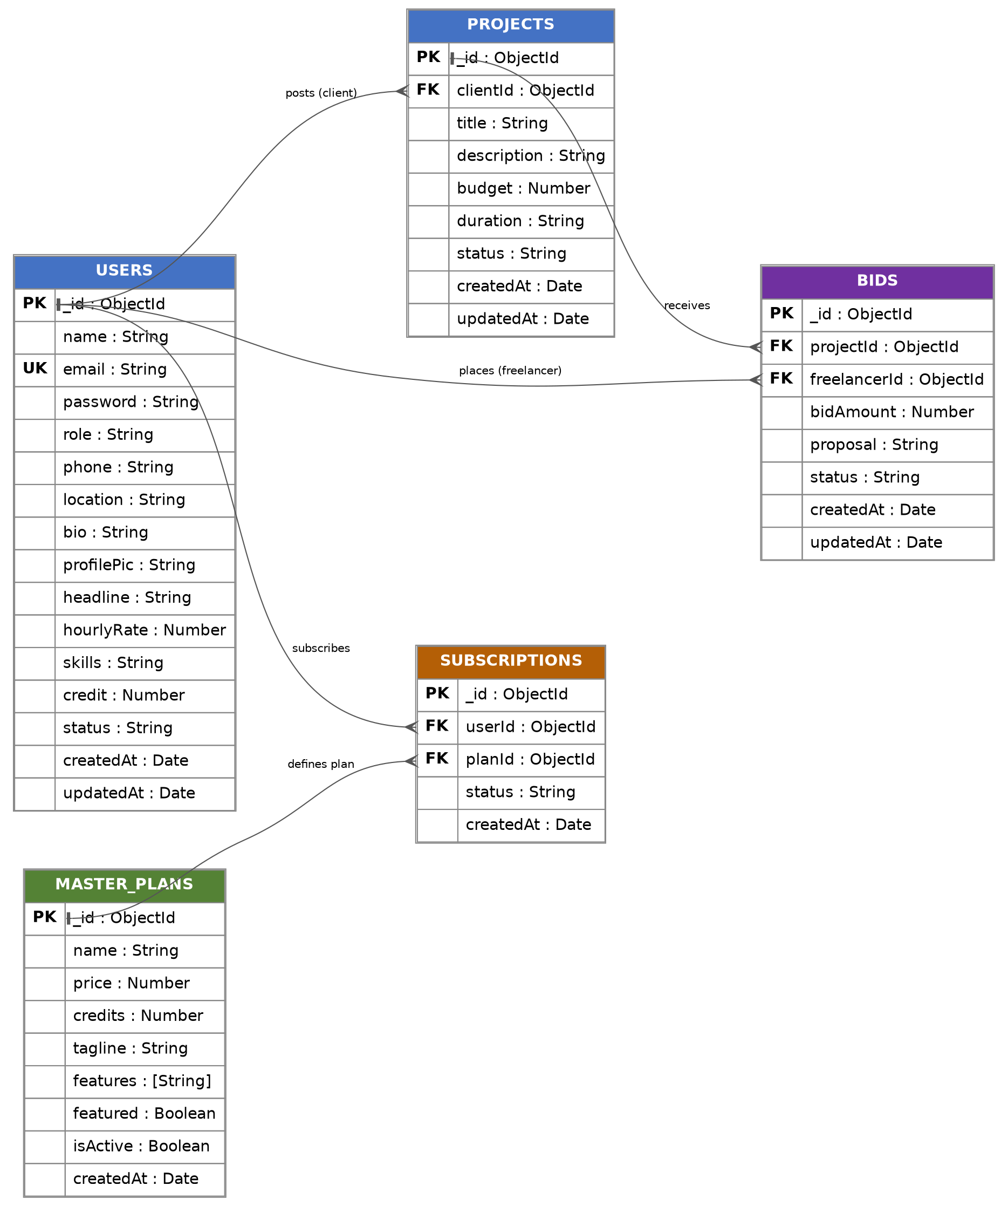

All remaining fields listed in Section 3 (such as email, password, name, and status columns) are simple scalar attributes of their parent collection and do not represent separate relationships — this keeps the schema focused on the handful of connections that actually drive the bidding workflow.

5. Relationships Between Models
From Model | Relationship | To Model / Description
User (role=Client) | One-to-Many | Project — a client can post many projects; each project belongs to exactly one client.
Project | One-to-Many | Bid — a project can receive many bids; each bid is placed on exactly one project.
User (role=Freelancer) | One-to-Many | Bid — a freelancer can place many bids; each bid is placed by exactly one freelancer.
User | One-to-Many | Subscription — a user can purchase many subscriptions over time (renewals/upgrades); each subscription belongs to exactly one user.
MasterPlan | One-to-Many | Subscription — a plan can be purchased by many users; each subscription references exactly one plan.

These relationships are intentionally kept as simple one-directional references so the bidding workflow — post project, receive bids, select freelancer, and finalize the deal — remains easy to trace end-to-end through the schema, matching the Project Flow described in Section 8.

6. Forms and Form Controls Used
The platform's forms are implemented as controlled React components, each bound to a corresponding Express REST endpoint that re-validates every field on the server using a library such as express-validator or Joi before writing to MongoDB (client-side validation with Formik + Yup is used for immediate feedback, but is never trusted alone).

6.1 Registration Form (Client / Freelancer)
- Fields: Name (text), Email (email), Password (password), Confirm Password (password), Role toggle (Client / Freelancer radio buttons).
- Validation: Required fields, valid email format, password minimum length, password-match check.
- On Submit: POST /api/auth/register — password is hashed with bcrypt before being saved; the new account is created with status 'Pending' until Admin approval.

6.2 Login Form
- Fields: Email (email), Password (password).
- On Submit: POST /api/auth/login — credentials are verified and a signed JWT is returned, which the frontend stores and attaches to the Authorization header of subsequent requests.

6.3 Add Project Form (Client)
- Fields: Title (text), Description (textarea), Category (dropdown), Budget (number), Deadline (date picker).
- On Submit: POST /api/projects — saved with status 'Pending' until Admin approval, then becomes visible to freelancers as 'Open'.

6.4 Place Bid Form (Freelancer)
- Fields: Proposed Amount (number), Delivery Days (number), Cover Message (textarea).
- On Submit: POST /api/bids — a bid can only be submitted once per freelancer per project, enforced by a unique compound index on (project, freelancer).

6.5 Contact Us Form (Common Module)
- Fields: Name (text), Email (email), Subject (text), Message (textarea).
- On Submit: POST /api/contact — submission is stored for Admin follow-up.

7. Tools & Platform (MERN Stack)

7.1 Technology Stack
- Frontend: React.js with functional components and Hooks, React Router for client-side routing, and Redux Toolkit (or the Context API) for global state such as the logged-in user and role.
- Backend Framework: Node.js with Express.js, exposing a REST API consumed by the React frontend.
- Database: MongoDB, accessed through the Mongoose ODM for schema definition, validation, and querying.
- Authentication: JSON Web Tokens (JWT) for stateless session handling, with bcrypt for password hashing and role-based middleware guarding Admin / Client / Freelancer routes.
- Styling: Bootstrap 5 or Tailwind CSS for responsive layout, plus custom CSS for the dashboards.
- Payment Gateway (optional): Razorpay or Stripe test-mode integration for subscription and project payments.
- File Uploads: Multer on the backend, optionally paired with Cloudinary, for profile photos and portfolio attachments.
- API Testing: Postman collections used to test every REST endpoint independently of the frontend.
- Version Control: Git & GitHub.
- Deployment (optional): Frontend on Vercel or Netlify; backend on Render or Railway; database on MongoDB Atlas.

8. Project Flow
The diagram below traces a single project from posting through to completion, matching the module structure described in Section 2 and the relationships described in Section 5.
Landing Page
|
Register / Login (role-based redirect: Admin / Client / Freelancer)
|
Client creates Project ---------> Project saved as 'Pending'
|
Admin approves Project ---------> Project status becomes 'Open'
|
Freelancers browse & view Project
|
Freelancers place Bid ----------> Bid saved as 'Pending'
|
Client reviews all Bids on the Project
|
Client selects best Freelancer --> Bid status becomes 'Accepted'
| (other bids become 'Rejected')
Final Deal created
|
Payment processed
|
Project marked 'Completed'
|
Client and Freelancer leave a Review & Rating

SCREENSHOTS

Landing page


About Us
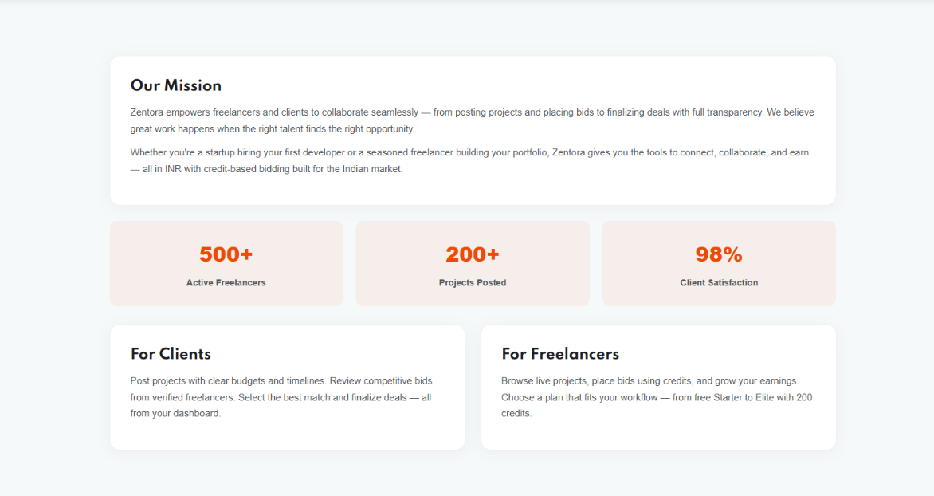
Services
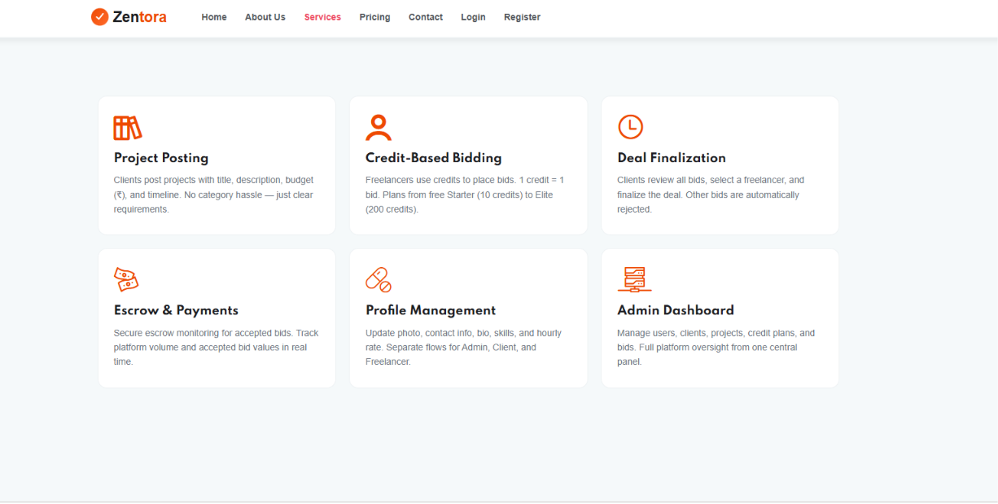

Pricing
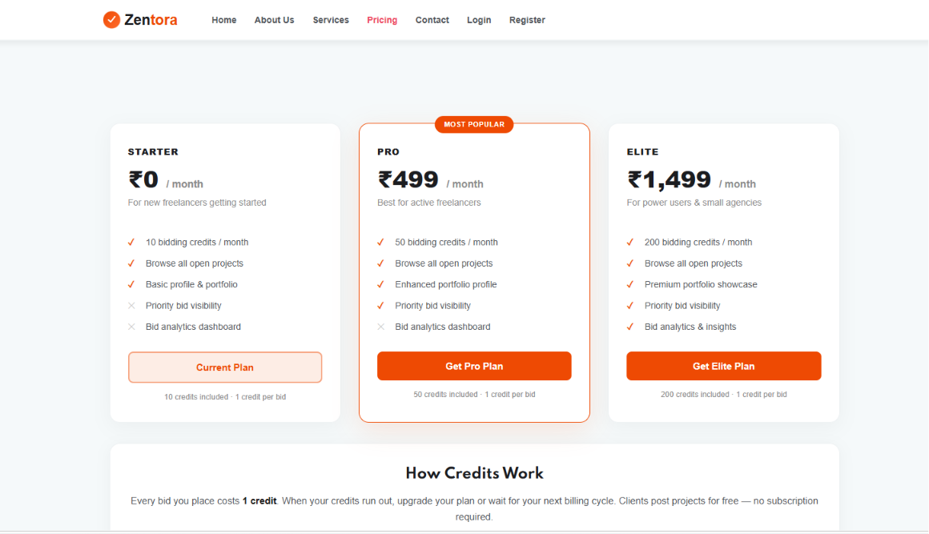
Contact Us
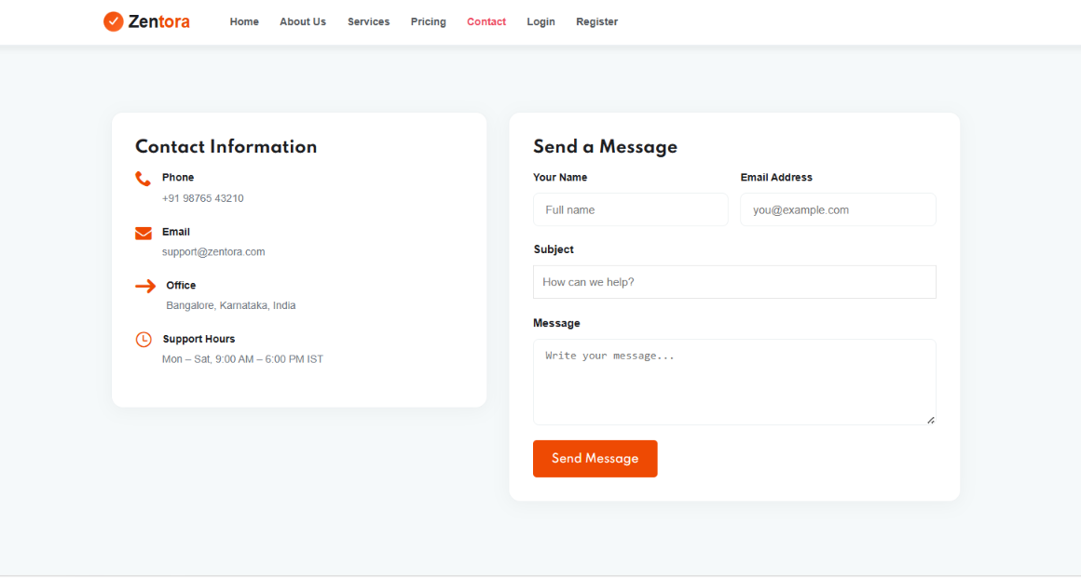

Login Page
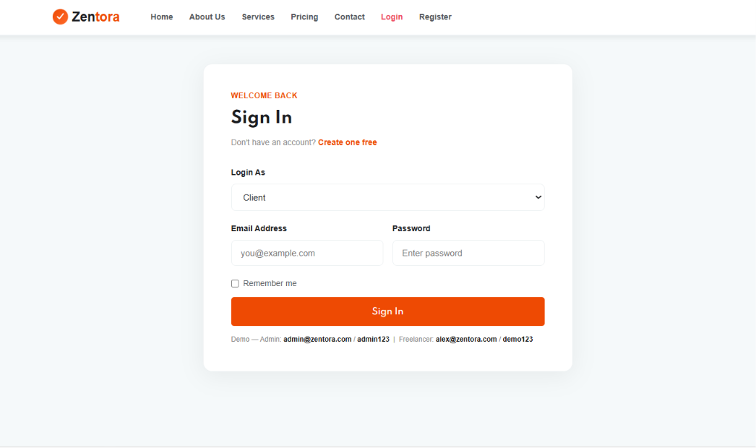
Registration page
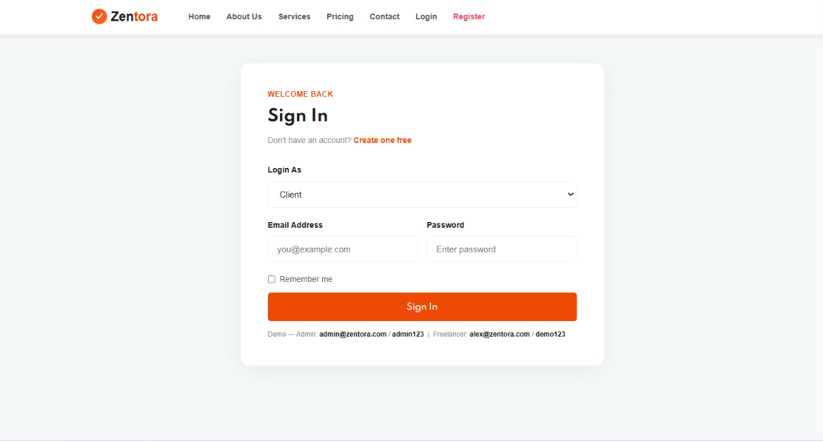

Admin Panel
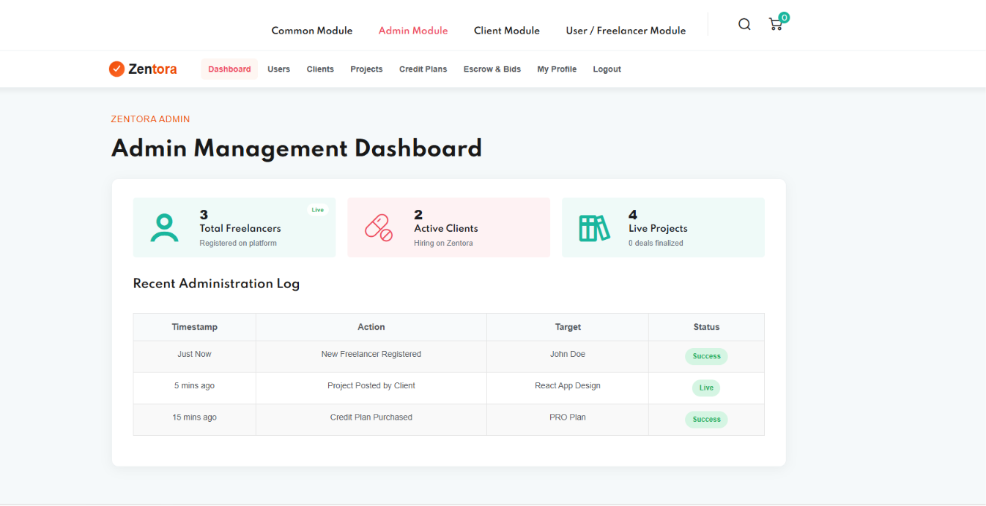

Client Dashboard
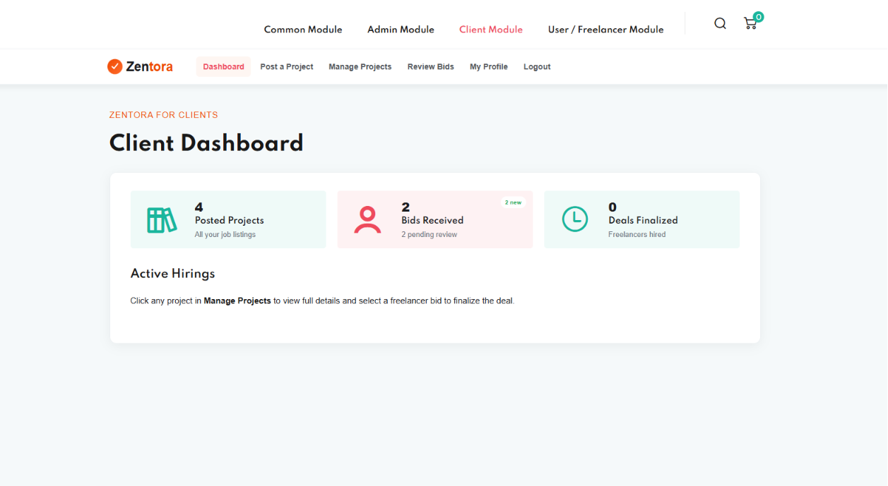

Freelancer Panel
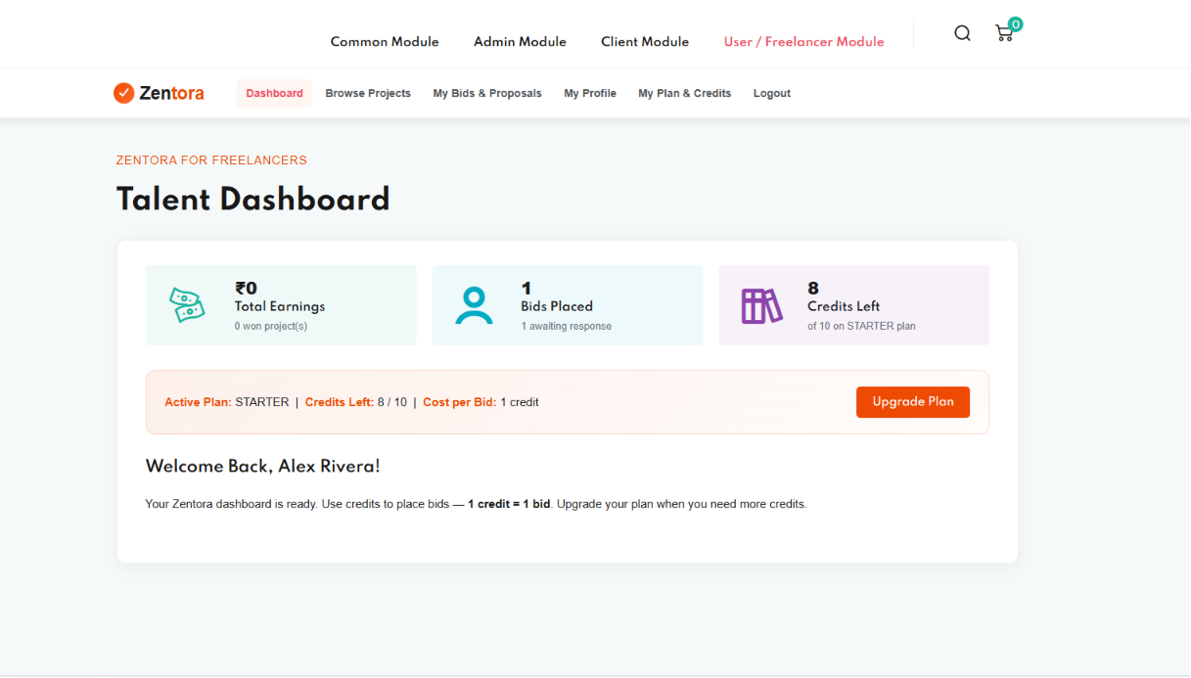

Footer Page

