**FCCI Phase Field Model**

**System Description and Gibbs energy modeling**

In this FCCI phase field model, we consider 3 phases i.e. ***α* - Uranium** phase (Phase 1), ***NdAs*** phase (Phase 2) and ***UAs*** phase (Phase 3). We will use the CALPHAD approach to model this phases computationally. In CALPHAD approach the Gibbs energy, (in eV) for individual phases is given by:

(1)

where = Gibbs energy for mechanical mixing.

= Gibbs energy contribution for ideal mixing.

= Excess Gibbs energy part.

**Phase 1 (*α* - Orthorhombic):**

(2)

(3)

(4)

where,

= -8407.734 + 130.955151*T* – 26.9182*TlnT* + 1.25156E-03*T2* – 4.42605E-06*T3* +   
 38568*T-1* (298.15*K* < *T* < 955*K*)

= -22521.8 + 292.121093*T* – 48.66*TlnT* (955*K* < *T* < 3000*K*)

is taken from the *SGTE* database.

= 0.05182 *eV*.

= 0.05182 *eV*.

are assumed because these values are not available in the *SGTE* database and,

= 4.17 *eV*

= 2.60 *eV*

are calculated using the DFT calculations.

**Phase 2 (*Nd-As*):**

(5)

(6)

(7)

where,

(298.15*K* < *T* < 900*K*)

(298.15*K* < *T* < 1090*K*)

are taken from the SGTE database and,

= -1.57 *eV*

is calculated using the DFT calculations.

**Phase 3 (*UAs*):**

(8)

(9)

(10)

where,

(298.15*K* < *T* < 1049*K*)

(298.15*K* < *T* < 1090*K*)

are taken from the SGTE database and,

is calculated using the DFT calculations.

**Gibbs free energy curves**

* **When *Nd* concentration is very low in the system.**

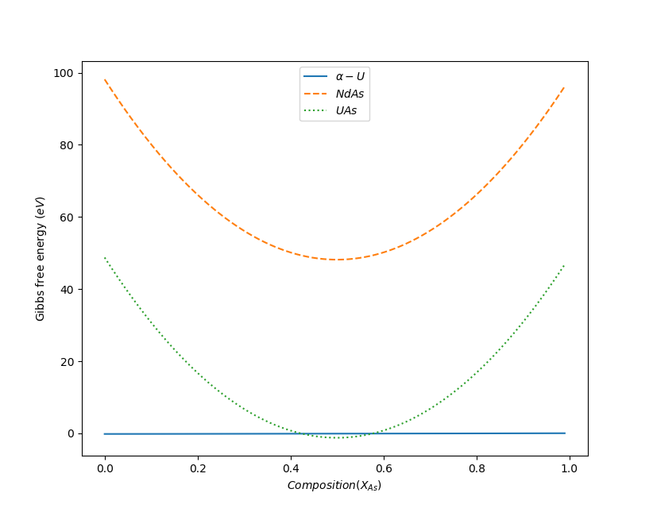

Figure 1: Gibbs energy Vs composition curve for the 3 phases in the system at negligible Nd concentration.

* **When *XNd* = *XAs* in the system.**

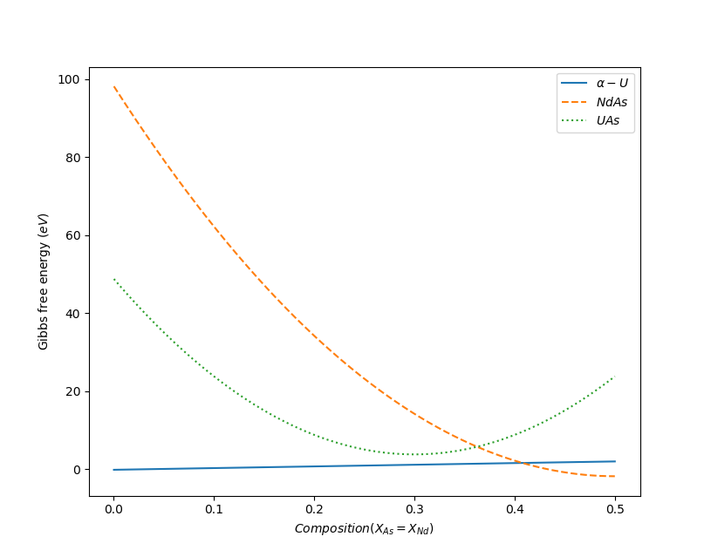

Figure 2: Gibbs energy Vs composition curve for the 3 phases in the system at negligible Nd concentration.

**Phase Field Modeling**

We have considered 3 different phases, 2 global and 6 local compositions in the system. This system is modeled with the help of *Kim-Kim-Suzuki* multi-phase field model under the *MOOSE* framework. The *Kim-Kim-Suzuki* multi-phase field model has an advantage over the traditional phase field model as it solves the problem by introducing the concept of phase concentrations. Additionally, in the *Kim-Kim-Suzuki* model, the interfacial width is de-coupled from the interfacial energy and can be changed according to the system requirements without affecting the latter.

For the phase field simulation, we consider a 200 × 2 simulation domain which is scaled from -10 to 10 in the X-axis and 0 to 2 in the Y-axis. In the simulation, we have considered time step of 10-5 and total end time 107.

**Initial conditions:**

The initial conditions for the Phase 1, 2 and 3 are taken as smooth hyperbolic tangent which varies from 0 to 1, which represents distinct phases as shown below in the Figure 3 and 4.

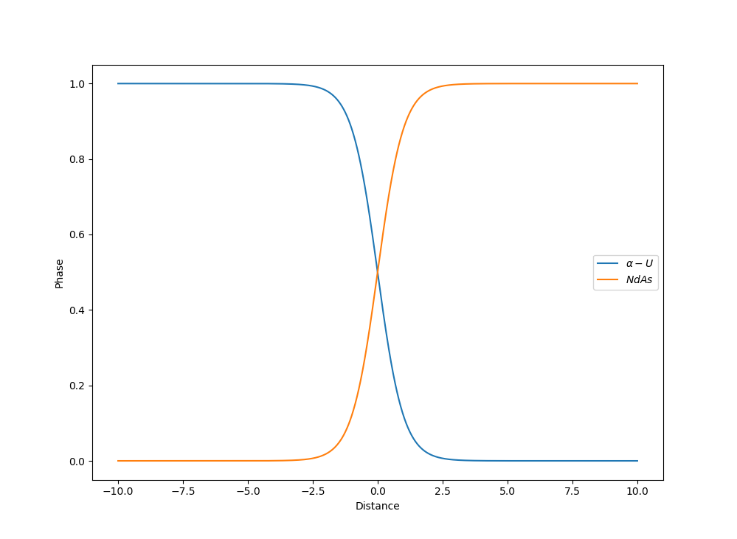

Figure 3: Initial conditions between phase 1 and phase 2 in the phase field simulation.

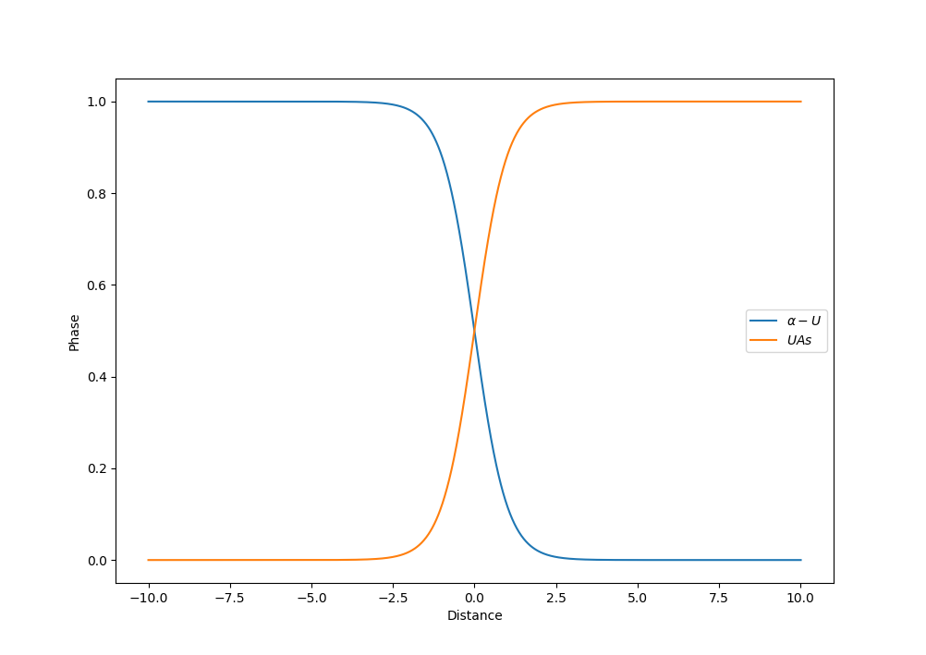

Figure 4: Initial conditions between phase 1 and phase 3 in the phase field simulation.

**Simulation results**

* **Equilibrium between Phase 1 and Phase 2 when enough ‘*Nd*’ is present in the system.**

Figure 5 and 6 shows the initial condition and final condition of the phases present in the system.

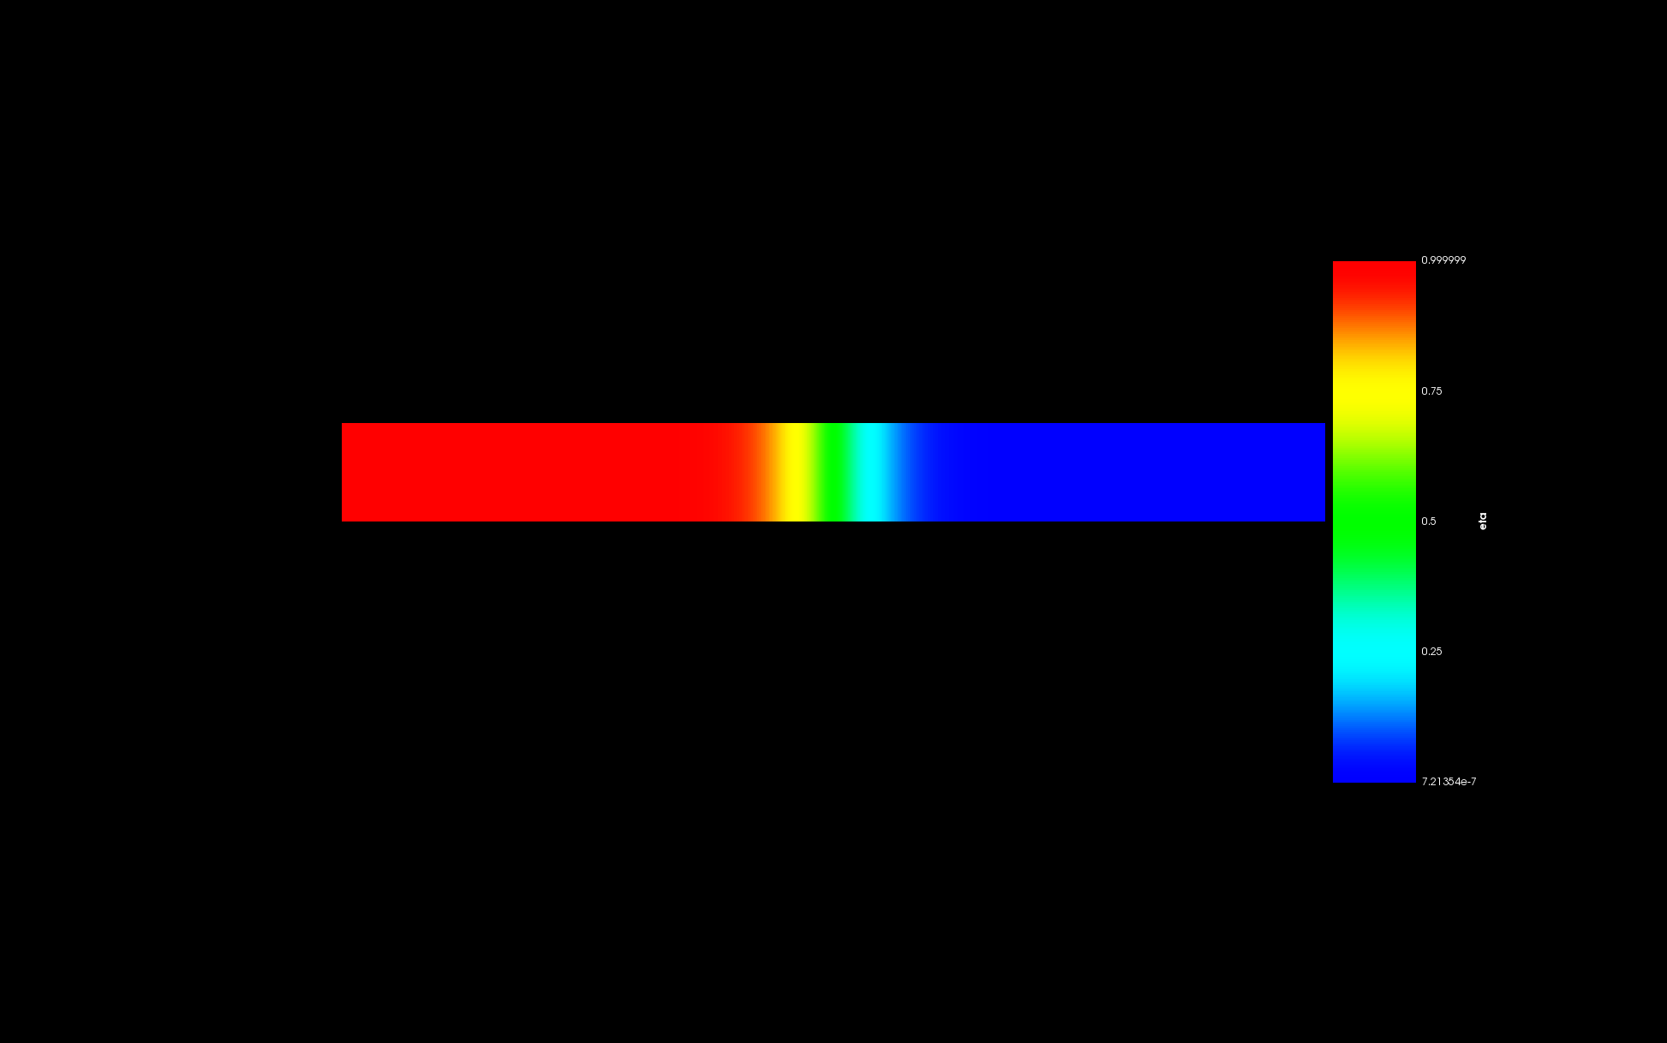

Figure 5: Initial condition of the system with Phase 1 and Phase 2.

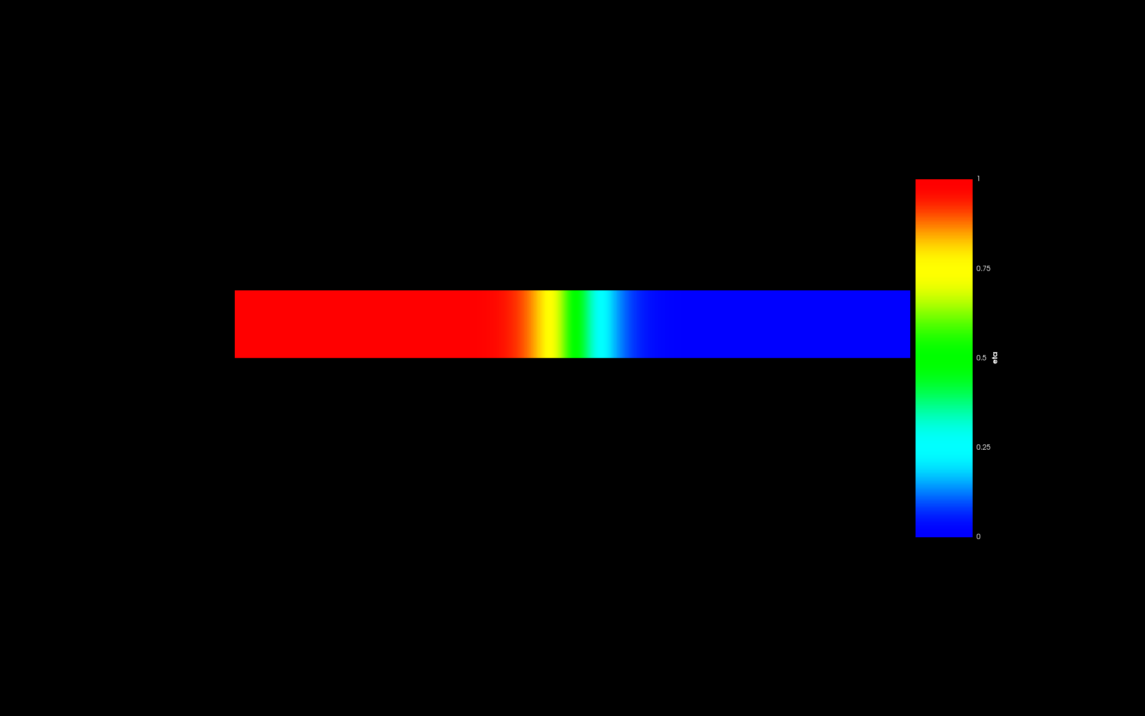

Figure 6: Final condition of the system showing Phase 1 and Phase 2 in equilibrium.

Figure 7 and 8 shows the global ‘*As*’ concentration in the system.

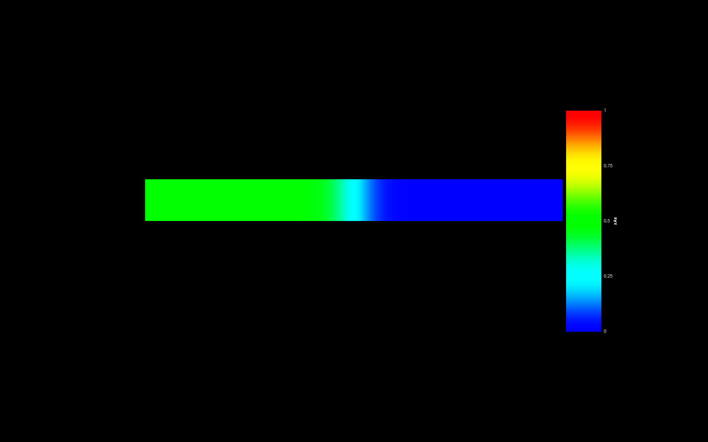

Figure 7: Initial ‘*As*’ content in the system.

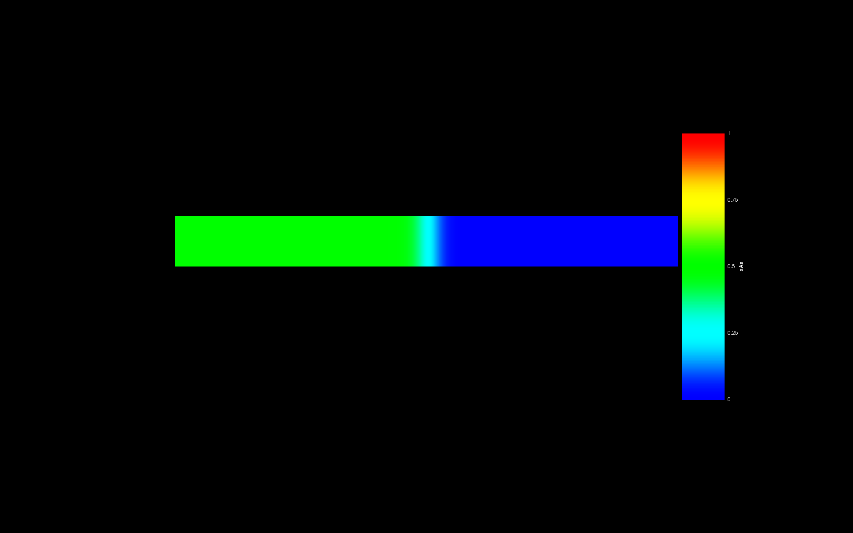

Figure 8: Final ‘*As*’ content in the system.

Figure 9 and 10 shows the global ‘*Nd*’ concentration in the system.

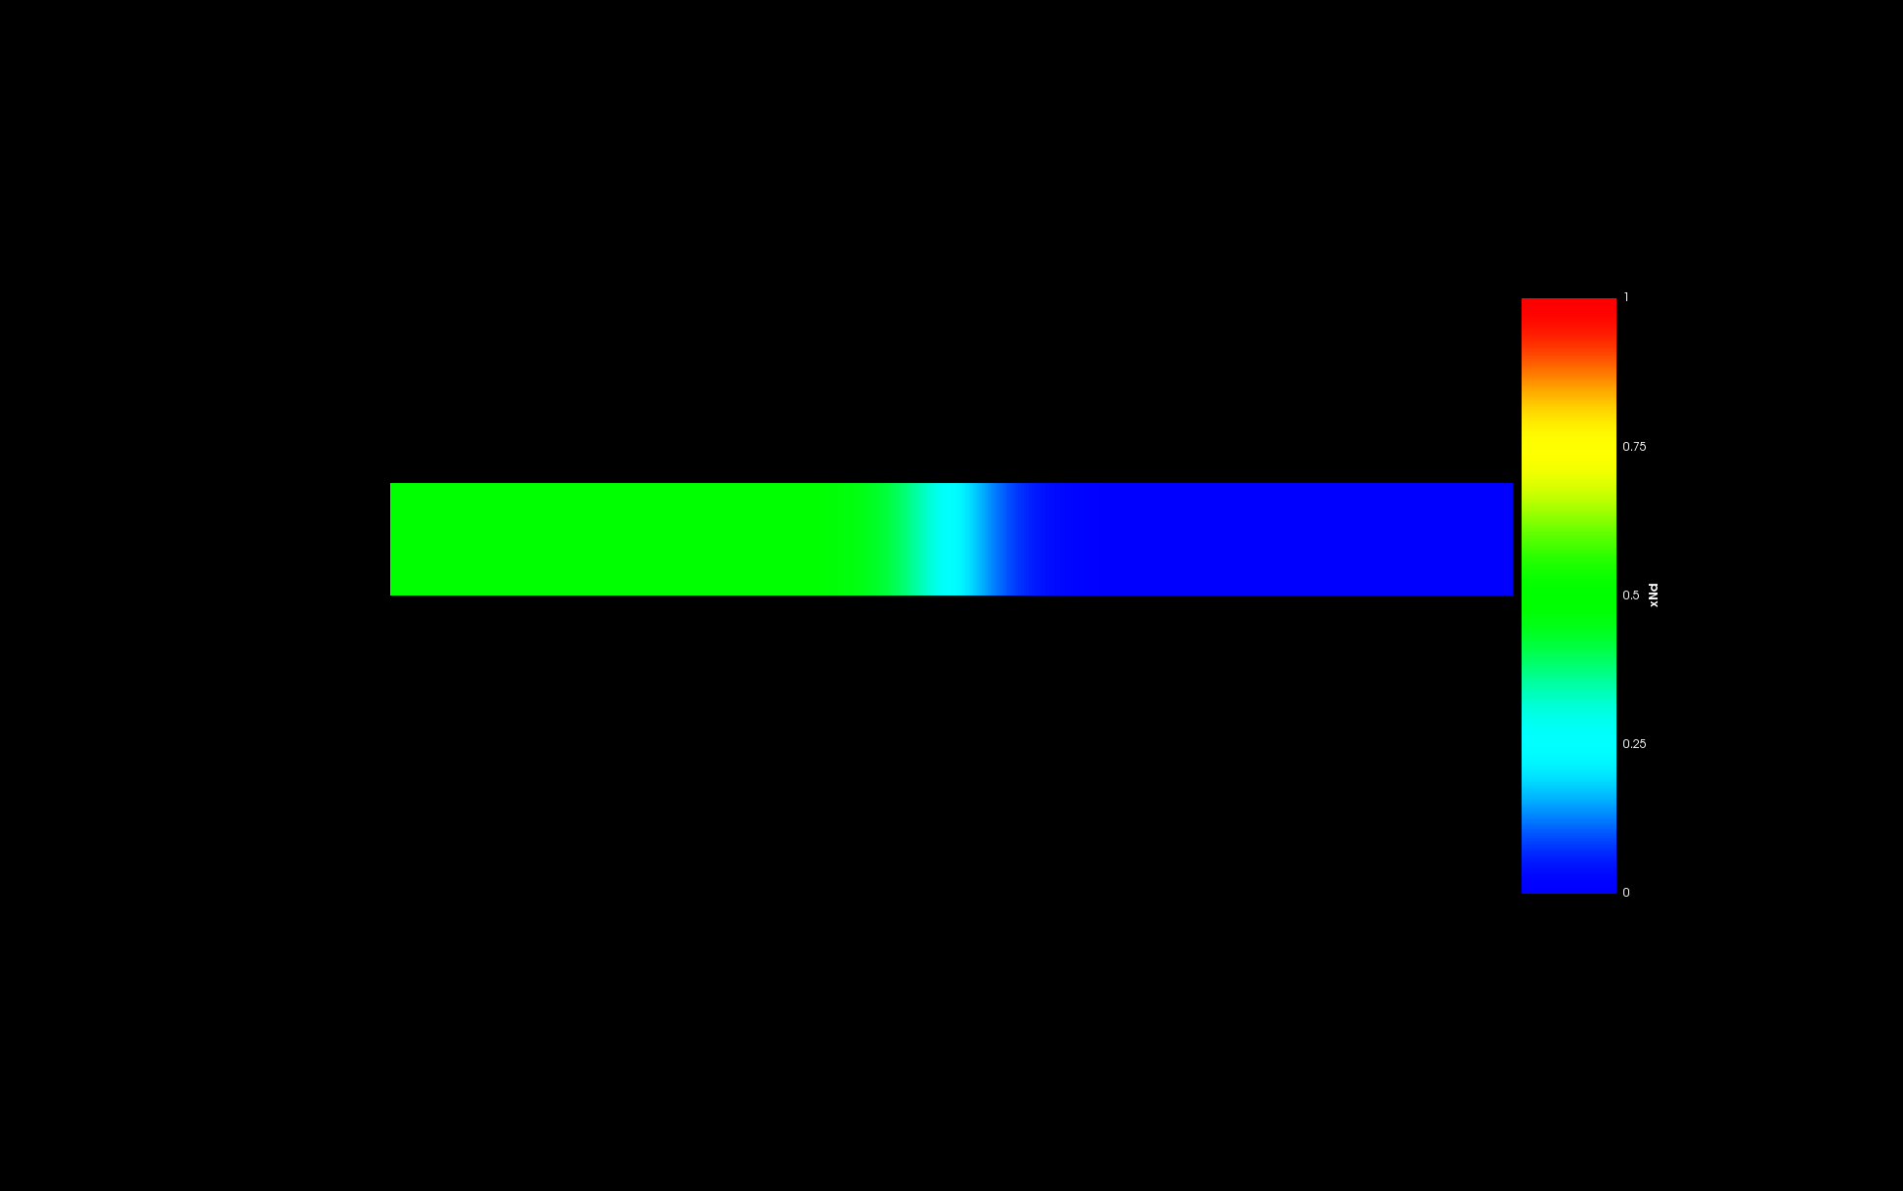

Figure 9: Initial ‘*Nd*’ content in the system.

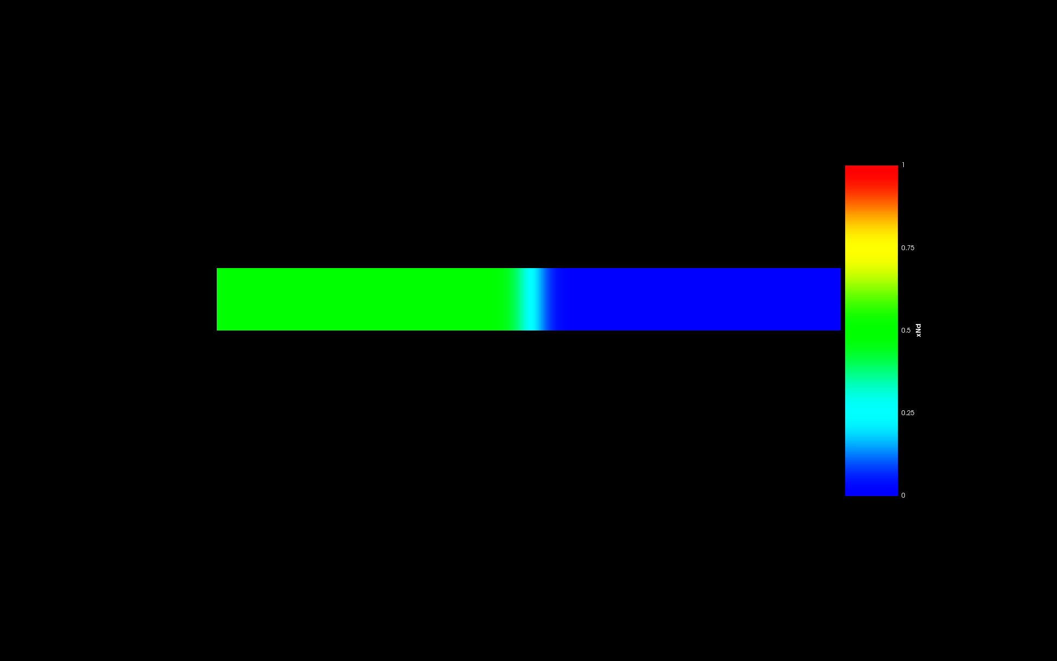

Figure 10: Final ‘*Nd*’ content in the system.

Figure 11 and 12 shows the local ‘*As*’ concentration in phase 1.

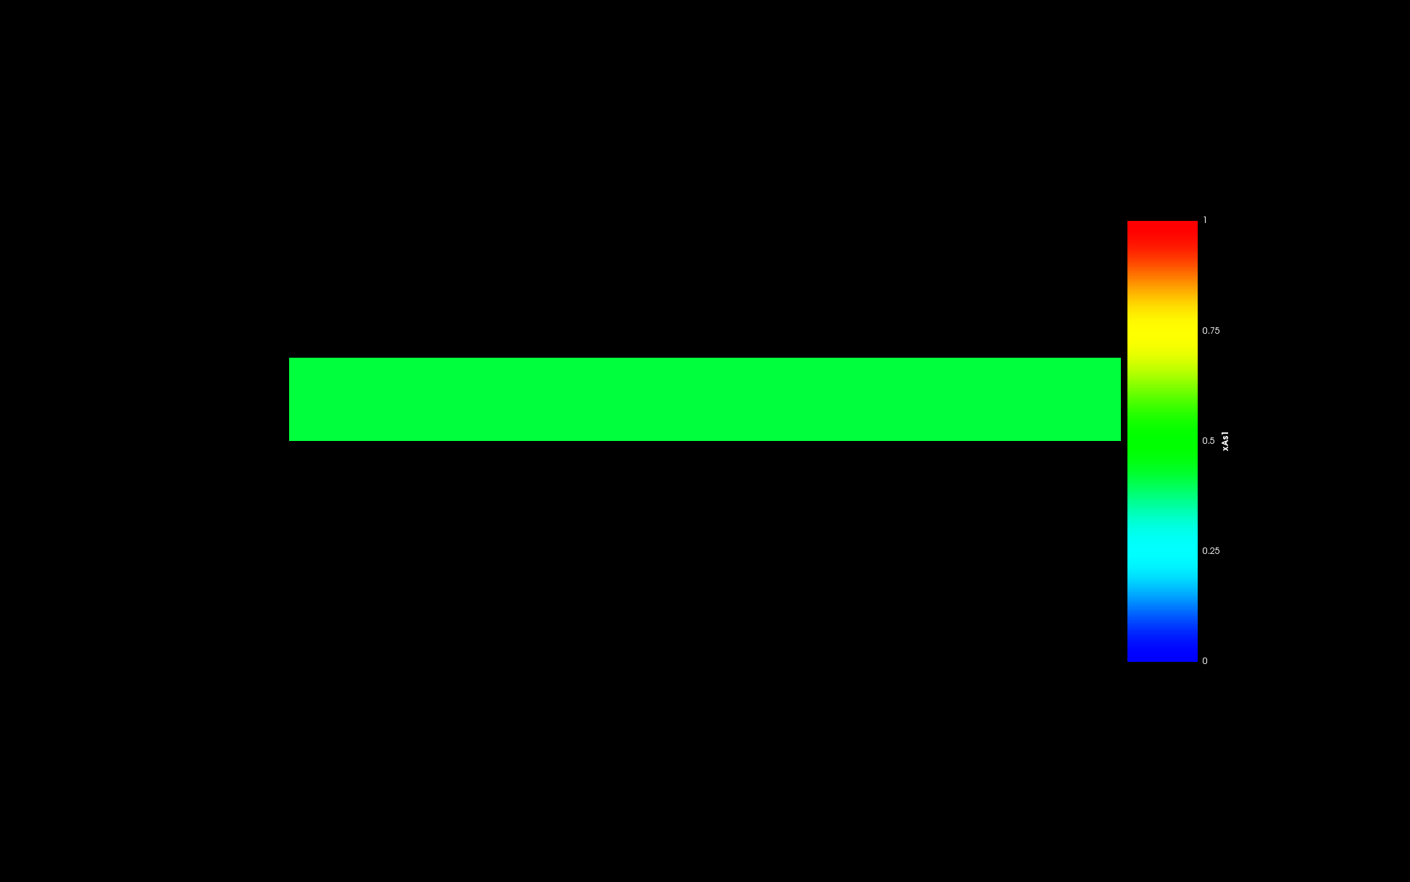

Figure 11: Initial ‘*As*’ content in Phase 1.

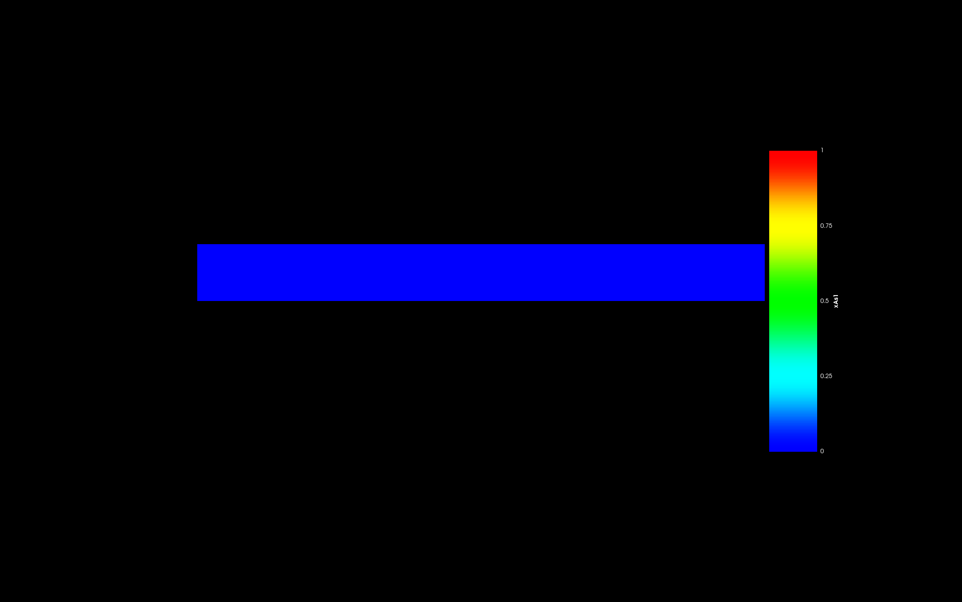

Figure 12: Final ‘*As*’ content in Phase 1.

Figure 13 and 14 shows the local ‘*As*’ concentration in phase 2.

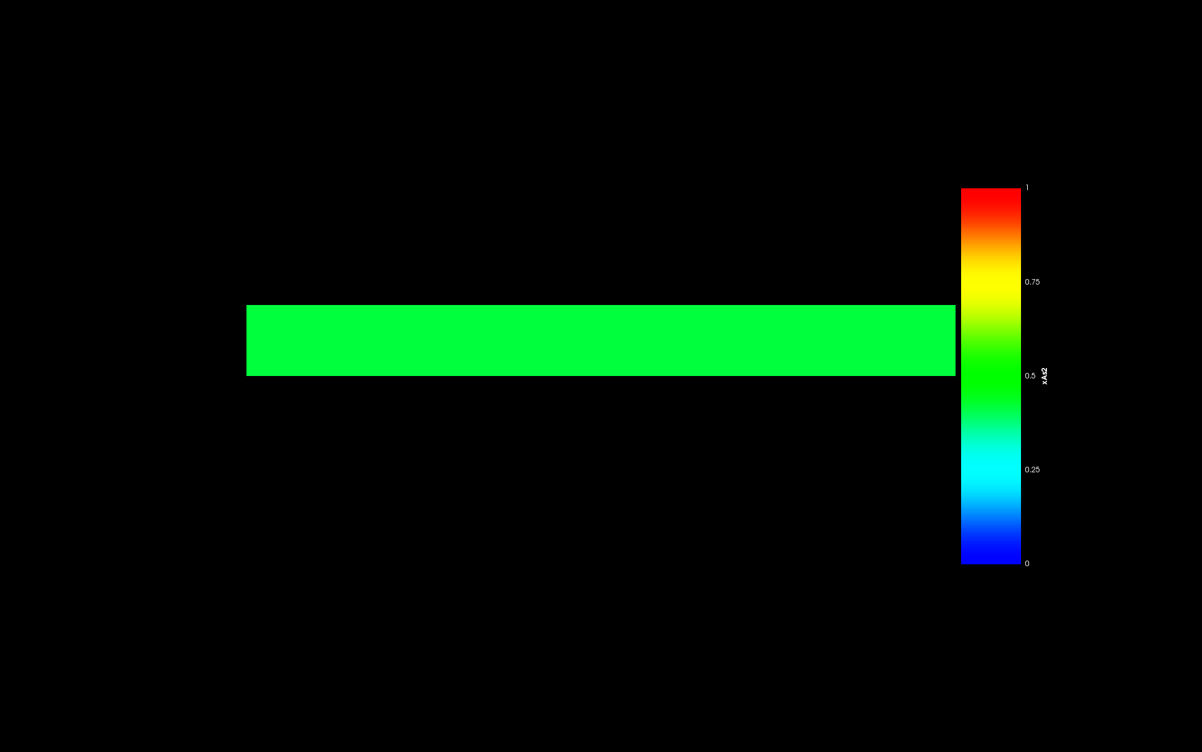

Figure 13: Initial ‘*As*’ content in Phase 2.

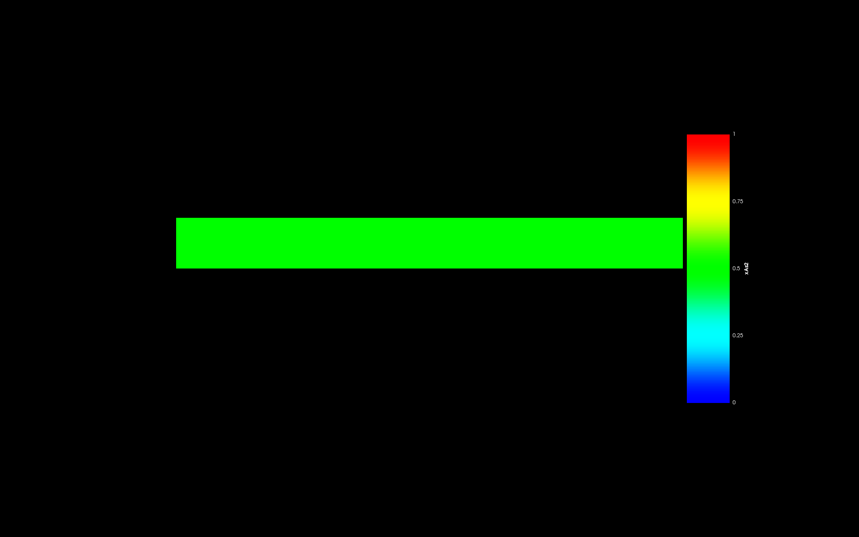

Figure 14: Final ‘*As*’ content in Phase 2.

Figure 15 and 16 shows the local ‘*Nd*’ concentration in phase 1.

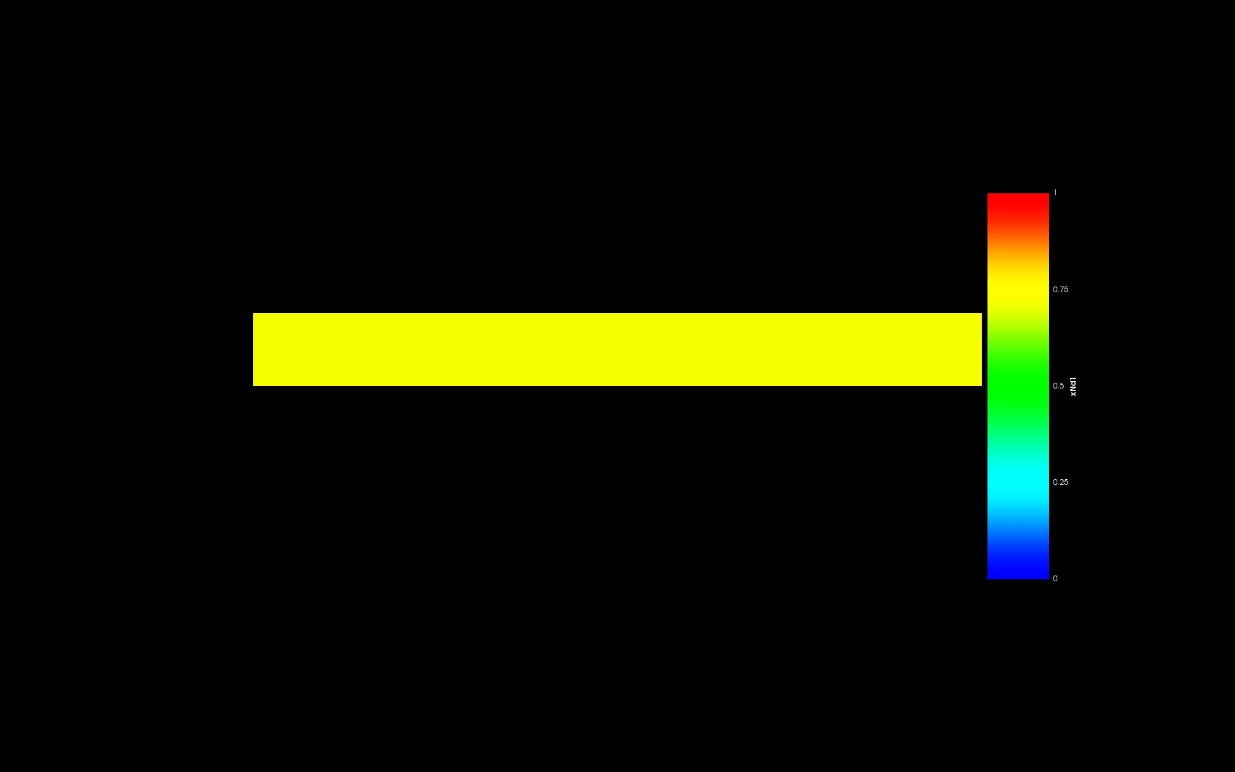

Figure 15: Initial ‘*Nd*’ content in Phase 1.

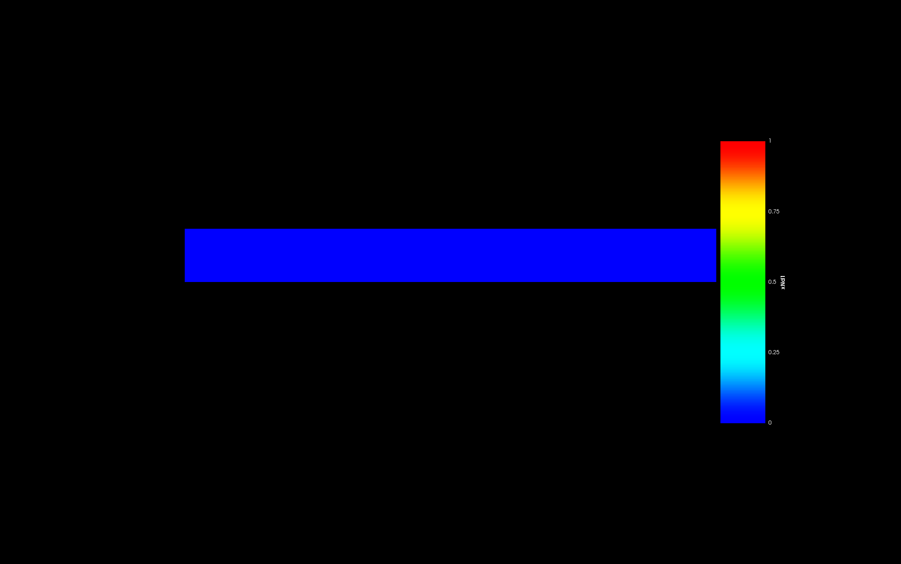

Figure 16: Final ‘*Nd*’ content in Phase 1.

Figure 17 and 18 shows the local ‘*Nd*’ concentration in phase 2.

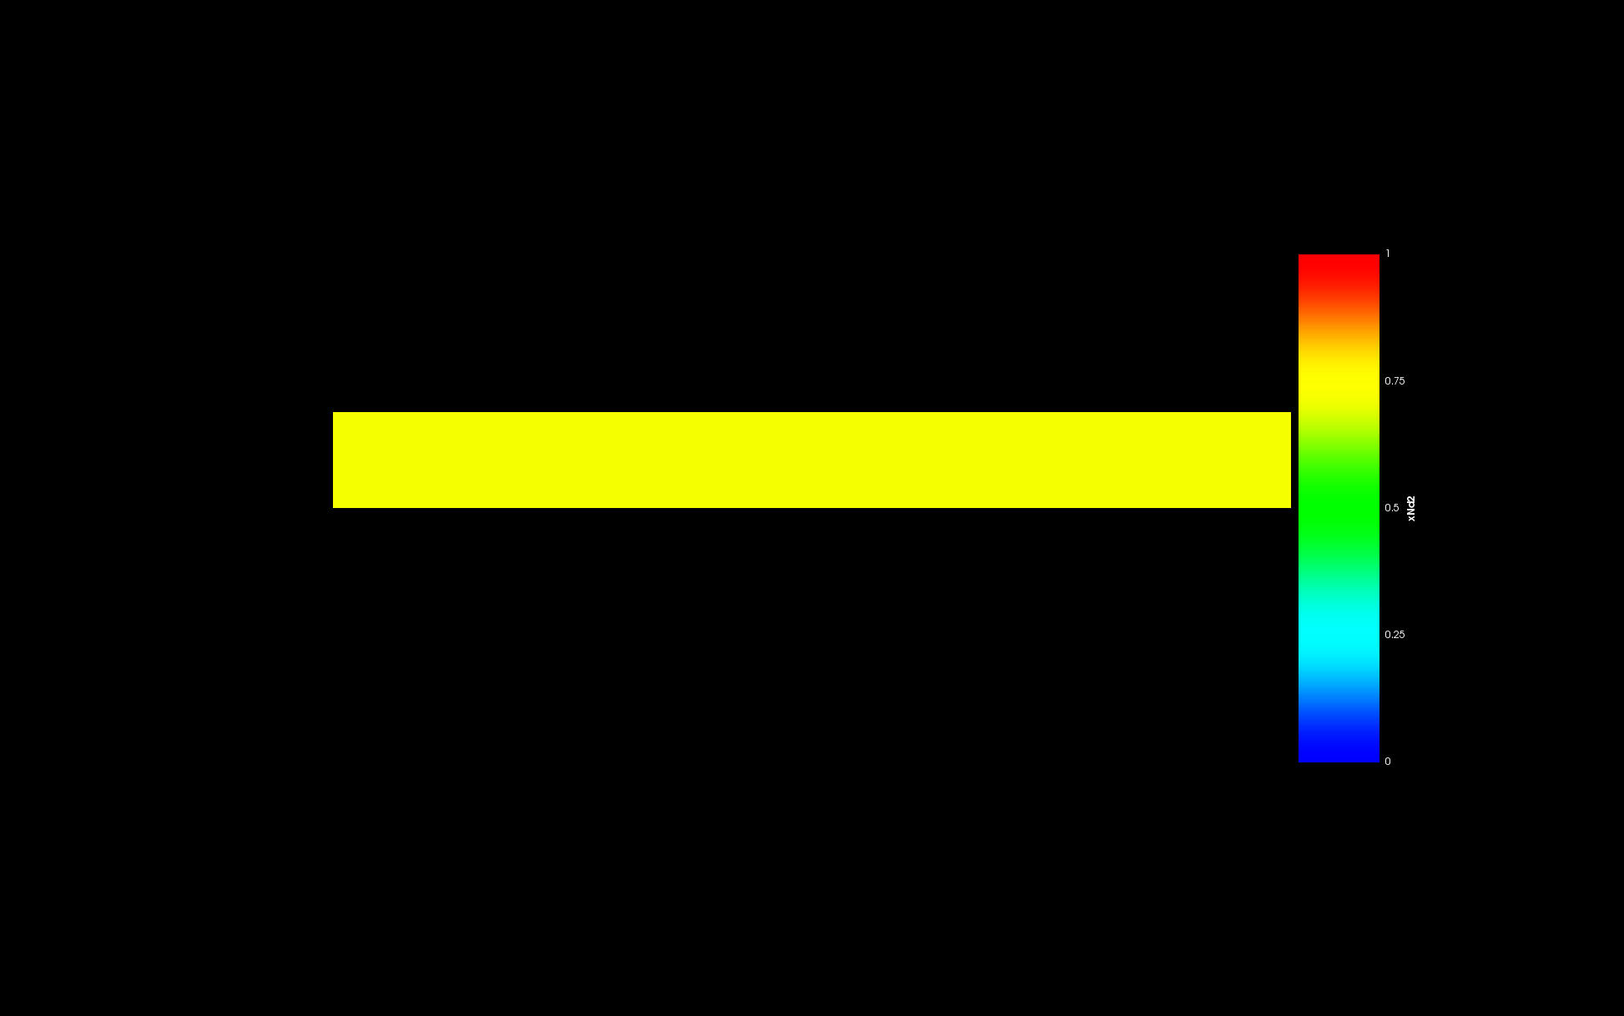

Figure 17: Initial ‘*Nd*’ content in Phase 2.

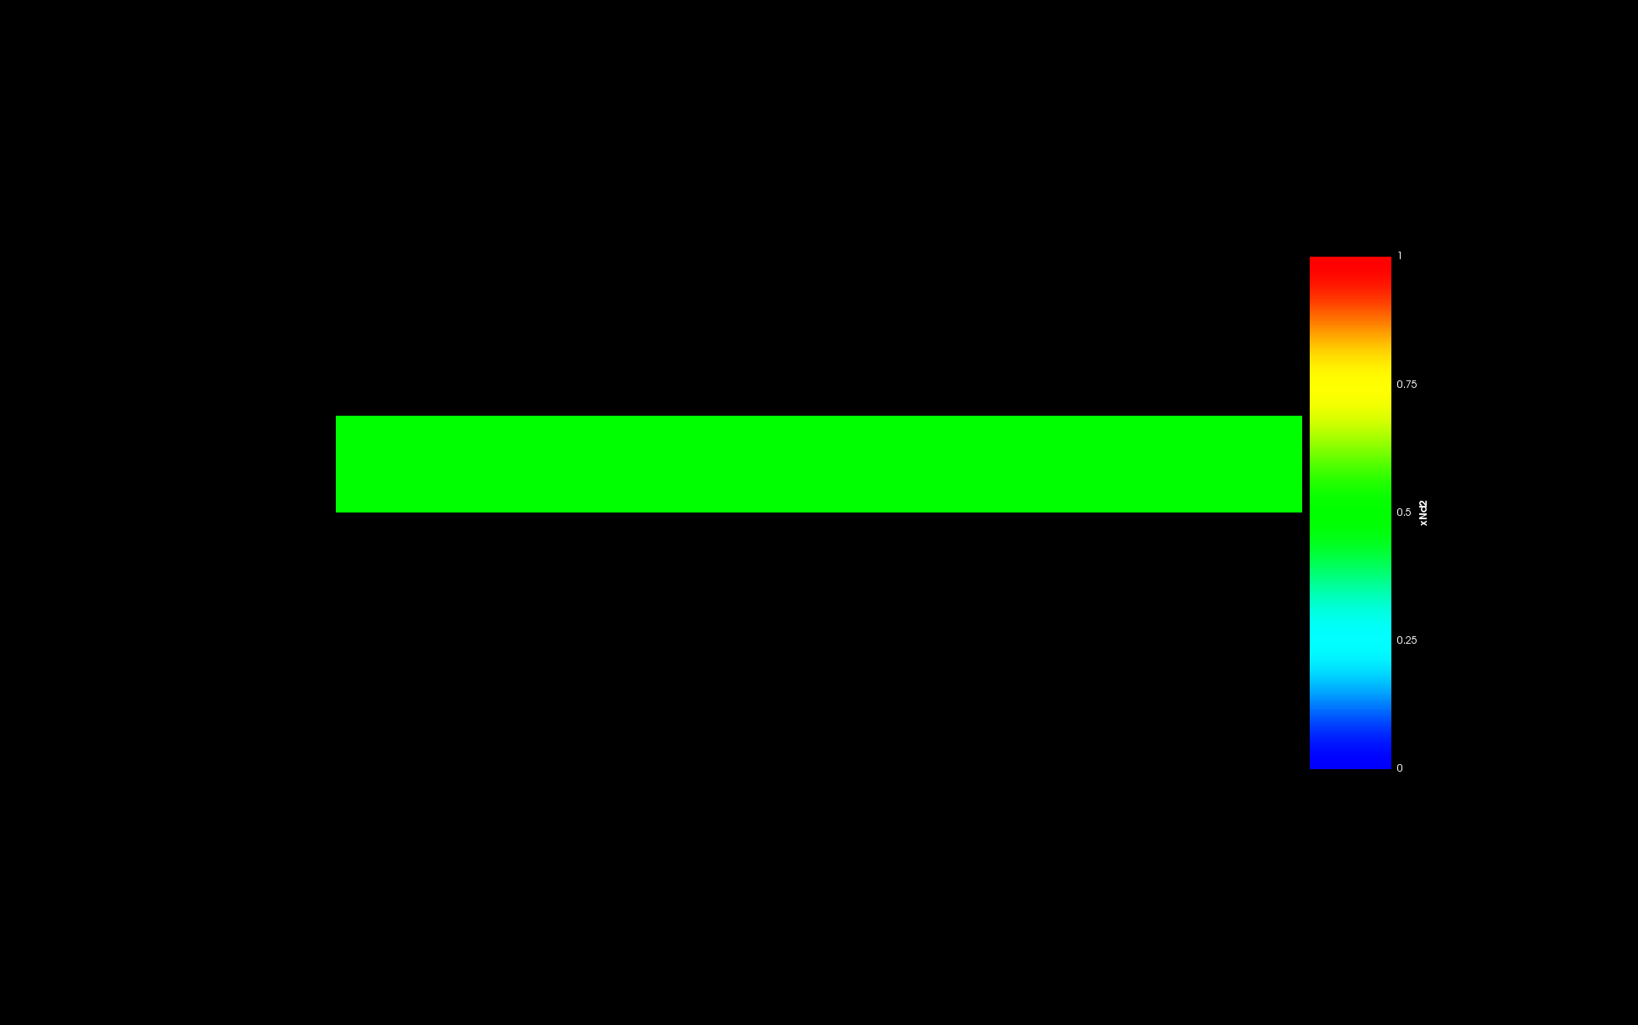

Figure 18: Final ‘*Nd*’ content in Phase 2.

* **Equilibrium between Phase 1 and Phase 3 when negligible ‘*Nd*’ is present in the system.**

Figure 19 and 20 shows the initial condition and final condition of the phases present in the system.

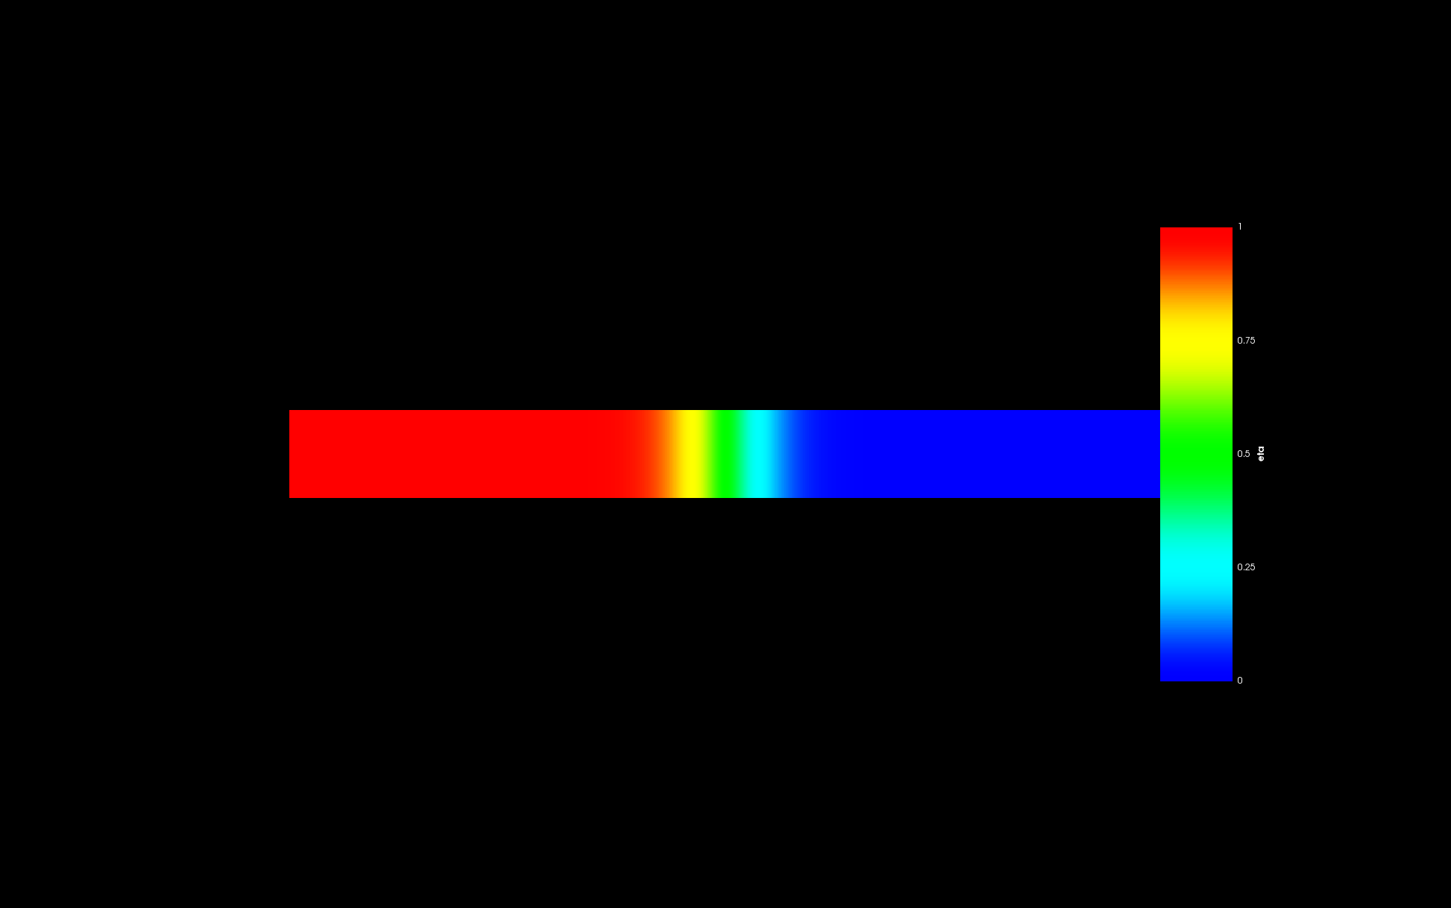

Figure 19: Initial condition of the system with Phase 1 and Phase 3.

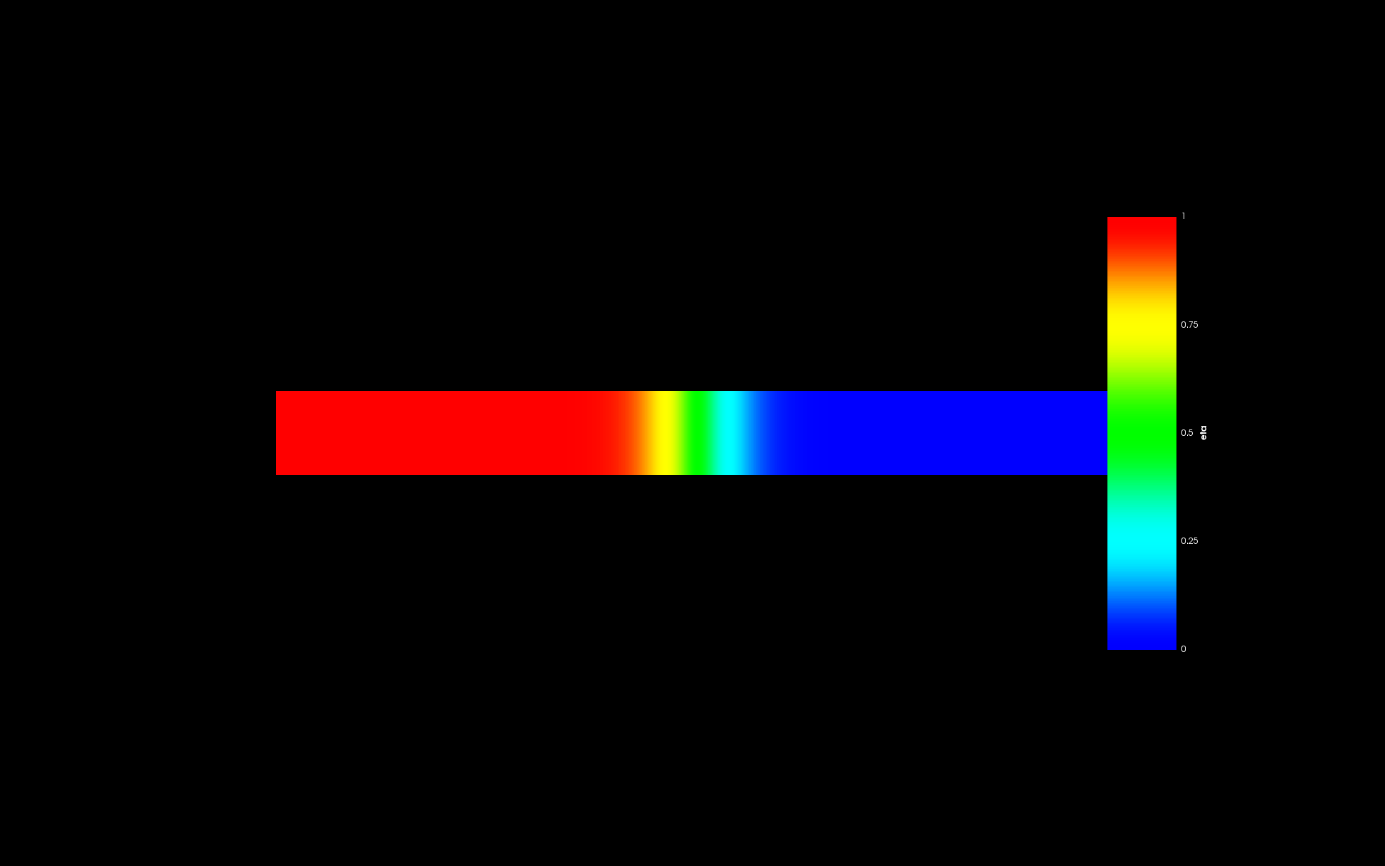

Figure 20: Final condition of the system showing Phase 1 and Phase 3 in equilibrium.

Figure 21 and 22 shows the global ‘*As*’ concentration in the system.

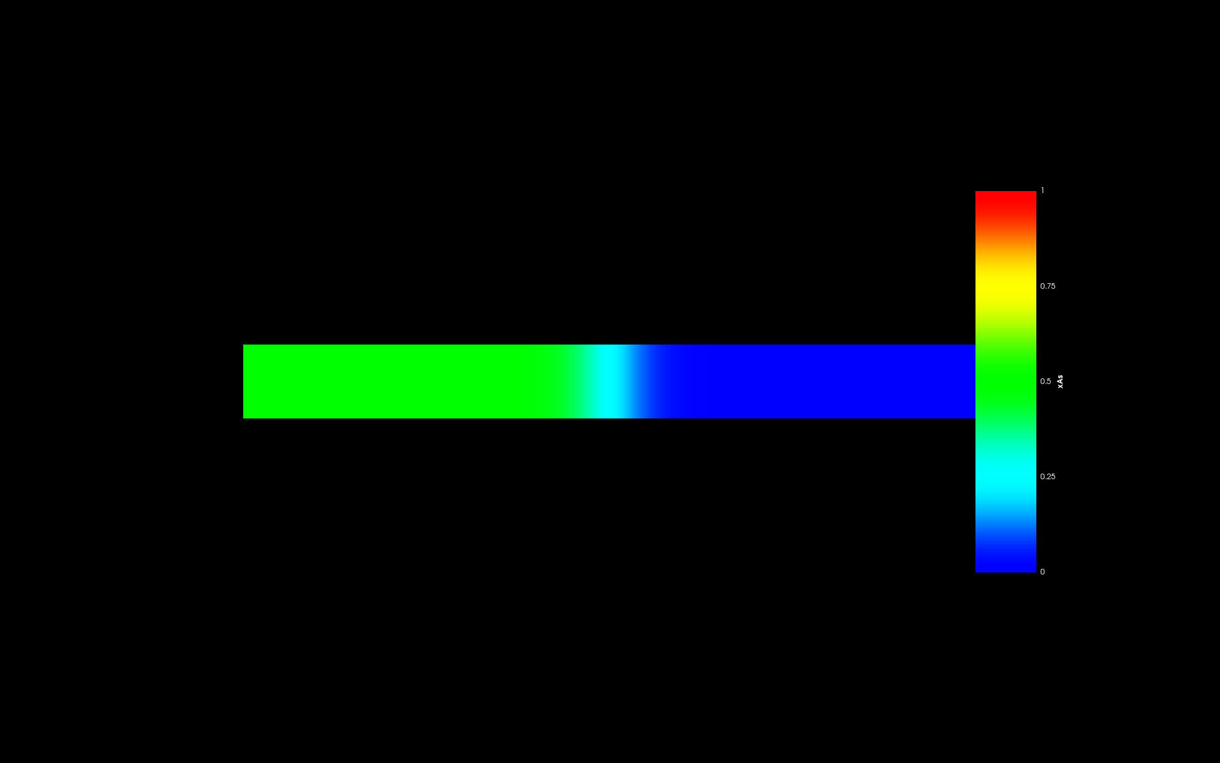

Figure 21: Initial ‘*As*’ content in the system.

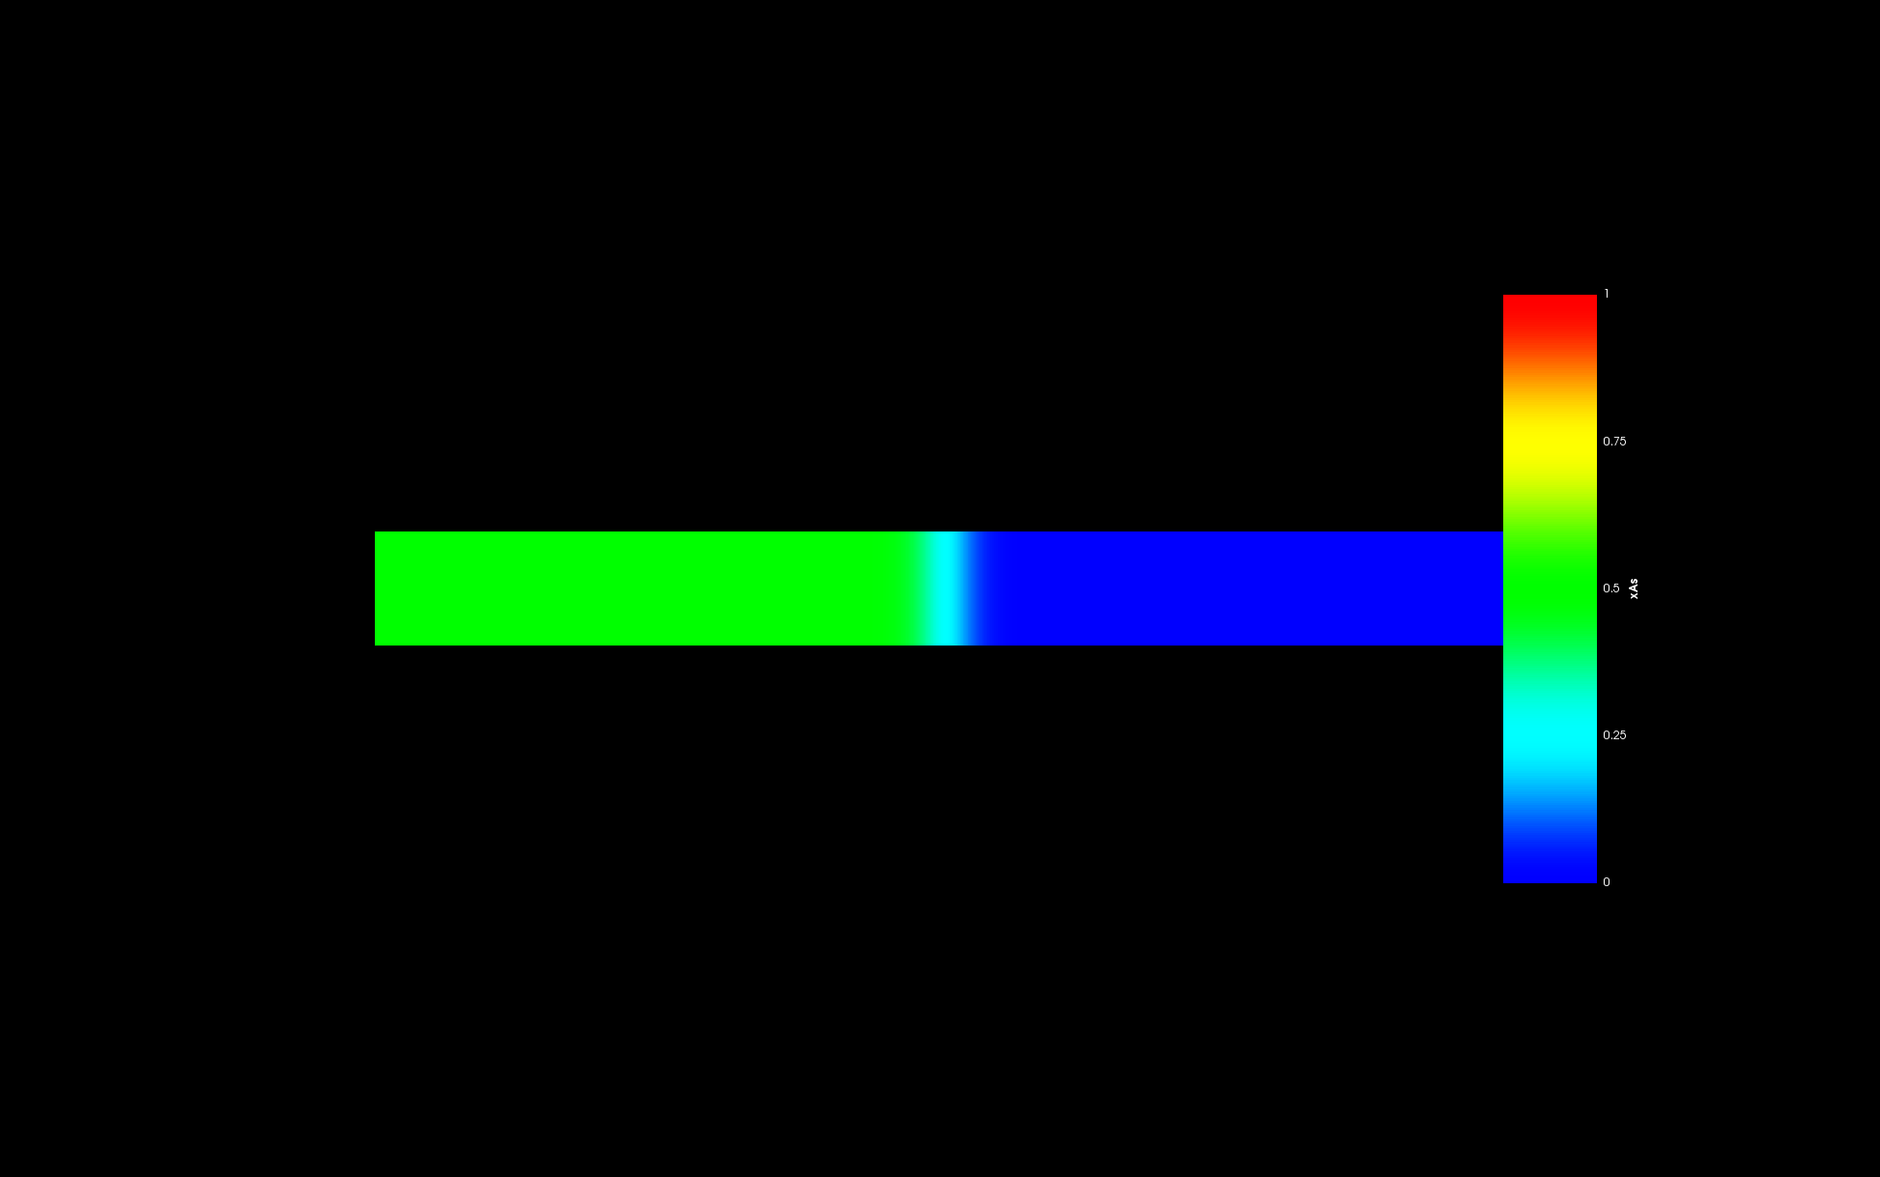

Figure 22: Final ‘*As*’ content in the system.

Figure 23 and 24 shows the global ‘*Nd*’ concentration in the system.

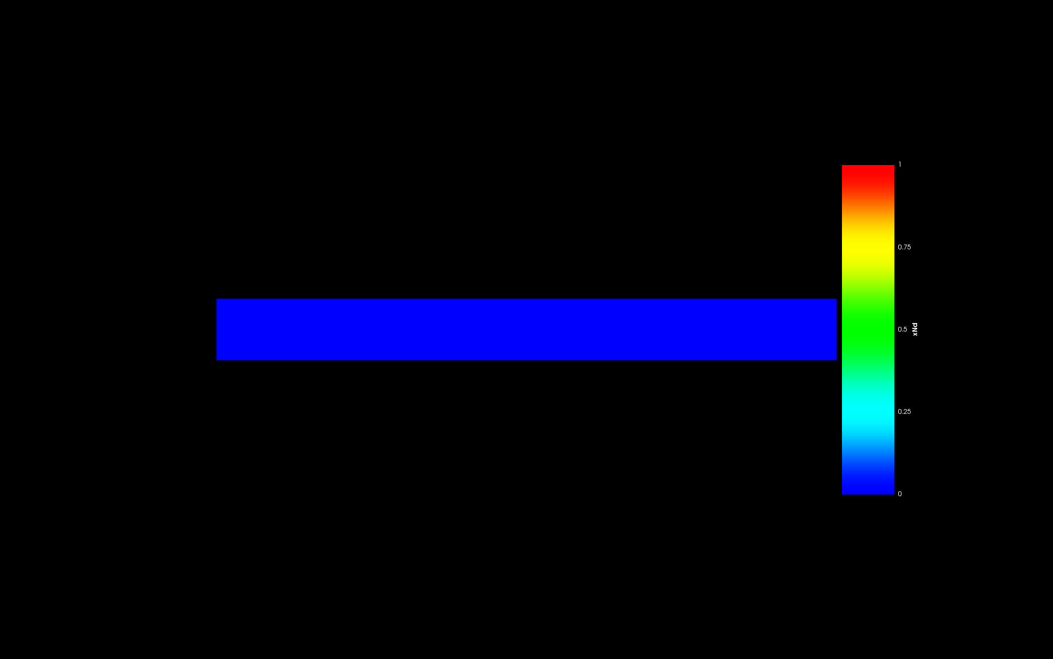

Figure 23: Initial ‘*Nd*’ content in the system.



Figure 24: Final ‘*Nd*’ content in the system.

Figure 25 and 26 shows the local ‘*As*’ concentration in phase 1.

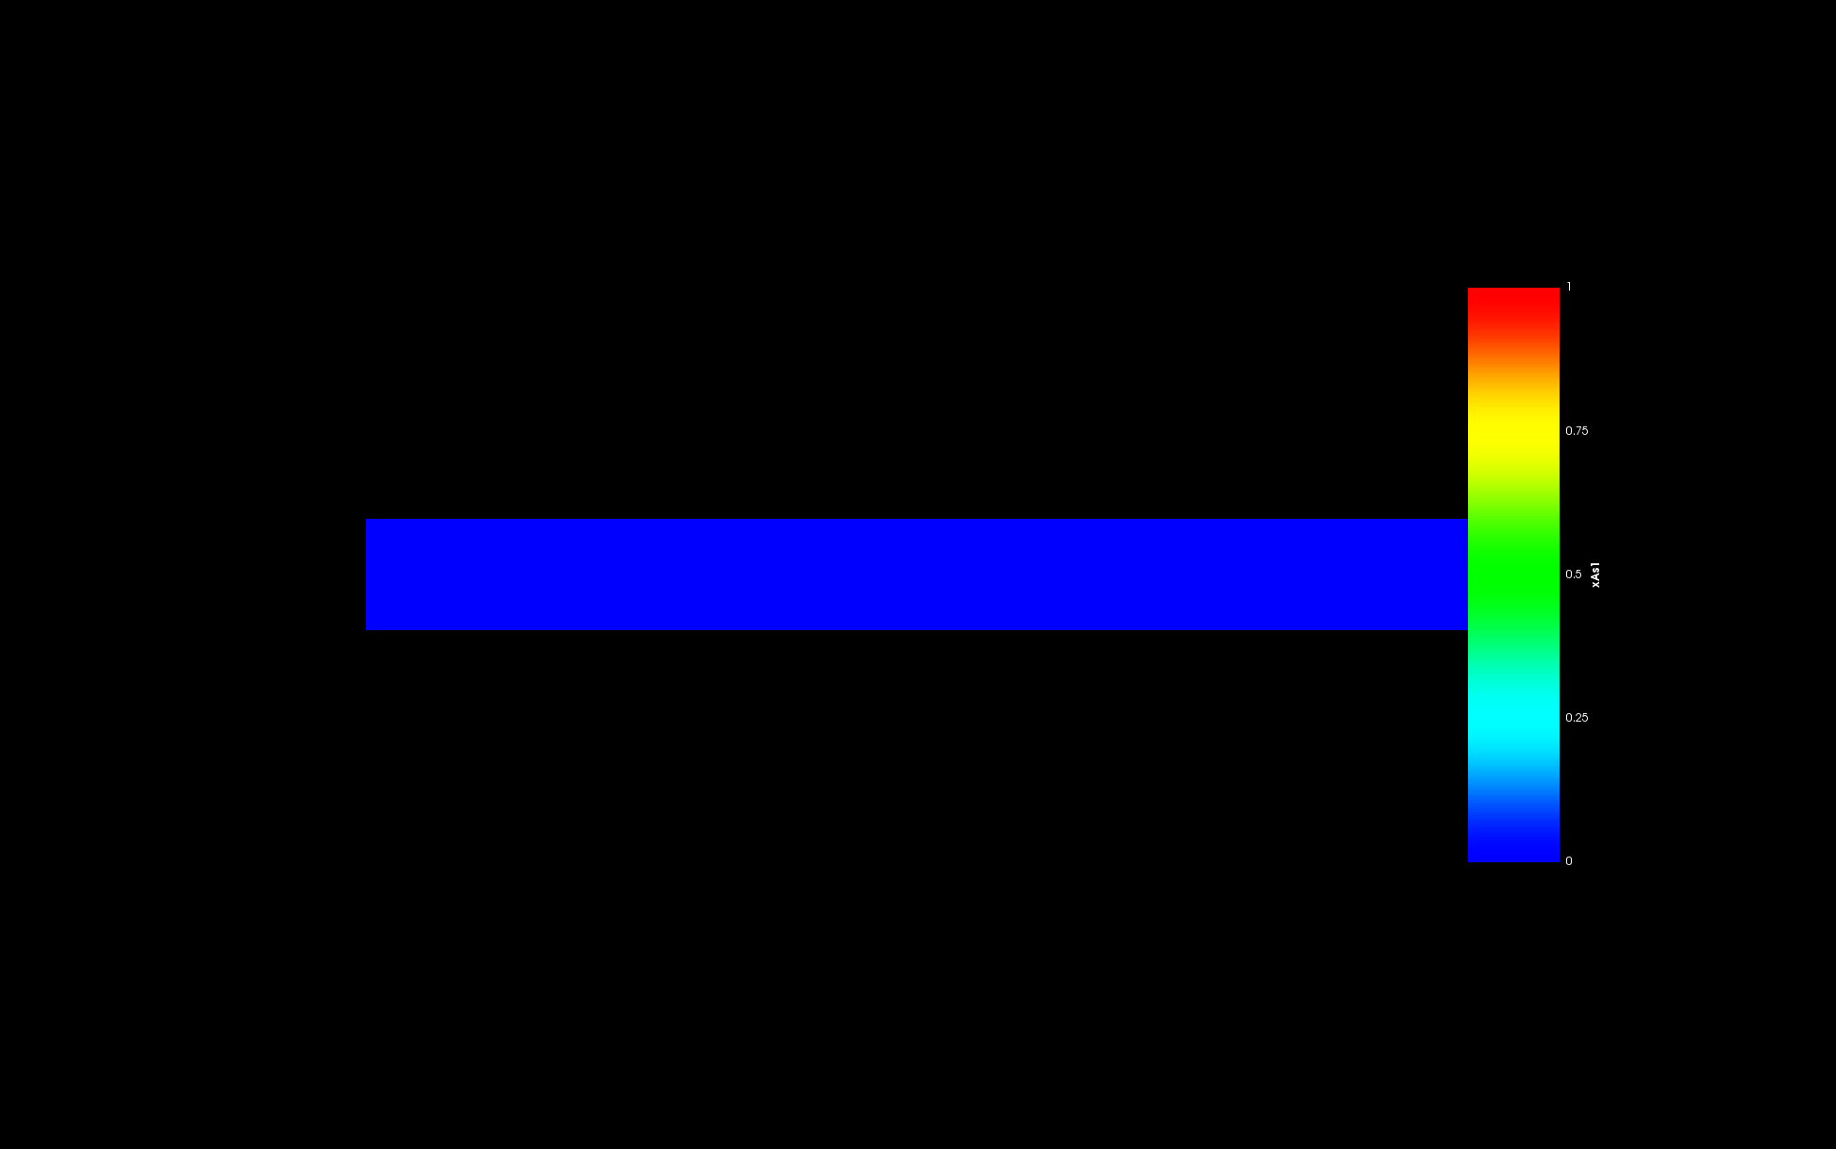

Figure 25: Initial ‘*As*’ content in Phase 1.

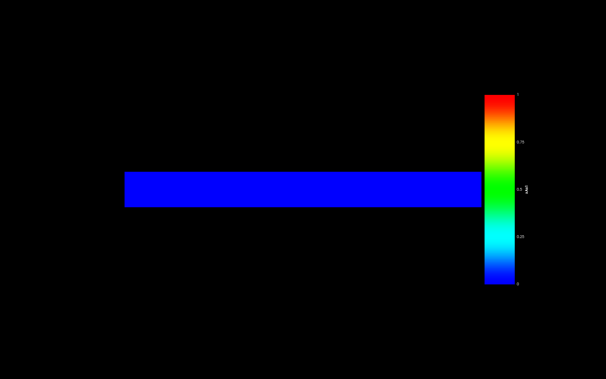

Figure 26: Final ‘*As*’ content in Phase 1.

Figure 27 and 28 shows the local ‘*As*’ concentration in phase 3.

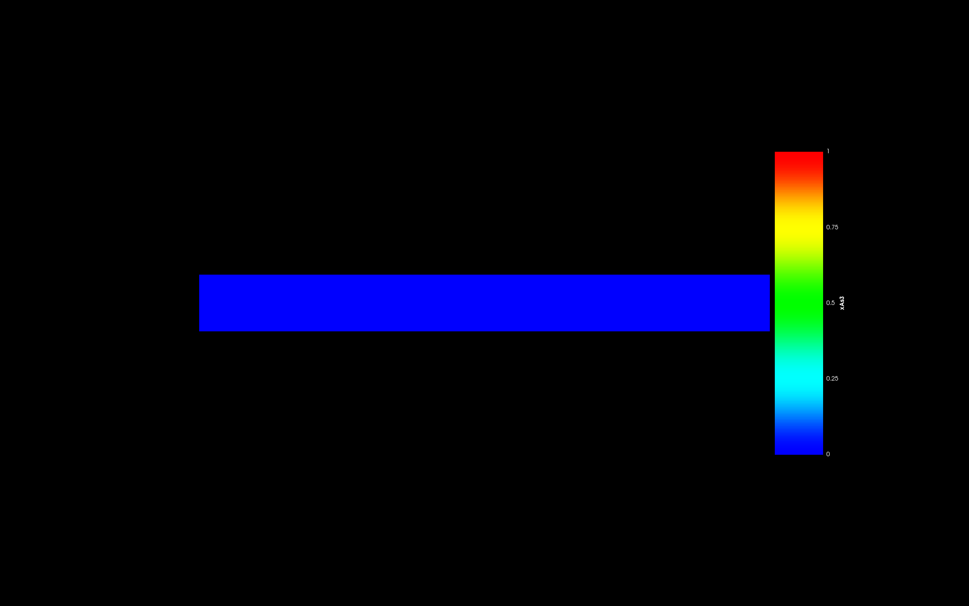

Figure 27: Initial ‘*As*’ content in Phase 3.

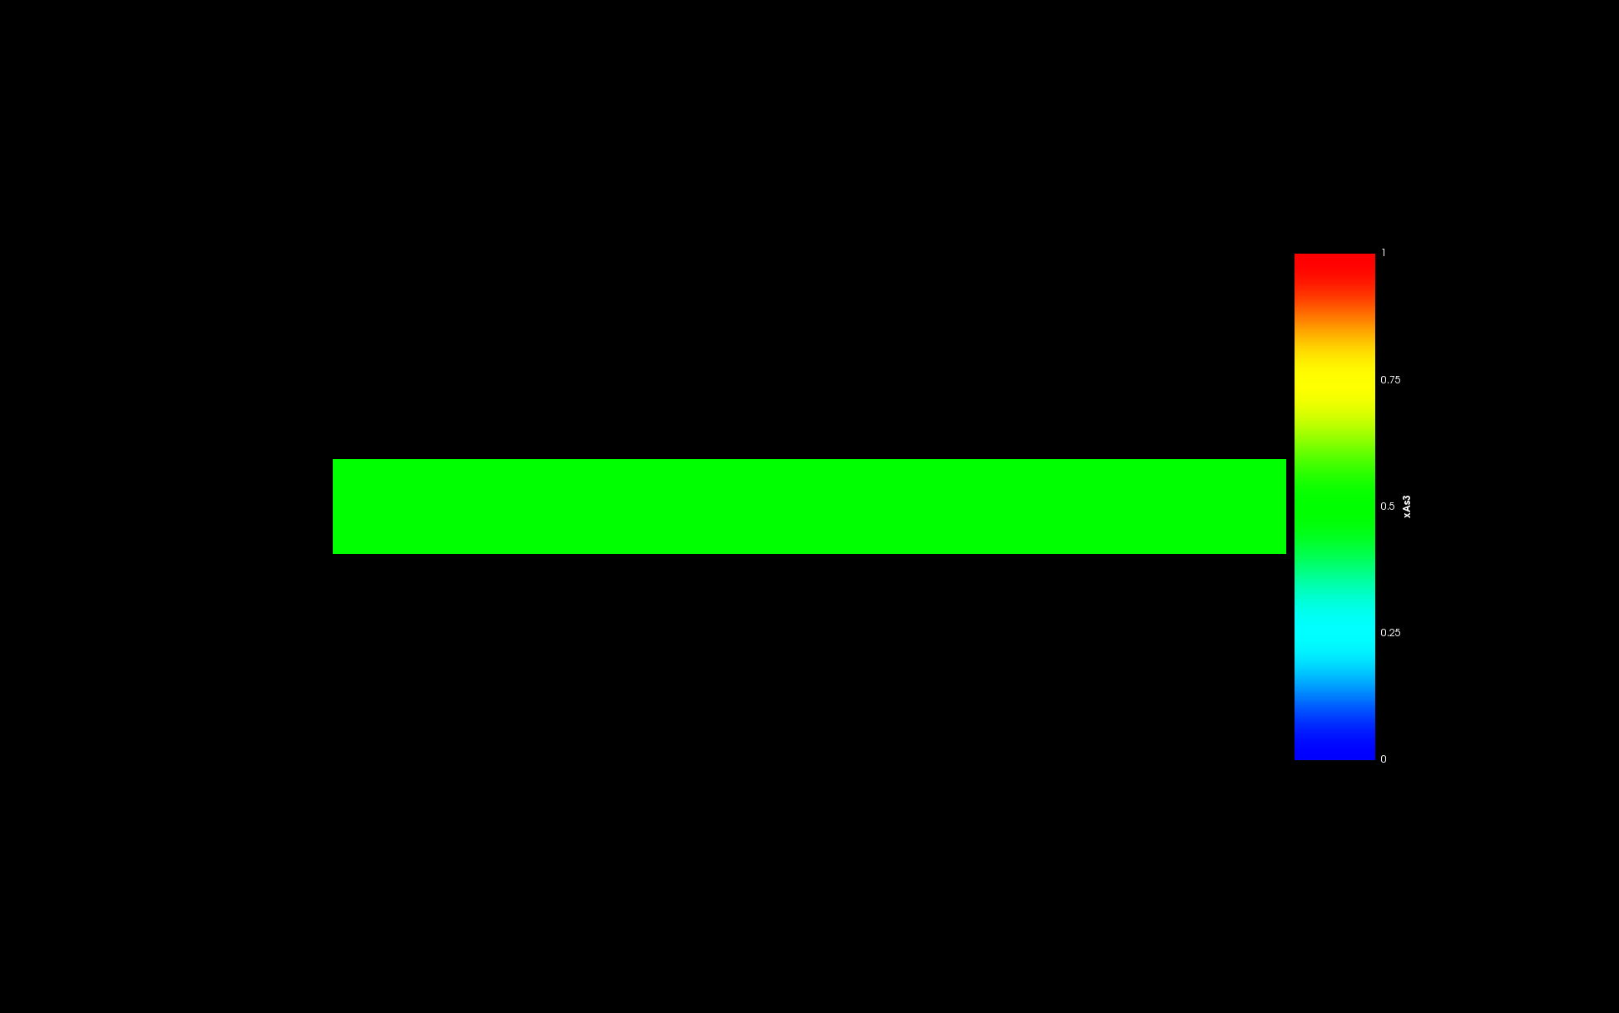

Figure 28: Final ‘*As*’ content in Phase 3.

Figure 29 and 30 shows the local ‘*Nd*’ concentration in phase 1.

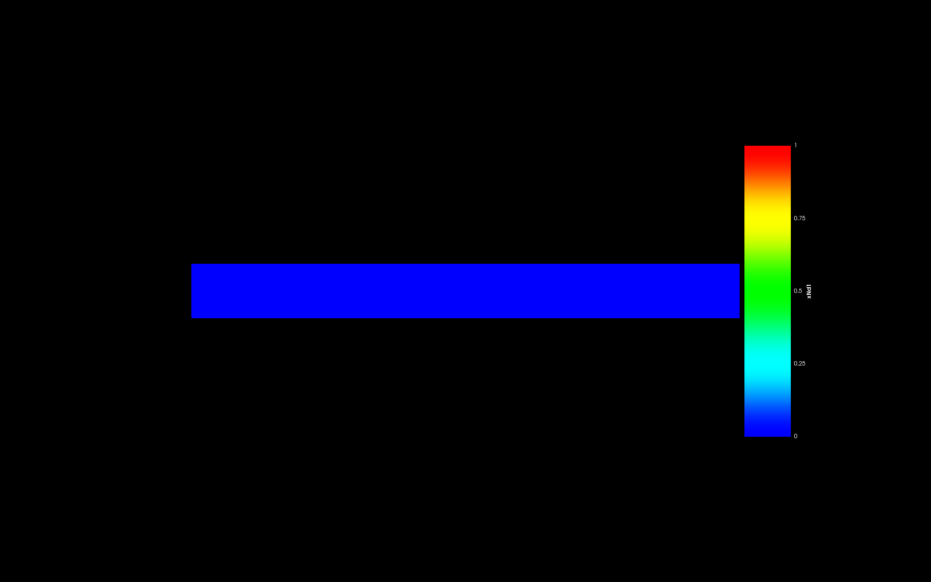

Figure 29: Initial ‘*Nd*’ content in Phase 1.

  
Figure 30: Final ‘*Nd*’ content in Phase 1.

Figure 31 and 32 shows the local ‘*Nd*’ concentration in phase 3.

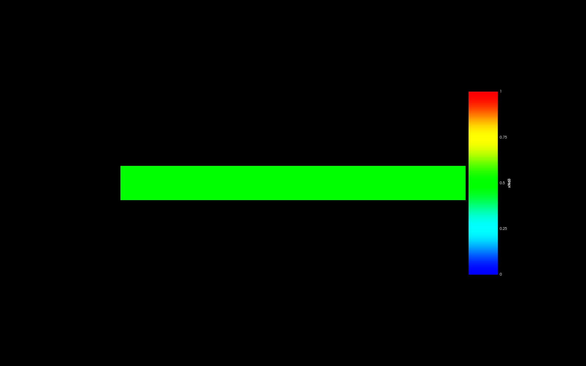

Figure 31: Initial ‘*Nd*’ content in Phase 3.

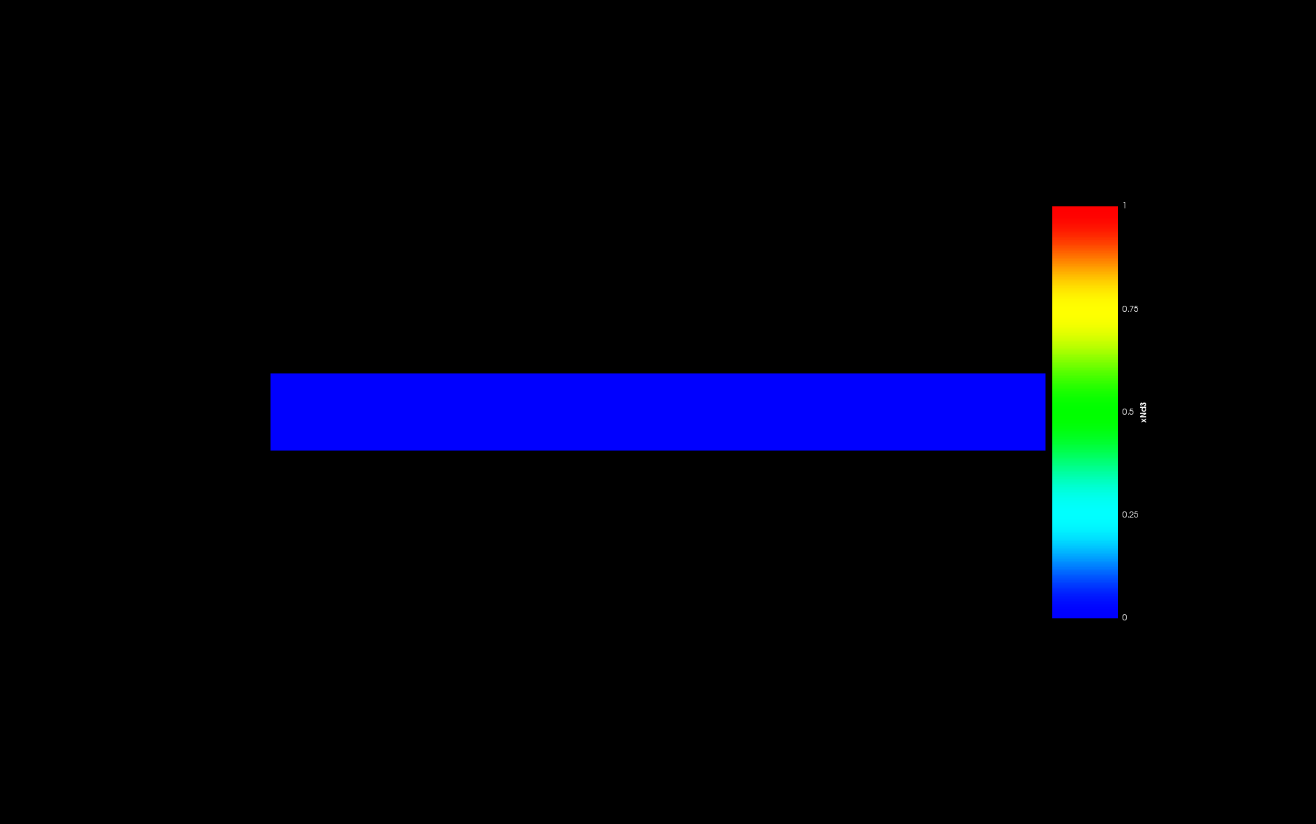

Figure 32: Final ‘*Nd*’ content in Phase 3.

**Discussion**

For equilibrium between Phase 1 (*U*) and Phase 2 (*NdAs*).

* We have shown a 2-phase equilibrium between Phase 1 and Phase 2 in the Gibbs energy plot in Figure 2 at sufficient ‘*Nd*’ content in the system which will end up forming Phase 2 i.e. the *NdAs* phase.
* The phase field simulation of this system also shows an equilibrium between Phase 1 and Phase 2 as shown in Figure 6.
* The local ‘*As*’ content in Phase 1 (*U*) and Phase 2 (*NdAs*) is 0 and 0.5 as shown in Figure 12 and 14 respectively. This is in accordance with the stoichiometry of the phases and is expected from the phase field simulation.
* The local ‘*Nd*’ content in Phase 1 (*U*) and Phase 2 (*NdAs*) is 0 and 0.5 as shown in Figure 16 and 18 respectively. This is in accordance with the stoichiometry of the phases and is expected from the phase field simulation.

For equilibrium between Phase 1 (*U*) and Phase 3 (*UAs*).

* We have shown a 2-phase equilibrium between Phase 1 and Phase 3 in the Gibbs energy plot in Figure 1 at neglibible ‘*Nd*’ content in the system which will end up forming Phase 3 i.e. the *UAs* phase.
* The phase field simulation of this system also shows an equilibrium between Phase 1 and Phase 3 as shown in Figure 20.
* The local ‘*As*’ content in Phase 1 (*U*) and Phase 3 (*UAs*) is 0 and 0.5 as shown in Figure 26 and 28 respectively. This is in accordance with the stoichiometry of the phases and is expected from the phase field simulation.
* The local ‘*Nd*’ content in Phase 1 (*U*) and Phase 3 (*UAs*) is 0 each as shown in Figure 30 and 32 respectively. This is in accordance with the stoichiometry of the phases and is expected from the phase field simulation.