**FCCI Phase Field Model**

**System Description and Gibbs energy modeling**

In this FCCI phase field model, we consider 3 phases i.e. ***α* - Uranium** phase (Phase 1), ***NdAs*** phase (Phase 2) and ***UAs*** phase (Phase 3). We will use the CALPHAD approach to model this phases computationally. In CALPHAD approach the Gibbs energy, (in eV) for individual phases is given by:

(1)

where = Gibbs energy for mechanical mixing.

= Gibbs energy contribution for ideal mixing.

= Excess Gibbs energy part.

**Phase 1 (*α* - Orthorhombic):**

(2)

(3)

(4)

where,

= -8407.734 + 130.955151*T* – 26.9182*TlnT* + 1.25156E-03*T2* – 4.42605E-06*T3* +   
 38568*T-1* (298.15*K* < *T* < 955*K*)

= -22521.8 + 292.121093*T* – 48.66*TlnT* (955*K* < *T* < 3000*K*)

is taken from the *SGTE* database.

= 0.05182 *eV*.

= 0.05182 *eV*.

are assumed because these values are not available in the *SGTE* database and,

= 4.17 *eV*

= 3.84 *eV*

are calculated using the DFT calculations.

**Phase 2 (*Nd-As*):**

(5)

(6)

(7)

where,

(298.15*K* < *T* < 900*K*)

(298.15*K* < *T* < 1090*K*)

are taken from the SGTE database and,

= -1.57 *eV*

is calculated using the DFT calculations.

**Phase 3 (*UAs*):**

(8)

(9)

(10)

where,

(298.15*K* < *T* < 1049*K*)

(298.15*K* < *T* < 1090*K*)

are taken from the SGTE database and,

is calculated using the DFT calculations.

**Gibbs free energy curves**

* **When *Nd* concentration is very low in the system.**

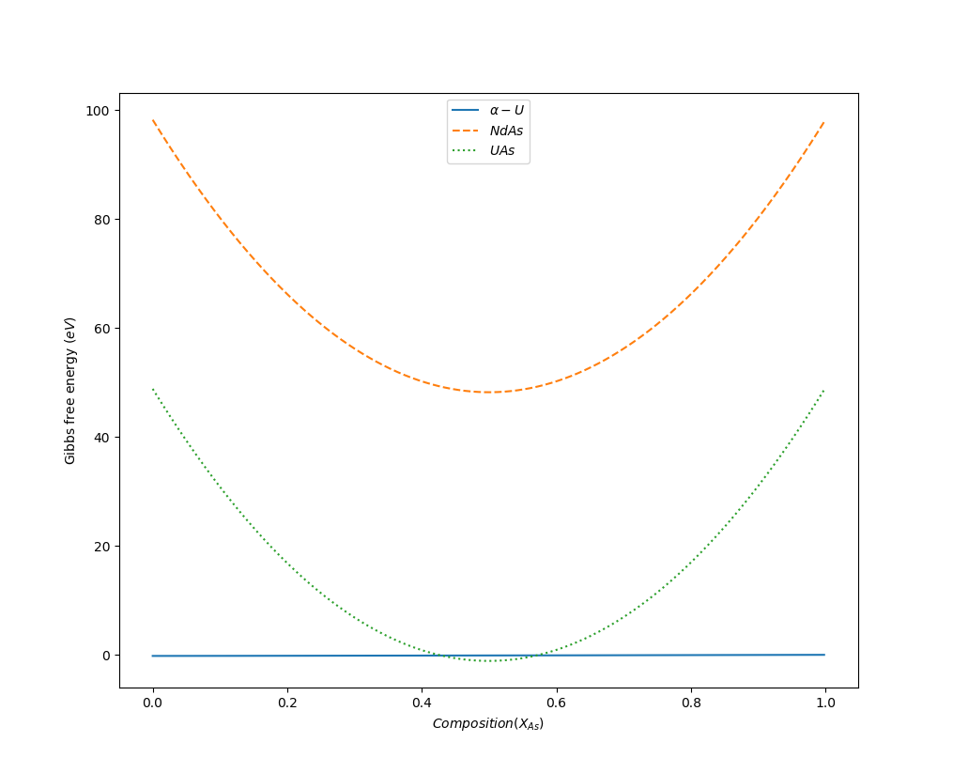

Figure 1: Gibbs energy Vs composition curve for the 3 phases in the system at negligible Nd concentration.

* **When *XNd* = *XAs* in the system.**

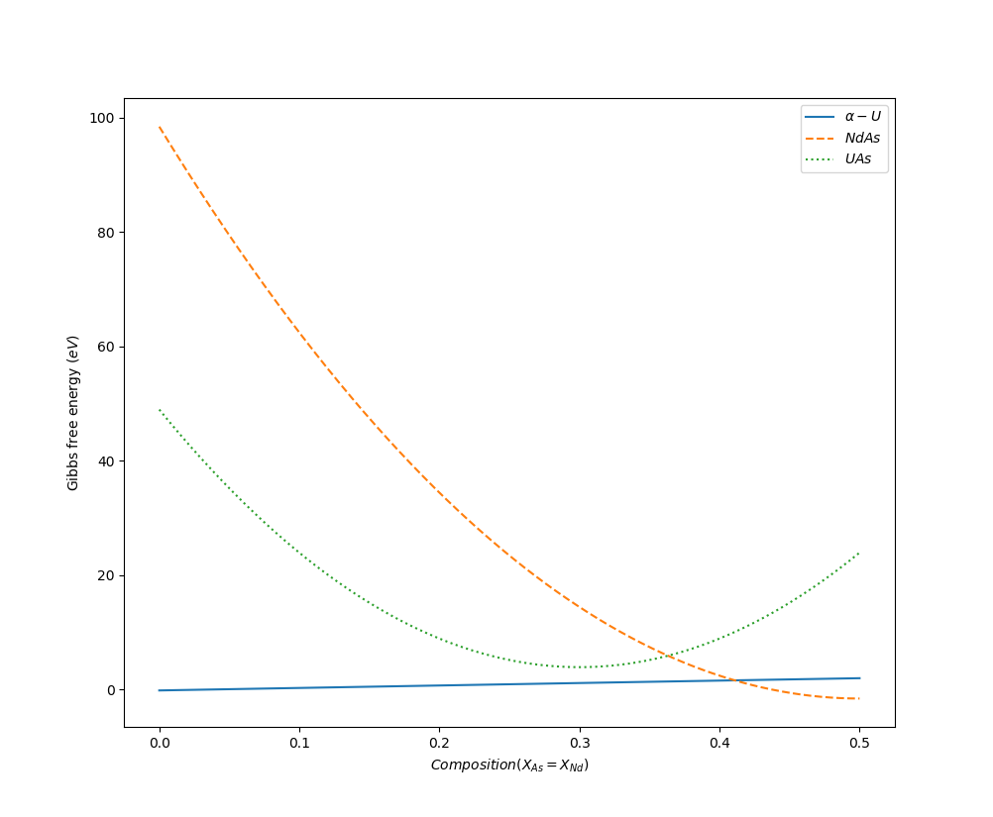

Figure 2: Gibbs energy Vs composition curve for the 3 phases in the system at negligible Nd concentration.

**Phase Field Modeling**

We have considered 3 different phases, 2 global and 6 local compositions in the system. This system is modeled with the help of *Kim-Kim-Suzuki* multi-phase field model under the *MOOSE* framework. The *Kim-Kim-Suzuki* multi-phase field model has an advantage over the traditional phase field model as it solves the problem by introducing the concept of phase concentrations. Additionally, in the *Kim-Kim-Suzuki* model, the interfacial width is de-coupled from the interfacial energy and can be changed according to the system requirements without affecting the latter.

For the phase field simulation, we consider a 25 × 25 simulation domain which is scaled from -10 to 10 both in the X-axis and the Y-axis. In the simulation, we have considered time step of 10-5 and total end time 107.

**Simulation results**

* **Equilibrium between Phase 1 and Phase 2 when enough ‘*Nd*’ is present in the system.**

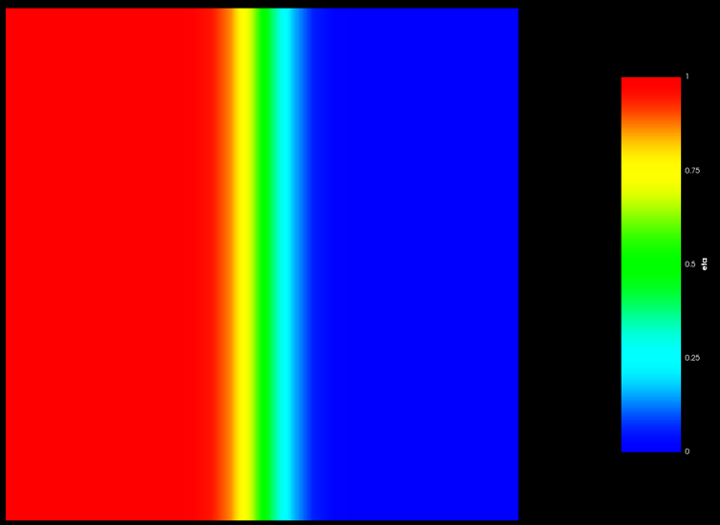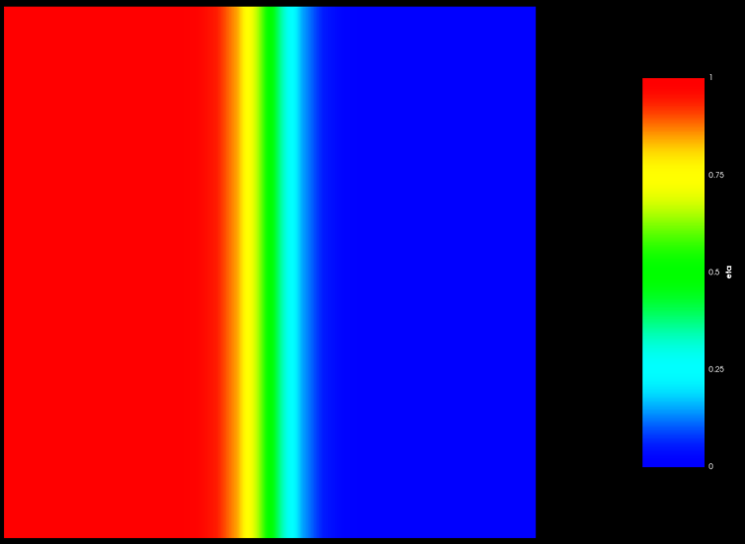Figure 3 shows the initial condition and final condition of the phases present in the system.

3(a) 3(b)

Figure 3: (a)Initial condition and (b)final condition of the system with Phase 1 and Phase 2.

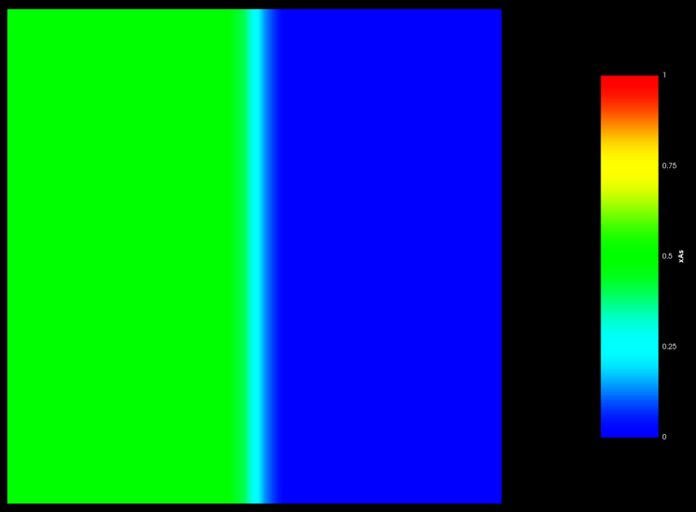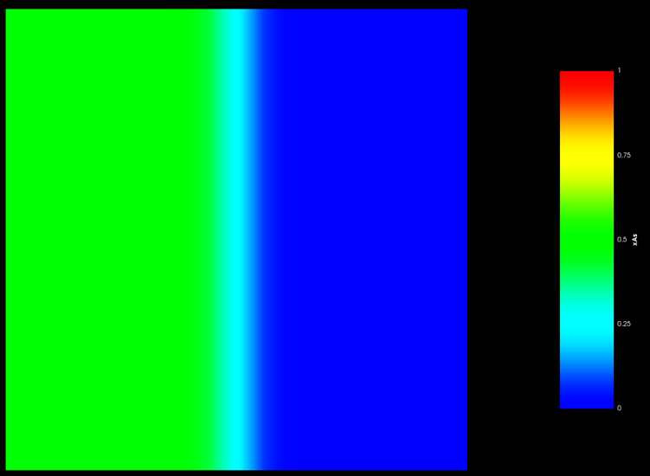Figure 4 shows the global ‘*As*’ concentration in the system.

4(a) 4(b)

Figure 4: (a)Initial and (b)final ‘*As*’ content in the system.

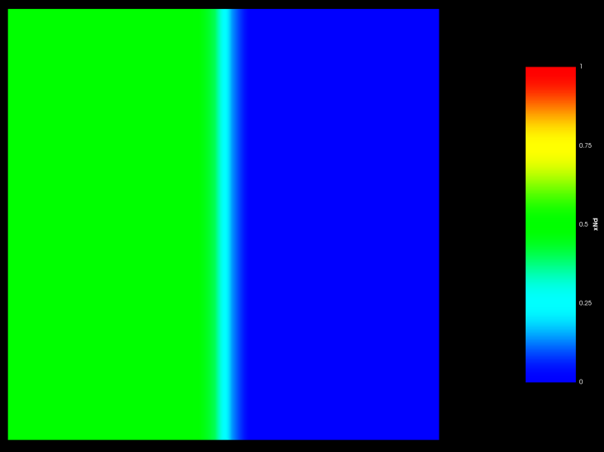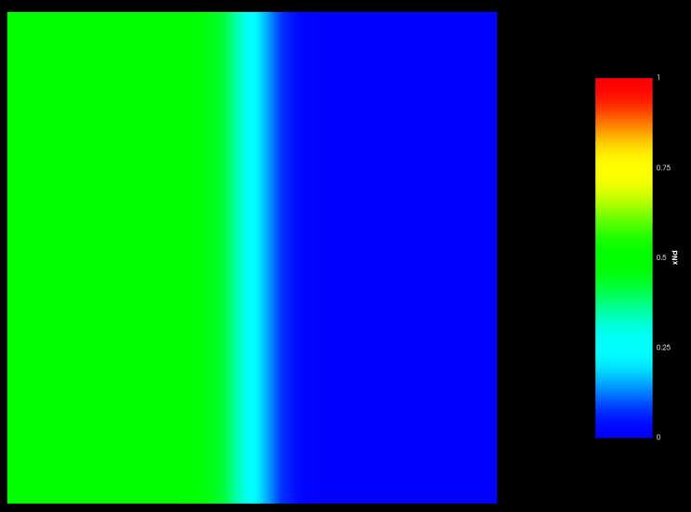Figure 5 shows the global ‘*Nd*’ concentration in the system.

5(a) 5(b)

Figure 5: (a)Initial and (b)final ‘*Nd*’ content in the system.

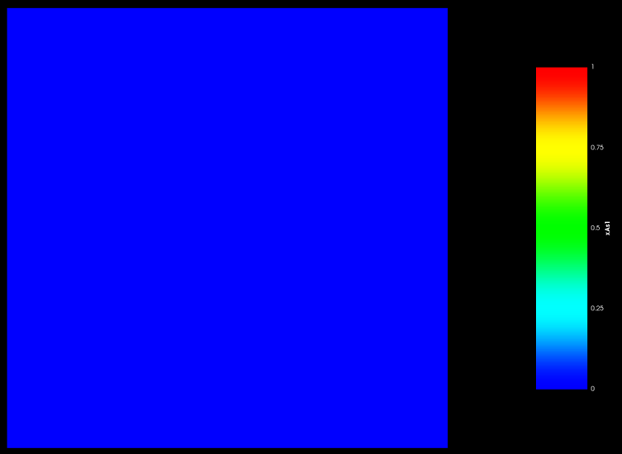Figure 6 shows the local ‘*As*’ concentration in phase 1.

6(a) 6(b)

Figure 6: (a)Initial and (b)final ‘*As*’ content in Phase 1(*U* – Phase).

Figure 7 shows the local ‘*As*’ concentration in phase 2.

7(a) 7(b)

Figure 7: (a)Initial and (b)final ‘*As*’ content in Phase 2(*NdAs* – Phase).

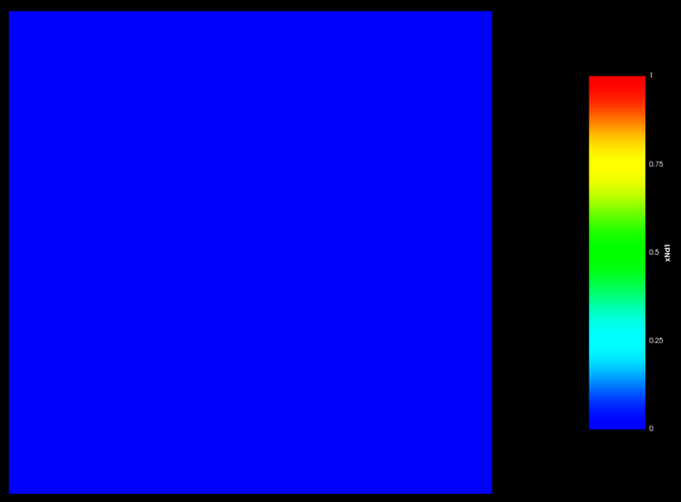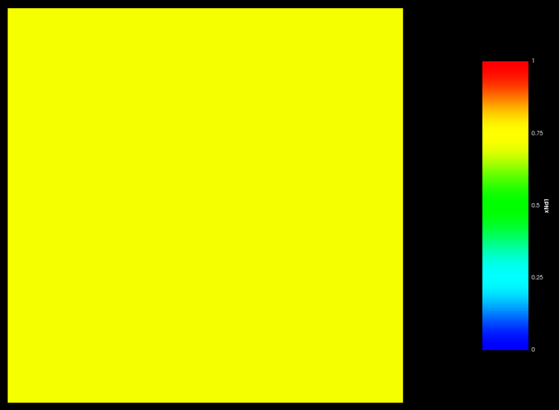Figure 8 shows the local ‘*Nd*’ concentration in phase 1.

8(a) 8(b)

Figure 8: (a)Initial and (b)final ‘*Nd*’ content in Phase 1(*U* – Phase).

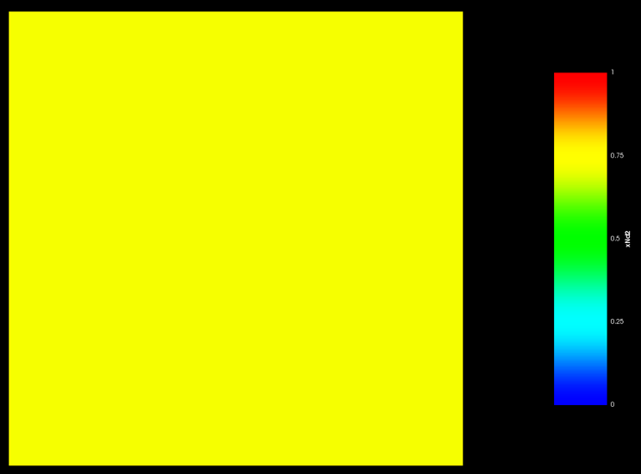Figure 9 shows the local ‘*Nd*’ concentration in phase 2.

9(a) 9(b)

Figure 9: (a)Initial and (b)final ‘*Nd*’ content in Phase 2(*NdAs* – Phase).

* **Equilibrium between Phase 1 and Phase 3 when negligible ‘*Nd*’ is present in the system.**

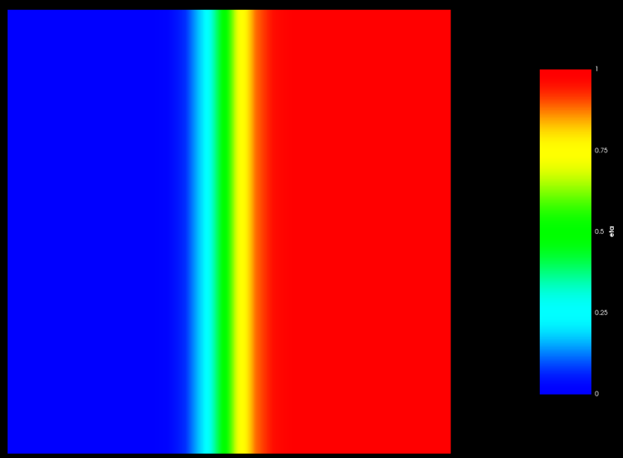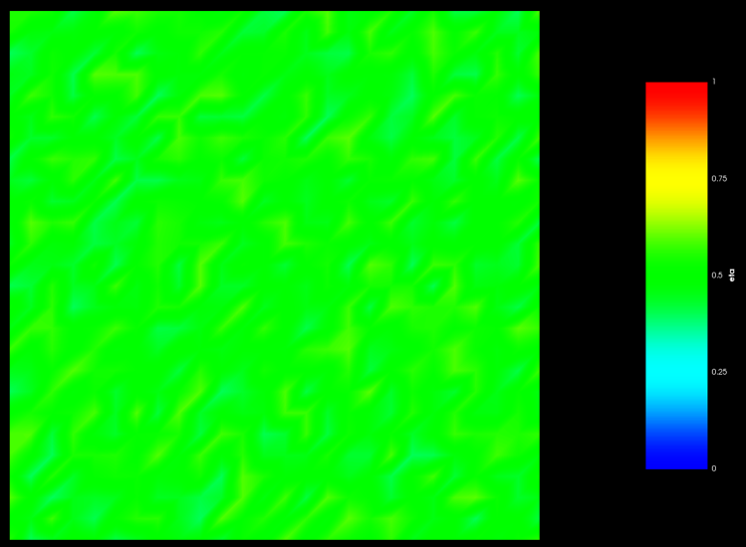Figure 10 shows the initial condition and final condition of the phases present in the system.

10(a) 10(b)

Figure 10: (a)Initial condition and (b)final condition of the system with Phase 1 and Phase 3.

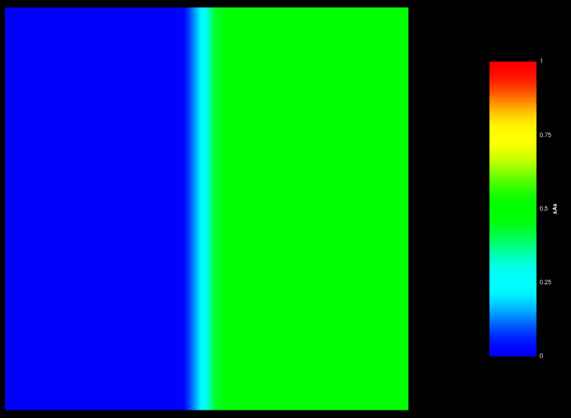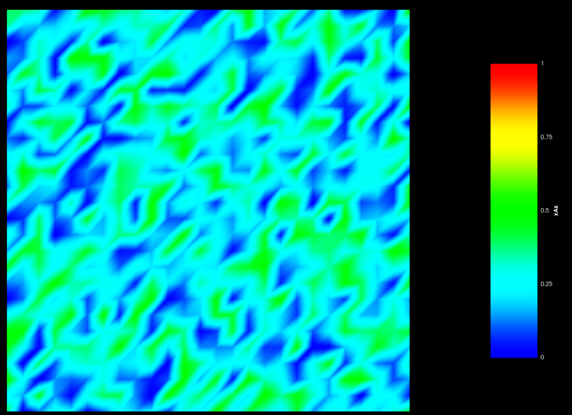Figure 11 shows the global ‘*As*’ concentration in the system.

11(a) 11(b)

Figure 11: (a)Initial and (b)final ‘*As*’ content in the system.

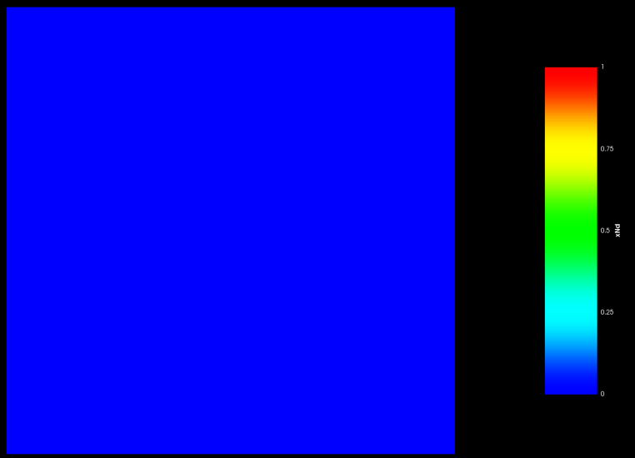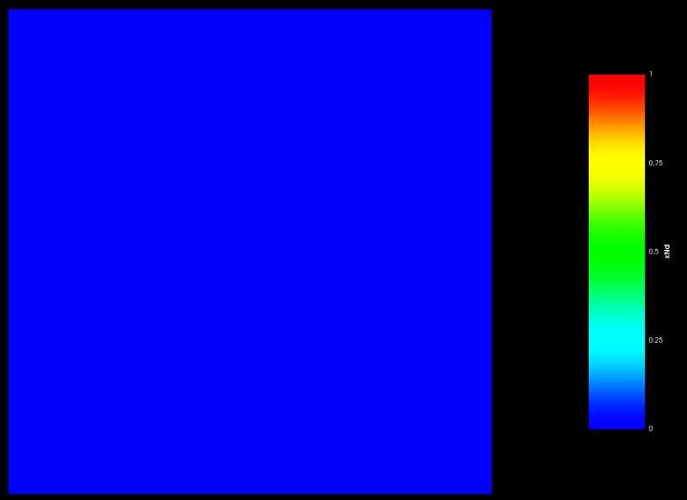Figure 12 shows the global ‘*Nd*’ concentration in the system.

12(a) 12(b)

Figure 12: (a)Initial and (b)final ‘*Nd*’ content in the system.

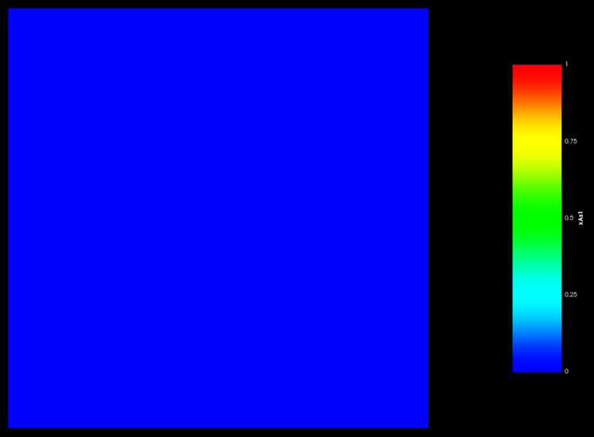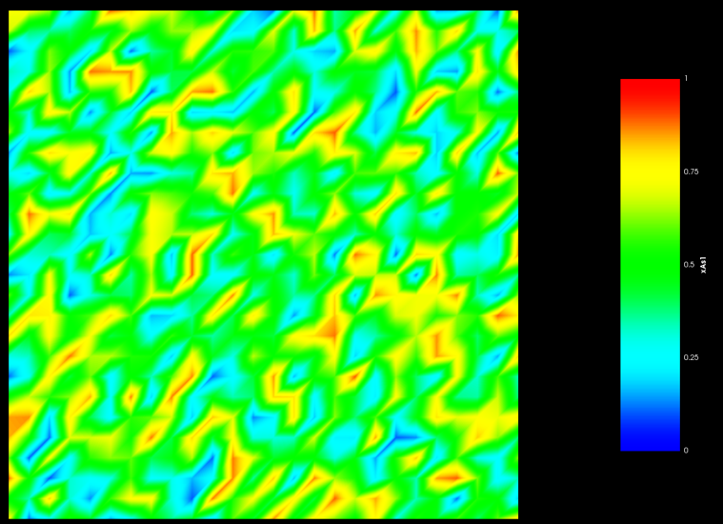Figure 13 shows the local ‘*As*’ concentration in phase 1.

13(a) 13(b)

Figure 13: (a)Initial and (b)final ‘*As*’ content in Phase 1(*U* – Phase).

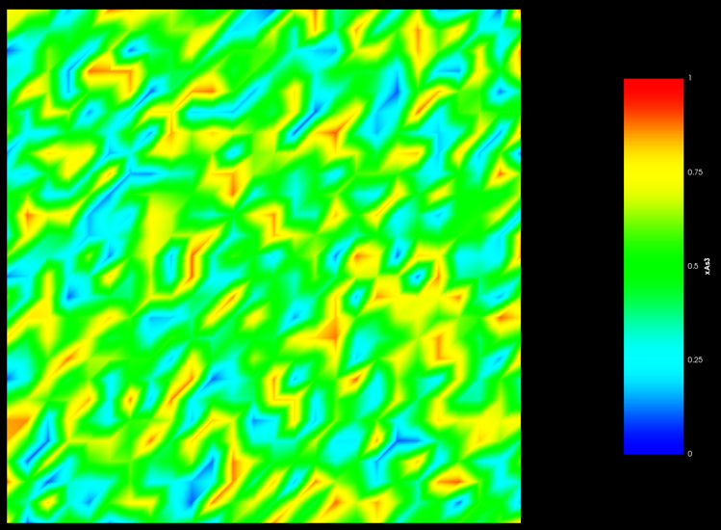Figure 14 shows the local ‘*As*’ concentration in phase 3.

14(a) 14(b)

Figure 14: (a)Initial and (b)final ‘*As*’ content in Phase 3(*UAs* – Phase).

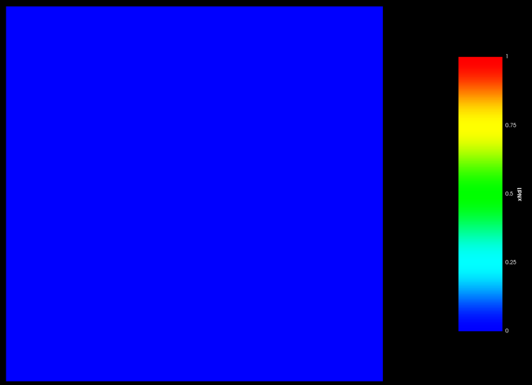Figure 15 shows the local ‘*Nd*’ concentration in phase 1.

15(a) 15(b)

Figure 15: (a)Initial and (b)final ‘*Nd*’ content in Phase 1(*U* – Phase).

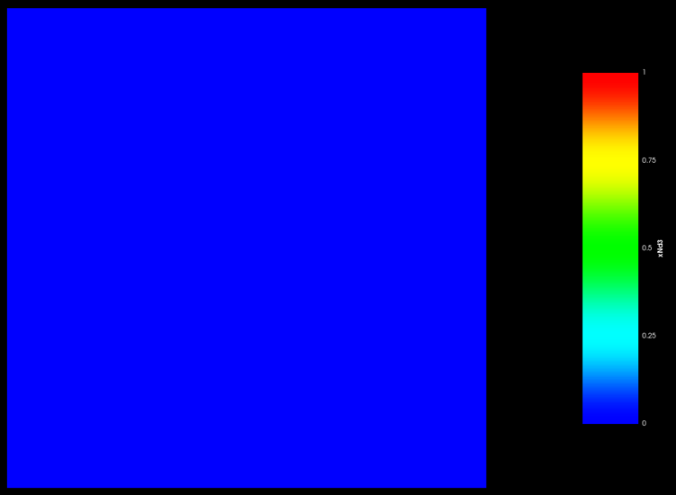Figure 16 shows the local ‘*Nd*’ concentration in phase 3.

16(a) 16(b)

Figure 16: (a)Initial and (b)final ‘*Nd*’ content in Phase 3(*UAs* – Phase).

* **Equilibrium between Phase 2 and Phase 3 when enough ‘*Nd*’ is present in the system.**

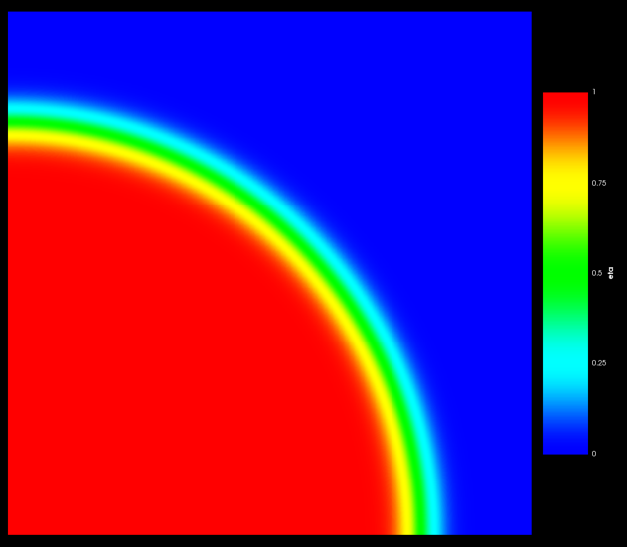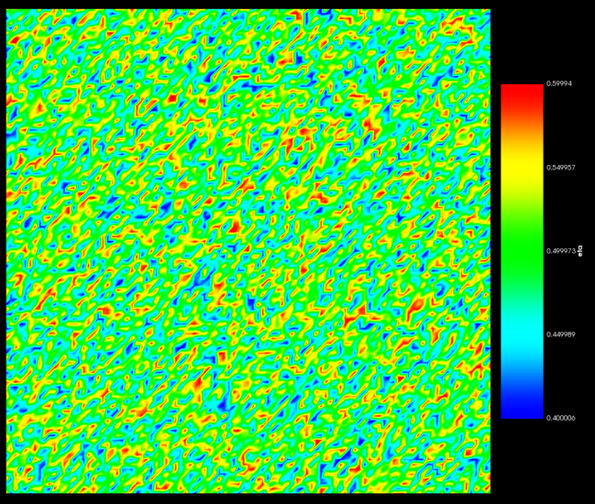Figure 17 shows the initial condition and final condition of the phases present in the system.

17(a) 17(b)

Figure 17: (a)Initial condition and (b)final condition of the system with Phase 2 and Phase 3.

Figure 18 shows the global ‘*As*’ concentration in the system.

18(a) 18(b)

Figure 18: (a)Initial and (b)final ‘*As*’ content in the system.

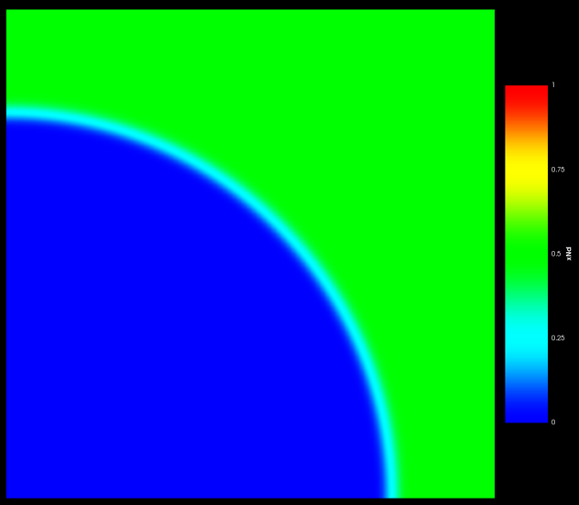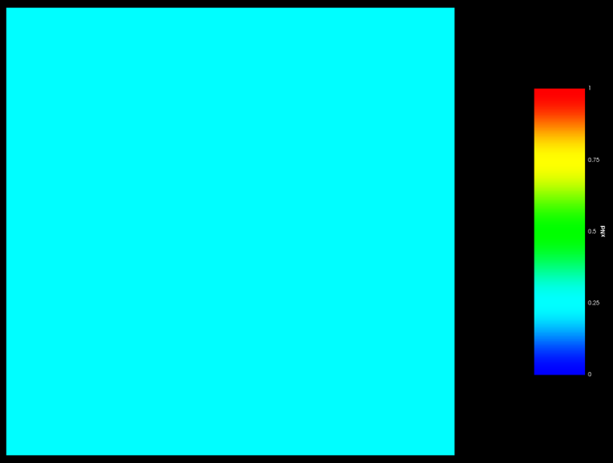Figure 19 shows the global ‘*Nd*’ concentration in the system.

19(a) 19(b)

Figure 19: (a)Initial and (b)final ‘*Nd*’ content in the system.

**Discussion**

For equilibrium between Phase 1 (*U*) and Phase 2 (*NdAs*).

* We have shown a 2-phase equilibrium between Phase 1 and Phase 2 in the Gibbs energy plot in Figure 2 at sufficient ‘*Nd*’ content in the system which will end up forming Phase 2 i.e. the *NdAs* phase.
* The phase field simulation of this system also shows an equilibrium between Phase 1 and Phase 2 as shown in Figure 3.
* The local ‘*As*’ content in Phase 1 (*U*) and Phase 2 (*NdAs*) is 0 and 0.5 as shown in Figure 6 and 7 respectively. This is in accordance with the stoichiometry of the phases and is expected from the phase field simulation.
* The local ‘*Nd*’ content in Phase 1 (*U*) and Phase 2 (*NdAs*) is 0 and 0.5 as shown in Figure 8 and 9 respectively. This is in accordance with the stoichiometry of the phases and is expected from the phase field simulation.

For equilibrium between Phase 1 (*U*) and Phase 3 (*UAs*).

* We have shown a 2-phase equilibrium between Phase 1 and Phase 3 in the Gibbs energy plot in Figure 1 at neglibible ‘*Nd*’ content in the system which will end up forming Phase 3 i.e. the *UAs* phase.
* The phase field simulation of this system also shows an equilibrium between Phase 1 and Phase 3 as shown in Figure 10.
* The local ‘*As*’ content in Phase 1 (*U*) and Phase 3 (*UAs*) is 0 and 0.5 as shown in Figure 13 and 14 respectively. This is in accordance with the stoichiometry of the phases and is expected from the phase field simulation.
* The local ‘*Nd*’ content in Phase 1 (*U*) and Phase 3 (*UAs*) is 0 each as shown in Figure 15 and 16 respectively. This is in accordance with the stoichiometry of the phases and is expected from the phase field simulation.

For equilibrium between Phase 2 (*NdAs*) and Phase 3 (*UAs*).

* The phase field simulation of this system also shows an equilibrium between Phase 2 and Phase 3 as shown in Figure 17.
* The global ‘*As*’ content in Phase 2 (*NdAs*) and Phase 3 (*UAs*) is 0.5 each and is shown in Figure 18. This is in accordance with the stoichiometry of the phases and is expected from the phase field simulation.
* The global ‘*Nd*’ content in Phase 2 (*NdAs*) and Phase 3 (*UAs*) is 0.5 and 0 and is shown in Figure 19(a) and 19(b) respectively. This is in accordance with the stoichiometry of the phases and is expected from the phase field simulation.