**FCCI Phase Field Model**

**System Description and Gibbs energy modeling**

In this FCCI phase field model, we consider 3 phases i.e. ***α* - Uranium** phase (Phase 1), ***NdAs*** phase (Phase 2) and ***UAs*** phase (Phase 3). We will use the CALPHAD approach to model this phases computationally. In CALPHAD approach the Gibbs energy, (in eV) for individual phases is given by:

(1)

where = Gibbs energy for mechanical mixing.

= Gibbs energy contribution for ideal mixing.

= Excess Gibbs energy part.

**Phase 1 (*α* - Orthorhombic):**

(2)

(3)

(4)

where,

= -8407.734 + 130.955151*T* – 26.9182*TlnT* + 1.25156E-03*T2* – 4.42605E-06*T3* +   
 38568*T-1* (298.15*K* < *T* < 955*K*)

= -22521.8 + 292.121093*T* – 48.66*TlnT* (955*K* < *T* < 3000*K*)

is taken from the *SGTE* database.

= 0.05182 *eV*.

= 0.05182 *eV*.

are assumed because these values are not available in the *SGTE* database and,

= 4.17 *eV*

= 3.84 *eV*

are calculated using the DFT calculations.

**Phase 2 (*Nd-As*):**

(5)

(6)

(7)

where,

(298.15*K* < *T* < 900*K*)

(298.15*K* < *T* < 1090*K*)

are taken from the SGTE database and,

= -1.57 *eV*

is calculated using the DFT calculations.

**Phase 3 (*UAs*):**

(8)

(9)

(10)

where,

(298.15*K* < *T* < 1049*K*)

(298.15*K* < *T* < 1090*K*)

are taken from the SGTE database and,

is calculated using the DFT calculations.

**Gibbs free energy curves**

* **When *Nd* concentration is very low in the system.**

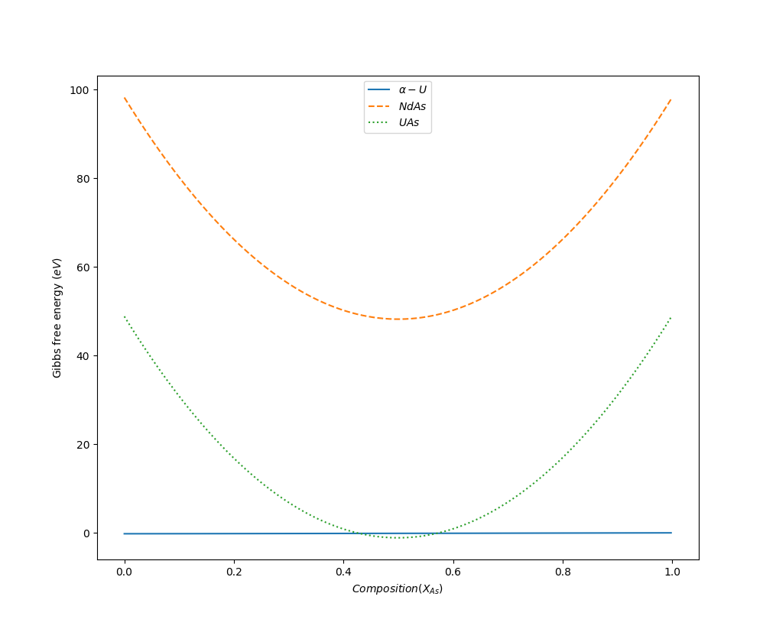

Figure 1: Gibbs energy Vs composition curve for the 3 phases in the system at negligible Nd concentration.

* **When *XNd* = *XAs* in the system.**

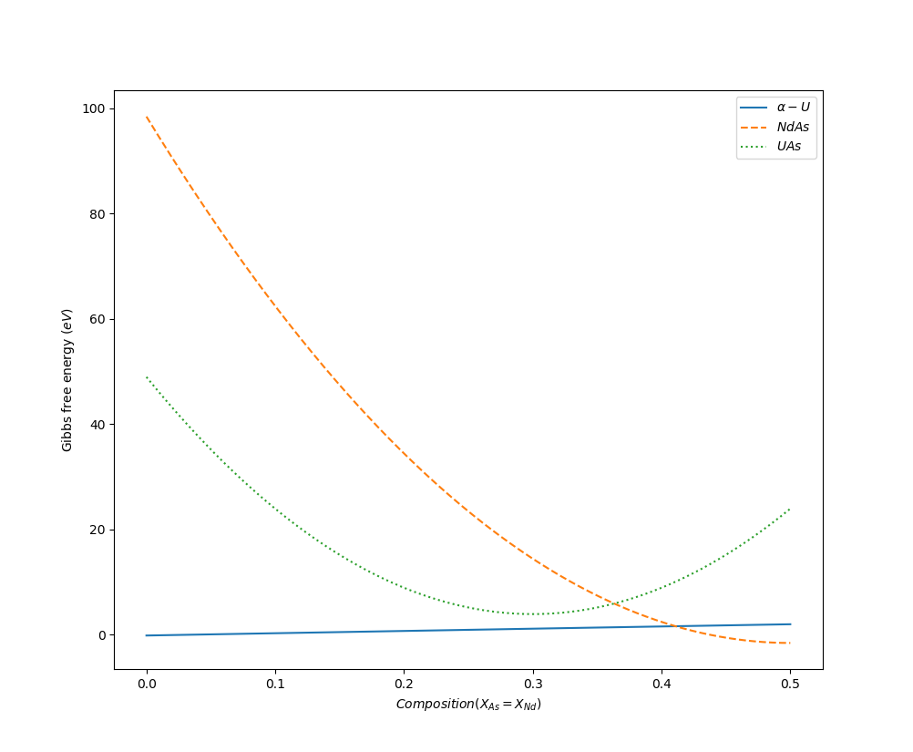

Figure 2: Gibbs energy Vs composition curve for the 3 phases in the system at negligible Nd concentration.

**Phase Field Modeling**

We have considered 3 different phases, 2 global and 6 local compositions in the system. This system is modeled with the help of *Kim-Kim-Suzuki* multi-phase field model under the *MOOSE* framework at 300*K*. The *Kim-Kim-Suzuki* multi-phase field model has an advantage over the traditional phase field model as it solves the problem by introducing the concept of phase concentrations. Additionally, in the *Kim-Kim-Suzuki* model, the interfacial width is de-coupled from the interfacial energy and can be changed according to the system requirements without affecting the latter.

For the phase field simulation, we consider a 100 × 100 simulation domain which is scaled from -25 to 25 both in the X-axis and the Y-axis. In the simulation, we have considered time step of 10-5 and total end time 107. The value of the coefficient of phase field gradient energy term (*κ*) and the double well barrier is set to be 1.5 and 1.35 respectively. We have also calculated the interfacial energy of the system and is 0.671 *eV*/nm2.

**Simulation results**

* **Equilibrium between Phase 1 and Phase 2 when enough ‘*Nd*’ is present in the system.**

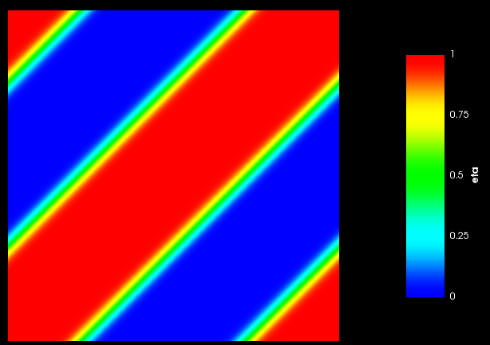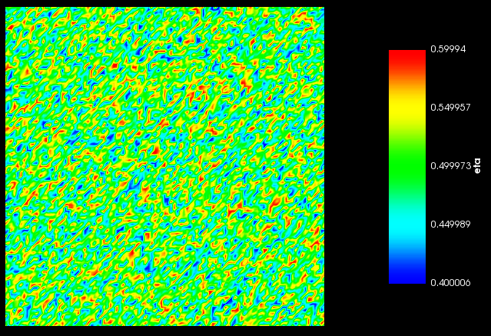Figure 3 shows the initial condition and final condition of the phases present in the system.

3(a) 3(b)

Figure 3: (a)Initial condition and (b)final condition of the system with Phase 1 and Phase 2.

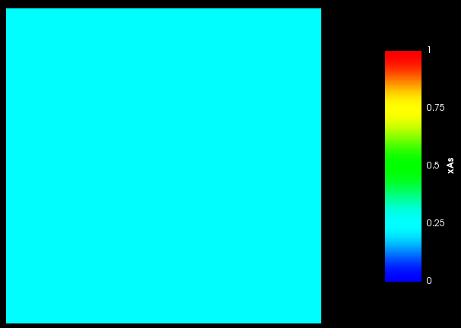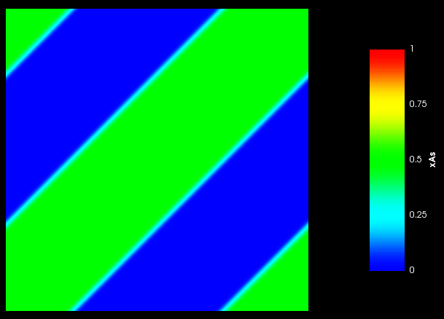Figure 4 shows the global ‘*As*’ concentration in the system.

4(a) 4(b)

Figure 4: (a)Initial and (b)final ‘*As*’ content in the system.

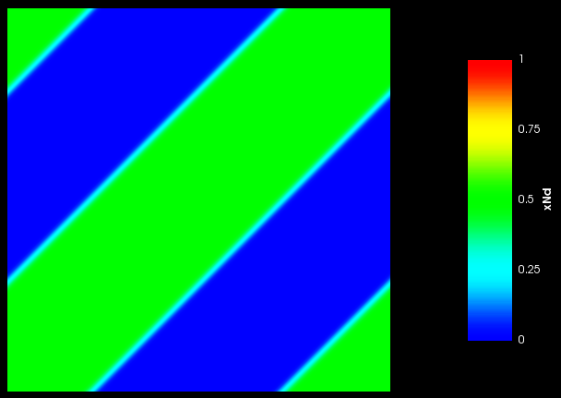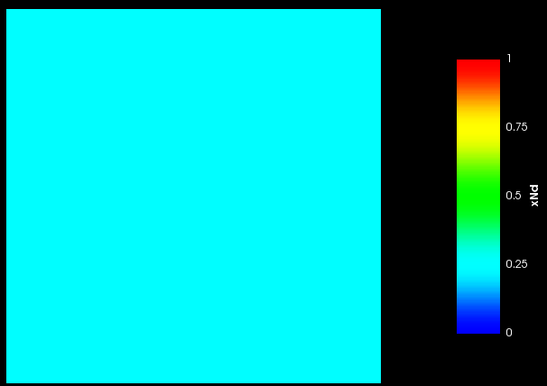Figure 5 shows the global ‘*Nd*’ concentration in the system.

5(a) 5(b)

Figure 5: (a)Initial and (b)final ‘*Nd*’ content in the system.

* **Equilibrium between Phase 1 and Phase 3 when negligible ‘*Nd*’ is present in the system.**

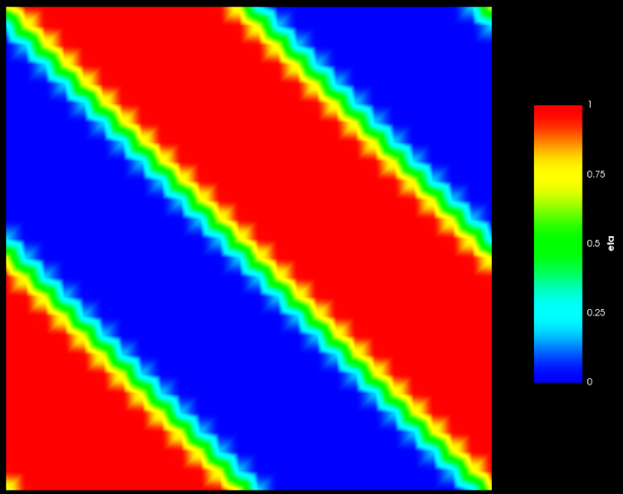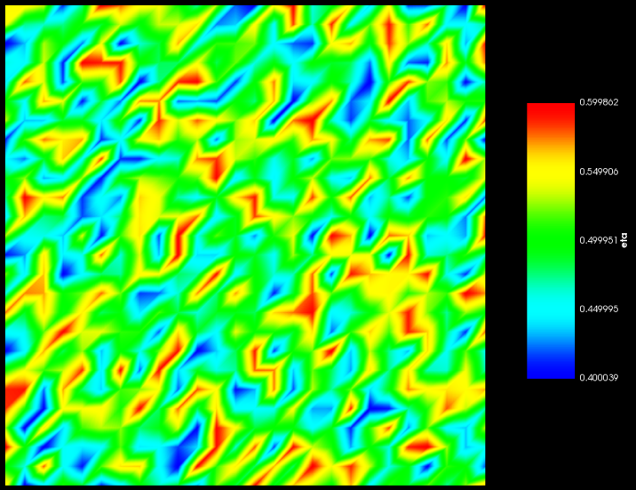Figure 6 shows the initial condition and final condition of the phases present in the system.

6(a) 6(b)

Figure 6: (a)Initial condition and (b)final condition of the system with Phase 1 and Phase 3.

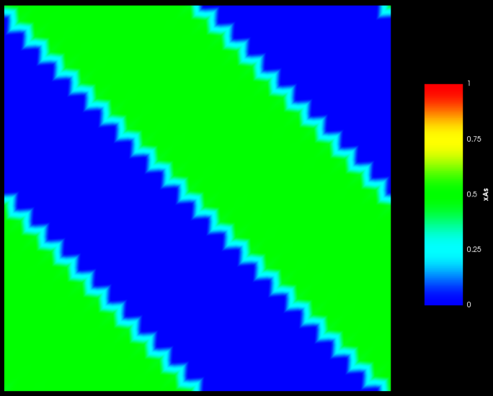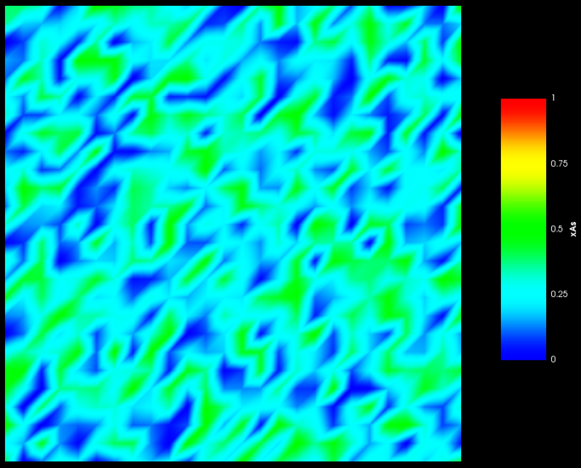Figure 7 shows the global ‘*As*’ concentration in the system.

7(a) 7(b)

Figure 7: (a)Initial and (b)final ‘*As*’ content in the system.

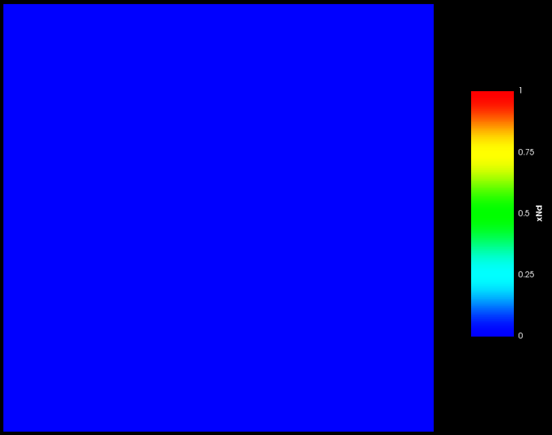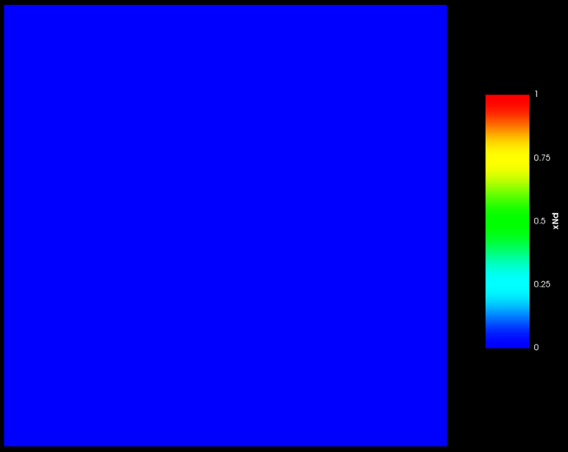Figure 8 shows the global ‘*Nd*’ concentration in the system.

8(a) 8(b)

Figure 8: (a)Initial and (b)final ‘*Nd*’ content in the system.

* **Equilibrium between Phase 2 and Phase 3 when enough ‘*Nd*’ is present in the system.**

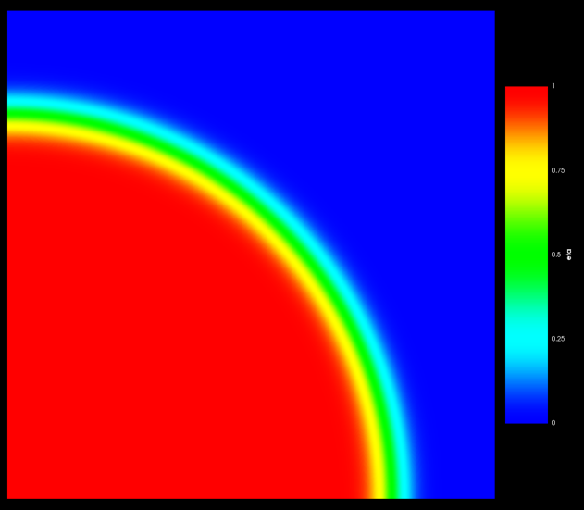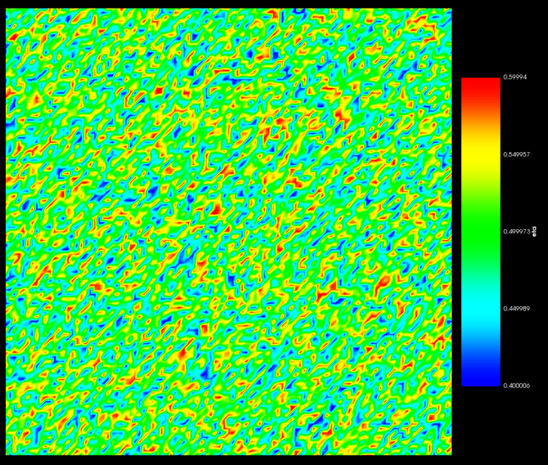Figure 9 shows the initial condition and final condition of the phases present in the system.

9(a) 9(b)

Figure 9: (a)Initial condition and (b)final condition of the system with Phase 2 and Phase 3.

Figure 10 shows the global ‘*As*’ concentration in the system.

10(a) 10(b)

Figure 10: (a)Initial and (b)final ‘*As*’ content in the system.

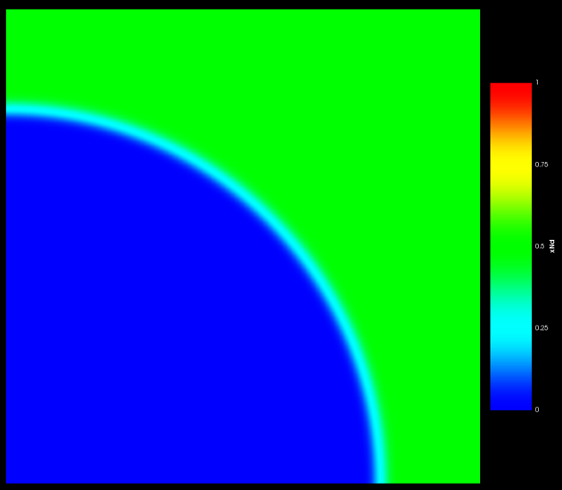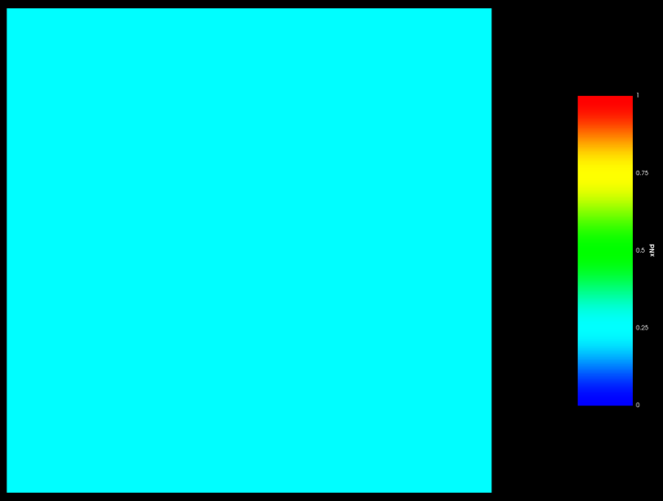Figure 11 shows the global ‘*Nd*’ concentration in the system.

11(a) 11(b)

Figure 11: (a)Initial and (b)final ‘*Nd*’ content in the system.

**Discussion**

For equilibrium between Phase 1 (*U*) and Phase 2 (*NdAs*).

* We have shown a 2-phase equilibrium between Phase 1 and Phase 2 in the Gibbs energy plot in Figure 2 at sufficient ‘*Nd*’ content in the system which will end up forming Phase 2 i.e. the *NdAs* phase.
* The phase field simulation of this system also shows an equilibrium between Phase 1 and Phase 2 as shown in Figure 3.
* The global ‘*As*’ content in Phase 1 (*U*) and Phase 2 (*NdAs*) is 0 and 0.5 as shown in Figure 4(a) and 4(b) respectively. This is in accordance with the stoichiometry of the phases and is expected from the phase field simulation.
* The global ‘*Nd*’ content in Phase 1 (*U*) and Phase 2 (*NdAs*) is 0 and 0.5 as shown in Figure 5(a) and 5(b) respectively. This is in accordance with the stoichiometry of the phases and is expected from the phase field simulation.

For equilibrium between Phase 1 (*U*) and Phase 3 (*UAs*).

* We have shown a 2-phase equilibrium between Phase 1 and Phase 3 in the Gibbs energy plot in Figure 1 at neglibible ‘*Nd*’ content in the system which will end up forming Phase 3 i.e. the *UAs* phase.
* The phase field simulation of this system also shows an equilibrium between Phase 1 and Phase 3 as shown in Figure 6.
* The global ‘*As*’ content in Phase 1 (*U*) and Phase 3 (*UAs*) is 0 and 0.5 as shown in Figure 7(a) and 7(b) respectively. This is in accordance with the stoichiometry of the phases and is expected from the phase field simulation.
* The global ‘*Nd*’ content in Phase 1 (*U*) and Phase 3 (*UAs*) is 0 each as shown in Figure 8. This is in accordance with the stoichiometry of the phases and is expected from the phase field simulation.

For equilibrium between Phase 2 (*NdAs*) and Phase 3 (*UAs*).

* The phase field simulation of this system also shows an equilibrium between Phase 2 and Phase 3 as shown in Figure 17.
* The global ‘*As*’ content in Phase 2 (*NdAs*) and Phase 3 (*UAs*) is 0.5 each and is shown in Figure 18. This is in accordance with the stoichiometry of the phases and is expected from the phase field simulation.
* The global ‘*Nd*’ content in Phase 2 (*NdAs*) and Phase 3 (*UAs*) is 0.5 and 0 and is shown in Figure 19(a) and 19(b) respectively. This is in accordance with the stoichiometry of the phases and is expected from the phase field simulation.