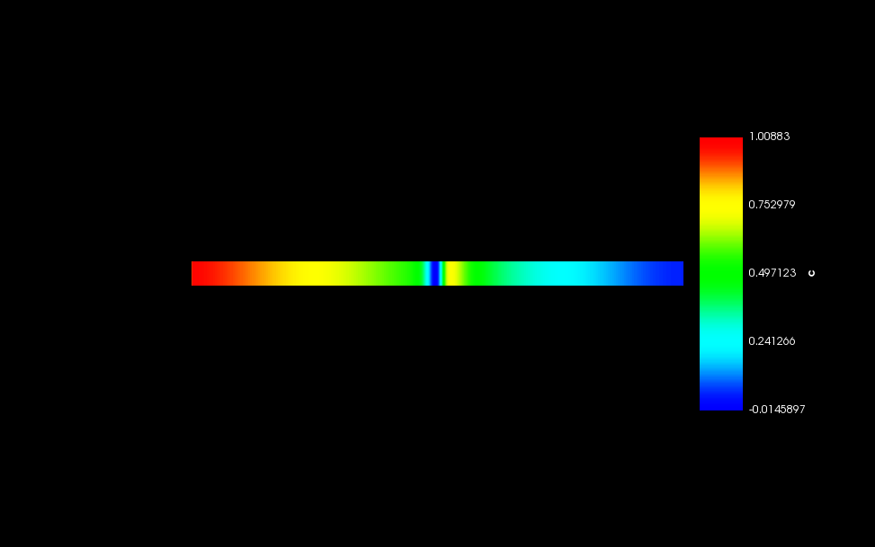

Figure 1: Interfacial width plot with respect to ‘c’

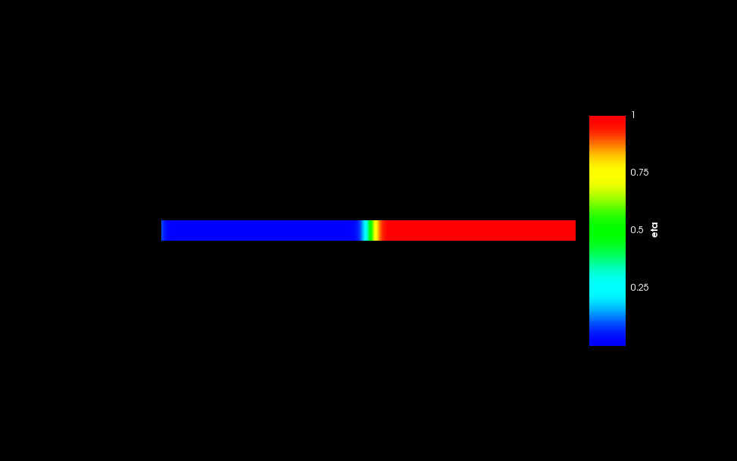

Figure 2: Interfacial width plot with respect to ‘eta’

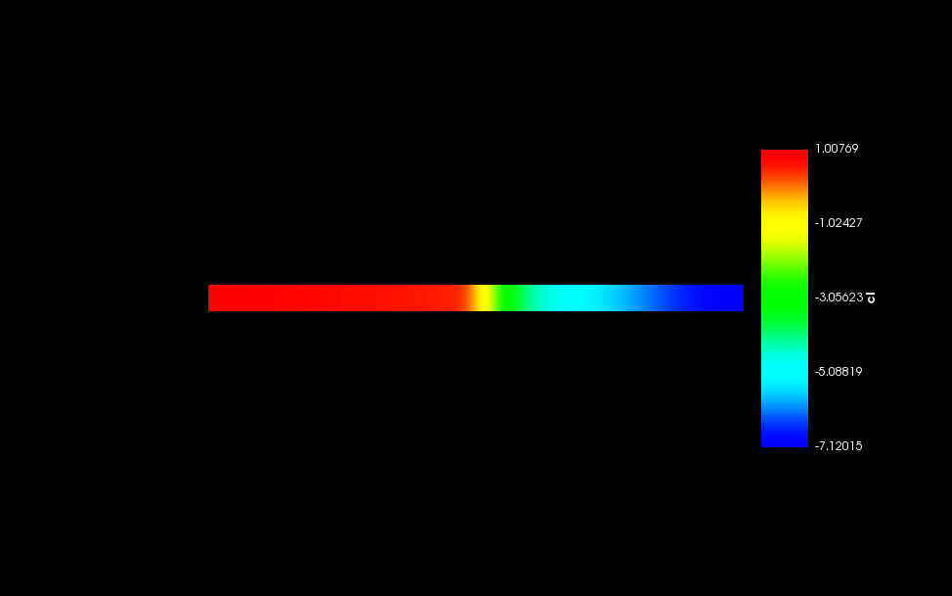

Figure 1: Interfacial width plot with respect to ‘cl’

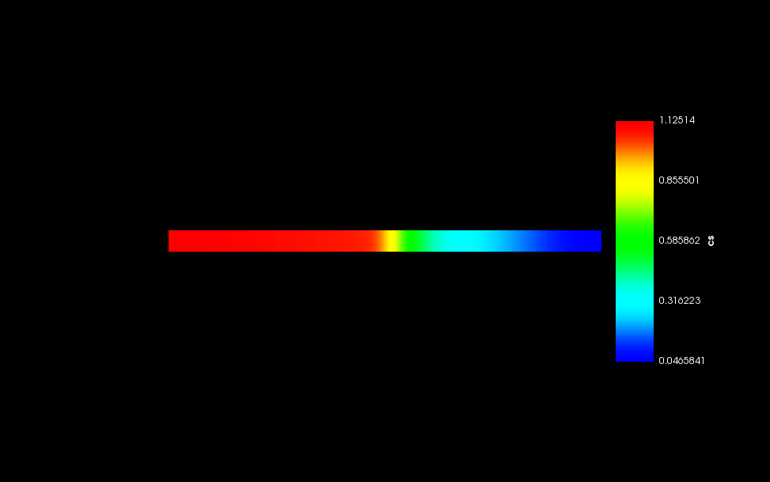

Figure 1: Interfacial width plot with respect to ‘cs’