**Kim Kim Suzuki Model**

In the last report we have fitted the spinodal decomposition curve for Fe-Cr system using two parabolic function, a switching function and a double-well potential function. The two parabolic equations were given as follows:

For left parabola:

lp(c) = 0.0000260486*c 2 + 0.0000239298*c – 0.000178164

For right parabola:

rp(c) = 0.000196227*c 2 – 0.000365148*c + 0.0000162483

We have also found out the interfacial energy of the system.

Now we have to move this system to the Kim Kim Suzuki model. One major advantage of the Kim Kim Suzuki model over traditional phase field model is that if gives the flexibility to change the interfacial energy of system by keeping the interfacial width constant.

The interface energy (σ) is given by:

$= \frac{\text{ϵ}\sqrt{w}}{3\sqrt{2}}$ (1)

The interface thickness (2λ) is given by:

$2 = α\sqrt{2} \frac{ϵ}{\sqrt{w}}$ (2)

Where, ε = Gradient energy coefficient, w = Double well barrier height and α = A constant which is dependent on the definition of the interface thickness.

It has the added complexity of introducing phase concentrations (ca, cb) i.e. a concentration variable for each component and each phase in addition to the global concentration (c):

c = (1-h(n)) ca + h(n)cb (3)

We want to change the interfacial energy of the system and at the same time we need the interfacial thickness to be constant.

σ` = nσ (4)

2λ` = 2λ (5)

On further exploring, we have the following equation satisfying the requirement:

$\frac{ϵ`}{\sqrt{w`}} = \frac{ϵ}{\sqrt{w}}$ (6)

On moving our earlier model with 2 order parameters to the Kim Kim Suzuki model gives the interfacial energy *0.0159476 J/mol* (which is calculated by using the process explained in the previous report), with ε = 0.025 and w = 1.0.

Using equation (5), we can change the interfacial energy by keeping the interfacial width constant (as shown in the Table 1).

|  |  |  |  |  |
| --- | --- | --- | --- | --- |
| S.No | ε | w | Interfacial energy | Interfacial width (in mesh size) |
| 1. | 0.0300 | 1.2 | 0.0197988 | 3 – 5 |
| 2. | 0.0250 | 1.0 | 0.0159476 | 3 – 5 |
| 3. | 0.0200 | 0.8 | 0.0120962 | 3 – 5 |
| *4.* | *0.0175* | *0.7* | *0.01017066* | *3 – 5* |
| 5. | 0.0150 | 0.6 | 0.00824505 | 3 – 5 |

We change it to *0.01017066* (nearest to the value available in the literature). The simulated is simulated in the MOOSE framework and image is shown below:

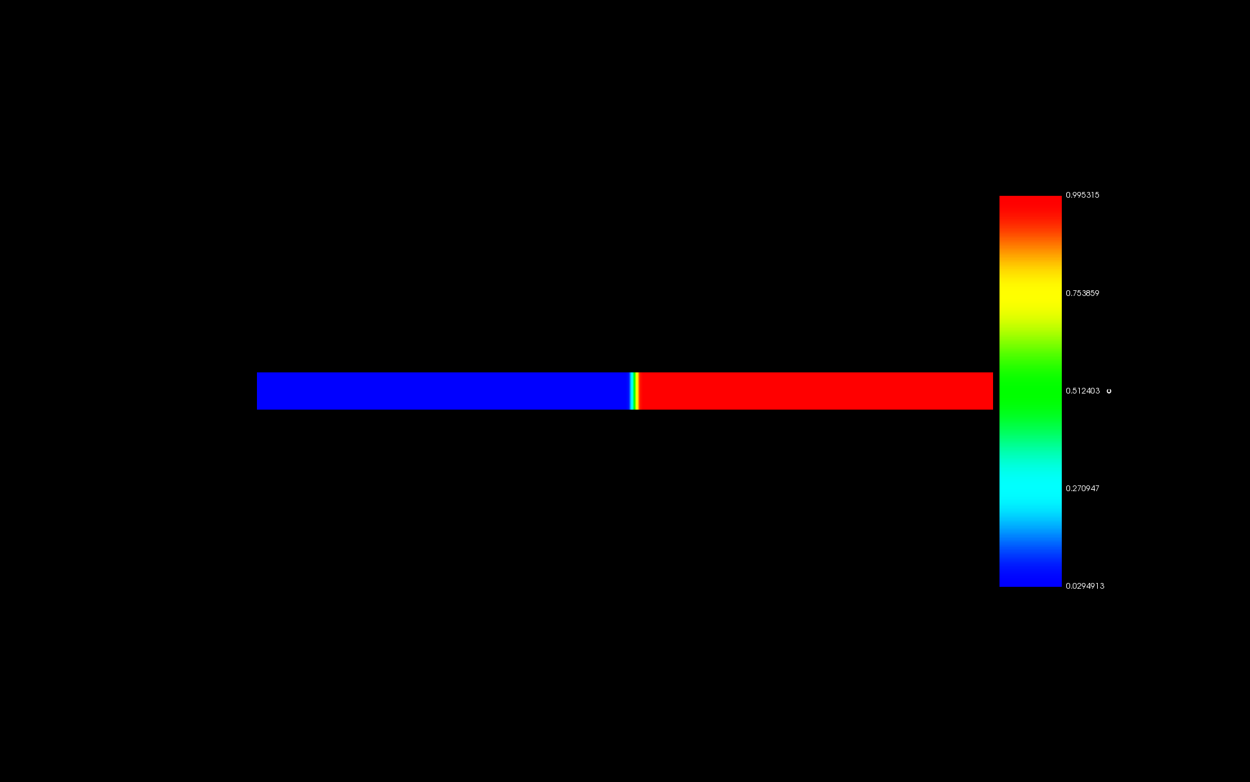

Figure 1: 1D simulation to explore the interfacial width with respect to ‘c’ in the Kim Kim Suzuki Model.

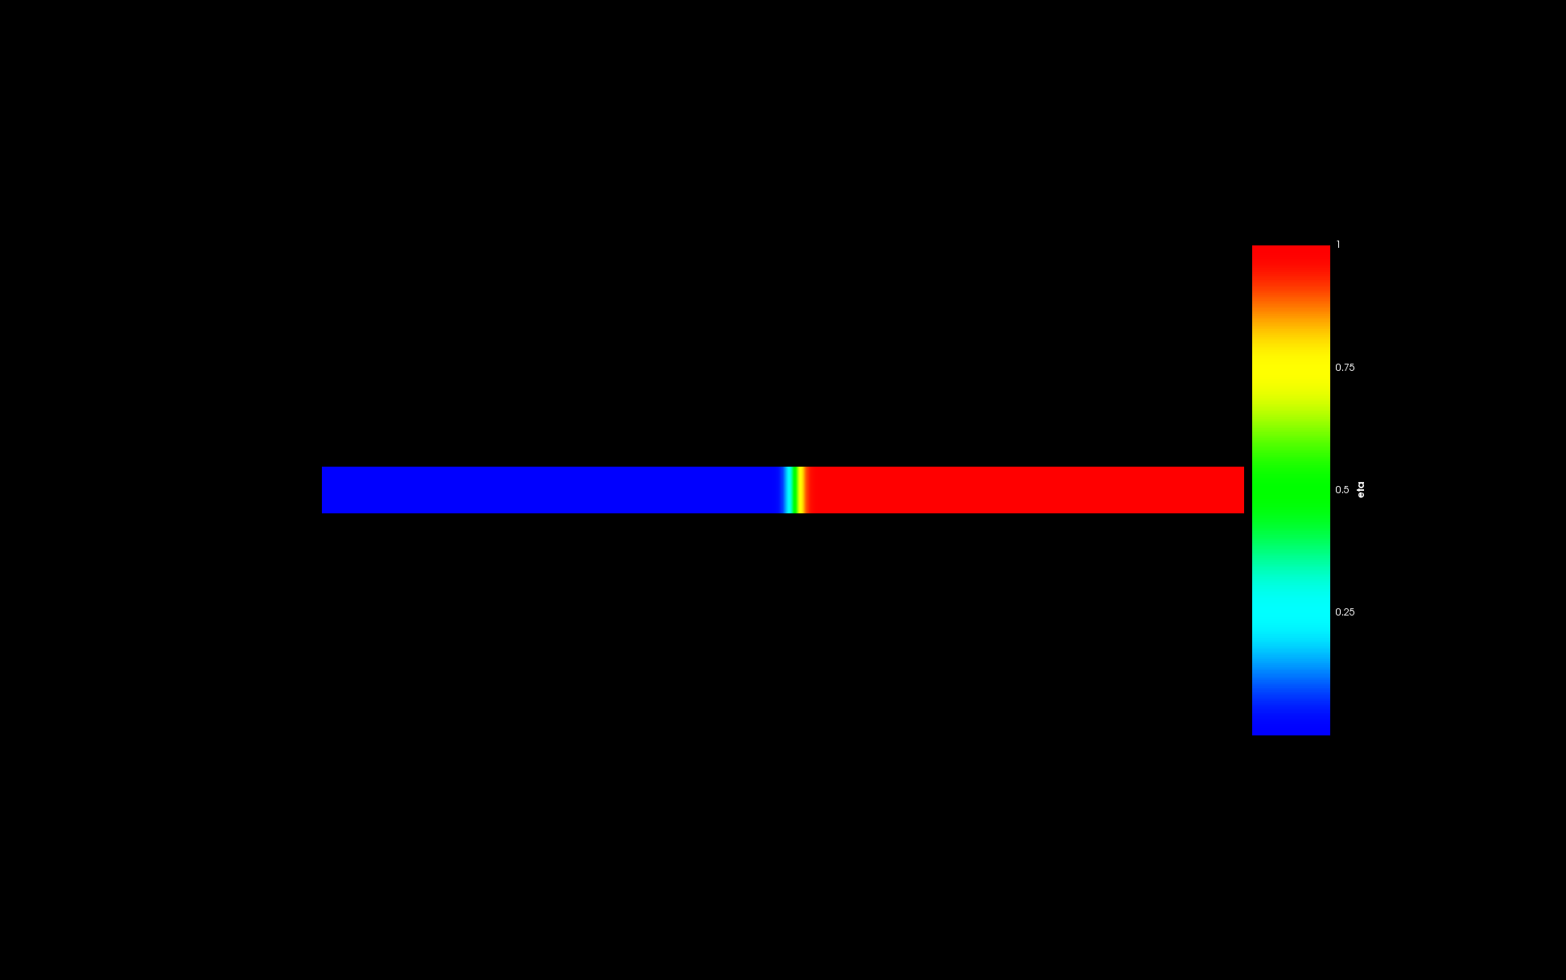

Figure 2: 1D simulation to explore the interfacial width with respect to ‘eta’ in the Kim Kim Suzuki Model.

The variation of the total energy of the system with time is as shown below:

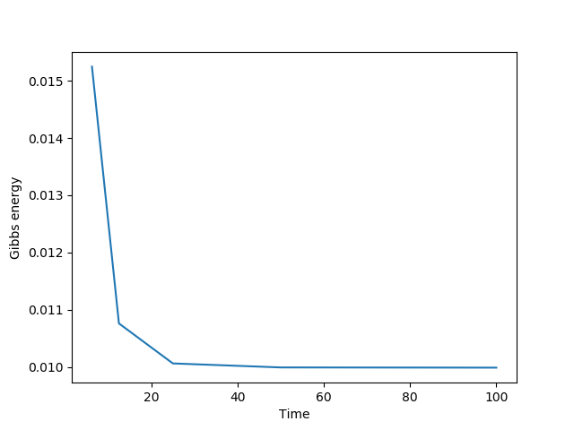

Figure 3: Variation of the Gibbs energy of the system with time.

Further planning:

* To formulate the Gibbs energy expression for different phases in the U-Nd-As system for the FCCI model.
* To simulate the U-Nd-As system in the MOOSE framework using the formulated Gibbs energy expressions.