**Dr. B.R Ambedkar National Institute of Technology, Jalandhar**



**Fundamentals of Database Management Systems Lab**

**ITPC-227**

**Submitted to Submitted by**

Ms Pooja Sharma Garima

Department of IT 20124031

G2

IT

**INDEX**

|  |  |  |  |  |
| --- | --- | --- | --- | --- |
| **S no.** | **Name of the Practical** | **Date** | **Page No.** | **Remarks** |
| 1 | ER Diagram 1 | 3/9/2021 | 1 |  |
| 2 | ER Diagram 2 | 10/9/2021 | 2 |  |
| 3 | Creating Database and Inserting Values in the Tables | 17/9/2021 | 3-11 |  |
| 4 | Select statement using various clauses | 24/9/2021 | 12-18 |  |
| 5 | Queries using update, delete, limit, min, max, count, avg, sum, like clauses | 1/10/2021 | 19-22 |  |
| 6 | Queries using IN, between, aliases, group by, having exists | 8/10/2021 | 23-26 |  |
| 7 | Join and Union operations | 22/10/2021 | 27-30 |  |
| 8 | Creating Views | 29/10/2021 | 31 |  |

**LAB 1**

**ER DIAGRAM 1**

**Consider following databases and draw ER diagram for it:**

**COLLEGE DATABASE:**

**STUDENT (USN, SName, Address, Phone, Gender)**

**SEMSEC (SSID, Sem, Sec)**

**CLASS (USN, SSID)**

**SUBJECT (Subcode, Title, Sem, Credits)**

**IAMARKS (USN, Subcode, SSID, Test1, Test2, Test3, FinalIA)**

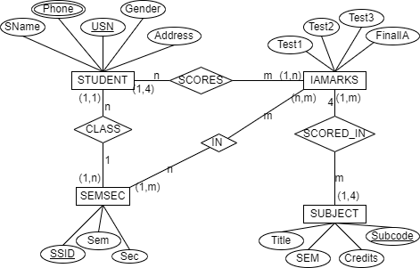

**LAB 2**

**ER DIAGRAM 2**

**Draw ER Diagram for the following:**

**A university registrar’s office maintains data about the following entities: (a) courses, including number, title, credits, syllabus and prerequisites;(b) course offerings, including course number, year, semester, section number, instructor(s), timings, and classroom; (c) students, including student_id, name, and program; and (d) instructors, including identification number, name, department, and in each course they are enrolled for must be appropriately modeled.**

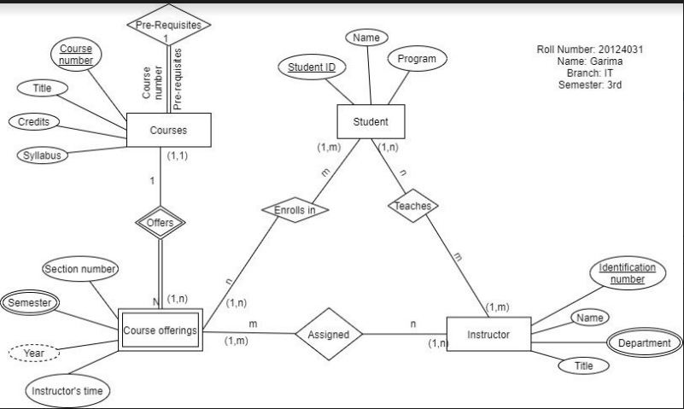

**LAB 3**

**Creating Database and Inserting Values in the Tables**

Create tables:

CREATE SCHEMA `college` ;

CREATE TABLE `college`.`student` (

`USN` INT NOT NULL,

`SNAME` VARCHAR(45) NOT NULL,

`ADDRESS` VARCHAR(50) NOT NULL,

`PHONE` VARCHAR(45) NOT NULL,

`GENDER` CHAR(1) NOT NULL,

PRIMARY KEY (`USN`));

CREATE TABLE `college`.`semsec` (

`SSID` INT NOT NULL,

`SEM` INT NOT NULL,

`SEC` VARCHAR(45) NOT NULL,

PRIMARY KEY (`SSID`));

CREATE TABLE `college`.`subject` (

`SUBCODE` INT NOT NULL,

`TITLE` VARCHAR(45) NOT NULL,

`SEM` VARCHAR(45) NOT NULL,

`CREDITS` INT NOT NULL,

PRIMARY KEY (`SUBCODE`));

use `college`;

drop table if exists `iamarks`;

create table `iamarks`(

`USN` int not null,

`Subcode` int not null,

`SSID` int not null,

`Test1` int,

`Test2` int,

`Test3` int,

`FinalIA` int);

alter table `iamarks`

add foreign key(`USN`) references `student`(`USN`);

alter table `iamarks`

add foreign key(`Subcode`) references `subject`(`Subcode`);

alter table `iamarks`

add foreign key(`SSID`) references `semsec`(`SSID`);

select * from `college`.`iamarks`;

Insert values:

SELECT * FROM college.student;

INSERT INTO `college`.`student` (`USN`, `SNAME`, `ADDRESS`, `PHONE`, `GENDER`) VALUES ('4031', 'GARIMA', 'BATHINDA', '1569874230', 'F');

INSERT INTO `college`.`student` (`USN`, `SNAME`, `ADDRESS`, `PHONE`, `GENDER`) VALUES ('4032', 'GAURAV PRIY', 'JAIPUR', '2365214790', 'M');

INSERT INTO `college`.`student` (`USN`, `SNAME`, `ADDRESS`, `PHONE`, `GENDER`) VALUES ('4033', 'GURLEEN KAUR', 'AMRITSAR', '2031579841', 'F');

INSERT INTO `college`.`student` (`USN`, `SNAME`, `ADDRESS`, `PHONE`, `GENDER`) VALUES ('4034', 'GURPREET', 'LUDHIANA', '2956314780', 'M');

INSERT INTO `college`.`student` (`USN`, `SNAME`, `ADDRESS`, `PHONE`, `GENDER`) VALUES ('4035', 'HARLEEN', 'PATIALA', '1025678943', 'F');

INSERT INTO `college`.`student` (`USN`, `SNAME`, `ADDRESS`, `PHONE`, `GENDER`) VALUES ('4036', 'HARMAN GREWAL', 'CHANDIGARH', '2305469871', 'M');

INSERT INTO `college`.`student` (`USN`, `SNAME`, `ADDRESS`, `PHONE`, `GENDER`) VALUES ('4037', 'HARTIK SALARIA', 'LUDHIANA', '1598743651', 'M');

INSERT INTO `college`.`student` (`USN`, `SNAME`, `ADDRESS`, `PHONE`, `GENDER`) VALUES ('4038', 'HIMANSHU GUPTA', 'FARIDKOT', '1457803562', 'M');

INSERT INTO `college`.`student` (`USN`, `SNAME`, `ADDRESS`, `PHONE`, `GENDER`) VALUES ('4039', 'HRIDANSHU YADAV', 'HOSHIARPUR', '2364785106', 'M');

INSERT INTO `college`.`student` (`USN`, `SNAME`, `ADDRESS`, `PHONE`, `GENDER`) VALUES ('4040', 'LOKESH KUMAR', 'VISHAKHAPATNAM', '1023657489', 'M');

INSERT INTO `college`.`student` (`USN`, `SNAME`, `ADDRESS`, `PHONE`, `GENDER`) VALUES ('4041', 'ISHTJOT KAUR', 'PATIALA', '2036514820', 'F');

INSERT INTO `college`.`student` (`USN`, `SNAME`, `ADDRESS`, `PHONE`, `GENDER`) VALUES ('4042', 'JAI DHAMWANI', 'MOGA', '1036791845', 'M');

INSERT INTO `college`.`student` (`USN`, `SNAME`, `ADDRESS`, `PHONE`, `GENDER`) VALUES ('4043', 'JASPREET SINGH', 'BATALA', '2306407819', 'M');

INSERT INTO `college`.`student` (`USN`, `SNAME`, `ADDRESS`, `PHONE`, `GENDER`) VALUES ('4044', 'KANAV PHULL', 'PATHANKOT', '2054672084', 'M');

INSERT INTO `college`.`student` (`USN`, `SNAME`, `ADDRESS`, `PHONE`, `GENDER`) VALUES ('4045', 'KARAN MEENA', 'ABOHAR', '1034657280', 'M');

INSERT INTO `college`.`student` (`USN`, `SNAME`, `ADDRESS`, `PHONE`, `GENDER`) VALUES ('4046', 'KARTIKEY', 'MALERKOTLA', '2054817025', 'M');

INSERT INTO `college`.`student` (`USN`, `SNAME`, `ADDRESS`, `PHONE`, `GENDER`) VALUES ('4047', 'KHUSHPREET', 'KHANNA', '2104370506', 'M');

INSERT INTO `college`.`student` (`USN`, `SNAME`, `ADDRESS`, `PHONE`, `GENDER`) VALUES ('4048', 'GURLEEN', 'MUKTSAR', '1975461823', 'F');

INSERT INTO `college`.`student` (`USN`, `SNAME`, `ADDRESS`, `PHONE`, `GENDER`) VALUES ('4049', 'ISHTJOT KAUR', 'BARNALA', '1502407386', 'F');

INSERT INTO `college`.`student` (`USN`, `SNAME`, `ADDRESS`, `PHONE`, `GENDER`) VALUES ('4050', 'KSHITIZ', 'FIROZPUR', '1202435679', 'M');

INSERT INTO `college`.`student` (`USN`, `SNAME`, `ADDRESS`, `PHONE`, `GENDER`) VALUES ('4051', 'ANJALI', 'PHAGWARA', '2014273865', 'F');

INSERT INTO `college`.`student` (`USN`, `SNAME`, `ADDRESS`, `PHONE`, `GENDER`) VALUES ('4052', 'NIHARIKA', 'ZIRAKPUR', '1043507068', 'F');

INSERT INTO `college`.`student` (`USN`, `SNAME`, `ADDRESS`, `PHONE`, `GENDER`) VALUES ('4053', 'RUCHI', 'SANGRUR', '1679835252', 'F');

INSERT INTO `college`.`student` (`USN`, `SNAME`, `ADDRESS`, `PHONE`, `GENDER`) VALUES ('4054', 'LOVISH BANSAL', 'RAJPURA', '1245786235', 'M');

INSERT INTO `college`.`student` (`USN`, `SNAME`, `ADDRESS`, `PHONE`, `GENDER`) VALUES ('4055', 'MAANVIR', 'BHADAUR', '2104253761', 'M');

INSERT INTO `college`.`student` (`USN`, `SNAME`, `ADDRESS`, `PHONE`, `GENDER`) VALUES ('4056', 'AANCHAL', 'MAUR', '1024356829', 'F');

INSERT INTO `college`.`student` (`USN`, `SNAME`, `ADDRESS`, `PHONE`, `GENDER`) VALUES ('4057', 'MAHIR BANSAL', 'GONIANA', '1025376821', 'M');

INSERT INTO `college`.`student` (`USN`, `SNAME`, `ADDRESS`, `PHONE`, `GENDER`) VALUES ('4058', 'MANAN', 'RAMPURA', '1578421325', 'M');

INSERT INTO `college`.`student` (`USN`, `SNAME`, `ADDRESS`, `PHONE`, `GENDER`) VALUES ('4059', 'MAURYA SHARMA', 'ANANDPUR SAHAB', '1659857432', 'M');

INSERT INTO `college`.`student` (`USN`, `SNAME`, `ADDRESS`, `PHONE`, `GENDER`) VALUES ('4060', 'MAYANK GERA', 'ABOHAR', '1025376597', 'M');

INSERT INTO `college`.`student` (`USN`, `SNAME`, `ADDRESS`, `PHONE`, `GENDER`) VALUES ('4061', 'NIKITA ', 'BATHINDA', '1025376451', 'F');

INSERT INTO `college`.`student` (`USN`, `SNAME`, `ADDRESS`, `PHONE`, `GENDER`) VALUES ('4062', 'VINOD', 'BATHINDA', '2458455273', 'M');

INSERT INTO `college`.`student` (`USN`, `SNAME`, `ADDRESS`, `PHONE`, `GENDER`) VALUES ('4063', 'DISHA', 'GURDASPUR', '2154152862', 'F');

INSERT INTO `college`.`student` (`USN`, `SNAME`, `ADDRESS`, `PHONE`, `GENDER`) VALUES ('4064', 'NAKUL', 'JALANDHAR', '2514896345', 'M');

INSERT INTO `college`.`student` (`USN`, `SNAME`, `ADDRESS`, `PHONE`, `GENDER`) VALUES ('4065', 'NAMAMISH', 'PHILLAUR', '2365214521', 'M');

INSERT INTO `college`.`student` (`USN`, `SNAME`, `ADDRESS`, `PHONE`, `GENDER`) VALUES ('4066', 'NAMAN', 'LUDHIANA', '1025479665', 'M');

INSERT INTO `college`.`student` (`USN`, `SNAME`, `ADDRESS`, `PHONE`, `GENDER`) VALUES ('4067', 'SHAHEER', 'KHANNA', '2848984694', 'M');

INSERT INTO `college`.`student` (`USN`, `SNAME`, `ADDRESS`, `PHONE`, `GENDER`) VALUES ('4068', 'NEHA', 'MANSA', '1654856484', 'F');

INSERT INTO `college`.`student` (`USN`, `SNAME`, `ADDRESS`, `PHONE`, `GENDER`) VALUES ('4069', 'NIKITA', 'MOGA', '2154849484', 'F');

INSERT INTO `college`.`student` (`USN`, `SNAME`, `ADDRESS`, `PHONE`, `GENDER`) VALUES ('4070', 'NISHANT', 'PATHANKOT', '1781646826', 'M');

SELECT * FROM college.semsec;

INSERT INTO `college`.`semsec` (`SSID`, `SEM`, `SEC`) VALUES ('101', '1', 'IT');

INSERT INTO `college`.`semsec` (`SSID`, `SEM`, `SEC`) VALUES ('102', '1', 'CIVIL');

INSERT INTO `college`.`semsec` (`SSID`, `SEM`, `SEC`) VALUES ('103', '1', 'BT');

INSERT INTO `college`.`semsec` (`SSID`, `SEM`, `SEC`) VALUES ('201', '2', 'IT');

INSERT INTO `college`.`semsec` (`SSID`, `SEM`, `SEC`) VALUES ('202', '2', 'CIVL');

INSERT INTO `college`.`semsec` (`SSID`, `SEM`, `SEC`) VALUES ('203', '2', 'BT');

INSERT INTO `college`.`semsec` (`SSID`, `SEM`, `SEC`) VALUES ('301', '3', 'IT');

INSERT INTO `college`.`semsec` (`SSID`, `SEM`, `SEC`) VALUES ('302', '3', 'CIVIL');

INSERT INTO `college`.`semsec` (`SSID`, `SEM`, `SEC`) VALUES ('303', '3', 'BT');

SELECT * FROM college.subject;

INSERT INTO `college`.`subject` (`SUBCODE`, `TITLE`, `SEM`, `CREDITS`) VALUES ('2012', 'DATABASE MANAGEMENT SYSTEM', '2', '3');

INSERT INTO `college`.`subject` (`SUBCODE`, `TITLE`, `SEM`, `CREDITS`) VALUES ('2011', 'DATA STRUCTURE AND ALGORITHM', '2', '3');

INSERT INTO `college`.`subject` (`SUBCODE`, `TITLE`, `SEM`, `CREDITS`) VALUES ('3012', 'COMPUTER SYSTEM AND ARCHITECHTURE', '3', '3');

INSERT INTO `college`.`subject` (`SUBCODE`, `TITLE`, `SEM`, `CREDITS`) VALUES ('3011', 'OBJECT ORIENTED PROGRAMMING', '3', '3');

INSERT INTO `college`.`subject` (`SUBCODE`, `TITLE`, `SEM`, `CREDITS`) VALUES ('1011', 'COMPUTER PROGRAMMING', '1', '3');

INSERT INTO `college`.`subject` (`SUBCODE`, `TITLE`, `SEM`, `CREDITS`) VALUES ('1031', 'ENVIRONMENTAL STUDIES', '1', '2');

INSERT INTO `college`.`subject` (`SUBCODE`, `TITLE`, `SEM`, `CREDITS`) VALUES ('2031', 'MICROBIOLOGY', '2', '4');

INSERT INTO `college`.`subject` (`SUBCODE`, `TITLE`, `SEM`, `CREDITS`) VALUES ('2032', 'BIOCHEMISTRY', '2', '3');

INSERT INTO `college`.`subject` (`SUBCODE`, `TITLE`, `SEM`, `CREDITS`) VALUES ('3031', 'GENETIC ENGINEERING', '3', '3');

INSERT INTO `college`.`subject` (`SUBCODE`, `TITLE`, `SEM`, `CREDITS`) VALUES ('3032', 'IMMUNOLOGY', '3', '3');

INSERT INTO `college`.`subject` (`SUBCODE`, `TITLE`, `SEM`, `CREDITS`) VALUES ('1021', 'EG AND CADD', '1', '2');

INSERT INTO `college`.`subject` (`SUBCODE`, `TITLE`, `SEM`, `CREDITS`) VALUES ('2021', 'SURVEYING', '2', '3');

INSERT INTO `college`.`subject` (`SUBCODE`, `TITLE`, `SEM`, `CREDITS`) VALUES ('2022', 'HUMAN RESOURCE MANAGEMENT', '2', '3');

INSERT INTO `college`.`subject` (`SUBCODE`, `TITLE`, `SEM`, `CREDITS`) VALUES ('3021', 'CONCRETE TECHNOLOGY', '3', '4');

INSERT INTO `college`.`subject` (`SUBCODE`, `TITLE`, `SEM`, `CREDITS`) VALUES ('3022', 'RAILWAY, AIRPORT AND HARBOUR ENGINEERING', '3', '3')

select * from `college`.`iamarks`;

insert into `college`.`iamarks` (`USN`,`Subcode`,`SSID`,`Test1`,`Test2`,`Test3`,`FinalIA`) values ('4031','1011','101','18','15','16','32');

insert into `college`.`iamarks` (`USN`,`Subcode`,`SSID`,`Test1`,`Test2`,`Test3`,`FinalIA`) values ('4032','2021','202','15','11','11','34');

insert into `college`.`iamarks` (`USN`,`Subcode`,`SSID`,`Test1`,`Test2`,`Test3`,`FinalIA`) values ('4033','2012','201','18','14','15','33');

insert into `college`.`iamarks` (`USN`,`Subcode`,`SSID`,`Test1`,`Test2`,`Test3`,`FinalIA`) values ('4034','1031','103','10','7','18','24');

insert into `college`.`iamarks` (`USN`,`Subcode`,`SSID`,`Test1`,`Test2`,`Test3`,`FinalIA`) values ('4035','2031','203','16','12','14','28');

insert into `college`.`iamarks` (`USN`,`Subcode`,`SSID`,`Test1`,`Test2`,`Test3`,`FinalIA`) values ('4036','2011','201','15','16','10','26');

insert into `college`.`iamarks` (`USN`,`Subcode`,`SSID`,`Test1`,`Test2`,`Test3`,`FinalIA`) values ('4037','2022','202','14','18','18','33');

insert into `college`.`iamarks` (`USN`,`Subcode`,`SSID`,`Test1`,`Test2`,`Test3`,`FinalIA`) values ('4038','1021','102','12','15','12','26');

insert into `college`.`iamarks` (`USN`,`Subcode`,`SSID`,`Test1`,`Test2`,`Test3`,`FinalIA`) values ('4039','1031','103','13','14','10','32');

insert into `college`.`iamarks` (`USN`,`Subcode`,`SSID`,`Test1`,`Test2`,`Test3`,`FinalIA`) values ('4040','2021','202','10','6','8','24');

insert into `college`.`iamarks` (`USN`,`Subcode`,`SSID`,`Test1`,`Test2`,`Test3`,`FinalIA`) values ('4041','1011','101','19','17','19','28');

insert into `college`.`iamarks` (`USN`,`Subcode`,`SSID`,`Test1`,`Test2`,`Test3`,`FinalIA`) values ('4042','3031','303','14','14','10','23');

insert into `college`.`iamarks` (`USN`,`Subcode`,`SSID`,`Test1`,`Test2`,`Test3`,`FinalIA`) values ('4043','2011','201','16','11','17','34');

insert into `college`.`iamarks` (`USN`,`Subcode`,`SSID`,`Test1`,`Test2`,`Test3`,`FinalIA`) values ('4044','3032','303','20','18','11','32');

insert into `college`.`iamarks` (`USN`,`Subcode`,`SSID`,`Test1`,`Test2`,`Test3`,`FinalIA`) values ('4045','1031','103','14','9','18','24');

insert into `college`.`iamarks` (`USN`,`Subcode`,`SSID`,`Test1`,`Test2`,`Test3`,`FinalIA`) values ('4046','3011','301','7','7','6','21');

insert into `college`.`iamarks` (`USN`,`Subcode`,`SSID`,`Test1`,`Test2`,`Test3`,`FinalIA`) values ('4047','3012','301','15','12','18','33');

insert into `college`.`iamarks` (`USN`,`Subcode`,`SSID`,`Test1`,`Test2`,`Test3`,`FinalIA`) values ('4048','2031','203','16','17','12','27');

insert into `college`.`iamarks` (`USN`,`Subcode`,`SSID`,`Test1`,`Test2`,`Test3`,`FinalIA`) values ('4049','1011','101','13','15','14','28');

insert into `college`.`iamarks` (`USN`,`Subcode`,`SSID`,`Test1`,`Test2`,`Test3`,`FinalIA`) values ('4050','2021','202','9','8','10','24');

insert into `college`.`iamarks` (`USN`,`Subcode`,`SSID`,`Test1`,`Test2`,`Test3`,`FinalIA`) values ('4051','3021','302','17','16','15','29');

insert into `college`.`iamarks` (`USN`,`Subcode`,`SSID`,`Test1`,`Test2`,`Test3`,`FinalIA`) values ('4052','1021','102','11','10','12','32');

insert into `college`.`iamarks` (`USN`,`Subcode`,`SSID`,`Test1`,`Test2`,`Test3`,`FinalIA`) values ('4053','2011','201','19','12','15','33');

insert into `college`.`iamarks` (`USN`,`Subcode`,`SSID`,`Test1`,`Test2`,`Test3`,`FinalIA`) values ('4054','3022','302','15','11','18','35');

insert into `college`.`iamarks` (`USN`,`Subcode`,`SSID`,`Test1`,`Test2`,`Test3`,`FinalIA`) values ('4055','2022','202','18','16','10','24');

insert into `college`.`iamarks` (`USN`,`Subcode`,`SSID`,`Test1`,`Test2`,`Test3`,`FinalIA`) values ('4056','2021','202','20','18','18','34');

insert into `college`.`iamarks` (`USN`,`Subcode`,`SSID`,`Test1`,`Test2`,`Test3`,`FinalIA`) values ('4057','3032','303','14','9','6','26');

insert into `college`.`iamarks` (`USN`,`Subcode`,`SSID`,`Test1`,`Test2`,`Test3`,`FinalIA`) values ('4058','1021','102','18','14','11','28');

insert into `college`.`iamarks` (`USN`,`Subcode`,`SSID`,`Test1`,`Test2`,`Test3`,`FinalIA`) values ('4059','3022','302','8','15','7','23');

insert into `college`.`iamarks` (`USN`,`Subcode`,`SSID`,`Test1`,`Test2`,`Test3`,`FinalIA`) values ('4060','3011','301','16','12','14','29');

insert into `college`.`iamarks` (`USN`,`Subcode`,`SSID`,`Test1`,`Test2`,`Test3`,`FinalIA`) values ('4061','2012','201','15','17','11','32');

insert into `college`.`iamarks` (`USN`,`Subcode`,`SSID`,`Test1`,`Test2`,`Test3`,`FinalIA`) values ('4062','1011','101','10','8','15','28');

insert into `college`.`iamarks` (`USN`,`Subcode`,`SSID`,`Test1`,`Test2`,`Test3`,`FinalIA`) values ('4063','3012','301','19','19','14','33');

insert into `college`.`iamarks` (`USN`,`Subcode`,`SSID`,`Test1`,`Test2`,`Test3`,`FinalIA`) values ('4064','1031','103','14','6','8','23');

insert into `college`.`iamarks` (`USN`,`Subcode`,`SSID`,`Test1`,`Test2`,`Test3`,`FinalIA`) values ('4065','2011','201','16','17','15','34');

insert into `college`.`iamarks` (`USN`,`Subcode`,`SSID`,`Test1`,`Test2`,`Test3`,`FinalIA`) values ('4066','1021','102','17','12','12','24');

insert into `college`.`iamarks` (`USN`,`Subcode`,`SSID`,`Test1`,`Test2`,`Test3`,`FinalIA`) values ('4067','2032','203','20','16','11','32');

insert into `college`.`iamarks` (`USN`,`Subcode`,`SSID`,`Test1`,`Test2`,`Test3`,`FinalIA`) values ('4068','2021','202','16','15','10','33');

insert into `college`.`iamarks` (`USN`,`Subcode`,`SSID`,`Test1`,`Test2`,`Test3`,`FinalIA`) values ('4069','1011','101','19','14','18','34');

insert into `college`.`iamarks` (`USN`,`Subcode`,`SSID`,`Test1`,`Test2`,`Test3`,`FinalIA`) values ('4070','2022','202','14','11','12','28');

**LAB 4**

**Select statement using various clauses**

* Displaying whole table:

select * from student;

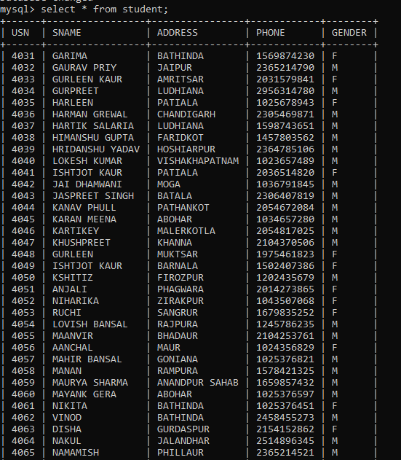

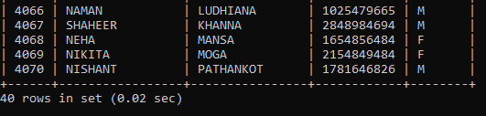

* select * from subject;

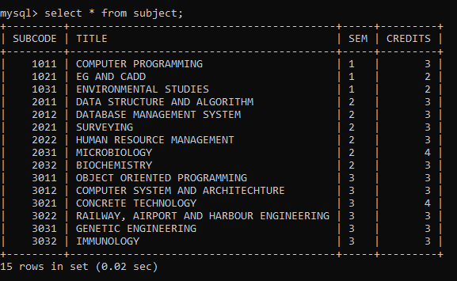

* select * from iamarks;

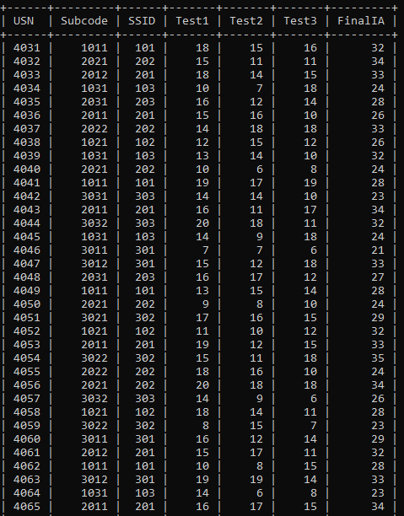

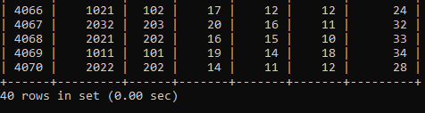

* select subcode from college.subject;

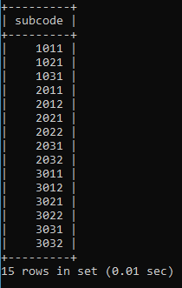

* select distinct Test1 from IAMarks;

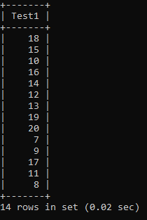

* select * from subject where credits=3;

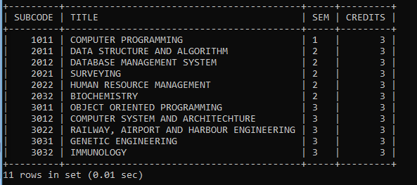

* select * from student where address='bathinda' and gender='F';

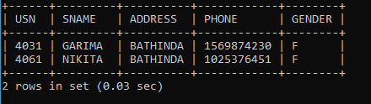

* select title from subject where credits=3 or sem=2;

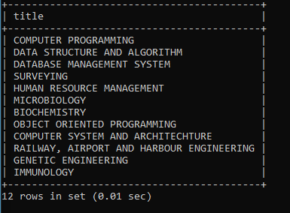

* select ssid from semsec where not sem=2;

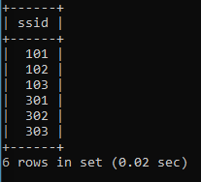

* select * from subject order by title;

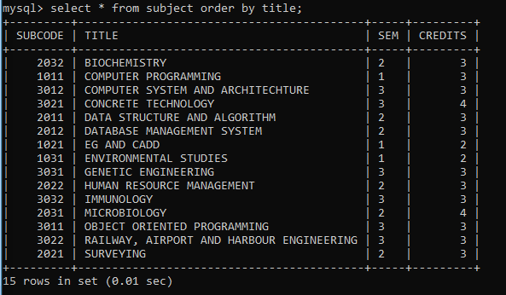

* select * from semsec order by ssid desc;

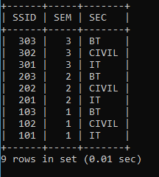

* select * from student where address is null;



* select distinct sec from semsec where sem is not null;

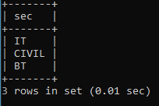

**LAB 5**

**Run queries using update, delete, limit, min, max, count, avg, sum, like clauses**

* update iamarks set test1=18 where usn=4036;



select * from iamarks where usn=4036;

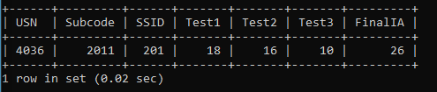

* use college;
* DELETE FROM iamarks WHERE usn='4048';
* select * from iamarks where usn=4048;

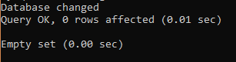

* select sname from student limit 5;

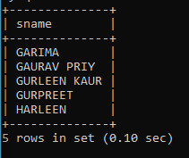

* select min(test1) as min_marks from iamarks;

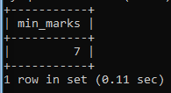

* select max(test3) as max_marks from iamarks;

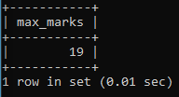

* select count(usn) as num_of_students from student;

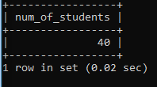

* select sem,count(sem) from subject group by sem;

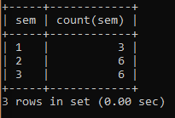

* select avg(test1) from iamarks;

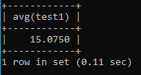

* select sum(credits) as total_credits from subject where sem=2;

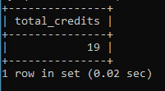

* select * from student where address like 'p%';

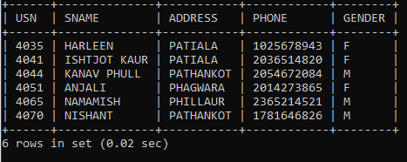

* select usn from student where address like 'b_thinda';

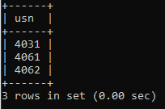

* drop schema if exists faculty;

create schema faculty;

CREATE TABLE `faculty`.`proffessor` (

`id` INT NOT NULL,

`name` VARCHAR(45) NOT NULL,

PRIMARY KEY (`id`));

SELECT * FROM faculty.proffessor;

INSERT INTO `faculty`.`proffessor` (`id`, `name`) VALUES ('101', 'ANU');

INSERT INTO `faculty`.`proffessor` (`id`, `name`) VALUES ('102', 'POONAM');

INSERT INTO `faculty`.`proffessor` (`id`, `name`) VALUES ('103', 'SHYAM');

INSERT INTO `faculty`.`proffessor` (`id`, `name`) VALUES ('104', 'ANAM');

select * from faculty.proffessor;

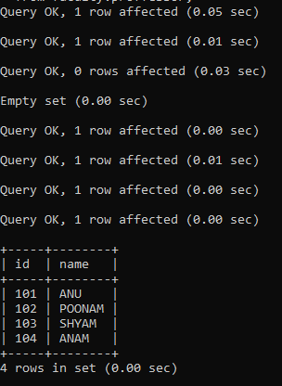

drop table proffessor;



select * from proffessor;



drop schema faculty;

use faculty;

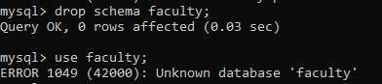

**LAB 6**

**Queries using IN, between, aliases, group by, having, exists**

* select * from subject where sem in (1,2);

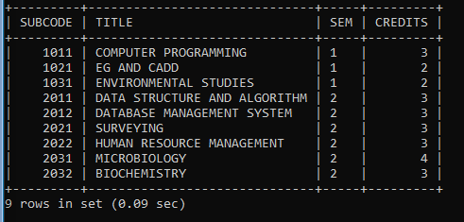

* select * from semsec where sec not in ('IT','BT');

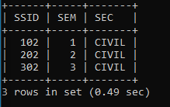

* select usn from iamarks where FinalIA between 20 and 30;

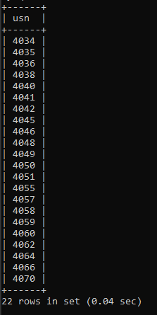

* select usn as roll_num, sname as name from student where address like 'b%';

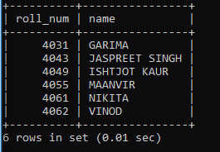

* select count(usn), address from student group by address;

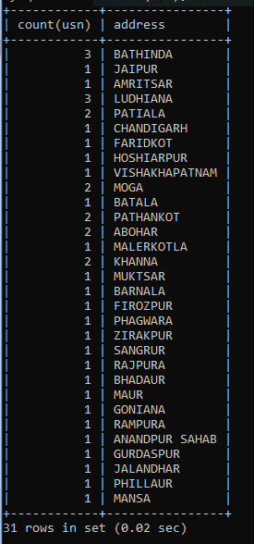

* select count(usn), address from student group by address order by address;

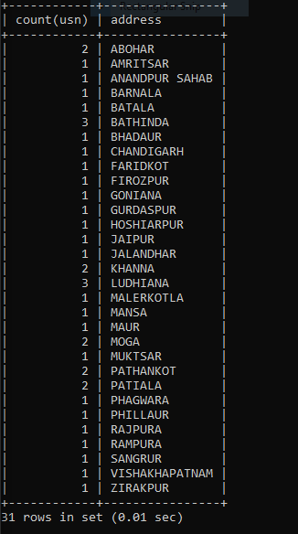

* select count(usn), address from student group by address having count(usn) > 1 order by address;

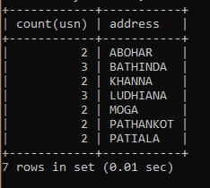

* select sname from student where exists (select usn from iamarks where student.usn=iamarks.usn and finalia>33);

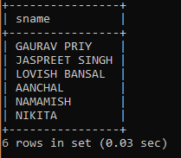

**LAB 7**

**Join and Union operations**

* select ssid,sec,title from semsec inner join subject on semsec.sem=subject.sem;

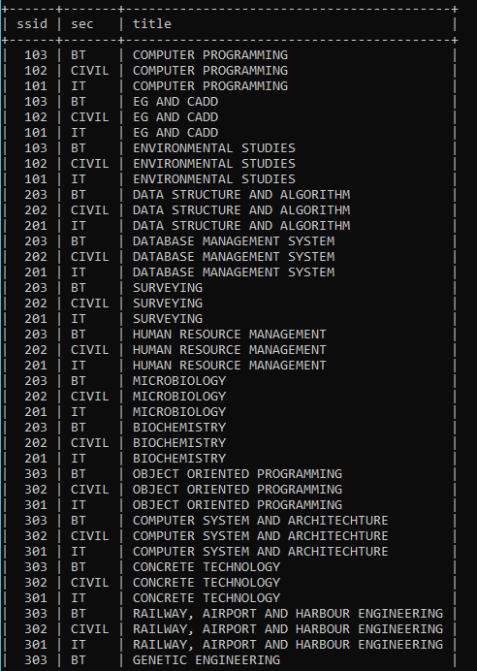

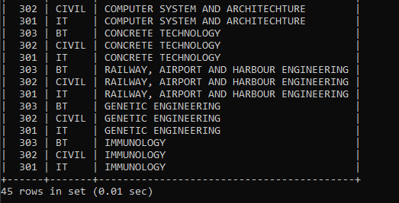

* select semsec.ssid,subject.title from semsec left join subject on semsec.sem=subject.sem;

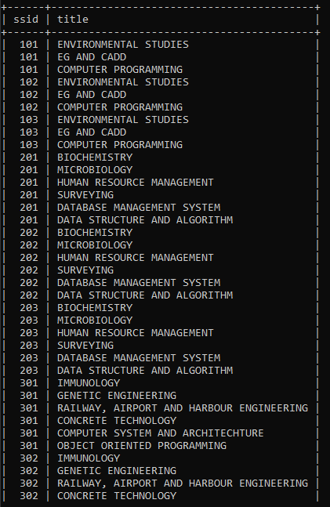

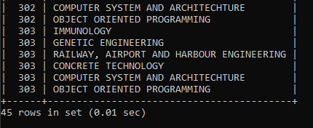

* select semsec.ssid,subject.title from semsec right join subject on semsec.sem=subject.sem;

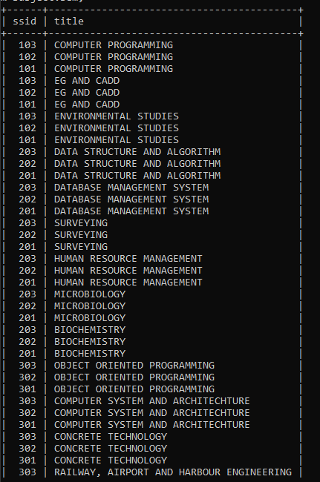

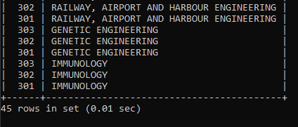

* select semsec.ssid,semsec.sec,subject.title,subject.subcode from subject left outer join semsec on subject.sem=semsec.sem union select semsec.ssid,semsec.sec,subject.title,subject.subcode from subject right outer join semsec on subject.sem=semsec.sem;

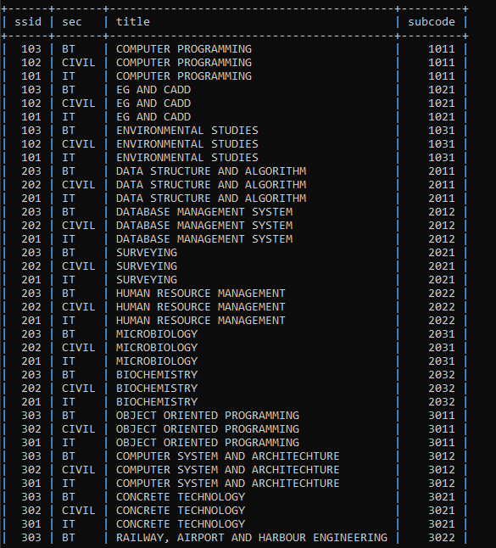

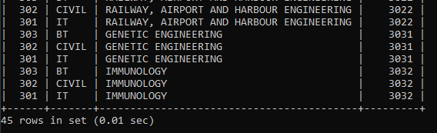

**LAB 8**

**Creating Views**

* create view student_info as select student.sname,student.phone from college.student where address='bathinda';



* select * from student_info;

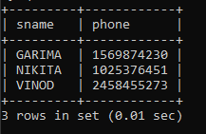

* create view Marks_above_average as select usn from iamarks where test1>(select avg(test1) from iamarks);



* select * from Marks_above_average;

