# **Process Scheduling Algorithms:**

* ***FCFS( First Come First Serve)***: FCFS algo. is a non-preemptive algorithm and it execute processes according to its arrival time(process that comes first in the ready queue). FCFS also suffers from starvation which arise if the first process has larger burst time.

Example:

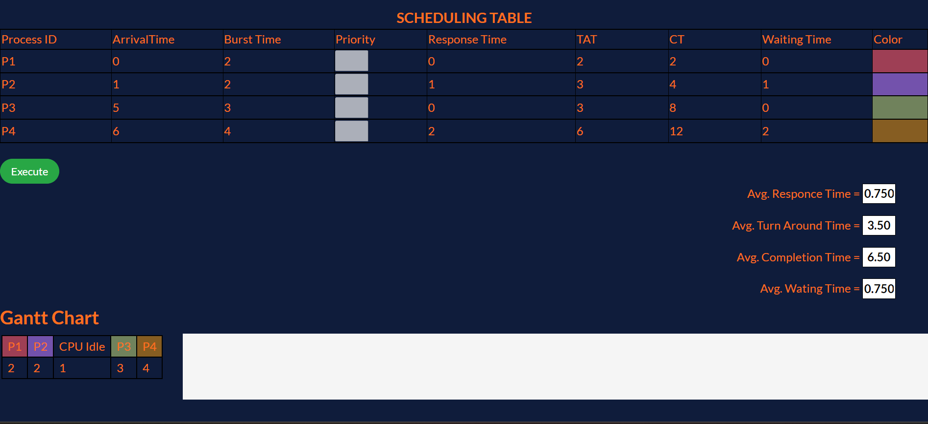

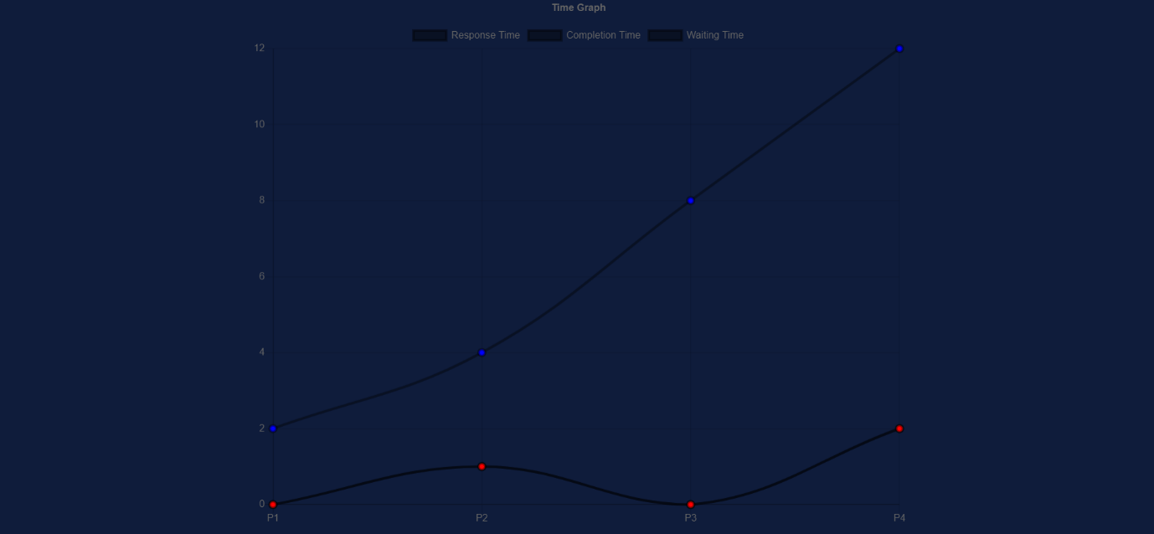

* ***SJF(Shortest Job First):*** SJF algo. is a non-preemptive algorithm in which the process having shortest /smallest burst time is executed first. It significantly reduces the average waiting time for other processes awaiting execution.

Example:

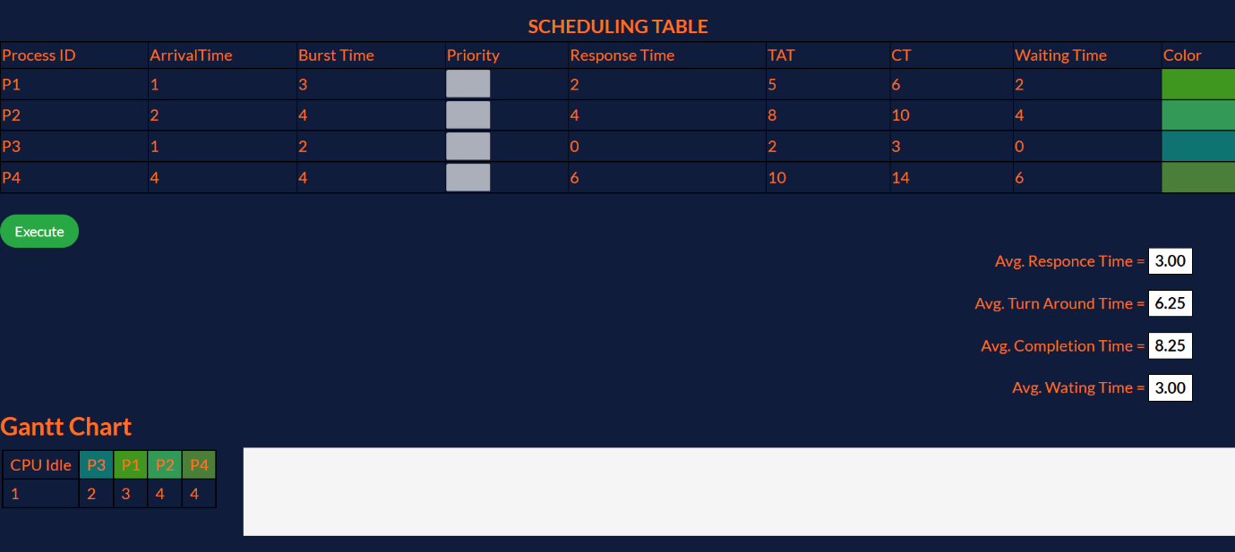

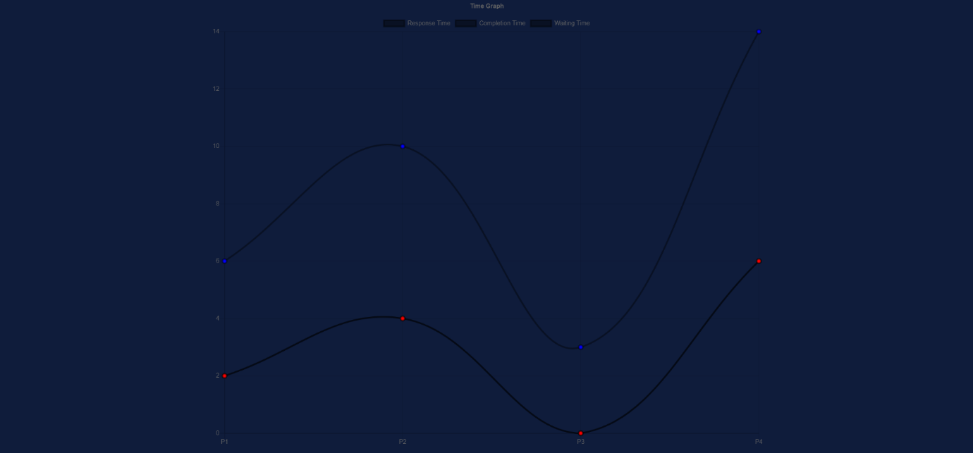

* ***Round Robin:*** Round robin is a pre-emptive algorithm. The process that is preempted is added to the end of the queue. This algorithm also offers starvation free execution of processes.

Examples:

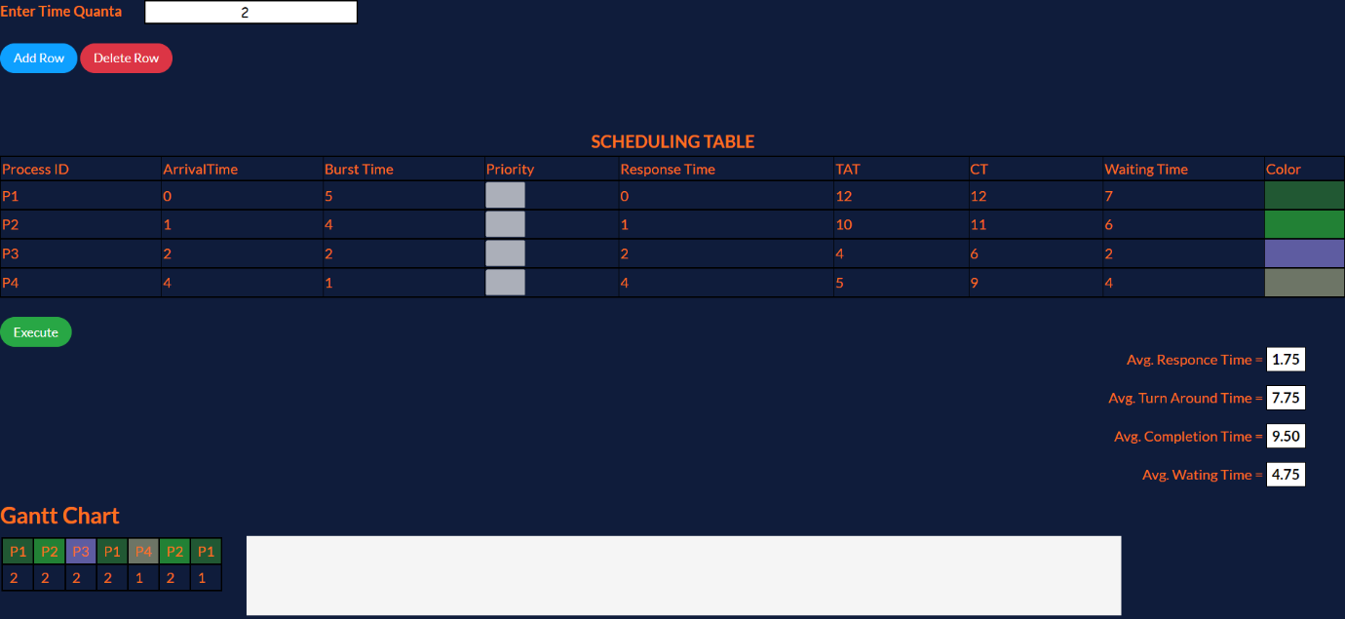

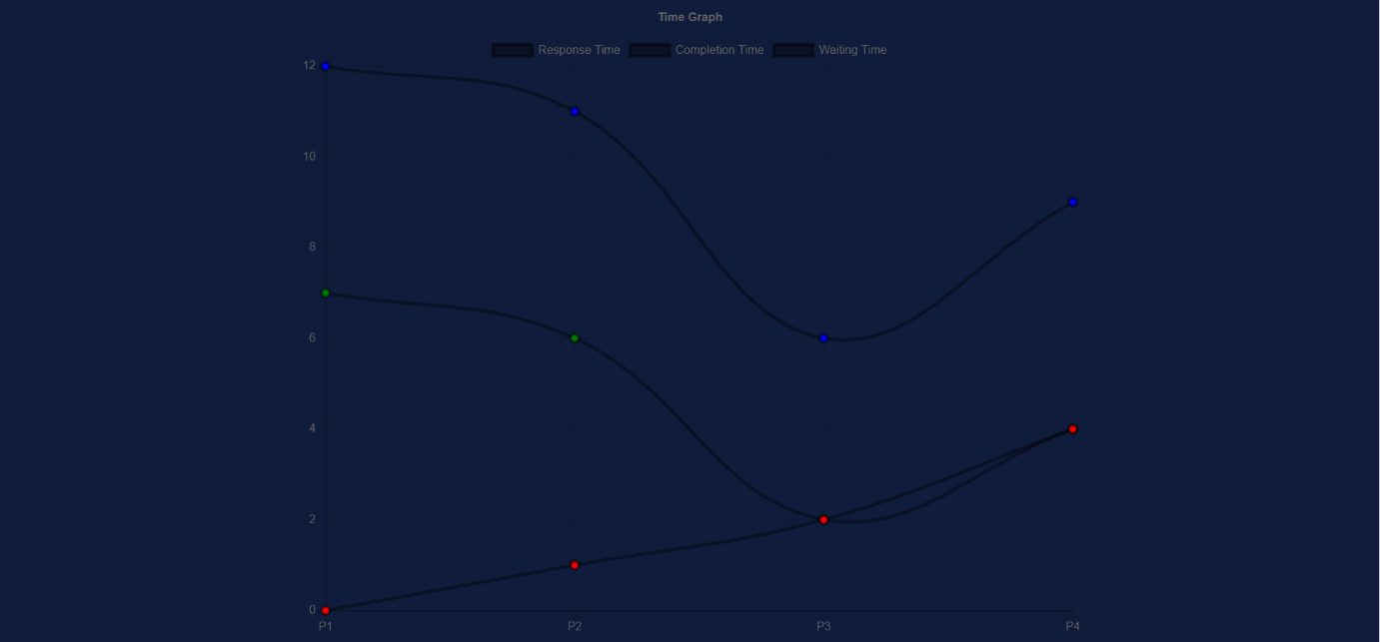

* ***Priority***: It is a non-preemptive algorithm. In this algo if the new process arrived at the ready queue has a higher priority than the currently running process, the CPU is preempted, which means the processing of the current process is stoped and the incoming new process with higher priority gets

the CPU for its execution.

Example:

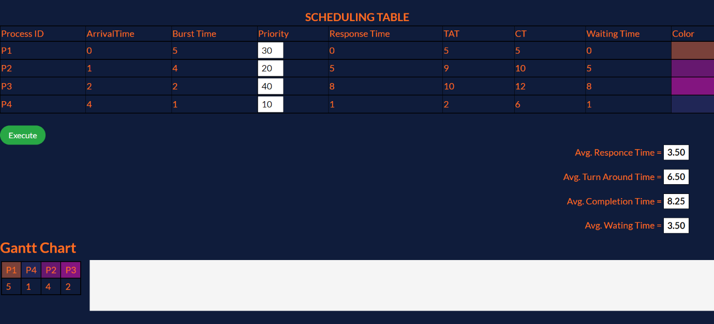

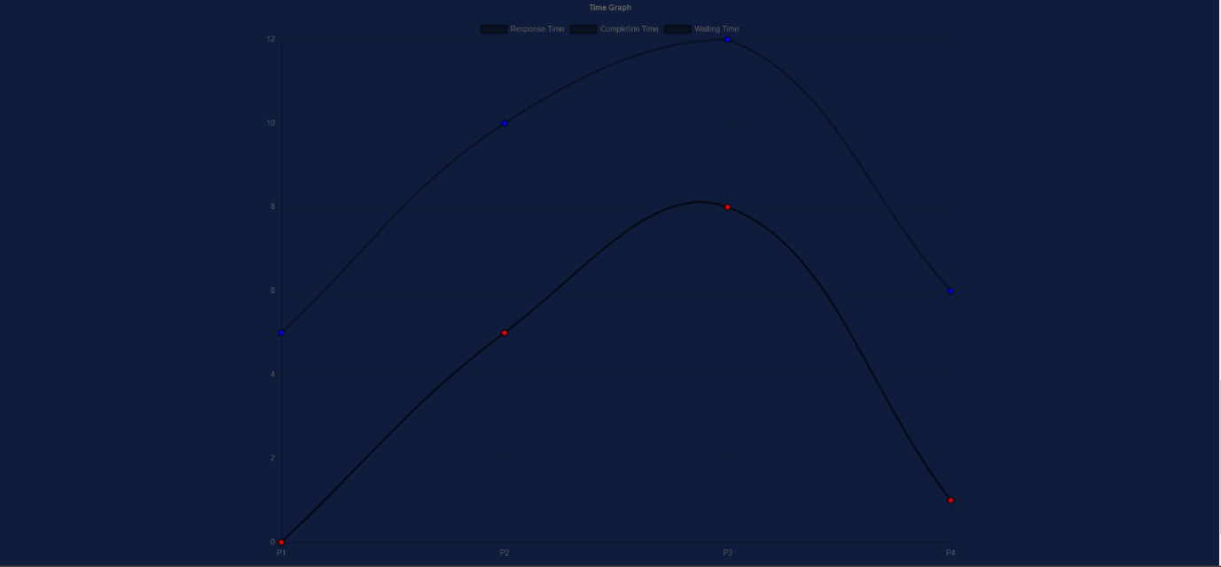

* ***SRTF(Shortest Remaining Time First):*** SRTF is a pre-emptive algorithm. At the arrival of every process, the short term scheduler schedules the process with the least remaining burst time among the list of available processes and the running process. Processes which have long burst time will have to wait for long time for execution.

Example:



