# 

**CAPSTONE PROJECT**

# **DOCUMENTATION**

**NORTHWIND TRADERS SALES ANALYTICS**

**ABHISHEK YADAV**

**PROJECT OVERVIEW**

**Project Overview: The project aims to develop a comprehensive Power BI report for Northwind Traders, a fictional company dealing in specialty foods. The primary objective is to create an intuitive and visually appealing dashboard that effectively communicates key performance metrics to aid stakeholders in making informed business decisions. The report will integrate data from various tables within the Northwind database to provide insights into sales analysis, customer segmentation, inventory trends, and employee performance.**

**The key components of the project include data import and cleaning, the selection of essential performance metrics, dashboard design, and the implementation of interactive features for data exploration. By leveraging the capabilities of Power BI, the report will empower stakeholders to analyse sales patterns, customer behaviour, and employee productivity, ultimately facilitating data-driven decision-making processes.**

**The anticipated impact of the project is to revolutionize Northwind Traders' approach to data analysis and enhance its competitiveness in the wholesale market landscape. Through the comprehensive insights provided by the Power BI report, the company will be better equipped to drive its business forward and remain competitive in the specialty foods industry.**

**The primary objective of this Power BI report is to provide Northwind Traders with a comprehensive and user-friendly dashboard that effectively communicates key performance metrics. The report aims to offer valuable insights into customer behaviour, sales trends, inventory management, and employee performance, enabling stakeholders to make data-driven decisions and drive business growth.**

**OBJECTIVE**

**The specific objectives includes :**

**Analysing sales patterns: Generate visualizations that depict sales trends over time, top-selling products, and geographical sales distribution.**

**Customer segmentation: Develop customer segments based on purchasing behaviour, geographical location, and other relevant criteria to understand customer preferences and target specific market segments effectively.**

**Inventory management: Provide insights into inventory trends, stock levels, and product availability to optimize inventory management and ensure efficient supply chain operations.**

**Employee performance evaluation: Evaluate employee performance based on sales contributions, customer satisfaction, and order fulfillment , fostering a culture of productivity and excellence.**

**Interactive data exploration: Implement interactive features such as filters and dynamic visualizations to enable users to explore data insights and make informed decisions based on specific parameters.**

**Enhancing decision-making processes: Empower stakeholders with actionable insights and facilitate data exploration to support strategic decision-making processes within the company.**

**By achieving these objectives, the Power BI report will enable Northwind Traders to gain a deeper understanding of its operations, identify growth opportunities, and optimize various aspects of its business, ultimately contributing to its success and competitiveness in the specialty foods market.**

**The development of the Power BI report for Northwind Traders holds significant importance in enhancing the company's operational efficiency, strategic decision-making, and competitive positioning within the specialty foods industry. The report's significance lies in several key aspects:**

**SIGNIFICANCE**

**Data-driven decision-making: The report will enable stakeholders to make informed decisions based on comprehensive data analysis, fostering a culture of evidence-based decision-making and minimizing the reliance on intuition or guesswork.**

**Improved business performance: By providing insights into sales trends, customer behaviour, inventory management, and employee performance, the report will help optimize various aspects of the business, leading to improved operational efficiency and increased profitability.**

**Enhanced customer understanding: Through customer segmentation and analysis, the report will facilitate a deeper understanding of customer preferences, enabling the company to tailor its marketing strategies and product offerings to better meet customer needs.**

**Streamlined inventory management: By providing insights into inventory trends, the report will support effective inventory management, ensuring optimal stock levels, minimizing stock outs, and streamlining the supply chain processes.**

**Employee productivity and engagement: The report's evaluation of employee performance will encourage a culture of accountability and excellence, fostering employee productivity and engagement, which are essential for achieving organizational goals.**

**Competitive advantage: The report's insights will enable Northwind Traders to stay ahead of the competition by identifying market trends, understanding customer preferences, and streamlining its operations, ultimately enhancing its competitive advantage within the specialty foods industry.**

**Long-term business growth: By facilitating strategic decision-making and providing actionable insights, the report will contribute to the company's long-term growth and sustainability, positioning Northwind Traders as a leading player in the specialty foods market.**

**Overall, the Power BI report's significance lies in its ability to transform data into actionable insights, empowering Northwind Traders to make well-informed decisions, streamline its operations, and achieve sustainable business growth in a competitive market landscape.**

|  |  |  |  |
| --- | --- | --- | --- |
| **Table Name: Category**  **DATA DICTIONARY** |  |  |  |
|  |  |  |  |
|  |  |  |  |
| **Column Name** | **Data Type** | **Constraints** | **Description** |
| CategoryID | int | Primary Key, Auto Increment | Unique identifier for each category. |
| CategoryName | varchar(15) |  | Name of the category. Limited to 15 characters. |
| Description | longtext |  | Description or details about the category. |
|  |  |  |  |
| **Table Name: customers** |  |  |  |
|  |  |  |  |
|  |  |  |  |
| **Column Name** | **Data Type** | **Constraints** | **Description** |
| CustomerID | varchar(5) | Primary Key | Unique identifier for each customer. Limited to 5 characters. |
| CompanyName | varchar(40) |  | Name of the customer's company. Limited to 40 characters. |
| ContactName | varchar(30) |  | Name of the primary contact person at the company. Limited to 30 characters. |
| ContactTitle | varchar(30) |  | Title or position of the primary contact person. Limited to 30 characters. |
| Address | varchar(60) |  | Street address of the customer. Limited to 60 characters. |
| City | varchar(15) |  | City where the customer is located. Limited to 15 characters. |
| Region | varchar(15) |  | Region or state where the customer is located. Limited to 15 characters. |
| PostalCode | varchar(10) |  | Postal code of the customer's location. Limited to 10 characters. |
| Country | varchar(15) |  | Country where the customer is located. Limited to 15 characters. |
| Phone | varchar(24) |  | Phone number for contacting the customer. Limited to 24 characters. |
| Fax | varchar(24) |  | Fax number for contacting the customer. Limited to 24 characters. |
|  |  |  |  |
|  |  |  |  |
| **Table Name: employees** |  |  |  |
|  |  |  |  |
|  |  |  |  |
| **Column Name** | **Data Type** | **Constraints** | **Description** |
| EmployeeID | int | Primary Key, Auto Increment | Unique identifier for each employee. |
| LastName | varchar(20) |  | Last name of the employee. Limited to 20 characters. |
| FirstName | varchar(10) |  | First name of the employee. Limited to 10 characters. |
| Title | varchar(30) |  | Job title or position of the employee. Limited to 30 characters. |
| TitleOfCourtesy | varchar(25) |  | Honorific title used with the employee's name. Limited to 25 characters. |
| BirthDate | datetime |  | Date of birth of the employee. |
| HireDate | datetime |  | Date when the employee was hired. |
| Address | varchar(60) |  | Street address of the employee. Limited to 60 characters. |
| City | varchar(15) |  | City where the employee is located. Limited to 15 characters. |
| Region | varchar(15) |  | Region or state where the employee is located. Limited to 15 characters. |
| PostalCode | varchar(10) |  | Postal code of the employee's location. Limited to 10 characters. |
| Country | varchar(15) |  | Country where the employee is located. Limited to 15 characters. |
| HomePhone | varchar(24) |  | Home phone number of the employee. Limited to 24 characters. |
| Extension | varchar(4) |  | Phone extension number for the employee. Limited to 4 characters. |
| Photo | longblob |  | Binary data for the employee's photo. |
| Notes | longtext |  | Additional notes or comments about the employee. |
| ReportsTo | int |  | EmployeeID of the person to whom this employee reports. |
|  |  |  |  |
| **Table Name: order details** |  |  |  |
|  |  |  |  |
|  |  |  |  |
| **Column Name** | **Data Type** | **Constraints** | **Description** |
| OrderID | int | Primary Key | Unique identifier for each order. |
| ProductID | int | Primary Key | Unique identifier for each product in the order. |
| UnitPrice | decimal(19,4) |  | Price of a single unit of the product. |
| Quantity | int |  | Number of units of the product ordered. |
| Discount | float |  | Discount applied to the product (in percentage). |
|  |  |  |  |
| **Table Name: orders** |  |  |  |
|  |  |  |  |
|  |  |  |  |
| **Column Name** | **Data Type** | **Constraints** | **Description** |
| OrderID | int | Primary Key, Auto Increment | Unique identifier for each order. |
| CustomerID | varchar(5) |  | Identifier for the customer placing the order. Limited to 5 characters. |
| EmployeeID | int |  | Identifier for the employee processing the order. |
| OrderDate | datetime |  | Date and time when the order was placed. |
| RequiredDate | datetime |  | Date by which the order needs to be fulfilled. |
| ShippedDate | datetime |  | Date and time when the order was shipped. |
| ShipVia | int |  | Shipping method identifier. |
| Freight | decimal(19,4) |  | Cost of shipping the order. |
| ShipName | varchar(40) |  | Name of the recipient/receiving company. Limited to 40 characters. |
| ShipAddress | varchar(60) |  | Street address for shipping. Limited to 60 characters. |
| ShipCity | varchar(15) |  | City for shipping address. Limited to 15 characters. |
| ShipRegion | varchar(15) |  | Region or state for shipping address. Limited to 15 characters. |
| ShipPostalCode | varchar(10) |  | Postal code for shipping address. Limited to 10 characters. |
| ShipCountry | varchar(15) |  | Country for shipping address. Limited to 15 characters. |
|  |  |  |  |
|  |  |  |  |
| **Table Name: products** |  |  |  |
|  |  |  |  |
|  |  |  |  |
| **Column Name** | **Data Type** | **Constraints** | **Description** |
| ProductID | int | Primary Key, Auto Increment | Unique identifier for each product. |
| ProductName | varchar(40) |  | Name of the product. Limited to 40 characters. |
| SupplierID | int |  | Identifier for the supplier of the product. |
| CategoryID | int |  | Identifier for the category of the product. |
| QuantityPerUnit | varchar(20) |  | Description of quantity per unit (e.g., 10 boxes). Limited to 20 characters. |
| UnitPrice | decimal(19,4) |  | Price of a single unit of the product. |
| UnitsInStock | int |  | Number of units currently available in stock. |
| UnitsOnOrder | int |  | Number of units currently on order. |
| ReorderLevel | int |  | Minimum level of units before reordering. |
| Discontinued | tinyint(1) |  | Flag indicating if the product is discontinued (1 for discontinued, 0 for active). |
|  |  |  |  |
|  |  |  |  |
| **Table Name: shippers** |  |  |  |
|  |  |  |  |
|  |  |  |  |
| **Column Name** | **Data Type** | **Constraints** | **Description** |
| ShipperID | int | Primary Key, Auto Increment | Unique identifier for each shipper. |
| CompanyName | varchar(40) |  | Name of the shipping company. Limited to 40 characters. |
| Phone | varchar(24) |  | Phone number for contacting the shipper. Limited to 24 characters. |
|  |  |  |  |
|  |  |  |  |
| **Table name :Suppliers** |  |  |  |
|  |  |  |  |
| **Column Name** | **Data Type** | **Constraints** | **Description** |
| SupplierID | int | Primary Key, Auto Increment | Unique identifier for each supplier. |
| CompanyName | varchar(40) |  | Name of the supplier's company. Limited to 40 characters. |
| ContactName | varchar(30) |  | Name of the primary contact person at the company. Limited to 30 characters. |
| ContactTitle | varchar(30) |  | Title or position of the primary contact person. Limited to 30 characters. |
| Address | varchar(60) |  | Street address of the supplier. Limited to 60 characters. |
| City | varchar(15) |  | City where the supplier is located. Limited to 15 characters. |
| Region | varchar(15) |  | Region or state where the supplier is located. Limited to 15 characters. |
| PostalCode | varchar(10) |  | Postal code of the supplier's location. Limited to 10 characters. |
| Country | varchar(15) |  | Country where the supplier is located. Limited to 15 characters. |
| Phone | varchar(24) |  | Phone number for contacting the supplier. Limited to 24 characters. |
| Fax | varchar(24) |  | Fax number for contacting the supplier. Limited to 24 characters. |
| HomePage | longtext |  | Website or homepage of the supplier. Can store large text data. |

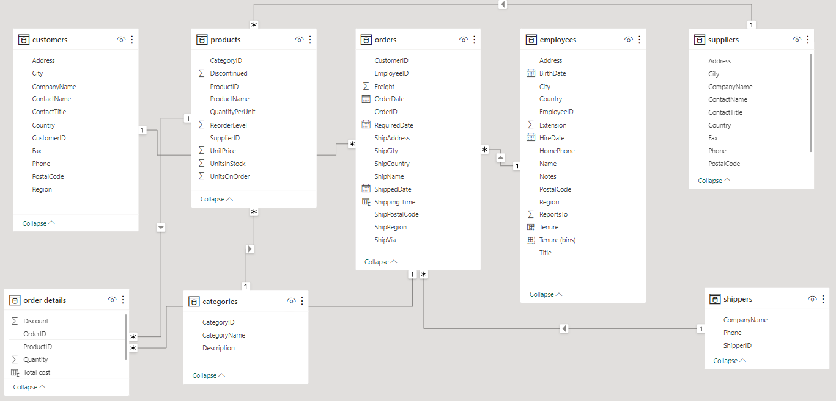

**ER DIAGRAM**

**STEPS TO CONNECT DATA**

**DATA ACQUISITION FROM GITHUB:**

**Retrieve the necessary dataset from the Northwind database, containing essential information about customers, orders, employees, products, suppliers, and shippers. Ensure comprehensive coverage of relevant data points.**

**DATA TRANSFORMATION AND ENHANCEMENT:**

**Create a detailed project report outlining the project lifecycle. Include sections on data collection methods, transformation techniques, problem statement formulation, tools integration, Power BI solutions, Exploratory Data Analysis (EDA) insights, and PowerPoint visualizations. Document the entire process meticulously.**

**DATA CONNECTION AND PREPARATION:**

**Establish connections between the Northwind database and analytical tools such as Power BI, Excel, and SQL Server Management Studio. Prepare the dataset for analysis, ensuring data integrity and consistency.**

**PROBLEM STATEMENT SOLUTIONS IN POWER BI:**

**Utilize Power BI's advanced features to address specific problem statements related to customer analysis, order trends, employee performance, product sales, supplier management, and shipping efficiency. Employ data visualization, exploration, and analysis tools in Power BI to derive actionable insights and formulate solutions.**

**EXPLORATORY DATA ANALYSIS (EDA) USING EXCEL AND MYSQL WORKBENCH:**

**Conduct Exploratory Data Analysis (EDA) using Excel and MYSQL workbench, based on the complexity of the analysis. Extract meaningful patterns, relationships, and trends from the data. Use statistical methods and visualizations to gain insights into different aspects of the business.**

**CREATION OF VISUAL AND INSIGHTFUL POWERPOINT PRESENTATION:**

**Develop a comprehensive PowerPoint presentation summarizing the project's objectives, methodologies, problem statement solutions, and key visualizations. Dedicate sections to each problem statement, providing in-depth analysis, conclusions, and actionable insights. Use visuals and charts to enhance the presentation's impact.**

**DETAILED DOCUMENTATION:**

**Compile a detailed project report documenting each stage of the project. Include thorough explanations of data acquisition, transformation processes, tools integration, Power BI solutions, EDA findings, and PowerPoint visualizations. Provide insights into decision-making processes and the impact of the analysis on Northwind Traders' operations. Ensure clarity and coherence in the documentation for future reference and analysis.**

**EDA PROBLEMS**

**PROBLEM STATEMENT WITH SOLUTIONS AND INSIGHTS**

1. What are the key factors influencing customer retention or loyalty based on the dataset?

**Given the limited data availability, analysing the key factors affecting customer retention for Northwind Traders might require a combination of data-driven analysis and qualitative insights. Here are some steps that can help in exploring and understanding customer retention factors:**

**Customer Feedback and Surveys: Conduct customer surveys or collect feedback through various touchpoints to gather qualitative data on customer satisfaction, experience, and preferences. Utilize open-ended questions to understand their perceptions of product or service quality, customer service satisfaction, and overall experience.**

**Qualitative Analysis: Perform qualitative analysis on the gathered feedback to identify recurring themes, pain points, and positive aspects that contribute to customer loyalty. Look for patterns related to convenience, personalization, communication, and brand reputation.**

**Customer Interaction Analysis: Review customer interactions, such as support tickets, inquiries, and complaints, to understand how the company addresses customer issues and concerns. Identify areas for improvement in customer engagement, communication, and problem resolution.**

**Sales and Order Data Analysis: Analyse historical sales and order data to identify patterns related to customer behaviour, purchase frequency, and order value. This analysis can provide insights into the impact of loyalty programs, incentives, and price competitiveness on customer retention.**

**Market Research and Competitor Analysis: Conduct market research and competitor analysis to understand industry benchmarks and best practices related to customer retention strategies. Compare Northwind Traders' approach to that of competitors to identify potential gaps and opportunities for improvement.**

**Internal Stakeholder Interviews: Conduct interviews with sales and customer service teams to gain insights into their interactions with customers. These interviews can provide valuable information on customer preferences, challenges, and the effectiveness of current retention strategies.**

**By combining these approaches, you can gain a comprehensive understanding of the factors influencing customer retention, even with limited data availability. This holistic analysis will enable Northwind Traders to make informed decisions and implement**

**targeted strategies to enhance customer retention and loyalty in the absence of comprehensive data.**

2.How do customer preferences vary based on their location or demographics? Can we explore this through interactive visualizations?

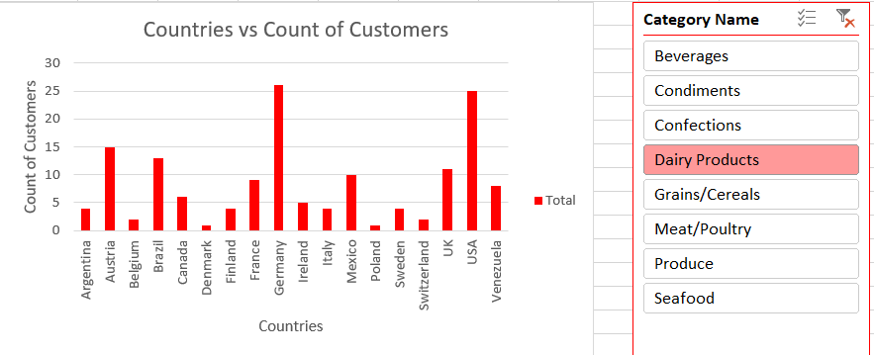

**The analysis of performance metrics across various countries reveals notable disparities, with Germany and the USA exhibiting the highest metrics and Denmark and Poland demonstrating comparatively lower performance. The data suggests potential opportunities for targeted expansion strategies in high-performing regions, while emphasizing the need for focused initiatives to address challenges in underperforming markets. A comprehensive understanding of the underlying factors influencing these variations can facilitate the development of tailored approaches to maximize market potential and drive sustainable growth in the respective regions.**

3.Are there any interesting patterns or clusters in customer behaviour that can be visualized to identify potential market segments?

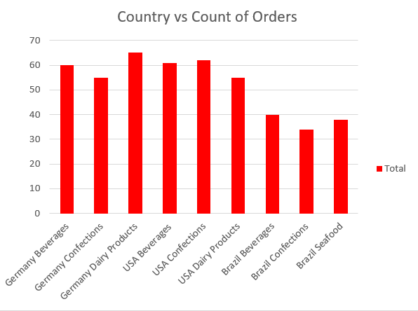

**In the dataset, we don't have market segmentation information. However, I have conducted an analysis focusing on potential markets based on customer country. I have identified the top three countries with the highest order counts. Furthermore, I have narrowed down the analysis by considering the top three product categories that contribute the most orders within each of these countries. By examining these product categories specific to each country, we can uncover potential market opportunities**.

4. Are there any specific product categories or SKUs that contribute significantly to order revenue? Can we identify them through visualizations?

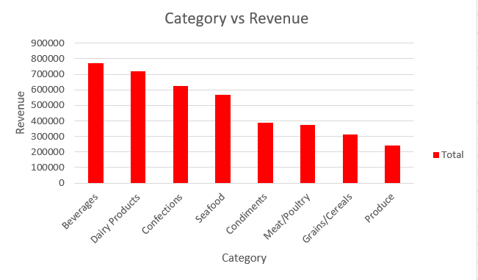

**Beverages Lead Revenue: Beverages generate the highest revenue, emphasizing their significance within Northwind Traders product lineup.**

**Competitive Dairy and Confections: Dairy Products and Confections closely follow Beverages in revenue generation, indicating their importance as strong revenue drivers.**

**Promising Categories: Seafood and Condiments contribute notable revenue, presenting opportunities for targeted growth strategies.**

**Untapped Potential: Meat/Poultry and Grains/Cereals show potential for increased focus to drive higher revenue.**

**Exploration Opportunities: The Produce category, while contributing comparatively less revenue, presents untapped market potential that could be harnessed through strategic initiatives.**

5. Are there any correlations between order size and customer demographics or product categories? Can we explore this visually using scatter plots or heatmaps?

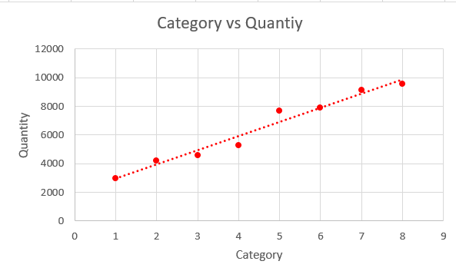

**High Demand Categories: Beverages and Dairy Products demonstrate the highest quantities sold, indicating strong and consistent consumer demand.**

**Significant Interest: Confections and Seafood also show substantial quantities sold, reflecting consistent market appeal and consumer interest.**

**Stable Demand: Condiments and Grains/Cereals maintain stable demand, indicating consistent market interest in these categories.**

**Promising Potential: Meat/Poultry and Produce show promising demand, suggesting opportunities for targeted marketing and potential growth.**

6. How does order frequency vary across different customer segments? Can we visualize this using bar charts or treemaps?

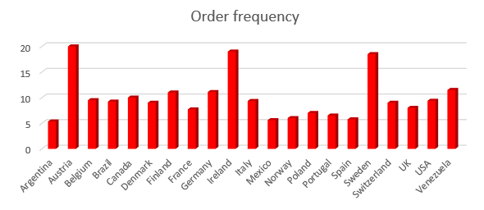

**High Demand Countries: Austria, Finland, Ireland, Sweden, and Venezuela demonstrate consistently high order frequencies, indicating strong market engagement.**

**Stable Markets: Belgium, Brazil, Canada, Denmark, Germany, Italy, Switzerland, and the USA maintain stable order rates, reflecting reliable customer engagement.**

**Potential Growth: Argentina, France, Mexico, Norway, Poland, Portugal, Spain, and the UK show moderate order frequencies, suggesting opportunities for targeted expansion strategies.**

7. Are there any correlations between employee satisfaction levels and key performance indicators? Can we explore this visually through scatter plots or line charts?

**We don’t have adequate data to analyse the correlation between employee satisfaction level and KPI data on employee satisfaction levels, which can be obtained through surveys or feedback mechanisms, and collect relevant KPI data, such as productivity, sales performance, or customer satisfaction ratings**.

8. How does employee turnover vary across different departments or job roles? Can we visualize this using bar charts or heatmaps ?

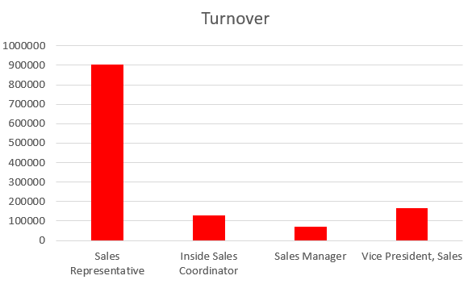

**High Turnover: Sales Representative department shows the highest turnover, indicating a need for targeted retention strategies.**

**Moderate Turnover: Inside Sales Coordinator department demonstrates moderate turnover, suggesting the need for initiatives to enhance job satisfaction.**

**Low Turnover: Sales Manager and Vice President, Sales departments exhibit lower turnover, emphasizing the importance of maintaining employee satisfaction and career development opportunities.**

9. Can we identify any patterns or clusters in employee skill sets or qualifications through visualizations? How can this information be used for talent management?

**Certainly, despite data limitations, identifying patterns or clusters in employee skill sets or qualifications can be facilitated through various visualization techniques. Some common methods to uncover underlying structures in the data and represent clusters or patterns include:**

**Scatter Plots: Visualize relationships between different skill sets or qualifications and their distribution among employees.**

**Heat maps: Illustrate the prevalence of specific skills within different employee clusters, providing insights into skill distribution.**

**Network Graphs: Represent the interconnectedness of different skills or qualifications, highlighting their relationships and dependencies.**

**Radar Charts: Compare the skill sets or qualifications of employees across various dimensions, aiding in identifying strengths and weaknesses.**

**Tree Maps: Show the hierarchical structure of skill sets and qualifications within the organization, offering a comprehensive view of the skill landscape.**

**Understanding these patterns can significantly benefit talent management in various ways:**

**Skill Gap Identification: Spot skill gaps and develop tailored training programs to address them effectively. Cross-Functional Team Building: Facilitate the formation of cross-functional teams by identifying employees with complementary skill sets.**

**Efficient Recruitment: Streamline the recruitment process by identifying critical skill sets for specific roles within the organization.**

**Career Development Planning: Plan career development paths for employees based on their current skill sets and the skills required for different roles.**

**Strategic Workforce Planning: Make informed decisions about workforce planning, identifying potential candidates for leadership positions and strategic initiatives.**

**Leveraging these insights, organizations can optimize their talent management strategies, ensuring the right skills are in the right positions to drive the accomplishment of business objectives.**

10. Are there any correlations between product attributes (e.g., size, color, features) and sales performance? Can we explore this visually using scatter plots or heatmaps?

**Data Limitations: Incomplete data points, missing variables, and potential inconsistencies limit the depth of the analysis, impeding a comprehensive understanding of customer preferences and market trends.**

**Cautious Interpretation: Exercise caution in interpreting preliminary findings due to data limitations, as they may not fully capture the complexities of the relationship between product attributes and sales performance.**

**Recommendations for Data Collection: Improve data collection through enhanced methods and rigorous quality controls to ensure a more accurate and comprehensive dataset for future analysis.**

**Alternative Approaches: Supplement the existing dataset with qualitative insights, customer surveys, and external market research to provide a more holistic perspective on product attributes and sales performance.**

**Future Research Opportunities: Emphasize the need for gathering extensive and accurate data to support in-depth analysis for informed decision-making and strategic planning.**

11. How does product demand fluctuate over different seasons or months? Can we visualize this through line charts or area charts?

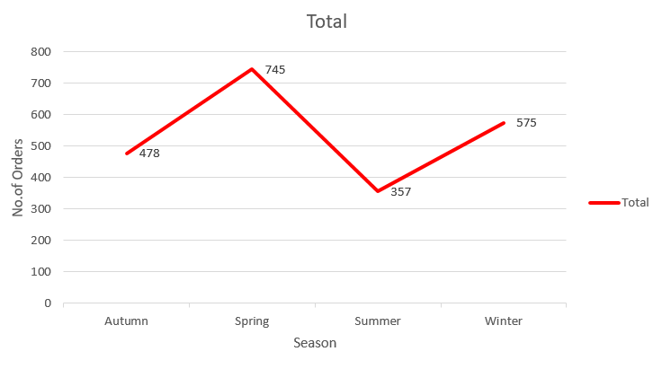

**Spring Dominance: Spring records the highest number of product orders, indicating a peak in customer demand during this season.**

**Winter Follows Spring: Winter follows closely behind Spring in the number of product orders, suggesting sustained consumer activity during the colder months.**

**Autumn and Summer Orders: Autumn and Summer demonstrate relatively lower product orders, highlighting potential areas for targeted marketing and promotional strategies to stimulate demand during these seasons.**

**Understanding the seasonal trends in product orders can guide Northwind Traders in optimizing inventory management, marketing campaigns, and product promotions to align with customer preferences and seasonal demand fluctuations.**

12. Can we identify any outliers or anomalies in product performance or sales using visualizations? How can this information be used for product optimization?

**Certainly, visualizations help identify outliers in product performance or sales data, enabling businesses to optimize product performance and overall strategies. Key benefits include:**

**Root cause analysis: Identifying reasons behind out liers aids in understanding issues affecting product performance and consumer behaviour.**

**Quality improvement: Addressing outliers related to product quality facilitates improvements in the production process, enhancing customer satisfaction.**

**Inventory management: Analysing outliers in sales data enables efficient inventory management, optimizing stock levels for different products.**

**Market segmentation: Recognizing outliers in customer preferences assists in tailoring marketing strategies and product offerings, enhancing overall sales and market share.**

**Pricing strategy adjustment: Identifying outliers in pricing data guides businesses in optimizing pricing strategies, ensuring competitiveness and profitability.**

13. Are there any correlations between supplier attributes (e.g., location, size, industry) and performance metrics (e.g., on-time delivery, product quality)? Can we explore this visually through scatter plots or heat maps?

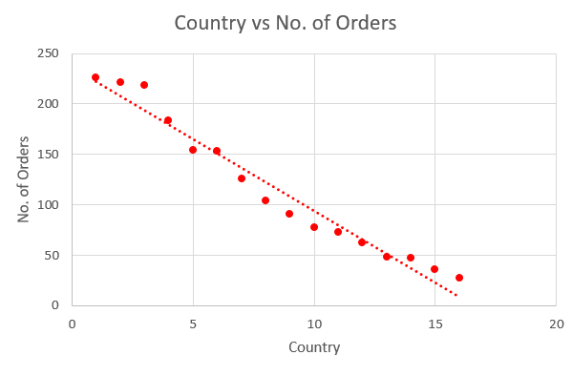

**Efficient Deliveries: The USA, Australia, and Germany demonstrate the highest number of orders delivered on time, indicating efficient delivery systems and processes in these countries.**

**Moderate Performance: The UK, Italy, and France show a moderate number of orders delivered on time, signifying a need for potential improvements in the delivery process to ensure timely deliveries and customer satisfaction.**

**Opportunities for Improvement: Countries such as Canada, Japan, and Norway display a comparatively lower number of orders delivered on time, highlighting areas for potential enhancements in the delivery process to meet customer expectations and improve service quality.**

**Understanding the delivery time performance across different countries allows Northwind Traders to identify areas for improvement in their delivery processes, optimize logistics operations, and enhance customer satisfaction, thereby strengthening their global market presence.**

14. How does supplier performance vary across different product categories or departments? Can we visualize this using stacked bar charts or grouped column charts?

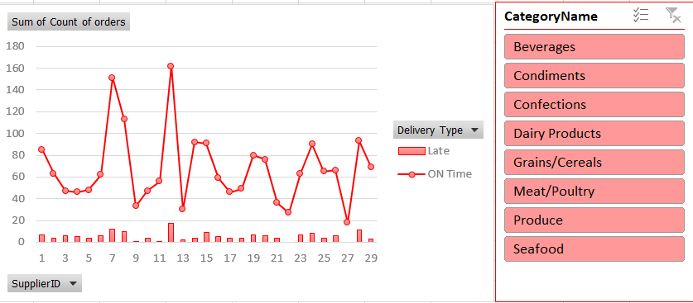

**Timely Deliveries: The majority of orders across different categories were delivered on time, reflecting a generally efficient delivery process and adherence to delivery schedules.**

**Occasional Delays: Some orders experienced delays, representing a small portion of the total orders. This suggests the need for continuous monitoring and improvements in the delivery process to minimize delays and maintain high service standards.**

**Consistent Performance: Overall, the data indicates a consistent performance in timely order deliveries, with only a small fraction of orders experiencing delays, showcasing the company's commitment to efficient logistics management and customer satisfaction.**

15. Can we identify any trends or patterns in supplier costs or pricing structures through visualizations? How can this information be used for procurement optimization?

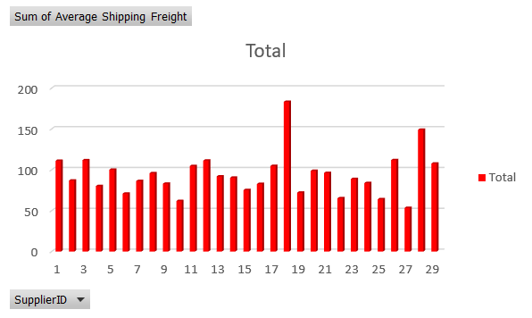

**Variability in Shipping Costs: Shipping freight costs vary significantly across different suppliers, ranging from 53.43 to 183.29, indicating potential differences in shipping methods, distances, or product types.**

**Optimization Opportunities: Suppliers with higher freight costs, such as Supplier 18 with an average of 183.29, may benefit from cost optimization strategies and negotiations to streamline shipping expenses and improve overall cost efficiency.**

**Cost-Effective Suppliers: Suppliers with relatively lower average shipping freight costs, such as Suppliers 10, 22, and 25, present opportunities for maintaining cost-effective shipping solutions and fostering long-term partnerships to ensure consistent and affordable logistics service.**

**Analysing these insights can assist Northwind Traders in making informed decisions related to supplier selection, negotiation strategies, and overall cost management to optimize shipping operations and maintain competitive pricing for customers**Top of Form

**POWER BI PROBLEMS**

1.How does customer distribution vary across different regions or customer segments? Can we visualize it on a map or bar chart?

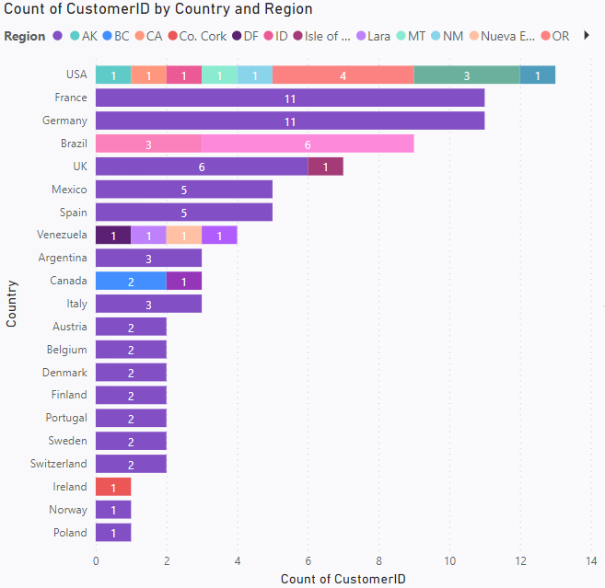

**From the graph it can be seen that USA is having maximum number of customer with respect Region and Poland is having lowest customers** 2. What is the trend in customer acquisition over time? Can we create a line chart or area chart to display it?

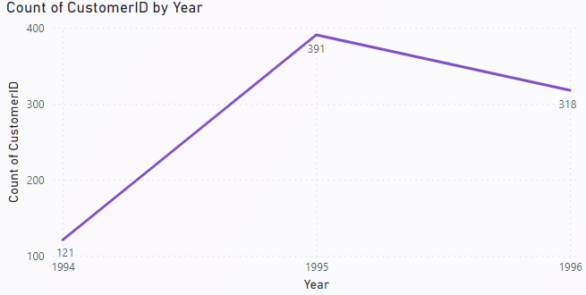

**From the graph it can be seen that in year 1995 has the maximum number of customers i.e. 391 and in year 1994 has the minimum number of customers i.e. 121.**

3.Can we visualize the distribution of customer demographics such as age, gender, or income using histograms or pie charts?

**Data is inadequate for this problem statement so I have visualized number of order per county**

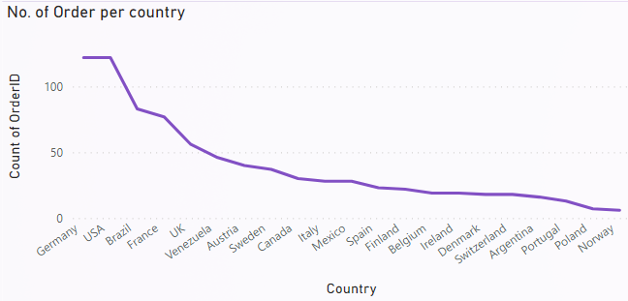

**From the graph it can be seen that Germany is having maximum number of Orders and Norway is having minimum number of Orders**

4.How does order volume change over time? Can we create a time series chart or stacked bar chart to visualize it?

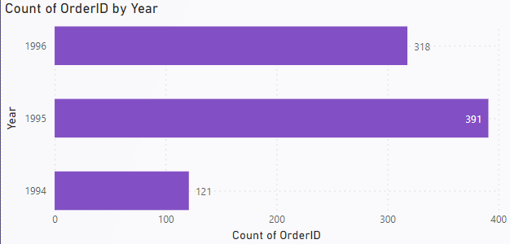

**From the Bar Graph in year 1995 maximum number of Orders has been placed and on year 1994 minimum number of orders has been ordered**

5. What is the distribution of order values? Can we create a histogram or box plot to display it?

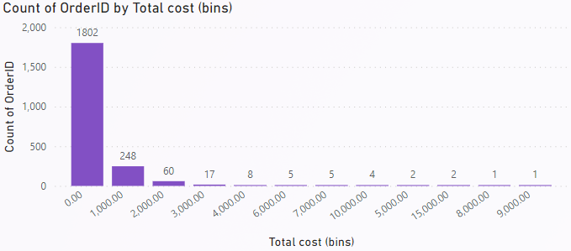

**From the graph it can be seen that the price less than 1000 is having the maximum number of Orders i.e. 1802 and least number of orders in price above 8000 and 9000.**

6. Can we visualize the average order processing time or shipping duration using a bar chart or box plot?

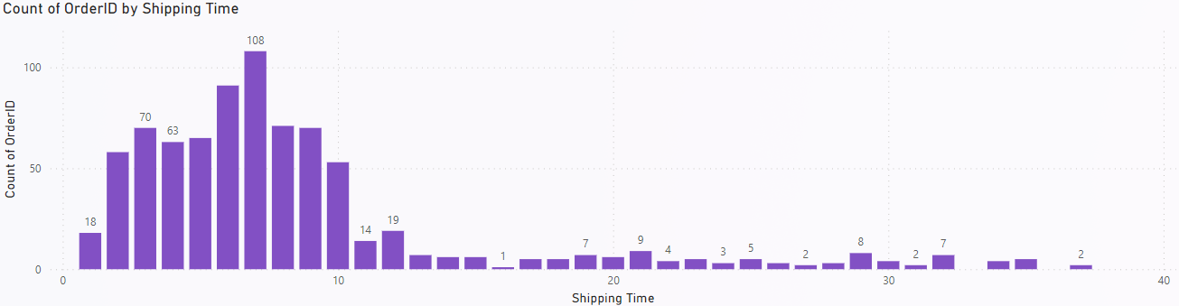

**From the graph it can be seen that shipping time below 10 days is having maximum number of Orders and above that the number of Orders is decreasing .**

7. How does employee productivity vary across different departments or job roles? Can we create a stacked bar chart or grouped column chart to visualize it?

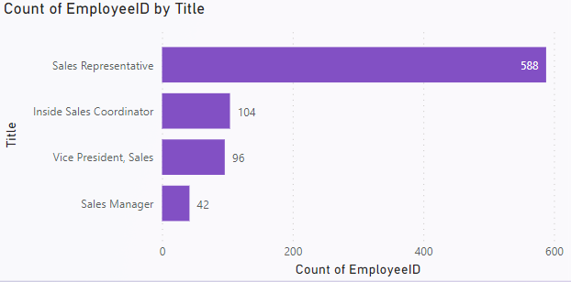

**From the graph it can be seen that Sales Representative has the maximum number of Employees i.e. 588 and Sales Manager is having lowest number of Employee i.e. 42**8. What is the distribution of employee tenure? Can we create a histogram or box plot to display it?

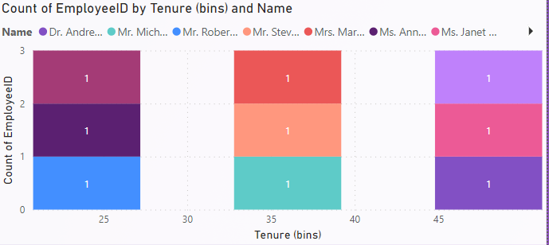

**From the graph it can be seen that Nancy, Janet and Andrew i.e. more than 45 months is having maximum tenure and Robert, Annie and Laura is having lowest tenure i.e. less than 25 months**

9. Can we visualize employee performance ratings or KPIs using a radar chart or bullet graph?

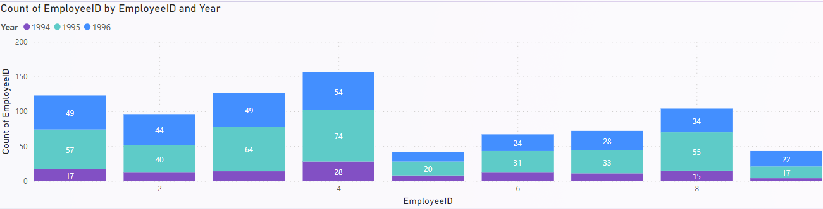

**From the graph it can be seen that Employee ID 4 is having maximum number of Orders over years** 10. What is the distribution of product ratings or reviews? Can we create a histogram or stacked bar chart to visualize it?

**We don’t have sufficient data to analyse this problem :**

**Although specific product rating or review data is not available at this time, the analysis of product ratings or reviews typically involves examining the frequency distribution of different rating levels. This distribution provides insights into customer satisfaction and product performance. To visualize this, a histogram or a stacked bar chart can be employed. A histogram would display the frequency of ratings within specific rating ranges, while a stacked bar chart could illustrate the distribution of ratings across different products or product categories. By leveraging these visualizations, it is possible to identify trends in customer feedback and assess the overall sentiment towards the products, thereby informing potential areas for improvement and highlighting successful product lines**

11. How does the sales volume vary across different product categories? Can we create a bar chart or treemap to display it?

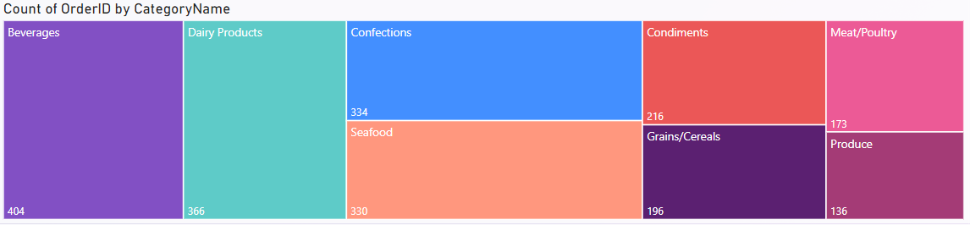

**From the tree map we can see that Beverages is having maximum number of Orders i.e. 404 and Produce is having least number of orders i.e. 136**

12. Can we visualize the pricing distribution of products using a box plot or violin plot?

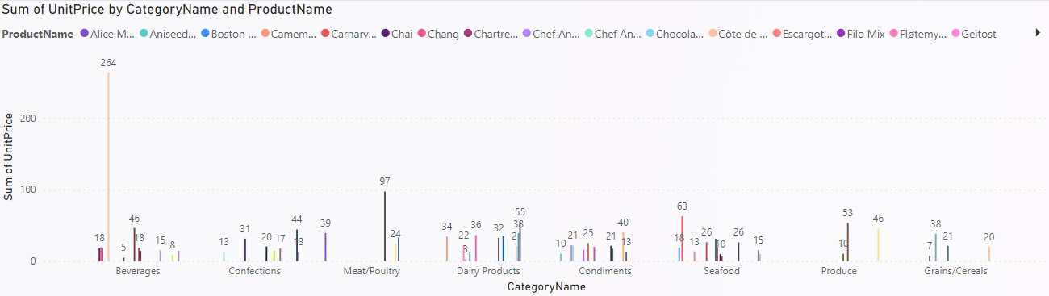

**From the graph it can be seen that Beverages is having the highest unit price i.e. product name is Cote de Blaye and in the Dairy Products Geitost is having lowest unit price i.e. 2.50**

13. What is the distribution of supplier ratings or performance metrics? Can we create a bar chart or radar chart to visualize it?

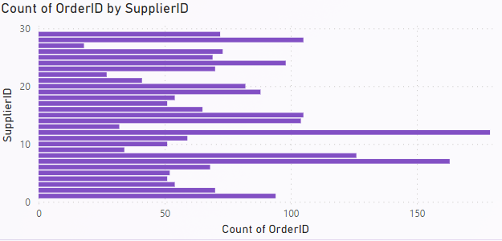

**From the graph it can be seen that Shipper ID 12 is having maximum number of orders i.e. 179 and Shipper Id 27 is having lowest number of orders i.e. 18**

14. How does the cost or pricing structure vary across different suppliers? Can we create a box plot or stacked bar chart to display it?

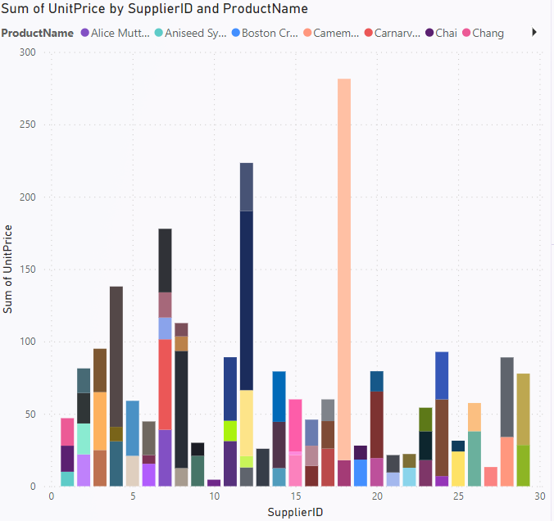

**From the graph it can be seen that Supplier ID 18 is having highest unit price for product Cote de Blaye i.e. and Supplier Id 10 is having lowest Unit price for product Chai** 15. Can we visualize the geographical distribution of suppliers using a map or bubble chart?

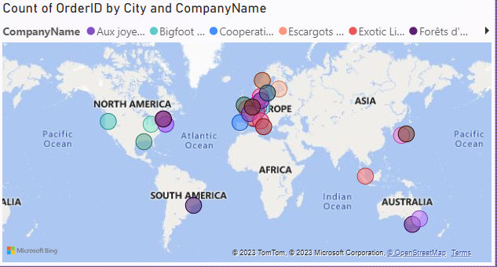

**From the map it can be clearly seen that Europe is the biggest market for the North Wind Traders**

16. Average shipping time by Shipper

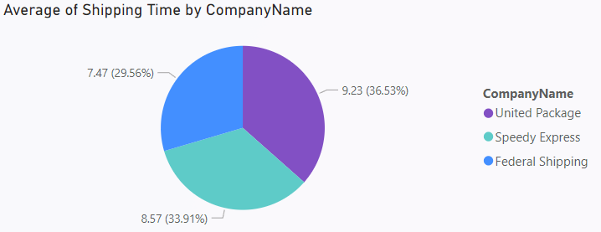

**From the pie chart it can be seen that United Package is taking maximum shipping time on an average i.e. 9.23 days and Federal is taking least time to Ship its products i.e. 7.47 days**

17. Number of Order Shipped by Individual Shipper

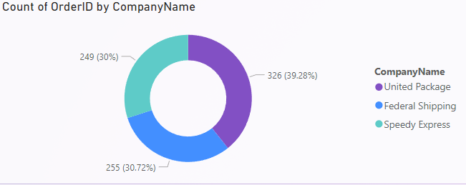

**From the pie chart It can be seen that United Package is having maximum number of orders i.e. 326 and Speedy Express is having lowest number of Orders i.e. 249**

18. Number of Orders Shipped to Each Country

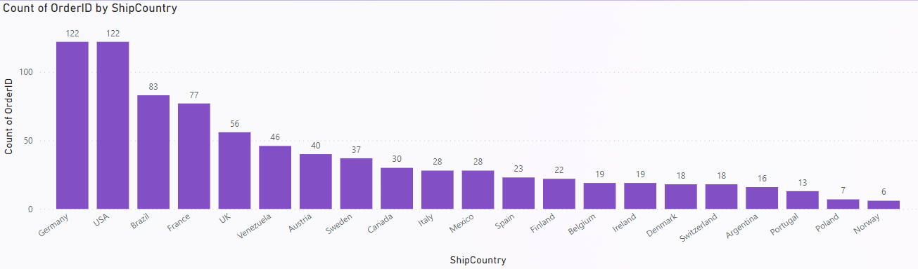

**From the graph it can be seen that Germany and USA is having maximum number of Orders i.e. 122 and Norway is having least number of orders i.e. 6**

**CONCUSION**

**In conclusion, the Excel and Power BI report designed for Northwind Traders presents a comprehensive view of the company's operations, emphasizing key insights into customer behaviour, sales patterns, and employee performance. By consolidating data from multiple tables, the report offers valuable insights into various aspects of the business, including sales analysis, customer segmentation, inventory trends, and employee performance metrics. The interactive visualizations and dynamic filters empower stakeholders to make data-driven decisions effectively, facilitating a deeper understanding of the company's performance and providing avenues for strategic decision-making.**

**Through this report, Northwind Traders can gain a competitive edge in the wholesale market landscape by leveraging the insights provided to optimize their operations, enhance customer satisfaction, and drive business growth. The user-friendly interface and visually appealing dashboard facilitate efficient data exploration and analysis, enabling stakeholders to stay informed and proactive in their decision-making processes. With its emphasis on comprehensive insights and user empowerment, the Power BI report is poised to revolutionize how Northwind Traders interacts with its data and drives the company forward in the dynamic and competitive market landscape.**