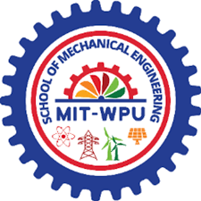


PROJECT REPORT
On

DESIGN OF TWO STAGE REDUCTION GEARBOX

Submitted by:
PB04 NEEL SATHE
PB08 HARSH SANGHAVI
PB11 ABHISHEK LELE
PB15 HARSH NANDE
PB16 OM SADUL

Under guidance of
Prof. S.P Shisode

INDEX

TITLE | Pg.
INTRODUCTION | 3
LIST OF COMPONENTS | 5
PROBLEM STATEMENT | 6
SELECTION OF MOTOR | 7
MATERIAL SELECTION & FOS | 8
NOTATIONS | 10
BEARING SELECTION | 11
CALCULATIONS | 13
LUBRICATION | 43
CAD MODELS | 45
ASSEMBLY, DISASSEMBLY AND FUTURE SCOPE | 53
MAINTAINANCE | 54
CITATIONS | 55
CONCLUSION | 56

CERTIFICATE
Certified that Mr of Class T.Y. BTech. Mechanical Division 2 Roll No. has completed the laboratory work in the Transmission System Design during the semester V of the academic year 2023-24.

Signature of the Faculty Seal of the Head of the Department

INTRODUCTION

A two-stage helical-spur speed reduction gearbox is a mechanical device used to decrease the rotational speed of an input shaft and increase the torque transmitted to an output shaft. This type of gearbox combines elements of helical and spur gear designs in a two-stage configuration. The primary purpose of this gearbox is to reduce the speed from the input shaft while amplifying the torque to the output shaft. Each stage of gearing accomplishes a portion of this transformation, allowing for a significant reduction in rotational speed while proportionally increasing the torque output. The arrangement of gears in a two-stage helical-spur gearbox is designed to provide an efficient power transmission system.
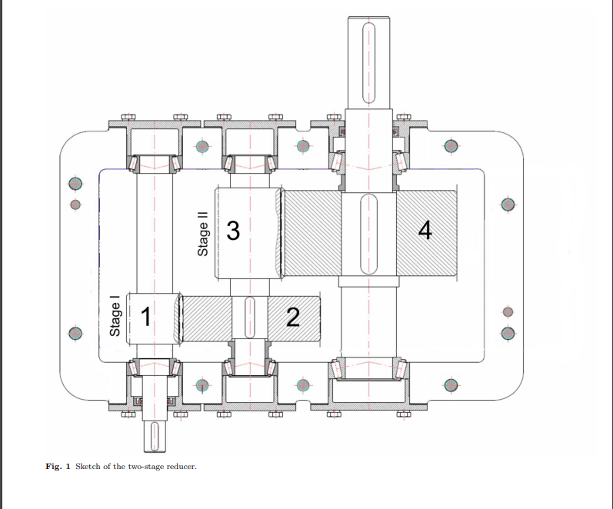
This gearbox contains two pairs of gears, a combination of helical and spur gears. The first stage usually consists of helical gears to reduce the input speed and increase torque. The second stage uses spur gears to further reduce speed or modify torque characteristics based on the required output. Helical gears contribute to the smooth operation and load distribution, while spur gears in the second stage optimize torque conversion.

These gearboxes find applications in various industries where precise control over speed and torque transmission is required, such as industrial machinery, automotive transmissions, conveyors, and more. The combination of helical and spur gears in a two-stage setup offers a balance between efficiency, smooth operation, and power transmission capabilities.

a. Helical pair:
A helical gear and pinion are two meshing gears that have teeth cut in a helical pattern. A helical gear is a cylindrical gear with angled teeth that are cut at an angle, called helix angle, to the gear's axis in a helical pattern. These gears resemble spur gears, but their teeth are cut at an angle, resulting in a helical shape along the gear's surface. Helical gears provide smoother and quieter operation compared to spur gears due to the gradual engagement of their teeth. The pinion is a smaller gear with teeth that mesh with the larger helical gear. Helical gear and pinion sets offer advantages such as reduced noise, smoother operation, higher load-bearing capacity, and better torque transmission compared to spur gear and pinion setups. They are commonly used in various applications where efficiency, smoothness, and power transmission are essential, such as in automotive transmissions, machinery, industrial equipment, and more.

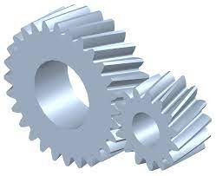
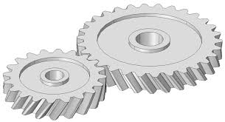

b. Spur pair:
A spur gear is a cylindrical gear with straight teeth cut parallel to the gear's axis. These gears are one of the simplest and most common types of gears. Spur gears are efficient in power transmission but may produce more noise and vibration compared to helical gears due to the sudden engagement of their teeth. Spur gears and pinions are widely used in various applications where simplicity, cost-effectiveness, and moderate power transmission are required. They are commonly found in applications such as automotive transmissions, machinery, conveyor systems, and many other mechanical devices.

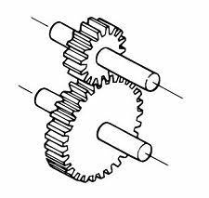
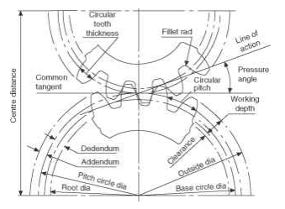

Due to the nature of their straight teeth, spur gears and pinions might produce more noise and vibration compared to helical gears.
Therefore, helical pair is used in stage 1 and spur pair is used in stage 2.

LIST OF COMPONENTS
Main components | Applications
Helical-Spur Gear Pair | Helical gears and spur gears in a two-stage configuration to achieve speed reduction and torque increase in a mechanical transmission system.
Shafts | In a two-stage helical-spur gearbox, shafts play a crucial role in transmitting rotational motion and power between the different stages and gears within the gearbox
Keys | A key is a small metal component used to connect rotating machine elements to shafts to prevent relative rotation between the two. Keys transmit torque from the shaft to the connected component by providing a positive connection.
Bearings | A machine element that constrains relative motion to only the desired motion and reduces friction between moving parts.

PROBLEM STATEMENT

A two-stage helical-spur reduction unit tailored for a paper mill application, that involves drives which rotate rollers used for pressing, drying, and smoothening the paper pulp, is to be designed. The drive receives power of 12kW from the shaft of an electric motor rotating at 2800 rpm. The output shaft should rotate at the desired speed of 200 rpm in order to ensure the proper control of papermaking process.
Assuming suitable data and proper calculations, design the two-stage reduction unit for the above stated application

OBJECTIVE
The overarching objective is to design a robust, efficient, and reliable two-stage helical-spur reduction unit that efficiently converts the high-speed, low-torque input from the electric motor into the lower-speed, higher-torque output necessary to drive the rollers used in the paper mill process while maintaining precise control over the papermaking stages. The primary goal is to reduce the speed from the input shaft, provided by the electric motor rotating at 2800 rpm, to the desired output speed of 200 rpm. This reduced speed is critical for controlling the papermaking process associated with rollers used for pressing, drying, and smoothening the paper pulp.
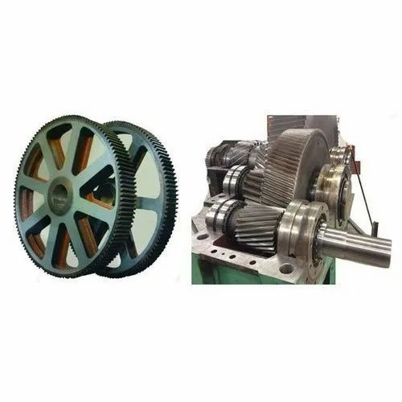

SELECTION OF MOTOR

There are several characteristics that you need to pay attention to when selecting motor but voltage, current, torque, and velocity (RPM) are most important.

1. Current is what powers the motor and too much current will damage the motor. For DC motors, operating and stall current are important.

2. Voltage is used to keep net current flowing in one direction and to overcome back current. The higher the voltage, the higher the torque.

3. Velocity, or speed (RPM), can be complex regarding motors. The general rule is that motors run most efficiently at the highest speeds but it is not always possible if gearing is required.

Hence, Selected Motor Designation: 2FD1 107-08 selected from Hindustan Electric Motors Catalogue.
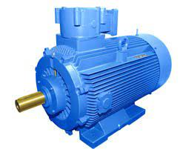

MATERIAL SELECTION

The selection of materials holds paramount importance in the design of a two-stage helical-spur reduction unit for a paper mill application. The gears and components within this gearbox must withstand high torque, continuous operation, and potentially harsh environmental conditions. Choosing materials with superior strength, durability, and wear resistance is essential to ensure the longevity and reliability of the gearbox. Considering factors such as the ability to withstand wear from particles in the paper mill environment, resistance to corrosion due to moisture or chemicals, and effective heat dissipation to manage frictional heat generation is crucial.

- Material for Helical Pair – AISI 4130 Steel

The selection of AISI 4130 steel for the helical gear pair in the two-stage reduction unit for the paper mill application was based on several crucial factors. AISI 4130 steel offers a combination of desirable properties crucial for the efficient operation of the gearbox in this demanding environment. Its exceptional strength and durability make it well-suited to handle the high torque and continuous operation required within the gearbox. Moreover, AISI 4130 steel possesses excellent wear resistance, crucial in a paper mill setting where abrasive particles and contaminants are prevalent, ensuring prolonged gear tooth life and reduced maintenance needs.

- Material for Spur Pair – 1200 Maraging Steel

The selection of 1200 maraging steel for the spur gear pair within the two-stage reduction unit for the paper mill application was deliberate due to its specific properties that align with the demands of the gearbox. 1200 maraging steel possesses exceptional strength and toughness, making it well-suited for applications where high impact resistance and durability are paramount. The paper mill environment often introduces dynamic loads and shock forces on the gears, requiring a material that can withstand such stress without compromising its integrity.

- Material for Shafts – Steel FeE 580

The selection of steel FeE 580 for the shaft within the two-stage reduction unit for the paper mill application was driven by its specific mechanical properties that align with the functional demands of the shaft. FeE 580 steel offers notable strength, excellent ductility, and good machinability, making it an optimal choice for applications requiring robustness and formability. Its high tensile strength and toughness are crucial for withstanding the torque loads and stresses experienced by the shaft during operation.

- Material for Keys – AISI 1045 Medium Carbon Steel

The decision to opt for AISI 1045 medium carbon steel for the keys within the two-stage reduction unit for the paper mill application stemmed from its specific material properties ideally suited for this critical component. AISI 1045 steel offers a balance of strength, hardness, and machinability, making it a fitting choice for key components requiring resilience and precision.

Factor of safety:
While designing a component, it is necessary to provide sufficient reserve strength in case of an accident. This is achieved by taking a suitable factor of safety. The factor of safety is defined as the ratio of failure stress upon allowable stress.
In case of our project, we have considered fos=2 for gear calculations as according to VB Bhandari's Design of Machine Elements "For use with reliable materials where loading and environmental conditions are not severe, a range of 1.5-2.5 can be used as fos". Considering our material properties we have chosen fos=2

NOTATIONS

Abbrevations | Description
zp | Pinion Teeth
zg | Gear Teeth
dp | Diameter of pinion
dg | Diameter of gear
Pt | Static load
Pd | Dynamic Load
Peff | Effective Load
Mt | Torque
P | Power
Sb | Beam Strength
Sw | Wear Strength
σb | Bending Strength
Sut | Ultimate Strength
mn | Normal module of helical gears
m | Module
b | Face width
N | RPM
Fos | Factor of safety
C | Deformation factor
Cv | Velocity Factor
Cs | Service Factor
v | Pitch Line Velocity
e | Error

BEARING SELECTION

1. Structure:

Inner and Outer Rings: Deep groove ball bearings consist of an inner ring and an outer ring. These rings have carefully designed grooves, known as raceways, that facilitate the movement of the rolling elements.

Balls: Steel or ceramic balls are positioned between the inner and outer rings. These balls are evenly spaced and roll along the raceways to minimize friction.

Cage: The cage, also called a retainer or separator, surrounds the balls and prevents them from coming into direct contact with each other. It maintains the relative positions of the balls and ensures even distribution within the bearing.
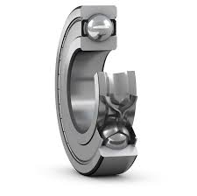
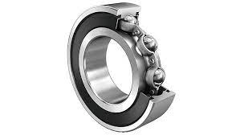
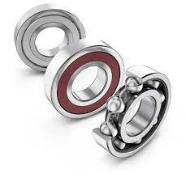

2. Ball Bearings:

Material: The balls in deep groove ball bearings are typically made of steel or ceramic, depending on the application's requirements.

Function: The primary function of the balls is to reduce friction and distribute the load evenly across the raceways.

3. Cage:

Purpose: The cage serves to keep the balls separated and maintain their proper alignment. It prevents friction between balls, reduces wear, and contributes to the overall durability of the bearing.

Materials: Cages are commonly made of steel, brass, or other suitable materials, depending on factors such as operating conditions and application requirements.

4. Types of Deep Groove Ball Bearings:

Single Row Bearings: This is the most common type, featuring a single set of balls positioned between the inner and outer rings.

Double Row Bearings: These bearings have two sets of balls arranged in separate rows, providing increased load-carrying capacity.

Open Bearings: Lack seals or shields, making them suitable for applications where debris ingress is not a concern.

Shielded Bearings: Equipped with metal shields on one or both sides to protect against contamination and reduce friction.

Sealed Bearings: Feature rubber or metal seals to provide enhanced protection against environmental factors and contaminants.

Type of bearing used in our case is Rolling contact bearings: -
Single row deep grove Ball Bearings.

CALCULATIONS
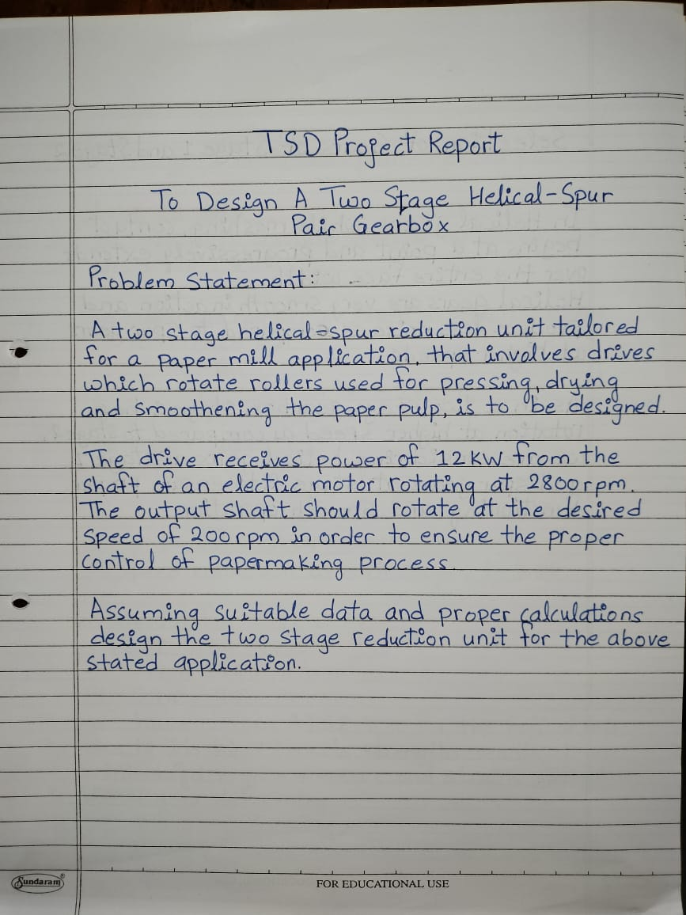

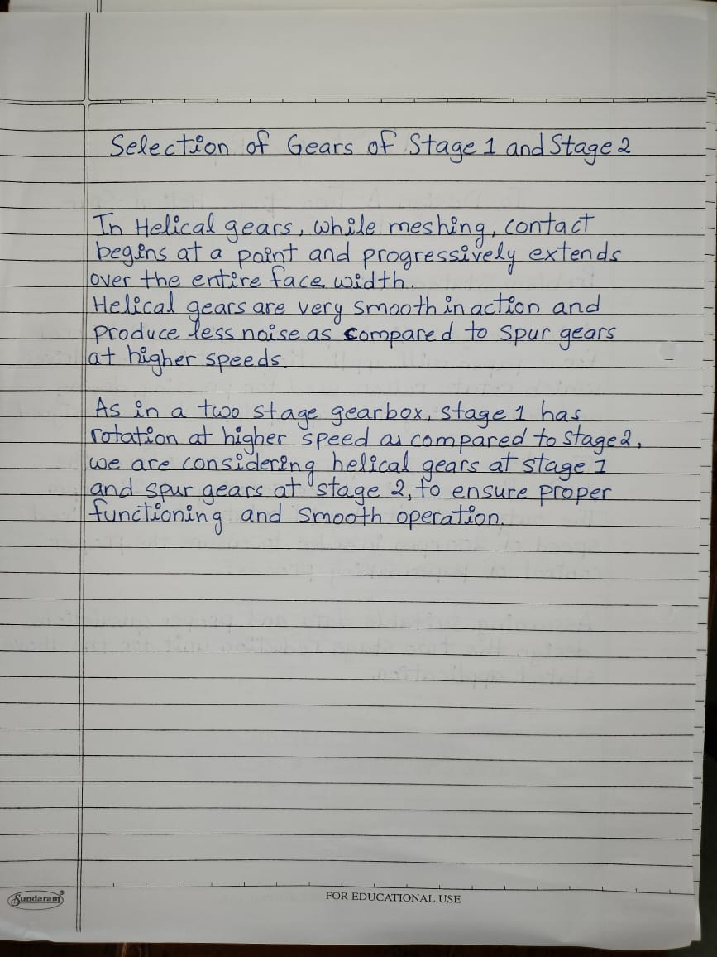

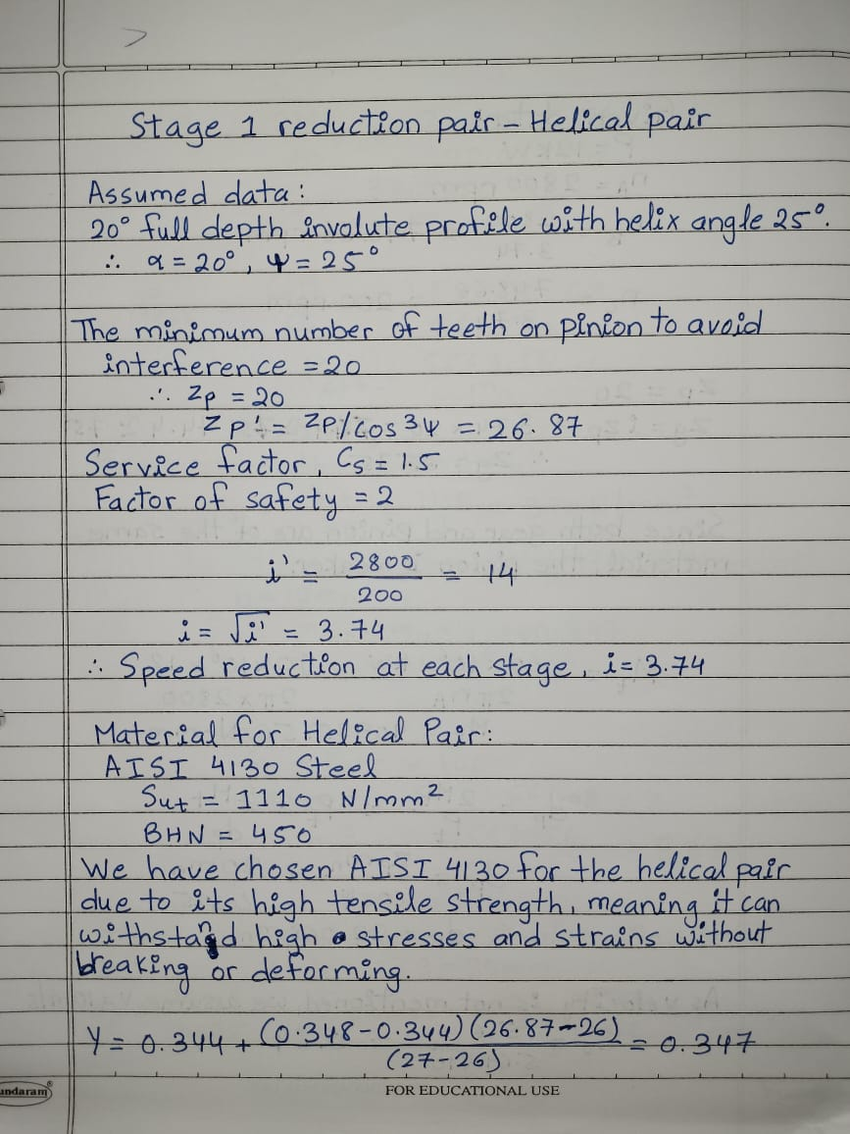

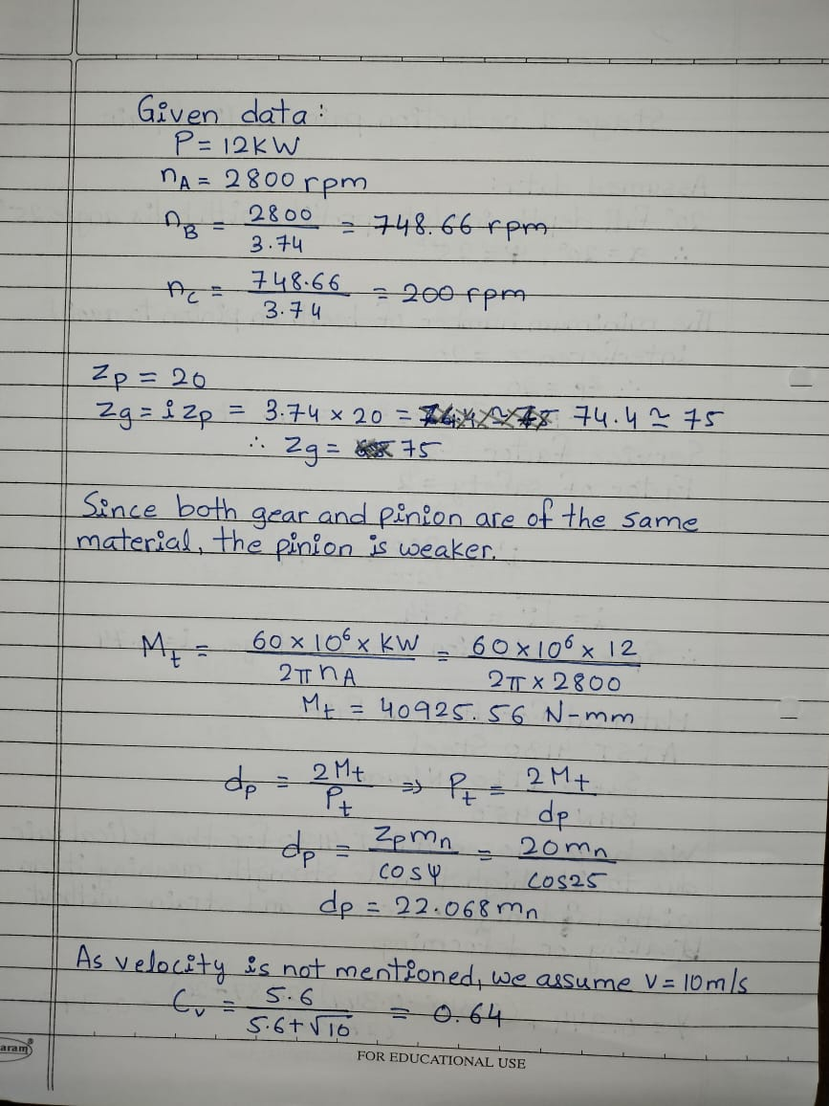

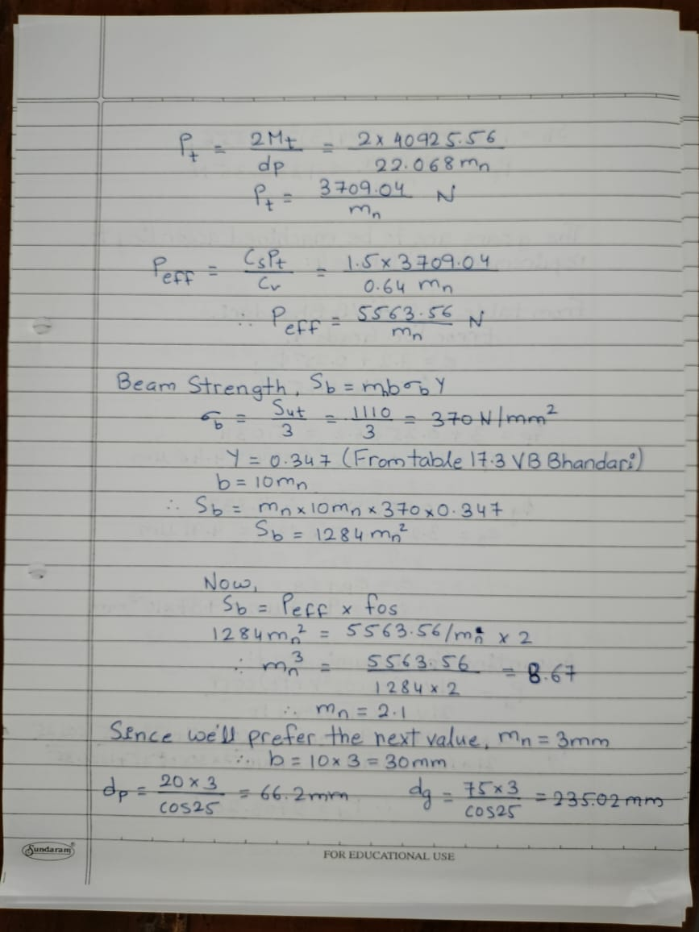

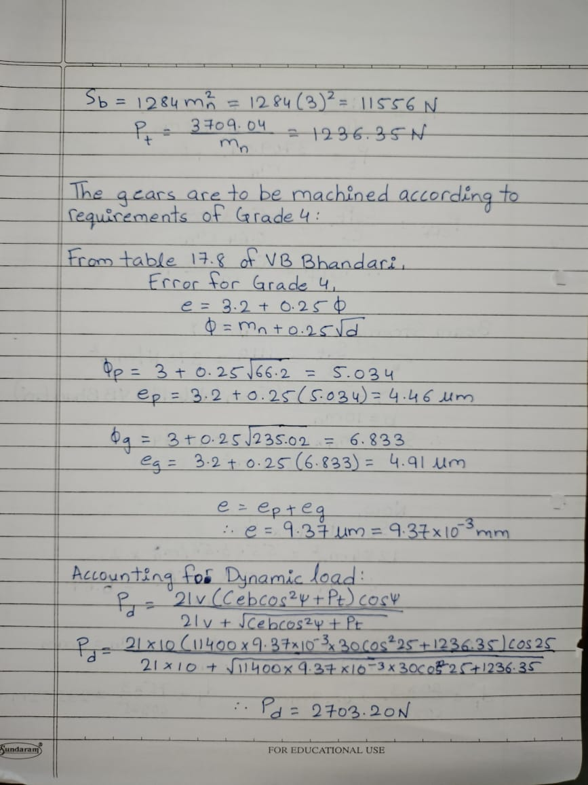

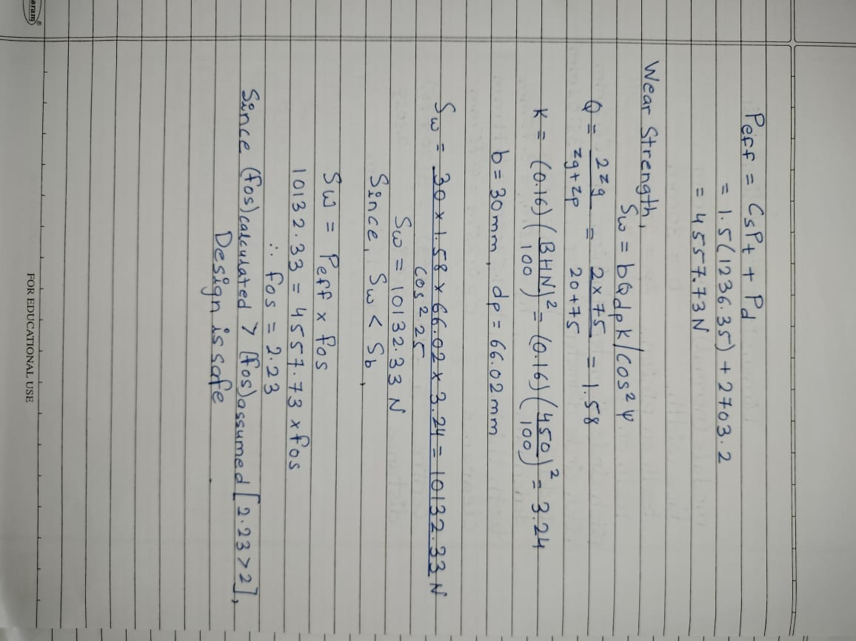

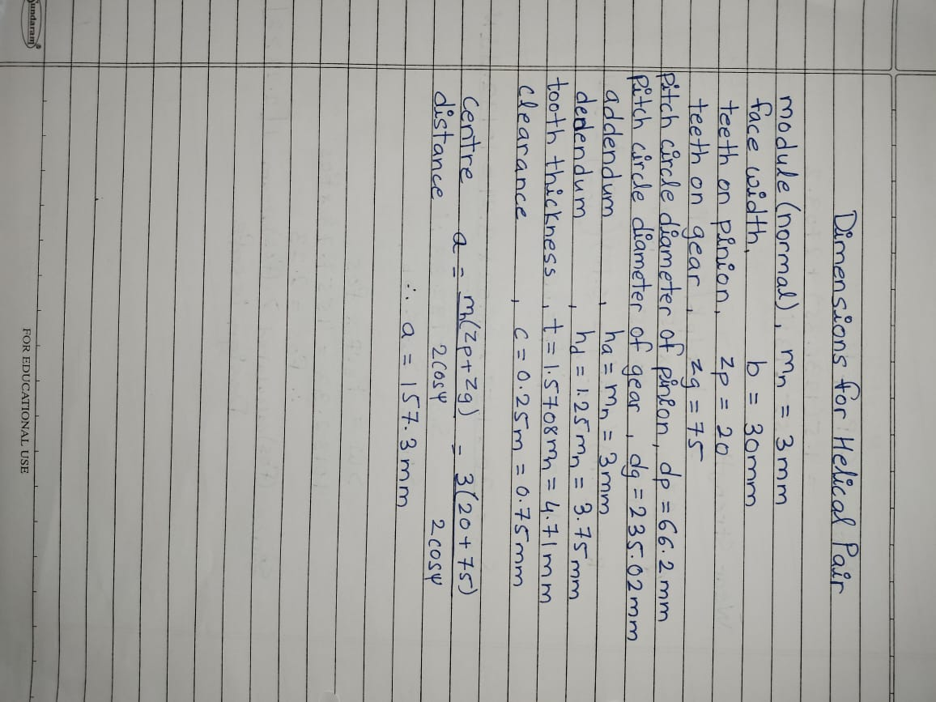

DIMENSIONS OF HELICAL GEAR
Module, m_{n} | 3 mm
Face width, b | 30 mm
Teeth of pinion, z_{p} | 20
Teeth of gear, z_{g} | 75
Pitch circle Diameter of pinion, d_{p} | 66.2 mm
Pitch circle diameter of gear, d_{g} | 235.02 mm
Addendum, h_{a} | 3 mm
Dedendum, h_{a} | 3.75 mm
Tooth Thickness, t | 4.71 mm
Clearance, c | 0.75 mm
Centre distance, a | 157.3 mm

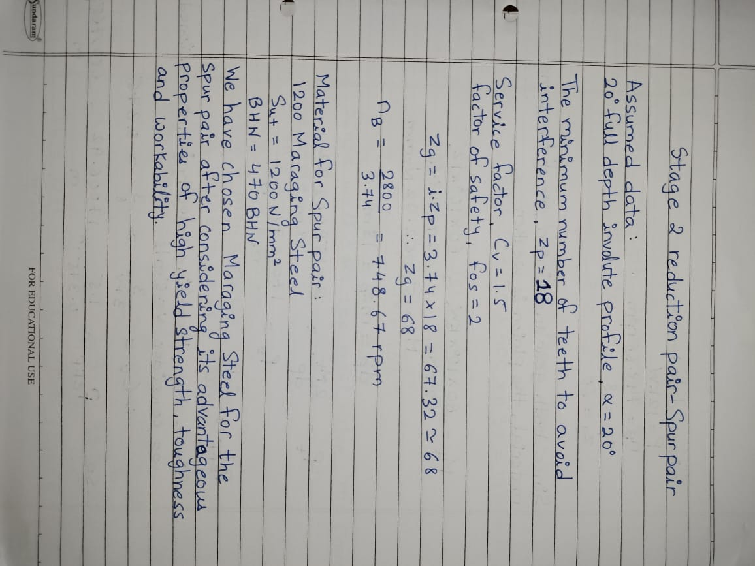

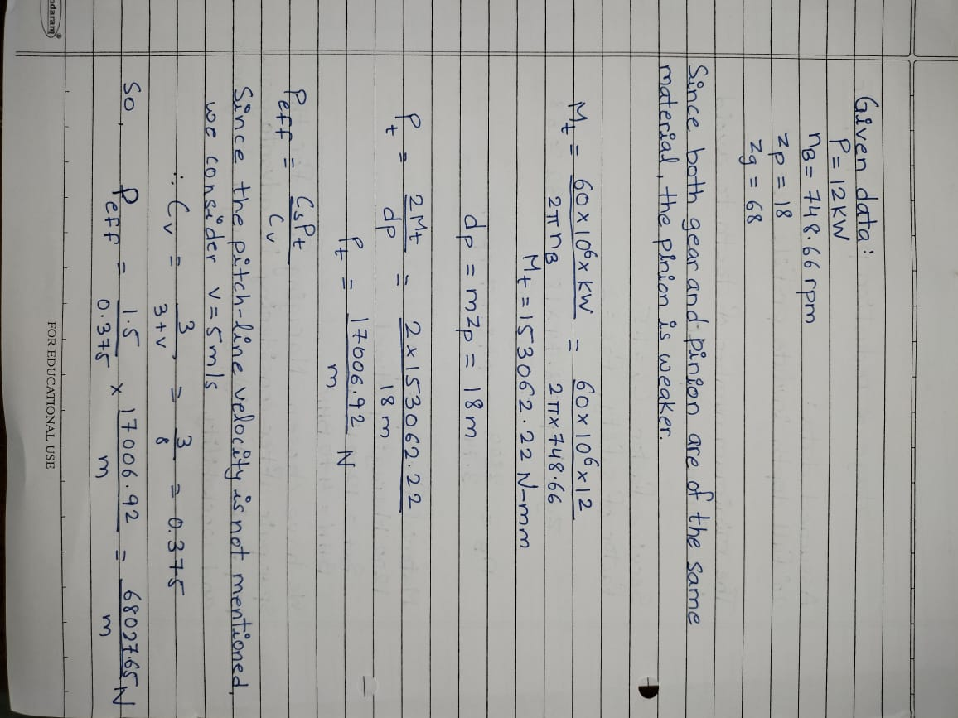

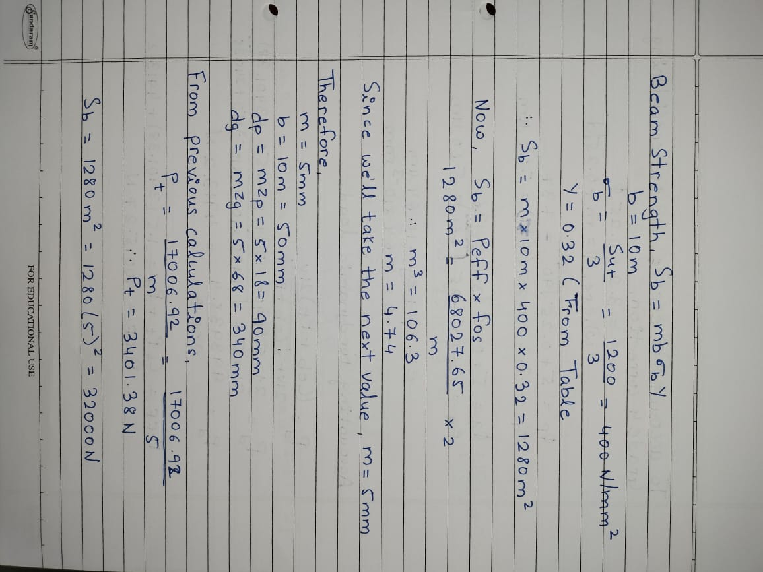

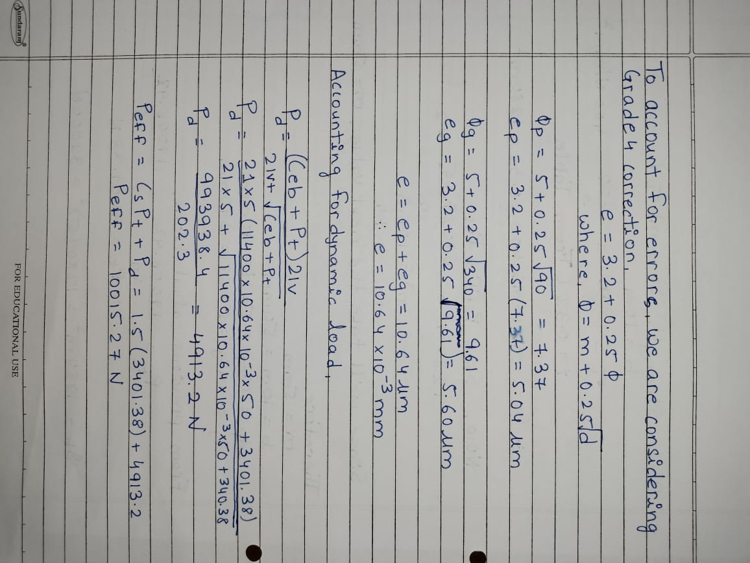

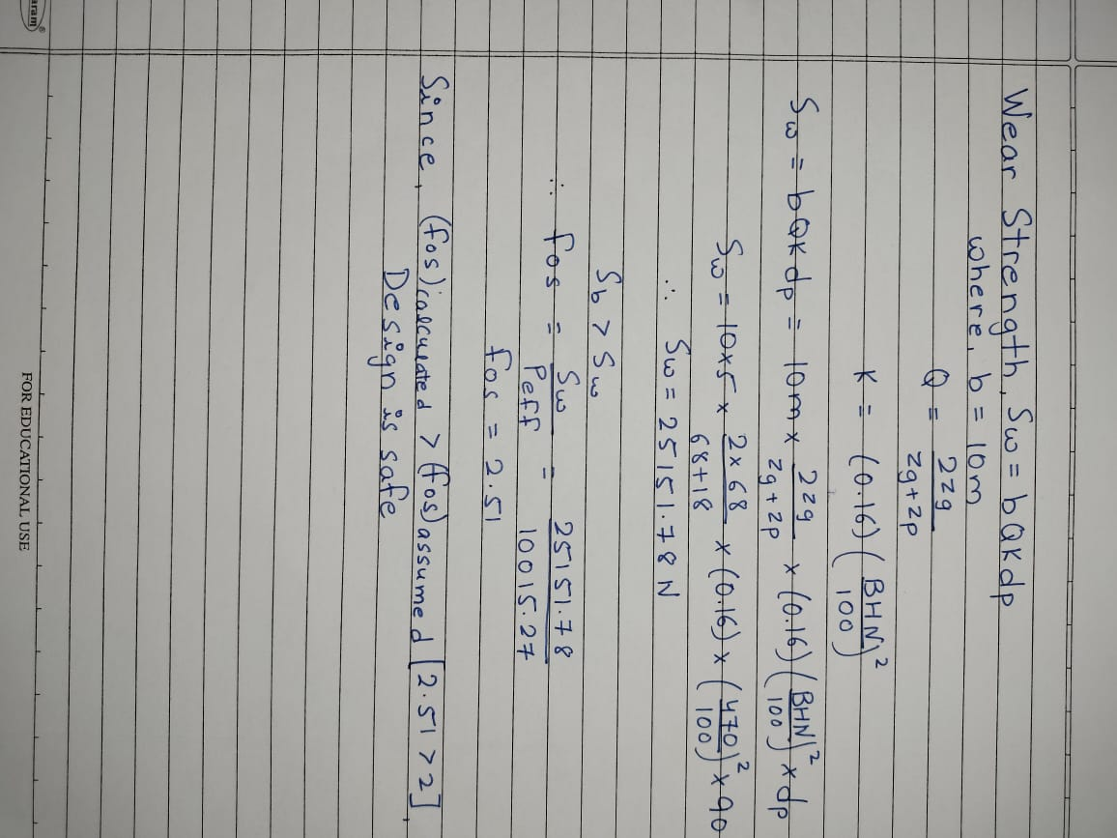

DIMENSIONS OF SPUR GEAR

Module, m_{n} | 5 mm
Face width, b | 50 mm
Teeth of pinion, z_{p} | 18
Teeth of gear, z_{g} | 68
Pitch circle Diameter of pinion, d_{p} | 90 mm
Pitch circle diameter of gear, d_{g} | 340 mm
Addendum, h_{a} | 5 mm
Dedendum, h_{a} | 6.25 mm
Tooth Thickness, t | 7.54 mm

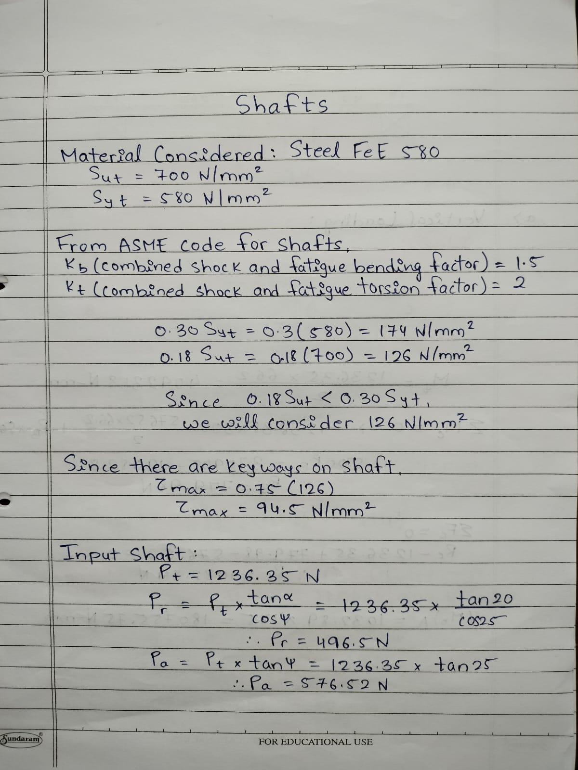

Calculations for Shafts were performed using ASME Code for Shaft Design.
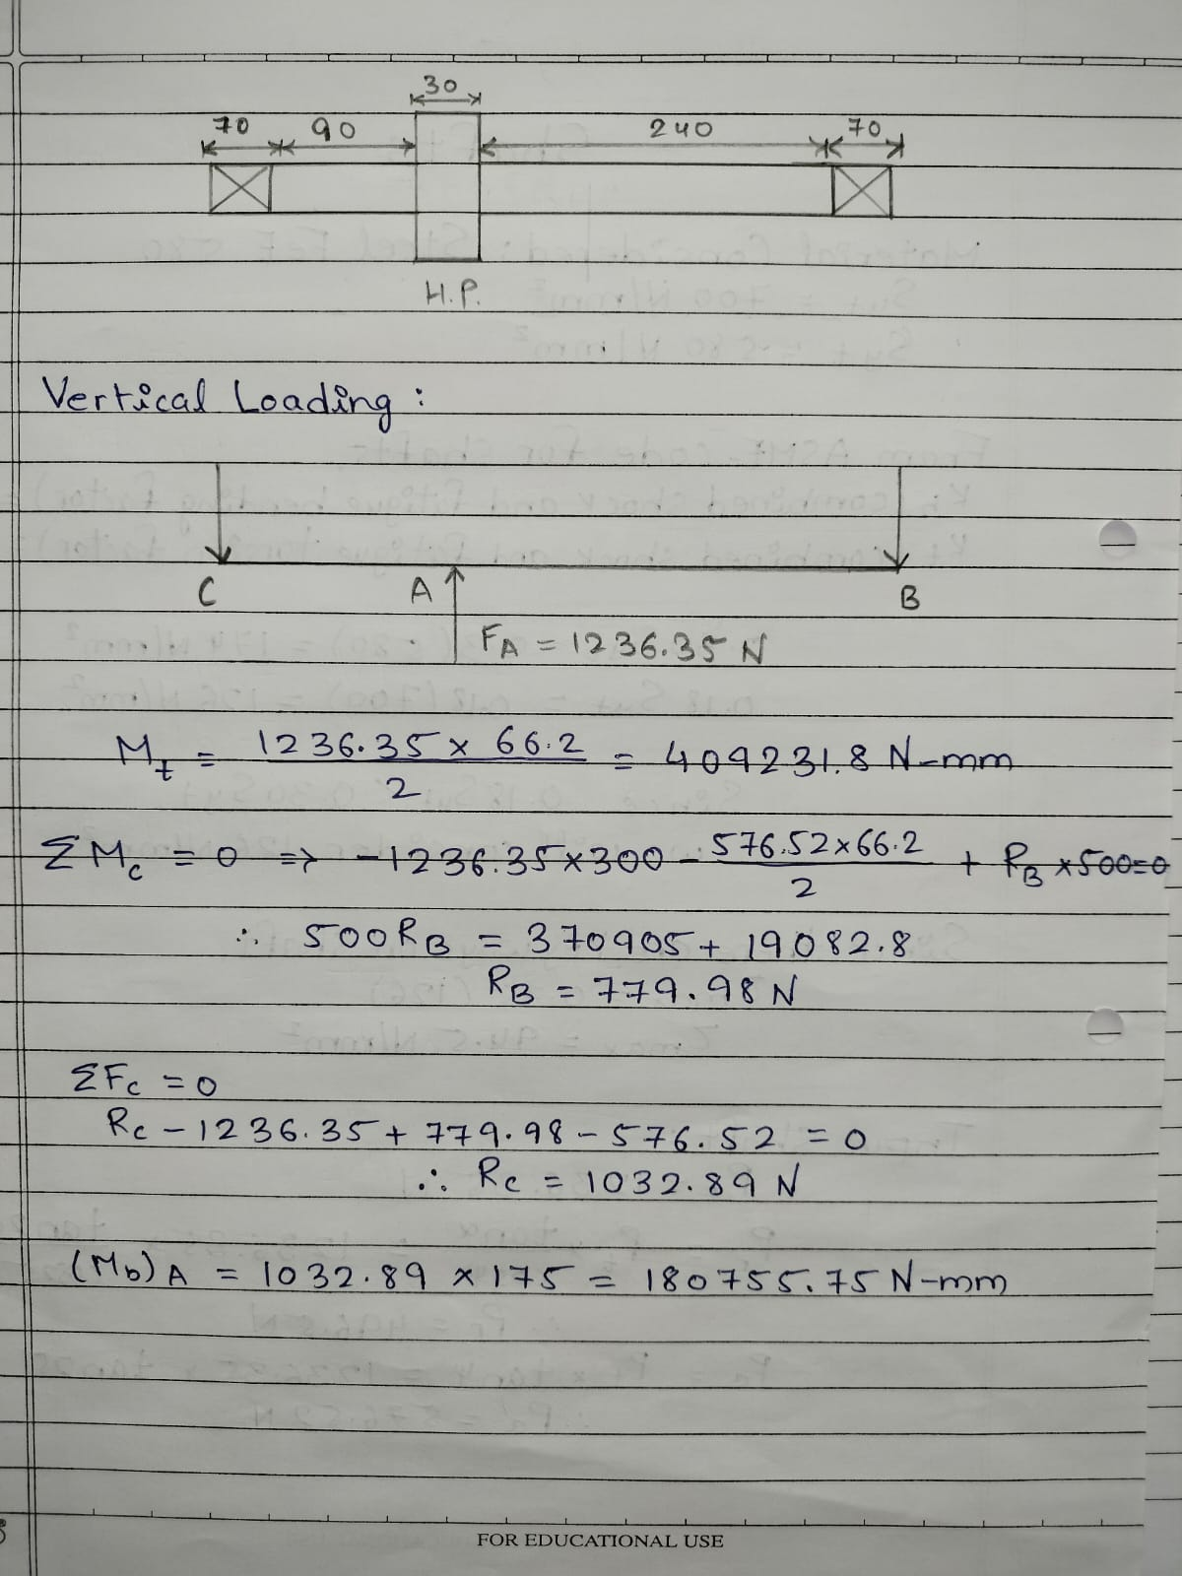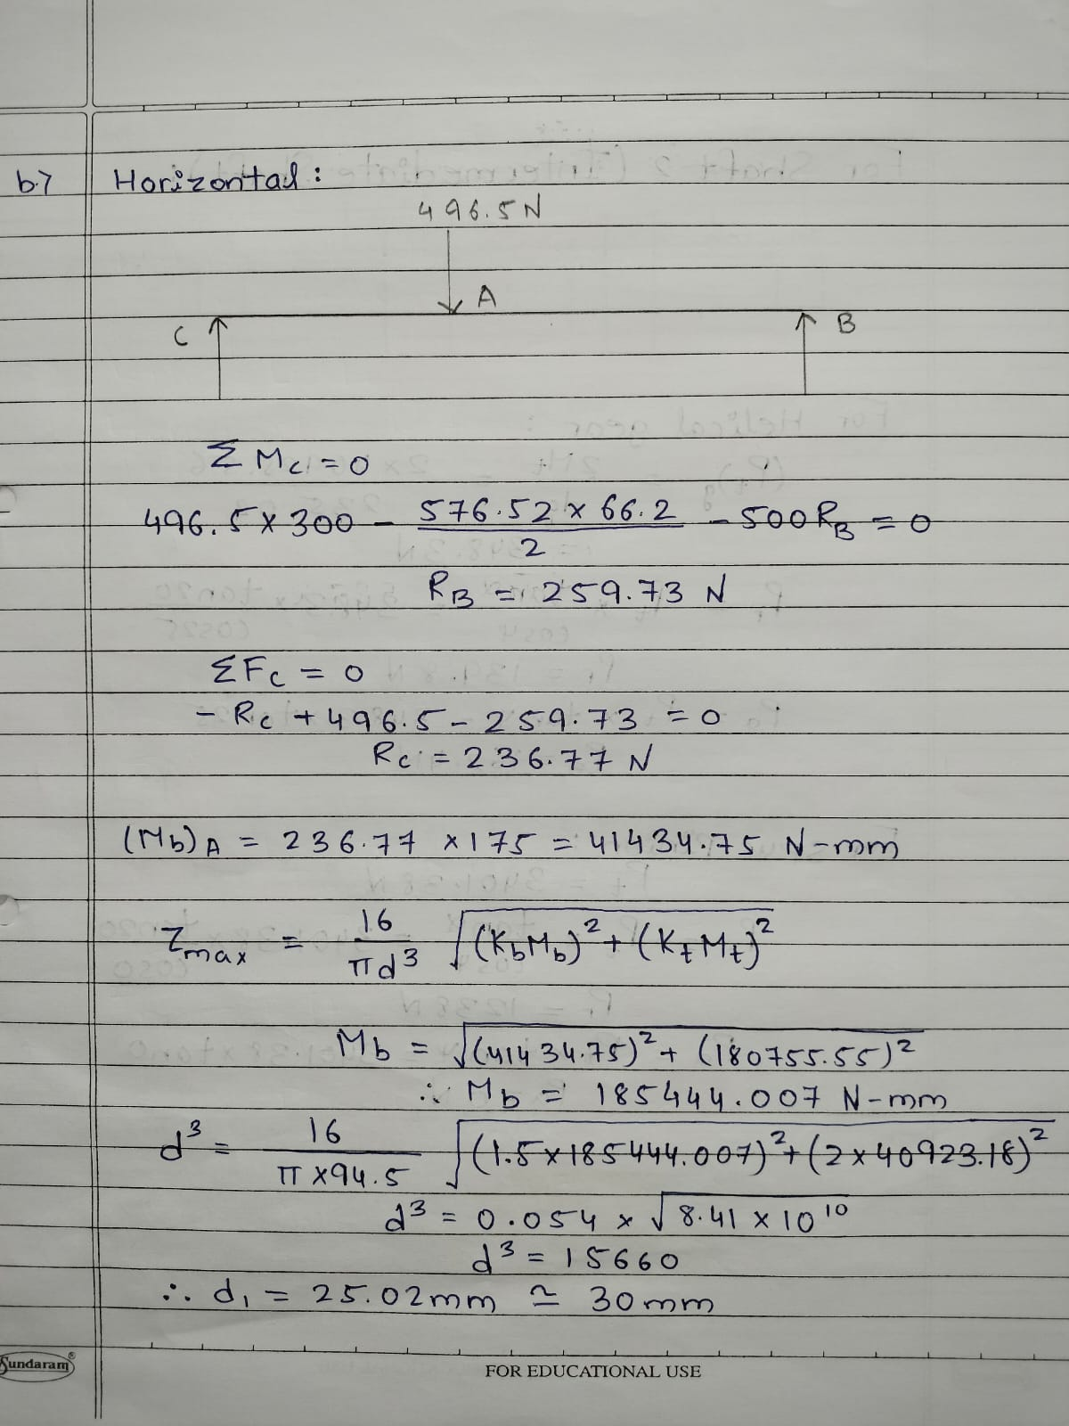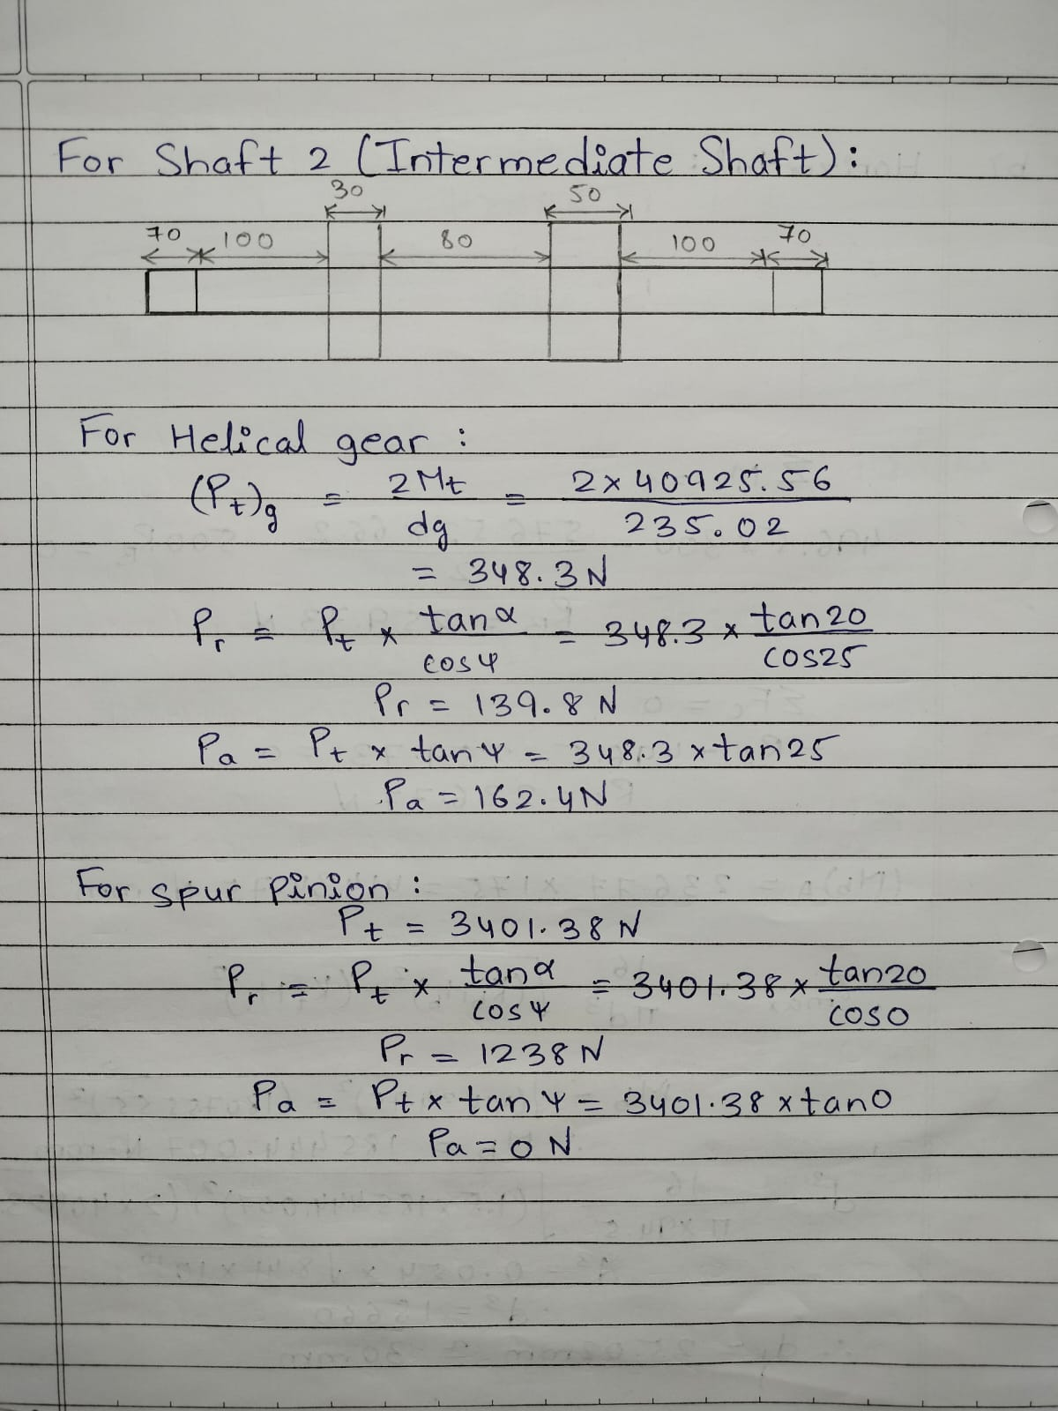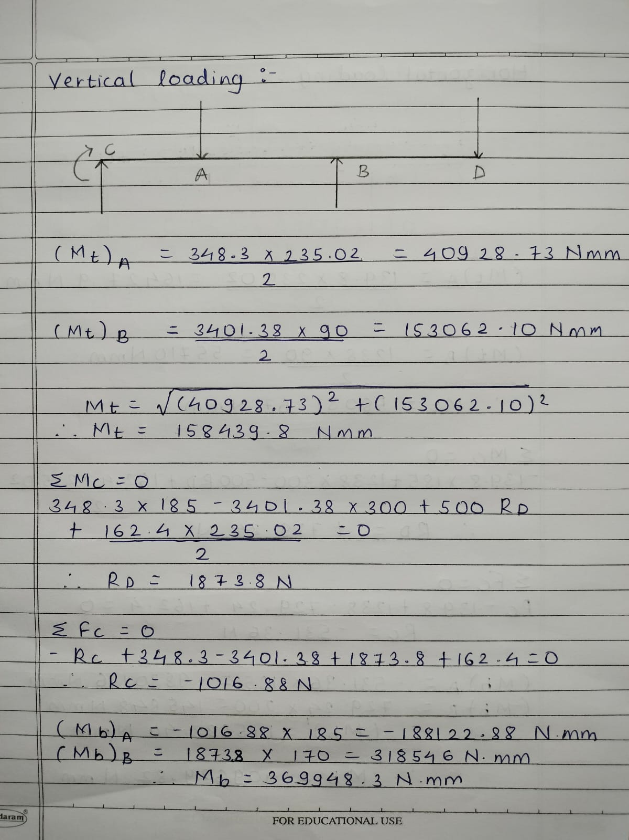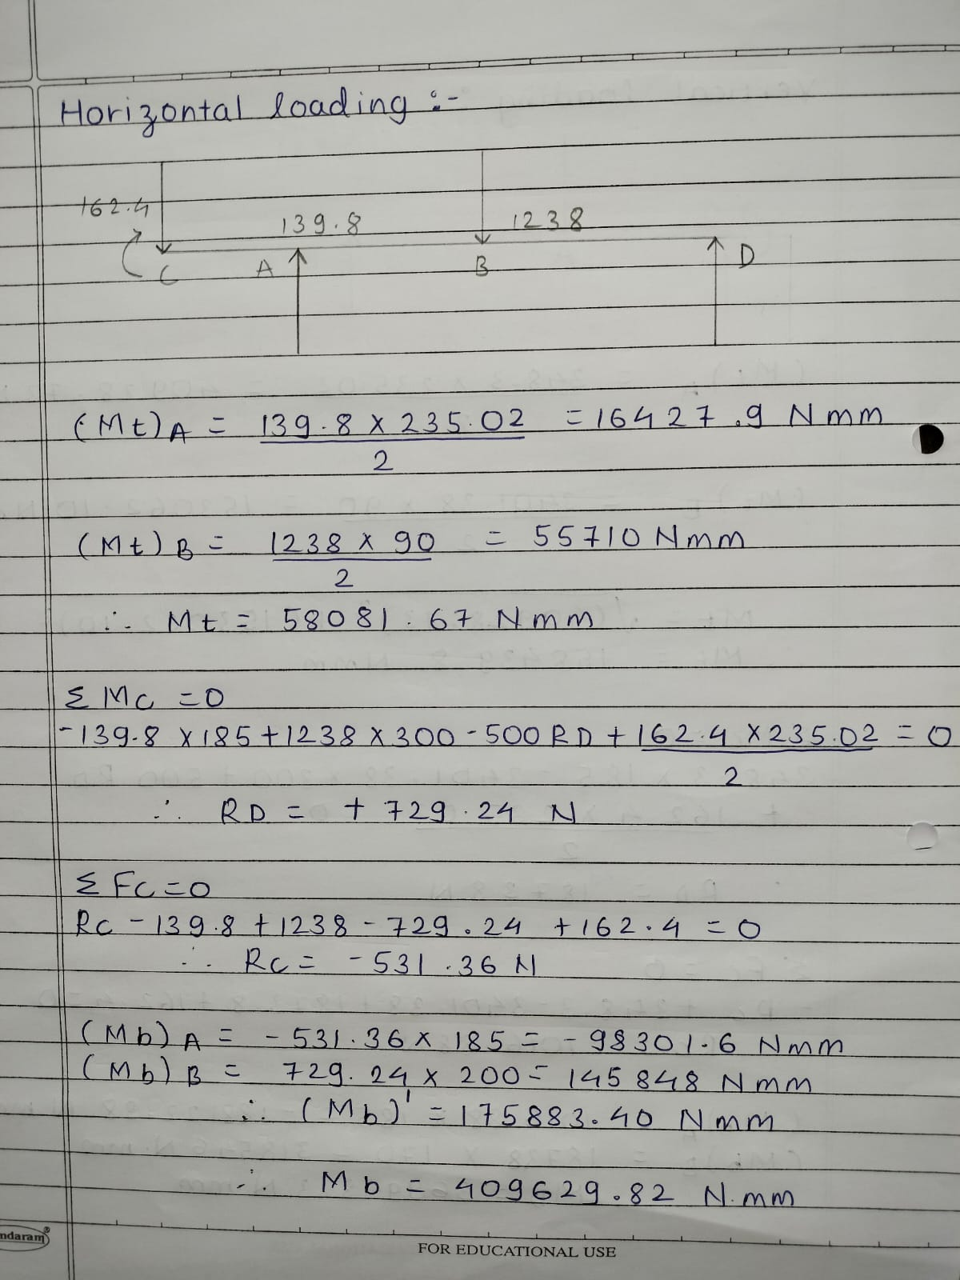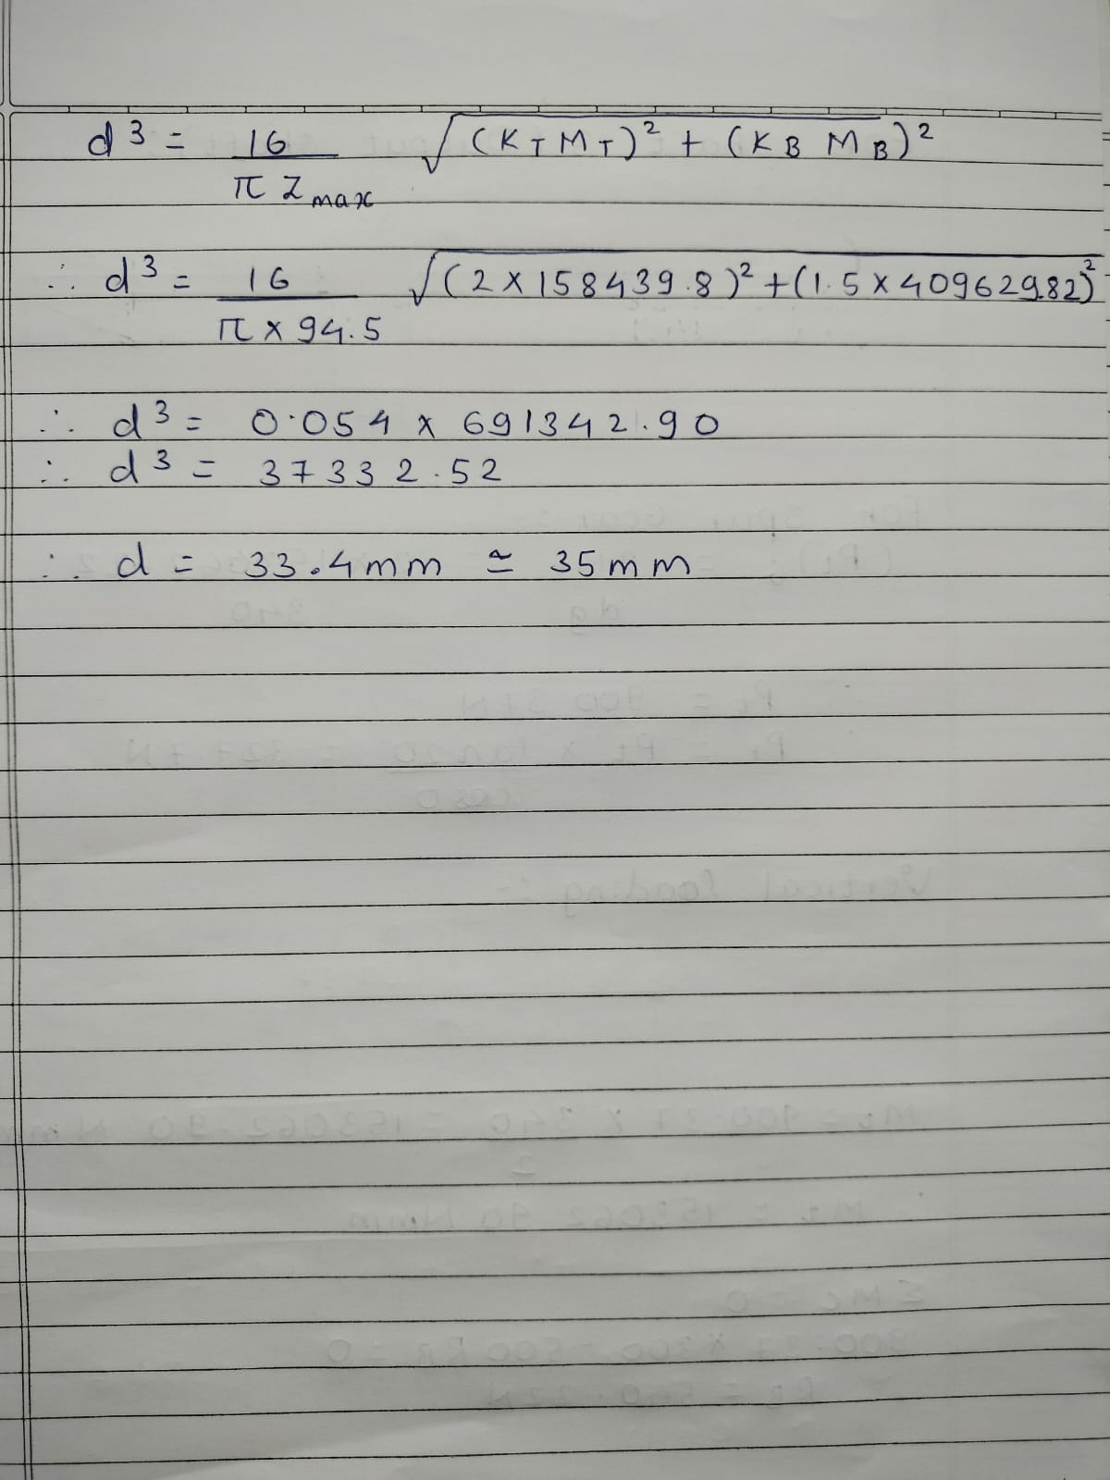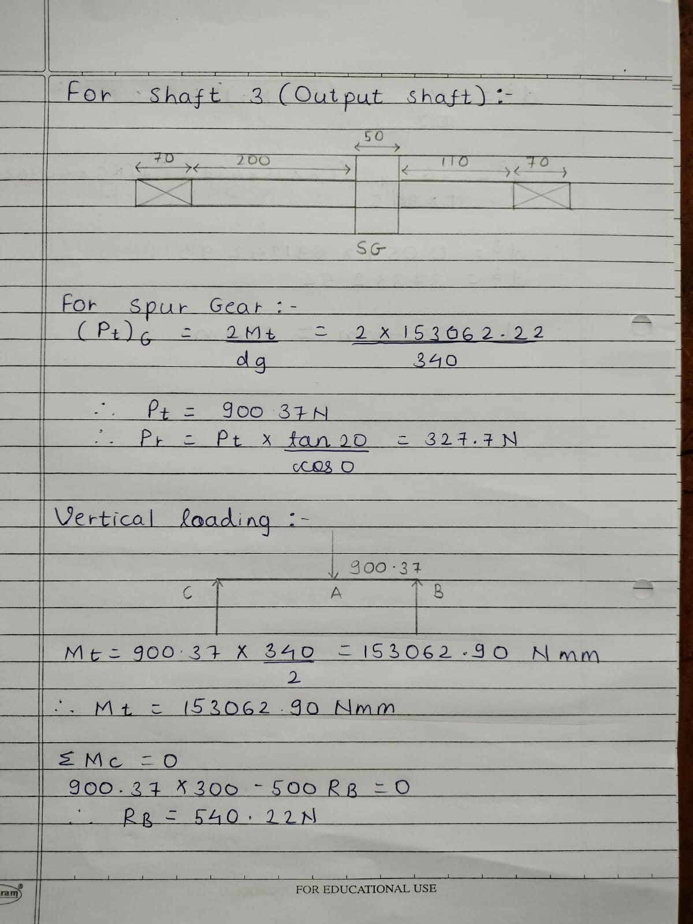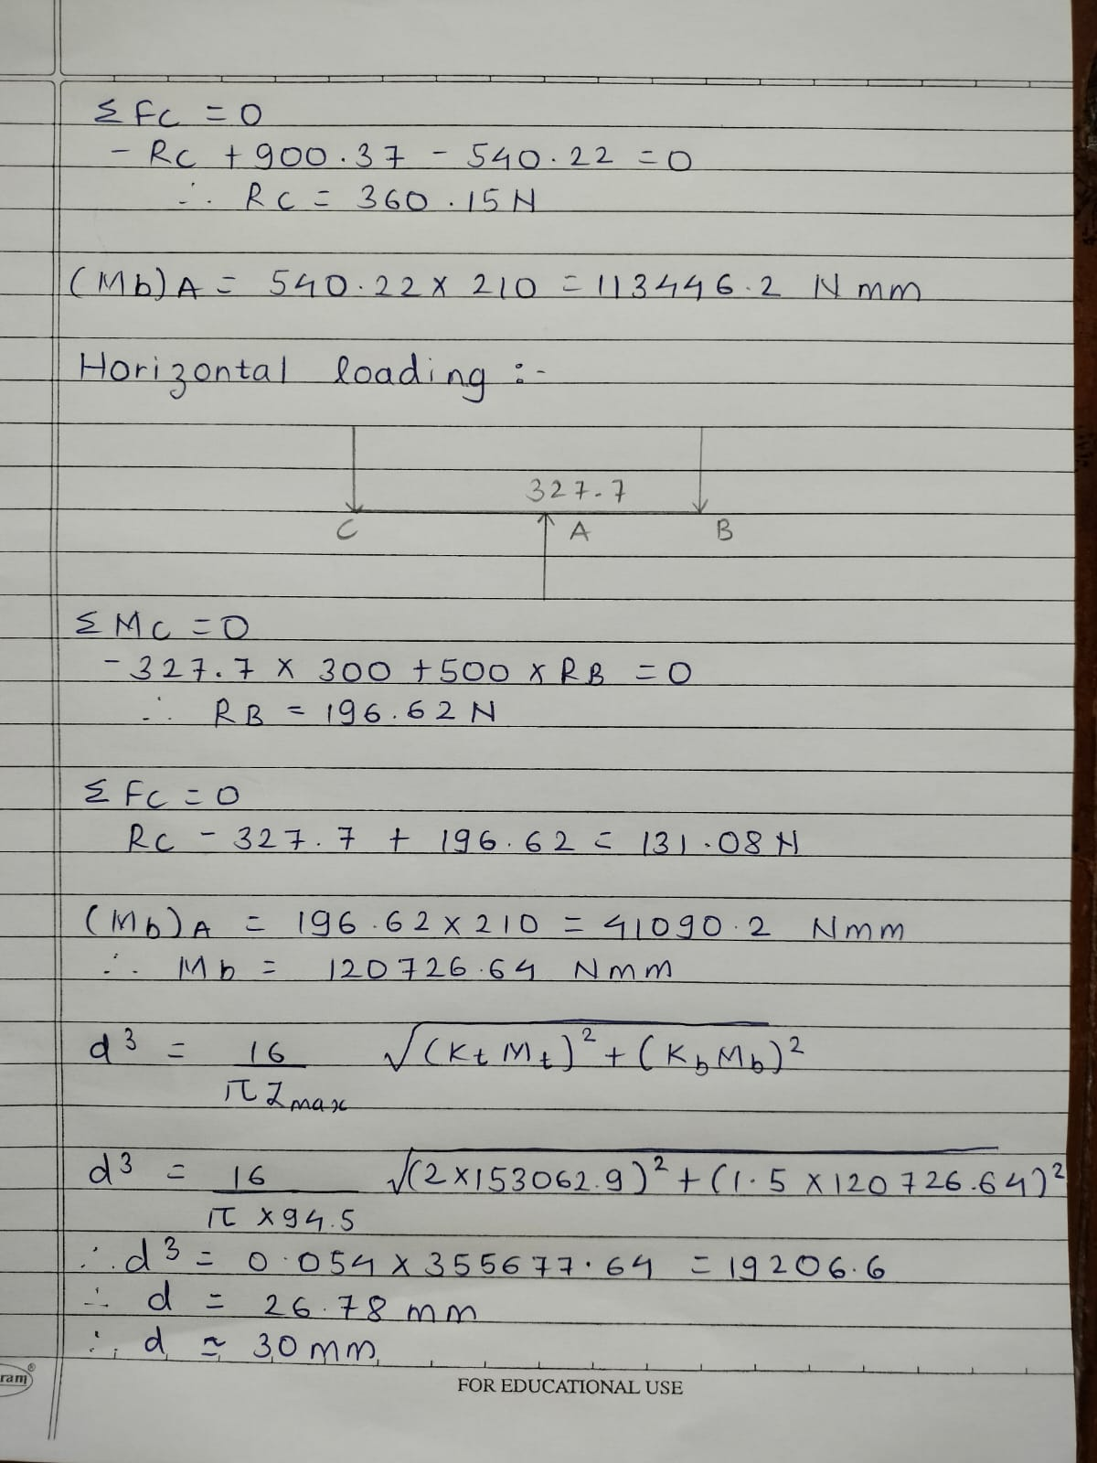

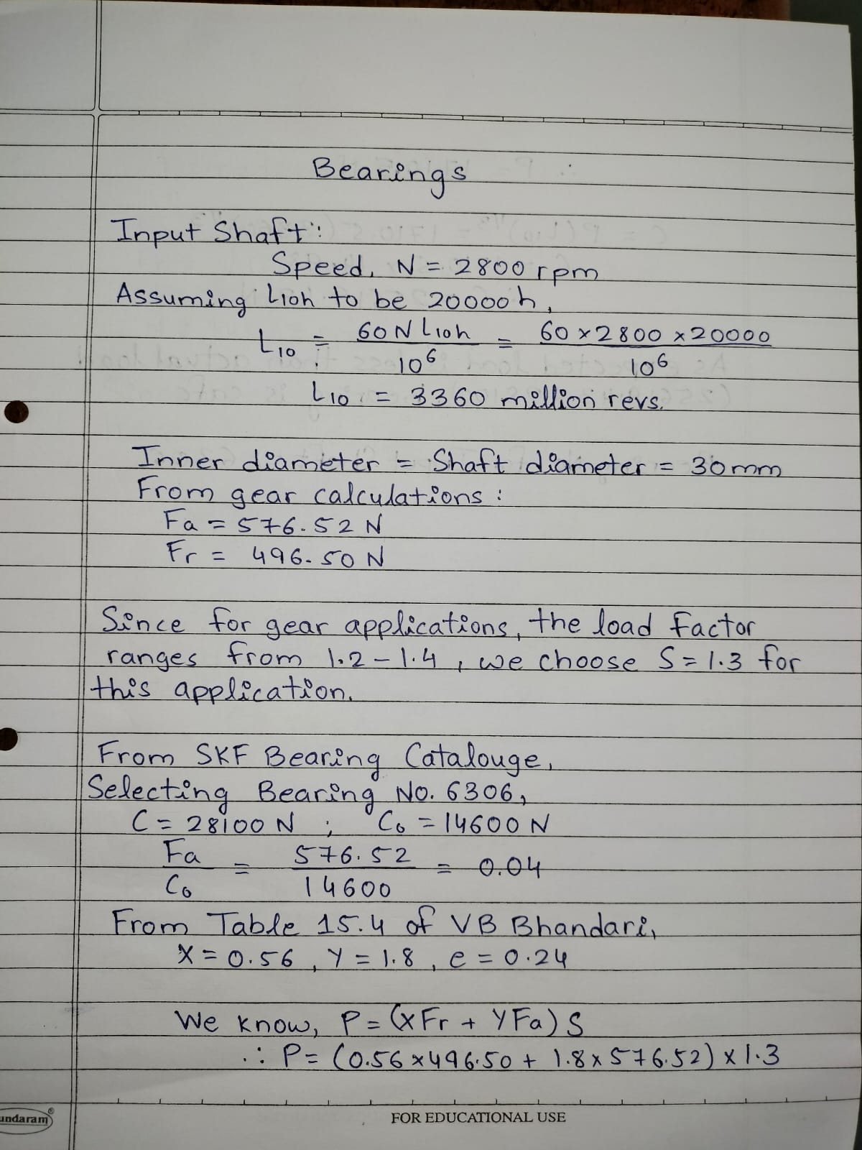

Co = Static Load Capacity; C= Dynamic Load Capacity.

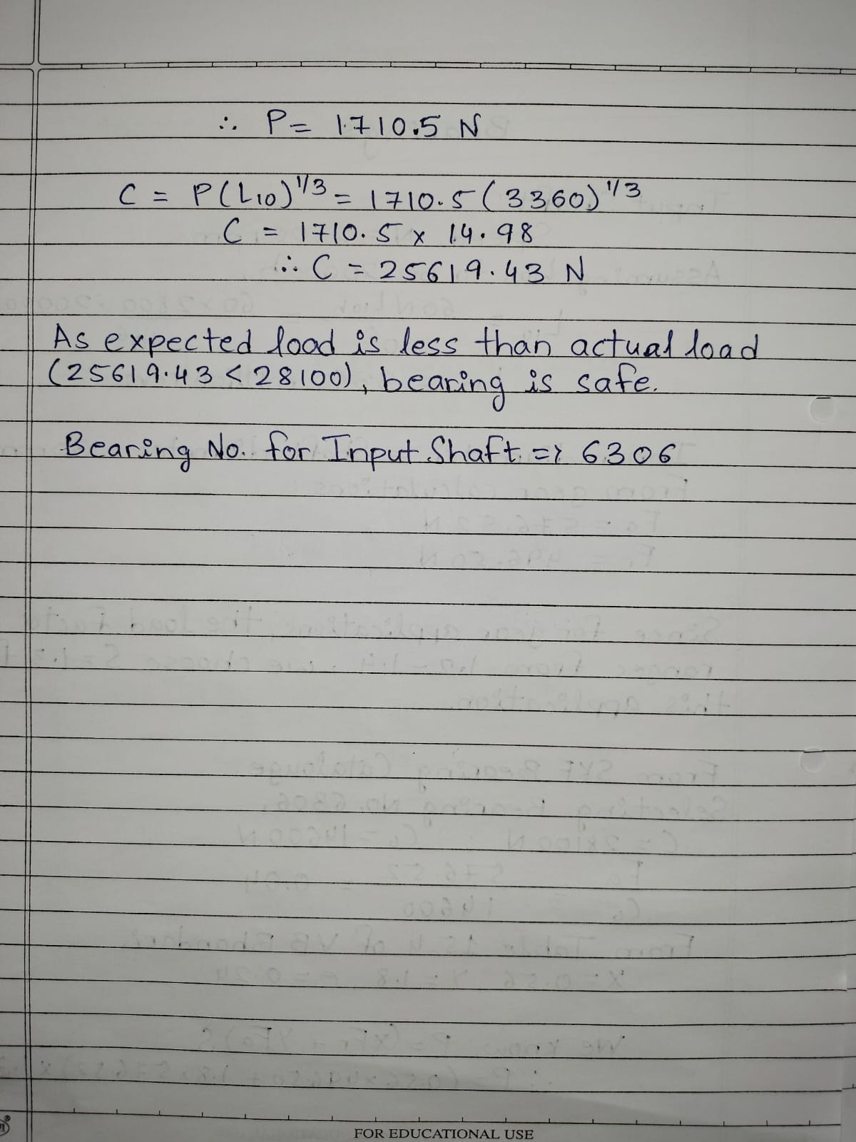
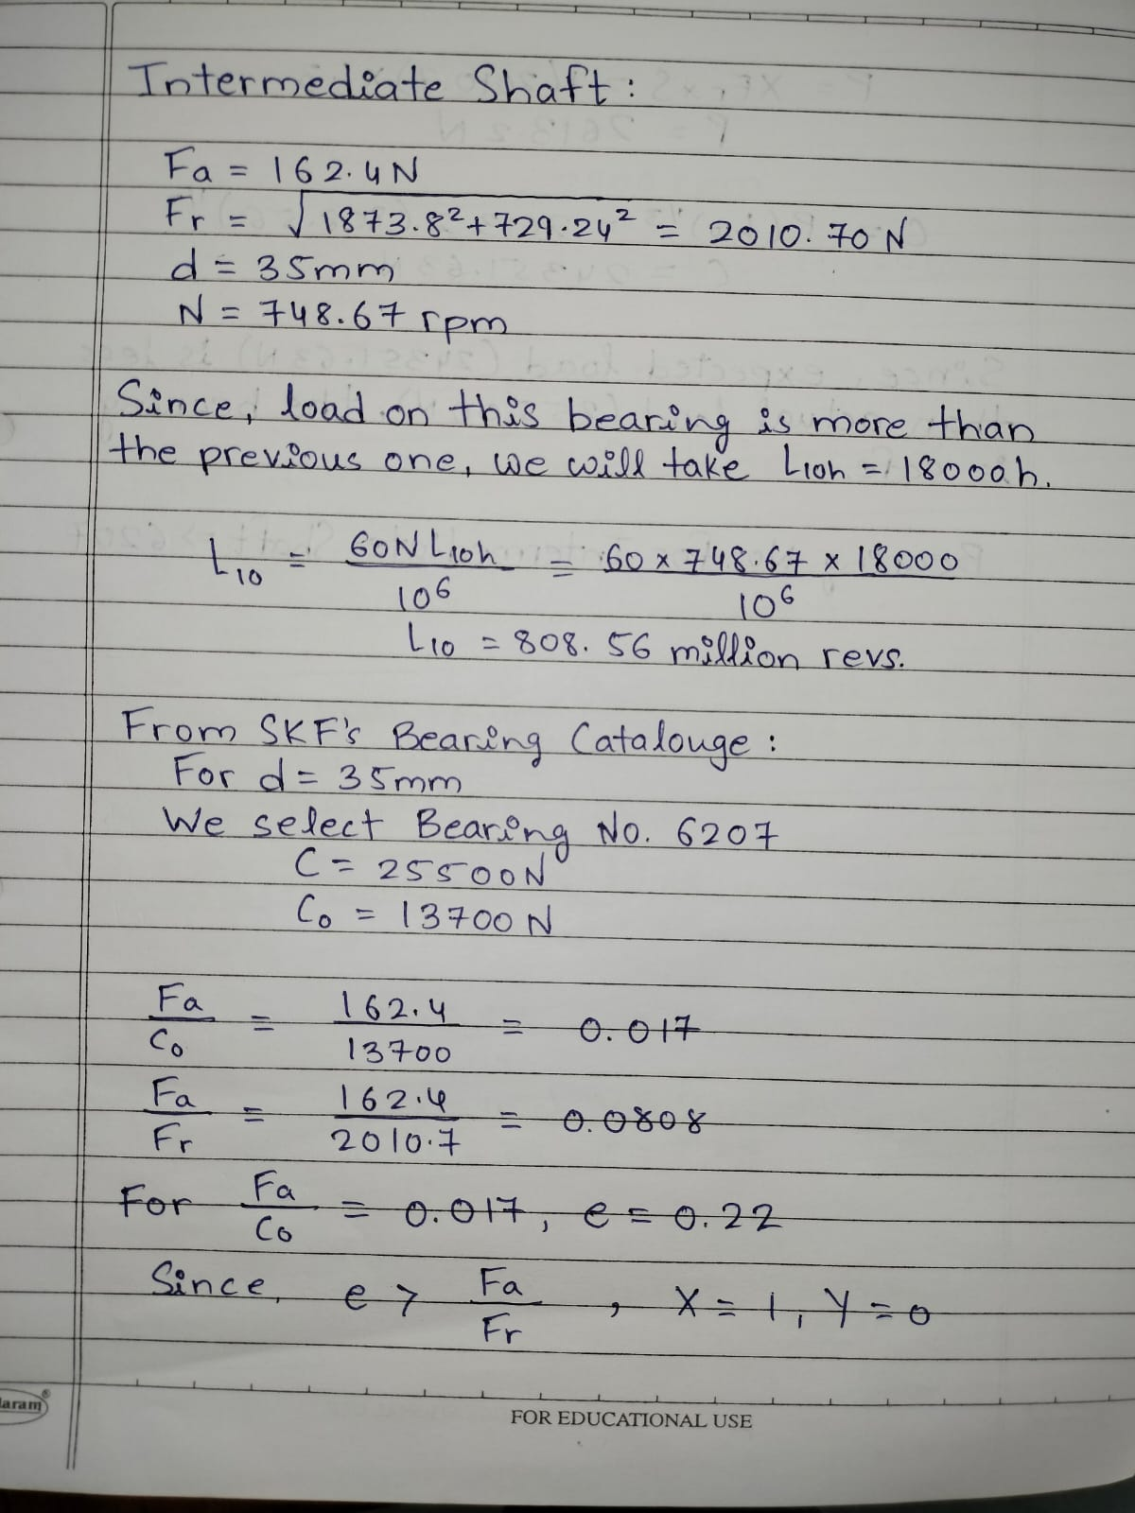
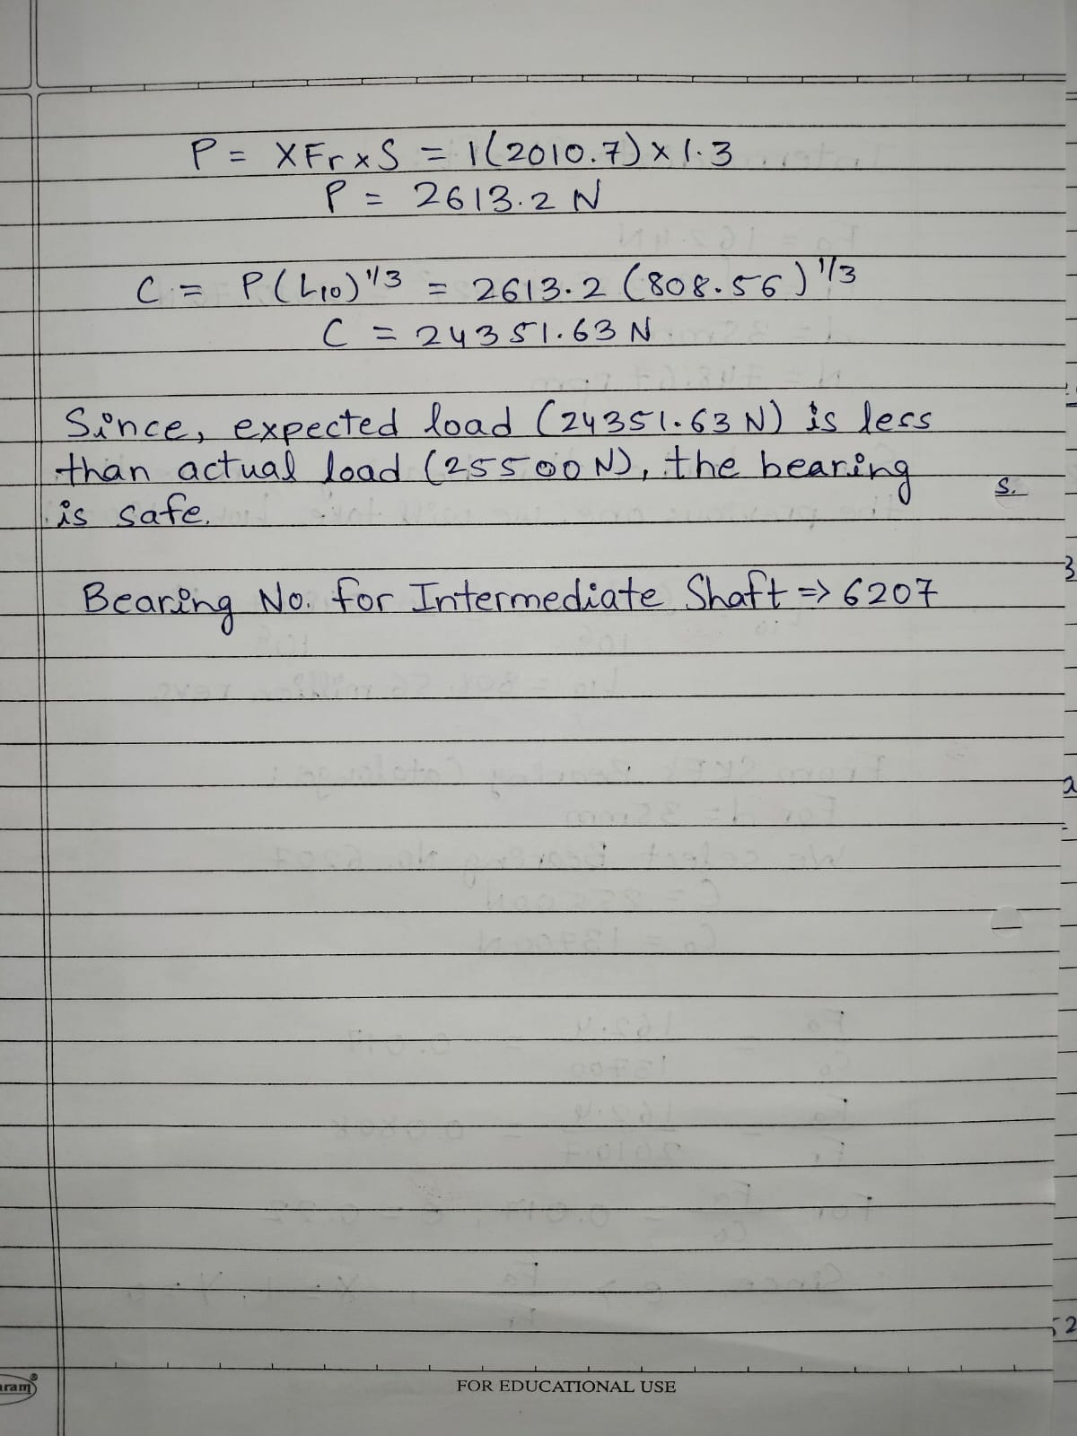

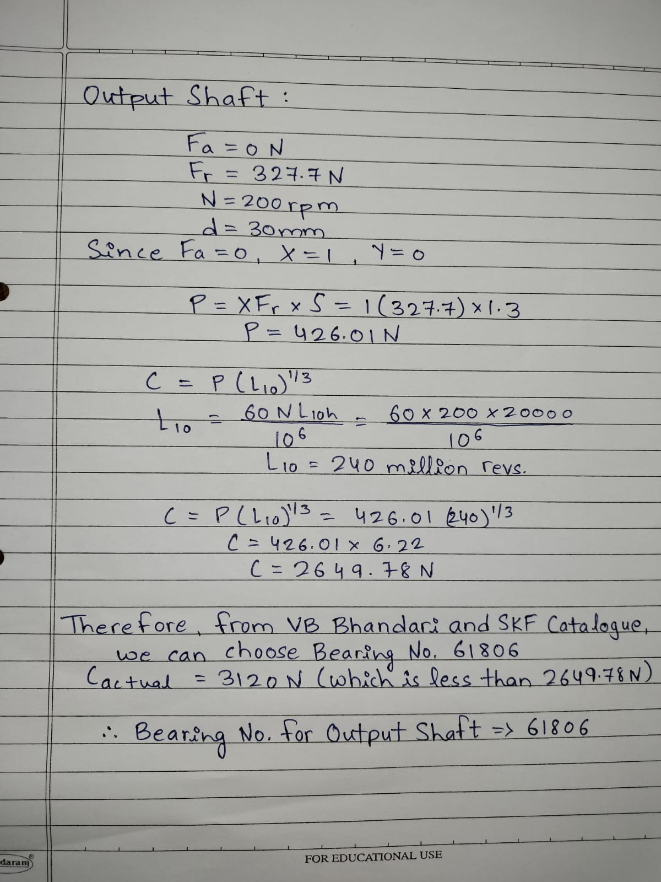
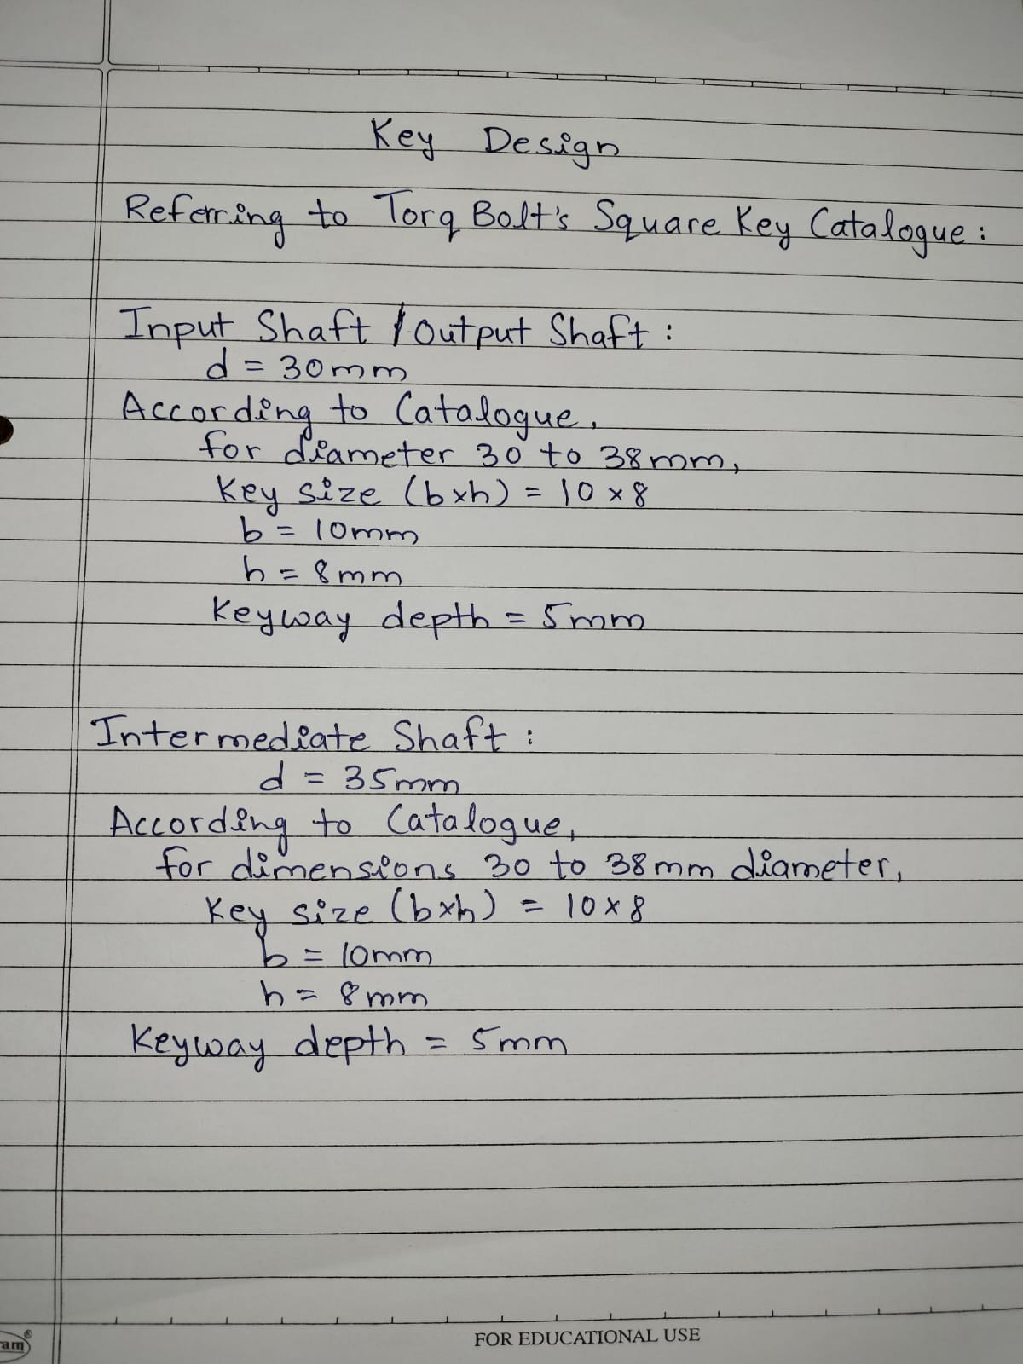

LUBRICATION

Lubrication in a two-stage gearbox is crucial to ensure smooth operation, reduce friction, dissipate heat, and protect the gears and bearings from wear. The appropriate lubrication strategy depends on factors such as gear type, speed, load, and operating conditions. Here are some general guidelines for lubricating a two-stage gearbox:

1. Oil Selection:
Viscosity: Choose an oil with the appropriate viscosity for the operating conditions. Viscosity is critical for forming an effective lubricating film between gear teeth and bearings.
Temperature Consideration: Consider the expected temperature range during operation and select an oil with a viscosity that remains within the desired range.

2. Oil Level and Fill:
Proper Fill Level: Maintain the gearbox oil at the recommended fill level to ensure proper lubrication and cooling.
Breather and Ventilation: Ensure proper ventilation through breathers and vents to prevent pressure buildup inside the gearbox.

3. Oil Change Intervals:
Regular Monitoring: Monitor the condition of the lubricant regularly, and schedule oil changes based on the gearbox manufacturer's recommendations or as indicated by oil analysis results.
Contamination Control: Change the oil if contamination levels (such as particles, water, or other impurities) exceed acceptable limits.

4. Lubrication System:
Splash Lubrication: In some gearboxes, lubrication is achieved through splash lubrication, where the gears dip into the oil sump and transfer lubricant during operation.
Circulating Systems: For more demanding applications, consider circulating systems with pumps to ensure a continuous flow of oil to critical components.

5. Additives:
Extreme Pressure (EP) Additives: If the gearbox operates under high loads, consider using oils with EP additives to protect gears from extreme pressure conditions.
Anti-Wear Additives: Additives such as anti-wear agents can enhance the protection of bearings and other critical components.

6. Seals and Gaskets:
Ensure Sealing Integrity: Check and replace seals and gaskets as needed to prevent oil leaks and contamination.

7. Operating Conditions:
Temperature Control: Maintain the gearbox within recommended temperature ranges to avoid excessive heat, which can degrade the oil and reduce its effectiveness.

8. Manufacturer Recommendations:
Follow Guidelines: Always follow the gearbox manufacturer's recommendations for lubrication, including oil type, fill level, and change intervals.

9. Monitoring and Analysis:
Oil Analysis: Periodically perform oil analysis to assess the lubricant's condition, identify potential issues, and determine the need for maintenance.
Proper lubrication maintenance is essential for the longevity and efficiency of a two-stage gearbox. Always refer to the gearbox manufacturer's guidelines and consult with lubrication experts to tailor the lubrication strategy to the specific requirements of your gearbox and operating conditions.

Krytox™ high-performance lubricants are designed to protect high-temperature gearbox gears, bearings, and seals. Krytox™ fluoropolymer greases will not oxidize, even in applications with operating temperatures up to approximately 270 °C (518 °F).
Krytox™ gearbox greases and oils help eliminate bearing and gear failures resulting from lubricant oxidation, which leads to extended seal and gearbox life. In many applications, Krytox™ gearbox lubricants last the life of the gearbox, greatly reducing or eliminating the need for maintenance and relubrication.

CAD MODELS

1. Spur pinion

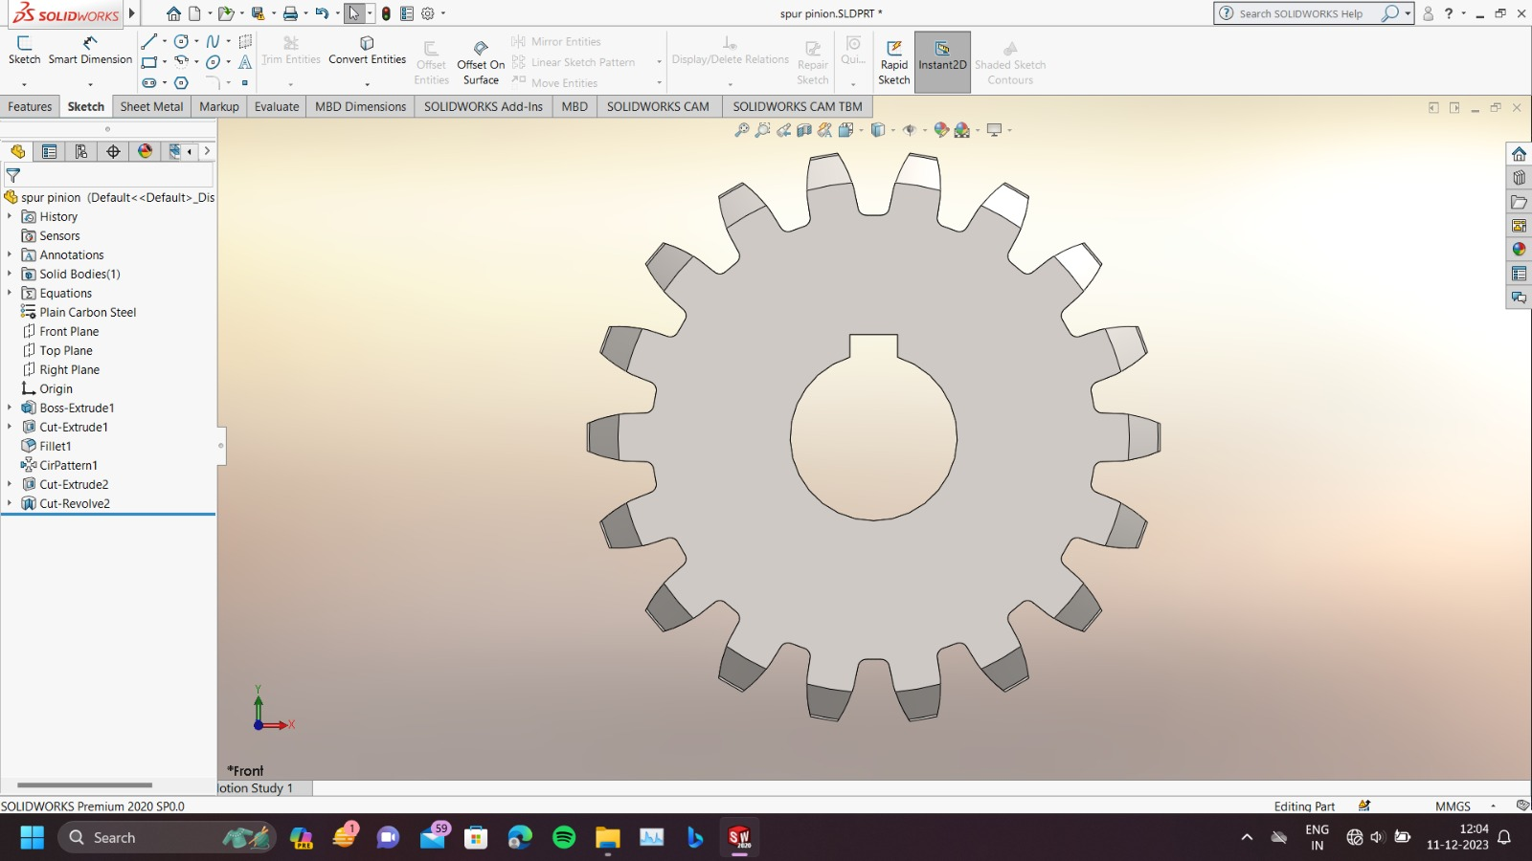
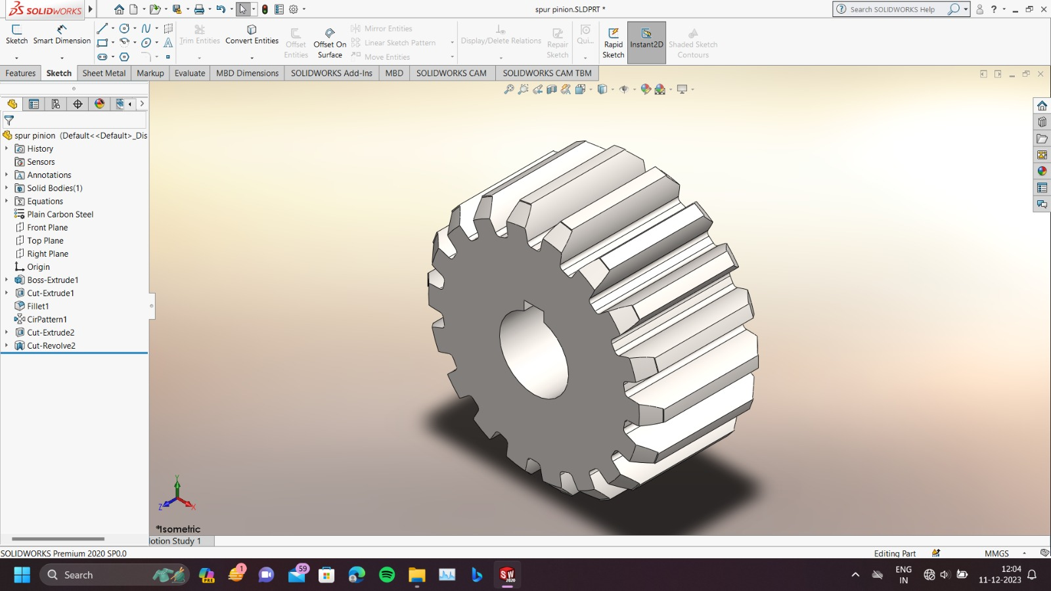

2. Spur Gear
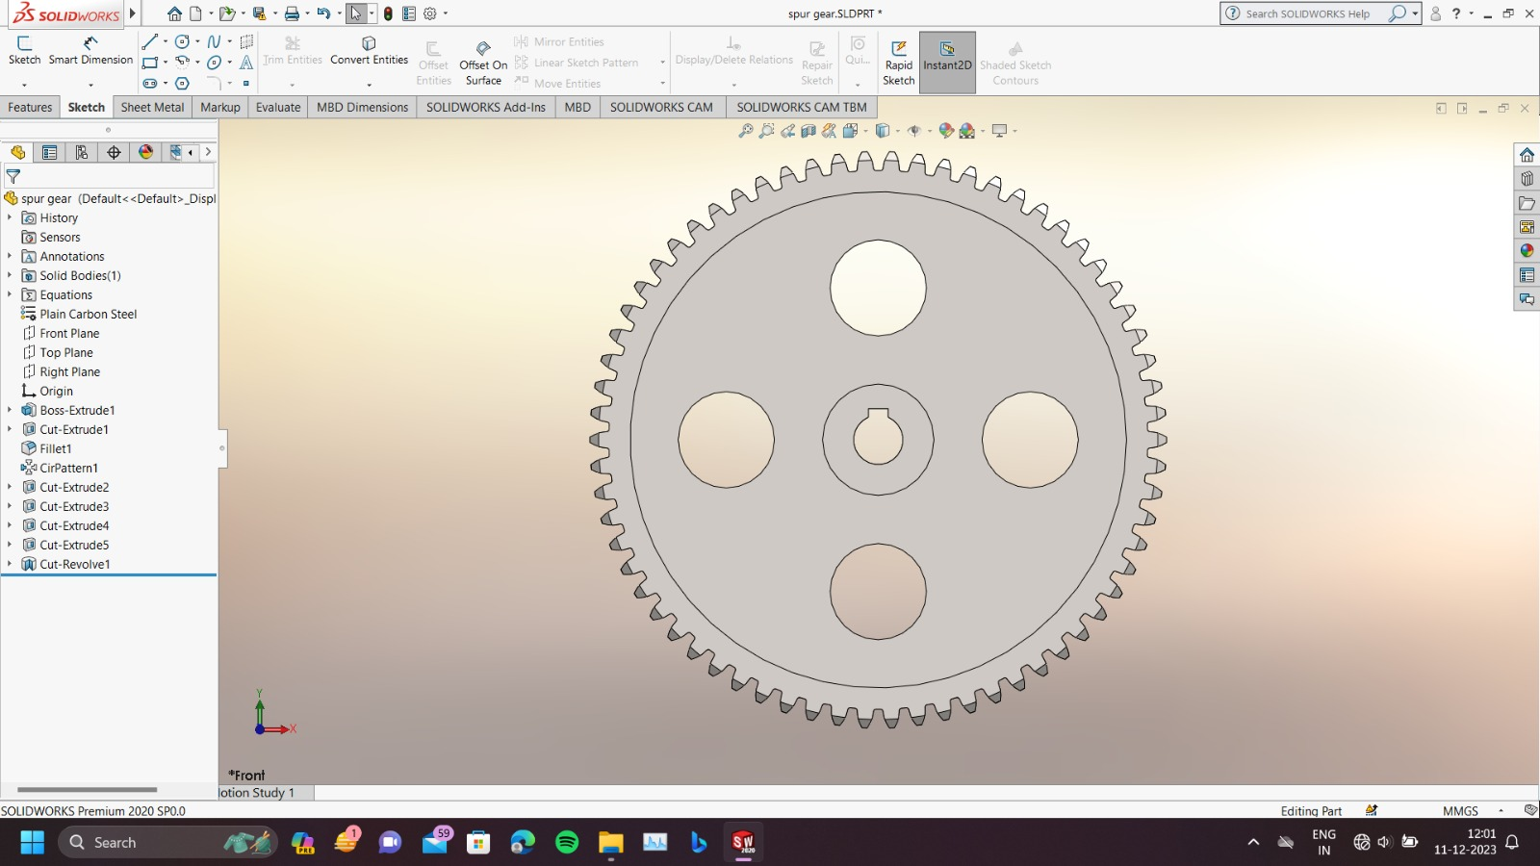
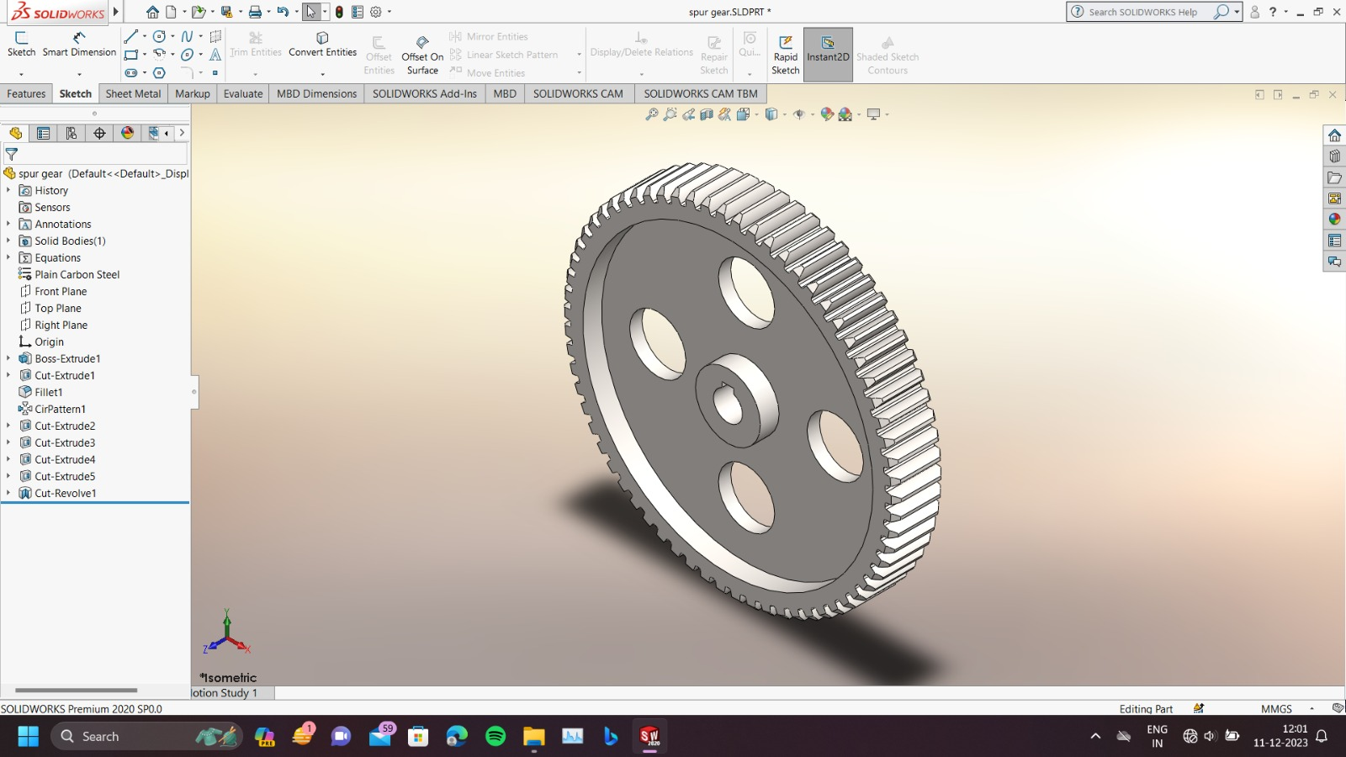

3. Helical Pinion

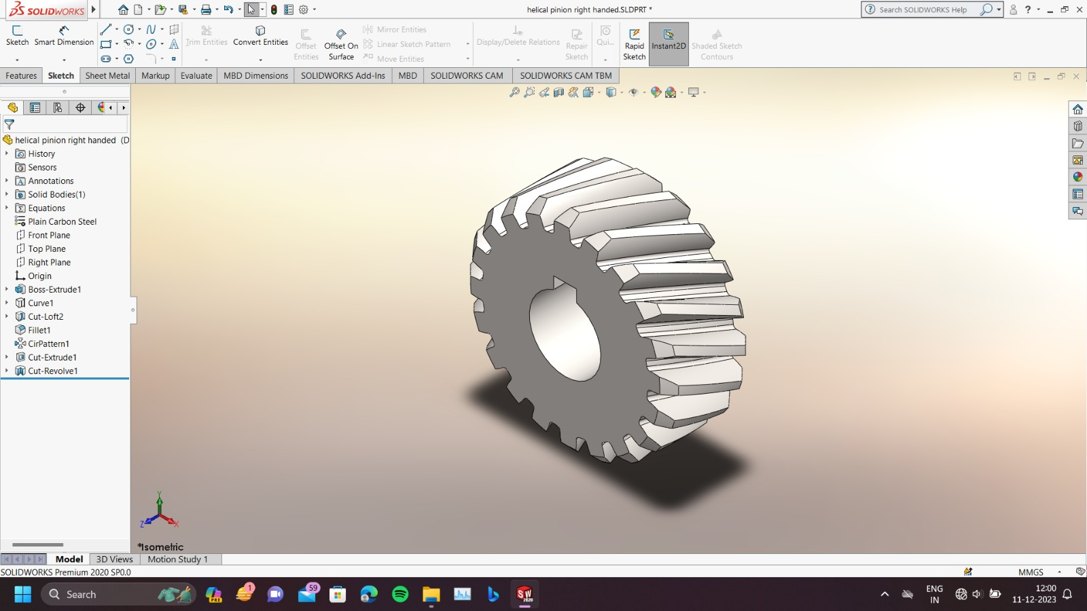

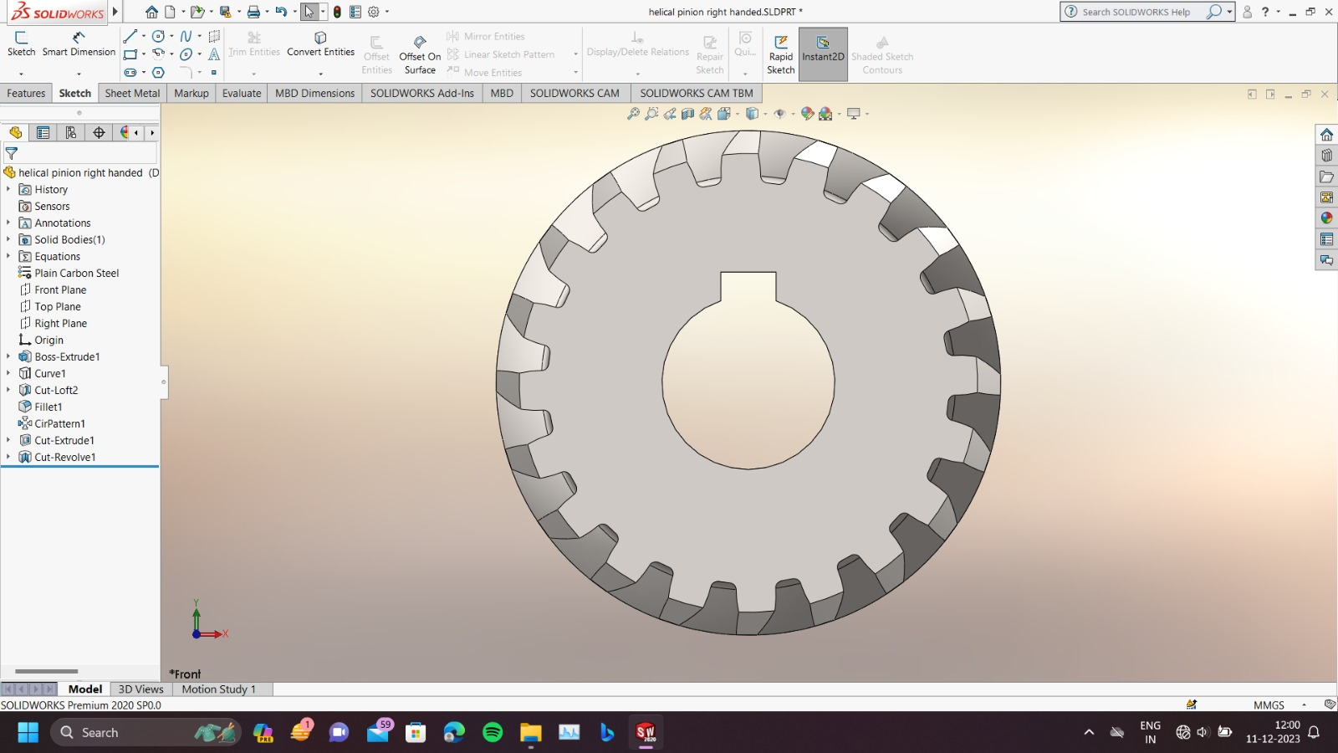

4. Helical Gear

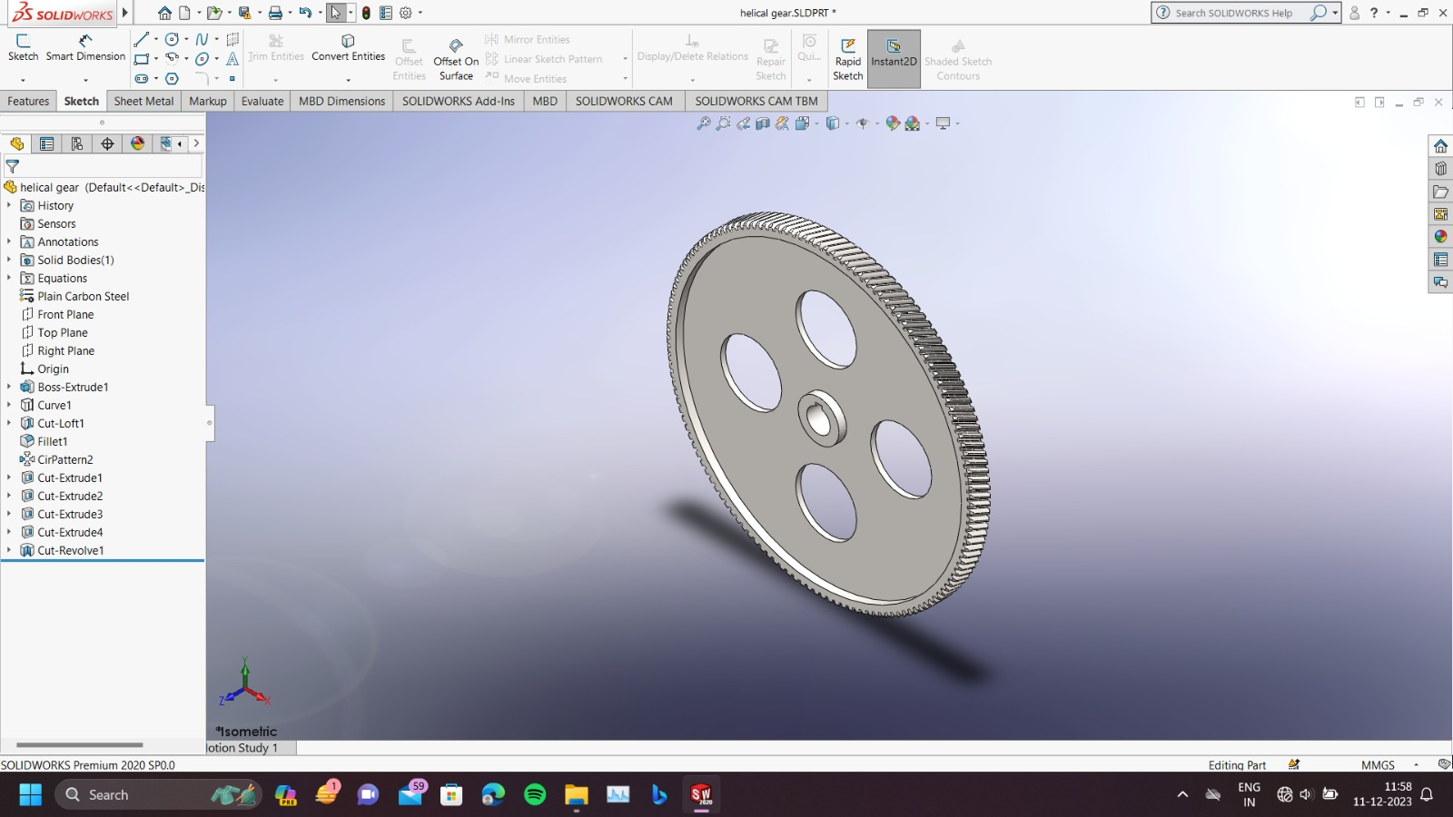

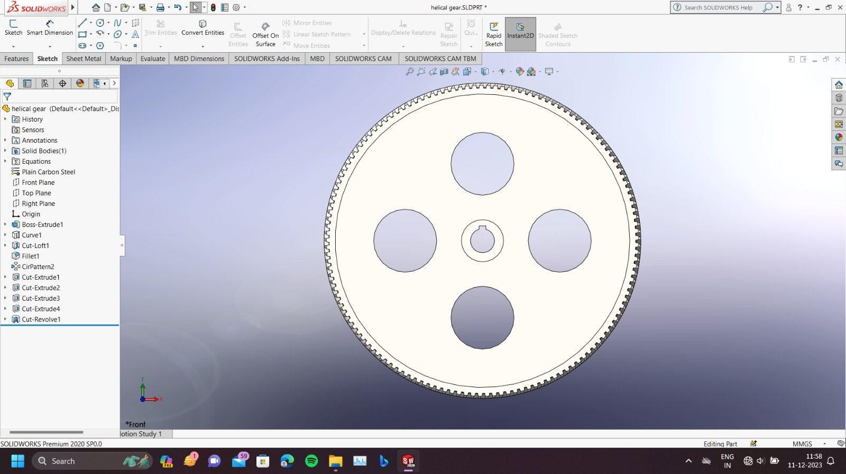

5. Intermediate Shaft (Shaft 2)

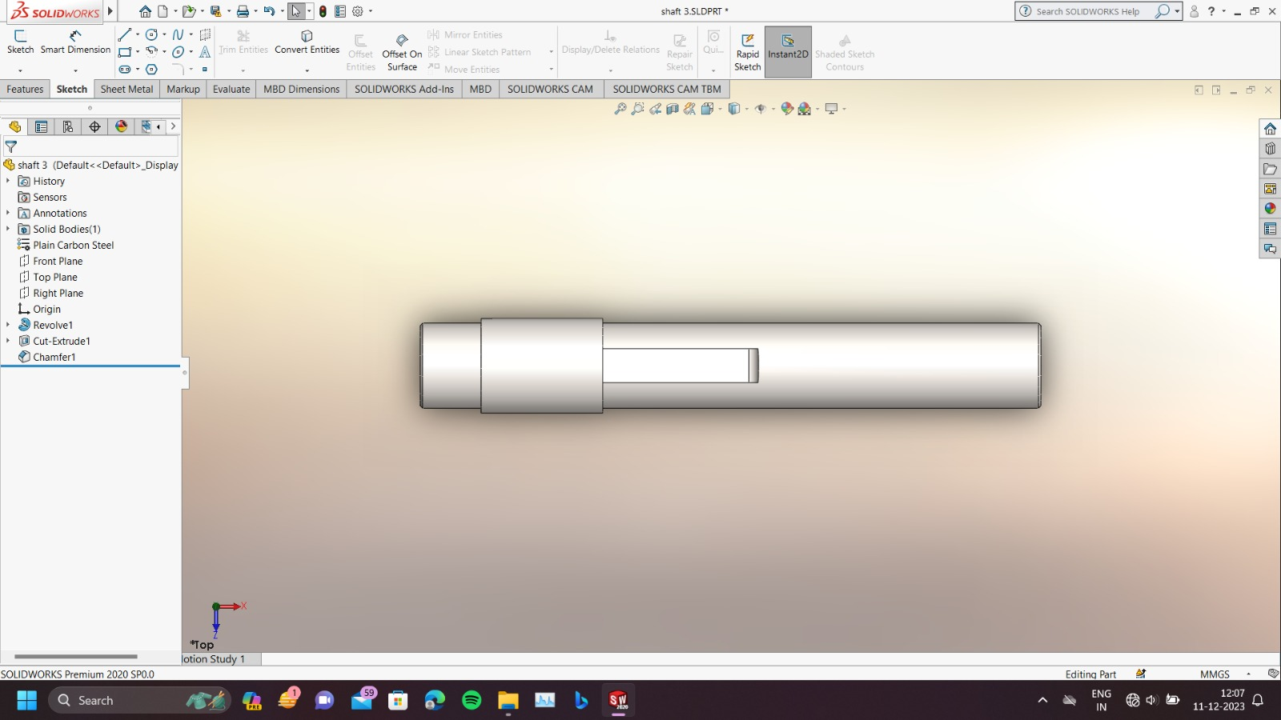
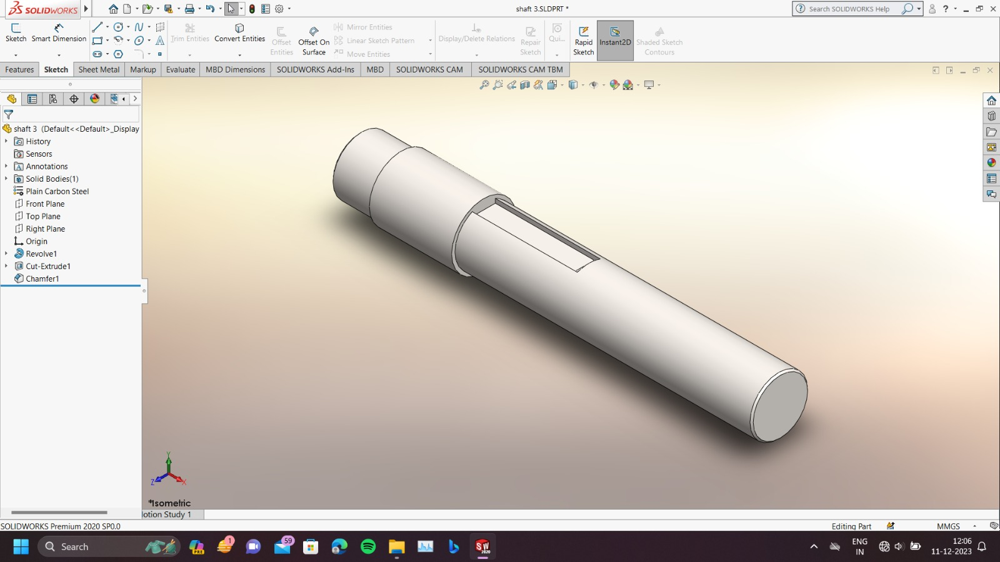

6. Shaft 1,3

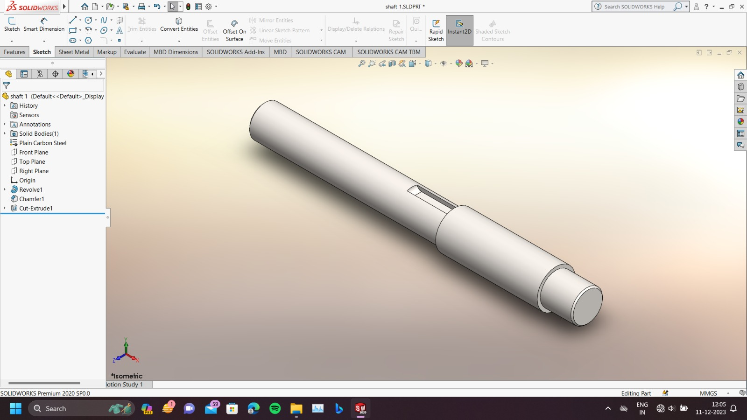

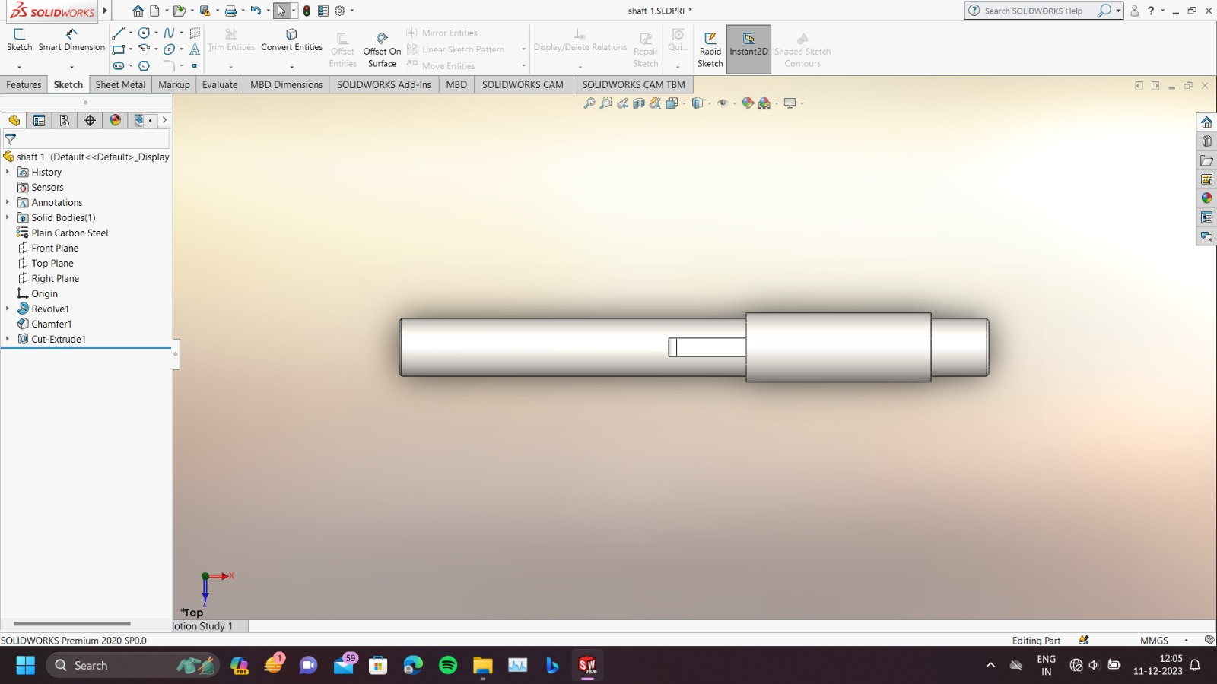

8. Casing

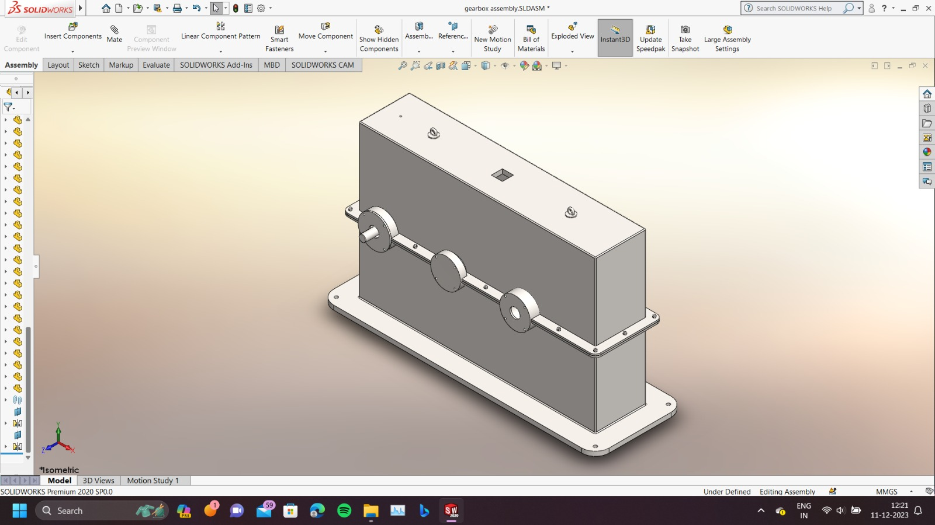
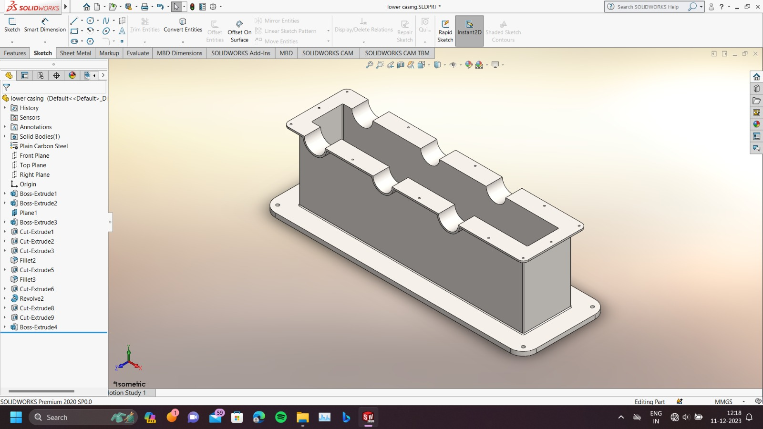

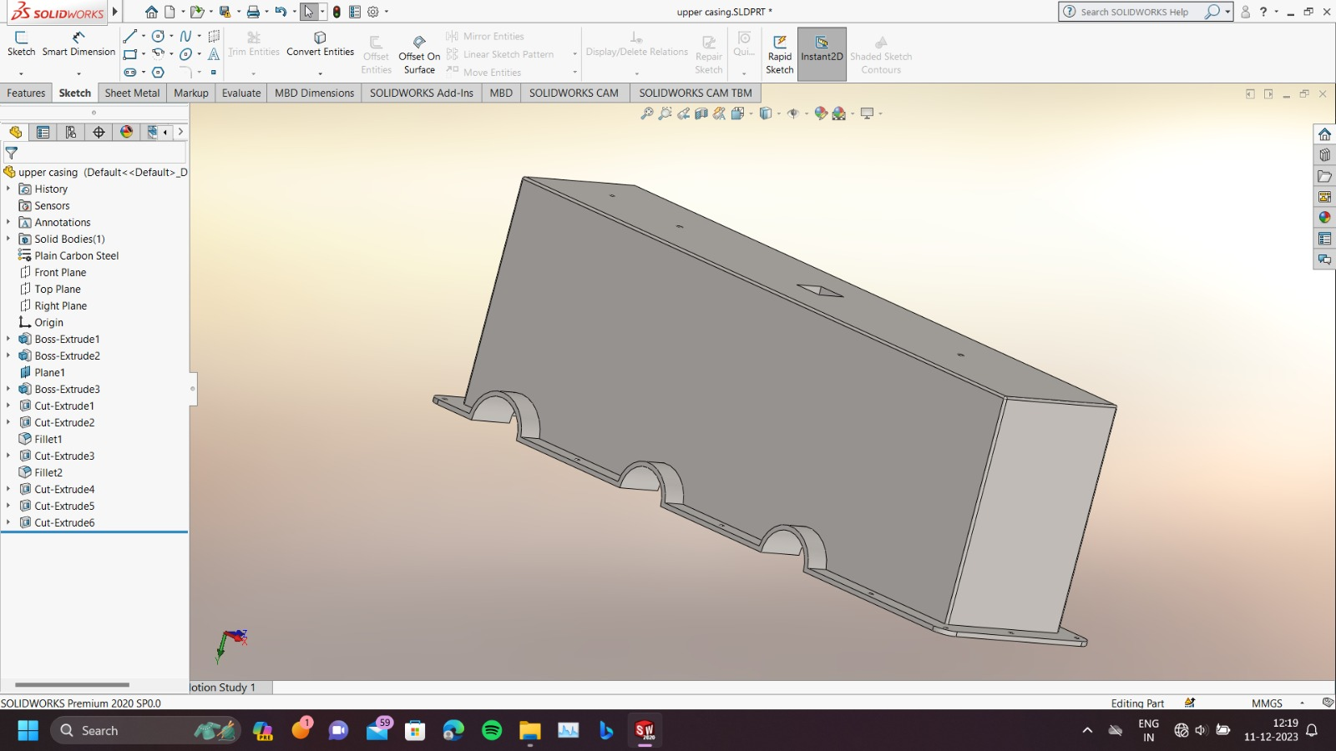

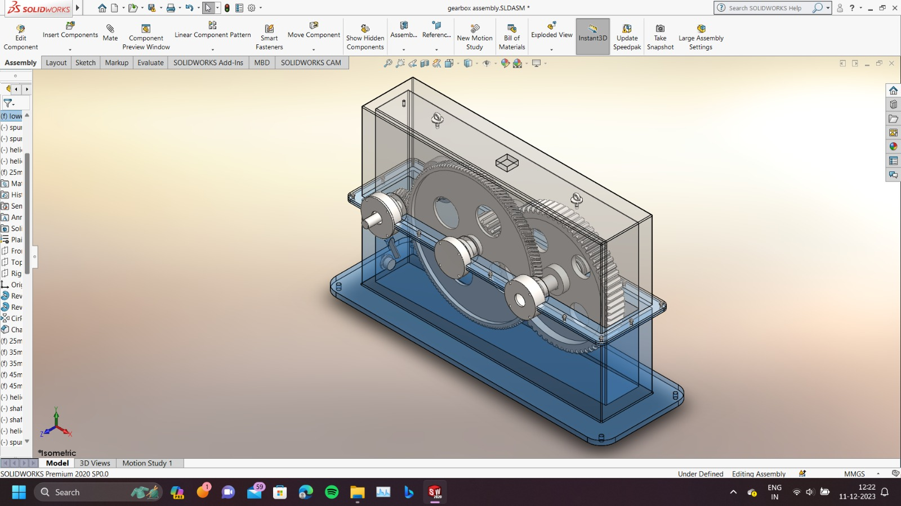

ASSEMBLY, DISASSEMBLY AND FUTURE SCOPE

ASSEMBLY
1. Insert first Helical Pinion onto the first shaft.
2. Insert the bearings on both ends of the first shaft and casing.
3. Place this assembly into the bottom cover of the casing.
4. lnsert Helical gear and spur gear onto the second shaft.
5. Insert bearings on both ends of the second shaft.
6. Similarly, place this assembly into the bottom cover of the casing ensuring that the first and second helical gear are in mesh.
7. Insert Spur gear onto the third shaft.
8. Insert bearings on both ends of the third shaft.
9. Place this assembly into the bottom cover of the casing ensuring
that the first and second spur gear are in mesh.
10.Place the side cover and tighten the screws of the casing

DISASSEMBLY
1. Remove all the screws of the casing of the gearbox.
2. Remove the top cover of the casing.
3. Remove all the components of the gearbox from the casing.
4. Remove the bearings and the gears from the shafts.

FUTURE SCOPE
1. Fatigue Analysis for Life calculation.
2. Structural Analysis To used composite material for gears.
4. As we have selected economically viable materials, the life might not be as long as comparitively expensive materials
MAINTAINANCE

All gearboxes must receive periodic maintenance including an oil change. Oil should be
checked regularly for contamination from dirt, debris, and other fluids such as water. The oil
should also be changed periodically based on hours of operation and on oil temperature. O1l
nat operates at elevated temperatures (above 150° F), needs to be changed more often than
oil that operates at 120° F. As the temperature increases up to 180° F the o1l change
Irequency increases significantly. Between 180° and 200° F the recommended time between
Changes 1s reduced by 75%. Elevated temperatures accelerate the breakdown of the oil's
molecular structure thereby inhibiting its ability to form a protective film. If oil continuously
operates above 200° F, a circulating lube oil system should be considered to cool the oil.

CONCLUSION

In conclusion, the design of a two-stage gearbox is a critical engineering task that requires careful consideration of various factors to ensure optimal performance, efficiency, and durability. The selection of materials, gear types, lubrication systems, and other design elements plays a crucial role in achieving the desired functionality and reliability of the gearbox. Additionally, adherence to manufacturing standards and precision in component machining are essential to minimize friction, noise, and wear.

A well-designed two-stage gearbox should meet or exceed the specified torque and speed requirements while considering factors such as load distribution, thermal management, and compatibility with the intended application. The incorporation of advanced gear profiles, suitable lubrication strategies, and robust sealing mechanisms contributes to the gearbox's overall effectiveness and longevity.

Throughout the design process, engineers must balance considerations related to cost, weight, space constraints, and maintenance requirements.

Ultimately, a successful two-stage gearbox design integrates engineering principles with practical considerations, resulting in a reliable and efficient transmission system that meets the demands of its intended application.

REFERENCES.

- Design of Machine Elements by V B Bhandari
- Machine Design by Shigley
- Mechine Design by P C Sharma
- Design Data book BY PSG
- SKF Bearing catalogue
- Hindustan Electric Motor Catalogue
- Torq Bolt’s Square key Catalogue.

