Name:Abhishek Mukundan Iyer

Class: B.Tech. Data Science

Roll No.: J021

Year: 2nd

Experiment No. 4

**Question 1**

**Code:**

int SensorValue = 0;

void setup()

{

pinMode(A0, INPUT);

pinMode(LED_BUILTIN, OUTPUT);

Serial.begin(9600);

}

void loop()

{

SensorValue = analogRead(A0);

if (SensorValue <= 200)

{

digitalWrite(LED_BUILTIN, HIGH);

Serial.print("Its DARK, Turn on the LED : ");

Serial.println(SensorValue);

}

else

{

digitalWrite(LED_BUILTIN, LOW);

Serial.print("Its BRIGHT, Turn off the LED : ");

Serial.println(SensorValue);

}

}

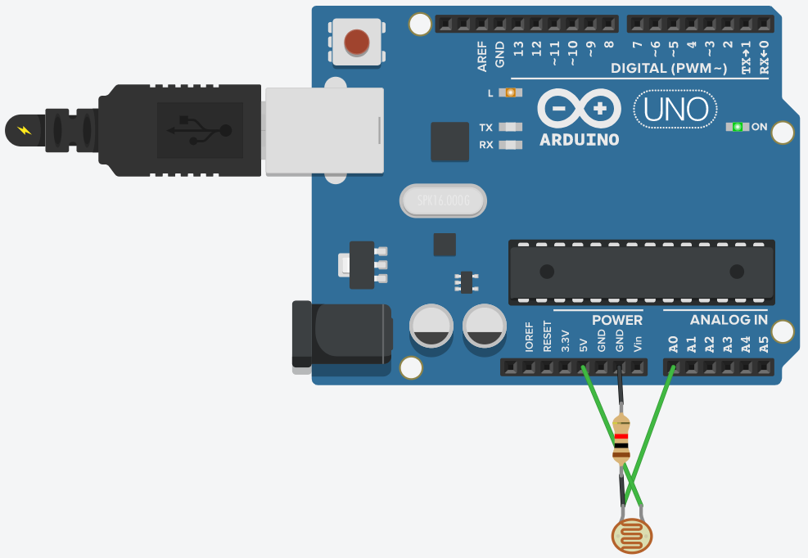

**Question 2**

**Code:**

int SensorValue = 0;

void setup()

{

pinMode(A0, INPUT);

pinMode(13, OUTPUT);

Serial.begin(9600);

}

void loop()

{

SensorValue = analogRead(A0);

if (SensorValue <= 200)

{

digitalWrite(13, HIGH);

Serial.print("Its DARK, Turn on the LED : ");

Serial.println(SensorValue);

}

else

{

digitalWrite(13, LOW);

Serial.print("Its BRIGHT, Turn off the LED : ");

Serial.println(SensorValue);

}

}

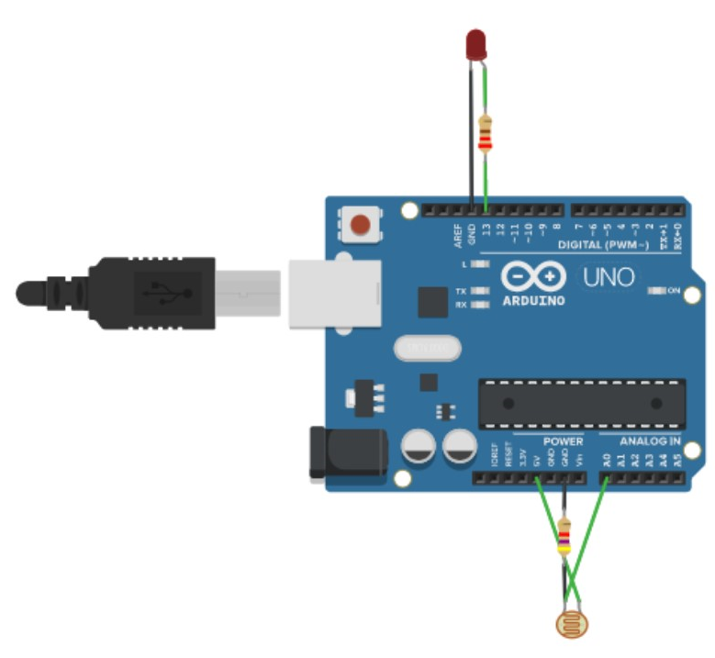 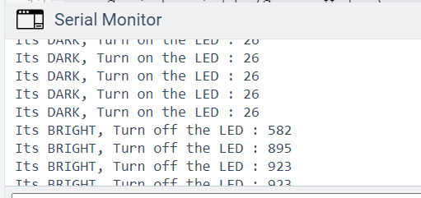

**Question 3**

**Code:**

#include <Servo.h>

Servo myservo;

void setup()

{

myservo.attach(2);

}

void loop()

{

myservo.write(0);

delay(1000);

myservo.write(45);

delay(1000);

myservo.write(0);

delay(1000);

myservo.write(90);

delay(1000);

}

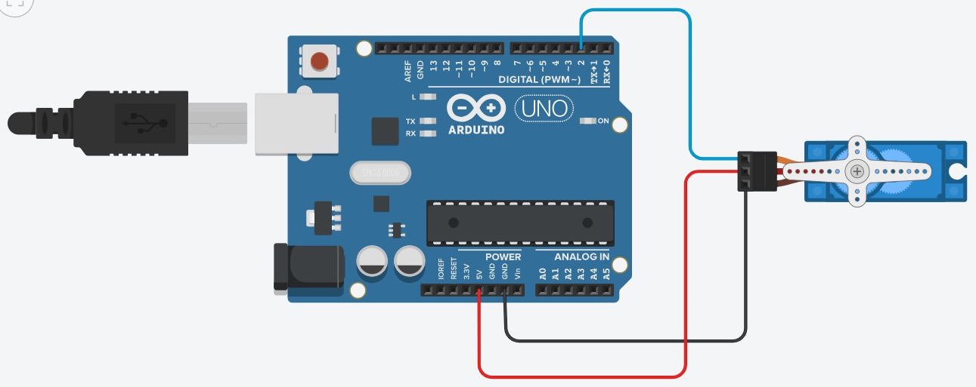

**Question 4**

**Code:**

#include<Servo.h>

Servo myservo;

int buttonState =0;

int i=0;

void setup()

{

pinMode(4, INPUT);

myservo.attach(2);

}

void loop()

{

buttonState = digitalRead(4);

if (buttonState == HIGH)

{

for (i=0; i<=180; i++)

{

myservo.write(i);

}

myservo.write(0);

}

else

{

myservo.write(0);

}

}

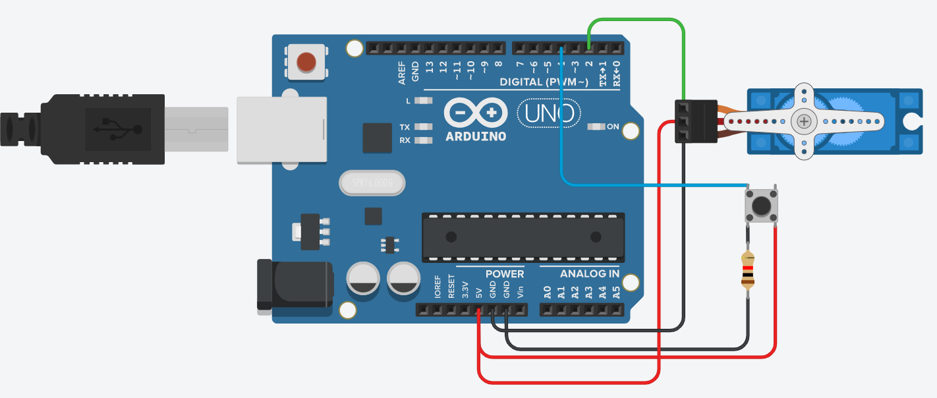

**Question 5**

**Code:**

#include<Servo.h>

int sensorValue =0;

Servo myservo;

void setup()

{

pinMode(A0, INPUT);

myservo.attach(2);

}

void loop()

{

sensorValue = analogRead(A0);

if (sensorValue < 512)

{

myservo.write(map(sensorValue,0,511,0,180));

}

if (sensorValue > 511)

{

myservo.write(map(sensorValue,512,1023,180,0));

}

}

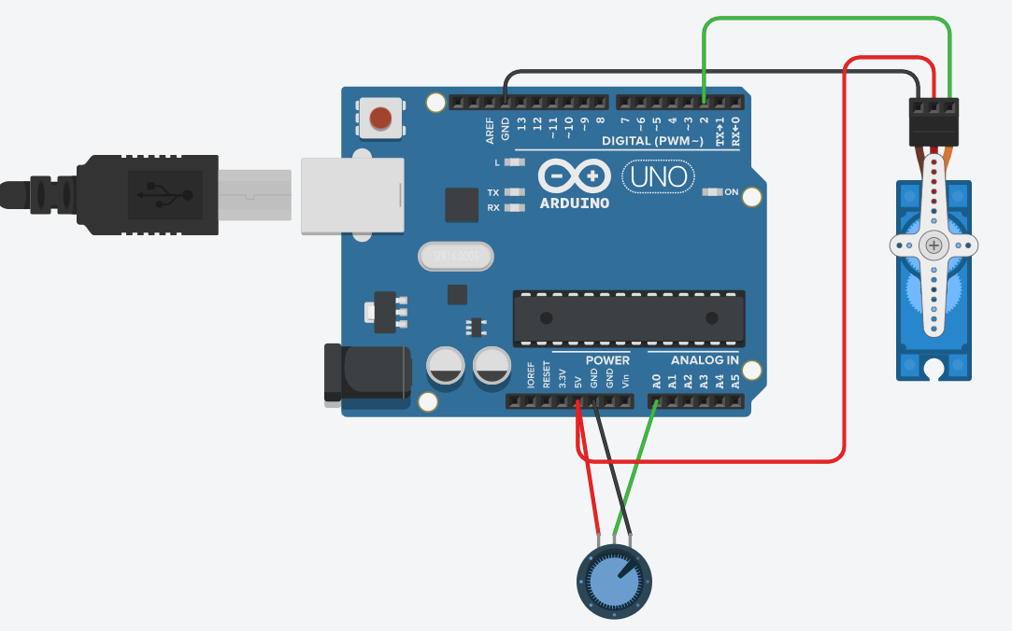

**Question 6**

**Code:**

#include<Servo.h>

Servo myservo;

void setup()

{

myservo.attach(2);

}

void loop()

{

for(int i=0;i<=180;i++)

{

myservo.write(i);

delay(10);

}

for(int j=180;j>=0;j--)

{

myservo.write(j);

delay(10);

}

}



**Question 7**

**Code:**

#include<Servo.h>

Servo myservo;

int buttonState =0;

int i=0;

void setup()

{

pinMode(6, INPUT);

pinMode(9, OUTPUT);

myservo.attach(2);

}

void loop()

{

buttonState = digitalRead(6);

if (buttonState == HIGH)

{

tone(9,440);

myservo.write(180);

}

else

{

noTone(9);

myservo.write(0);

}

}

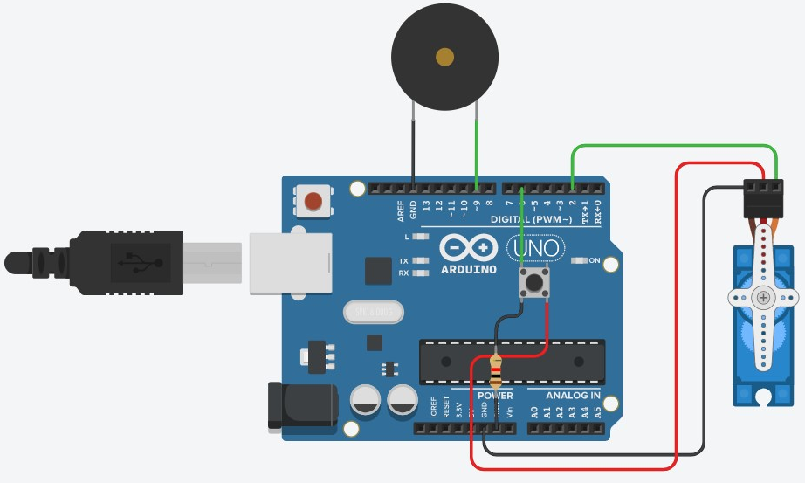

**Question 8**

**Code:**

#include<Servo.h>

Servo myservo;

void setup()

{

myservo.attach(2);

pinMode(7,OUTPUT);

pinMode(10,OUTPUT);

pinMode(13,OUTPUT);

}

void loop()

{

digitalWrite(13, HIGH);

myservo.write(0);

delay(2000); // Wait for 2000 millisecond(s)

digitalWrite(13, LOW);

delay(1000); // Wait for 1000 millisecond(s)

digitalWrite(10, HIGH);

delay(1000);

digitalWrite(10, LOW);

delay(1000);

digitalWrite(7, HIGH);

myservo.write(180);

delay(2000);

digitalWrite(7, LOW);

delay(1000);

}

