Assignment 2

Name: Abhishek Mukundan

Class: B.Tech. Data Science

Year: 2nd

Roll No.: J021

Q1. A traffic signal has red which is on for 5 sec.... In the last 2 sec we hear the buzzer with frequency of 440 Hz... Followed by yellow light blinking 5 Times where is on and off for half sec each followed by green which is on for 5 sec. At the last two sec of green .... A buzzer of 440 Hz frequency is on.

Answer:

**Code:**

void setup()

{

pinMode(10, OUTPUT);

pinMode(7, OUTPUT);

pinMode(3, OUTPUT);

pinMode(1, OUTPUT);

}

void loop()

{

digitalWrite(10, HIGH);

delay(3000);

tone(1,440);

delay(2000);

noTone(1);

digitalWrite(10, LOW);

for(int i=0; i<5;i++)

{

digitalWrite(7, HIGH);

delay(500);

digitalWrite(7, LOW);

delay(500);

}

digitalWrite(3, HIGH);

delay(3000);

tone(1,440);

delay(2000);

noTone(1);

digitalWrite(3, LOW);

delay(1000);

}

**Picture:**

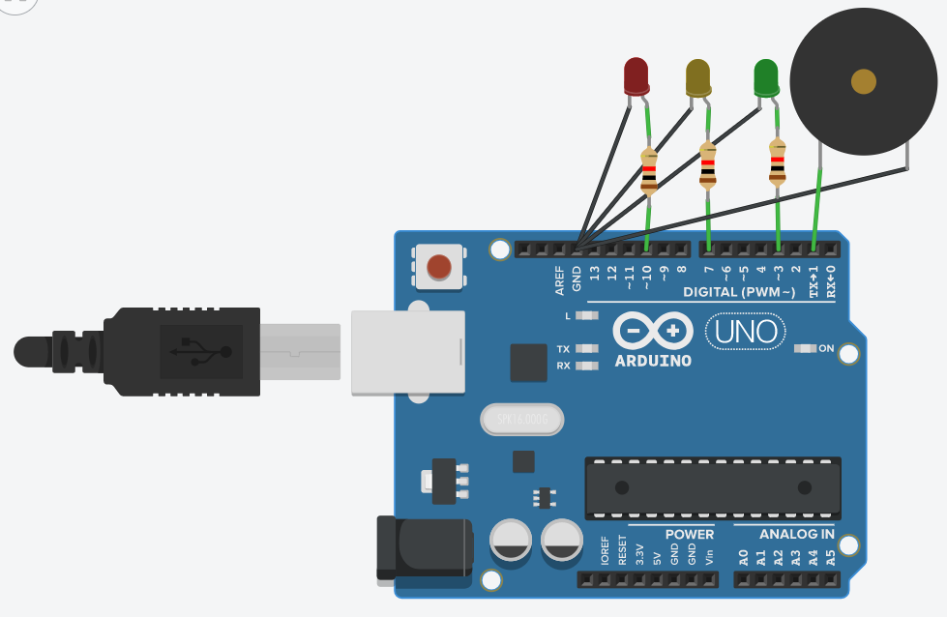

Q2. CONTROL BUZZER TONE USING POTENTIOMETER

//output pitch range (120 - 1500Hz)

//POTENTIOMETER - 0-1023

Answer:

**Code:**

void setup()

{

pinMode(10, OUTPUT);

pinMode(A0, INPUT);

}

void loop()

{

tone(9,map(analogRead(A0),0,1023,120,1500));

delay(2);

}

**Picture:**

