Features of Git

Some remarkable features of Git are as follows:

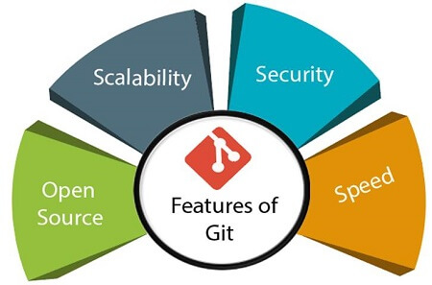

* **Open Source**