

Mini Project Report

on

**Testing Volunteer Management Application**

SUBMITTED BY

Name of Student Roll No.

1. Shweta Mandal BECO2425B038
2. Abhishek Mahajan BECO2425B040

Under the guidance of

**Mrs. Snehal Sarangi**

In partial fulfillment of the requirements for

Bachelor’s Degree in Computer Engineering

of

**SAVITRIBAI PHULE PUNE UNIVERSITY**

**[2024 – 2025]**

Department of Computer Engineering

D. Y. PATIL COLLEGE OF ENGINEERING, Akurdi, PUNE 411044.

## Description: DYPCOE Akurdi Pune (@DYPCOEAK) | Twitter

## D. Y. Patil College of Engineering Akurdi, Pune-411044

**Department of Computer Engineering**

**CERTIFICATE**

This is to certify that **Shweta Mandal** and **Abhishek Mahajan** have satisfactorily completed the mini project work entitled **“Testing of Volunteer Management”** which is a bonafide work carried out by them under the supervision of **Mrs. Snehal Sarangi** and it is approved for the partial fulfillment of requirement of Savitribai Phule Pune University, for the award of the degree of Bachelors of Engineering (Computer Engg.) for the academic year 2024-25.

Mrs. Snehal Sarangi Dr. Mrs. M.A. Potey

(Mini Project Guide) (HOD Computer)

Place: Akurdi

Date:

# ACKNOWLEDGEMENT

With immense pleasure, we present the mini project report as part of the curriculum of the B.E. Computer Engineering. We wish to thank all the people who gave us an unending support right from when the idea was conceived.

We express sincere and profound thanks to Mrs. Snehal Sarangi and HOD Dr. Mrs. M.A. Potey, who is ready to help with the most diverse problems that We have encountered along the way. We express sincere thanks to all staff and colleagues who have helped directly or indirectly in completing this project work successfully.

Names Roll No Signatures

1. Shweta Mandal BECO2425B038
2. Abhishek Mahajan BECO2425B040

# Table of Contents

|  |  |  |
| --- | --- | --- |
| Sr. No | Chapters | Page No |
| 01 | Problem Statement | 1 |
| 02 | Introduction | 1 |
| 03 | System Environment and Technology Stack | 2 |
| 04 | Test Plan | 3 |
| 05 | Bug Taxonomy | 4 |
| 06 | Regression Test Scripts | 5-6 |
| 07 | Bugs Identified using Automation Testing | 7-10 |
| 08 | Test Report | 11-12 |
| 09 | Conclusion | 13 |

1. **Problem Statement:**

Create a small web-based application by selecting relevant system environment / platform and programming languages. Narrate concise Test Plan consisting features to be tested and bug taxonomy. Narrate scripts in order to perform regression tests. Identify the bugs using Selenium WebDriver and IDE and generate test reports encompassing exploratory testing.

1. **Introduction:**

The Volunteer Management System is a web-based application developed using the MERN stack (MongoDB, Express.js, React.js, Node.js), designed to streamline the management of volunteer information. The system allows users to easily add, update, and delete volunteer details such as name, address, email, and phone number. All volunteers are displayed on the home page, where they can be updated or removed with a simple click. The goal of this project is to develop a functional application while implementing a comprehensive testing strategy using tools like Selenium WebDriver and IDE. The testing plan focuses on validating core functionalities, performing regression tests, and identifying bugs, followed by generating test reports. This project not only emphasizes the practical implementation of a web application but also highlights the importance of quality assurance in software development.

1. **System Environment and Technology Stack**

**Platform:**

**Web-Based Application:** Accessible via modern web browsers.

**Frontend:**

* **Framework:** React.js (part of the MERN stack)
* **Languages:** JavaScript (ES6+), HTML5, CSS3
* **Libraries/Tools:** Axios for API calls, React Router for navigation

**Backend:**

* **Runtime Environment:** Node.js
* **Framework:** Express.js
* **Database:** MongoDB (NoSQL database)

**Testing Tools:**

* **Automation Testing:** Selenium WebDriver
* **Integrated Development Environment (IDE):** Selenium IDE

## Test Plan

A Test Plan outlines the strategy and approach for testing the Volunteer Management application. It includes the features to be tested, testing objectives, resources, schedule, and deliverables.

**4.1 Objectives**

* Ensure all functionalities work as intended.
* Identify and fix defects before deployment.
* Validate that updates do not introduce new bugs (regression testing).
* Ensure the application meets quality standards and user requirements.

**4.2 Scope**

* **Add New Volunteer:** Form validation, data persistence.
* **Update Volunteer Information:** Partial and full updates, data integrity.
* **Delete Volunteer:** Confirmation prompts, data removal.
* **Home Page:** Display of volunteer list, update/delete button functionality.

**4.3 Features to Be Tested**

1. **Add New Volunteer**
   * Form fields: name, address, email, phone.
   * Validation: Required fields, email format, phone number format.
   * Successful addition: Volunteer appears in the list.
2. **Update Volunteer Information**
   * Editing existing volunteer details.
   * Validation on updated fields.
   * Data integrity: Only updated fields change, others remain intact.
3. **Delete Volunteer**
   * Deletion confirmation prompt.
   * Successful removal from the list.
4. **Home Page Display**
   * Correct rendering of volunteer list.
   * Functionality of update and delete buttons for each volunteer.
   * Pagination or infinite scroll (if implemented).

## Bug Taxonomy

Bug taxonomy categorizes bugs based on their nature and impact. Bug Taxonomy for project:

1. **Functional Bugs**
   * **UI Functionality:** Buttons not responding, forms not submitting.
   * **API Failures:** Incorrect data retrieval or storage.
2. **Performance Bugs**
   * **Load Times:** Pages or actions taking too long to respond.
3. **Usability Bugs**
   * **Navigation Issues:** Confusing UI elements, poor layout.
   * **Accessibility Problems:** Lack of support for screen readers, poor contrast.
4. **Security Bugs**
   * **Data Validation:** Inadequate input sanitization leading to vulnerabilities.
5. **Compatibility Bugs**
   * **Browser Compatibility:** Issues specific to certain browsers.
   * **Device Compatibility:** Problems on mobile vs. desktop.
6. **Data Integrity Bugs**
   * **Data Loss:** Data not saved or incorrectly modified.
   * **Consistency Issues:** Inconsistent data across different views or components.

## Regression Test Scripts

Regression testing ensures that recent code changes haven't adversely affected existing functionalities. Below are scripts for regression testing of application using Selenium WebDriver.

1. **Add New Volunteer**

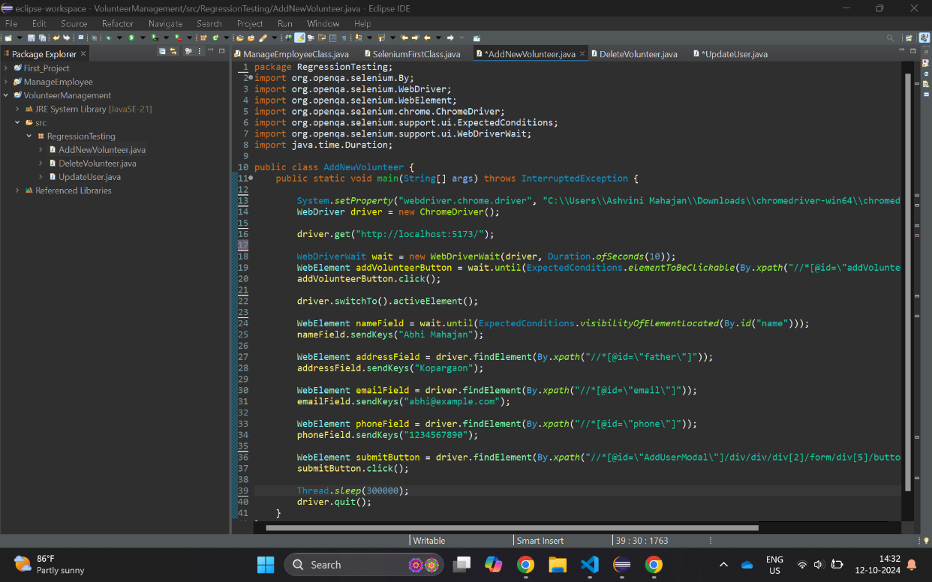

1. **Update Volunteer**

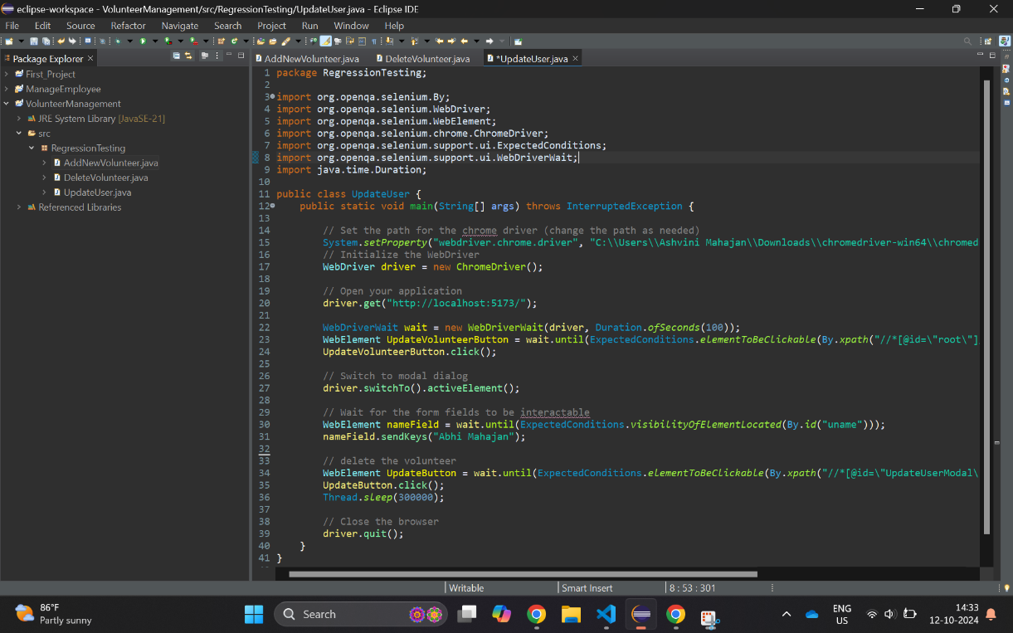

1. **Delete Volunteer**

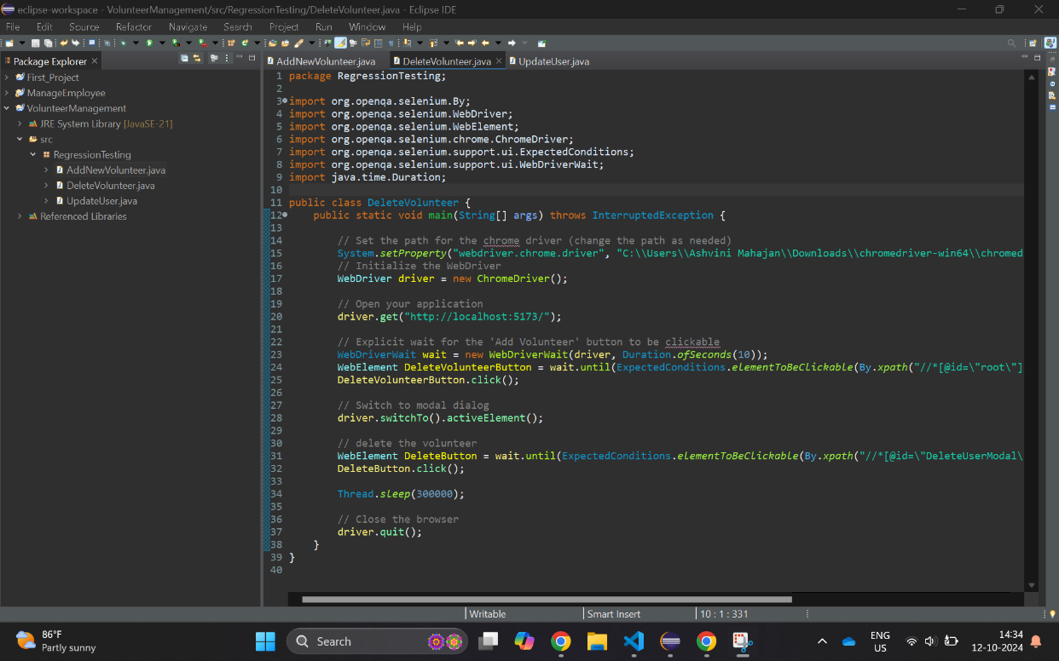

## Bugs Identified Using Automation Testing

**Bug ID:** BUG-001  
**Title:** Update Volunteer Phone Number Fails  
**Description:** Changing the phone number clears all other fields in the update form.  
**Steps to Reproduce:**

1. Navigate to the Home Page.
2. Click on the 'Update' button for a volunteer.
3. Change the phone number and submit.  
   **Expected Result:** Phone number updates successfully without affecting other fields.  
   **Actual Result:** Phone number updates, but other fields are cleared.  
   **Severity:** Major (affects core functionality)  
   **Priority:** High (needs immediate attention)  
   **Attachments:**

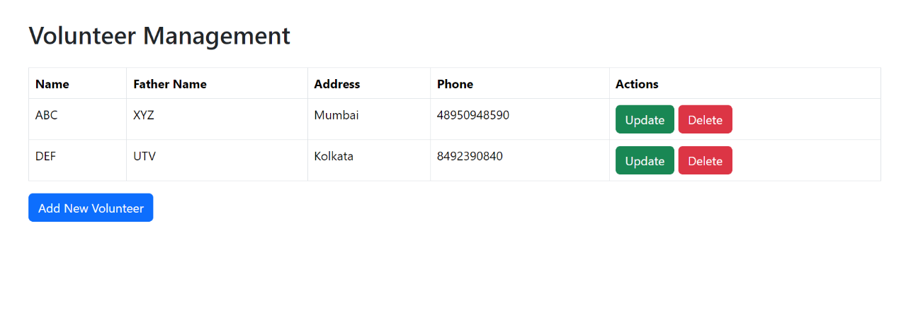

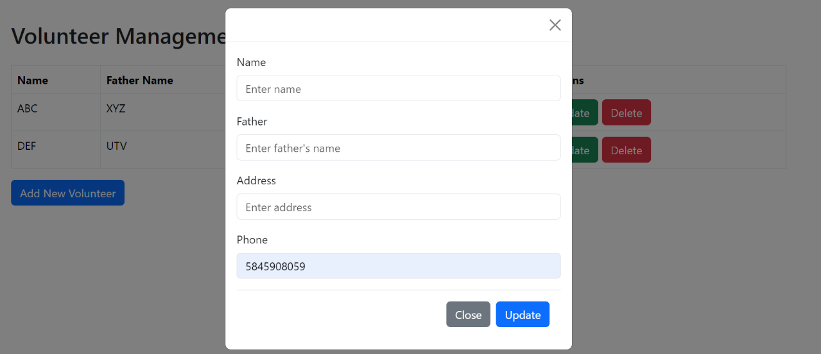

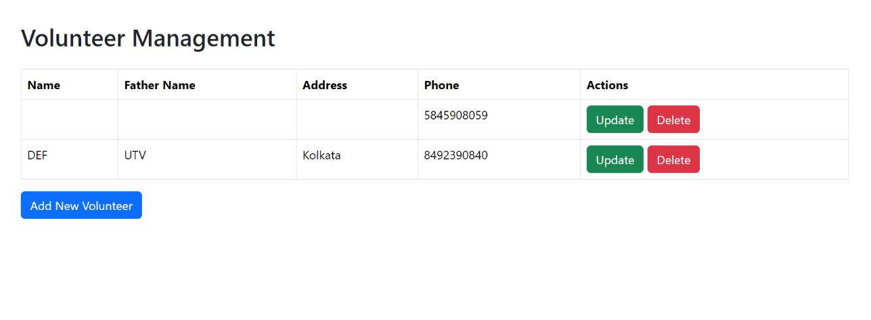

**Bug ID:** BUG-002  
**Title:** Add Volunteer Form Validation Missing  
**Description:** Volunteers can be added without filling required fields, resulting in invalid entries.  
**Steps to Reproduce:**

1. Navigate to the Home Page.
2. Click on 'Add Volunteer' button.
3. Leave required fields empty and submit.  
   **Expected Result:** Form should prevent submission and show validation messages for required fields.  
   **Actual Result:** Form allows submission with missing required information.  
   **Severity:** Major (affects core functionality)  
   **Priority:** High (needs immediate attention)  
   **Attachments:**

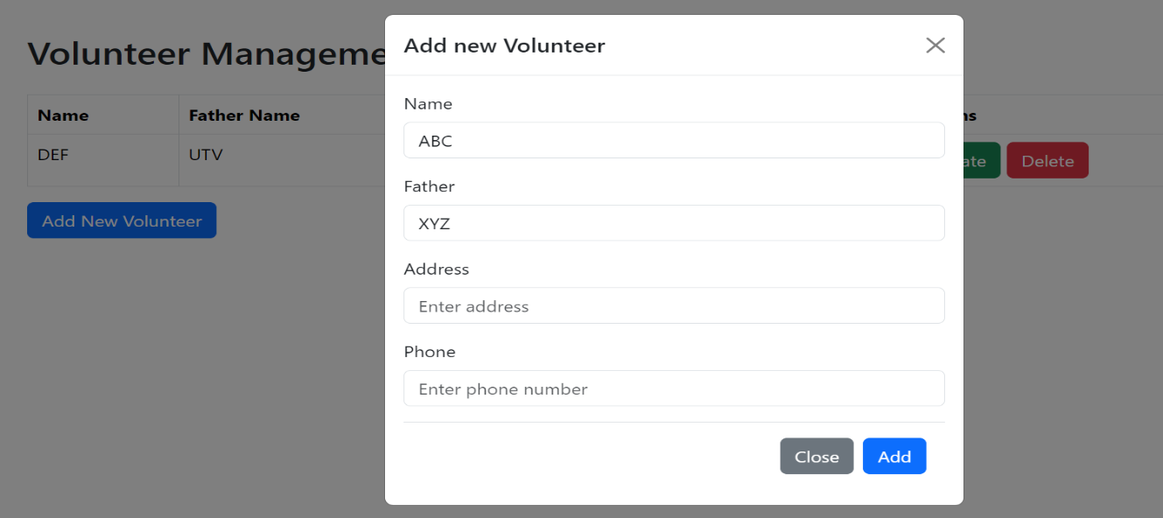

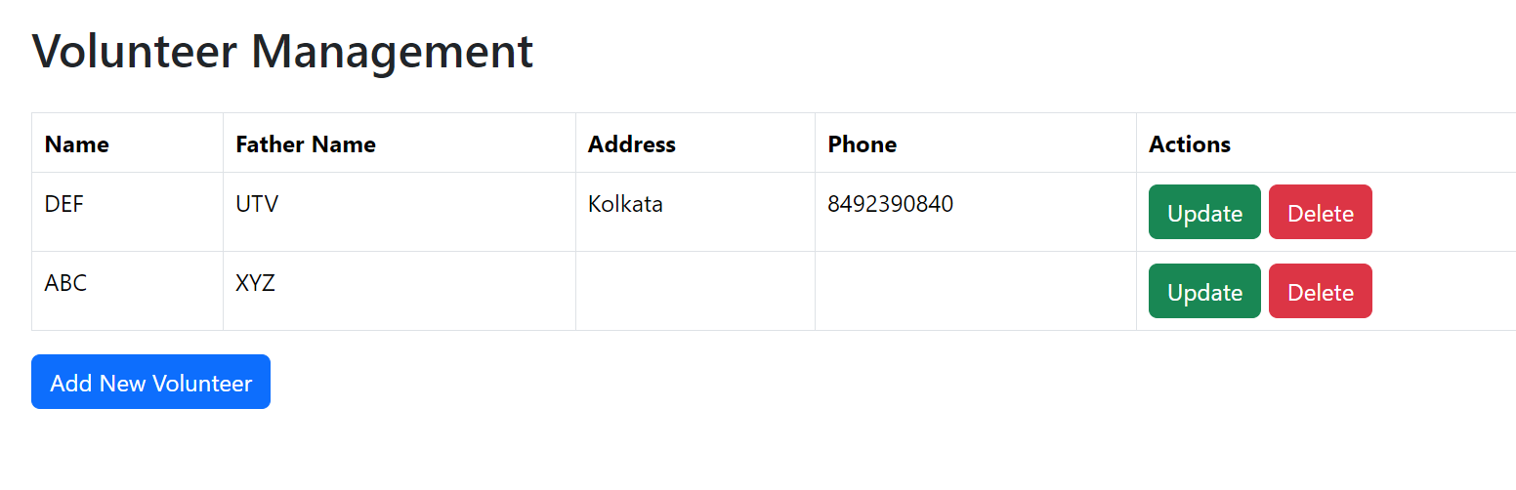

**Bug ID:** BUG-003  
**Title:** Volunteer List Not Updating After Deletion  
**Description:** After deleting a volunteer, the list does not refresh, and the deleted volunteer still appears until a manual refresh.  
**Steps to Reproduce:**

1. Navigate to the Home Page.
2. Click on the 'Delete' button for a volunteer.
3. Check if the volunteer is removed from the list.  
   **Expected Result:** Volunteer list should automatically refresh to reflect the deletion.  
   **Actual Result:** Volunteer list still shows the deleted entry until manual refresh.  
   **Severity:** Minor (affects user experience)  
   **Priority:** Medium (needs attention)  
   **Attachments:**

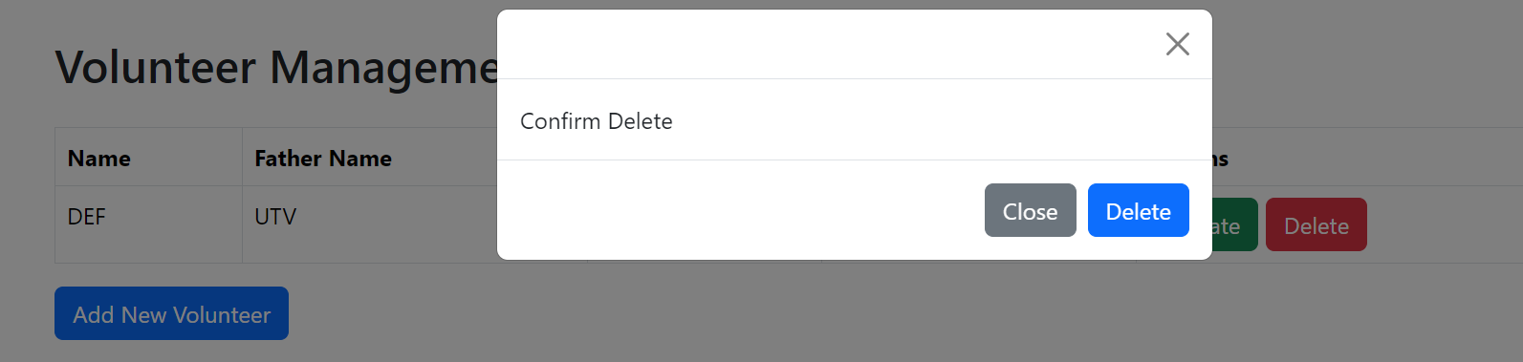

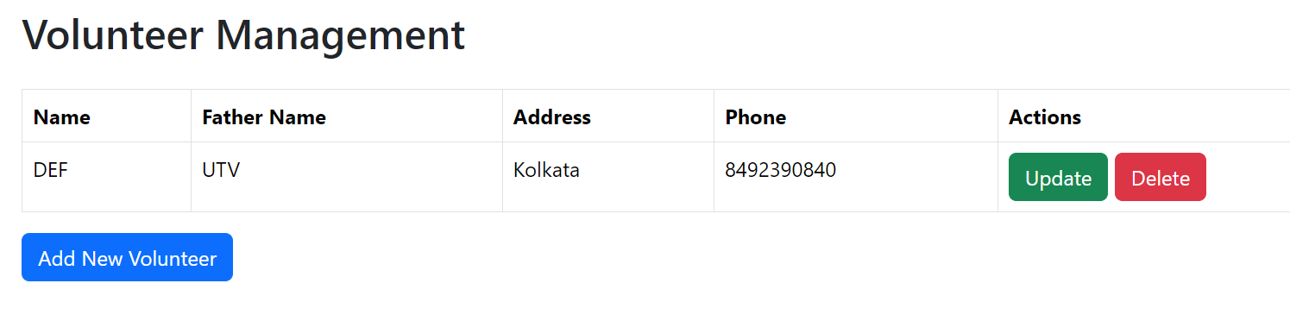

**Bug ID:** BUG-004  
**Title:** Phone Number Field Accepting Non-Numeric Characters  
**Description:** The phone number field allows non-numeric characters, leading to invalid phone numbers being saved in the database.  
**Steps to Reproduce:**

1. Navigate to the Home Page.
2. Click on 'Add Volunteer' button.
3. Enter non-numeric characters in the phone number field.
4. Submit.  
   **Expected Result:** Phone number field should only accept numeric characters and display validation error for non-numeric inputs.  
   **Actual Result:** Form allows non-numeric characters to be submitted in the phone number field.  
   **Severity:** Major (affects data integrity)  
   **Priority:** High (needs immediate attention)  
   **Attachments:**

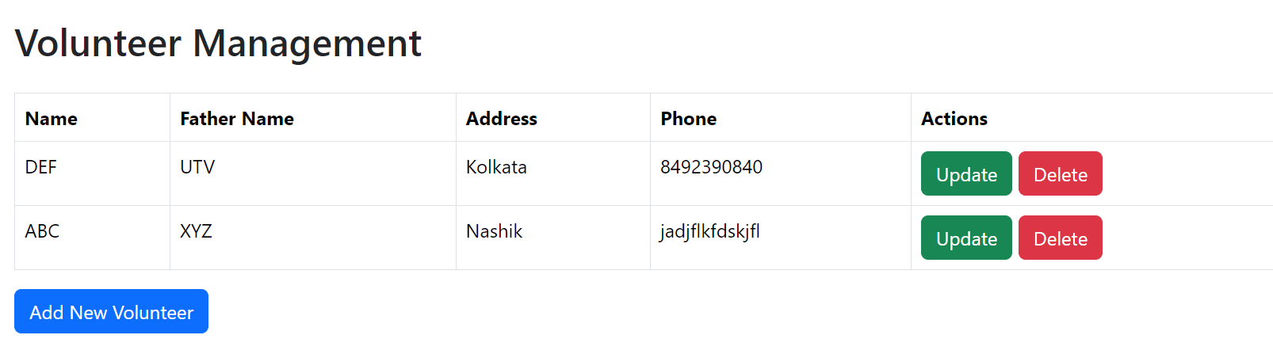

1. **Test Report**

**Project Name:** Volunteer Management System  
**Test Report Date:** 12th October 2024  
**Tested By:** Abhishek Mahajan  
**Environment:**

* Platform: Windows 11
* Browser: Chrome v129.0
* Automation Tool: Selenium WebDriver (Java)
* Test Management Tool: Manual & Selenium IDE

**Test Summary:**

The Volunteer Management System was tested for functionality, usability, and data integrity. Testing included adding, updating, and deleting volunteers, as well as validation of user input. Automated regression tests were executed using Selenium WebDriver to ensure that previous functionalities were not broken after new updates.

**Test Scope:**

**Functionalities Tested:**

* + Add new volunteer
  + Update volunteer information
  + Delete volunteer
  + List volunteers
  + Form validation for volunteer details (name, email, phone number)

**Test Results Summary:**

|  |  |  |  |  |
| --- | --- | --- | --- | --- |
| **Case ID** | **Test Case Name** | **Tested Functionality** | **Test Status** | **Comments** |
| TC-001 | Add New Volunteer | Add new volunteer form functionality | Passed | Volunteer added successfully with correct data. |
| TC-002 | Update Volunteer Information | Update an existing volunteer's details | Failed | Bug found: Updating phone number clears other fields (BUG-001). |
| TC-003 | Delete Volunteer | Delete volunteer from list | Passed | Volunteer deleted successfully and list updated. |
| TC-004 | Phone Number Validation | Validate phone number field input | Failed | Bug found: Non-numeric characters are allowed in phone number field (BUG-004). |
| TC-005 | Volunteer List Refresh | Refresh volunteer list after deletion | Failed | Bug found: List does not auto-refresh after deletion (BUG-003). |

**Bug Summary:**

|  |  |  |  |  |
| --- | --- | --- | --- | --- |
| **Bug ID** | **Title** | **Severity** | **Priority** | **Status** |
| BUG-001 | Update Volunteer Phone Number Fails | Major | High | Open |
| BUG-002 | Add Volunteer Form Validation Missing | Major | High | Resolved |
| BUG-003 | Volunteer List Not Updating After Deletion | Minor | Medium | Open |
| BUG-004 | Phone Number Field Accepting Non-Numeric Input | Major | High | Open |

**Conclusion and Recommendations:**

The Volunteer Management System showed several functional issues related to form validation and data integrity. The major bugs (BUG-001, BUG-004) need immediate attention to ensure proper user data handling. It is recommended to fix these issues and conduct another round of regression testing to confirm that the fixes do not break any existing functionality.

## Conclusion

The testing for the Volunteer Management System was successfully conducted using Selenium scripts to automate key functionalities. Several critical issues were identified during testing, including a bug where updating the phone number clears other fields (BUG-001) and inadequate form validation that allows invalid phone number formats (BUG-004). Additionally, the volunteer list does not automatically refresh after deletions (BUG-003), impacting user