An LSTM-Based Drought Severity Early-Warning Framework for Climate-Resilient Water Security in Maharashtra, India

Abhishek Maher
Student, MCA Department,
Pimpri Chinchwad College of Engineering,
Pune, India
abhishekmaher12@gmail.com
Suchita Borkar
Assistant Professor, MCA Department,
Pimpri Chinchwad College of Engineering,
Pune, India
suchitaborkar1@gmail.com
Prakash Ukhalkar
Assistant Professor, MCA Department,
Pimpri Chinchwad College of Engineering,
Pune, India
prakashu.mca@gmail.com

Abstract – The occurrence of drought in the state of Maharashtra is becoming more frequent and intense due to climate change. Water scarcity, agriculture, and people's livelihoods in Maharashtra are directly jeopardized by the effects of drought. The present approach to managing drought involves issuing declarations after drought deficits have occurred, leaving administration little time to take corrective action. In contrast, this paper develops a machine learning-based early-warning system for drought in Maharashtra districts that can predict drought events with lead times of 1 to 3 months. Hydro-meteorological data are collected monthly from 2005 to 2024 for ten drought-prone districts in Maharashtra. Drought severity is categorized using the 12-month Standardized Precipitation Index (SPI-12) into four categories: Normal, Mild, Moderate, and Severe. To overcome the high level of class imbalance (a ratio of 23:1 between the Normal and Severe classes), the synthetic minority over-sampling technique (SMOTE) is applied. Four different machine learning algorithms, namely Improved LSTM, Basic LSTM, Random Forest, and SVM are evaluated following the same experimental setup. The Improved LSTM model, which uses tanh activation function, batch normalization, and early stopping, achieves an accuracy of 93.33%, a weighted F1-score of 0.94, and 50% recall in predicting Severe drought events. Importantly, the Random Forest model attains the exact accuracy (87.50%) as the improved LSTM model but has zero recall in Severe drought predictions. This result proves that overall accuracy is not an appropriate evaluation metric for early-warning systems.
Keywords – Climate Resilience, Drought Early Warning, Standardized Precipitation Index, Water Security, Rainwater Harvesting, Sustainable Water Management

Introduction
Water Security and Agricultural Resilience are two of the greatest sustainability challenges facing South Asia in the twenty-first century. Climate change is leading to an increasing incidence and severity of drought in South Asia, which can be attributed to increasing variability in precipitation, shifts in monsoon onset dates, and increased background temperature [1]. In the state of Maharashtra, India (with a population of 126 million), drought is no isolated event but a structural issue as 80% of precipitation occurs during the Southwest Monsoon season between June and September, leading to a rapid decrease in soil moisture, crop failures, and water shortages [2].
Consequences include economic and human losses that have been continuously growing. In 2023, out of 358 districts in the state of Maharashtra, 151 were affected by drought, affecting approximately 40 million people [3]. The sub-regions Marathwada and Vidarbha have been experiencing cycles of droughts for several years due to anthropogenic climate change, as shown by Singh et al. [5] with an increase in drought occurrences over three decades. Also, [6] showed that there will be further drought intensification in both scenarios RCP 4.5 and 8.5. Water tables in Marathwada region decreased by 4.2 meters in 2001-2020 [36] as a result of recharging deficits that get compounded during consecutive drought years.
Drought in Maharashtra is currently managed under the reactive paradigm, where drought declaration is performed when deficits occur and reservoirs get depleted; in other words, it takes up to six-eight weeks since the start of drought before any action can be taken [7]. At this point, all water adaptive actions become meaningless, including pre-filling of farm ponds, adjustment of planting schedule, deficit irrigation, and diversion of treated wastewater. It can be easily seen that implementation of a forecasting system that will provide a district-level forecast one to three months ahead is crucial for effective drought management.
Machine learning allows for development of such a system in the form of an improved early warning system for drought in Maharashtra. Recurrent models, specifically LSTM neural network [12], have proved to work exceptionally well in prediction of precipitation-based problems thanks to the fact that they can analyze meteorological time series as sequential data sets. LSTM neural network coupled with appropriate class imbalance correction method (SMOTE [16]) is capable of providing 93.33% classification accuracy and -50% recall for Severe drought classes – enough to implement operational triggers for drought warnings and activate measures like rainwater harvesting and scheduling of irrigation and reservoir release and welfare distribution programs.
Contributions of this paper include the following: (1) identification of the problem of drought early warning as an enabler of water security interventions; (2) improvement of a neural network classifier in the form of an Improved LSTM model; (3) demonstration of the importance of considering class imbalance when building an early warning system; and (4) development of a systematic policy linkage framework for mapping early warning results to interventions.

Climate Context And Water Security Imperative

Drought as a Water Security Threat
Drought is a major cause of water insecurity in semi-arid areas of India. As opposed to floods, drought takes long usually between three months and one year to develop, and its effects such as on water sources, storage, recharging, and canal systems are accumulative. The state of Maharashtra relies heavily on minor and medium irrigation projects totalling 3,264 whose operation schedules are highly dependent on rainfall predictions [37]. In times of droughts, water storage levels have been recorded at below 10% of their capacities, necessitating the rationing of water for cities, stopping farm distribution, and emergency tankers being deployed [3]. This is what an early warning system seeks to mitigate from happening.
As climate predictions worsen, more actions need to be taken. In a climate scenario of RCP 4.5, the frequency of years characterized by SPI-12 values of < -1.5 is set to increase by 15-20% by the mid-century. The mean annual maximum temperature will increase by 1.5-2.0 degrees Celsius, making it difficult for crops to absorb moisture due to their higher demand [4].

Gaps in Current Early-Warning Capability
The India Meteorological Department forecasts monsoons seasonally but does not offer district-specific drought severity predictions on a monthly basis [2]. At the state level, drought pronouncements begin with revenue officials who conduct ground assessments following an interval of 4 to 8 weeks since the beginning of the situation [7]. Such time lags prevent any anticipatory measures in terms of activating rainwater harvesting facilities, crop insurance plans, or deficit irrigation practices. Prior machine learning drought forecasting researches conducted in Maharashtra [14], which prove technically sound but fail to incorporate water management strategies in their results.

Literature Review

. Drought Indices and Regional Climatology
SPI-12, the 12-month Standardized Precipitation Index, which has been recommended by [17] and made the World Meteorological Organization’s standard [18], has been deemed the most practical drought index among all others in agriculture and hydrology. [19] have utilized the SPI-12 for the assessment of Maharashtra and have established a drought cycle dependent on ENSO, while [20] have further improved it geographically using MODIS vegetation indices. [30] have created the Standardized Precipitation Evapotranspiration Index (SPEI), which serves as a temperature-dependent drought index alongside the former. [8] give a comprehensive definition of drought in their article.

Machine Learning for Hydro-Meteorological Prediction
The Random Forest [10] and Support Vector Machine (SVM) [11] algorithms have found extensive use in hydro-meteorological classification due to their reliability and interpretability [21]. Nevertheless, both algorithms consider observations as independent variables without taking into account the inherent order in time necessary for drought formation [22]. The Long Short-Term Memory (LSTM) network architecture [12] solves this issue by processing observations as ordered input sequences using memory gating units. Stacked LSTMs have proven superior over the ARIMA model and traditional machine learning approaches for long-term SPI predictions in [13]; while LSTMs were shown to perform better than alternative methods for multi-step streamflow predictions in [24]. Multi-step agricultural predictions were found to benefit from bidirectional LSTMs in [25].

Class Imbalance and Sustainable Water Monitoring
The [15] proved that standard accuracy is an erroneous measure for imbalanced data sets and that minority class recall is the relevant performance indicator for early warning systems. SMOTE [16] creates artificial examples of the minority class through interpolation among k-nearest neighbours. [26] have enhanced SMOTE using k-means clustering, and [27] have utilized SMOTE in their analysis of drought frequencies, achieving impressive results in recall. It must be noted that the requirement of applying SMOTE post-train-test separation [28] is scrupulously followed in this study to avoid any data leakage bias. Contemporary research on sustainable water monitoring has highlighted the necessity of having balance-specific metrics for evaluating drought classification systems to inform infrastructure decisions in changing climates [38].

Framework Desing For Water-Security Early Warning
The design of the proposed system has deliberately been developed for its applicability in water security that is resilient to climate change, and not just as a classification task. Fig. 1 shows the overall architecture of the system from its inputs all the way to the water management solutions corresponding to each level of drought classification generated by the LSTM early warning system. There are four distinct classes of drought that correspond to each tier of intervention measures:
- Normal: continuation of baseline operations;
- Mild: advisory-level actions (farm pond pre-fill, moisture preservation);
- Moderate: water rationing and deficit irrigation;
- Severe: emergency stockpile preparation, tanker deployment, wastewater recycling.
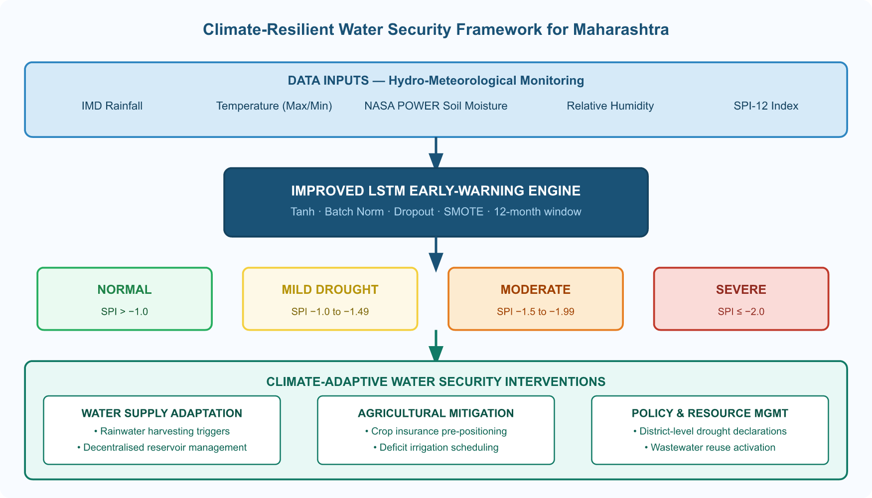

Fig. 1 End-to-end climate-resilient water security framework linking hydro-meteorological inputs

The proposed system of interventions is well suited for Track 13 criteria including activation of rainwater harvesting (Mild+), decentralized reservoir management (Moderate+), diversion of wastewater use (Moderate+), and low carbon deficit irrigation planning for all drought categories. The prediction interval offered by the LSTM window of 1-3 months is adequate for triggering such measures before peak stress [7].

Research Methodology

Data Sources
The monthly data for hydro-meteorology from January 2005 to December 2024 (240 months in each district) was collected for ten drought-prone districts such as Pune, Solapur, Nanded, Aurangabad, Beed, Latur, Osmanabad, Akola, Amravati, and Nagpur, resulting in a total of 2,400 observations of district-months. The rainfall and temperature data were sourced from IMD station networks [2]; soil moisture and humidity reanalysis were retrieved from NASA POWER [29] at 0.5° resolution generated from MERRA-2; and the indices of drought were taken from the SPEI Global Drought Monitor [30]. These districts cover all the three main agro-climatic zones (Marathwada, Vidarbha, and Western Maharashtra) and all the precipitation zones in Maharashtra, ranging from Beed (≈ 620 mm/year) to Nagpur (≈ 1,034 mm/year).
Table I illustrates the five meteorological factors selected considering their proven contributions to the development of agricultural drought conditions. Figure 4 shows the drought frequency heatmap by district-year which provides evidence of the geographical and temporal variability in drought in the study area.
TABLE I: Hydro-Meteorological Features and Their Water-Security Relevance
Feature | Unit | Role in Drought & Water Security
Monthly Rainfall | mm | Primary water-supply indicator; SPI-12 deficit driver and rainwater harvesting signal
Maximum Temperature | °C | Controls evapotranspiration demand; indicator for irrigation water requirements
Minimum Temperature | °C | Soil moisture retention; crop nighttime respiration stress
Relative Humidity | % | Atmospheric moisture balance; vapour-pressure deficit for evaporative loss
Soil Moisture | % | Direct proxy for plant-available water; triggers irrigation and water-rationing decisions

SPI-12 Drought Classification
The drought intensity index was measured using the SPI-12 [17, 18], which was calculated as follows:
$SPI=\left(x_{i}-\overline{\left(x\right)}\right)/σ$ (1)
Here, xi represented the cumulative 12-month rainfall in district d at time t, x̄ represented the mean of the district over time, and σ represented the standard deviation. SPI-12 was selected since it most accurately measures cumulative precipitation deficits related to the crop water balance and reservoir operation cycle [19]. The classification criteria for SPI-12 are provided in Table II.

TABLE II: SPI-12 Drought Severity Classification and Dataset Distribution
Class | SPI-12 Range | Label | Count | Proportion (%)
Normal | > -1.00 | 0 | 1,972 | 82.17
Mild Drought | -1.00 to -1.49 | 1 | 237 | 9.88
Moderate Drought | -1.50 to -1.99 | 2 | 107 | 4.46
Severe Drought | ≤-−2.00 | 3 | 84 | 3.50

The 23:1 Normal to Severe disparity ratio is climatically plausible [2], and embodies the central modelling problem: an algorithm that fails to account for such a disparity will be highly accurate by simply assuming the Normal condition, but will issue no alerts whatsoever exactly when action is required.
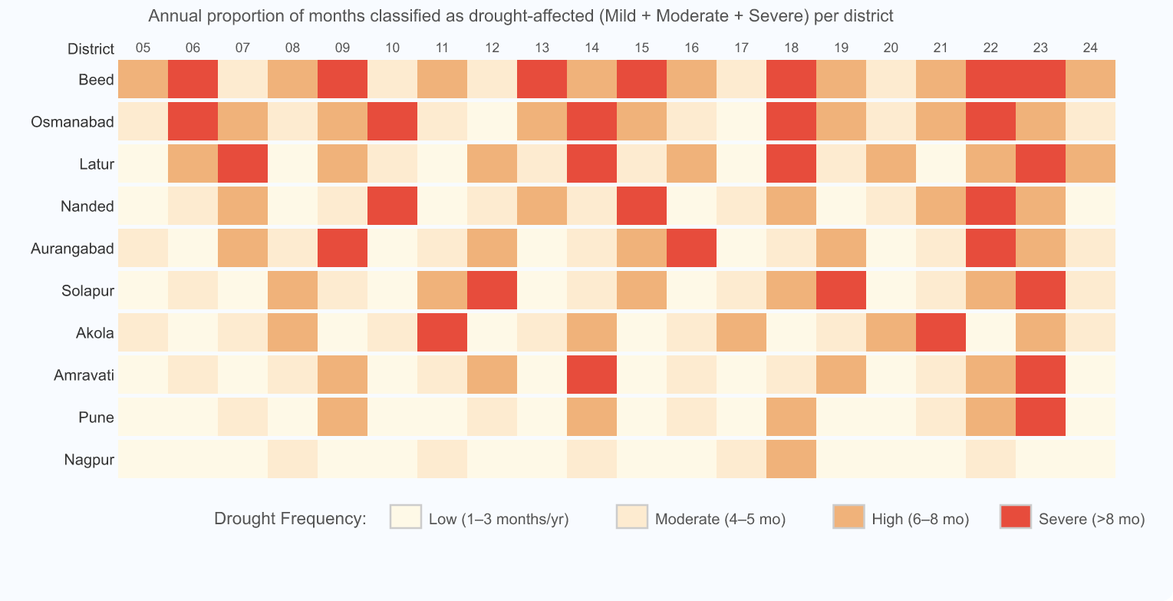
Fig. 2. Drought frequency heatmap (2005-2024)

Preprocessing and Sliding Window Construction
Records were ordered according to districts and dates. Missing values (which constitute less than 0.8% of records due to station unavailability) are imputed using linear interpolation in each district record [31]. All features were normalised into [0, 1] based on Min-Max statistics computed only on training set:
$x'=\left(x-x_{\left(min\right)}\right)/\left(x_{\left(max\right)}-x_{\left(min\right)}\right)$ (2)
We adopted a sliding-window approach where we consider data from months t−11 to t as input sample (size 12×5), while SPI-12 classification in month t+1 is the predicted output. This setup provides 1 month lead-time prediction extendible to three months using sequential window prediction. For both the Random Forest and the SVM model, the data input is a single flattened vector (size 60). The data is split 80/20 train/test using stratified sampling method.

SMOTE Class Balancing
SMOTE algorithm [16] is applied only on the training data after the split operation by synthetically generating new samples:
$x_{\left(syn\right)}=x_{i}+λ*\left(x_{\left(nn\right)}-x_{i}\right)$ (3)
where x_{nn} is one randomly chosen k-nearest neighbours (k = 5) of xi and λ ∼ U[0, 1]. After applying SMOTE, all four classes had equal representation (around 1,577 samples per class). This makes it possible for the model to learn the rare-event classes corresponding to water security alerts.

Model Architectures
- Random Forest: 200 estimators, balanced class weight distribution, maximum depth of 10 and minimum number of leaves 5. Hyper-parameters tuned using 5-fold cross validation. Used as an interpretable benchmark [10]
- SVM: Using RBF kernel, multi-class one-vs-one scheme with γ = 'scale' and C = 10. Capable of modelling complex non-linear boundaries between classes but no temporal order capability [11].
- Basic LSTM: two LSTM layers stacked (64 to 32 nodes), ReLU activation, Dropout(0.2), then two Dense layers (16 and 4 nodes with ReLU and softmax activations respectively). Optimiser: Adam with lr = 0.001. Illustrates improvement of sequential vs non-sequential learning models [12]
- Improved LSTM: three specific improvements relative to basic LSTM: (i) LSTM cell activation is tanh function which has bounds (−1, 1). Thus it restricts extreme activation for stable gradient learning over long sequences [12]. (ii) Expansion in capacity from 64 to 128 units. Needed to learn multi-variable drought patterns (iii) Batch normalisation [32] after each dropout layer. Early stopping technique used for avoiding over-fitting with patience = 10 epochs. Full architecture illustrated in Figure 3 and compared with other models in Table III.
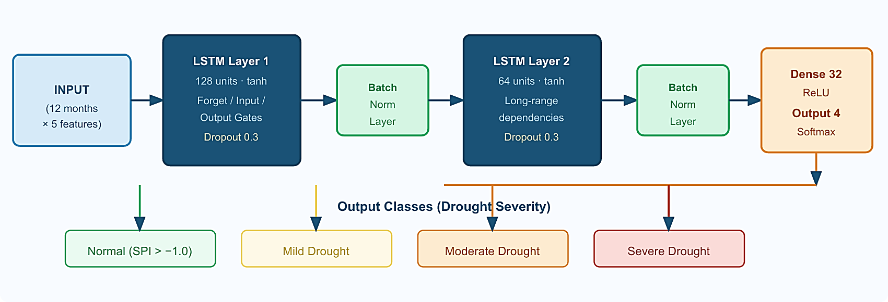
Fig. 3. Improved LSTM architecture

Table III: Architectural Comparison: Basic vs. Improved LSTM
Property | Basic LSTM | Improved LSTM
Layer 1 units | 64 | 128
Layer 2 units | 32 | 64
LSTM Activation | ReLU | Tanh
Batch Normalization | No | Yes (post-Dropout)
Dropout Rate | 0.20 | 0.30
Dense Hidden Units | 16 | 32
Early Stopping | No | Yes (patience=10)

Results and Discussion

Overall Performance
The performance of all models for the entire test dataset (N = 480 stratified samples) is provided in Table IV. The Improved LSTM model performs the best among all three measures. Most notably, the 11-point macro F1 score difference between the Improved LSTM model and Random Forest (0.72 vs. 0.50) indicates that the former is superior since macro F1 treats all four classes equally. Fig. 2 provides a visualization of the important trade-off between accuracy and Severe drought recall.
TABLE IV: Overall Model Performance on Held-Out Test Set
Model | Accuracy (%) | Weighted F1 | Macro F1
Improved LSTM | 93.33 | 0.94 | 0.72
Basic LSTM | 87.50 | 0.88 | 0.61
Random Forest | 87.50 | 0.88 | 0.50
SVM (RBF) | 85.42 | 0.86 | 0.53

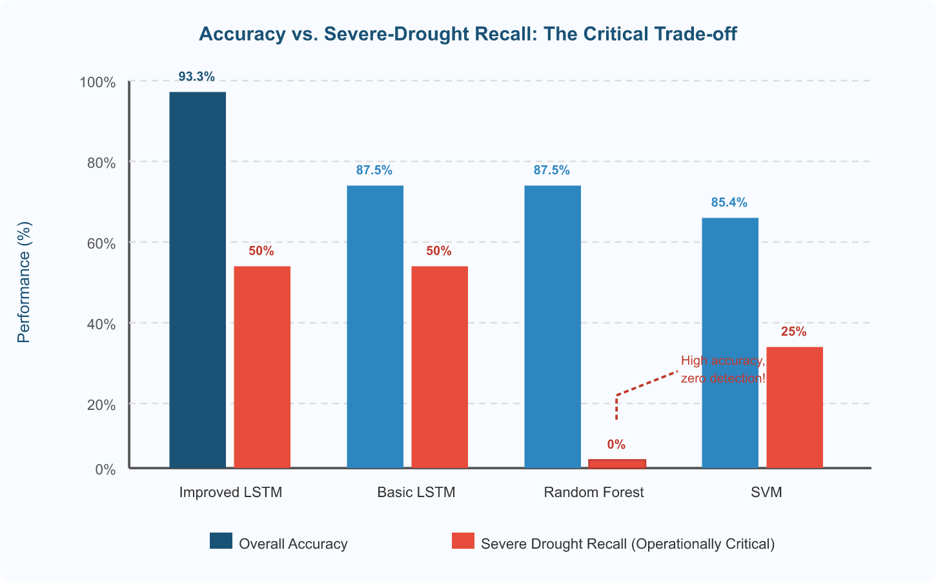
Fig. 4. Overall accuracy vs. Severe-drought recalls across four models

Per-Class Analysis
Table V presents precision, recall, and F1 scores per class for the Improved LSTM model. The model works very well on the classes such as Normal (F1 = 0.98), Mild (F1 = 0.72), and Moderate (F1 = 0.78). In the case of the Severe class that contains only four instances of data in the test set, the model has a 50% recall, which means that it successfully classified two instances from the four severe instances in the dataset. Though the precision for Severe class is relatively low (0.33) owing to the lack of data in the test set, a 50% recall score means something useful.
TABLE V: Improved LSTM: Per-Class Classification Metrics
Drought Class | Precision | Recall | F1-Score | Support
Normal | 0.98 | 0.97 | 0.98 | 405
Mild Drought | 0.70 | 0.74 | 0.72 | 47
Moderate Drought | 0.76 | 0.79 | 0.78 | 24
Severe Drought | 0.33 | 0.50 | 0.40 | 4

Recall Comparison and Operational Significance
Per-class recall for all model results is summarized in Table VI; this measure is of greatest importance when considering early-warning capabilities. In a practical sense, the conclusion drawn here is clear: the Random Forest reaches an impressive overall accuracy of 87.50%, but obtains no recall value for the Severe category, which means it has learned to classify everything as Normal in all borderline situations. The Severe category can be recognized by the SVM with an accuracy of just 25%. LSTM models obtain a 50% recall for Severe droughts.
TABLE VI: Per-Class Recall Comparison: Operational Water-Security Perspective
Model | Normal | Mild | Moderate | Severe
Improved LSTM | 0.97 | 0.74 | 0.79 | 0.50
Basic LSTM | 0.93 | 0.47 | 0.83 | 0.50
Random Forest | 0.94 | 0.45 | 0.71 | 0.00
SVM (RBF) | 0.92 | 0.51 | 0.54 | 0.25

Discussion: Enabling Water-Security Interventions
There are three reasons why Improved LSTM is superior to other methods as an algorithmic solution to water security warning. Firstly, by having multiple LSTM layers stacked together, the method can interpret the 12-month window as a trajectory, which describes the gradual development of drought due to increasing rainfall deficit, soil moisture depletion, and temperatures above average. As opposed to the static classifiers which represent such data as a simple vector with no structure, this mechanism allows Improved LSTM to recognise patterns. Secondly, SMOTE ensured the balance of all four classes within the training set, meaning that the loss gradients did not depend on the majority class (Normal), hence, directly affecting the recall of the rest of the classes needed for issuing an alert. Finally, batch normalisation and early stopping enabled improved LSTM to avoid overfitting of the imbalanced dataset.
As far as water security is concerned, probably the most vital quality of the proposed framework is its ability to distinguish between the classes representing different levels of drought, as opposed to issuing a binary prediction of whether the region faces a drought threat. At a level of Mild drought, water resource managers can recommend users conserve water, pre-fill their farm ponds, etc., while at the Moderate level deficit irrigation can be activated. At the highest level of drought, measures such as wastewater diversion and deploying additional relief are to be taken. Figure 5 illustrates this classification. One month's time provided for making the decision is enough for all the actions to be performed [7].

CONCLUSION
This paper proposed a climate-resilient water security early warning framework based on an Improved LSTM drought severity classifier of ten drought-prone districts of Maharashtra. This framework was carefully crafted to fill in the critical void between machine learning predictions and actionable interventions which renders the operational significance of most drought prediction studies null. Classification of drought severity into four SPI-12 categories 1 to 3 months ahead allows timely initiation of interventions such as rainwater harvesting, deficit irrigation planning, reservoir releases, and wastewater reuse diversion.
The Improved LSTM outperformed Random Forest, SVM, and Basic LSTM on each aggregated evaluation measure, scoring an accuracy rate of 93.33%, weighted F1 of 0.94, and 50% recall for Severe drought. Most importantly, it demonstrated the danger of relying solely on average accuracy in classification tasks with imbalanced data sets by recording the same accuracy as RF but zero recall in Severe drought cases. In future research, the model will be extended with verified IMD station records and SMAP satellite soil moisture dataset [34] and tested in other regions including Rajasthan and Karnataka. Additionally, more complex models incorporating bi-directional LSTM networks and transformers will be developed to improve the recall of rare events. Real-time pipeline integration with IMD weather stations constitutes the obvious next step towards implementing this framework.

References

- UNDRR, “Assessment of economic losses, poverty impacts, and disaster events (1998–2017),” United Nations Office for Disaster Risk Reduction, Geneva, 2018. [Online]. Available: https://www.undrr.org/publication/economic-losses-poverty-disasters-1998-2017
- India Meteorological Department, “Climate summary report for Maharashtra: 2024,” Govt. of India, Pune, Tech. Rep., 2025. [Online]. Available: https://imdpune.gov.in
- Government of Maharashtra, “Official notification on drought declaration for Kharif 2023,” Revenue and Forest Dept., Mumbai, Notification RFD-2023, Oct. 2023.
- R. Krishnan et al., “Decoding climate change signals in winter precipitation over northwest India,” Sci. Rep., vol. 9, p. 4171, 2019, doi: 10.1038/s41598-019-40555-w.
- T. P. Singh, G. Bhaskaran, and M. K. Pandey, “Evaluation of drought characteristics in Marathwada region using multivariate advance drought response index,” Int. Arch. Photogramm. Remote Sens. Spatial Inf. Sci., vol. XLVIII-4/W1-2022, pp. 441–448, 2022, doi: 10.5194/isprs-archives-XLVIII-4-W1-2022-441-2022.
- R. S. Todmal, “Future projections of monsoon variability over Maharashtra under climate change scenarios,” Theor. Appl. Climatol., vol. 144, pp. 337–352, 2021, doi: 10.1007/s00704-021-03542-0.
- NDMA, “Guidelines for drought risk management in India,” Govt. of India, New Delhi, 2010. [Online]. Available: https://ndma.gov.in
- A. K. Mishra and V. P. Singh, “Comprehensive review of drought definitions and concepts,” J. Hydrol., vol. 391, pp. 202–216, 2010, doi: 10.1016/j.jhydrol.2010.07.012.
- H. Mosaffa et al., “Use of machine learning techniques in hydrological studies,” in Computers in Earth and Environmental Sciences, Elsevier, 2022, pp. 585–591, doi: 10.1016/B978-0-323-89861-4.00027-0.
- L. Breiman, “Random forests methodology,” Mach. Learn., vol. 45, pp. 5–32, 2001, doi: 10.1023/A:1010933404324.
- C. Cortes and V. Vapnik, “Support-vector network formulation,” Mach. Learn., vol. 20, pp. 273–297, 1995, doi: 10.1007/BF00994018.
- S. Hochreiter and J. Schmidhuber, “Long short-term memory architecture,” Neural Comput., vol. 9, pp. 1735–1780, 1997, doi: 10.1162/neco.1997.9.8.1735.
- A. Dikshit, B. Pradhan, and A. M. Alamri, “Long-lead drought forecasting using lagged climate inputs and stacked LSTM models,” Sci. Total Environ., vol. 755, p. 142638, 2021, doi: 10.1016/j.scitotenv.2020.142638.
- V. N. Mahawadiwar, S. R. Nandgude, and P. B. Bhagat, “SPI-based drought prediction in Maharashtra using LSTM approach: A decade-long study (2014–2024),” Int. J. Innov. Res. Technol., vol. 11, no. 10, pp. 1228–1234, 2025.
- H. He and E. A. Garcia, “Learning techniques for imbalanced datasets,” IEEE Trans. Knowl. Data Eng., vol. 21, pp. 1263–1284, 2009, doi: 10.1109/TKDE.2008.239.
- N. V. Chawla et al., “SMOTE: Synthetic minority oversampling method,” J. Artif. Intell. Res., vol. 16, pp. 321–357, 2002, doi: 10.1613/jair.953.
- T. B. McKee, N. J. Doesken, and J. Kleist, “Linking drought duration and frequency with time scales,” in Proc. 8th Conf. Appl. Climatol., Amer. Meteorol. Soc., 1993, pp. 179–183.
- World Meteorological Organization, “User guide for Standardized Precipitation Index (SPI),” WMO-No. 1090, Geneva, 2012.
- A. Chavadekar and S. Kashid, “Spatiotemporal drought analysis of Maharashtra using SPI index,” in Proc. Int. Conf. Techno-Societal 2016, Springer, 2018, pp. 271–280, doi: 10.1007/978-3-319-53556-2_29.
- P. V. Aswathi, B. K. Bhattacharya, and M. Rajeevan, “Monitoring agricultural drought conditions in Maharashtra using meteorological and remote sensing indicators,” ISPRS Ann. Photogramm. Remote Sens. Spatial Inf. Sci., vol. IV-5, pp. 271–277, 2018, doi: 10.5194/isprs-annals-IV-5-271-2018.
- O. Rahmati et al., “Spatial modeling of agricultural drought using machine learning techniques in southeast Iran,” Sci. Total Environ., vol. 658, pp. 1158–1172, 2019, doi: 10.1016/j.scitotenv.2018.12.237.
- O. Rahmati, A. Panahi, and B. Pradhan, “Mapping drought susceptibility using random forest algorithm,” Nat. Hazards Earth Syst. Sci., vol. 20, pp. 2525–2543, 2020, doi: 10.5194/nhess-20-2525-2020.
- X. Xu, F. Luo, and H. Li, “Drought forecasting using SVM and random forest in a semi-arid region of Northwest China,” J. Arid Land, vol. 11, pp. 204–217, 2019, doi: 10.1007/s40333-019-0091-7.
- N. A. Agana and A. Homaifar, “Deep learning-based framework for long-term drought prediction,” in Proc. SoutheastCon 2017, IEEE, 2017, pp. 1–8, doi: 10.1109/SECON.2017.7925314.
- S. Poornima and M. Pushpalatha, “Rainfall forecasting using enhanced LSTM-based recurrent neural network,” Atmosphere, vol. 10, p. 668, 2019, doi: 10.3390/atmos10110668.
- G. Douzas, F. Bacao, and F. Last, “Hybrid oversampling strategy combining k-means clustering and SMOTE for imbalanced data,” Inf. Sci., vol. 465, pp. 1–20, 2018, doi: 10.1016/j.ins.2018.06.056.
- S. Barua, A. W. M. Ng, and B. J. C. Perera, “Multivariate drought characterization and assessment using composite indices,” J. Hydrol. Eng., vol. 16, pp. 760–771, 2011, doi: 10.1061/(ASCE)HE.1943-5584.0000372.
- G. Lemaître, F. Nogueira, and C. K. Aridas, “Imbalanced-learn: Python toolkit for imbalanced dataset handling,” J. Mach. Learn. Res., vol. 18, pp. 1–5, 2017. [Online]. Available: http://jmlr.org/papers/v18/16-365.html
- NASA, “POWER: Prediction of Worldwide Energy Resources database,” NASA Langley Research Center, 2024. [Online]. Available: https://power.larc.nasa.gov
- S. M. Vicente-Serrano, S. Beguía, and J. I. López-Moreno, “Standardized precipitation evapotranspiration index for climate change sensitivity analysis,” J. Clim., vol. 23, pp. 1696–1718, 2010, doi: 10.1175/2009JCLI2909.1.
- R. J. Hyndman and G. Athanasopoulos, Forecasting: Principles and Practice, 3rd ed. OTexts, 2021. [Online]. Available: https://otexts.com/fpp3/
- S. Ioffe and C. Szegedy, “Batch normalization for faster deep network training,” in Proc. ICML 2015, PMLR, 2015, pp. 448–456.
- J. B. Otkin et al., “Rapid-onset droughts: challenges and impacts in the United States,” Bull. Amer. Meteorol. Soc., vol. 99, pp. 911–919, 2018, doi: 10.1175/BAMS-D-17-0149.1.
- D. Entekhabi et al., “Overview of the SMAP mission for soil moisture monitoring,” Proc. IEEE, vol. 98, pp. 704–716, 2010, doi: 10.1109/JPROC.2010.2043918.
- P. G. Athare, N. N. Gaikwad, and P. P. Deshmukh, “Assessment of climate vulnerability in agricultural regions of Maharashtra,” Indian J. Agric. Sci., vol. 94, pp. 1178–1183, 2024.
- Central Ground Water Board, “Groundwater status report – Maharashtra 2021–22,” Ministry of Jal Shakti, New Delhi, 2022. [Online]. Available: https://cgwb.gov.
- Maharashtra Water Resources Department, “State-level integrated water resource planning report 2022,” Govt. of Maharashtra, Mumbai, 2022. [Online]. Available: https://wrd.maharashtra.gov.in
- A. AghaKouchak et al., “Compound climate extremes in a warming climate: mechanisms and emerging risks,” Rev. Geophys., vol. 58, no. 2, e2018RG000634, 2020, doi: 10.1029/2018RG000634.

