IMPORTANT NOTE

As part of your evaluation assignment, you need to answer any one question of your choice.

Please download and use the answering template available on step 1.

Kindly elaborate as much as possible.

**Advance Java, JSP**

(1)



Which of the following is correct for the above given JAVA project?

1. Code will generate compile time error.
2. Code will generate runtime error.
3. Code will redirect to the link provided in the statement response.sendRedirect.
4. Code will redirect to the link provided in the statement response.sendRedirect with username input.

(2)



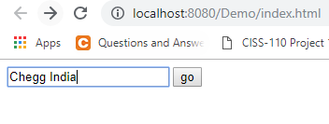

Which of the following option is correct when go button is pressed?

1. Output= "Welcome dear Chegg IndiaThe application driver name is=sun.jdbc.odbc.JdbcOdbcDriver"
2. Output= "Welcome dear CheggIndiaThe application driver name is=null".
3. Will result in compile time error
4. Will result in runtime error.

(3)



Which of the following is the correct group of JSP action attributes from the above given JSP action attributes.?

1. 1, 2, 3, 4
2. 1, 3, 4
3. 1, 2, 4
4. 1, 2, 3

(4)



Which of the following is the correct group of JSP action tags from the above given JSP action tags.?

1. 1,2,3,4
2. 1,3,4,5
3. 2,3,4,5
4. 1,2,4,5

(5)



What is the output of the above program?

1. Compile time error
2. Run time error
3. Chegg 12.6

India 51

1. Chegg 12.6 India 51