Version Control System setup and usage using GIT

What is version control ?

Version control systems are a category of software tools that help a software team manage changes to source code over time.

1. Setting up a repository

Command 1 : git init
Purpose of Command : Create an empty local repository.
Usages : git init
Sample Input/Output :
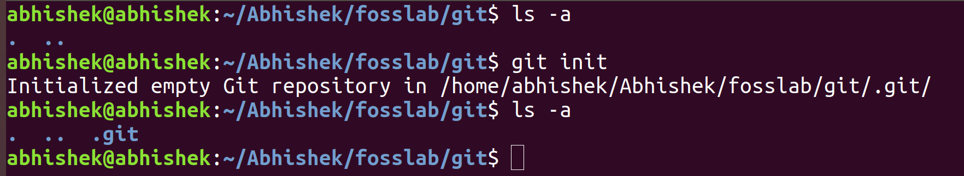
Command 2 : git config
Purpose of Command :Configure the author name and email address to be used with your commits.
Usages :git config --global user.name <username>
git config –global user.email <email ID>
Sample Input/Output :

Command 3 : git remote add
Purpose of Command :To add a remote repo url to your local git config
Usages : git remote add <remote_name><remote_repo_url>
Sample Input/Output :
2 Adding content

Command 4 : git add
Purpose of Command : Add one or more files to staging.
Usages : git add <filename> #to add a perticular file
git add . #to add all files in the directory
Sample Input/Output :
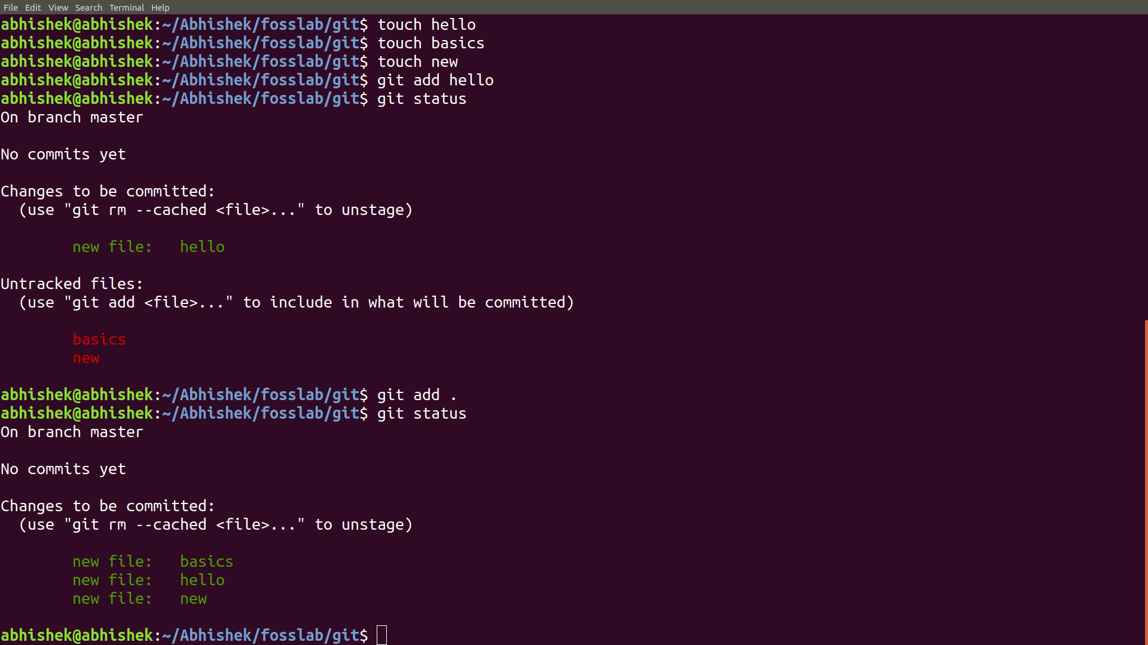
3 Committing the data

Command 5 : git commit
Purpose of Command :Commit changes to head (but not yet to the remote repository).
Usages :git commit -m <commit message>
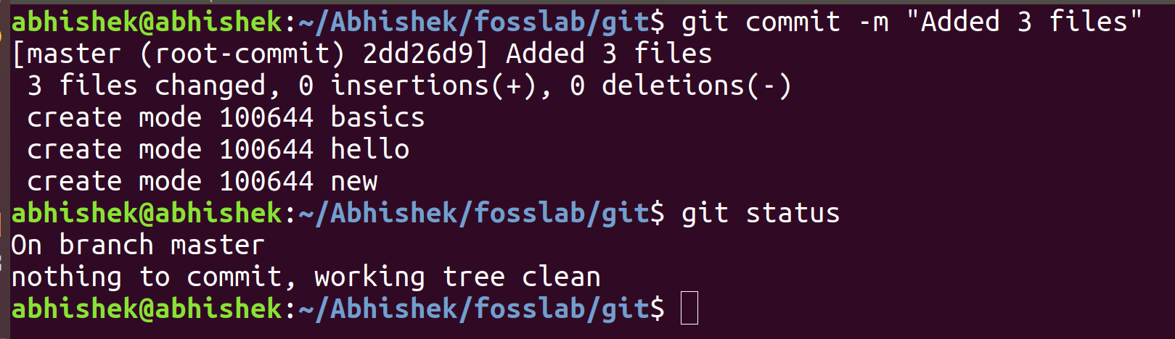
Sample Input/Output :
4 Updating the local copy

Command 6 :git push
Purpose of Command :Send changes to the master branch of your remote repository
Usages : git push <remote> <branch>
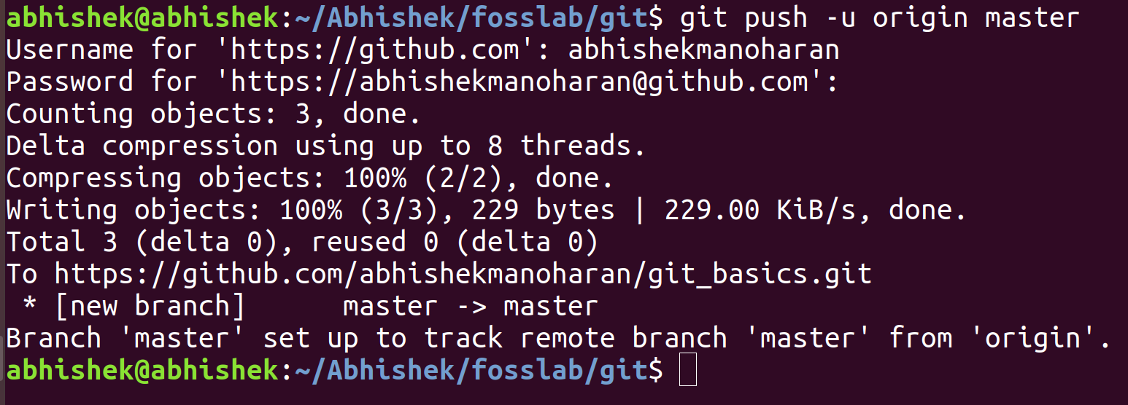
Sample Input/Output :

5 Checking out a repository

Command 7 : git clone
Purpose of Command :Create a working copy of a local repository.
Usages : git clone <path>
Sample Input/Output :

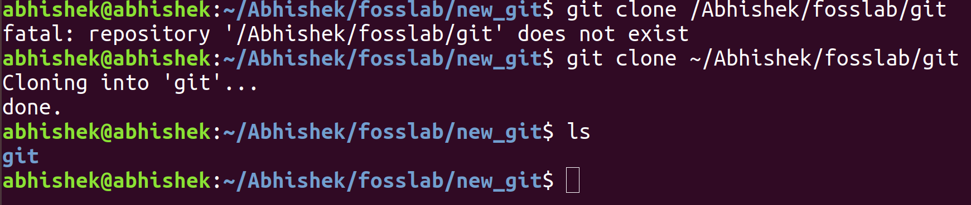

Command 8 :git checkout
Purpose of Command :To do basic branch operation.
Usages :git checkout -b <branch_name> #create and switch
git checkout<branch_name> #switch to a branch
git checkout -- <filename> #undo changes
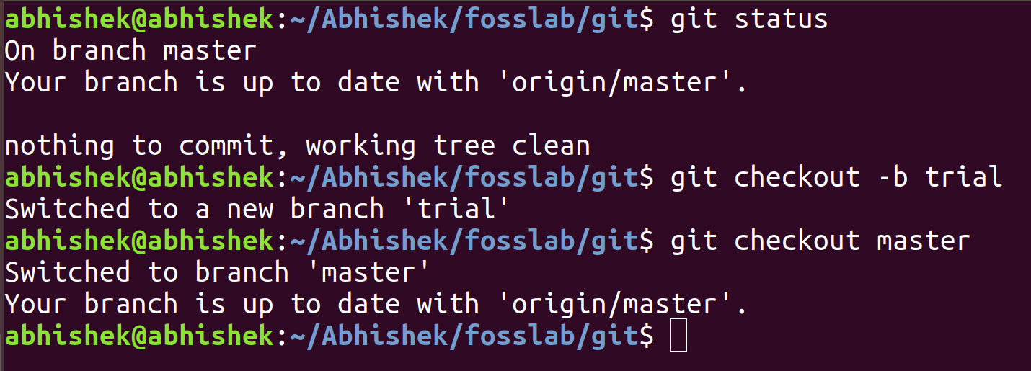
Sample Input/Output :

6 Comparing different revisions

Command 9 :git diff / git show
Purpose of Command :Diffing is a function that takes two input data sets and outputs the changes between them
Usages :git diff <commit ID 1> <commit ID 2>
Sample Input/Output :

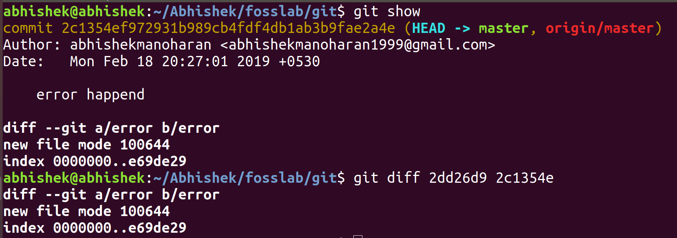
7 Revert

Command 10 :git revert
Purpose of Command :The “git revert” command can be considered an 'undo' command.
Usages :git revert <HEAD>
Sample Input/Output :
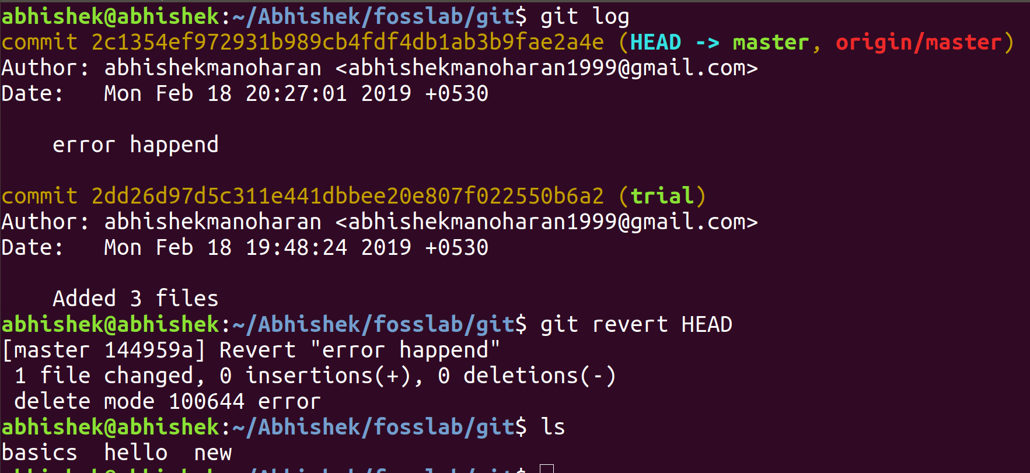

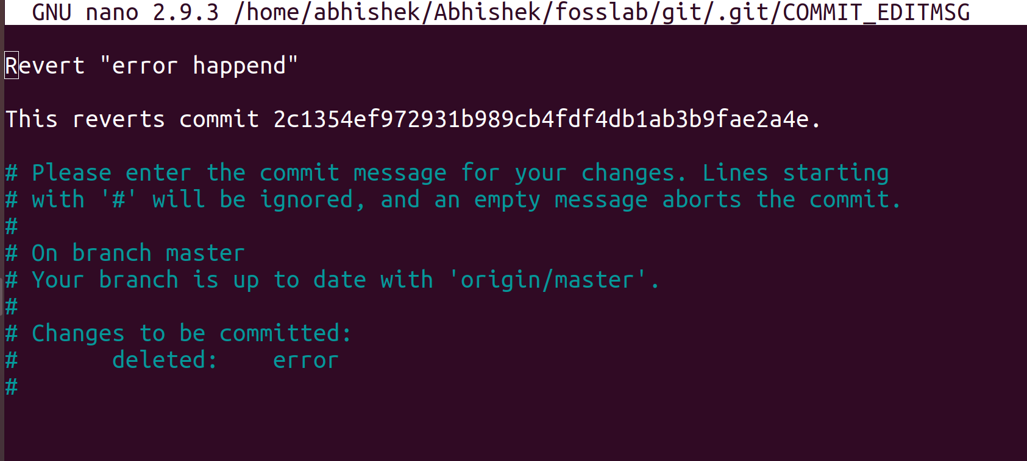

8 Conflict and conflict resolution

Merge conflicts occur when competing changes are made to the same line of a file, or when one person edits a file and another person deletes the same file.
Command 11 :git merge
Purpose of Command :The git merge command's primary responsibility is to combine separate branches and resolve any conflicting edits.
Usages :
Sample Input/Output :

here there is no conflict since only one user is working in the repository.
But if a conflict happends....
The ======= line will be the "center" of the conflict. All the content between the center and the <<<<<<< HEAD line is content that exists in the current branch master which the HEAD ref is pointing to.
The user have to edit manually according to which lines are needed and which are not and then push the edited file again to remove the conlict.
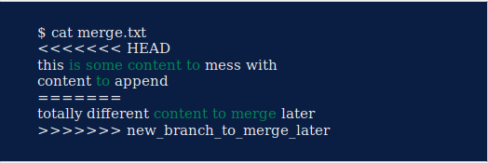
*Above screenshot is copied from a website since it is difficult to generate a conflict with single user.
Submitted by

Abhishek manoharan
TVE17CS002
Roll no. 2

