Shell Scripting – Set 2
Qno 6 -9
Foss Lab

Submitted by

Abhishek Manoharan
Roll number 2
S3 CSE

6. Write a shell script that will take an input file and remove identical lines.

Algorithm

1 If $# = 1 do 2 else do 6
2 If file exist then do 3 else do 6
3 Store the line by line ignoring repeated lines in a temporary variable
4 Remove the first file
5 Move conten of temporary file to the first file
6 exit
shell script
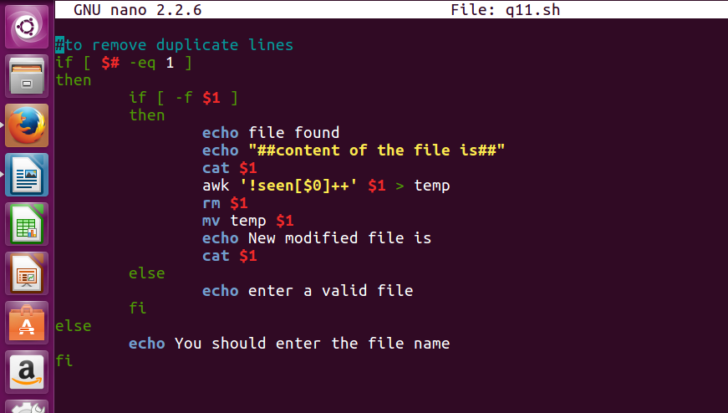
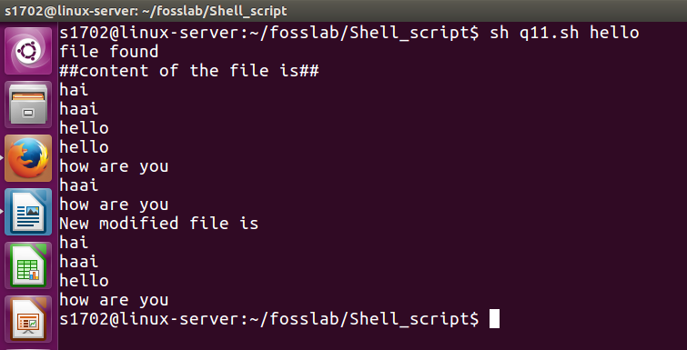
output
7. Write a shell script that displays a list of all the files in the current
directory to which the user has read, write and execute permissions.

Algorithm

1 For loop for all the files in the current directory
2 if the file has read,write,execute permisson do 3 else do 4
3 Print file name
4 Exit

Shell script
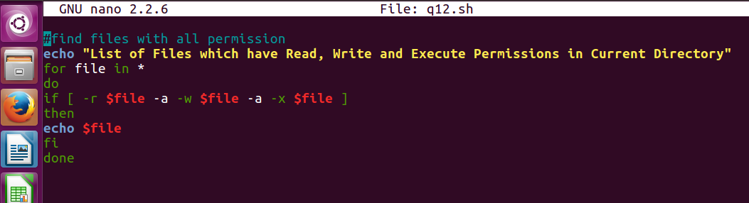

output

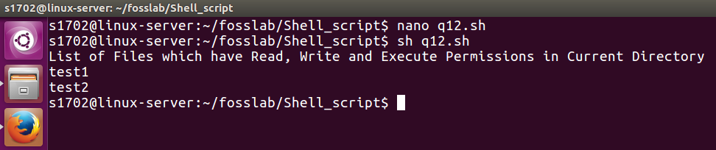

8.
Write a shell script that folds long lines into 40 columns. Thus any line
that exceeds 40 characters must be broken after 40th ; a\ is to be
appended as the indication of folding and the processing is to be
continued with the residue. The input is to be through a text file created
by the user.

Algorithm

1 if $# is 1 do 2 else go to 13
2 if file exist do 3 else go to 13
3 store the number of lines in “n”
4 i =1
5 while i <= n do 6 to 12
6 store the i th line in “line”
7 store number of charecters in “cc”
6 while cc > 40 do 7 to 9
7 print first 40 charecter and a /
8 store the remaining charecter is “line”
9 store charecter count of new “line” in cc
10 end while
11 print line
12 i =i +1
13 exit

shell script

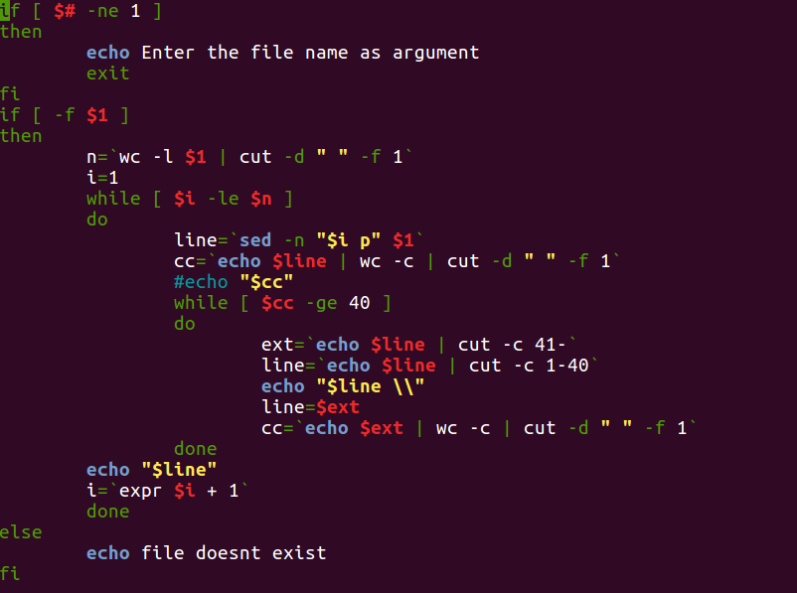
output
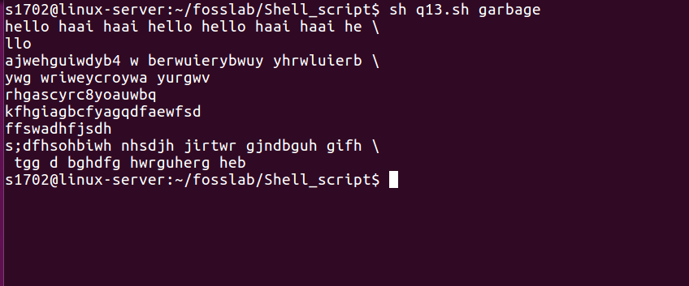

9. Write a shell script to delete all lines containing a specific word in one or more file supplied as argument to it.

Algorithm

1 If #$ not equal to zero do 2 else go to 5.
2 Read the word to be deleted in the file.
3 if the file exist do 4 else check the next file name till input ends.
4 delete the lines containing the word usuing sed command.
5 exit

shell script

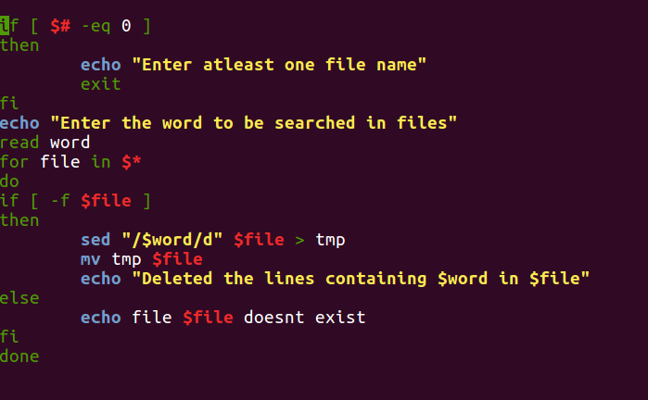

Output

