Disk Scheduling
Exp 02
FCFS

#include<stdio.h>
#include<stdlib.h>
void main(){
int size,init,n,pos,i;
float total=0;

printf("Enter the Disk size: ");
scanf("%d",&size);
printf("Enter the initial head position: ");
scanf("%d",&init);
pos=init;
printf("Enter the number of requests: ");
scanf("%d",&n);

int *req=(int *)malloc(n*sizeof(int));

printf("Enter the request\n");
for(i=0;i<n;++i){
scanf("%d",&req[i]);
if(req[i]>=size || req[i]<0){
printf("are you dumb\n");
break;
}
}
for(i=0;i<n;++i){
if(req[i]<=init){
total+=init-req[i];
printf("Move from %d to %d with seek %d\n",init,req[i],init-req[i]);
}
else{
total+=req[i]-init;
printf("Move from %d to %d with seek %d\n",init,req[i],req[i]-init);
}
init=req[i];
}

printf("Total seek time is %f \n",total);
printf("Average seek time is %f \n",total/n);

}

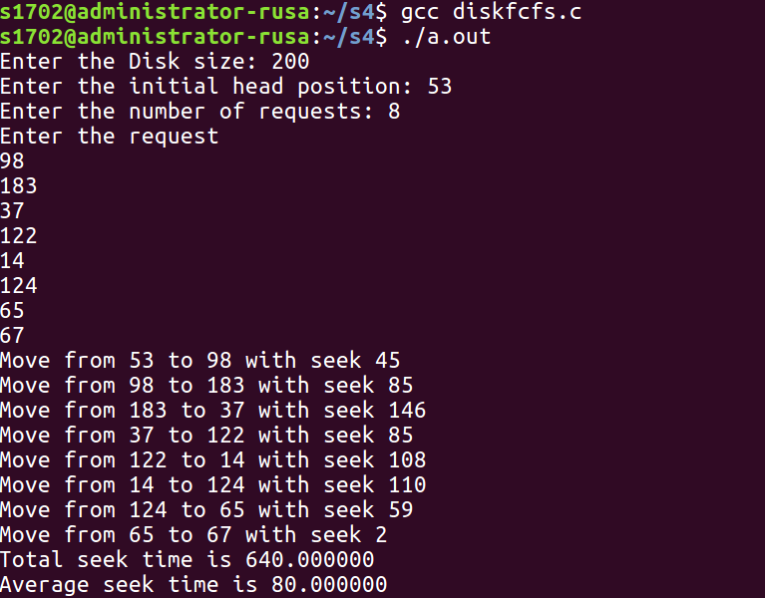

SCAN

#include<stdio.h>
#include<stdlib.h>
void swap(int *a,int *b){
int temp;
temp=*a;
*a=*b;
*b=temp;
}
int main(){
int size,init,n,pos,i;
float total=0;

printf("Enter the Disk size: ");
scanf("%d",&size);
printf("Enter the initial head position: ");
scanf("%d",&init);
pos=init;
printf("Enter the number of requests: ");
scanf("%d",&n);

int *req=(int *)malloc(n*sizeof(int));
printf("Enter the request\n");
for(i=0;i<n;++i){
scanf("%d",&req[i]);
if(req[i]>=size || req[i]<0){
printf("are you dumb\n");
return 0;
break;
}
}
for(i=0;i<n-1;++i){
for(int j=i;j<n;++j)
if(req[i]>req[j])
swap(&req[i],&req[j]);
}
int min=0;
for(min=0;req[min]<=init;++min);
//printf("%d",req[min]);
min--;
for(i=min;i>=0;--i){
total+=init-req[i];
printf("Move from\t%d\tto\t%d\twith seek %d\n",init,req[i],init-req[i]);
init=req[i];
}
if(init!=0){
printf("Move from\t%d\tto\t0\twith seek %d\n",init,init);
total+=init;
init=0;
}
for(i=(min+1);i<n;++i){
total+=req[i]-init;
printf("Move from\t%d\tto\t%d\twith seek %d\n",init,req[i],req[i]-init);
init=req[i];
}

printf("***Total seek time is %f*** \n",total);
printf("***Average seek time is %f*** \n",total/n);
return 0;
}

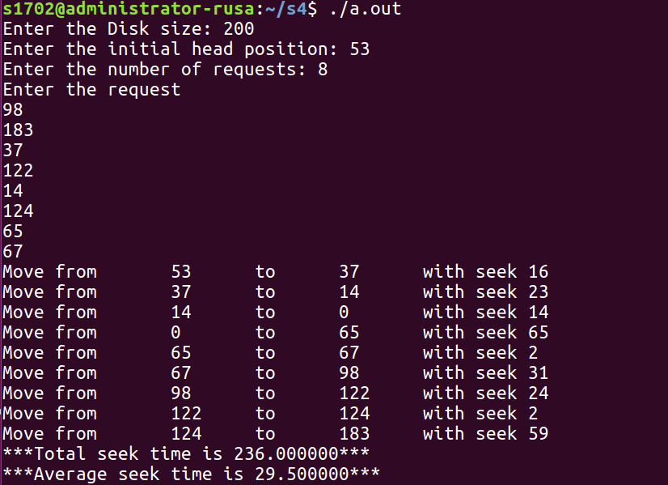
C-SCAN

#include<stdio.h>
#include<stdlib.h>
void swap(int *a,int *b){
int temp;
temp=*a;
*a=*b;
*b=temp;
}
int main(){
int size,init,n,pos,i;
float total=0;

printf("Enter the Disk size: ");
scanf("%d",&size);
printf("Enter the initial head position: ");
scanf("%d",&init);
pos=init;
printf("Enter the number of requests: ");
scanf("%d",&n);

int *req=(int *)malloc(n*sizeof(int));
printf("Enter the request\n");
for(i=0;i<n;++i){
scanf("%d",&req[i]);
if(req[i]>=size || req[i]<0){
printf("are you dumb\n");
return 0;
break;
}
}
for(i=0;i<n-1;++i){
for(int j=i;j<n;++j)
if(req[i]>req[j])
swap(&req[i],&req[j]);
}
int min=0;
for(min=0;req[min]<=init;++min);
//printf("%d",req[min]);
min--;
for(i=min;i>=0;--i){
total+=init-req[i];
printf("Move from\t%d\tto\t%d\twith seek %d\n",init,req[i],init-req[i]);
init=req[i];
}
if(init!=0){
printf("Move from\t%d\tto\t0\twith seek %d\n",init,init);
total+=init;
init=0;
}
printf("Move from\t0\tto\t%d\twith seek %d\n",size-1,size-1);
init=size-1;
total+=size-1;
for(i=n-1;i>min;--i){
total+=init-req[i];
printf("Move from\t%d\tto\t%d\twith seek %d\n",init,req[i],init-req[i]);
init=req[i];
}

printf("***Total seek time is %f*** \n",total);
printf("***Average seek time is %f*** \n",total/n);
return 0;
}

